@ 1-Maj7#5.pdf
@ 2-sus b9.pdf
@ 3-minMaj13#11#9,pdf
@ 4-Maj7#11#9.pdf
@ 5-sus9.pdf @ 6-min9.pdf @ 7-Maj7.pdf
@ 8-dim7b13.pdf
@ 9-13#11#9.pdf
@ 10-Maj7#11.pdf @ 11-minMaj9.pdf @ 12-min7b5.pdf @ 13-7#9#5.pdf @ 13b9.pdf
@ 16-Maj9.pdf
@ 15-min11_9_.pdf

The Melodic Triads Study Group

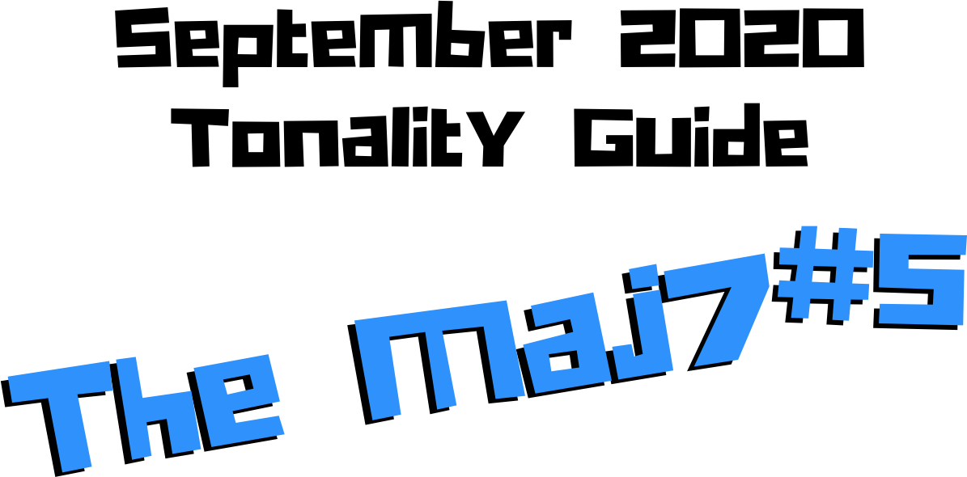

Jordan Klemons
NYC Jazz Guitar Masterclasses

CONTENTS
-INTRODUCTION
-THE MUST KNOW-
-ADVANCING MELODY-
-DIGGING DEEPER-
-THE MELODIC TRIAD BEBOP SCALE-
-ADVANCING HARMONY-
-TENSION LAYERS-
-OUTRO-

This ebook is the copyrighted property of Jordan Klemons. All images, information, layout, and designs belong to Jordan Klemons. This document may not be altered, reproduced, distributed, or transmitted in any form or by any means without the prior written permission of the author.

INTRODUCTION
Thank you for downloading the pdf materials for this month’s melodic triads tonality study guide. Inside you will find all of the supplemental theory, notation, tab, charts, concepts, and examples for the accompanying videos to help you develop your understanding, your ear, your emotional connection with, and your sense of harmonic and melodic freedom within this month’s tonality… as well as its use in some short, common, jazz chord progressions that you will be able to immediately implement in your own playing.
The information in this guide is dangerous. I mean that literally. When the process is respected, and you understand how all of these ideas fit into the puzzle, this guide and the baby steps included can offer tremendous insight into how to begin making real music very quickly, and how to continue evolving and growing as a player for many years to come. However, if approached in the wrong way and the process is not respected, these ideas can confuse and derail a musician’s ability to progress. It’s important not to jump too far ahead of yourself. The advice that a Miles, or a Scofield, or a Coltrane would give to a beginner is different than what they would give an intermediate or to an advanced player. And all of that would be different than how they would talk to a professional who’s already playing on their level. This is important to remember.
This guide is meant to show many different layers of musical growth and how, when using the melodic triad approach, they can all be boiled down and viewed simply as an extension of the most basic elements of music. Namely… a triad. Think of the pages that follow as an architect’s blue prints for a skyscraper. If you haven’t built a strong foundation, your skyscraper will fall. If you attempt to skip the first 50 stories and jump to building the penthouse, the skyscraper will fall. If you try to put up the fancy exterior of the building before you complete the steel frame, the skyscraper will fall. Yes, the information all the way at the end of this guide is constructed using the same ideas and concepts that are presented in the first chapter, but the process must be respected for anything to work. Otherwise it will only leave you confused, frustrated, feeling like a failure, and wanting to give up. Be patient with yourself. The short cut IS the long road. Take it. Spend two or three months working on the long road and watch how much you progress. Focus on your sound, on your ear, and on your musicianship… and trust that the simplicity of the ideas and the process itself will take care of you. They will. But only if you respect them. It’s like a relationship - you have to be present and give of yourself, and then you will receive in abundance.

As you work through these pages, try to keep in mind this Bill Evans’ quote from The Universal Mind.

**********************************

The whole process of learning the facility of being able to play jazz is to take these problems from the outer level in, one by one, and to stay with it at a very intense, conscious-concentration level until that process becomes secondary and subconscious. Now, when that becomes subconscious, then you can begin concentrating on that next problem, which will allow you to do a little bit more.

I don’t consider myself as talented as many people but in some ways that was an advantage because I didn’t have a great facility immediately so I had to be more analytical and in a way — that forced me to build something.
Most people just don’t realize the immensity of the problem and, either because they can’t conquer it immediately, think that they haven’t got the ability, or they’re so impatient to conquer it that they never do see it through. If you do understand the problem then you can enjoy your whole trip through.

People tend to approximate the product rather than attacking it in a realistic, true way at any elementary level — regardless of how elementary — but it must be entirely true and entirely real and entirely accurate. They would rather approximate the entire problem than to take a small part of it and be real and true about it. To approximate the whole thing in a vague way gives you a feeling that you’ve more or less touched the thing, but in this way you just lead yourself toward confusion and ultimately you’re going to get so confused that you’ll never find your way out.

It is true of any subject that the person that succeeds in anything has the realistic viewpoint at the beginning and [knows] that the problem is large and that he has to take it a step at a time and that he has to enjoy the step-by-step learning procedure. They’re trying to do a thing in a way that is so general [that] they can’t possibly build on that. If they build on that, they’re building on top of confusion and vagueness and they can’t possibly progress. If you try to approximate something that is very advanced and don’t know what you’re doing, you can’t advance.

**********************************

I’ve setup the material in these tonality lessons to start with the most basic and fundamental elements of music, and to grow outwards in complexity. Everything builds on what came before it, so everything is connected. You DON’T need to master everything in these lessons to play music. You only really need the first section and a little bit of creativity and concern for your sound - that’s enough to create something beautiful..
I recommend that if you’re new with us, even if you’re already an advanced player, you begin focused entirely on the first section of this guide, The Must Know, and give yourself a minimum of 3 - 6 months to get used to this method and the initial concepts presented. It’s a very different approach to standard theory, and your goal should be (as Bill Evans said) to be able to make genuine, authentic music with the ideas in the first section. Once you feel you can hear and play music using these ideas on a small handful of tonalities and applied to some tunes, then it is time to start advancing forward.

I would continue giving yourself an addition 3 - 6 months for each subsequent section, as each builds on the last and becomes more and more advanced… starting from the most basic and simple ingredients, and eventually working our way up to learning to hear and use all 12 notes of the western chromatic scale harmonically and melodically over any chord in a musical way.
I strongly recommend that you follow this rough timeline. I believe it’s the most effective way to cut through the learning process and get straight to making beautiful music, and then to set yourself on the path to continue growing and building for years to come.
The melodic triad ideas I’m working on today, I didn’t even know they existed during the first few years of my own studies. As we grow and progress and get comfortable, we can naturally start to evolve the ideas into more advanced applications. That’s the beauty of starting with the fundamentals, learning to make genuine, authenticate music from our own self first… and then building layers of complexity on top of, but always connected to, those very fundamentals. Much like a large skyscraper building starts with a huge hole in the earth, then is filled with concrete and steel, and then the steel frame will hold the building as it goes up. We won’t see any of these structures. But without them, the building would collapse. Only once the structure is there can the work of putting up the exterior, the glass, the interior, the design, the furniture, etc. take place.
Thank you again for downloading this study guide and working on your music with us. I look forward to hearing your playing and your contributions to the melodic triad conversation inside our facebook group, and for those of you subscribed to our Private Community, inside our melodic triad mastermind group.
Happy Practicing!
Your friend on the path towards jazz guitar mastery,
-Jordan Klemons

The Melodic Triad Study Group - a part of
NYC Jazz Guitar Masterclasses

THE MUST KNOW
The theory, ideas, voicings, and “scalar” ideas presented in this section may seem too simple and elementary to be of value. But I urge you, even the intermediate and advanced players - do not skip this section. I recommend that if you’re within the first 3 - 12 months of study with us that you focus entirely on learning to apply these ideas to musical situations. You can skim the rest of the pages if you’d like, but this should be where you build from. After close to 25 years of playing music seriously, I still spent my first year of working on melodic triads only on this material. The great thing about these ideas is that not only can you comp, improvise, compose, and arrange beautiful music over standards, bebop, modern jazz, and original works with them, but they also act as the foundation on top of which we can grow into more and more complex ideas without ever leaving behind these basic building blocks of harmony and melody.
Do not simply see these as intellectual theory ideas. These are meant to be internalized. To understand the theory is great. To hear the sounds in your ear with a sense of familiarity is just as important. To connect with them personally and be able to hear and express emotion through them is of the utmost importance when it comes to developing our musicianship. This should be the goal.

THEORY
The Maj7#5 - sometimes called the augmented major 7 - feels like floating in slow motion through the air. Imagine hanging onto the side of the space station as it orbits around the earth and gently pushing yourself off of it. In today’s modern jazz culture, the most common way we’re likely to see this tonality getting used is just as a more “hip” substitute for a Maj7 chord. If you see a Maj7 chord in a tune, you can put the Maj7#5 in its place. It gives a much more angular and modern sound. We do also see this chord written into tunes sometimes as a passing chord between basic 6 chords and Maj7 chord. We would expect to hear the 1, 3, and 7 stay the same but hear the chromatic movement between the natural 5, the #5, and 6/13. We will look at examples of this movement in this PDF.

What makes up a CMaj7#5 tonality?
Two basic ingredients.
- A basic CMaj7 shell voicing chord
- An E major triad
A good way to think of this is to visualize a piano player with two hands. Their left hand would be playing C-E-B (a basic CMaj7 shell voicing) and their right hand would be playing an E major triad.

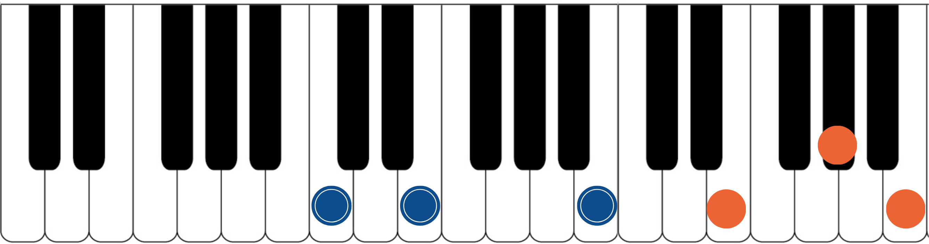

The blue dots would represent the fingers of the piano player’s left hand. Notice they spell out C, E, and B. That’s the 1, 3, and 7 of a basic CMaj7 chord. The orange dots represent the piano player’s right hand. They spell out E, G#, and B. That’s an E major triad. If you have access to a piano or keyboard, I strongly encourage you sit down and play these seven notes simultaneously. Listen to how big of a sound they create together. Play it a few times. Try and feel the emotion and the color they create together. Then remind yourself of the elementary and simple nature of what’s happening in each of your two hands separately. A basic chord in your left hand. A basic triad in your right hand.
The magic happens when we use these sounds together… and when we begin to build chord voicings and melodic ideas around these two simple sounds.

***This E major triad, which is now our melodic triad, is built on the 3rd of CMaj7… ‘E’ is a major 3rd up from ‘C’. This relationship is critical to understand and memorize as it will allow us to transpose this Maj7#5 tonality into any key quickly. We will notate this as ‘T3’. This notation comes from Stefon Harris. The ’T’ is short for ‘triad’ and we make it upper case to notate that it’s a major triad. The 3 tells us that the melodic triad is built on the 3rd of the harmony. So if we want a GMaj7#5, we think

T3, we find the 3rd of G (which is B), and we know that the melodic triad is B major.***
This pianistic chord construction is the starting point for everything we are going to look at together. Hidden inside of this seven-note chord is a universe of potential harmonic and melodic ideas. The following pages can all be traced back to this construction idea. Basic chord, basic triad. Left hand, right hand. Harmonic structure, melodic structure. Hence the term… melodic triad. Even if you don’t have access to a piano, I encourage you to sit and think about this diagram until it makes sense to you.

GETTING THE PIANISTIC VOICINGS ONTO THE GUITAR
Taking the concept of the piano construction, where the CMaj7 shell voicing is always underneath the E major triad, we can develop three basic inversions of this chord by inverting the E triad and keeping the CMaj7 shell voicing underneath it as much as possible.
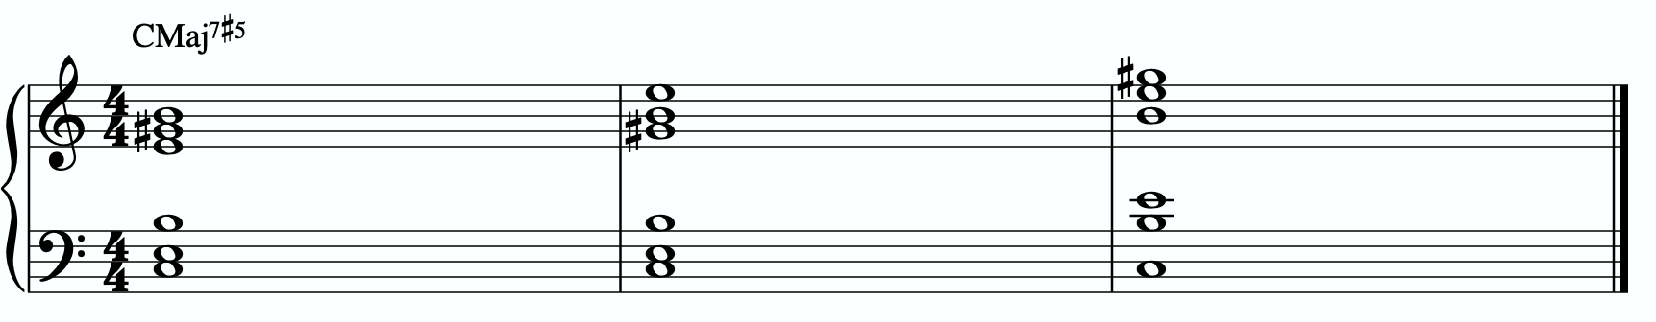
In order to get these three inversions, we will use the piano -> guitar technique described in the video - where we put the shell voicing on the bottom three strings and the triad inversions on the top three strings. This will give us a three “pianistic” inversions of this tonality on the guitar.
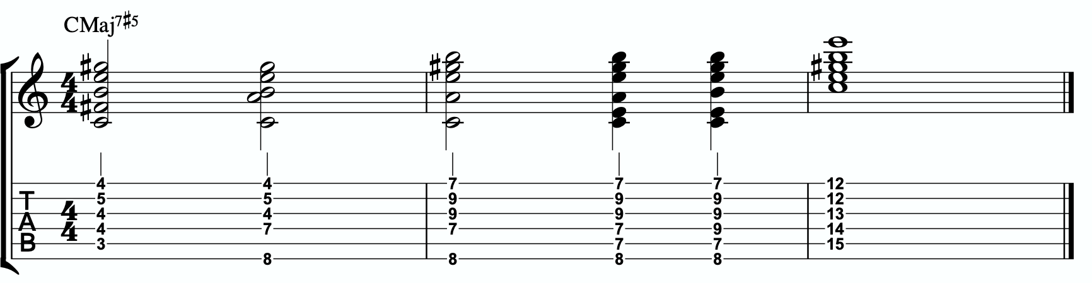

Notice the three basic inversions of the Bb major triad on strings 1 - 3.

A few exceptions are being made here.
In measure 1 I prefer the first option. This voicing leaves the 3rd and 7th out of the shell voicing, replaces them with the 5th, but uses the #11/#4 in its place (it falls into the same category). This is done because the physicality makes it awkward to get the 3rd and 7th in the lower structure of the chord, but it’s okay as these two pitches are already present in the melodic triad. The 2nd choice can work as well and is a little cleaner. It removes the 3rd and 7th from the lower structure shell voicing and replaces the 7th with the 6th, which is a very related note. However, it’s a little bit more of a stretch to reach and it makes it harder to use outside of rubato and ballad playing.
In measure 2 we have a similar voicing as mentioned in the previous paragraph. My preferred voicing is the 1st one listed, where the 3rd has been removed from the shell voicing (which is already present in the melodic triad, so it’s not missing), and the 7th is being replaced by the 6th. This makes it easier to play AND avoids having doubled E or B notes. But play with the other two options to see which you prefer.

In measure 3 we have almost the full voicing. We are simply leaving the 7th out of our lower structure shell voicing. However it’s already present in the melodic triad, so using these five pitches we’re able to present the fully-extended, two hand voicing… despite us repeating the E note on both the 4th and 1st strings.

THE PRIMARY QUADRATONIC
Because this particular type of CMaj7 contains an E major triad in the right hand, that E triad is going to be the foundation of our melodic structures. It governs everything. Rather than simply behaving as the chord tones that they correspond to harmonically, when used melodically, they will function as the 1, 3, and 5 of our melody… the strongest and most stable resolution points we can build lines with.
The ideal starting point is our primary quadratonic. A quadratonic is a triad that has one additional note added to it. It’s a four note structure made up of three stable notes (the melodic triad) and one ‘free radical’ or melodic tension note. This extra note serves two functions. First, it’s there to create melodic tension that will help us create movement, emotion, and lyrical phrases without getting trapped inside running scales or chord tones. Second, it will help imply the sound of the harmony we’re playing over and glue the melodic triad inside the chord so they don’t sound like two separate sounds, but rather one unified, colorful tonality.

We only have 12 notes in western music, and three of those 12 are being used in our melodic triad. That means we only have nine possible melodic tension notes. All nine of these could be used to create melodic tension against our triad. But some will help imply the sound of our original harmony better than others. Our primary quadratonic will be made of our melodic triad and the primary tension note - or the note the most respects the basic harmony.

Straight from Stefon Harris’ brilliant mind comes this rule that will help us figure out what are the most important notes:

The Hierarchy of Harmonic Importance.
3 - 7 - 5 - 9 - 11 - 13 - R

These are the chord tones of our basic harmony (the left hand of our piano player).

Here’s how this works:
- Is the 3rd of CMaj7#5 in the E major triad?
Yes. The 3rd of CMaj7#5 is E. That’s in the E triad… next
-Is the 7th of CMaj7#5 in the E major triad?
Yes. The 7 of CMaj7#5 is B. That’s in the E triad… next
-Is the 5th of CMaj7#5 in the E major triad?
Yes. The 5th of CMaj7#5 is G# (the SHARP 5). That’s in the E triad… next
-Is the 9th of CMaj7#5 in the E major triad?
No. The 9th of CMaj7#5 is D. That’s not present in the E triad but gives us tension b7 and can’t be used… next

-Is the 11th of CMaj7#5 in the E major triad?
No. The 11th of CMaj7#5 is F# (the SHARP 11). That’s not present in the E triad.

So our primary tension note is F#.
This F# - while the #11 of CMaj7#5 - is going to be heard by the ear in relationship to the E major triad. Since F# is the 2 of E, we will call this tension 2. So our primary quadratonic is E tension 2.
We’ll notate this as:
/ 2
E

By making the triad bold and circling it, it draws our eye directly to the melodic triad so we can think first about our strong resolution points, then it quickly lets us know what our primary melodic tension note is.

At this point your primary goals should be to be able to play the three pianistic voicings, to be able to visualize the primary quadratonic over the basic shell voicings on the fretboard, to develop your ears to hear the melodic tension note wanting to move and the root note of the melodic triad as melodic ‘do’ - or the root note of the melody.

Here are some examples of these fundamental voicings, shell voicings, and melodic ideas being used in music situations.
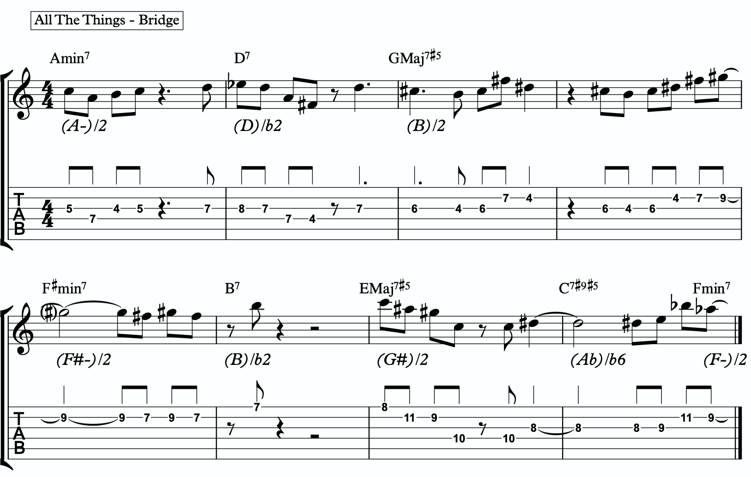
1a

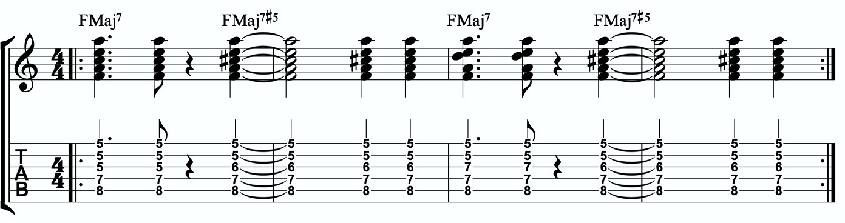
1b

ADVANCING MELODY
This section is going to look at more advanced and complex application of melodic triads to scalar ideas and arpeggios for the creation of bebop and modern jazz vocabulary based on simple structures that we can be playful with rather than memorization of riffs. Don’t be fooled by the idea of these ideas being more advanced or complicated. This doesn’t mean the music you play with these ideas will necessarily be better or more “advanced sounding” then the use of the pure primary quadratonic. In fact, often times I find that the use of the pure quadratonic can carry a level of maturity and intensity into the music that is hard to maintain when using more complicated ideas.
But, I still think it’s worth being aware of how we can build more advanced structures directly from the melodic triad.

Chromaticism Within The Quadratonic
One of the quickest ways to begin developing more complex lines is to incorporate chromaticism and leading tones within the quadratonic. By first learning to master the pure quadratonic, it should make it easier to begin spontaneously connecting individual notes within these structures in a way that will create a sense of improvisational freedom with our bebop and modern jazz playing. Playing this way will allow us to breathe long, flowing, complex lines within very the very basic, simple, steel frames of our buildings.
Here is our primary quadratonic:
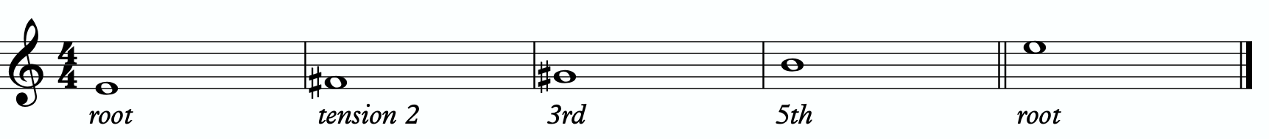

In between any of these notes, we can hang a chromatic line or place a leading tone (a note chromatically below the target) to bring us to the next note. When we use these techniques, we want to make sure that we resolve to a quadratonic note, and ideally we want to play at least two quadratonic notes immediately following the chromatic line to cement our phrase inside the tonality.

Here is an example:
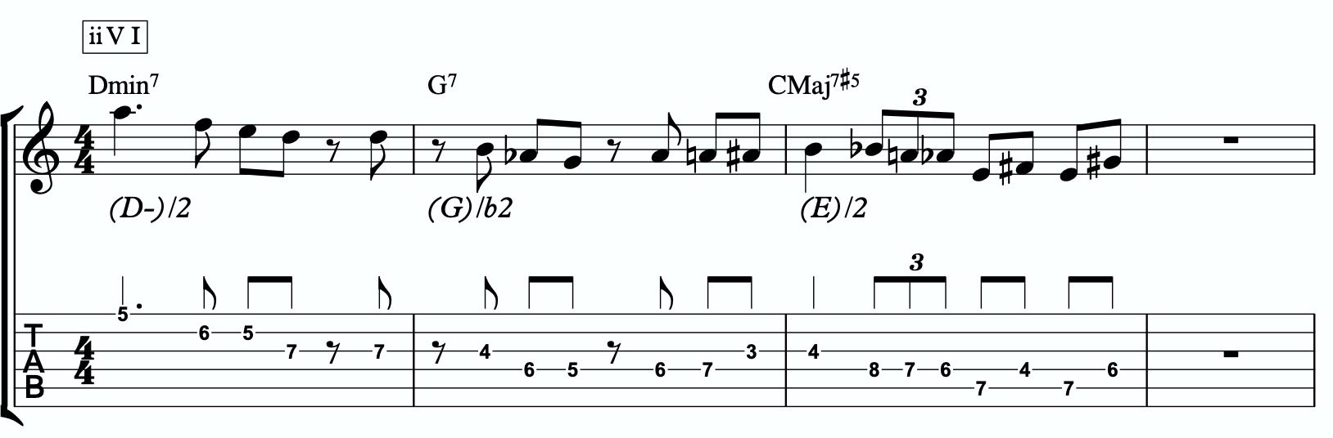
2a

Quadratonic Arpeggios
So far we have only discussed using quadratonics to develop phrases and scalar like ideas. Let’s look at how we can create the sound of arpeggios with them.
We will begin by starting on the primary tension note. After playing this note, we can move to the nearest melodic triad note and sweep quickly through that triad, landing on the tension note an octave away from where we began.
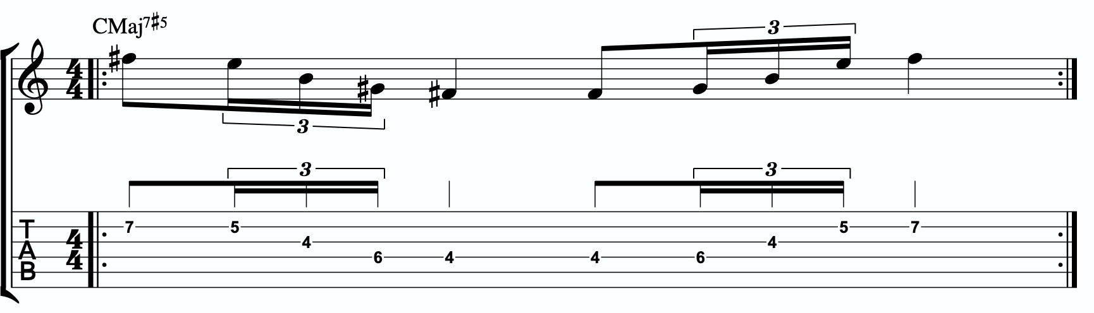
2b

We want to be able to play these ascending and descending starting on any octave of the tension note in any position of the fretboard. If we can incorporate this technique and the chromatic techniques above into our quadratonics then we are giving ourselves resolution notes, tension notes, chromatic runs, leading tones, and quick arpeggio-style runs that we can freely play within during our improvisation while remaining securely inside the color, emotion, and function of any given tonality.

Here is an example of these techniques being used together:
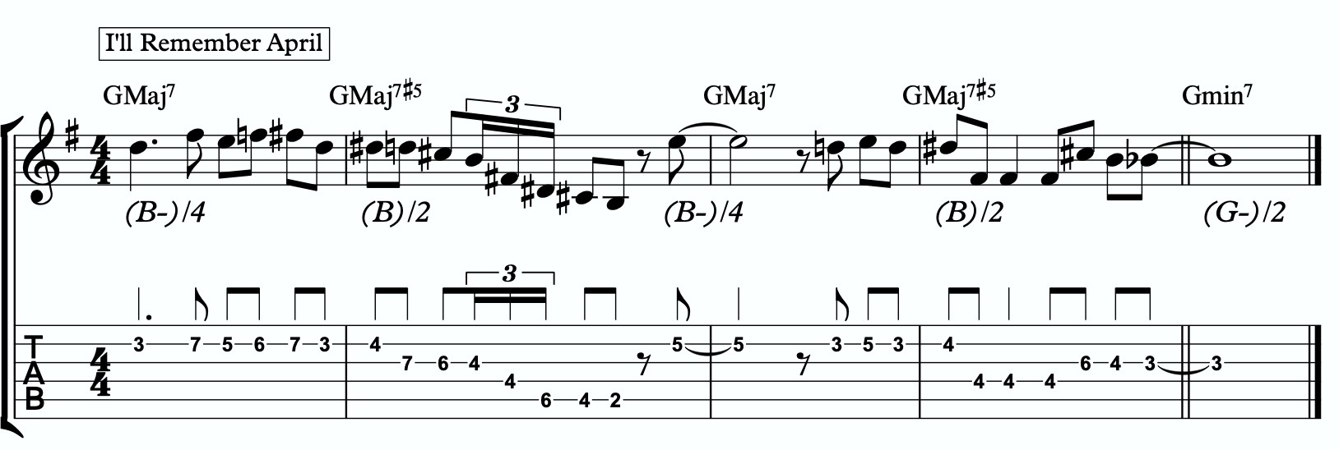
2c

DIGGING DEEPER
The goal of this section is to take small baby steps to evolve the fundamentals of melodic triads in the previous sections into new harmonic and melodic territory. If you are not already comfortable with the shell voicings, the three inversions of the pianistic voicings in all 12 keys, the primary quadratonic, and how to hear and feel the primary tension note against the melodic triad over the sus9, I would hold off and continue working on that.

FOUR NOTE VOICINGS
Let’s begin with harmony. Our first goal should be to minimize down these big, dense, pianistic voicings into something more manageable for the guitar. Four note voicings are ideal for our instrument. But sometimes it can be tough to get those colorful, pianistic type lush chords on the guitar because we just don’t have enough fingers. This is due to what I call bottom-up thinking. We are trained to think R, 3rd, etc etc. From the bottom of the chord moving upwards. By the time we get to the sweet spot notes, we’re out of fingers.
Instead, we’re going to think top-down. Our priority is the melodic triad. With these chords, the very first thing we will think about is the melodic triad. Then we are going to add one note underneath it, much like a slash chord. However, we don’t always use the root note. I usually like to try the 3rd first, but that’s already present in our triad. And so is the 7th and the 5th. Those are the two most harmonically defining notes we have. Next would be the 5th. G. So while it’s generally my last choice, in this case, we WILL use the harmonic root note as our 4th note.
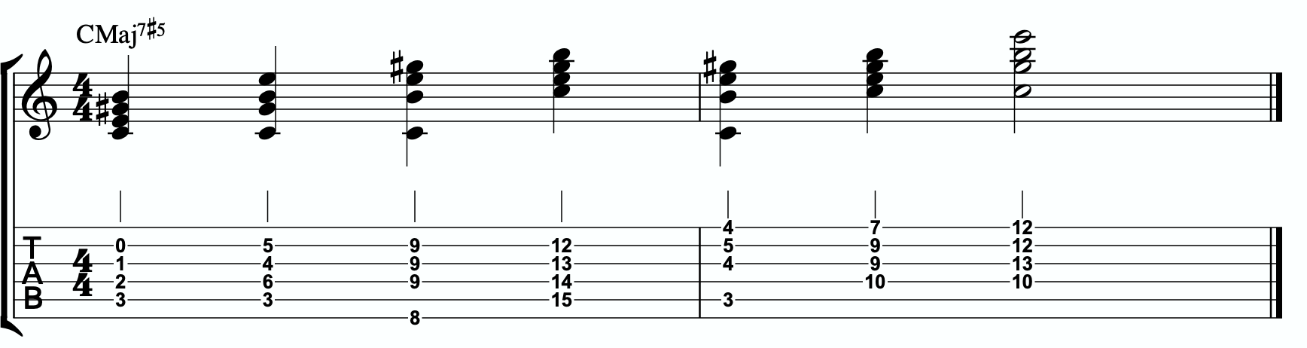
3a

Each of these voicings gives us the root, 3rd, #5th, and either the major 7th.

THREE NOTE QUADRATONIC VOICINGS
Three note qudaratonic voicings are an incredible and special tool for us. Unlike traditional drop chords that can be practiced through all inversions, these three note chord inversions offer us some special benefits. First, they highlight the sweet spot notes and get us into the really colorful parts of the chord. Second, by ignoring one of the four notes in each voicing, we’re not simply jumbling up the same four pitches each time we invert. One pitch is always disappearing or appearing as we move through these inversion. It makes for a much more captivating series of inversions as the ear is unconsciously losing and finding pitches at every turn.
We’re going to follow the “drop 2” idea, however not in the traditional sense. When we speak about “drop 2” chords traditionally, we mean that we take the second to the top note and “drop” it down an octave. We’re not going to do that. We’re simply going to remove it from the picture.

4 |  | 4 | 3 |  | 3
3 | > |  | 2 | >
2 |  | 2 | 1 |  | 1
1 |  | 1 | 4 |  | 4

Notice that when this technique is applied, the first series of numbers is different from the second. They both share 1 and 4, but the first series has a 2 and is missing the 3 whereas the second series has the 3 and is missing the 2. If we did this for every inversion of 1 - 4, each one would be slightly different.

If we apply this to our primary quadratonic, we get this series of three note voicings for our chord.
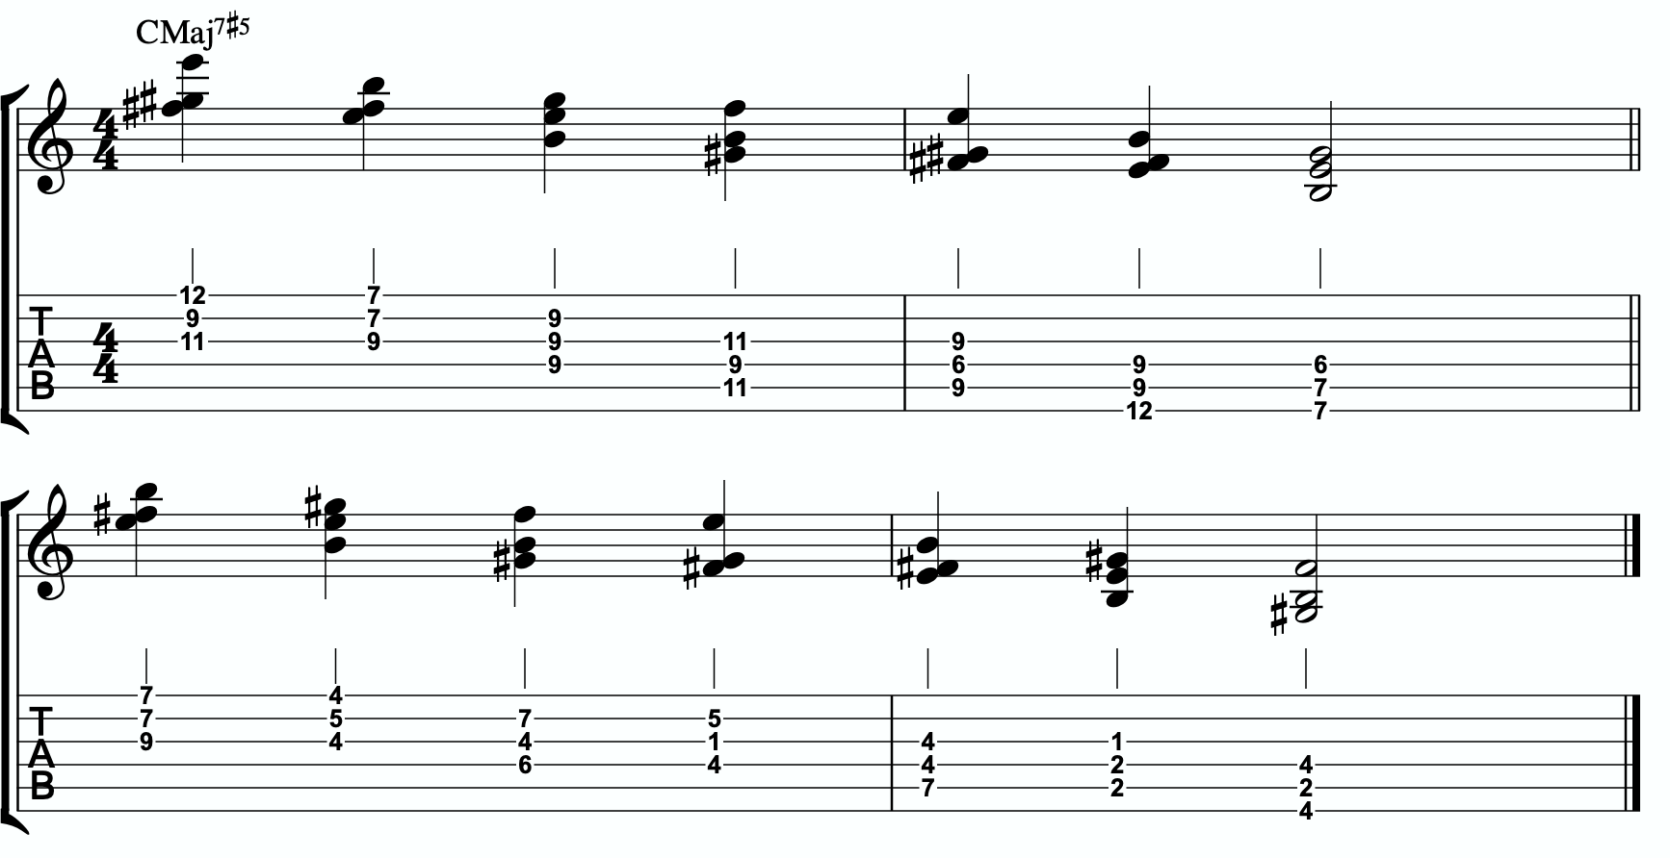
3b

QUADRATONIC SCALAR RUN
Let’s bring it back to single note ideas, melody, and improvisation. The Must Know was all about learning to hear and manipulate melodic tension and resolution using the quadratonic. But we can also use the quadratonic like a scale or an arpeggio. It seems simple because there are only four notes involved… but that’s only one note less than a pentatonic scale. And if you think about it, we only have 12 notes in western music, so if the quadratonic takes up four notes, then that’s actually ONE THIRD of all of the notes in the entire western tonal system. That’s quite a lot.
Let’s start with a scalar type run. Ideally you should already be able to hear and use the tension note and the resolution points of the melodic triad to develop beautiful, clear, authoritative phrasing that works with the harmony, and even implies it, without being stuck outlining it. Not we want to focus on developing the ability to create long, flowing, legato, fluid runs that create the impression of harmony. Traditional scales can sometimes be helpful for this, but they often times have notes that aren’t going to help define the sound of the harmony that’s happening. This quadratonic approach to a run will clear away those less essential notes.

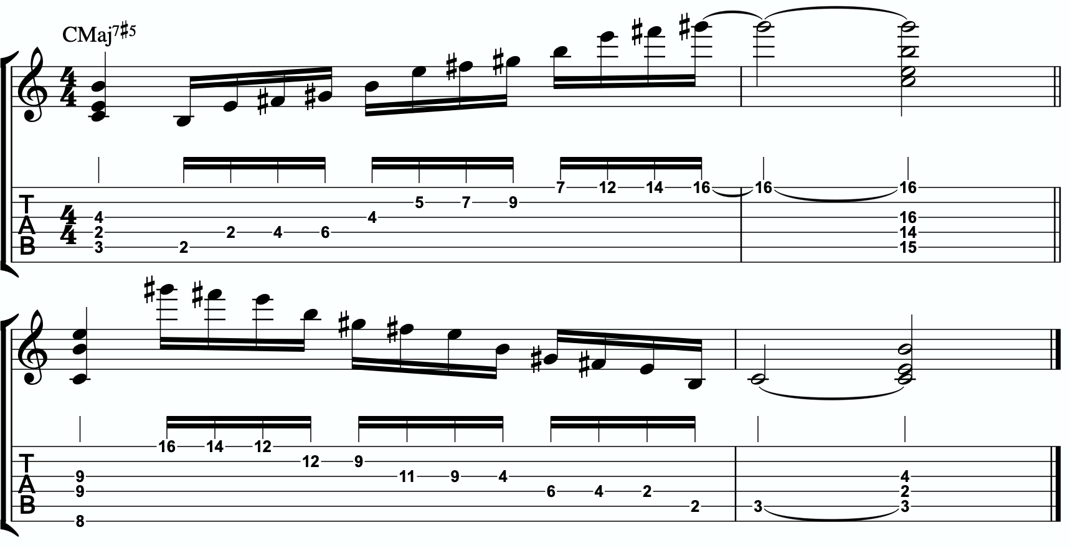
3c

THE SECONDARY TENSION NOTE & PENTATONIC SCALE
Once we can develop authentic phrases with the primary tension note and the quadratonic it gives us, and once we can see it as a scale that we can run through, we can move on and look at the secondary tension note. At this point, I recommend that you put the primary tension note on the back burner and leave it out for a while. Treat this as a whole new tension note. Go back through the ear training process and learn where it is on the fretboard, what it sounds like, how it wants to move, and how to create simple phrases with it.
In order to find the secondary tension note, we go back to Stefon’s formula.

The Hierarchy of Harmonic Importance.
3 - 7 - 5 - 9 - 11 - 13 - R
- Since we started by adding the 11th, is the 13th of CMaj7#5 in the E major triad?
No. The 13th is A, and that’s in our E triad. Boom.

So our secondary tension note is A.
A is the 13th of CMaj7#5, but it will be heard against the melodic triad which is E major. A is the 4 of E major, so that means our secondary quadratonic is E major tension 4 and it gives us this tonality’s melodic triads pentatonic scale.

/ 2, 4
E
Here are an example of this pentatonic scale in use:
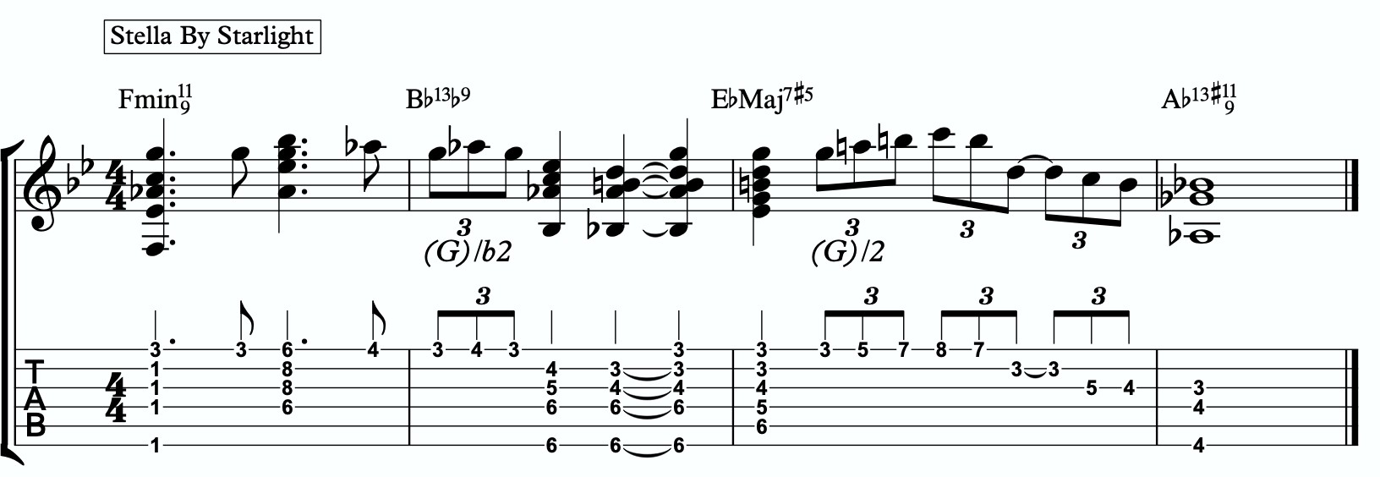
3d
,4

THE MELODIC TRIAD BEBOP SCALE
Hopefully by now you’re starting to see the way melodic triads can offer a very direct path through all the traps of scale running, noodling, and outlining chords progression using 1 - 3 - 5 - 7 chord tones and arpeggios. All of these can be great devices (maybe not noodling), but have dangers to them.
The melodic triads approach helps us start with the sweet spot notes, and build our harmony and melodic from there. Before you start working on the melodic triad bebop scale or anything beyond this point, I strongly encourage you to make sure that you’re not simply reading these ideas like a theory book to be memorized. These are meant to infiltrate your ears, map the fretboard, and apply directly to musical situations in tunes. If you’re been studying and applying the melodic triads approach for enough time that you’re getting comfortable with it, we can take the next step. It’s only one extra note… but it’s a game changer.
In order to understand what the melodic triad bebop scale is, you need to understand what a traditional bebop scale is and the purpose for why it’s built the way it is. The standard diatonic scale is made of seven notes. The problem with playing a seven note scale is that it’s made of an odd number of pitches, so if you’re playing in 8th notes in 4/4 time, it’s going to flip itself around and start to place weak sounding notes on strong beats and strong sounding notes on weak beats.

C major scale
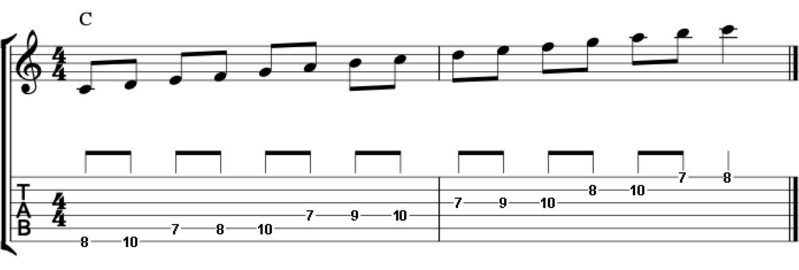

In music, we have strong beats and weak beats. We can see these pretty easily by looking at the beamed groups of 8th notes. There are always two of them. The first one, on the left of each group, is the strong down beat, and the second one, on the right of each grouping, is the weak up beat. We count them:

1 - & - 2 - & - 3 - & - 4 - &

That makes up one full measure of 8th notes in 4/4. The strong beats are on the number, and the weak beats are on the & (the “and”). If we look at the C major scale above, we see that it starts on the C note (very important) on a down beat. Then the next down beat, beat 2, has the E note. That’s the 3rd of CMaj… so we’re doing good. The 3rd down beat has the G note… still good. But the 4th down beat has the 7th of the scale, and then the C root note happens on the & of 4. And that puts the D note, the 2nd of the scale, on the down beat of the following measure. The following few down beats all have weak notes on them, putting the strong CMaj “chord tones” on the weaker up beats. It finally loops back around and lands on the C note on beat 4.
The traditional bebop scales took care of this problem by adding one single note. This evens it out to an eight note scale and lines up the pitches of the scale with the beats in the measure.

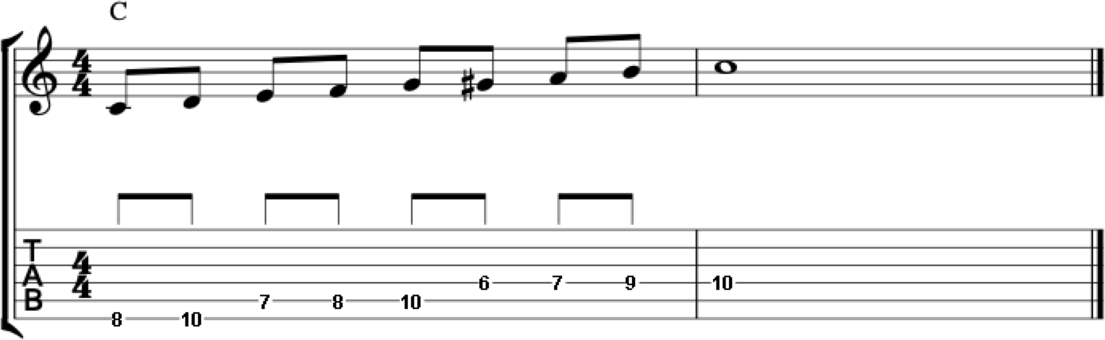

Some players would call this a bebop scale, or if you’re familiar with the Barry Harris method, you might call this the 6 diminished scale. Regardless, what’s important is that if you look at the strong beats, the notes spell out C - E - G - A. That’s a C6 chord. It gives

us a perfect combination of melody (the scale - with tension and resolution points), harmony (the C6 chord - the resolution points), and rhythm (the timing of getting all of the important notes to fall on the strong beats). It’s a beautiful, perfect, and very helpful scale to know.
I still rarely if ever think about, practice, or use it. Doesn’t mean you shouldn’t. But hopefully by now you’re starting to see just how powerful triads are. This scale is built around four note chords like C6 or C7, not three note triads.
But there’s a way to combine the two concepts. The pure simplicity and strength of the triad, with the rhythmic perfection of the bebop scale concept.
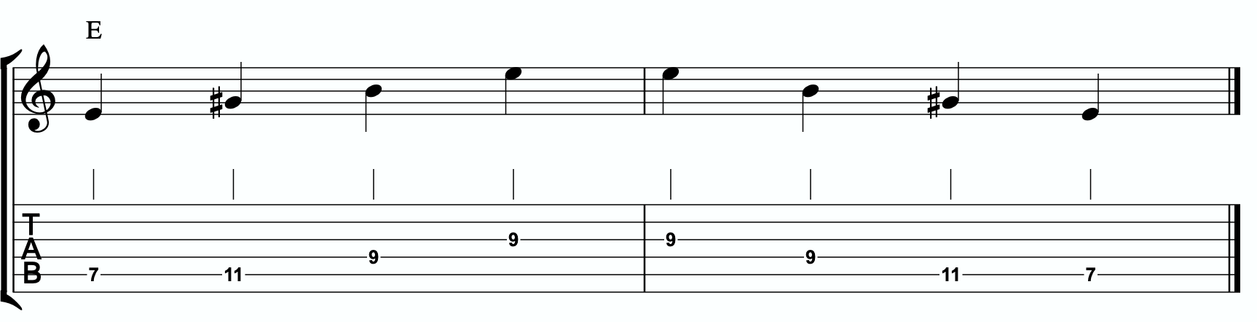
We simply add one single passing note between every triad note. Here’s one octave of a E major triad. Our melodic triad for CMaj7#5.

Now I’m going to insert one passing note between each triad note. The key is to pick the passing note that best respects and defines the CMaj7#5.

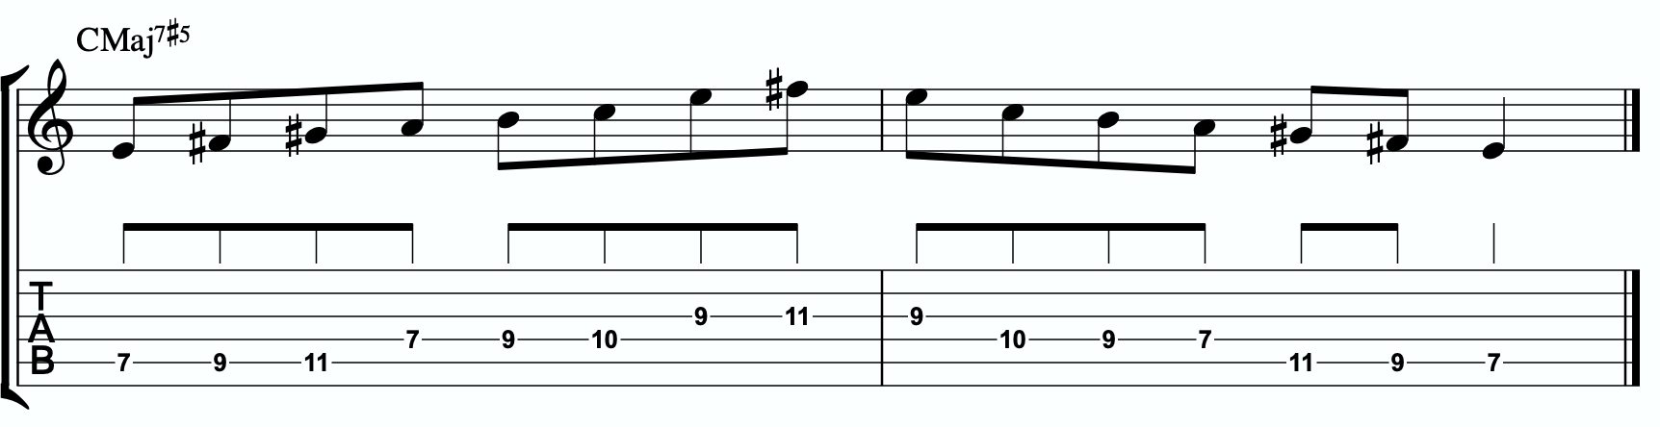

This is our melodic triad bebop scale. It’s a six note scale that helps us outline the tonality we’re working with by stabilizing the notes of our melodic triad.

Notice that it’s just an Emajor triad with passing notes. If we look at those passing notes in relationship to the E major triad we get tension 2, tension 4, and tension b6. Two of the three tension notes are straight from our primary and secondary quadratonics. No, that’s not a coincidence. That’s due to the perfect nature of how triads function when we dig through harmony and melody with them. So we’re simply adding a third tension note. In this case, it’s tension b6. You could use that as a quadratonic - E tension b6 over a CMaj7#5 chord. The melodic triad bebop scale gives us a rhythmically aligned “scale” but it also gives us three tension notes, each with their own unique emotional quality to them, that we can take advantage of if we don’t want to get stuck running scales and want to return to a focus on melodic tension and resolution and lyrical phrases.

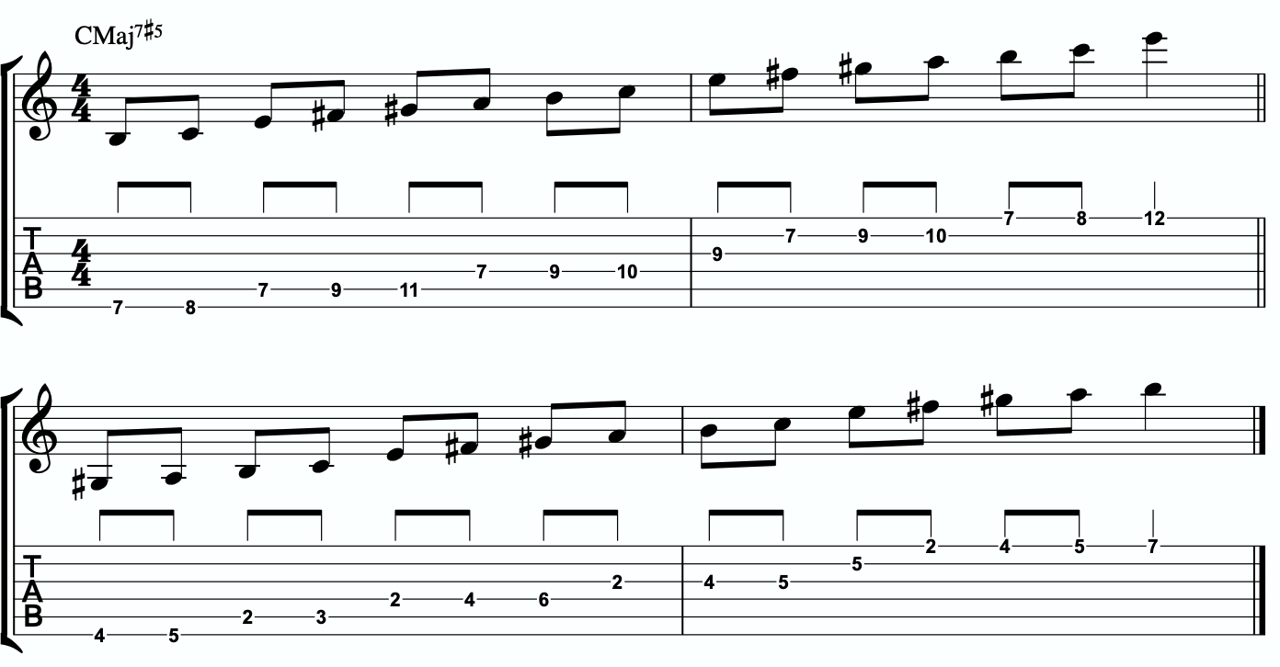
4a

Here is the same scale but harmonizing all of the melodic triad notes with our three note
quadratonic voicings:

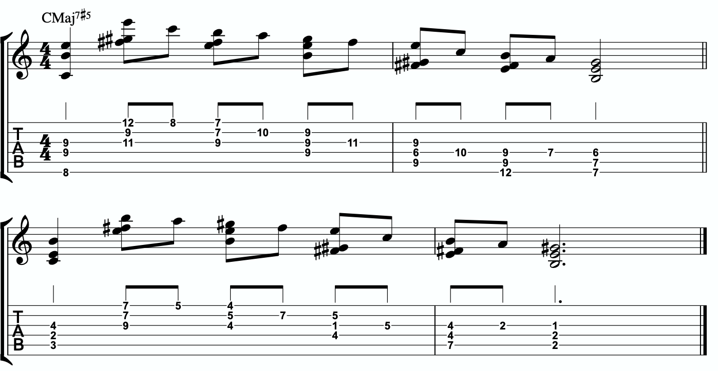
4b

ADVANCING HARMONY
We are getting into more and more advanced material now. Please remember that you do NOT need any of these continued lessons and concepts to play music. It is significantly more important that you develop your ability to be authentic, spontaneous, and playful with the material in The Must Know and then, if you feel comfortable, in Digging Deeper. Each section is building on the last, so if you’re struggling, it’s simply a check engine light to return back to earlier sections.
That said, we’re still far from a complete exploration of the depth of this one little triad.
This section we will explore some more advanced harmonic ideas. You may have heard me talk about liquid harmony. This is a way of visualizing the creation of harmony that involves movement. Think of a chord voicing like a block of ice. It’s frozen in time. We play it, we move to another chord, we move to another chord. Most of us learned to play harmony this way with a focus on shell voicings and drop chords. Liquid harmony is the idea of taking those blocks of ice and melting them down into a little. Not necessarily completely. But we want at least some of the ice to return to water so that it can flow and move. It helps free us up to transcend more static voicings, even cool sounding ones, and creates a more pianistic, movement-oriented sound. Not simply movement from one chord to another, though that’s important as well. But movement inside of a single chord. That’s what this section will explore.

HARMONIC QUADRATONICS
This is possibly the simplest, most effective, and most fun ways to create liquid harmony. The idea is that we play the primary quadratonic, but instead of thinking of it as a scale that we play with single notes, we play it as a chord. We will play three notes of the quadratonic. The tension note will be part of the chord, and it will replace the nearest melodic triad note. So the chord will be made up of two melodic triad notes and the melodic tension note. Then, while holding the two melodic triad notes and allowing them to continue ringing, we will resolve the tension note back into the triad. If we’re playing solo guitar or accompanying another musician, we may want to play the root note of the chord (“left hand”) or even the whole shell voicing. However in a full ensemble with a bass player, or if we’re playing solo and simply want a more impressionist style sound, we can leave that out and play these ideas as rootless “chords”.

Here is an example:

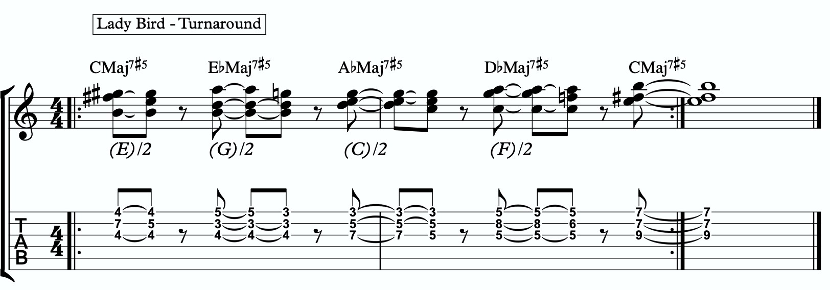
5a

Quadratonic Dyads
This is a similar concept to our quadratonic 3-note voicings, except now we’re creating 2 note grouping by pairing together every other note.
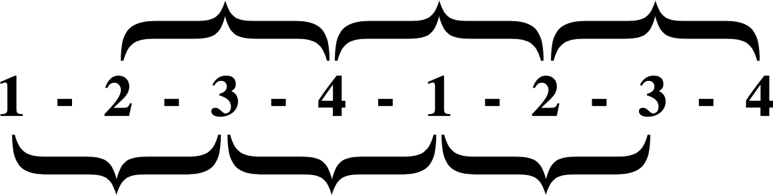

So if our quadratonic is made of Bb - D - F - G, we will group the Bb and the F together and the D and G together. And we will get this:

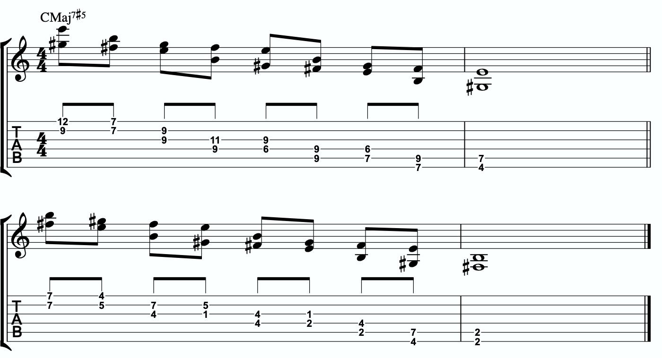
5b

TRIAD PAIRS
Sticking with our melodic triad bebop scale, we actually have our melodic triad version of triad pairs hiding right there in plain site. We know that all the resolution points are the notes of our melodic triad. But if we look at all of the passing tension notes we added, we actually have a second triad. This scale is two triads together. We have our melodic, or our “resolution” triad, and then we have our tension triad.
For this tonality, our triad pair is E and F# diminished.
/ F#º
E
We can of course arpeggiate these triads out to create single note ideas, but this section is specifically about harmony.

So let’s look at a harmonic application for our tonality inside a chord progression.
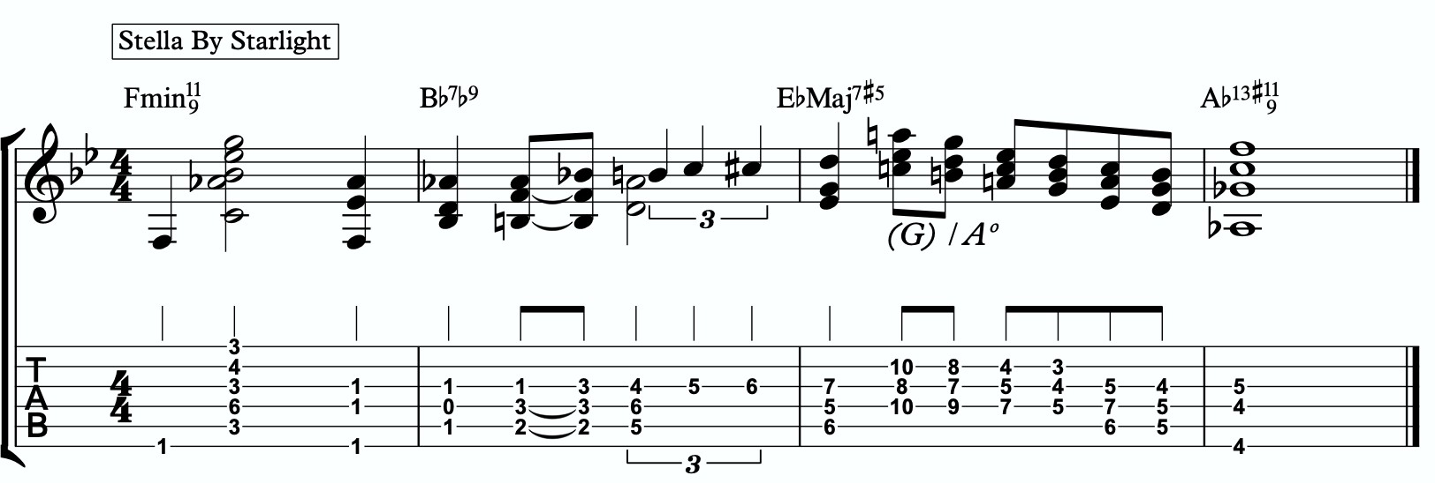
5c

Here is a dyad application, where we leave out one note from each triad.

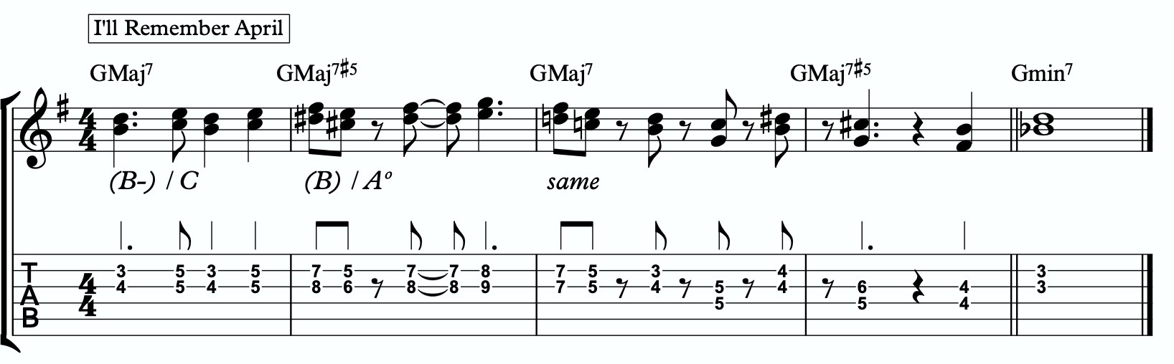
5d

TENSION LAYERS
Everything up until this section has been based on the idea that the melodic triad is the strongest organization for resolution, color, harmony, and melody. We leave the triad temporarily with different techniques to create tension, harmonically and melodically, but always in service to bring us back to rest in the resolved nature of the melodic triad.
In this section, we’re going to talk about the idea of thinking of tension as existing in layers. This way, we have different levels of tension that we can move in and out of - like rungs on a ladder that we can climb up, climb down, or simply pick one and stand still on it to enjoy the view.

LAYER ONE
This one is easy. Layer one is the primary quadratonic. The melodic triad is the most stable set of notes we have for our tonality. The primary tension note offers us a very respectful tension note to create melody. There is tension inside this quadratonic, but it’s accessible and always brings us right back into resolution. We must be comfortable making music with this sound before we can continue.

E / 2

LAYER TWO
But what if we want to move up a rung on the ladder? We know from the melodic triads bebop scale that our triad pair for this tonality is E major and F# diminished. So far, we have only thought of the F# diminished as a tension triad that can be used to bounce back and forth with E. But what if we momentarily “modulated” into the F# diminished triad to create a new rung on our ladder? Like modulating in a tune between the relative major and minor of a key, the key doesn’t actually change, but we can momentarily alter the color and the emotion.
By switching over to thinking of our tension triad, we can add a tension note to the triad and create a tension quadratonic.

The tension quadratonic, when mixed with the primary quadratonic will allow us the ability to navigate seven diatonic notes melodically and harmonically in a structured and authoritative way that will imply the harmony, give multiple colors and layers of tension, and allow for six different resolution points within any tonality. That’s half of all of our available pitches.

How do we chose the primary tension note for our new tension quadratonic?

We go back to the hierarchy of harmonic importance. What’s the next chord tone from the hoh? We can account for the root, 3rd, 5th, 7th, 11th, and 13th. But we haven’t yet used the 9th. So that’s going to be the tension note for our tension quadratonic.
The 9th of CMaj7#5 is D. If we add a D note against our tension triad, F# diminished, we get this four note structure - F#, A, C, D. That’s an F# diminished triad with a tension b6. It also happens to create a D major triad and that triad will have a stronger quality to it than the F# diminished. This will effectively trick our ear into hearing this quadratonic as a D major tension b7 (D - F# - A + C).

/ b7
D

This quadratonic will sound less “in” than the primary quadratonic, however the tension note in it will give it a sensation of tension and resolution within itself.
Here is an example of this quadratonic pair being used harmonically:
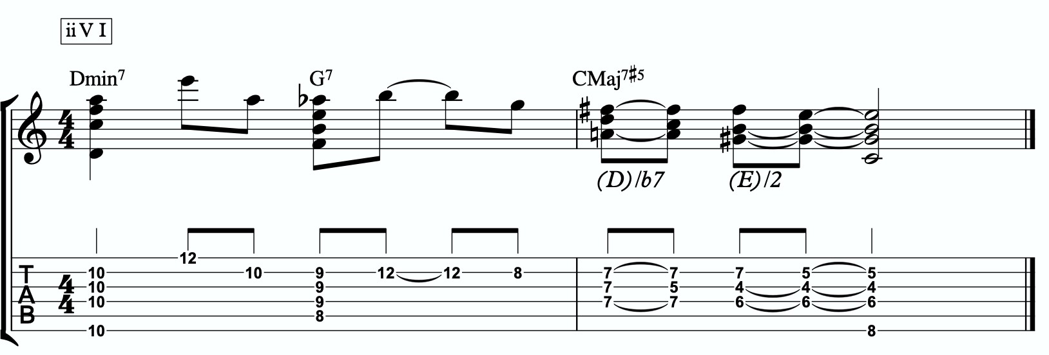
6a

Harmonizing Our Bebop Scale With Tension Layers

Let’s look at our six note melodic triad bebop scale and harmonize it using our quadratonic pairs. We will do this using two different techniques brought up earlier in this study booklet. First, we will move through the bebop scale using our harmonic quadratonics to create liquid harmony within each voicing as we move between the two quadratonics to harmonize each note. Finally, we will apply the three note quadratonic voicing to the bebop scale.

Harmonic Quadratonics & Liquid Harmony

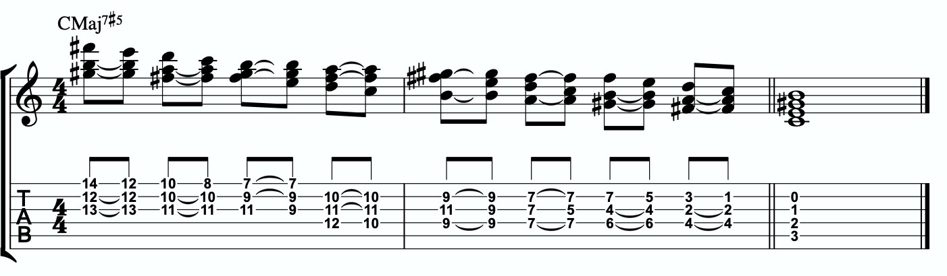
6b

Three Note Quadratonic Voicings
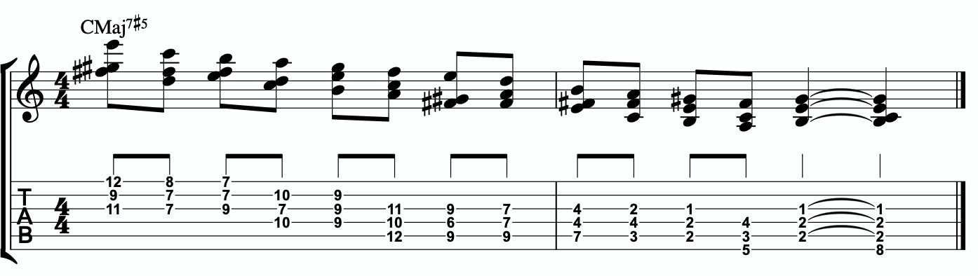
6c

THE OUTRO
I just want to personally thank you for working through these ideas. I am obsessed with exploring, mapping out, and demystifying jazz harmony and melody, and attempting to understand it and execute it using the simplest and most fundamental ingredients in music. I’ve found over many years of playing and study, and learning from some of the greatest minds in the jazz world today, that it’s often times our ego and our own self- inflicted limitations that hold us back the most from growing and evolving towards our potential.
The most dangerous words to development of our musicianship are, “I already know that.”
Most of us generally spend a couple of music theory classes learning our triads. Maybe we read a book about advanced triad application and get some cool intellectual ideas to play with. But for me, it’s all about that Bill Evans quote.
**********************************

The whole process of learning the facility of being able to play jazz is to take these problems from the outer level in, one by one, and to stay with it at a very intense, conscious-concentration level until that process becomes secondary and subconscious. Now, when that becomes subconscious, then you can begin concentrating on that next problem, which will allow you to do a little bit more.

I don’t consider myself as talented as many people but in some ways that was an advantage because I didn’t have a great facility immediately so I had to be more analytical and in a way — that forced me to build something.
Most people just don’t realize the immensity of the problem and, either because they can’t conquer it immediately, think that they haven’t got the ability, or they’re so impatient to conquer it that they never do see it through. If you do understand the problem then you can enjoy your whole trip through.

People tend to approximate the product rather than attacking it in a realistic, true way at any elementary level — regardless of how elementary — but it must be entirely true and entirely real and entirely accurate. They would rather approximate the entire problem than to take a small part of it and be real and true about it. To approximate the whole thing in a vague way gives you a feeling that you’ve more or less touched the thing, but in this way you just lead yourself toward confusion and ultimately you’re going to get so confused that you’ll never find your way out.

It is true of any subject that the person that succeeds in anything has the realistic viewpoint at the beginning and [knows] that the problem is large and that he has to take it a step at a time and that he has to enjoy the step-by-step learning procedure. They’re trying to do a thing in a way that is so general [that] they can’t possibly build on that. If they build on that, they’re building on top of confusion and vagueness and they can’t possibly progress. If you try to approximate something that is very advanced and don’t know what you’re doing, you can’t advance.

**********************************

Was Bill referring to melodic triads? I very highly doubt that. I’ve never heard him talk much about triads. But consider the underlying philosophy he’s pointing at. Know the

basics. Regardless of how elementary! But it must be entirely true, real, and accurate. Be able to play genuine, authentic music using the most fundamental ideas first. Then it leaves room to grow.
This is why I refer to the first section in this ebook as The Must Know. It’s a basic shell voicing, and a basic triad. And while these two concepts are as simple as they come in music, we must understand them in a true, real, and accurate way. If we did this for a handful of tonalities, we could play beautiful music for the rest of our lives, and for me, I would feel fulfilled. It would offer emotion-driven, precise, human, lyrical melody combined with lush, colorful, pianistic harmony. Mix in a strong sense of time and feel, and that’s everything a jazz musician needs.
But like Bill talks about, when we don’t try to approximate but instead start with the elementary ideas and build a foundation with them, then it gives us room for growth. Look at everything we worked through together in this ebook! All built from one triad and how it relates to one chord (piano diagram!). As of the time of putting this together, I’m still working on many of these ideas myself… and I’m still coming up with new ways of building harmony and melody around the melodic triad.
This is why I can’t recommend enough, even to the intermediate and advanced players out there - spend some serious time in The Must Know section. Own it. Be able to play authentic ideas with it. Apply it to tunes. Move it through the circle of 5ths. Do whatever you can to internalize it and develop your ears to it. Then you can begin moving on. I would encourage everyone… peak ahead if you would like to to keep an eye on where this particular path is heading, but be very self-aware and learn to see when you’re getting in over your head. When this happens, not if, just take a deep breath and back up a few sections. It simply means your foundation isn’t quite strong enough yet to carry the weight of those more complex ideas. If you want it, and you put the time and effort it, you’ll get there.
Like one of my students always likes to tell himself at the end of our lessons…..
“Easy does it. But do it.”

Thank you again. Don’t forget to come and hang in our open office hours to ask questions if you’re confused on anything.
Happy Practicing!
-Jordan Klemons

The Melodic Triads Study Group

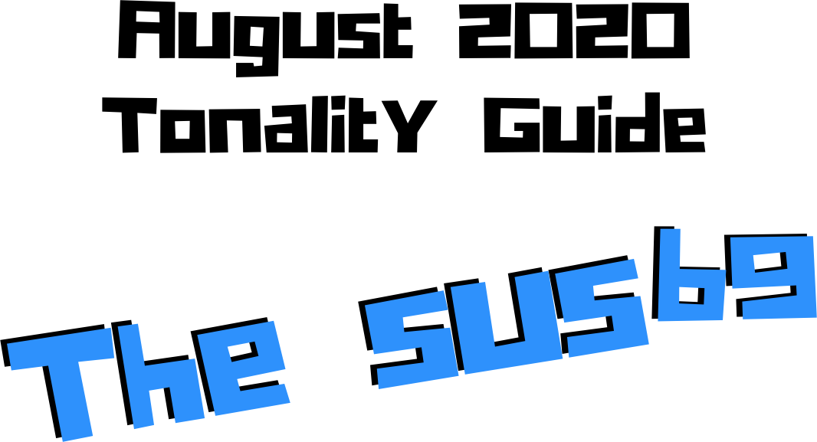

Jordan Klemons
NYC Jazz Guitar Masterclasses

CONTENTS
-INTRODUCTION
-THE MUST KNOW-
-ADVANCING MELODY-
-DIGGING DEEPER-
-THE MELODIC TRIAD BEBOP SCALE-
-ADVANCING HARMONY-
-TENSION LAYERS-
-OUTRO-

This ebook is the copyrighted property of Jordan Klemons. All images, information, layout, and designs belong to Jordan Klemons. This document may not be altered, reproduced, distributed, or transmitted in any form or by any means without the prior written permission of the author.

INTRODUCTION
Thank you for downloading the pdf materials for this month’s melodic triads tonality study guide. Inside you will find all of the supplemental theory, notation, tab, charts, concepts, and examples for the accompanying videos to help you develop your understanding, your ear, your emotional connection with, and your sense of harmonic and melodic freedom within this month’s tonality… as well as its use in some short, common, jazz chord progressions that you will be able to immediately implement in your own playing.
The information in this guide is dangerous. I mean that literally. When the process is respected, and you understand how all of these ideas fit into the puzzle, this guide and the baby steps included can offer tremendous insight into how to begin making real music very quickly, and how to continue evolving and growing as a player for many years to come. However, if approached in the wrong way and the process is not respected, these ideas can confuse and derail a musician’s ability to progress. It’s important not to jump too far ahead of yourself. The advice that a Miles, or a Scofield, or a Coltrane would give to a beginner is different than what they would give an intermediate or to an advanced player. And all of that would be different than how they would talk to a professional who’s already playing on their level. This is important to remember.
This guide is meant to show many different layers of musical growth and how, when using the melodic triad approach, they can all be boiled down and viewed simply as an extension of the most basic elements of music. Namely… a triad. Think of the pages that follow as an architect’s blue prints for a skyscraper. If you haven’t built a strong foundation, your skyscraper will fall. If you attempt to skip the first 50 stories and jump to building the penthouse, the skyscraper will fall. If you try to put up the fancy exterior of the building before you complete the steel frame, the skyscraper will fall. Yes, the information all the way at the end of this guide is constructed using the same ideas and concepts that are presented in the first chapter, but the process must be respected for anything to work. Otherwise it will only leave you confused, frustrated, feeling like a failure, and wanting to give up. Be patient with yourself. The short cut IS the long road. Take it. Spend two or three months working on the long road and watch how much you progress. Focus on your sound, on your ear, and on your musicianship… and trust that the simplicity of the ideas and the process itself will take care of you. They will. But only if you respect them. It’s like a relationship - you have to be present and give of yourself, and then you will receive in abundance.

As you work through these pages, try to keep in mind this Bill Evans’ quote from The Universal Mind.

**********************************

The whole process of learning the facility of being able to play jazz is to take these problems from the outer level in, one by one, and to stay with it at a very intense, conscious-concentration level until that process becomes secondary and subconscious. Now, when that becomes subconscious, then you can begin concentrating on that next problem, which will allow you to do a little bit more.

I don’t consider myself as talented as many people but in some ways that was an advantage because I didn’t have a great facility immediately so I had to be more analytical and in a way — that forced me to build something.
Most people just don’t realize the immensity of the problem and, either because they can’t conquer it immediately, think that they haven’t got the ability, or they’re so impatient to conquer it that they never do see it through. If you do understand the problem then you can enjoy your whole trip through.

People tend to approximate the product rather than attacking it in a realistic, true way at any elementary level — regardless of how elementary — but it must be entirely true and entirely real and entirely accurate. They would rather approximate the entire problem than to take a small part of it and be real and true about it. To approximate the whole thing in a vague way gives you a feeling that you’ve more or less touched the thing, but in this way you just lead yourself toward confusion and ultimately you’re going to get so confused that you’ll never find your way out.

It is true of any subject that the person that succeeds in anything has the realistic viewpoint at the beginning and [knows] that the problem is large and that he has to take it a step at a time and that he has to enjoy the step-by-step learning procedure. They’re trying to do a thing in a way that is so general [that] they can’t possibly build on that. If they build on that, they’re building on top of confusion and vagueness and they can’t possibly progress. If you try to approximate something that is very advanced and don’t know what you’re doing, you can’t advance.

**********************************

I’ve setup the material in these tonality lessons to start with the most basic and fundamental elements of music, and to grow outwards in complexity. Everything builds on what came before it, so everything is connected. You DON’T need to master everything in these lessons to play music. You only really need the first section and a little bit of creativity and concern for your sound - that’s enough to create something beautiful..
I recommend that if you’re new with us, even if you’re already an advanced player, you begin focused entirely on the first section of this guide, The Must Know, and give yourself a minimum of 3 - 6 months to get used to this method and the initial concepts presented. It’s a very different approach to standard theory, and your goal should be (as Bill Evans said) to be able to make genuine, authentic music with the ideas in the first section. Once you feel you can hear and play music using these ideas on a small handful of tonalities and applied to some tunes, then it is time to start advancing forward.

I would continue giving yourself an addition 3 - 6 months for each subsequent section, as each builds on the last and becomes more and more advanced… starting from the most basic and simple ingredients, and eventually working our way up to learning to hear and use all 12 notes of the western chromatic scale harmonically and melodically over any chord in a musical way.
I strongly recommend that you follow this rough timeline. I believe it’s the most effective way to cut through the learning process and get straight to making beautiful music, and then to set yourself on the path to continue growing and building for years to come.
The melodic triad ideas I’m working on today, I didn’t even know they existed during the first few years of my own studies. As we grow and progress and get comfortable, we can naturally start to evolve the ideas into more advanced applications. That’s the beauty of starting with the fundamentals, learning to make genuine, authenticate music from our own self first… and then building layers of complexity on top of, but always connected to, those very fundamentals. Much like a large skyscraper building starts with a huge hole in the earth, then is filled with concrete and steel, and then the steel frame will hold the building as it goes up. We won’t see any of these structures. But without them, the building would collapse. Only once the structure is there can the work of putting up the exterior, the glass, the interior, the design, the furniture, etc. take place.
Thank you again for downloading this study guide and working on your music with us. I look forward to hearing your playing and your contributions to the melodic triad conversation inside our facebook group, and for those of you subscribed to our Private Community, inside our melodic triad mastermind group.
Happy Practicing!
Your friend on the path towards jazz guitar mastery,
-Jordan Klemons

The Melodic Triad Study Group - a part of
NYC Jazz Guitar Masterclasses

THE MUST KNOW
The theory, ideas, voicings, and “scalar” ideas presented in this section may seem too simple and elementary to be of value. But I urge you, even the intermediate and advanced players - do not skip this section. I recommend that if you’re within the first 3 - 12 months of study with us that you focus entirely on learning to apply these ideas to musical situations. You can skim the rest of the pages if you’d like, but this should be where you build from. After close to 25 years of playing music seriously, I still spent my first year of working on melodic triads only on this material. The great thing about these ideas is that not only can you comp, improvise, compose, and arrange beautiful music over standards, bebop, modern jazz, and original works with them, but they also act as the foundation on top of which we can grow into more and more complex ideas without ever leaving behind these basic building blocks of harmony and melody.
Do not simply see these as intellectual theory ideas. These are meant to be internalized. To understand the theory is great. To hear the sounds in your ear with a sense of familiarity is just as important. To connect with them personally and be able to hear and express emotion through them is of the utmost importance when it comes to developing our musicianship. This should be the goal.

THEORY
Dominant chords are all about craving movement. They are crunchy little drama queens that leave us on the edge of our seats waiting to find out what’s about to happen. The sus variation of dominants is a little more subtle and rounded, but still leaves us expecting movement. The inclusion of the b9 note in this tonality gives the feeling of fear… like something is lurking and hunting us. Will it be okay? Are we in danger? This tonality is incredibly dramatic and reminds me of Tchaikovsky and great russian, romantic era composers who knew how to toy with our emotions. It’s very unsettling yet captivating… you can’t look away… and it’s so beautiful you don’t want to. Being from the 7sus family of chords, it functions best as a dominant. If it resolves us to a major key, it’s like feeling worried and threatened for no reason. But resolve it to a minor tonic, and it’s like fearing the worst… and then experiencing it.

What makes up a Csusb9 tonality?
Two basic ingredients.
- A basic C7sus chord
- A Bb minor triad
A good way to think of this is to visualize a piano player with two hands. Their left hand would be playing C-F-B (a basic C7sus shell voicing) and their right hand would be playing a Bb minor triad.

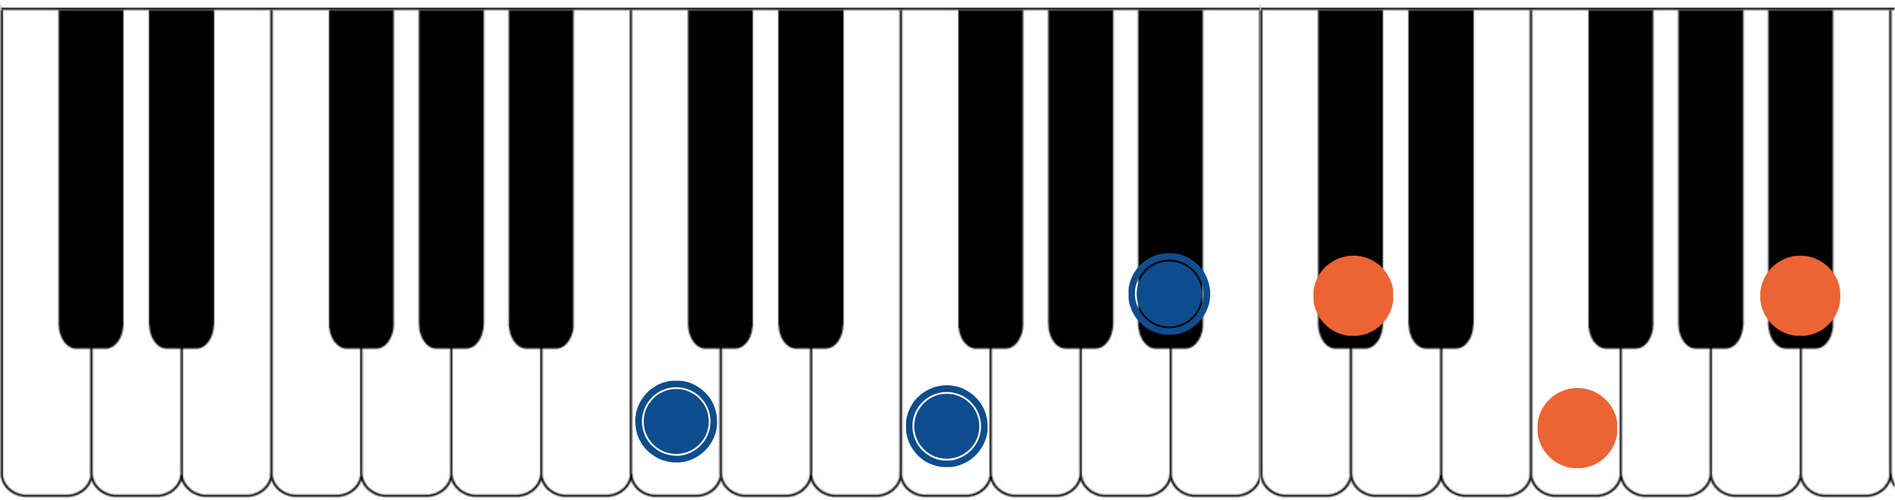

The blue dots would represent the fingers of the piano player’s left hand. Notice they spell out C, F, and Bb. That’s the 1, 4, and b7 of a basic C7sus chord. The orange dots represent the piano player’s right hand. They spell out Db, F, and Bb. That’s a Bb minor triad. If you have access to a piano or keyboard, I strongly encourage you sit down and play these six notes simultaneously. Listen to how big of a sound they create together.
Play it a few times. Try and feel the emotion and the color they create together. Then remind yourself of the elementary and simple nature of what’s happening in each of your two hands separately. A basic chord in your left hand. A basic triad in your right hand.
The magic happens when we use these sounds together… and when we begin to build chord voicings and melodic ideas around these two simple sounds.

***This Bb minor triad, which is now our melodic triad, is built on the b7th of C7sus… ‘Bb’ is a b7th up from ‘C’. This relationship is critical to understand and memorize as it will allow us to transpose this susb9 tonality into any key quickly. We will notate this as ‘tb7’. This notation comes from Stefon Harris. The ’t’ is short for ‘triad’ and we make it lower case to notate that it’s a minor triad. The b7 tells us that

the melodic triad is built on the b7th of the harmony. So if we want a Gsusb9, we think tb7, we find the b7 of G (which is F), and we know that the melodic triad is F minor.***
This pianistic chord construction is the starting point for everything we are going to look at together. Hidden inside of this seven-note chord is a universe of potential harmonic and melodic ideas. The following pages can all be traced back to this construction idea. Basic chord, basic triad. Left hand, right hand. Harmonic structure, melodic structure. Hence the term… melodic triad. Even if you don’t have access to a piano, I encourage you to sit and think about this diagram until it makes sense to you.

GETTING THE PIANISTIC VOICINGS ONTO THE GUITAR
Taking the concept of the piano construction, where the C7sus chord is always underneath the Bb minor triad, we can develop three basic inversions of this chord by inverting the Bb minor triad and keeping the C7sus chord underneath it as much as possible.
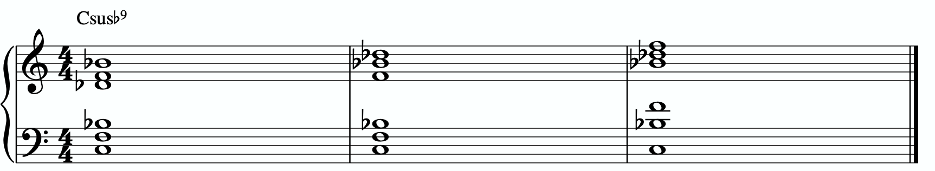
In order to get these three inversions, we will use the piano -> guitar technique described in the video - where we put the shell voicing on the bottom three strings and the triad inversions on the top three strings. This will give us a three “pianistic” inversions of this tonality on the guitar.
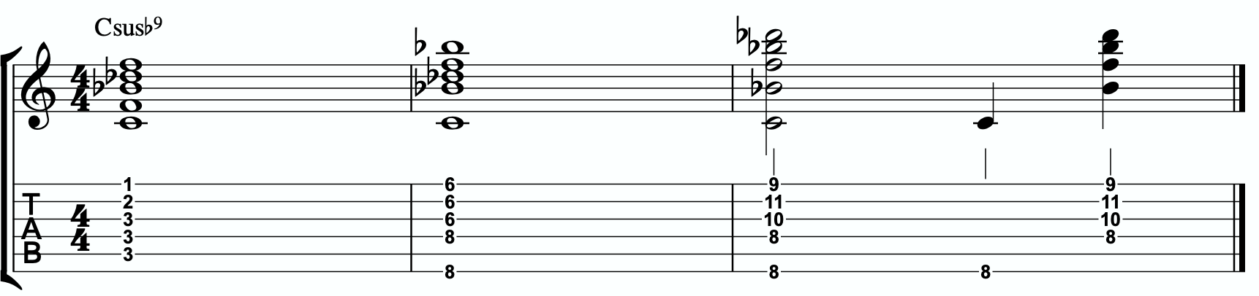

Notice the three basic inversions of the Bb minor triad on strings 1 - 3.

A few exceptions are being made here.
Notice in measure 1 we are playing a five note, not six note voicing. Because the C root note is on the 5th string (root 5), we can’t play all three notes of the C7sus shell on the lower three strings while keeping this in root position. Fortunately, we don’t need to leave a note out, however. The b7 of the shell voicing is Bb. And that Bb falls on the 3rd string in the root 5 shell voicings AND for the Bb minor triad in this position. So we’re using that one, single note as though it were present in the shell and in the melodic triad. It’s being shared between the two.
In measure 2 we are playing a 5 note voicing again. Technically this voicing is possible. If we barred down the 6th fret on the top three strings and the 8th fret on the bottom three, you would have a full Bb minor triad over a full C7sus shell. Play with that. I find it a little too muddy sounding to my ear. Just as a personal choice. And since the F note is BOTH the 4th in the shell voicing AND the 5th of our melodic triad, if we leave that note out of the shell voicing it immediately cleans up the muddy feeling but the pitch is still present an octave above. So this is my preferred voicing. Try both ways and see which you prefer.
In measure 3 we have a similar situation as in measure 2. I leave out the 4th from the shell voicing to get rid of the muddy feeling that stacking perfect 4ths on the lower three strings yields while the F note is still present on the top three strings. I also often find myself breaking the chord apart, playing the low root note first, then following it up with the top four notes. Just a preference. Find what works for you.

THE PRIMARY QUADRATONIC
Because this particular type of C7sus contains a Bb minor triad in the right hand, that triad is going to be the foundation of our melodic structures. It governs everything. Rather than simply behaving as the chord tones that they correspond to harmonically, when used melodically, they will function as the 1, b3, and 5 of our melody… the strongest and most stable resolution points we can build lines with.
The ideal starting point is our primary quadratonic. A quadratonic is a triad that has one additional note added to it. It’s a four note structure made up of three stable notes (the melodic triad) and one ‘free radical’ or melodic tension note. This extra note serves two functions. First, it’s there to create melodic tension that will help us create movement, emotion, and lyrical phrases without getting trapped inside running scales or chord tones. Second, it will help imply the sound of the harmony we’re playing over and glue the

melodic triad inside the chord so they don’t sound like two separate sounds, but rather one unified, colorful tonality.
We only have 12 notes in western music, and three of those 12 are being used in our melodic triad. That means we only have nine possible melodic tension notes. All nine of these could be used to create melodic tension against our triad. But some will help imply the sound of our original harmony better than others. Our primary quadratonic will be made of our melodic triad and the primary tension note - or the note the most respects the basic harmony.

Unlike most of our tonalities, this one falls into THE b9 RULE.
This rules states that if one of the melodic triad notes yields the chord tone of a b9 for the harmony we are playing over, we must use the chord’s root note as our first addition note. The b9 is, by nature, an incredibly tense note and craves resolution. So the ear is actually going to interpret the b9 as the tension note even though it is part of the triad, and we hear the new added note (the tonality’s root note) as the resolution for that b9.
The only time we break this rule is if the chord’s root note will create a weaker triad, as we do not want to “resolve” a triad to a weaker triad. For example, if the major 3rd of a melodic triad were the b9 of the chord, we would NOT follow the b9 rule. Why? Because if the major 3rd of the melodic triad were the b9 and we tried to resolve that note down a half step, we would be resolving a major triad down into a minor triad. Minor triads are a weaker sound than major. When moving between these two triad types the ear will tend to gravitate towards interpreting everything based on the sound of major. So resolving away from major into minor will be a very weak way to create tension and resolution.
The same thing is true with resolving a minor triad down into a diminished triad. If the 5th of a minor melodic triad were the chord’s b9, we would not resolve the 5th of the minor triad down to the b5th, as we’re resolving minor to diminished.
In this case, the b9 of the C7sus chord is Db, the minor 3rd of the Bb minor triad. Resolving that down will not cause an issue between triad types, and so the first note we will add will be the chord’s root note, C.
This can be notated as (Bb-)/2 but be aware that it will behave more like a (Bbsus2)/b3 where the b3 of the triad will want to resolve down to the sus2 of the triad. This will primarily affect how you do your ear training and phrase with the primary quadratonic and pentatonic scale. Once we get into the melodic triad bebop scale and triad pairs, we will act as though everything were normal.

Here are some examples of these fundamental voicings and melodic ideas being used in musical situations.

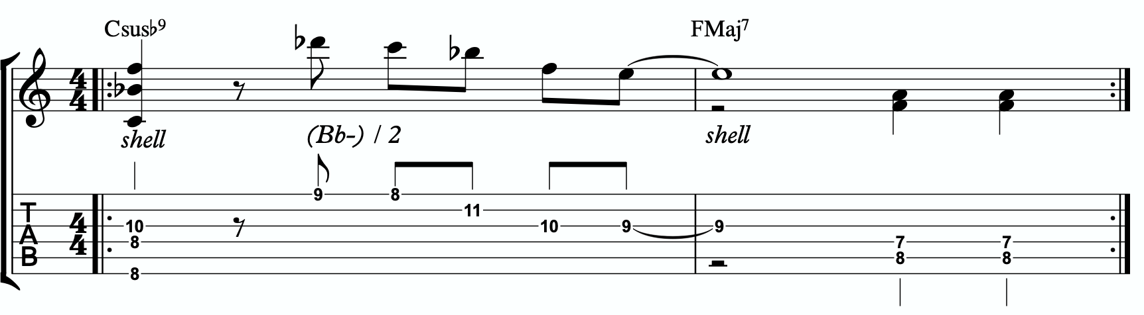
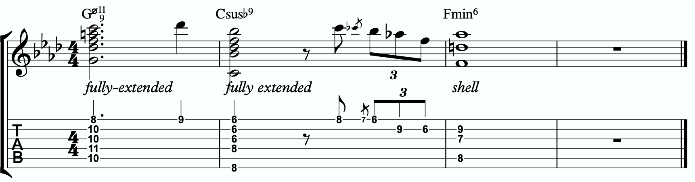
1a
1b

ADVANCING MELODY
This section is going to look at more advanced and complex application of melodic triads to scalar ideas and arpeggios for the creation of bebop and modern jazz vocabulary based on simple structures that we can be playful with rather than memorization of riffs. Don’t be fooled by the idea of these ideas being more advanced or complicated. This doesn’t mean the music you play with these ideas will necessarily be better or more “advanced sounding” then the use of the pure primary quadratonic. In fact, often times I find that the use of the pure quadratonic can carry a level of maturity and intensity into the music that is hard to maintain when using more complicated ideas.
But, I still think it’s worth being aware of how we can build more advanced structures directly from the melodic triad.

Chromaticism Within The Quadratonic
One of the quickest ways to begin developing more complex lines is to incorporate chromaticism and leading tones within the quadratonic. By first learning to master the pure quadratonic, it should make it easier to begin spontaneously connecting individual notes within these structures in a way that will create a sense of improvisational freedom with our bebop and modern jazz playing. Playing this way will allow us to breathe long, flowing, complex lines within very the very basic, simple, steel frames of our buildings.
Here is our primary quadratonic:
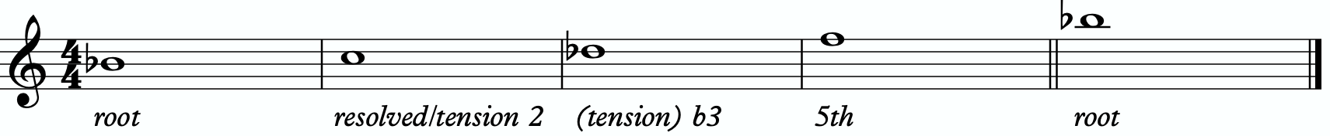

In between any of these notes, we can hang a chromatic line or place a leading tone (a note chromatically below the target) to bring us to the next note. When we use these techniques, we want to make sure that we resolve to a quadratonic note, and ideally we want to play at least two quadratonic notes immediately following the chromatic line to cement our phrase inside the tonality.

Here’s are an example:
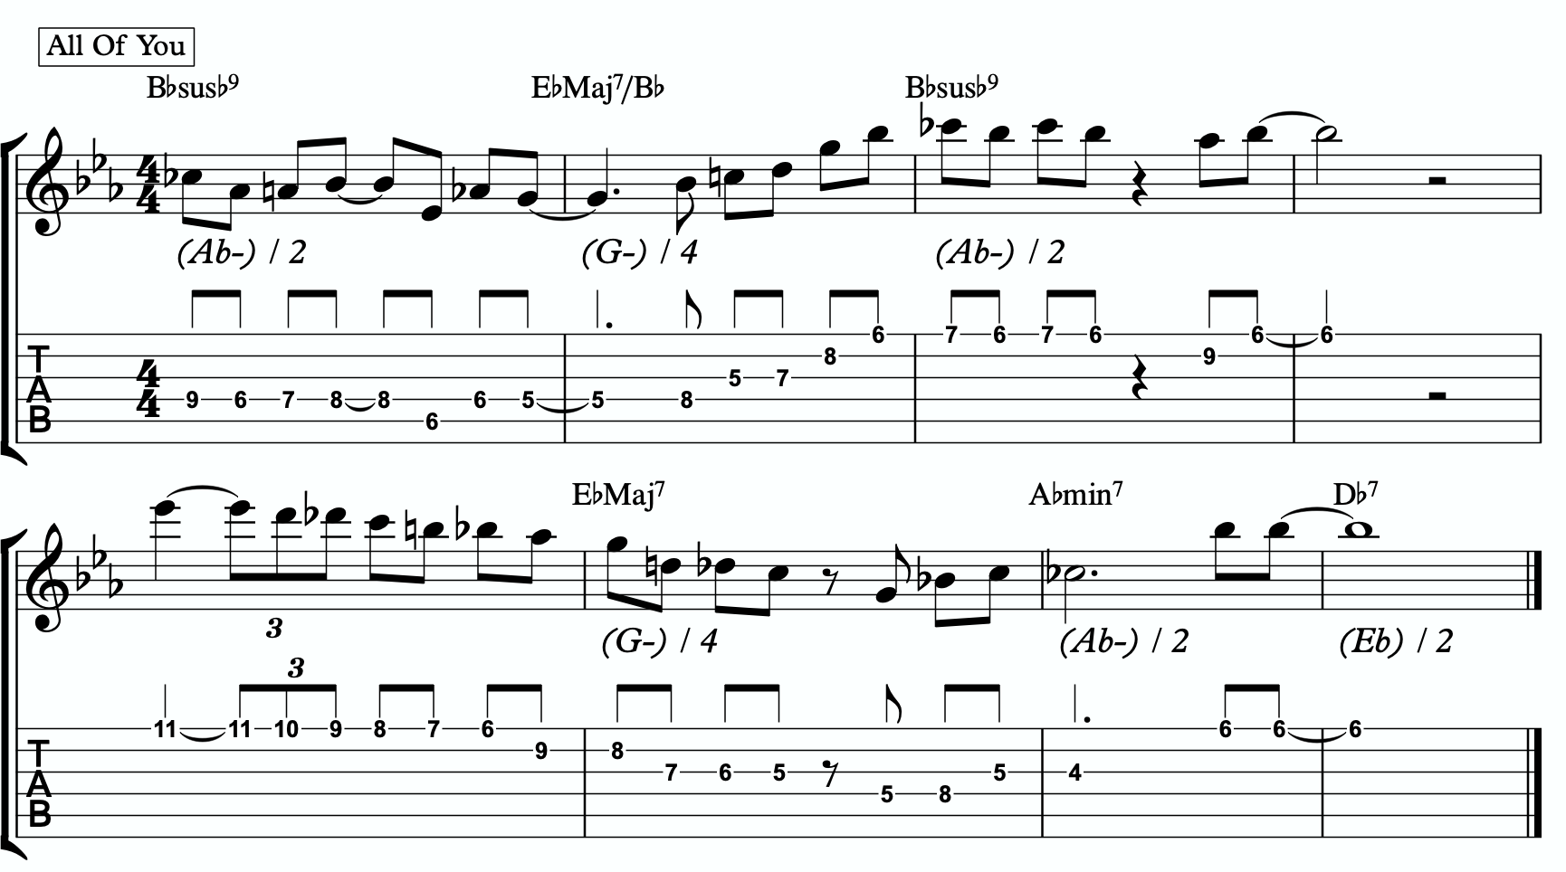
2a

Quadratonic Arpeggios
So far we have only discussed using quadratonics to develop phrases and scalar like ideas. Let’s look at how we can create the sound of arpeggios with them.
We will begin by starting on the primary tension note. After playing this note, we can move to the nearest melodic triad note and sweep quickly through that triad, landing on the tension note an octave away from where we began.
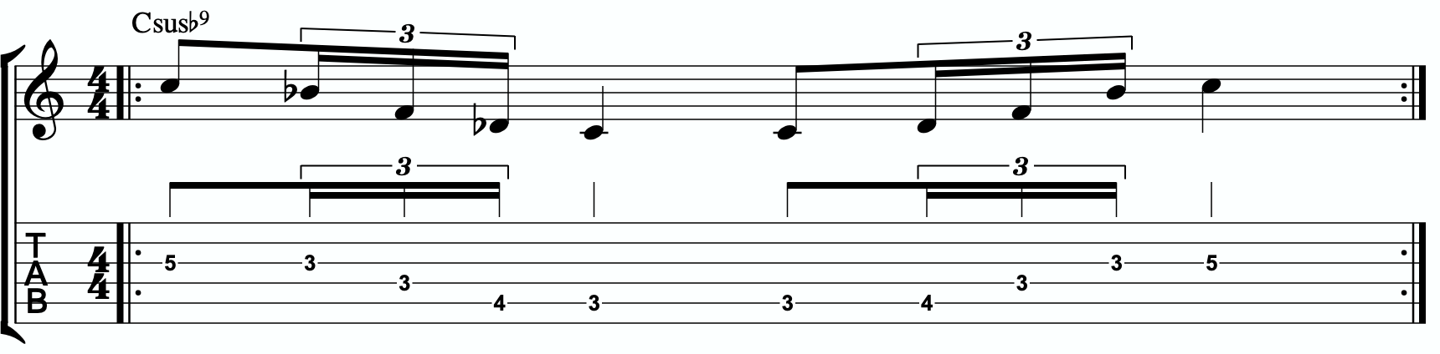
2b

We want to be able to play these ascending and descending starting on any octave of the tension note in any position of the fretboard. If we can incorporate this technique and the chromatic techniques above into our quadratonics then we are giving ourselves resolution notes, tension notes, chromatic runs, leading tones, and quick arpeggio-style runs that we can freely play within during our improvisation while remaining securely inside the color, emotion, and function of any given tonality.

Here is an example of these techniques being used together:
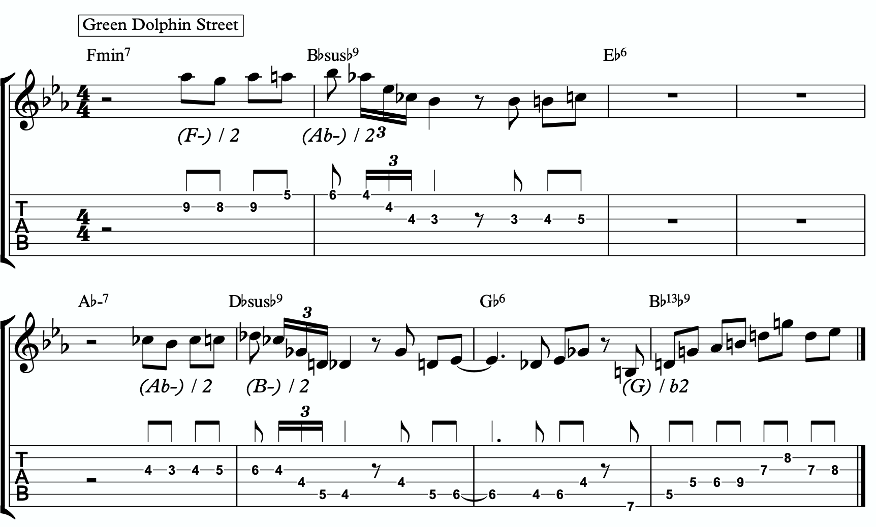
2c

DIGGING DEEPER
The goal of this section is to take small baby steps to evolve the fundamentals of melodic triads in the previous sections into new harmonic and melodic territory. If you are not already comfortable with the shell voicings, the three inversions of the pianistic voicings in all 12 keys, the primary quadratonic, and how to hear and feel the primary tension note against the melodic triad over the sus9, I would hold off and continue working on that.

FOUR NOTE VOICINGS
Let’s begin with harmony. Our first goal should be to minimize down these big, dense, pianistic voicings into something more manageable for the guitar. Four note voicings are ideal for our instrument. But sometimes it can be tough to get those colorful, pianistic type lush chords on the guitar because we just don’t have enough fingers. This is due to what I call bottom-up thinking. We are trained to think R, 3rd, etc etc. From the bottom of the chord moving upwards. By the time we get to the sweet spot notes, we’re out of fingers.
Instead, we’re going to think top-down. Our priority is the melodic triad. With these chords, the very first thing we will think about is the melodic triad. Then we are going to add one note underneath it, much like a slash chord. However, we don’t always use the root note. I usually like to try the 3rd first (4th in this case). For this tonality, the 4th of C7sus is already present in the Bb minor triad. So is the b7. The 5th is next. G is not present in Bb minor, so we will play Bb minor over a G bass note.
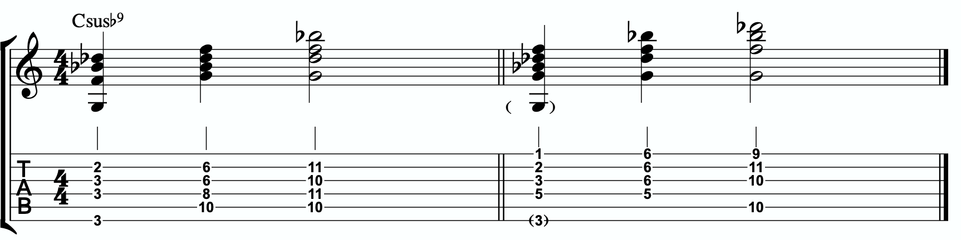
3a

Each of these voicings gives us the sus4, 5th, b7th, and b9th of our Csusb9.

THREE NOTE QUADRATONIC VOICINGS

Three note qudaratonic voicings are an incredible and special tool for us. Unlike traditional drop chords that can be practiced through all inversions, these three note chord inversions offer us some special benefits. First, they highlight the sweet spot notes and get us into the really colorful parts of the chord. Second, by ignoring one of the four notes in each voicing, we’re not simply jumbling up the same four pitches each time we invert. One pitch is always disappearing or appearing as we move through these inversion. It makes for a much more captivating series of inversions as the ear is unconsciously losing and finding pitches at every turn.
We’re going to follow the “drop 2” idea, however not in the traditional sense. When we speak about “drop 2” chords traditionally, we mean that we take the second to the top note and “drop” it down an octave. We’re not going to do that. We’re simply going to remove it from the picture.

4 |  | 4 | 3 |  | 3
3 | > |  | 2 | >
2 |  | 2 | 1 |  | 1
1 |  | 1 | 4 |  | 4

Notice that when this technique is applied, the first series of numbers is different from the second. They both share 1 and 4, but the first series has a 2 and is missing the 3 whereas the second series has the 3 and is missing the 2. If we did this for every inversion of 1 - 4, each one would be slightly different.

If we apply this to our primary quadratonic, we get this series of three note voicings for our chord.

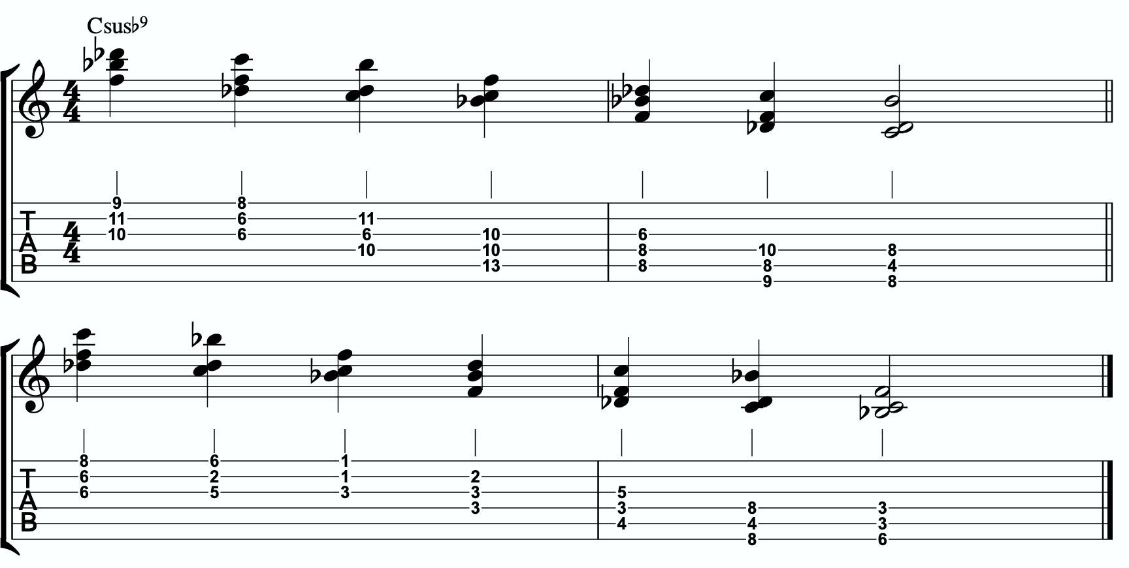
3b

QUADRATONIC SCALAR RUN
Let’s bring it back to single note ideas, melody, and improvisation. The Must Know was all about learning to hear and manipulate melodic tension and resolution using the quadratonic. But we can also use the quadratonic like a scale or an arpeggio. It seems simple because there are only four notes involved… but that’s only one note less than a pentatonic scale. And if you think about it, we only have 12 notes in western music, so if the quadratonic takes up four notes, then that’s actually ONE THIRD of all of the notes in the entire western tonal system. That’s quite a lot.
Let’s start with a scalar type run. Ideally you should already be able to hear and use the tension note and the resolution points of the melodic triad to develop beautiful, clear, authoritative phrasing that works with the harmony, and even implies it, without being stuck outlining it. Not we want to focus on developing the ability to create long, flowing, legato, fluid runs that create the impression of harmony. Traditional scales can sometimes be helpful for this, but they often times have notes that aren’t going to help define the sound of the harmony that’s happening. This quadratonic approach to a run will clear away those less essential notes.

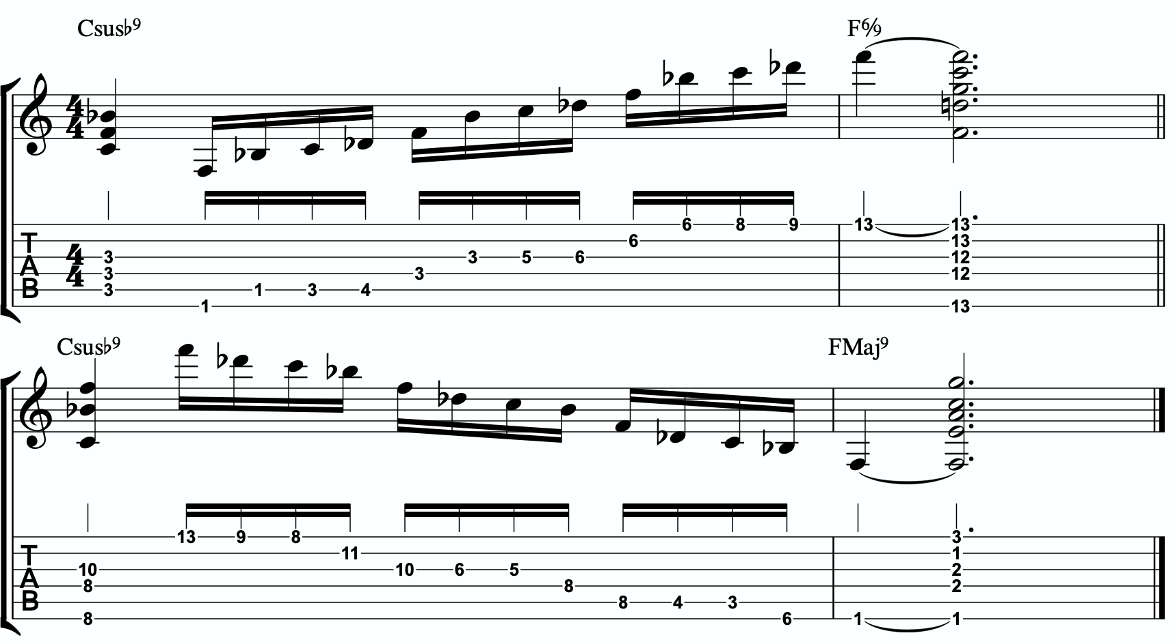
3c

THE SECONDARY TENSION NOTE & PENTATONIC SCALE
Once we can develop authentic phrases with the primary tension note and the quadratonic it gives us, and once we can see it as a scale that we can run through, we can move on and look at the secondary tension note. Because we skipped the hierarchy of harmonic importance for our primary “tension” note - and used the b9 rule instead - we will pretend as though we are looking for our primary tension notes and start at the beginning.
So we go to Stefon’s formula.

The Hierarchy of Harmonic Importance.
3 - 7 - 5 - 9 - 11 - 13 - R
- Is the 3rd of Csusb9 in the Bb minor triad?
For a sus chord, the 3rd IS the 4th. The 4th is F. And F is present. Next.
- Is the 7th of Csusb9 in the Bb minor triad?

Yes. The b7 is Bb, and that’s in the Bb minor triad. Next.
- Is the 5th of Csusb9 in the Bb minor triad?
The 5th of Csusb9 is G. G is not present. And it causes no problems.

So our secondary tension note is G.
G is the 5th of Csusb9, but it will be heard against the melodic triad which is Bb minor. G is the 6 of Bb minor, so that means our secondary quadratonic is Bb minor tension 6 and it gives us this tonality’s melodic triads pentatonic scale.

/ 2,6
Bb-

Here is an example of this pentatonic scale in use:
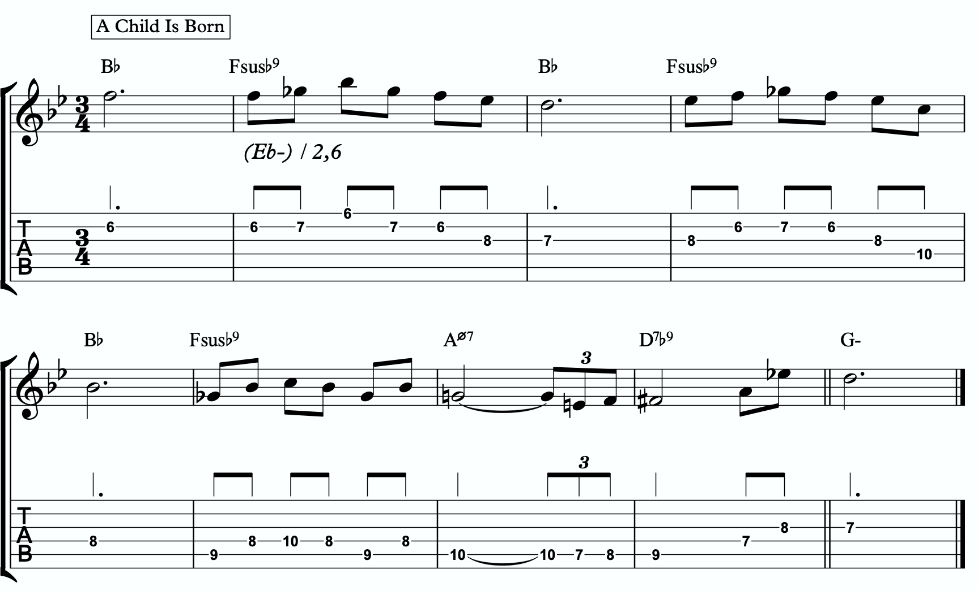
3d

THE MELODIC TRIAD BEBOP SCALE
Hopefully by now you’re starting to see the way melodic triads can offer a very direct path through all the traps of scale running, noodling, and outlining chords progression using 1 - 3 - 5 - 7 chord tones and arpeggios. All of these can be great devices (maybe not noodling), but have dangers to them.
The melodic triads approach helps us start with the sweet spot notes, and build our harmony and melodic from there. Before you start working on the melodic triad bebop scale or anything beyond this point, I strongly encourage you to make sure that you’re not simply reading these ideas like a theory book to be memorized. These are meant to infiltrate your ears, map the fretboard, and apply directly to musical situations in tunes. If you’re been studying and applying the melodic triads approach for enough time that you’re getting comfortable with it, we can take the next step. It’s only one extra note… but it’s a game changer.
In order to understand what the melodic triad bebop scale is, you need to understand what a traditional bebop scale is and the purpose for why it’s built the way it is. The standard diatonic scale is made of seven notes. The problem with playing a seven note scale is that it’s made of an odd number of pitches, so if you’re playing in 8th notes in 4/4 time, it’s going to flip itself around and start to place weak sounding notes on strong beats and strong sounding notes on weak beats.

C major scale

In music, we have strong beats and weak beats. We can see these pretty easily by looking at the beamed groups of 8th notes. There are always two of them. The first one, on the left of each group, is the strong down beat, and the second one, on the right of each grouping, is the weak up beat. We count them:

1 - & - 2 - & - 3 - & - 4 - &

That makes up one full measure of 8th notes in 4/4. The strong beats are on the number, and the weak beats are on the & (the “and”). If we look at the C major scale above, we see that it starts on the C note (very important) on a down beat. Then the next down beat, beat 2, has the E note. That’s the 3rd of CMaj… so we’re doing good. The 3rd down beat has the G note… still good. But the 4th down beat has the 7th of the scale, and then the C root note happens on the & of 4. And that puts the D note, the 2nd of the scale, on the down beat of the following measure. The following few down beats all have weak notes on them, putting the strong CMaj “chord tones” on the weaker up beats. It finally loops back around and lands on the C note on beat 4.
The traditional bebop scales took care of this problem by adding one single note. This evens it out to an eight note scale and lines up the pitches of the scale with the beats in the measure.

Some players would call this a bebop scale, or if you’re familiar with the Barry Harris method, you might call this the 6 diminished scale. Regardless, what’s important is that if you look at the strong beats, the notes spell out C - E - G - A. That’s a C6 chord. It gives

us a perfect combination of melody (the scale - with tension and resolution points), harmony (the C6 chord - the resolution points), and rhythm (the timing of getting all of the important notes to fall on the strong beats). It’s a beautiful, perfect, and very helpful scale to know.
I still rarely if ever think about, practice, or use it. Doesn’t mean you shouldn’t. But hopefully by now you’re starting to see just how powerful triads are. This scale is built around four note chords like C6 or C7, not three note triads.
But there’s a way to combine the two concepts. The pure simplicity and strength of the triad, with the rhythmic perfection of the bebop scale concept.
We simply add one single passing note between every triad note. Here’s one octave of a Bb minor triad. Our melodic triad for Csusb9.
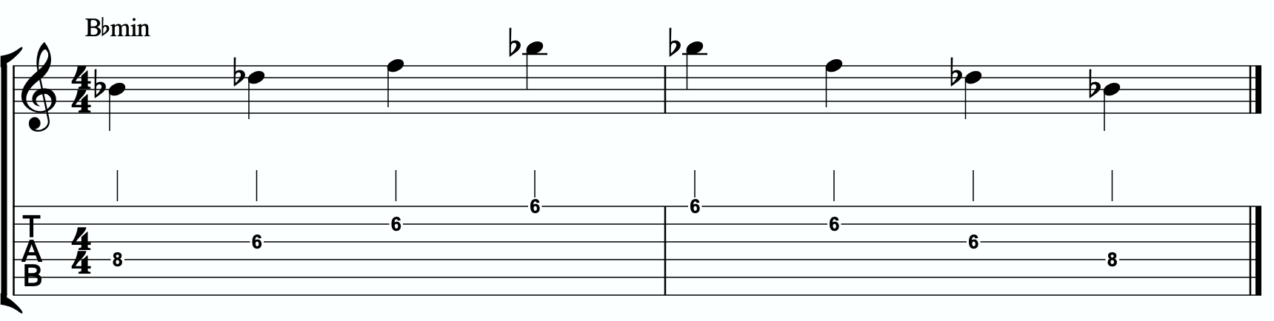

Now we’re going to insert one passing note between each triad note. The key is to pick the passing note that best respects and defines the Csusb9.
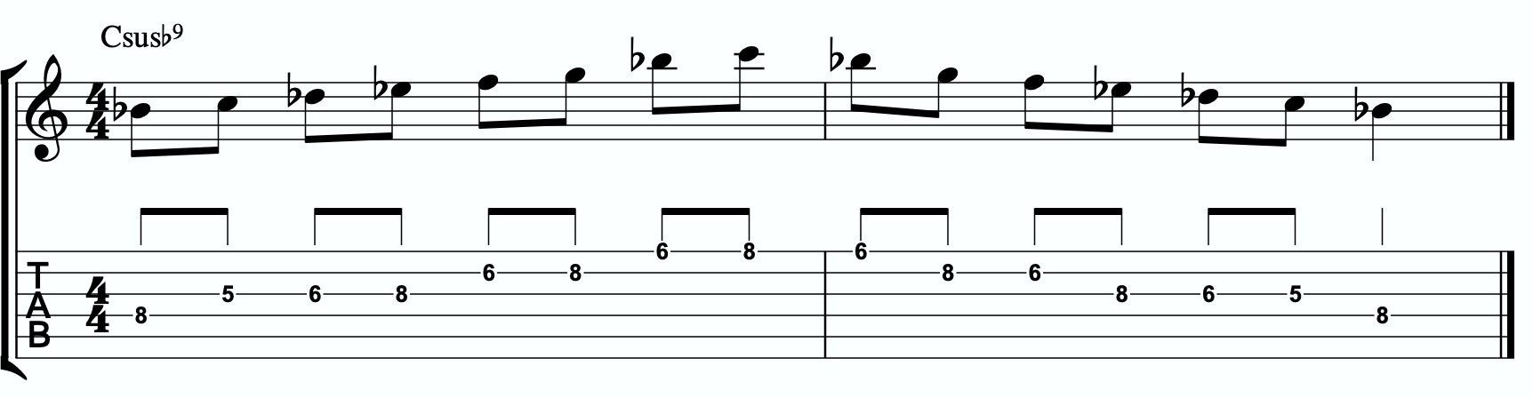

This is our melodic triad bebop scale. It’s a six note scale that helps us outline the tonality we’re working with by stabilizing the notes of our melodic triad.
Notice that it’s just a Bb minor triad with passing notes. If we look at those passing notes in relationship to the triad, we get tension 2, tension 4, and tension 6. Two of the three tension notes are straight from our primary and secondary quadratonics. No, that’s not a coincidence. That’s due to the perfect nature of how triads function when we dig through harmony and melody with them. So we’re simply adding a third tension note. In this case, it’s tension 4. You could use that as a quadratonic - Bb minor tension 4 over a C7sus chord. The melodic triad bebop scale gives us a rhythmically aligned “scale” but it also gives us three tension notes, each with their own unique emotional quality to them, that we can take advantage of if we don’t want to get stuck running scales and want to return to a focus on melodic tension and resolution and lyrical phrases.
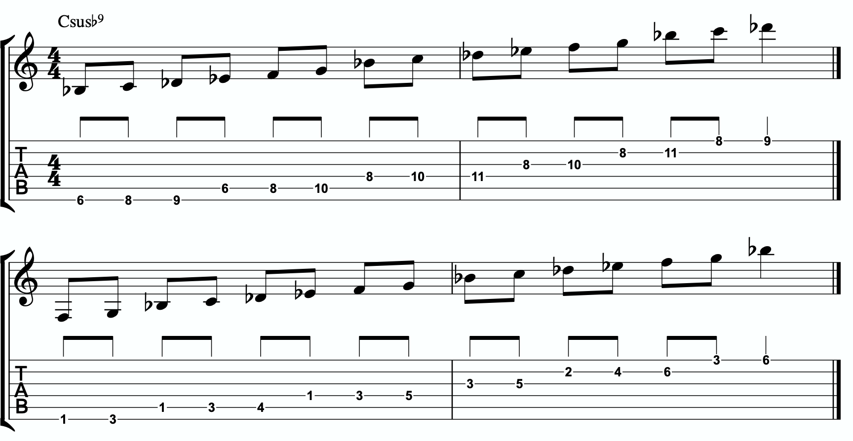
4a

Here is the same scale but harmonizing all of the melodic triad notes with our three note
quadratonic voicings:

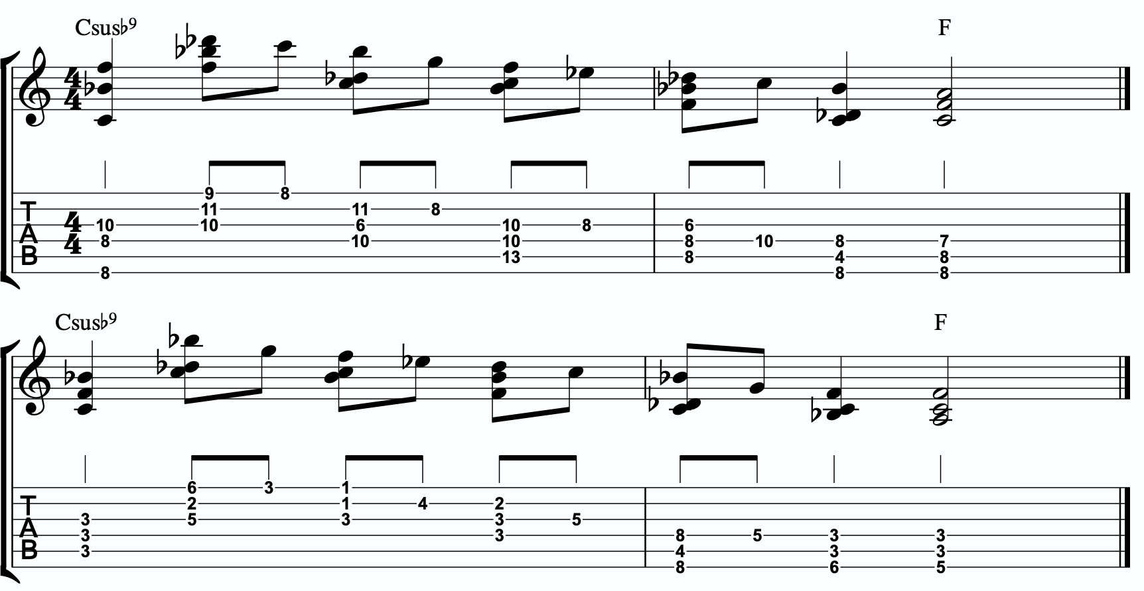
4b

ADVANCING HARMONY
We are getting into more and more advanced material now. Please remember that you do NOT need any of these continued lessons and concepts to play music. It is significantly more important that you develop your ability to be authentic, spontaneous, and playful with the material in The Must Know and then, if you feel comfortable, in Digging Deeper. Each section is building on the last, so if you’re struggling, it’s simply a check engine light to return back to earlier sections.
That said, we’re still far from a complete exploration of the depth of this one little triad.
This section we will explore some more advanced harmonic ideas. You may have heard me talk about liquid harmony. This is a way of visualizing the creation of harmony that involves movement. Think of a chord voicing like a block of ice. It’s frozen in time. We play it, we move to another chord, we move to another chord. Most of us learned to play harmony this way with a focus on shell voicings and drop chords. Liquid harmony is the idea of taking those blocks of ice and melting them down into a little. Not necessarily completely. But we want at least some of the ice to return to water so that it can flow and move. It helps free us up to transcend more static voicings, even cool sounding ones, and creates a more pianistic, movement-oriented sound. Not simply movement from one chord to another, though that’s important as well. But movement inside of a single chord. That’s what this section will explore.

HARMONIC QUADRATONICS
This is possibly the simplest, most effective, and most fun ways to create liquid harmony. The idea is that we play the primary quadratonic, but instead of thinking of it as a scale that we play with single notes, we play it as a chord. We will play three notes of the quadratonic. The tension note will be part of the chord, and it will replace the nearest melodic triad note. So the chord will be made up of two melodic triad notes and the melodic tension note. Then, while holding the two melodic triad notes and allowing them to continue ringing, we will resolve the tension note back into the triad. If we’re playing solo guitar or accompanying another musician, we may want to play the root note of the chord (“left hand”) or even the whole shell voicing. However in a full ensemble with a bass player, or if we’re playing solo and simply want a more impressionist style sound, we can leave that out and play these ideas as rootless “chords”.

NYC Jazz Guitar Masterclasses
Here is an example:
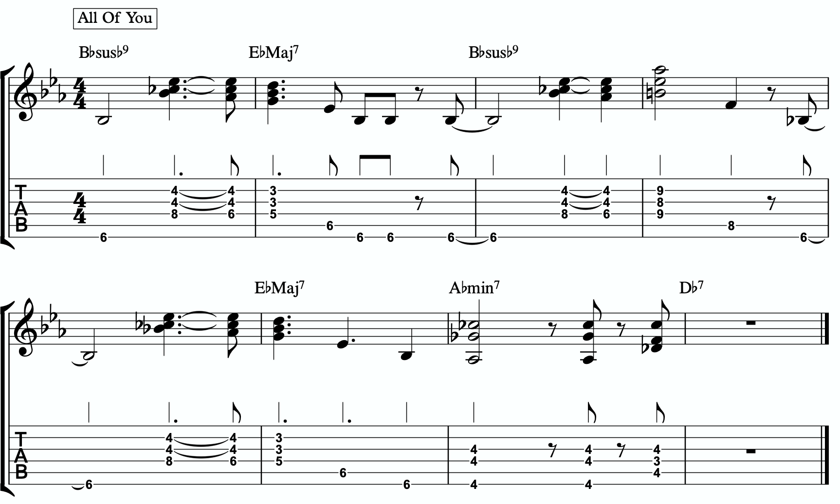
5a

Quadratonic Dyads
This is a similar concept to our quadratonic 3-note voicings, except now we’re creating 2 note grouping by pairing together every other note.

So if our quadratonic is made of Bb - C - Db - F, we will group the Bb and the Db together and the C and F together. And we will get this:
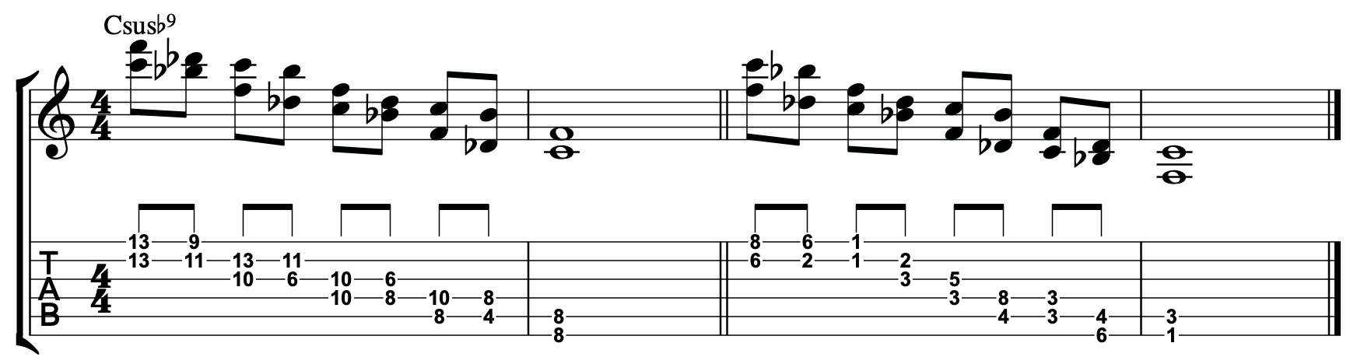
5b

TRIAD PAIRS
Sticking with our melodic triad bebop scale, we actually have our melodic triad version of triad pairs hiding right there in plain site. We know that all the resolution points are the notes of our melodic triad. But if we look at all of the passing tension notes we added, we actually have a second triad. This scale is two triads together. We have our melodic, or our “resolution” triad, and then we have our tension triad.
For this tonality, our triad pair is Bb minor and C minor.

/ C-
Bb-

We can of course arpeggiate these triads out to create single note ideas, but this section is specifically about harmony. So let’s look at a harmonic application for our tonality inside a chord progression.

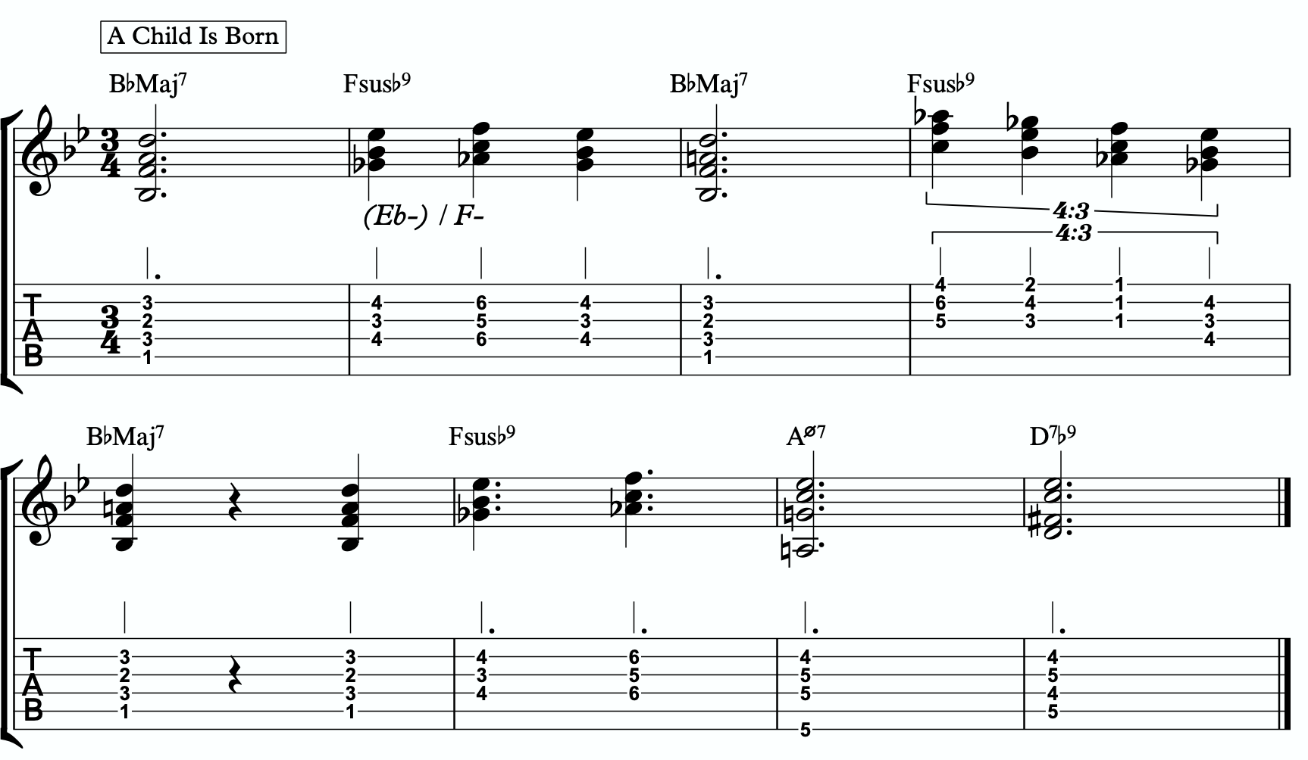
5c

Here is a dyad application, where we leave out one note from each triad.
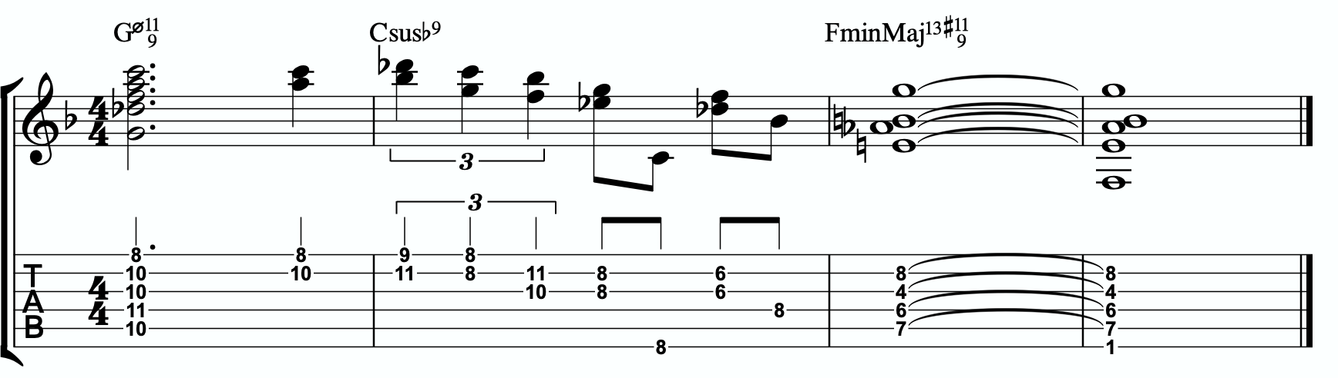
5d

TENSION LAYERS
Everything up until this section has been based on the idea that the melodic triad is the strongest organization for resolution, color, harmony, and melody. We leave the triad temporarily with different techniques to create tension, harmonically and melodically, but always in service to bring us back to rest in the resolved nature of the melodic triad.
In this section, we’re going to talk about the idea of thinking of tension as existing in layers. This way, we have different levels of tension that we can move in and out of - like rungs on a ladder that we can climb up, climb down, or simply pick one and stand still on it to enjoy the view.

LAYER ONE
This one is easy. Layer one is the primary quadratonic. The melodic triad is the most stable set of notes we have for our tonality. The primary tension note offers us a very respectful tension note to create melody. There is tension inside this quadratonic, but it’s accessible and always brings us right back into resolution. We must be comfortable making music with this sound before we can continue.

/ 2
Bb-

LAYER TWO
But what if we want to move up a rung on the ladder? We know from the melodic triads bebop scale that our triad pair for this tonality is Bb minor and C minor. So far, we have only thought of the C as a tension triad that can be used to bounce back and forth with Bb minor. But what if we momentarily “modulated” into the C minor triad to create a new rung on our ladder? Like modulating in a tune between the relative major and minor of a key, the key doesn’t actually change, but we can momentarily alter the color and the emotion.
By switching over to thinking of our tension triad, we can add a tension note to the triad and create a tension quadratonic.

The tension quadratonic, when mixed with the primary quadratonic will allow us the ability to navigate seven diatonic notes melodically and harmonically in a structured and authoritative way that will imply the harmony, give multiple colors and layers of tension, and allow for six different resolution points within any tonality. That’s half of all of our available pitches.

How do we chose the primary tension note for our new tension quadratonic?

We go back to the hierarchy of harmonic importance. What’s the next chord tone from the hoh? We can account for the root, 4th (counts as our 3rd), 5th, b7th, b9th, and the #9th. But we haven’t yet used the 13. So that’s going to be the tension note for our tension quadratonic. Technically, because the chord’s name doesn’t specify whether it’s a 13 or a b13, we could experiment with either… and that would yield two different tension quadratonics, but I find the natural 13 gives a more traditional sound, so that’s what we’ll use for this study.
The 13 of C7sus is A. If we add an A note against our tension triad, C minor, we get this four note structure - C, Eb, G, A. That’s a C minor triad with a tension 6.

/ 6
C-
This quadratonic will sound less “in” than the primary quadratonic, however the tension note in it will give it a sensation of tension and resolution within itself.

Here is example of this quadratonic pair being used harmonically:
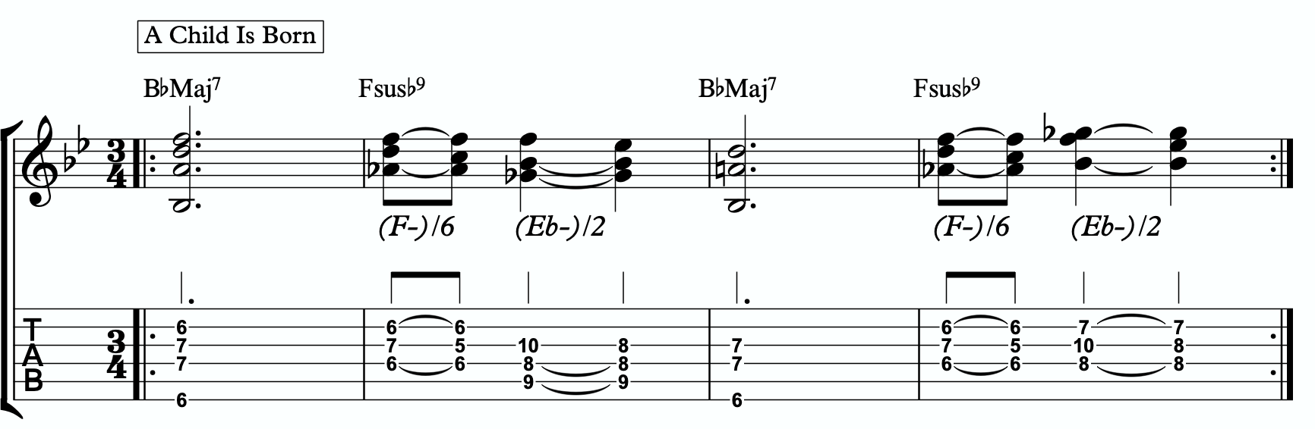
6a

Harmonizing Our Bebop Scale With Tension Layers

Let’s look at our six note melodic triad bebop scale and harmonize it using our quadratonic pairs. We will do this using two different techniques brought up earlier in this study booklet. First, we will move through the bebop scale using our harmonic quadratonics to create liquid harmony within each voicing as we move between the two quadratonics to harmonize each note. Finally, we will apply the three note quadratonic voicing to the bebop scale.

Harmonic Quadratonics & Liquid Harmony
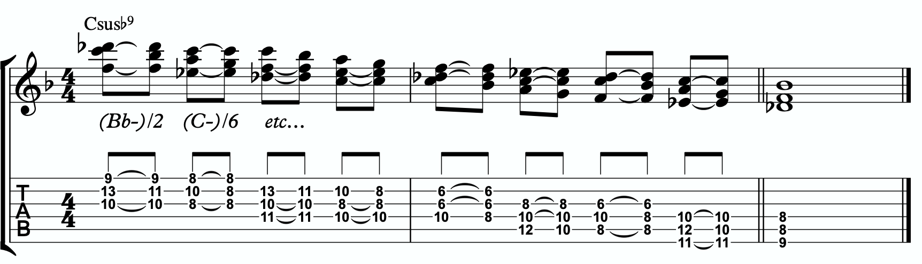
6b

Three Note Quadratonic Voicings
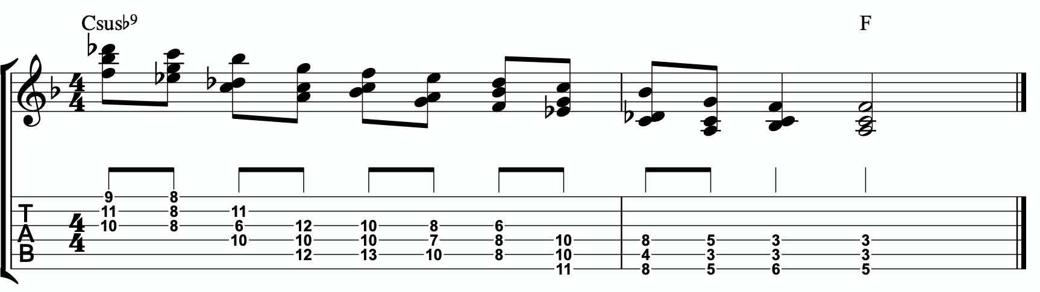
6c

THE OUTRO
I just want to personally thank you for working through these ideas. I am obsessed with exploring, mapping out, and demystifying jazz harmony and melody, and attempting to understand it and execute it using the simplest and most fundamental ingredients in music. I’ve found over many years of playing and study, and learning from some of the greatest minds in the jazz world today, that it’s often times our ego and our own self- inflicted limitations that hold us back the most from growing and evolving towards our potential.
The most dangerous words to development of our musicianship are, “I already know that.”
Most of us generally spend a couple of music theory classes learning our triads. Maybe we read a book about advanced triad application and get some cool intellectual ideas to play with. But for me, it’s all about that Bill Evans quote.
**********************************

The whole process of learning the facility of being able to play jazz is to take these problems from the outer level in, one by one, and to stay with it at a very intense, conscious-concentration level until that process becomes secondary and subconscious. Now, when that becomes subconscious, then you can begin concentrating on that next problem, which will allow you to do a little bit more.

I don’t consider myself as talented as many people but in some ways that was an advantage because I didn’t have a great facility immediately so I had to be more analytical and in a way — that forced me to build something.
Most people just don’t realize the immensity of the problem and, either because they can’t conquer it immediately, think that they haven’t got the ability, or they’re so impatient to conquer it that they never do see it through. If you do understand the problem then you can enjoy your whole trip through.

People tend to approximate the product rather than attacking it in a realistic, true way at any elementary level — regardless of how elementary — but it must be entirely true and entirely real and entirely accurate. They would rather approximate the entire problem than to take a small part of it and be real and true about it. To approximate the whole thing in a vague way gives you a feeling that you’ve more or less touched the thing, but in this way you just lead yourself toward confusion and ultimately you’re going to get so confused that you’ll never find your way out.

It is true of any subject that the person that succeeds in anything has the realistic viewpoint at the beginning and [knows] that the problem is large and that he has to take it a step at a time and that he has to enjoy the step-by-step learning procedure. They’re trying to do a thing in a way that is so general [that] they can’t possibly build on that. If they build on that, they’re building on top of confusion and vagueness and they can’t possibly progress. If you try to approximate something that is very advanced and don’t know what you’re doing, you can’t advance.

**********************************

Was Bill referring to melodic triads? I very highly doubt that. I’ve never heard him talk much about triads. But consider the underlying philosophy he’s pointing at. Know the

basics. Regardless of how elementary! But it must be entirely true, real, and accurate. Be able to play genuine, authentic music using the most fundamental ideas first. Then it leaves room to grow.
This is why I refer to the first section in this ebook as The Must Know. It’s a basic shell voicing, and a basic triad. And while these two concepts are as simple as they come in music, we must understand them in a true, real, and accurate way. If we did this for a handful of tonalities, we could play beautiful music for the rest of our lives, and for me, I would feel fulfilled. It would offer emotion-driven, precise, human, lyrical melody combined with lush, colorful, pianistic harmony. Mix in a strong sense of time and feel, and that’s everything a jazz musician needs.
But like Bill talks about, when we don’t try to approximate but instead start with the elementary ideas and build a foundation with them, then it gives us room for growth. Look at everything we worked through together in this ebook! All built from one triad and how it relates to one chord (piano diagram!). As of the time of putting this together, I’m still working on many of these ideas myself… and I’m still coming up with new ways of building harmony and melody around the melodic triad.
This is why I can’t recommend enough, even to the intermediate and advanced players out there - spend some serious time in The Must Know section. Own it. Be able to play authentic ideas with it. Apply it to tunes. Move it through the circle of 5ths. Do whatever you can to internalize it and develop your ears to it. Then you can begin moving on. I would encourage everyone… peak ahead if you would like to to keep an eye on where this particular path is heading, but be very self-aware and learn to see when you’re getting in over your head. When this happens, not if, just take a deep breath and back up a few sections. It simply means your foundation isn’t quite strong enough yet to carry the weight of those more complex ideas. If you want it, and you put the time and effort it, you’ll get there.
Like one of my students always likes to tell himself at the end of our lessons…..
“Easy does it. But do it.”

Thank you again. Don’t forget to come and hang in our open office hours to ask questions if you’re confused on anything.
Happy Practicing!
-Jordan Klemons

The Melodic Triads Study Group

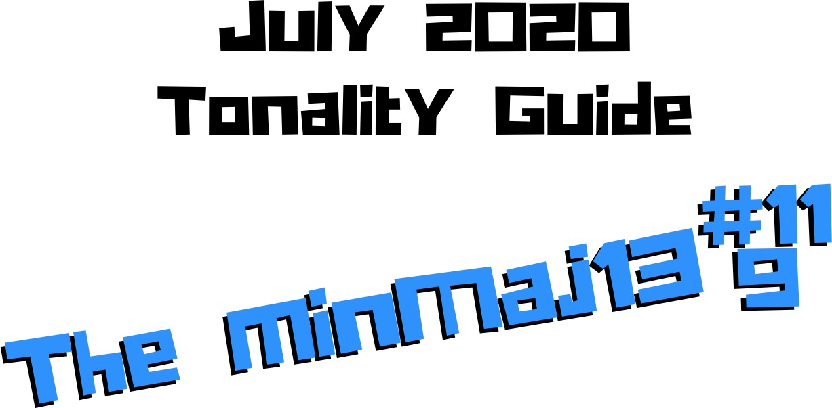

Jordan Klemons
NYC Jazz Guitar Masterclasses

CONTENTS
-INTRODUCTION
-THE MUST KNOW-
-ADVANCING MELODY-
-DIGGING DEEPER-
-THE MELODIC TRIAD BEBOP SCALE-
-ADVANCING HARMONY-
-TENSION LAYERS-
-OUTRO-

This ebook is the copyrighted property of Jordan Klemons. All images, information, layout, and designs belong to Jordan Klemons. This document may not be altered, reproduced, distributed, or transmitted in any form or by any means without the prior written permission of the author.

INTRODUCTION
Thank you for downloading the pdf materials for this month’s melodic triads tonality study guide. Inside you will find all of the supplemental theory, notation, tab, charts, concepts, and examples for the accompanying videos to help you develop your understanding, your ear, your emotional connection with, and your sense of harmonic and melodic freedom within this month’s tonality… as well as its use in some short, common, jazz chord progressions that you will be able to immediately implement in your own playing.
The information in this guide is dangerous. I mean that literally. When the process is respected, and you understand how all of these ideas fit into the puzzle, this guide and the baby steps included can offer tremendous insight into how to begin making real music very quickly, and how to continue evolving and growing as a player for many years to come. However, if approached in the wrong way and the process is not respected, these ideas can confuse and derail a musician’s ability to progress. It’s important not to jump too far ahead of yourself. The advice that a Miles, or a Scofield, or a Coltrane would give to a beginner is different than what they would give an intermediate or to an advanced player. And all of that would be different than how they would talk to a professional who’s already playing on their level. This is important to remember.
This guide is meant to show many different layers of musical growth and how, when using the melodic triad approach, they can all be boiled down and viewed simply as an extension of the most basic elements of music. Namely… a triad. Think of the pages that follow as an architect’s blue prints for a skyscraper. If you haven’t built a strong foundation, your skyscraper will fall. If you attempt to skip the first 50 stories and jump to building the penthouse, the skyscraper will fall. If you try to put up the fancy exterior of the building before you complete the steel frame, the skyscraper will fall. Yes, the information all the way at the end of this guide is constructed using the same ideas and concepts that are presented in the first chapter, but the process must be respected for anything to work. Otherwise it will only leave you confused, frustrated, feeling like a failure, and wanting to give up. Be patient with yourself. The short cut IS the long road. Take it. Spend two or three months working on the long road and watch how much you progress. Focus on your sound, on your ear, and on your musicianship… and trust that the simplicity of the ideas and the process itself will take care of you. They will. But only if you respect them. It’s like a relationship - you have to be present and give of yourself, and then you will receive in abundance.

As you work through these pages, try to keep in mind this Bill Evans’ quote from The Universal Mind.

**********************************

The whole process of learning the facility of being able to play jazz is to take these problems from the outer level in, one by one, and to stay with it at a very intense, conscious-concentration level until that process becomes secondary and subconscious. Now, when that becomes subconscious, then you can begin concentrating on that next problem, which will allow you to do a little bit more.

I don’t consider myself as talented as many people but in some ways that was an advantage because I didn’t have a great facility immediately so I had to be more analytical and in a way — that forced me to build something.
Most people just don’t realize the immensity of the problem and, either because they can’t conquer it immediately, think that they haven’t got the ability, or they’re so impatient to conquer it that they never do see it through. If you do understand the problem then you can enjoy your whole trip through.

People tend to approximate the product rather than attacking it in a realistic, true way at any elementary level — regardless of how elementary — but it must be entirely true and entirely real and entirely accurate. They would rather approximate the entire problem than to take a small part of it and be real and true about it. To approximate the whole thing in a vague way gives you a feeling that you’ve more or less touched the thing, but in this way you just lead yourself toward confusion and ultimately you’re going to get so confused that you’ll never find your way out.

It is true of any subject that the person that succeeds in anything has the realistic viewpoint at the beginning and [knows] that the problem is large and that he has to take it a step at a time and that he has to enjoy the step-by-step learning procedure. They’re trying to do a thing in a way that is so general [that] they can’t possibly build on that. If they build on that, they’re building on top of confusion and vagueness and they can’t possibly progress. If you try to approximate something that is very advanced and don’t know what you’re doing, you can’t advance.

**********************************

I’ve setup the material in these tonality lessons to start with the most basic and fundamental elements of music, and to grow outwards in complexity. Everything builds on what came before it, so everything is connected. You DON’T need to master everything in these lessons to play music. You only really need the first section and a little bit of creativity and concern for your sound - that’s enough to create something beautiful..
I recommend that if you’re new with us, even if you’re already an advanced player, you begin focused entirely on the first section of this guide, The Must Know, and give yourself a minimum of 3 - 6 months to get used to this method and the initial concepts presented. It’s a very different approach to standard theory, and your goal should be (as Bill Evans said) to be able to make genuine, authentic music with the ideas in the first section. Once you feel you can hear and play music using these ideas on a small handful of tonalities and applied to some tunes, then it is time to start advancing forward.

I would continue giving yourself an addition 3 - 6 months for each subsequent section, as each builds on the last and becomes more and more advanced… starting from the most basic and simple ingredients, and eventually working our way up to learning to hear and use all 12 notes of the western chromatic scale harmonically and melodically over any chord in a musical way.
I strongly recommend that you follow this rough timeline. I believe it’s the most effective way to cut through the learning process and get straight to making beautiful music, and then to set yourself on the path to continue growing and building for years to come.
The melodic triad ideas I’m working on today, I didn’t even know they existed during the first few years of my own studies. As we grow and progress and get comfortable, we can naturally start to evolve the ideas into more advanced applications. That’s the beauty of starting with the fundamentals, learning to make genuine, authenticate music from our own self first… and then building layers of complexity on top of, but always connected to, those very fundamentals. Much like a large skyscraper building starts with a huge hole in the earth, then is filled with concrete and steel, and then the steel frame will hold the building as it goes up. We won’t see any of these structures. But without them, the building would collapse. Only once the structure is there can the work of putting up the exterior, the glass, the interior, the design, the furniture, etc. take place.
Thank you again for downloading this study guide and working on your music with us. I look forward to hearing your playing and your contributions to the melodic triad conversation inside our facebook group, and for those of you subscribed to our Private Community, inside our melodic triad mastermind group.
Happy Practicing!
Your friend on the path towards jazz guitar mastery,
-Jordan Klemons

The Melodic Triad Study Group - a part of
NYC Jazz Guitar Masterclasses

THE MUST KNOW
The theory, ideas, voicings, and “scalar” ideas presented in this section may seem too simple and elementary to be of value. But I urge you, even the intermediate and advanced players - do not skip this section. I recommend that if you’re within the first 3 - 12 months of study with us that you focus entirely on learning to apply these ideas to musical situations. You can skim the rest of the pages if you’d like, but this should be where you build from. After close to 25 years of playing music seriously, I still spent my first year of working on melodic triads only on this material. The great thing about these ideas is that not only can you comp, improvise, compose, and arrange beautiful music over standards, bebop, modern jazz, and original works with them, but they also act as the foundation on top of which we can grow into more and more complex ideas without ever leaving behind these basic building blocks of harmony and melody.
Do not simply see these as intellectual theory ideas. These are meant to be internalized. To understand the theory is great. To hear the sounds in your ear with a sense of familiarity is just as important. To connect with them personally and be able to hear and express emotion through them is of the utmost importance when it comes to developing our musicianship. This should be the goal.

THEORY
The minMaj13#11(9) is dark, intense, and mysterious… yet somehow bright and shimmering at the same time. It’s reminiscent of the ‘James Bond Chord’ (the minMaj9), but there’s something more mysterious and bright happening. It makes me feel like I’ve been transported into an enchanted forrest. Filled with magical creatures, sorcerers, demons, wizards, elves… it’s mesmerizingly beautiful, but there’s potential danger everywhere. This is the vibe I get from this tonality. Beautiful, magical, and hypnotizing, yet filled with potential danger and requiring caution to navigate. Being from the minMaj7 family of chords, it functions best as a minor tonic chord or as a minor iv chord in a major key.

What makes up a CminMaj13#11(9) tonality?
Two basic ingredients.
- A basic CminMaj7 chord
- A D major triad
A good way to think of this is to visualize a piano player with two hands. Their left hand would be playing C-Eb-B (a basic CMaj7 shell voicing) and their right hand would be playing a D major triad.

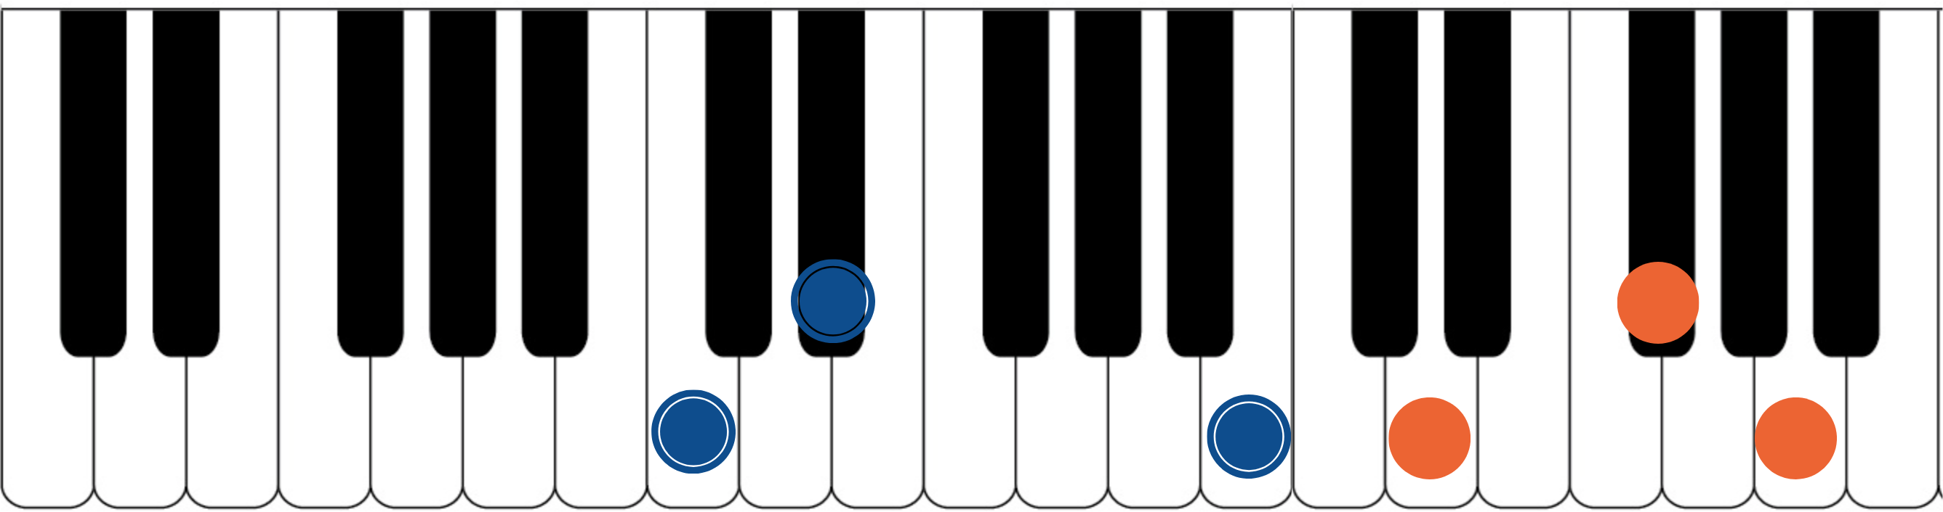

The blue dots would represent the fingers of the piano player’s left hand. Notice they spell out C, Eb, and B. That’s the 1, b3, and 7 of a basic CminMaj7 chord. The orange dots represent the piano player’s right hand. They spell out D, F#, and A. That’s a D major triad. If you have access to a piano or keyboard, I strongly encourage you sit down and play these seven notes simultaneously. Listen to how big of a sound they create together. Play it a few times. Try and feel the emotion and the color they create together. Then remind yourself of the elementary and simple nature of what’s happening in each of your two hands separately. A basic chord in your left hand. A basic triad in your right hand. The magic happens when we use these sounds together… and when we begin to build chord voicings and melodic ideas around these two simple sounds.

***This D major triad, which is now our melodic triad, is built on the 2nd of CminMaj7… ‘D’ is a 2nd up from ‘C’. This relationship is critical to understand and memorize as it will allow us to transpose this minMaj13#11(9) tonality into any key quickly. We will notate this as ‘T2’. This notation comes from Stefon Harris. The ’T’ is short for ‘triad’ and we make it upper case to notate that it’s a major triad. The 2 tells

us that the melodic triad is built on the 2nd of the harmony. So if we want a GminMaj13#11(9), we think T2, we find the 2nd of G (which is A), and we know that the melodic triad is A major.***
This pianistic chord construction is the starting point for everything we are going to look at together. Hidden inside of this seven-note chord is a universe of potential harmonic and melodic ideas. The following pages can all be traced back to this construction idea. Basic chord, basic triad. Left hand, right hand. Harmonic structure, melodic structure. Hence the term… melodic triad. Even if you don’t have access to a piano, I encourage you to sit and think about this diagram until it makes sense to you.

GETTING THE PIANISTIC VOICINGS ONTO THE GUITAR
Taking the concept of the piano construction, where the CminMaj7 chord is always underneath the D major triad, we can develop three basic inversions of this chord by inverting the D triad and keeping the CminMaj7 chord underneath it as much as possible.
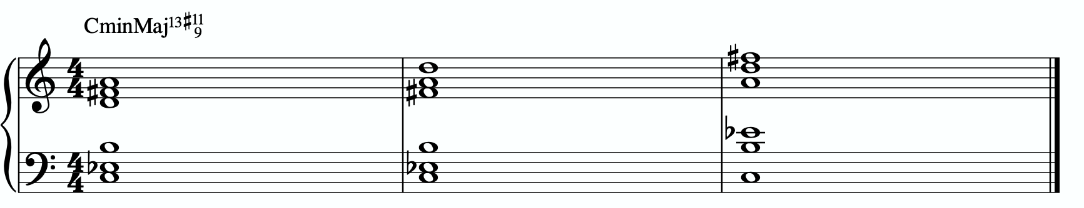
In order to get these three inversions, we will use the piano -> guitar technique described in the video - where we put the shell voicing on the bottom three strings and the triad inversions on the top three strings. This will give us a three “pianistic” inversions of this tonality on the guitar.
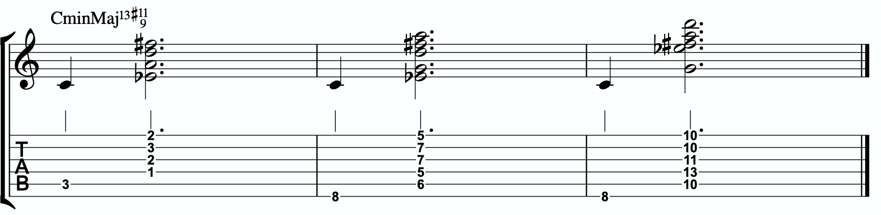

Notice the three basic inversions of the D major triad on strings 1 - 3.

A few exceptions are being made here.
Notice in all three inversions we are breaking apart the chord, playing the root note first, and then following it up with the rest of the voicing. This is simply due to the physicality of the guitar. I haven’t found a way to play all of the notes simultaneously for any of these voicings.

In measure 1 we are only playing five notes instead of all six. We’re missing the Maj7 from the shell voicing. We don’t want to put it below the root note, and it doesn’t fit between the root note and the D major triad as all of the strings are being used. So we have to leave it out. This is okay because the D triad gives us the A note (the 13) which can also serve as the 6th, making this a min6 chord with the #11 and the 9. Almost identical to the minMaj7. In measures 2 and 3 we’re subbing in the 5th of the C minor chord in place of the major 7th simply due to physicality issues. If the major 7th were possible to reach, I would prefer to use it. But since it’s not, we can do a 1-b3-5 “shell voicing” instead of a 1-b3-7.

THE PRIMARY QUADRATONIC
Because this particular type of CminMaj7 contains a D major triad in the right hand, that D triad is going to be the foundation of our melodic structures. It governs everything.
Rather than simply behaving as the chord tones that they correspond to harmonically, when used melodically, they will function as the 1, 3, and 5 of our melody… the strongest and most stable resolution points we can build lines with.
The ideal starting point is our primary quadratonic. A quadratonic is a triad that has one additional note added to it. It’s a four note structure made up of three stable notes (the melodic triad) and one ‘free radical’ or melodic tension note. This extra note serves two functions. First, it’s there to create melodic tension that will help us create movement, emotion, and lyrical phrases without getting trapped inside running scales or chord tones. Second, it will help imply the sound of the harmony we’re playing over and glue the melodic triad inside the chord so they don’t sound like two separate sounds, but rather one unified, colorful tonality.
We only have 12 notes in western music, and three of those 12 are being used in our melodic triad. That means we only have nine possible melodic tension notes. All nine of these could be used to create melodic tension against our triad. But some will help imply the sound of our original harmony better than others. Our primary quadratonic will be

made of our melodic triad and the primary tension note - or the note the most respects the basic harmony.

Straight from Stefon Harris’ brilliant mind comes this rule that will help us figure out what are the most important notes:

The Hierarchy of Harmonic Importance.
3 - 7 - 5 - 9 - 11 - 13 - R

These are the chord tones of our basic harmony (the left hand of our piano player).

Here’s how this works:
- Is the 3rd of CminMaj7 in the D major triad?
No. The 3rd of CminMaj7 is Eb. Eb is not in D and causes no problems.

So our primary tension note is Eb.
This Eb - while the b3 of CminMaj7 - is going to be heard by the ear in relationship to the D major triad. Since Eb is the b2 of D, we will call this tension b2. So our primary quadratonic is D tension b2.
We’ll notate this as:
/ b2
D
By making the triad bold and circling it, it draws our eye directly to the melodic triad so we can think first about our strong resolution points, then it quickly lets us know what our primary melodic tension note is.

At this point your primary goals should be to be able to play the three pianistic voicings, to be able to visualize the primary quadratonic over the basic shell voicings on the fretboard, to develop your ears to hear the melodic tension note wanting to move and the root note of the melodic triad as melodic ‘do’ - or the root note of the melody.
Here are some examples of these fundamental voicings and melodic ideas being used in musical situations.

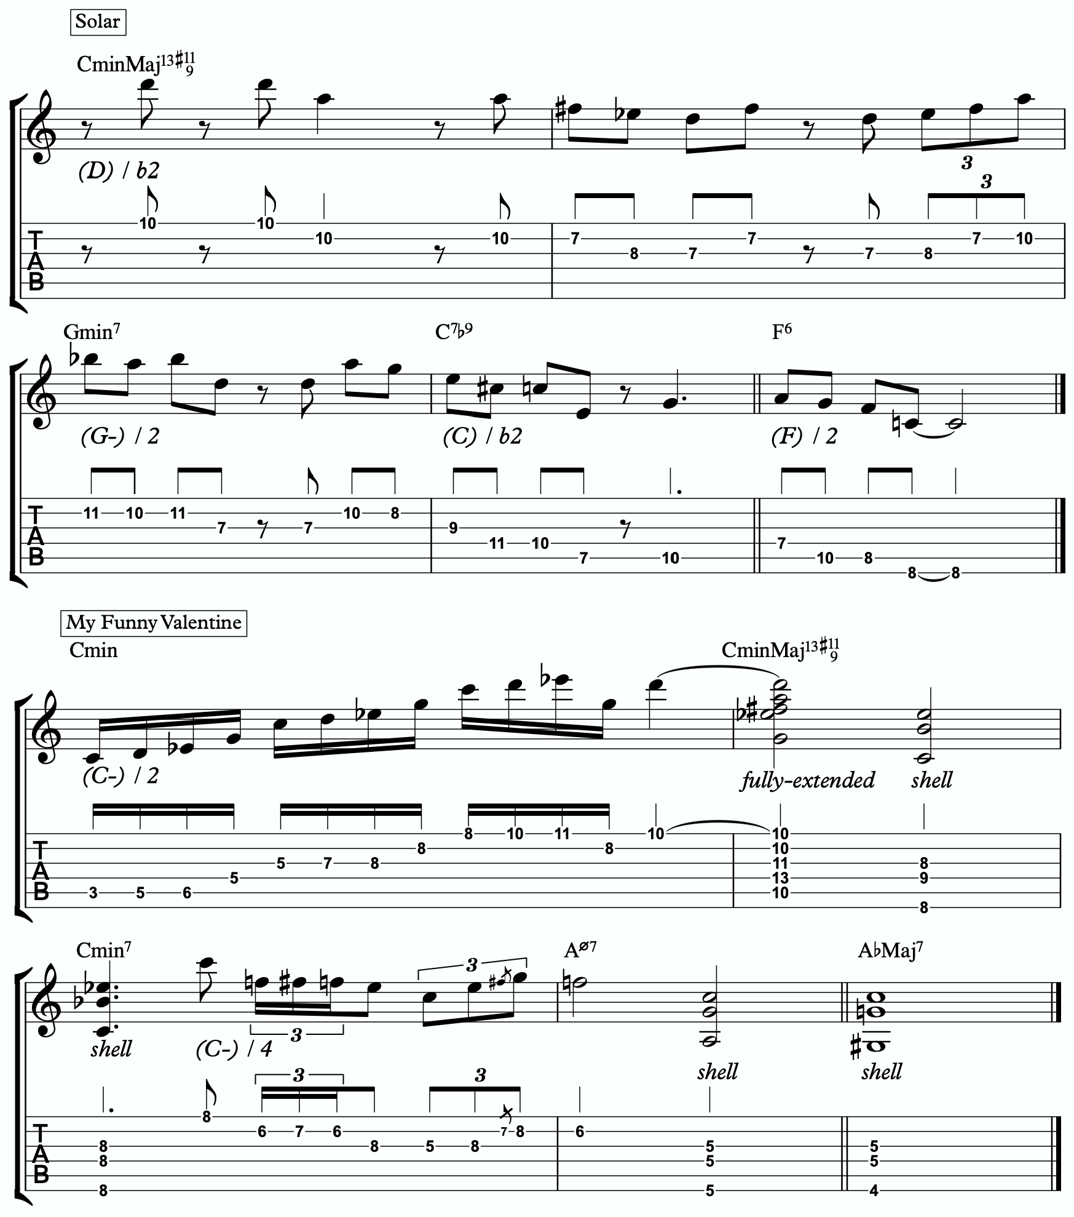
1a

1b

ADVANCING MELODY
This section is going to look at more advanced and complex application of melodic triads to scalar ideas and arpeggios for the creation of bebop and modern jazz vocabulary based on simple structures that we can be playful with rather than memorization of riffs. Don’t be fooled by the idea of these ideas being more advanced or complicated. This doesn’t mean the music you play with these ideas will necessarily be better or more “advanced sounding” then the use of the pure primary quadratonic. In fact, often times I find that the use of the pure quadratonic can carry a level of maturity and intensity into the music that is hard to maintain when using more complicated ideas.
But, I still think it’s worth being aware of how we can build more advanced structures directly from the melodic triad.

Chromaticism Within The Quadratonic
One of the quickest ways to begin developing more complex lines is to incorporate chromaticism and leading tones within the quadratonic. By first learning to master the pure quadratonic, it should make it easier to begin spontaneously connecting individual notes within these structures in a way that will create a sense of improvisational freedom with our bebop and modern jazz playing. Playing this way will allow us to breathe long, flowing, complex lines within very the very basic, simple, steel frames of our buildings.
Here is our primary quadratonic:
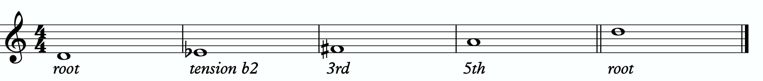

In between any of these notes, we can hang a chromatic line or place a leading tone (a note chromatically below the target) to bring us to the next note. When we use these techniques, we want to make sure that we resolve to a quadratonic note, and ideally we want to play at least two quadratonic notes immediately following the chromatic line to cement our phrase inside the tonality.

Here are an example:
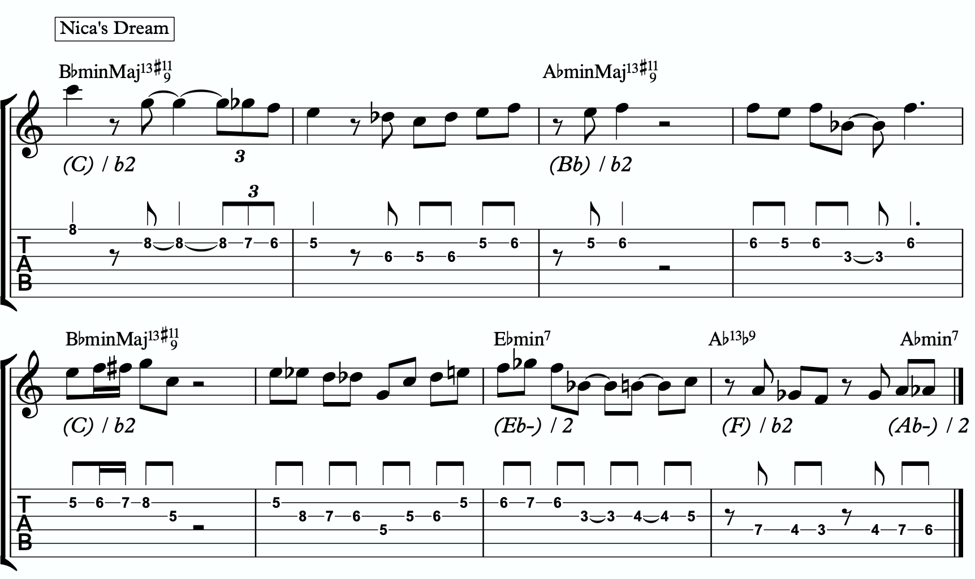
2a

Quadratonic Arpeggios
So far we have only discussed using quadratonics to develop phrases and scalar like ideas. Let’s look at how we can create the sound of arpeggios with them.
We will begin by starting on the primary tension note. After playing this note, we can move to the nearest melodic triad note and sweep quickly through that triad, landing on the tension note an octave away from where we began.
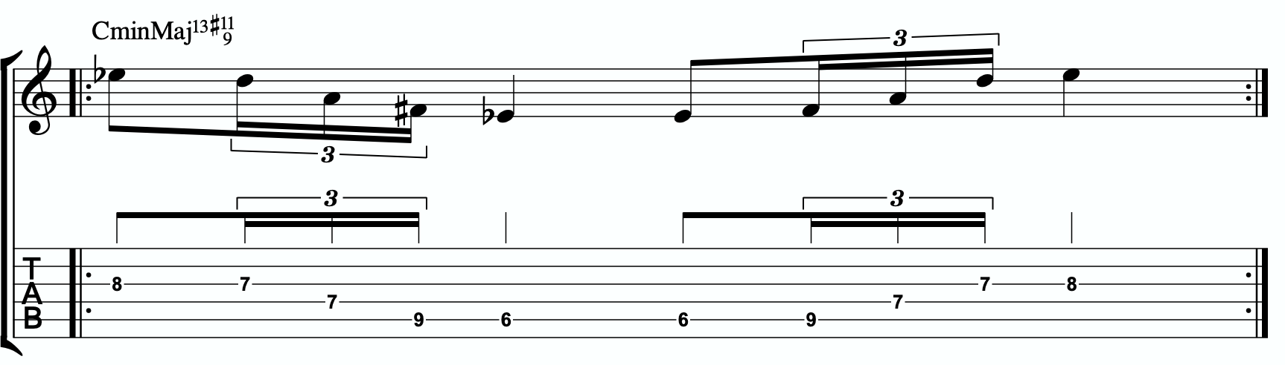
2b

We want to be able to play these ascending and descending starting on any octave of the tension note in any position of the fretboard. If we can incorporate this technique and the chromatic techniques above into our quadratonics then we are giving ourselves resolution notes, tension notes, chromatic runs, leading tones, and quick arpeggio-style runs that we can freely play within during our improvisation while remaining securely inside the color, emotion, and function of any given tonality.

Here is an example of these techniques being used together:
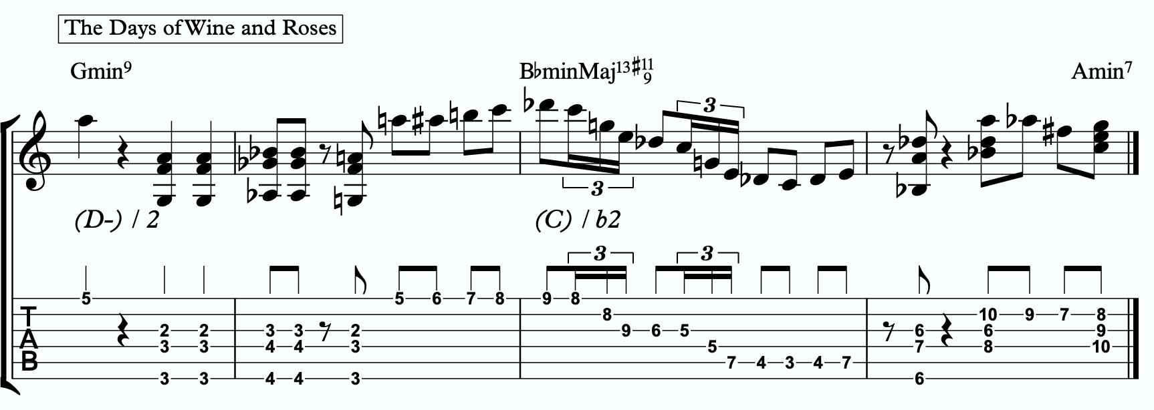
2c

DIGGING DEEPER
The goal of this section is to take small baby steps to evolve the fundamentals of melodic triads in the previous sections into new harmonic and melodic territory. If you are not already comfortable with the shell voicings, the three inversions of the pianistic voicings in all 12 keys, the primary quadratonic, and how to hear and feel the primary tension note against the melodic triad over the sus9, I would hold off and continue working on that.

FOUR NOTE VOICINGS
Let’s begin with harmony. Our first goal should be to minimize down these big, dense, pianistic voicings into something more manageable for the guitar. Four note voicings are ideal for our instrument. But sometimes it can be tough to get those colorful, pianistic type lush chords on the guitar because we just don’t have enough fingers. This is due to what I call bottom-up thinking. We are trained to think R, 3rd, etc etc. From the bottom of the chord moving upwards. By the time we get to the sweet spot notes, we’re out of fingers.
Instead, we’re going to think top-down. Our priority is the melodic triad. With these chords, the very first thing we will think about is the melodic triad. Then we are going to add one note underneath it, much like a slash chord. However, we don’t always use the root note. I usually like to try the 3rd first. For this tonality, the 3rd of CminMaj7 is Eb. Eb is not already present in the D major triad, nor does it clash with it. So our four-note voicings will be based on a D major triad over an Eb bass note.
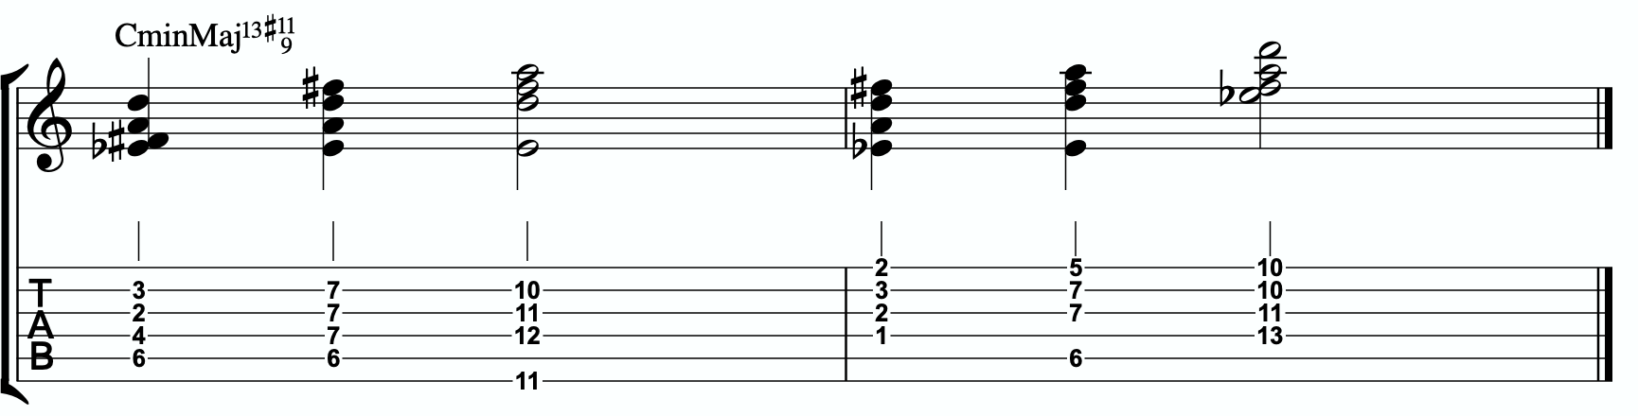
3a

Each of these voicings gives us the b3rd, 9th, #11th, and 13th of our CminMaj13#11(9).

THREE NOTE QUADRATONIC VOICINGS

Three note qudaratonic voicings are an incredible and special tool for us. Unlike traditional drop chords that can be practiced through all inversions, these three note chord inversions offer us some special benefits. First, they highlight the sweet spot notes and get us into the really colorful parts of the chord. Second, by ignoring one of the four notes in each voicing, we’re not simply jumbling up the same four pitches each time we invert. One pitch is always disappearing or appearing as we move through these inversion. It makes for a much more captivating series of inversions as the ear is unconsciously losing and finding pitches at every turn.
We’re going to follow the “drop 2” idea, however not in the traditional sense. When we speak about “drop 2” chords traditionally, we mean that we take the second to the top note and “drop” it down an octave. We’re not going to do that. We’re simply going to remove it from the picture.

4 |  | 4 | 3 |  | 3
3 | > |  | 2 | >
2 |  | 2 | 1 |  | 1
1 |  | 1 | 4 |  | 4

Notice that when this technique is applied, the first series of numbers is different from the second. They both share 1 and 4, but the first series has a 2 and is missing the 3 whereas the second series has the 3 and is missing the 2. If we did this for every inversion of 1 - 4, each one would be slightly different.

If we apply this to our primary quadratonic, we get this series of three note voicings for our chord.
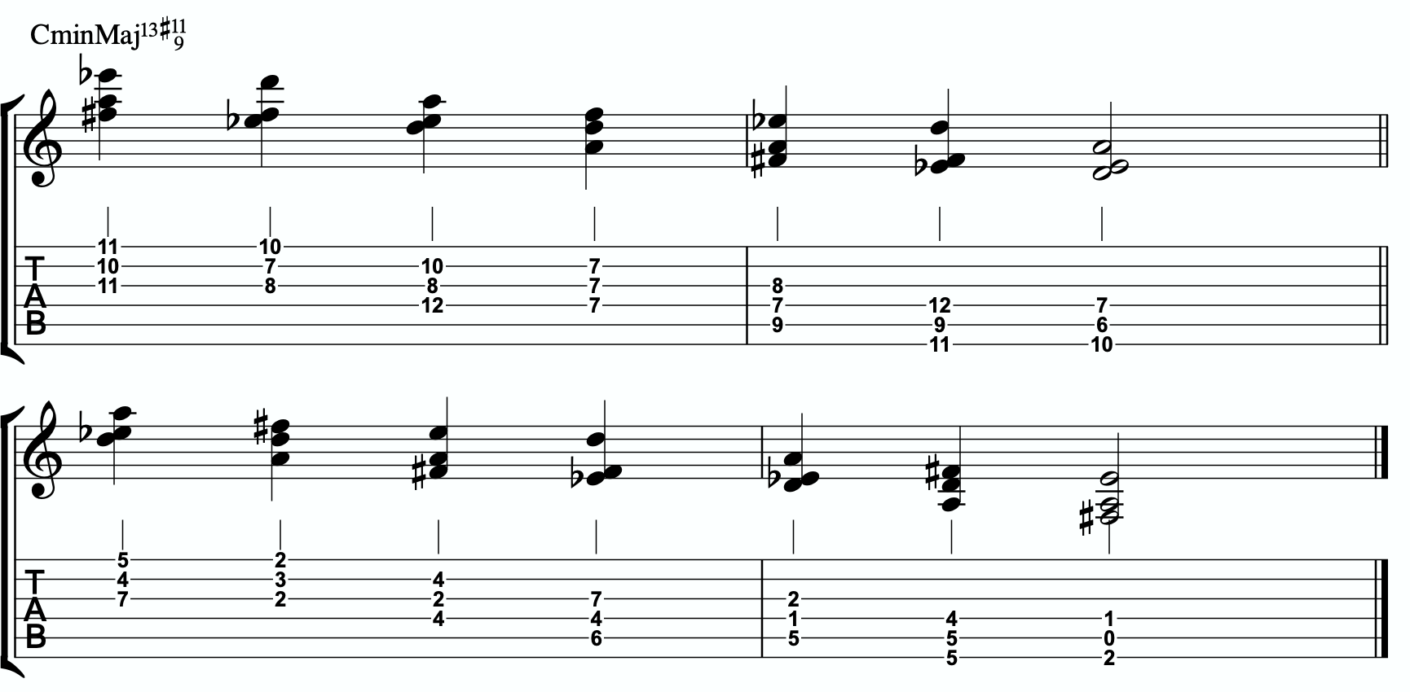
3b

QUADRATONIC SCALAR RUN
Let’s bring it back to single note ideas, melody, and improvisation. The Must Know was all about learning to hear and manipulate melodic tension and resolution using the quadratonic. But we can also use the quadratonic like a scale or an arpeggio. It seems simple because there are only four notes involved… but that’s only one note less than a pentatonic scale. And if you think about it, we only have 12 notes in western music, so if the quadratonic takes up four notes, then that’s actually ONE THIRD of all of the notes in the entire western tonal system. That’s quite a lot.
Let’s start with a scalar type run. Ideally you should already be able to hear and use the tension note and the resolution points of the melodic triad to develop beautiful, clear, authoritative phrasing that works with the harmony, and even implies it, without being stuck outlining it. Not we want to focus on developing the ability to create long, flowing, legato, fluid runs that create the impression of harmony. Traditional scales can sometimes be helpful for this, but they often times have notes that aren’t going to help define the sound of the harmony that’s happening. This quadratonic approach to a run will clear away those less essential notes.

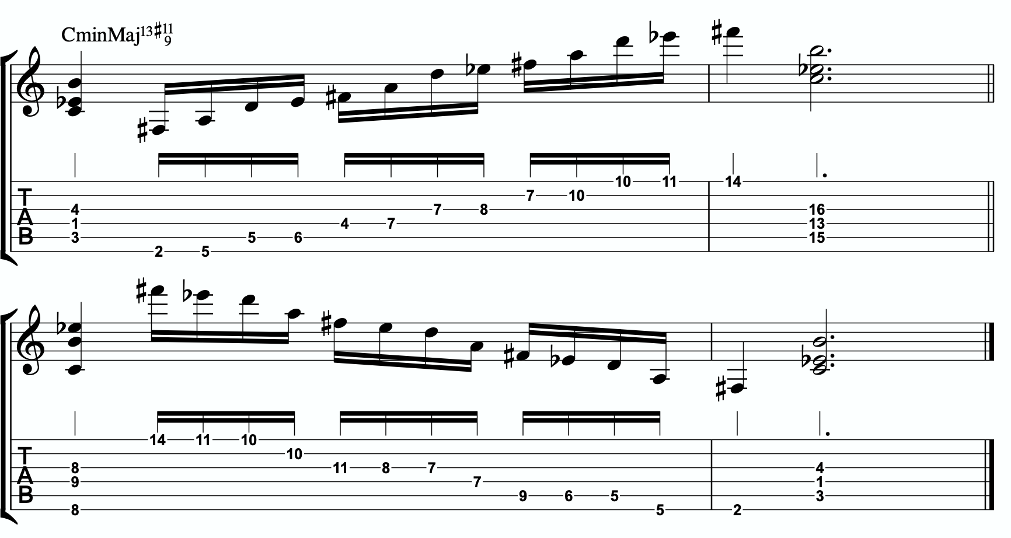
3c

THE SECONDARY TENSION NOTE & PENTATONIC SCALE
Once we can develop authentic phrases with the primary tension note and the quadratonic it gives us, and once we can see it as a scale that we can run through, we can move on and look at the secondary tension note. At this point, I recommend that you put the primary tension note on the back burner and leave it out for a while. Treat this as a whole new tension note. Go back through the ear training process and learn where it is on the fretboard, what it sounds like, how it wants to move, and how to create simple phrases with it.
In order to find the secondary tension note, we go back to Stefon’s formula.

The Hierarchy of Harmonic Importance.
3 - 7 - 5 - 9 - 11 - 13 - R
- Since we started by adding the 3rd, is the 7th of CMaj7#11#9 in the B major triad?
No. The 7th is B, and that’s not in our D triad.

So our secondary tension note is B.

B is the 5th of CminMaj13#11(9), but it will be heard against the melodic triad which is D major. B is the 6 of D major, so that means our secondary quadratonic is D major tension 6 and it gives us this tonality’s melodic triads pentatonic scale.

/ b2,6
D

Here is an example of this pentatonic scale in use:
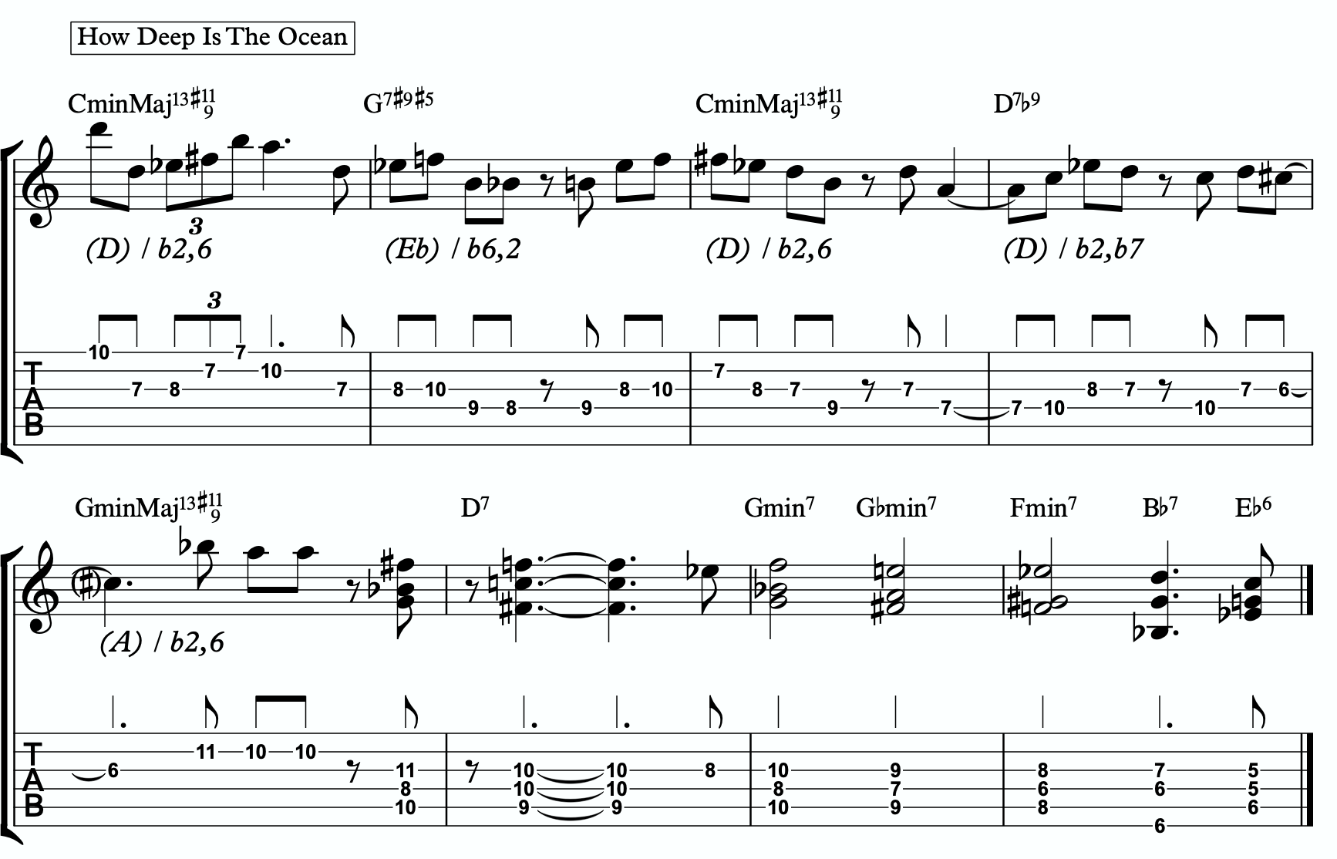
3d

THE MELODIC TRIAD BEBOP SCALE
Hopefully by now you’re starting to see the way melodic triads can offer a very direct path through all the traps of scale running, noodling, and outlining chords progression using 1 - 3 - 5 - 7 chord tones and arpeggios. All of these can be great devices (maybe not noodling), but have dangers to them.
The melodic triads approach helps us start with the sweet spot notes, and build our harmony and melodic from there. Before you start working on the melodic triad bebop scale or anything beyond this point, I strongly encourage you to make sure that you’re not simply reading these ideas like a theory book to be memorized. These are meant to infiltrate your ears, map the fretboard, and apply directly to musical situations in tunes. If you’re been studying and applying the melodic triads approach for enough time that you’re getting comfortable with it, we can take the next step. It’s only one extra note… but it’s a game changer.
In order to understand what the melodic triad bebop scale is, you need to understand what a traditional bebop scale is and the purpose for why it’s built the way it is. The standard diatonic scale is made of seven notes. The problem with playing a seven note scale is that it’s made of an odd number of pitches, so if you’re playing in 8th notes in 4/4 time, it’s going to flip itself around and start to place weak sounding notes on strong beats and strong sounding notes on weak beats.

C major scale

In music, we have strong beats and weak beats. We can see these pretty easily by looking at the beamed groups of 8th notes. There are always two of them. The first one, on the left of each group, is the strong down beat, and the second one, on the right of each grouping, is the weak up beat. We count them:

1 - & - 2 - & - 3 - & - 4 - &

That makes up one full measure of 8th notes in 4/4. The strong beats are on the number, and the weak beats are on the & (the “and”). If we look at the C major scale above, we see that it starts on the C note (very important) on a down beat. Then the next down beat, beat 2, has the E note. That’s the 3rd of CMaj… so we’re doing good. The 3rd down beat has the G note… still good. But the 4th down beat has the 7th of the scale, and then the C root note happens on the & of 4. And that puts the D note, the 2nd of the scale, on the down beat of the following measure. The following few down beats all have weak notes on them, putting the strong CMaj “chord tones” on the weaker up beats. It finally loops back around and lands on the C note on beat 4.
The traditional bebop scales took care of this problem by adding one single note. This evens it out to an eight note scale and lines up the pitches of the scale with the beats in the measure.

Some players would call this a bebop scale, or if you’re familiar with the Barry Harris method, you might call this the 6 diminished scale. Regardless, what’s important is that if you look at the strong beats, the notes spell out C - E - G - A. That’s a C6 chord. It gives

us a perfect combination of melody (the scale - with tension and resolution points), harmony (the C6 chord - the resolution points), and rhythm (the timing of getting all of the important notes to fall on the strong beats). It’s a beautiful, perfect, and very helpful scale to know.
I still rarely if ever think about, practice, or use it. Doesn’t mean you shouldn’t. But hopefully by now you’re starting to see just how powerful triads are. This scale is built around four note chords like C6 or C7, not three note triads.
But there’s a way to combine the two concepts. The pure simplicity and strength of the triad, with the rhythmic perfection of the bebop scale concept.
We simply add one single passing note between every triad note.
Here’s one octave of a D major triad. Our melodic triad for CminMaj13#11(9).
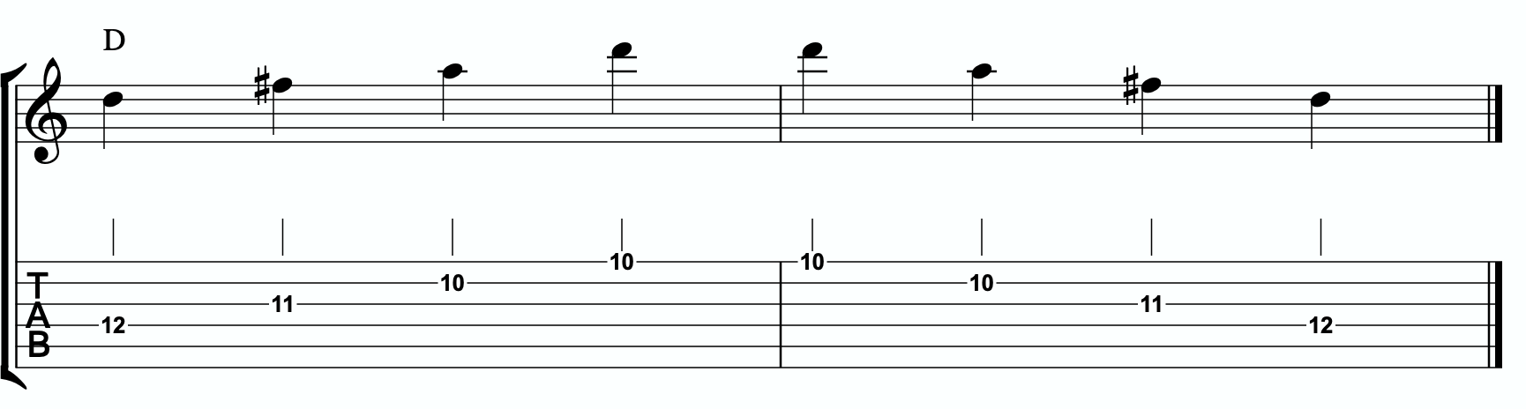

Now we’re going to insert one passing note between each triad note. The key is to pick the passing note that best respects and defines the CminMaj13#11(9).
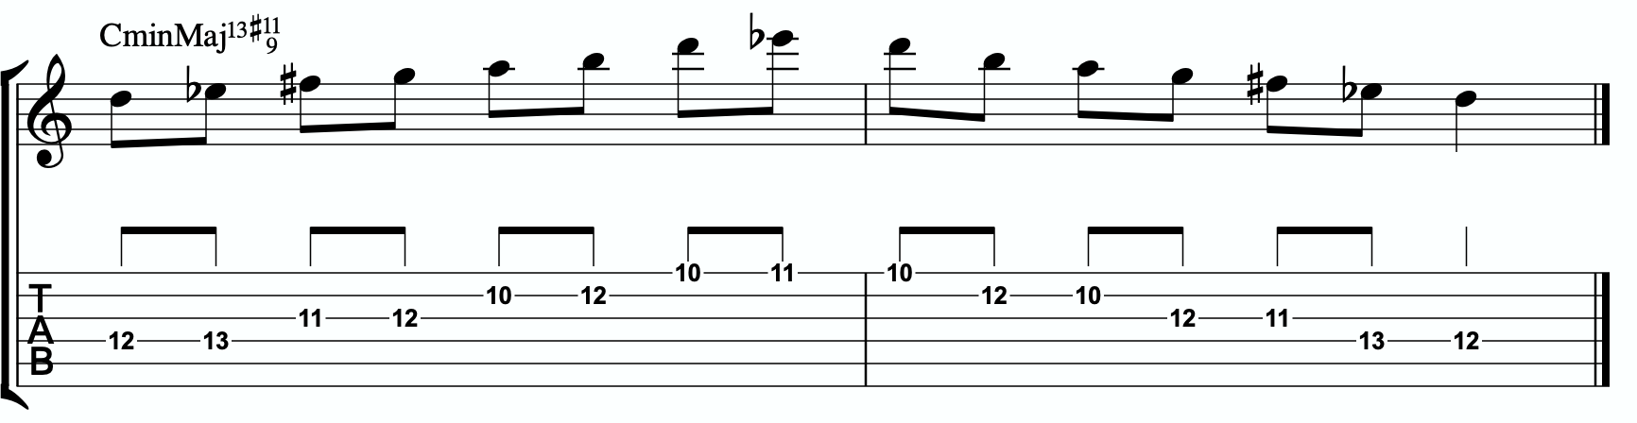

This is our melodic triad bebop scale. It’s a six note scale that helps us outline the tonality we’re working with by stabilizing the notes of our melodic triad.
Notice that it’s just a D major triad with passing notes. If we look at those passing notes in relationship to the D major triad, we get tension b2, tension 4, and tension 6. Two of the three tension notes are straight from our primary and secondary quadratonics. No, that’s not a coincidence. That’s due to the perfect nature of how triads function when we dig through harmony and melody with them. So we’re simply adding a third tension note. In this case, it’s tension 4. You could use that as a quadratonic - D tension 4 over a CminMaj7 chord. The melodic triad bebop scale gives us a rhythmically aligned “scale” but it also gives us three tension notes, each with their own unique emotional quality to them, that we can take advantage of if we don’t want to get stuck running scales and want to return to a focus on melodic tension and resolution and lyrical phrases.

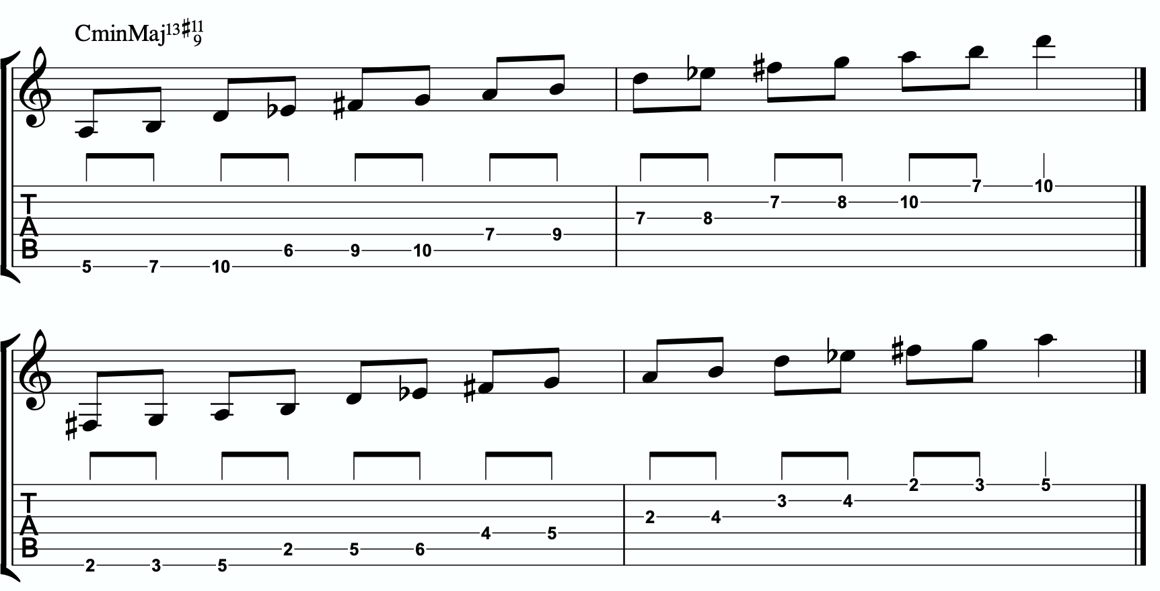
4a

Here is the same scale but harmonizing all of the melodic triad notes with our three note
quadratonic voicings:

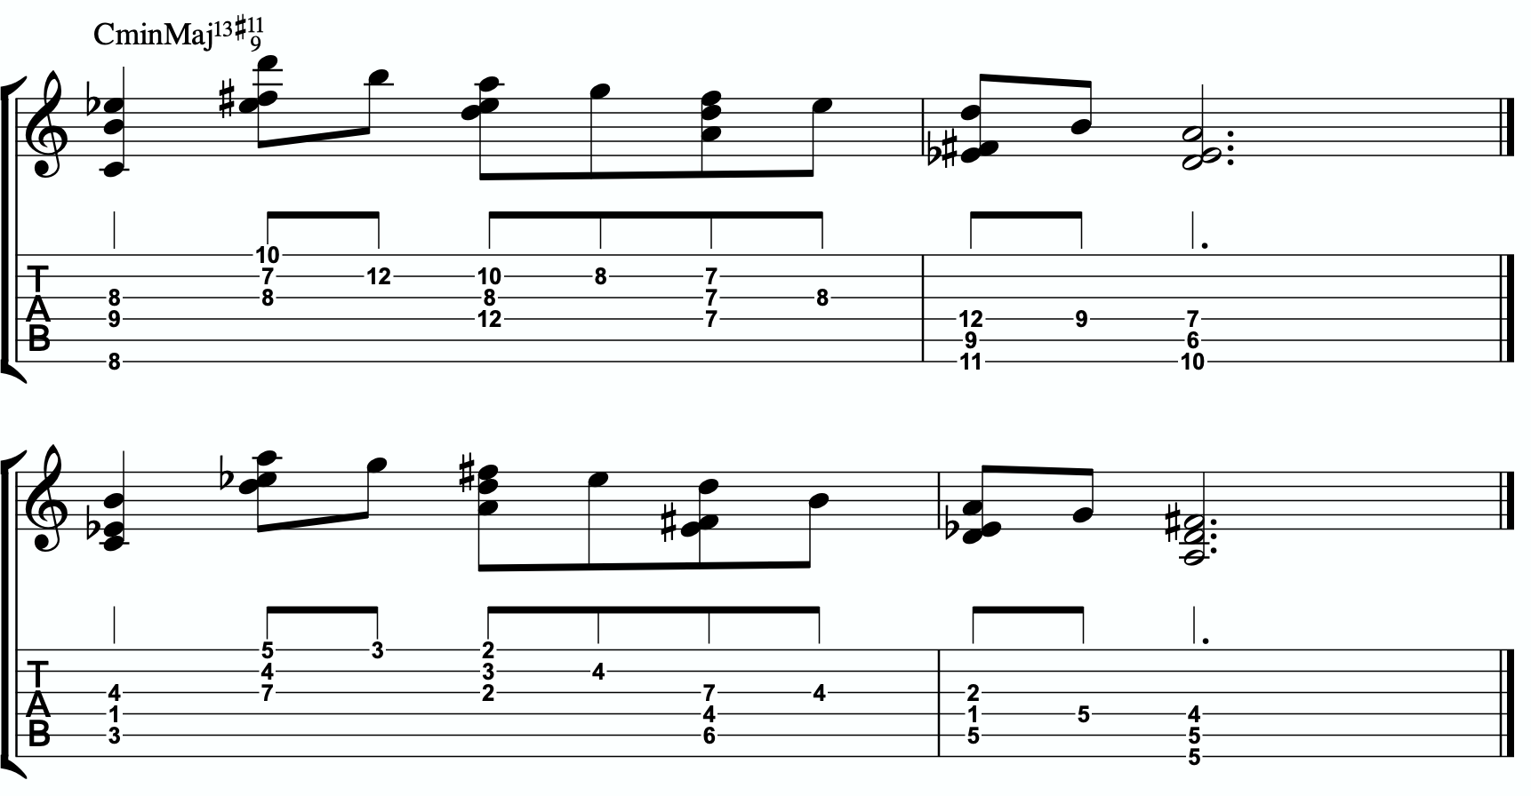
4b

ADVANCING HARMONY
We are getting into more and more advanced material now. Please remember that you do NOT need any of these continued lessons and concepts to play music. It is significantly more important that you develop your ability to be authentic, spontaneous, and playful with the material in The Must Know and then, if you feel comfortable, in Digging Deeper. Each section is building on the last, so if you’re struggling, it’s simply a check engine light to return back to earlier sections.
That said, we’re still far from a complete exploration of the depth of this one little triad.
This section we will explore some more advanced harmonic ideas. You may have heard me talk about liquid harmony. This is a way of visualizing the creation of harmony that involves movement. Think of a chord voicing like a block of ice. It’s frozen in time. We play it, we move to another chord, we move to another chord. Most of us learned to play harmony this way with a focus on shell voicings and drop chords. Liquid harmony is the idea of taking those blocks of ice and melting them down into a little. Not necessarily completely. But we want at least some of the ice to return to water so that it can flow and move. It helps free us up to transcend more static voicings, even cool sounding ones, and creates a more pianistic, movement-oriented sound. Not simply movement from one chord to another, though that’s important as well. But movement inside of a single chord. That’s what this section will explore.

HARMONIC QUADRATONICS
This is possibly the simplest, most effective, and most fun ways to create liquid harmony. The idea is that we play the primary quadratonic, but instead of thinking of it as a scale that we play with single notes, we play it as a chord. We will play three notes of the quadratonic. The tension note will be part of the chord, and it will replace the nearest melodic triad note. So the chord will be made up of two melodic triad notes and the melodic tension note. Then, while holding the two melodic triad notes and allowing them to continue ringing, we will resolve the tension note back into the triad. If we’re playing solo guitar or accompanying another musician, we may want to play the root note of the chord (“left hand”) or even the whole shell voicing. However in a full ensemble with a bass player, or if we’re playing solo and simply want a more impressionist style sound, we can leave that out and play these ideas as rootless “chords”.

Here is an example:
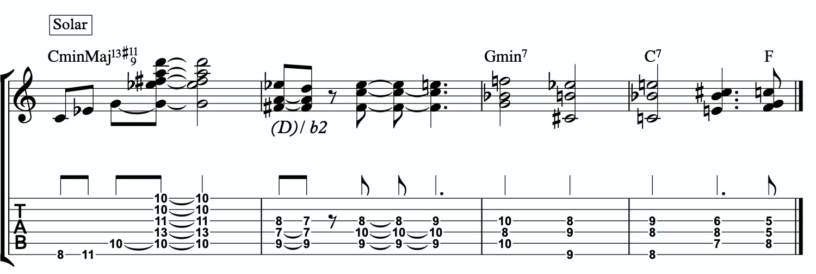
5a

Quadratonic Dyads
This is a similar concept to our quadratonic 3-note voicings, except now we’re creating 2 note grouping by pairing together every other note.

So if our quadratonic is made of D - Eb - F# - A, we will group the D and the F# together and the Eb and A together. And we will get this:
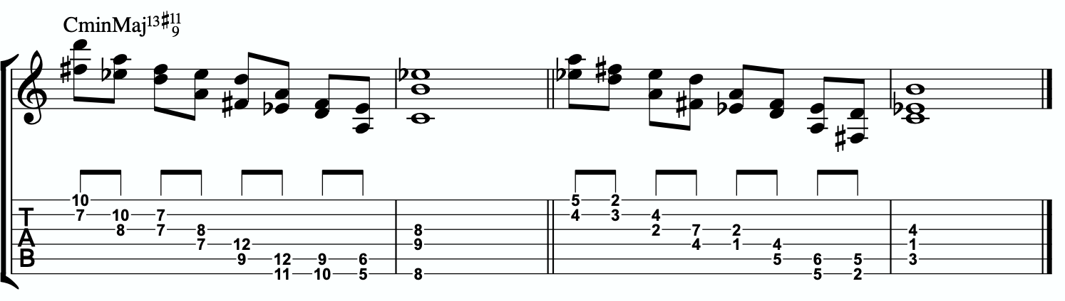
5b

TRIAD PAIRS
Sticking with our melodic triad bebop scale, we actually have our melodic triad version of triad pairs hiding right there in plain site. We know that all the resolution points are the notes of our melodic triad. But if we look at all of the passing tension notes we added, we actually have a second triad. This scale is two triads together. We have our melodic, or our “resolution” triad, and then we have our tension triad.
For this tonality, our triad pair is D and G+.

/ G+
D

We can of course arpeggiate these triads out to create single note ideas, but this section is specifically about harmony. So let’s look at a harmonic application for our tonality inside a chord progression.

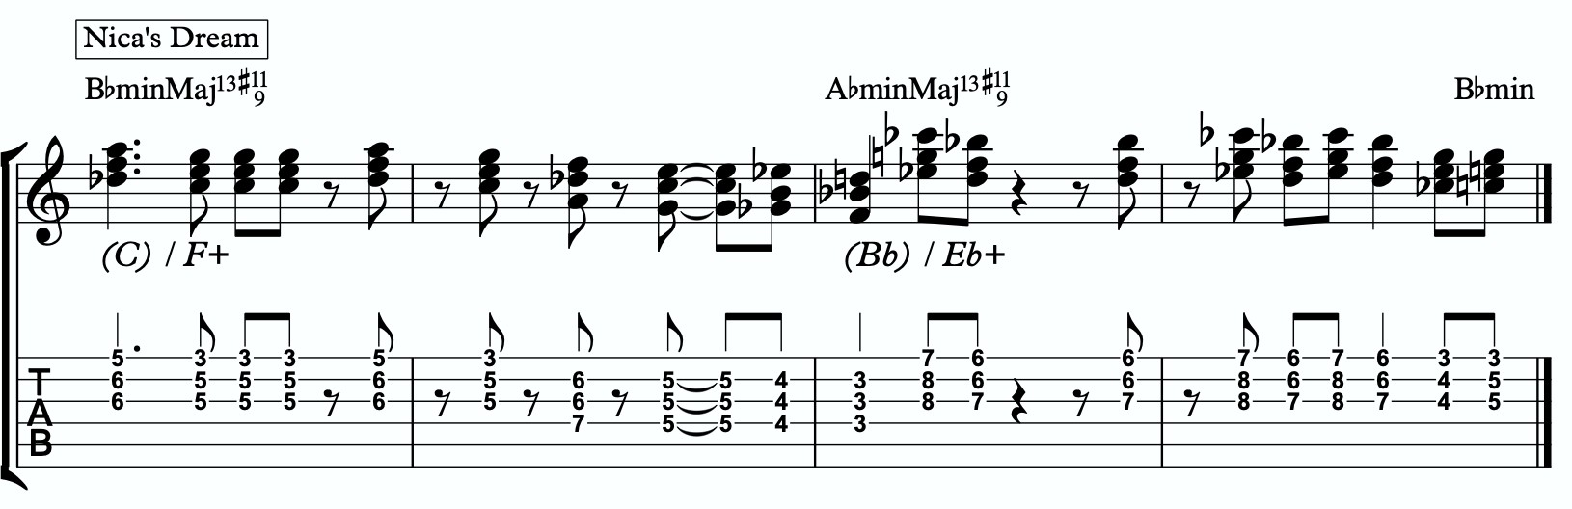
5c

Here is a dyad application, where we leave out one note from each triad.
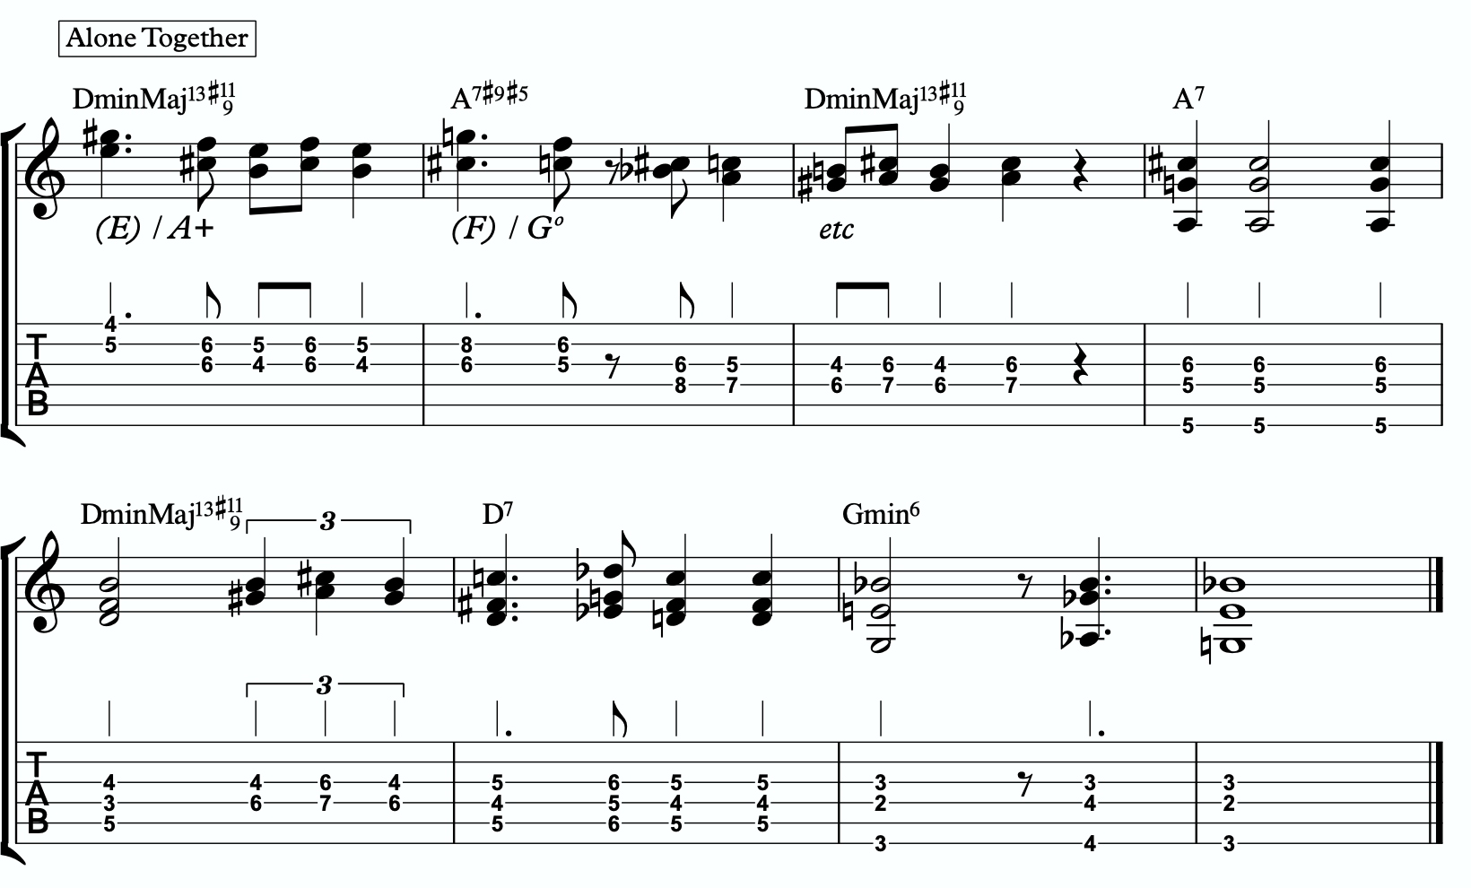
5d

TENSION LAYERS
Everything up until this section has been based on the idea that the melodic triad is the strongest organization for resolution, color, harmony, and melody. We leave the triad temporarily with different techniques to create tension, harmonically and melodically, but always in service to bring us back to rest in the resolved nature of the melodic triad.
In this section, we’re going to talk about the idea of thinking of tension as existing in layers. This way, we have different levels of tension that we can move in and out of - like rungs on a ladder that we can climb up, climb down, or simply pick one and stand still on it to enjoy the view.

LAYER ONE
This one is easy. Layer one is the primary quadratonic. The melodic triad is the most stable set of notes we have for our tonality. The primary tension note offers us a very respectful tension note to create melody. There is tension inside this quadratonic, but it’s accessible and always brings us right back into resolution. We must be comfortable making music with this sound before we can continue.

/ b2
D

LAYER TWO
But what if we want to move up a rung on the ladder? We know from the melodic triads bebop scale that our triad pair for this tonality is B major and C. So far, we have only thought of the C as a tension triad that can be used to bounce back and forth with B. But what if we momentarily “modulated” into the C triad to create a new rung on our ladder? Like modulating in a tune between the relative major and minor of a key, the key doesn’t actually change, but we can momentarily alter the color and the emotion.
By switching over to thinking of our tension triad, we can add a tension note to the triad and create a tension quadratonic.

The tension quadratonic, when mixed with the primary quadratonic will allow us the ability to navigate seven diatonic notes melodically and harmonically in a structured and authoritative way that will imply the harmony, give multiple colors and layers of tension, and allow for six different resolution points within any tonality. That’s half of all of our available pitches.

How do we chose the primary tension note for our new tension quadratonic?

We go back to the hierarchy of harmonic importance. What’s the next chord tone from the hoh? We can account for the b3rd, 5th, 7th, 9th, #11th, and the 13th. But we haven’t yet used the root. So that’s going to be the tension note for our tension quadratonic.
The root of CminMaj7 is C. If we add a C note against our tension triad, G augmented, we get this four note structure - G, B, C, Eb. That’s a G augmented triad with a tension 4. You might also notice that it spells out a CminMaj7 chord. For the sake of melodic tension and resolution, I would recommend you think of it as a (G+)/4 though. But it’s worth noting that our tension quadratonic is the 1-b3-5-7 of our basic harmony. That’s pretty wild!

/ 4
G+
This quadratonic will sound less “in” than the primary quadratonic, however the tension note in it will give it a sensation of tension and resolution within itself.

Here is example of this quadratonic pair being used harmonically:
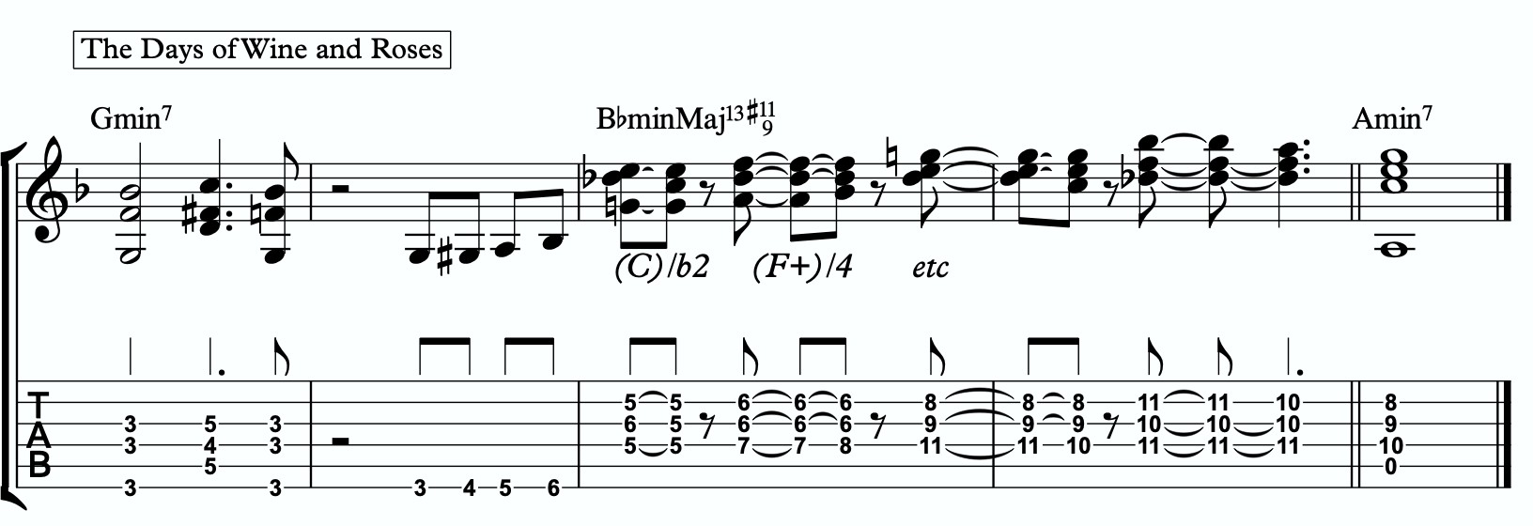
6a

Harmonizing Our Bebop Scale With Tension Layers

Let’s look at our six note melodic triad bebop scale and harmonize it using our quadratonic pairs. We will do this using two different techniques brought up earlier in this study booklet. First, we will move through the bebop scale using our harmonic quadratonics to create liquid harmony within each voicing as we move between the two quadratonics to harmonize each note. Finally, we will apply the three note quadratonic voicing to the bebop scale.

Harmonic Quadratonics & Liquid Harmony
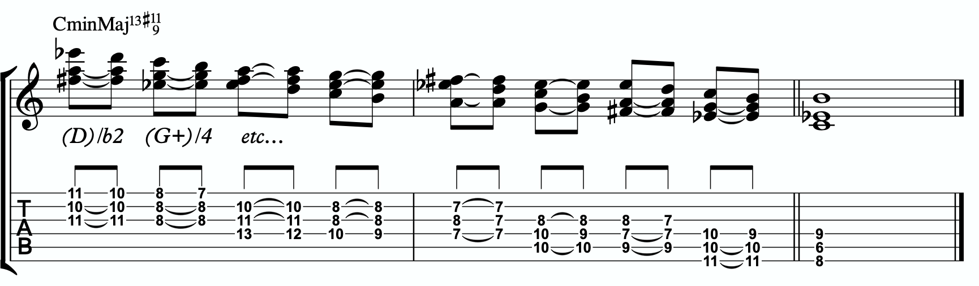
6b

Three Note Quadratonic Voicings
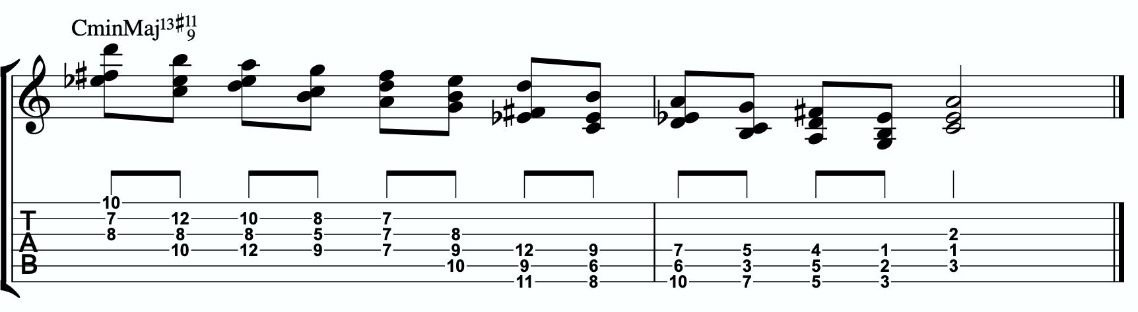
6c

THE OUTRO
I just want to personally thank you for working through these ideas. I am obsessed with exploring, mapping out, and demystifying jazz harmony and melody, and attempting to understand it and execute it using the simplest and most fundamental ingredients in music. I’ve found over many years of playing and study, and learning from some of the greatest minds in the jazz world today, that it’s often times our ego and our own self- inflicted limitations that hold us back the most from growing and evolving towards our potential.
The most dangerous words to development of our musicianship are, “I already know that.”
Most of us generally spend a couple of music theory classes learning our triads. Maybe we read a book about advanced triad application and get some cool intellectual ideas to play with. But for me, it’s all about that Bill Evans quote.
**********************************

The whole process of learning the facility of being able to play jazz is to take these problems from the outer level in, one by one, and to stay with it at a very intense, conscious-concentration level until that process becomes secondary and subconscious. Now, when that becomes subconscious, then you can begin concentrating on that next problem, which will allow you to do a little bit more.

I don’t consider myself as talented as many people but in some ways that was an advantage because I didn’t have a great facility immediately so I had to be more analytical and in a way — that forced me to build something.
Most people just don’t realize the immensity of the problem and, either because they can’t conquer it immediately, think that they haven’t got the ability, or they’re so impatient to conquer it that they never do see it through. If you do understand the problem then you can enjoy your whole trip through.

People tend to approximate the product rather than attacking it in a realistic, true way at any elementary level — regardless of how elementary — but it must be entirely true and entirely real and entirely accurate. They would rather approximate the entire problem than to take a small part of it and be real and true about it. To approximate the whole thing in a vague way gives you a feeling that you’ve more or less touched the thing, but in this way you just lead yourself toward confusion and ultimately you’re going to get so confused that you’ll never find your way out.

It is true of any subject that the person that succeeds in anything has the realistic viewpoint at the beginning and [knows] that the problem is large and that he has to take it a step at a time and that he has to enjoy the step-by-step learning procedure. They’re trying to do a thing in a way that is so general [that] they can’t possibly build on that. If they build on that, they’re building on top of confusion and vagueness and they can’t possibly progress. If you try to approximate something that is very advanced and don’t know what you’re doing, you can’t advance.

**********************************

Was Bill referring to melodic triads? I very highly doubt that. I’ve never heard him talk much about triads. But consider the underlying philosophy he’s pointing at. Know the

basics. Regardless of how elementary! But it must be entirely true, real, and accurate. Be able to play genuine, authentic music using the most fundamental ideas first. Then it leaves room to grow.
This is why I refer to the first section in this ebook as The Must Know. It’s a basic shell voicing, and a basic triad. And while these two concepts are as simple as they come in music, we must understand them in a true, real, and accurate way. If we did this for a handful of tonalities, we could play beautiful music for the rest of our lives, and for me, I would feel fulfilled. It would offer emotion-driven, precise, human, lyrical melody combined with lush, colorful, pianistic harmony. Mix in a strong sense of time and feel, and that’s everything a jazz musician needs.
But like Bill talks about, when we don’t try to approximate but instead start with the elementary ideas and build a foundation with them, then it gives us room for growth. Look at everything we worked through together in this ebook! All built from one triad and how it relates to one chord (piano diagram!). As of the time of putting this together, I’m still working on many of these ideas myself… and I’m still coming up with new ways of building harmony and melody around the melodic triad.
This is why I can’t recommend enough, even to the intermediate and advanced players out there - spend some serious time in The Must Know section. Own it. Be able to play authentic ideas with it. Apply it to tunes. Move it through the circle of 5ths. Do whatever you can to internalize it and develop your ears to it. Then you can begin moving on. I would encourage everyone… peak ahead if you would like to to keep an eye on where this particular path is heading, but be very self-aware and learn to see when you’re getting in over your head. When this happens, not if, just take a deep breath and back up a few sections. It simply means your foundation isn’t quite strong enough yet to carry the weight of those more complex ideas. If you want it, and you put the time and effort it, you’ll get there.
Like one of my students always likes to tell himself at the end of our lessons…..
“Easy does it. But do it.”

Thank you again. Don’t forget to come and hang in our open office hours to ask questions if you’re confused on anything.
Happy Practicing!
-Jordan Klemons

The Melodic Triads Study Group

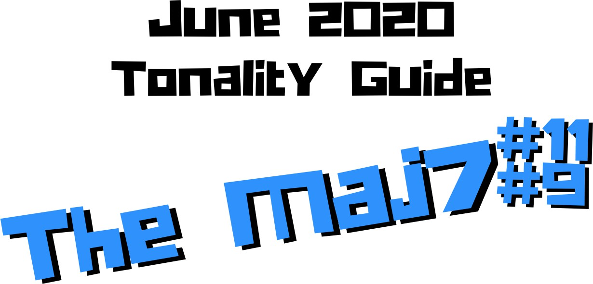

Jordan Klemons
NYC Jazz Guitar Masterclasses

CONTENTS
-INTRODUCTION
-THE MUST KNOW-
-ADVANCING MELODY-
-DIGGING DEEPER-
-THE MELODIC TRIAD BEBOP SCALE-
-ADVANCING HARMONY-
-TENSION LAYERS-
-OUTRO-

This ebook is the copyrighted property of Jordan Klemons. All images, information, layout, and designs belong to Jordan Klemons. This document may not be altered, reproduced, distributed, or transmitted in any form or by any means without the prior written permission of the author.

INTRODUCTION
Thank you for downloading the pdf materials for this month’s melodic triads tonality study guide. Inside you will find all of the supplemental theory, notation, tab, charts, concepts, and examples for the accompanying videos to help you develop your understanding, your ear, your emotional connection with, and your sense of harmonic and melodic freedom within this month’s tonality… as well as its use in some short, common, jazz chord progressions that you will be able to immediately implement in your own playing.
The information in this guide is . I mean that literally. When the process is respected, and you understand how all of these ideas fit into the puzzle, this guide and the baby steps included can offer tremendous insight into how to begin making real music very quickly, and how to continue evolving and growing as a player for many years to come. However, if approached in the wrong way and the process is not respected, these ideas can confuse and derail a musician’s ability to progress. It’s important not to jump too far ahead of yourself. The advice that a Miles, or a Scofield, or a Coltrane would give to a beginner is different than what they would give an intermediate or to an advanced player. And all of that would be different than how they would talk to a professional who’s already playing on their level. This is important to remember.
This guide is meant to show many different layers of musical growth and how, when using the melodic triad approach, they can all be boiled down and viewed simply as an extension of the most basic elements of music. Namely… a triad. Think of the pages that follow as an architect’s blue prints for a skyscraper. If you haven’t built a strong foundation, your skyscraper will fall. If you attempt to skip the first 50 stories and jump to building the penthouse, the skyscraper will fall. If you try to put up the fancy exterior of the building before you complete the steel frame, the skyscraper will fall. Yes, the information all the way at the end of this guide is constructed using the same ideas and concepts that are presented in the first chapter, but the process must be respected for anything to work. Otherwise it will only leave you confused, frustrated, feeling like a failure, and wanting to give up. Be patient with yourself. The short cut the long road. Take it. Spend two or three months working on the long road and watch how much you progress. Focus on your sound, on your ear, and on your musicianship… and trust that the simplicity of the ideas and the process itself will take care of you. They will. But only if you respect them. It’s like a relationship - you have to be present and give of yourself, and then you will receive in abundance.

As you work through these pages, try to keep in mind this Bill Evans’ quote from The Universal Mind.

**********************************

I’ve setup the material in these tonality lessons to start with the most basic and fundamental elements of music, and to grow outwards in complexity. Everything builds on what came before it, so everything is connected. You need to master everything in these lessons to play music. You only really need the first section and a little bit of creativity and concern for your sound - that’s enough to create something beautiful..
I recommend that if you’re new with us, even if you’re already an advanced player, you begin focused entirely on the first section of this guide, The Must Know, and give yourself a minimum of 3 - 6 months to get used to this method and the initial concepts presented. It’s a very different approach to standard theory, and your goal should be (as Bill Evans said) to be able to make genuine, authentic music with the ideas in the first section. Once you feel you can hear and play music using these ideas on a small handful of tonalities and applied to some tunes, it is time to start advancing forward.

I would continue giving yourself an addition 3 - 6 months for each subsequent section, as each builds on the last and becomes more and more advanced… starting from the most basic and simple ingredients, and eventually working our way up to learning to hear and use all 12 notes of the western chromatic scale harmonically and melodically over any
c3hbord in a musical way.
I strongly recommend that you follow this rough timeline. I believe it’s the most effective way to cut through the learning process and get straight to making beautiful music, and then to set yourself on the path to continue growing and building for years to come.
The melodic triad ideas I’m working on today, I didn’t even know they existed during the first few years of my own studies. As we grow and progress and get comfortable, we can naturally start to evolve the ideas into more advanced applications. That’s the beauty of starting with the fundamentals, learning to make genuine, authenticate music from our own self first… and then building layers of complexity on top of, but always connected to, those very fundamentals. Much like a large skyscraper building starts with a huge hole in the earth, then is filled with concrete and steel, and then the steel frame will hold the building as it goes up. We won’t see any of these structures. But without them, the building would collapse. Only once the structure is there can the work of putting up the exterior, the glass, the interior, the design, the furniture, etc. take place.
Thank you again for downloading this study guide and working on your music with us. I look forward to hearing your playing and your contributions to the melodic triad conversation inside our facebook group, and for those of you subscribed to our Private Community, inside our melodic triad mastermind group.
Happy Practicing!
Your friend on the path towards jazz guitar mastery,
-Jordan Klemons

The Melodic Triad Study Group - a part of

Text

THE MUST KNOW
The theory, ideas, voicings, and “scalar” ideas presented in this section may seem too simple and elementary to be of value. But I urge you, even the intermediate and advanced players - do not skip this section. I recommend that if you’re within the first 3 - 12 months of study with us that you focus entirely on learning to apply these ideas to musical situations. You can skim the rest of the pages if you’d like, but this should be where you build from. After close to 25 years of playing music seriously, I still spent my first year of working on melodic triads only on this material. The great thing about these ideas is that not only can you comp, improvise, compose, and arrange beautiful music over standards, bebop, modern jazz, and original works with them, but they also act as the foundation on top of which we can grow into more and more complex ideas without ever leaving behind these basic building blocks of harmony and melody.
Do not simply see these as intellectual theory ideas. These are meant to be internalized. To understand the theory is great. To hear the sounds in your ear with a sense of familiarity is just as important. To connect with them personally and be able to hear and express emotion through them is of the utmost importance when it comes to developing our musicianship. This should be the goal.

THEORY
The Maj7#11#9 is a dark, intense, evil sounding tonality. It’s like your being stalked by someone that wishes to do you harm. It leaves a sense of fear and uncertainty… even mystery. Using it takes a lot of care and ear development. It can generally be use when we see a tradition Maj7#11 chord, as it’s only one note different. However, it creates a very modern and out sound, so you have to be careful when applying it in ensemble playing. It can definitely clash. It also works great as a resolution to a major chord… like CMaj7#11#9 can resolve to C6 or CMaj7. And it can also function to simply replace the Maj7 chord. This is a very intense way to resolve a ii V I, but it is possible. It’s also possible to remove the ii and the V chords and simply use this as a Maj7 chord in a more modal or non-functional way.

What makes up a CMaj7#11#9 tonality?
Two basic ingredients.
- A basic CMaj7 chord
- A B major triad
A good way to think of this is to visualize a piano player with two hands. Their left hand would be playing C-E-B (a basic CMaj7 shell voicing) and their right hand would be playing a B major triad.

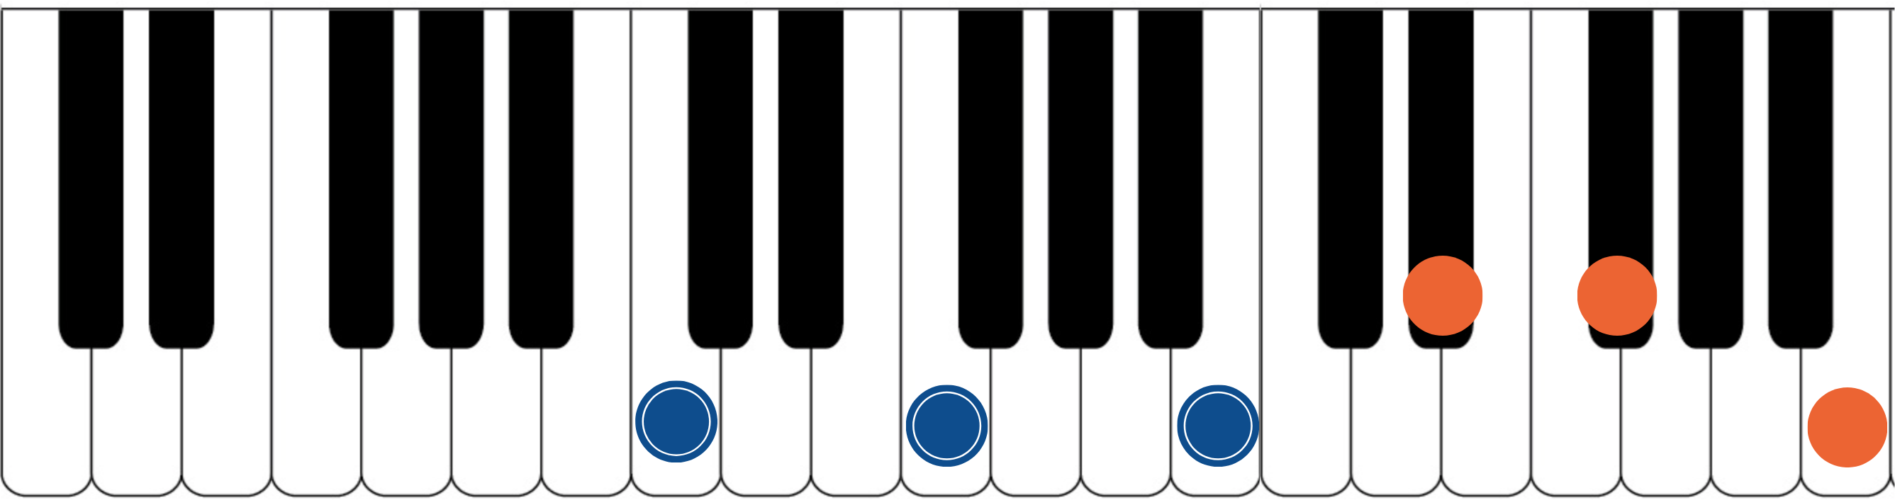

The blue dots would represent the fingers of the piano player’s left hand. Notice they spell out C, E, and B. That’s the 1, 3, and 7 of a basic CMaj7 chord. The orange dots represent the piano player’s right hand. They spell out D#, F#, and B. That’s an inverted B major triad. If you have access to a piano or keyboard, I strongly encourage you sit down and play these seven notes simultaneously. Listen to how big of a sound they create together. Play it a few times. Try and feel the emotion and the color they create together. Then remind yourself of the elementary and simple nature of what’s happening in each of your two hands separately. A basic chord in your left hand. A basic triad in your right
h6aand. The magic happens when we use these sounds together… and when we begin to build chord voicings and melodic ideas around these two simple sounds.

***This B major triad, which is now our melodic triad, is built on the 7th of CMaj7… ‘B’ is 7th up from ‘C’. This relationship is critical to understand and memorize as it will allow us to transpose this sus9 tonality into any key quickly. We will notate this as ‘T7’. This notation comes from Stefon Harris. The ’T’ is short for ‘triad’ and we make it upper case to notate that it’s a major triad. The 7 tells us that the melodic triad is

built on the 7h of the harmony. So if we want a GMaj7#11#9, we think T7, we find the 7th of G (which is F#), and we know that the melodic triad is F# major.***
This pianistic chord construction is the starting point for everything we are going to look at together. Hidden inside of this seven-note chord is a universe of potential harmonic and melodic ideas. The following pages can all be traced back to this construction idea. Basic chord, basic triad. Left hand, right hand. Harmonic structure, melodic structure. Hence the term… melodic triad. Even if you don’t have access to a piano, I encourage you to sit and think about this diagram until it makes sense to you.

GETTING THE PIANISTIC VOICINGS ONTO THE GUITAR
Taking the concept of the piano construction, where the CMaj7 chord is always underneath the B major triad, we can develop three basic inversions of this chord by inverting the B triad and keeping the CMaj7 chord underneath it as much as possible.
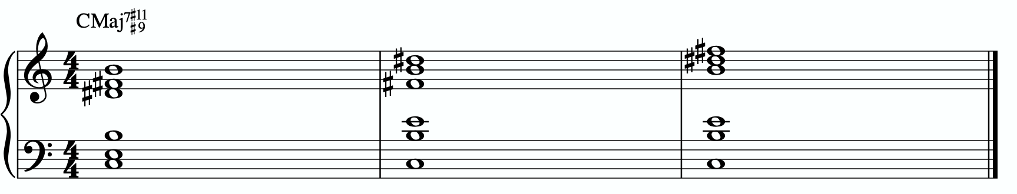
In order to get these three inversions, we will use the piano -> guitar technique described in the video - where we put the shell voicing on the bottom three strings and the triad inversions on the top three strings. This will give us a three “pianistic” inversions of this tonality on the guitar.
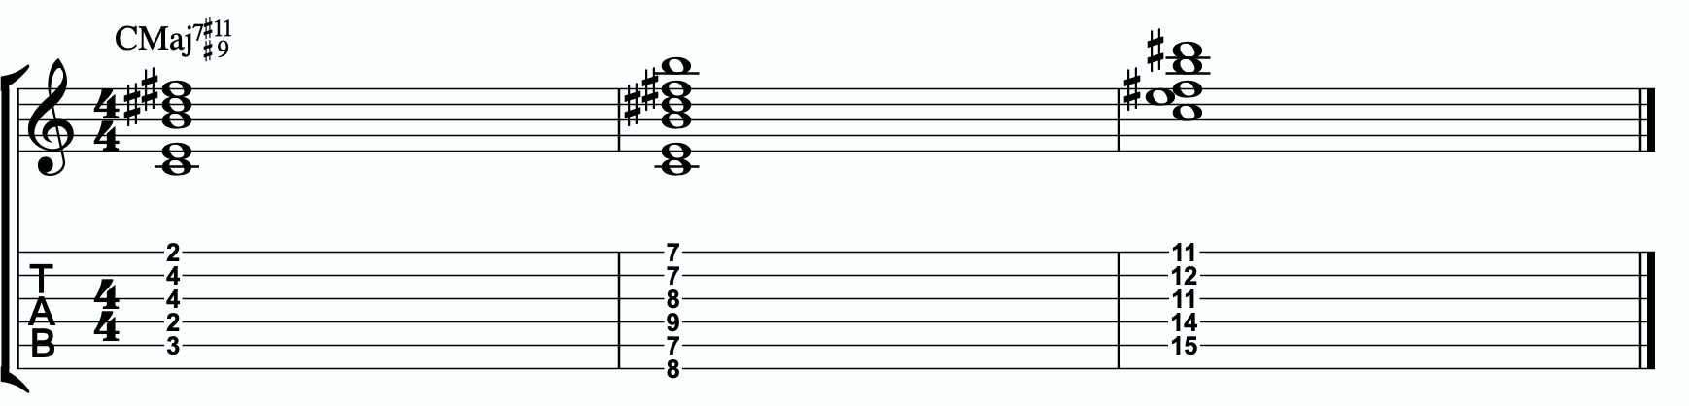

Notice the three basic inversions of the B major triad on strings 1 - 3.

A few exceptions are being made here.

In measure 1 we are sharing the 7th of the basic shell voicing (left hand), the B note, with the melodic triad (right hand). They both contain that B note, and to make this voicing work on the fretboard, we’re letting the 4th fret 3rd string B note be shared between the harmonic structure and the melodic structure.

In measure 3 we also can’t add an addition B note (one of the harmonic structure and one for the melodic structure). So again, we don’t worry about it. We have the B major triad on the top three strings, and then we simply have the root and 3rd of CMaj7 in the lower part of the chord. We still have all of our necessary pitches accounted for, but the basic shell voicing on the missing is broken apart.

THE PRIMARY QUADRATONIC
Because this particular type of CMaj7 contains a B major triad in the right hand, that B triad is going to be the foundation of our melodic structures. It governs everything. Rather than simply behaving as the chord tones that they correspond to harmonically, when used melodically, they will function as the 1, 3, and 5 of our melody… the strongest and most stable resolution points we can build lines with.
The ideal starting point is our primary quadratonic. A quadratonic is a triad that has one additional note added to it. It’s a four note structure made up of three stable notes (the melodic triad) and one ‘free radical’ or melodic tension note. This extra note serves two functions. First, it’s there to create melodic tension that will help us create movement, emotion, and lyrical phrases without getting trapped inside running scales or chord tones. Second, it will help imply the sound of the harmony we’re playing over and glue the melodic triad inside the chord so they don’t sound like two separate sounds, but rather one unified, colorful tonality.
We only have 12 notes in western music, and three of those 12 are being used in our melodic triad. That means we only have nine possible melodic tension notes. All nine of these could be used to create melodic tension against our triad. But some will help imply the sound of our original harmony better than others. Our primary quadratonic will be made of our melodic triad and the primary tension note - or the note the most respects the basic harmony.

Straight from Stefon Harris’ brilliant mind comes this rule that will help us figure out what are the most important notes:

The Hierarchy of Harmonic Importance.
3 - 7 - 5 - 9 - 11 - 13 - R

These are the chord tones of our basic harmony (the left hand of our piano player).

Here’s how this works:
- Is the 3rd of CMaj7 in the B major triad?
No. The 3rd of CMaj7 is E. E is not in B and causes no problems.

So our primary tension note is E.
This E - while the 3 of CMaj7 - is going to be heard by the ear in relationship to the B major triad. Since E is the 4 of B, we will call this tension 4. So our primary quadratonic is B tension 4.
We’ll notate this as:
/ 4
B
By making the triad bold and circling it, it draws our eye directly to the melodic triad so we can think first about our strong resolution points, then it quickly lets us know what our primary melodic tension note is.
At this point your primary goals should be to be able to play the three pianistic voicings, to be able to visualize the primary quadratonic over the basic shell voicings on the fretboard, to develop your ears to hear the melodic tension note wanting to move and the root note of the melodic triad as melodic ‘do’ - or the root note of the melody.

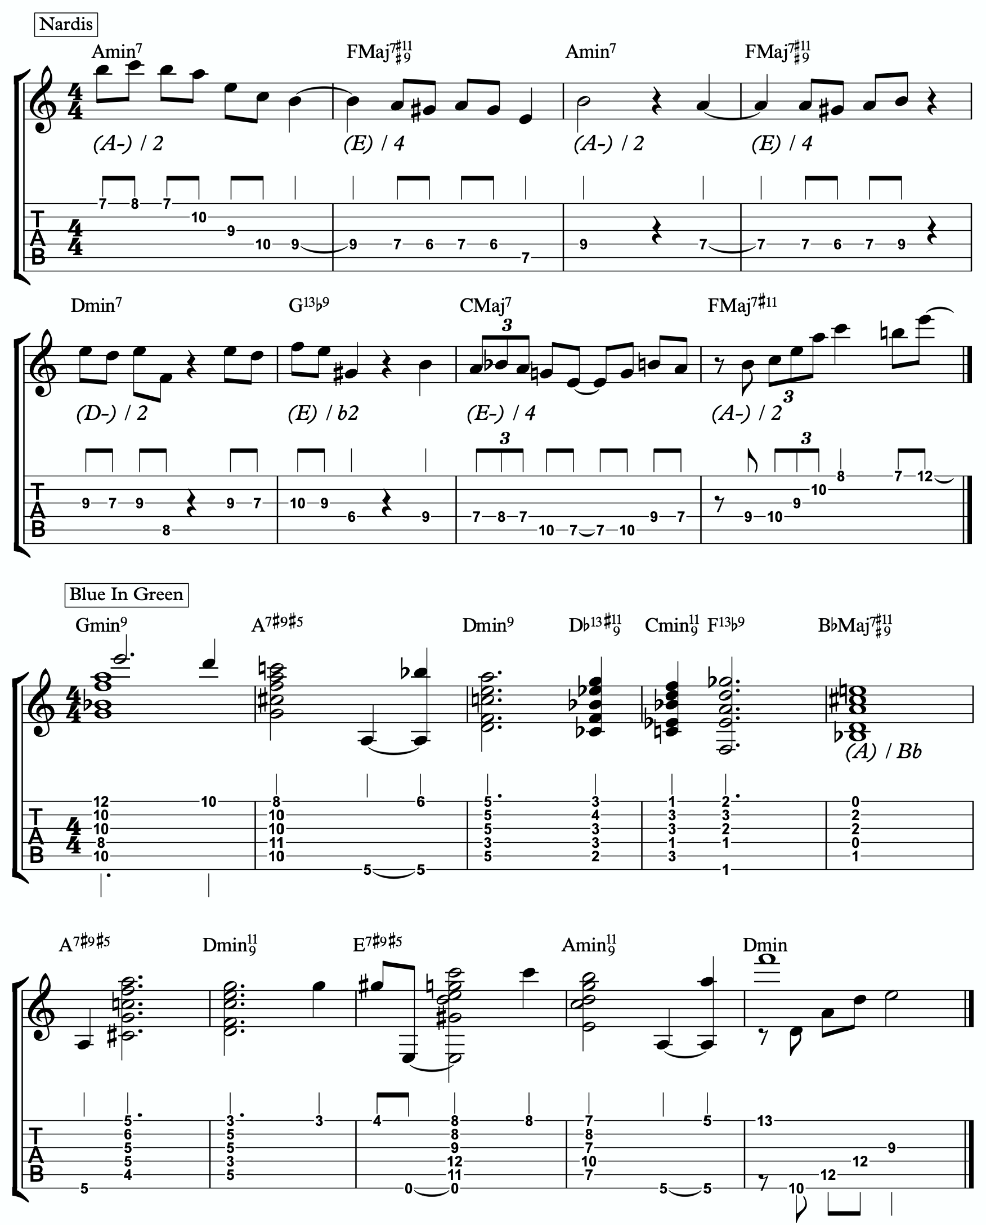
Here are some examples of these fundamental voicings and melodic ideas being used in musical situations.

1a

1b

ADVANCING MELODY
This section is going to look at more advanced and complex application of melodic triads to scalar ideas and arpeggios for the creation of bebop and modern jazz vocabulary based on simple structures that we can be playful with rather than memorization of riffs. Don’t be fooled by the idea of these ideas being more advanced or complicated. This doesn’t mean the music you play with these ideas will necessarily be better or more “advanced sounding” then the use of the pure primary quadratonic. In fact, often times I find that the use of the pure quadratonic can carry a level of maturity and intensity into the music that is hard to maintain when using more complicated ideas.
But, I still think it’s worth being aware of how we can build more advanced structures directly from the melodic triad.

Chromaticism Within The Quadratonic
One of the quickest ways to begin developing more complex lines is to incorporate chromaticism and leading tones within the quadratonic. By first learning to master the pure quadratonic, it should make it easier to begin spontaneously connecting individual notes within these structures in a way that will create a sense of improvisational freedom with our bebop and modern jazz playing. Playing this way will allow us to breathe long, flowing, complex lines within very the very basic, simple, steel frames of our buildings.
Here is our primary quadratonic:
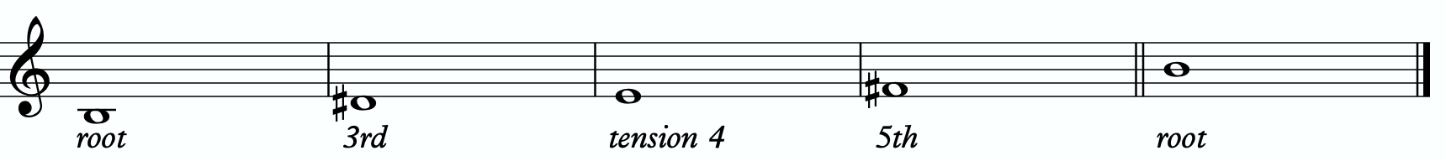

In between any of these notes, we can hang a chromatic line or place a leading tone (a note chromatically below the target) to bring us to the next note. When we use these techniques, we want to make sure that we resolve to a quadratonic note, and ideally we want to play at least two quadratonic notes immediately following the chromatic line to cement our phrase inside the tonality.

Here are an example:
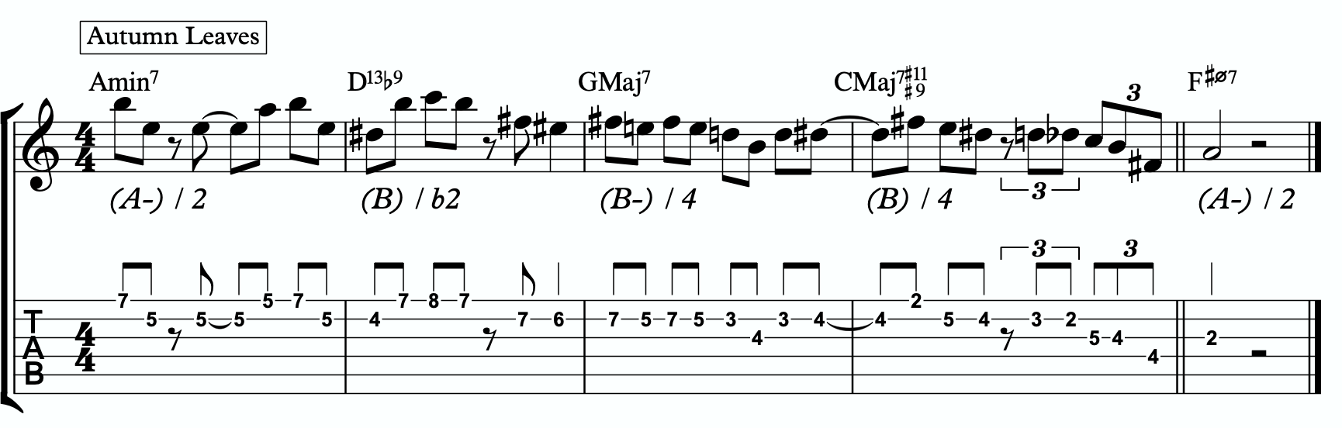
2a

Quadratonic Arpeggios
So far we have only discussed using quadratonics to develop phrases and scalar like ideas. Let’s look at how we can create the sound of arpeggios with them.
We will begin by starting on the primary tension note. After playing this note, we can move to the nearest melodic triad note and sweep quickly through that triad, landing on the tension note an octave away from where we began.
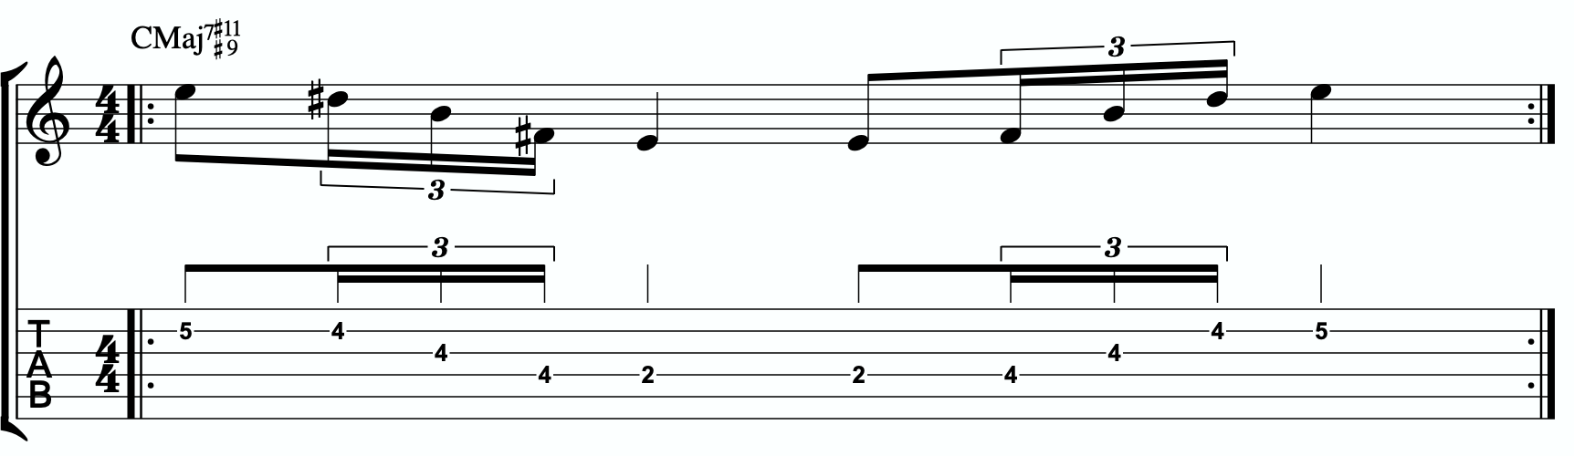
2b

We want to be able to play these ascending and descending starting on any octave of the tension note in any position of the fretboard. If we can incorporate this technique and the chromatic techniques above into our quadratonics then we are giving ourselves resolution notes, tension notes, chromatic runs, leading tones, and quick arpeggio-style runs that we can freely play within during our improvisation while remaining securely inside the color, emotion, and function of any given tonality.

Here is an example of these techniques being used together:
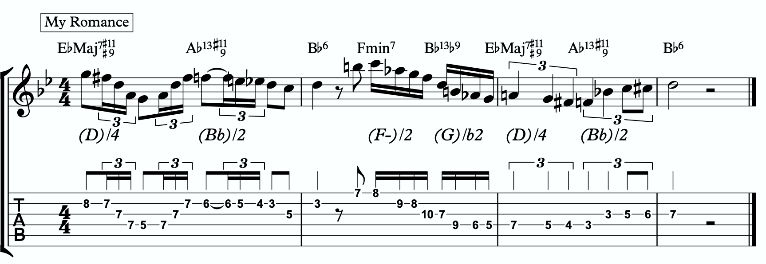
2c

DIGGING DEEPER
The goal of this section is to take small baby steps to evolve the fundamentals of melodic triads in the previous sections into new harmonic and melodic territory. If you are not already comfortable with the shell voicings, the three inversions of the pianistic voicings in all 12 keys, the primary quadratonic, and how to hear and feel the primary tension note against the melodic triad over the sus9, I would hold off and continue working on that.

FOUR NOTE VOICINGS
Let’s begin with harmony. Our first goal should be to minimize down these big, dense, pianistic voicings into something more manageable for the guitar. Four note voicings are ideal for our instrument. But sometimes it can be tough to get those colorful, pianistic type lush chords on the guitar because we just don’t have enough fingers. This is due to what I call bottom-up thinking. We are trained to think R, 3rd, etc etc. From the bottom of the chord moving upwards. By the time we get to the sweet spot notes, we’re out of fingers.
Instead, we’re going to think top-down. Our priority is the melodic triad. With these chords, the very first thing we will think about is the melodic triad. Then we are going to add one note underneath it, much like a slash chord. However, we don’t always use the root note. I usually like to try the 3rd first. For this tonality, the 3rd of CMaj7 is E. E is not already present in the B major triad, nor does it clash with it. So our four-note voicings will be based on a B major triad over an E bass note.
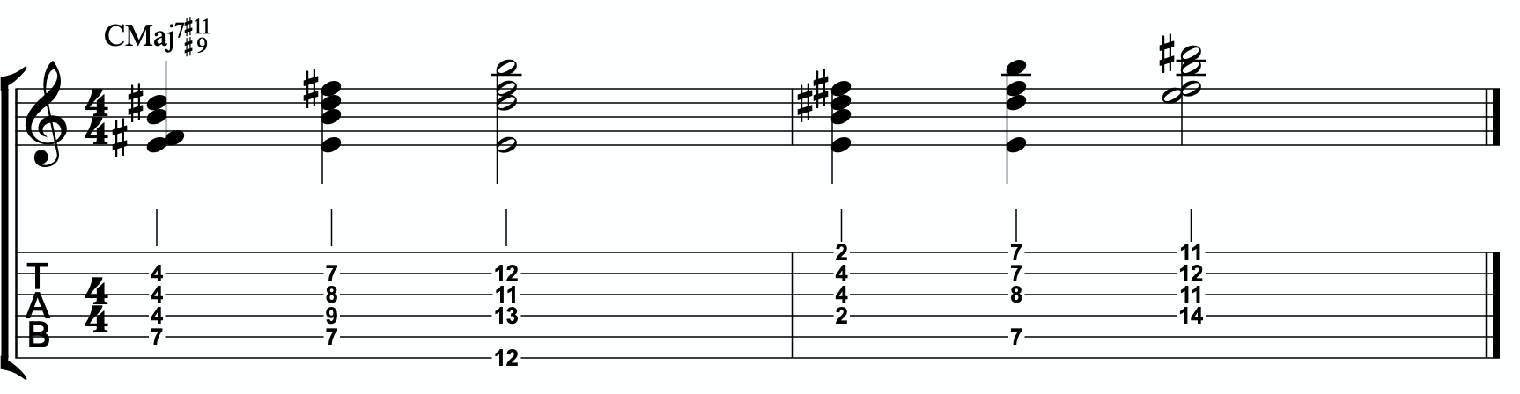
3a
Each of these voicings gives us the 3rd, 7th, #9th, and #11th of our CMaj7#11#9.

THREE NOTE QUADRATONIC VOICINGS

Three note qudaratonic voicings are an incredible and special tool for us. Unlike traditional drop chords that can be practiced through all inversions, these three note chord inversions offer us some special benefits. First, they highlight the sweet spot notes and get us into the really colorful parts of the chord. Second, by ignoring one of the four notes in each voicing, we’re not simply jumbling up the same four pitches each time we invert. One pitch is always disappearing or appearing as we move through these inversion. It makes for a much more captivating series of inversions as the ear is unconsciously losing and finding pitches at every turn.
We’re going to follow the “drop 2” idea, however not in the traditional sense. When we speak about “drop 2” chords traditionally, we mean that we take the second to the top note and “drop” it down an octave. We’re not going to do that. We’re simply going to remove it from the picture.

4 |  | 4 | 3 |  | 3
3 | > |  | 2 | >
2 |  | 2 | 1 |  | 1
1 |  | 1 | 4 |  | 4

Notice that when this technique is applied, the first series of numbers is different from the second. They both share 1 and 4, but the first series has a 2 and is missing the 3 whereas the second series has the 3 and is missing the 2. If we did this for every inversion of 1 - 4, each one would be slightly different.

If we apply this to our primary quadratonic, we get this series of three note voicings for our chord.
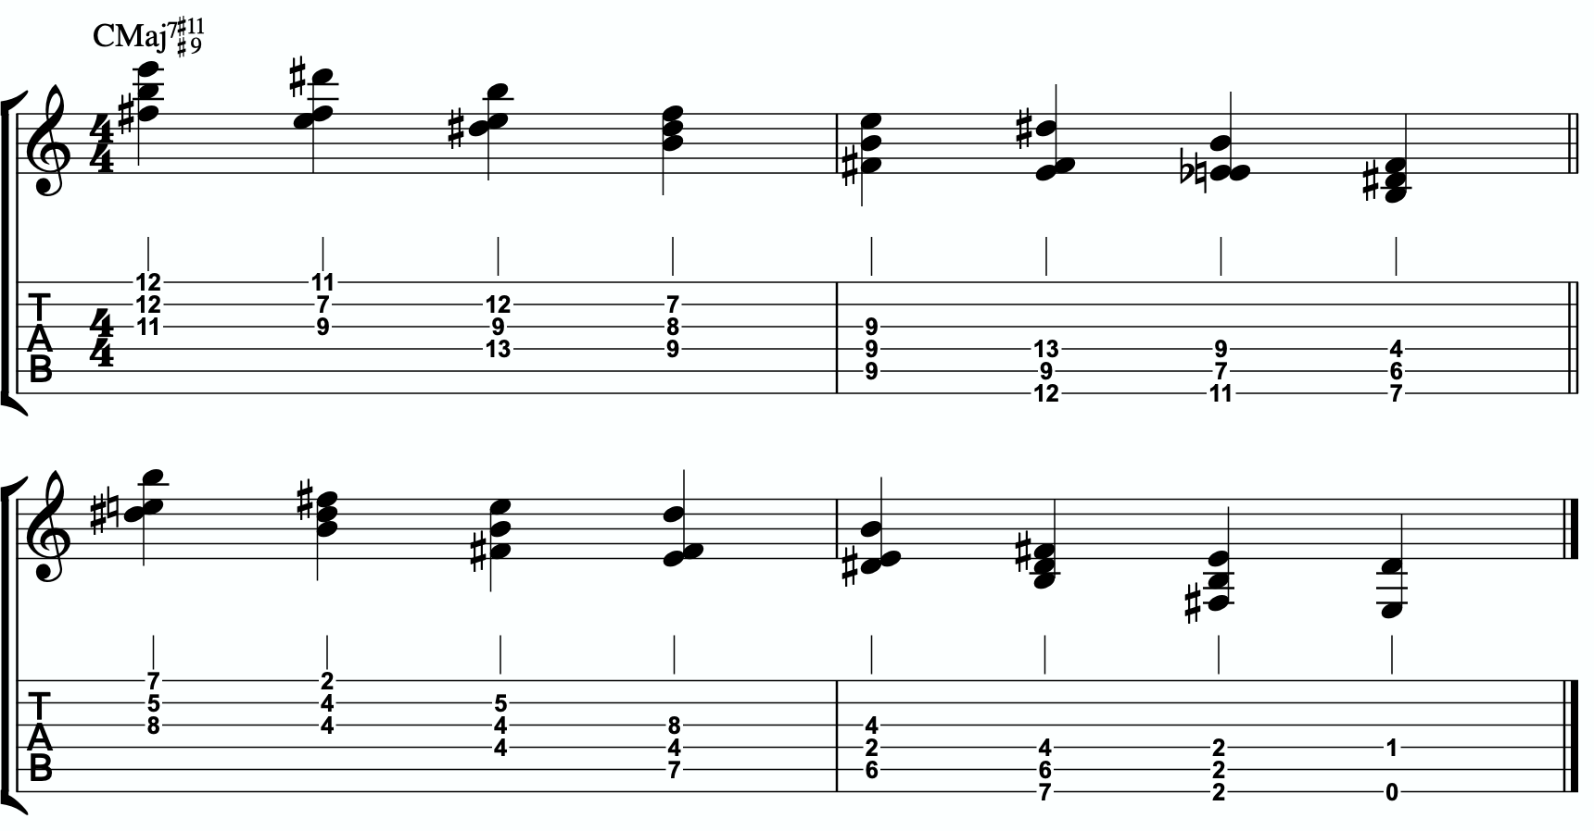
3b

QUADRATONIC SCALAR RUN
Let’s bring it back to single note ideas, melody, and improvisation. The Must Know was all about learning to hear and manipulate melodic tension and resolution using the quadratonic. But we can also use the quadratonic like a scale or an arpeggio. It seems simple because there are only four notes involved… but that’s only one note less than a pentatonic scale. And if you think about it, we only have 12 notes in western music, so if the quadratonic takes up four notes, then that’s actually ONE THIRD of all of the notes in the entire western tonal system. That’s quite a lot.
Let’s start with a scalar type run. Ideally you should already be able to hear and use the tension note and the resolution points of the melodic triad to develop beautiful, clear, authoritative phrasing that works with the harmony, and even implies it, without being stuck outlining it. Not we want to focus on developing the ability to create long, flowing, legato, fluid runs that create the impression of harmony. Traditional scales can sometimes be helpful for this, but they often times have notes that aren’t going to help define the sound of the harmony that’s happening. This^{T}q^{ex}u^{t}adratonic approach to a run will clear away those less essential notes.

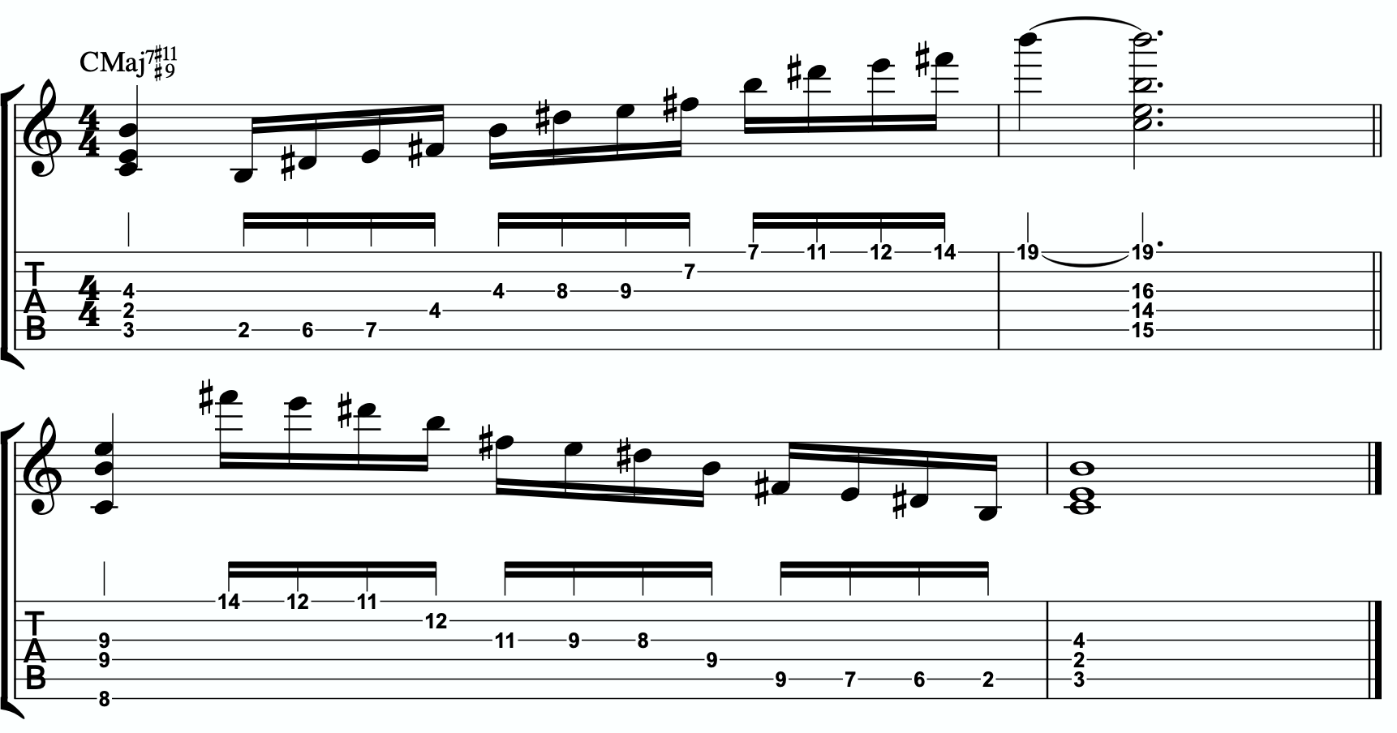
3c

THE SECONDARY TENSION NOTE & PENTATONIC SCALE
Once we can develop authentic phrases with the primary tension note and the quadratonic it gives us, and once we can see it as a scale that we can run through, we can move on and look at the secondary tension note. At this point, I recommend that you put the primary tension note on the back burner and leave it out for a while. Treat this as a whole new tension note. Go back through the ear training process and learn where it is on the fretboard, what it sounds like, how it wants to move, and how to create simple phrases with it.
In order to find the secondary tension note, we go back to Stefon’s formula.

The Hierarchy of Harmonic Importance.
3 - 7 - 5 - 9 - 11 - 13 - R
- Since we started by adding the 3rd, is the 7th of CMaj7#11#9 in the B major triad?
Yes. The 7th is B, and that’s in our B triad. Next.
- Is the 5th of CMaj7#11#9 in the B major triad?

No. The 5th is G. G is not in a B major triad nor does it cause any problems.

So our secondary tension note is G.
G is the 5th of CMaj7#11#9, but it will be heard against the melodic triad which is B major. G is the b6 of B major, so that means our secondary quadratonic is B major tension b6 and it gives us this tonality’s melodic triads pentatonic scale.

/ 4,b6
B

Here is an example of this pentatonic scale in use:
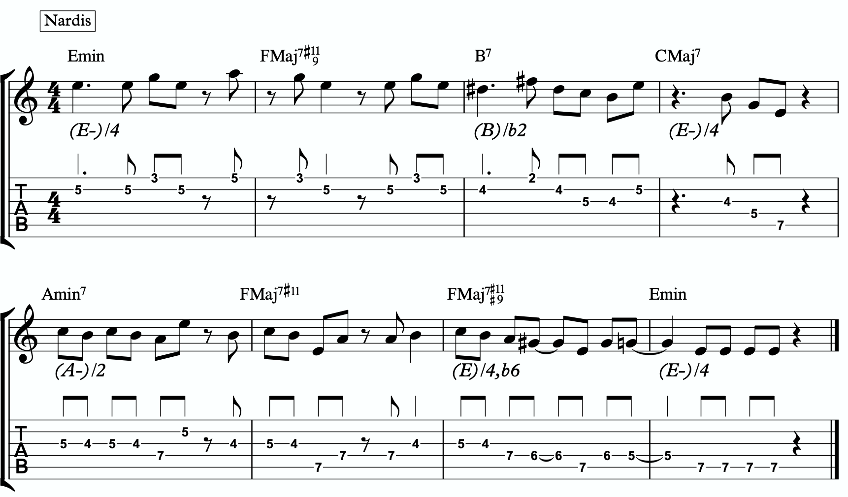
3d

THE MELODIC TRIAD BEBOP SCALE
Hopefully by now you’re starting to see the way melodic triads can offer a very direct path through all the traps of scale running, noodling, and outlining chords progression using 1 - 3 - 5 - 7 chord tones and arpeggios. All of these can be great devices (maybe not noodling), but have dangers to them.
The melodic triads approach helps us start with the sweet spot notes, and build our harmony and melodic from there. Before you start working on the melodic triad bebop scale or anything beyond this point, I strongly encourage you to make sure that you’re not simply reading these ideas like a theory book to be memorized. These are meant to infiltrate your ears, map the fretboard, and apply directly to musical situations in tunes. If you’re been studying and applying the melodic triads approach for enough time that you’re getting comfortable with it, we can take the next step. It’s only one extra note… but it’s a game changer.
In order to understand what the melodic triad bebop scale is, you need to understand what a traditional bebop scale is and the purpose for why it’s built the way it is. The standard diatonic scale is made of seven notes. The problem with playing a seven note scale is that it’s made of an odd number of pitches, so if you’re playing in 8th notes in 4/4 time, it’s going to flip itself around and start to place weak sounding notes on strong beats and strong sounding notes on weak beats.

C major scale

In music, we have strong beats and weak beats. We can see these pretty easily by looking at the beamed groups of 8th notes. There are always two of them. The first one, on the left of each group, is the strong down beat, and the second one, on the right of each grouping, is the weak up beat. We count them:

1 - & - 2 - & - 3 - & - 4 - &

That makes up one full measure of 8th notes in 4/4. The strong beats are on the number, and the weak beats are on the & (the “and”). If we look at the C major scale above, we see that it starts on the C note (very important) on a down beat. Then the next down beat, beat 2, has the E note. That’s the 3rd of CMaj… so we’re doing good. The 3rd down beat has the G note… still good. But the 4th down beat has the 7th of the scale, and then the C root note happens on the & of 4. And that puts the D note, the 2nd of the scale, on the down beat of the following measure. The following few down beats all have weak notes on them, putting the strong CMaj “chord tones” on the weaker up beats. It finally loops back around and lands on the C note on beat 4.
The traditional bebop scales took care of this problem by adding one single note. This evens it out to an eight note scale and lines up the pitches of the scale with the beats in the measure.

Some players would call this a bebop scale, or if you’re familiar with the Barry Harris method, you might call this the 6 diminished scale. Regardless, what’s important is that if you look at the strong beats, the notes spell out C - E - G - A. That’s a C6 chord. It gives

us a perfect combination of melody (the scale - with tension and resolution points), harmony (the C6 chord - the resolution points), and rhythm (the timing of getting all of the important notes to fall on the strong beats). It’s a beautiful, perfect, and very helpful scale to know.
I still rarely if ever think about, practice, or use it. Doesn’t mean you shouldn’t. But hopefully by now you’re starting to see just how powerful triads are. This scale is built around four note chords like C6 or C7, not three note triads.
But there’s a way to combine the two concepts. The pure simplicity and strength of the triad, with the rhythmic perfection of the bebop scale concept.
We simply add one single passing note between every triad note.
Here’s one octave of a B major triad. Our melodic triad for CMaj7#11#9.
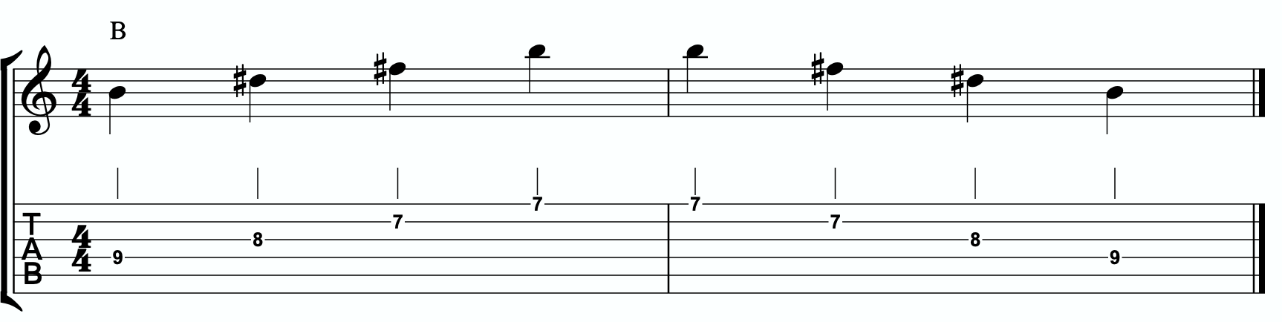

Now we’re going to insert one passing note between each triad note. The key is to pick the passing note that best respects and defines the CMaj7#11#9.

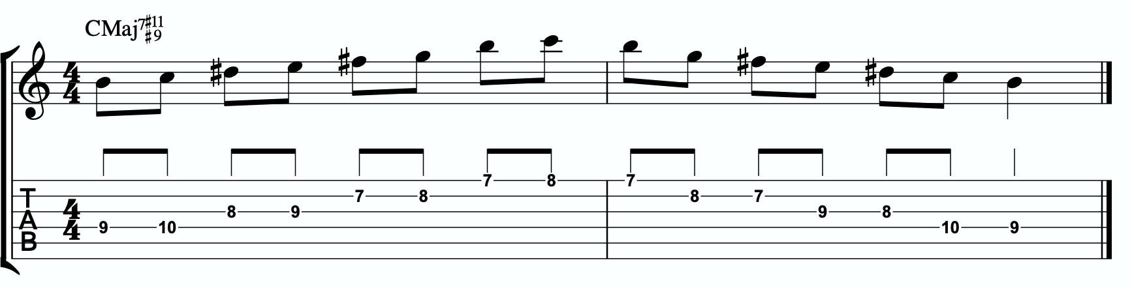

This is our melodic triad bebop scale. It’s a six note scale that helps us outline the tonality we’re working with by stabilizing the notes of our melodic triad.
Notice that it’s just a B major triad with passing notes. If we look at those passing notes in relationship to the B major triad, we get tension b2, tension 4, and tension b6. Two of the three tension notes are straight from our primary and secondary quadratonics. No, that’s not a coincidence. That’s due to the perfect nature of how triads function when we dig through harmony and melody with them. So we’re simply adding a third tension note. In this case, it’s tension b2. You could use that as a quadratonic - B tension b2 over a C chord. The melodic triad bebop scale gives us a rhythmically aligned “scale” but it also gives us three tension notes, each with their own unique emotional quality to them, that we can take advantage of if we don’t want to get stuck running scales and want to return to a focus on melodic tension and resolution and lyrical phrases.

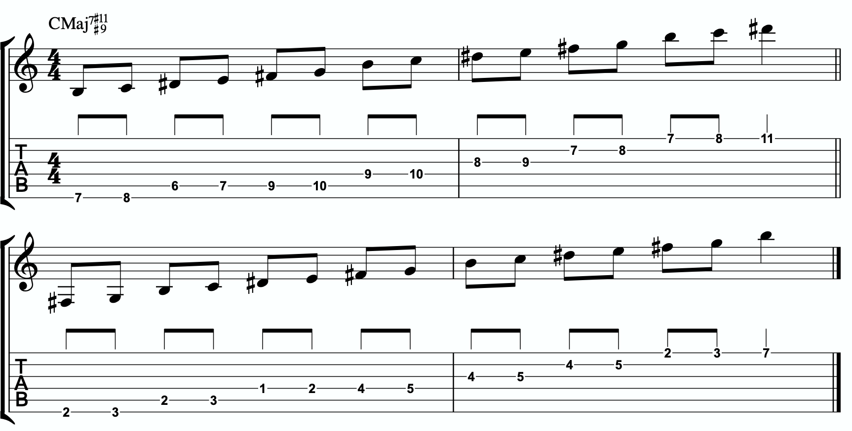
4a

Here is the same scale but harmonizing all of the melodic triad notes with our three note
quadratonic voicings:
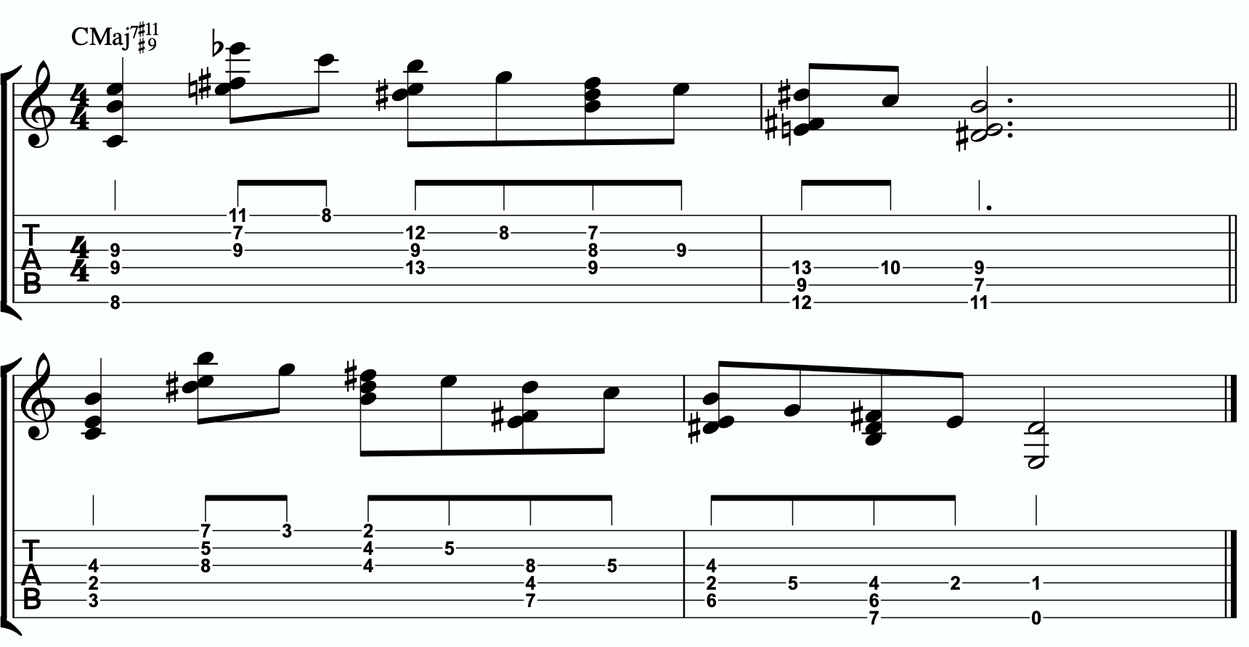
4b

ADVANCING HARMONY
We are getting into more and more advanced material now. Please remember that you do NOT need any of these continued lessons and concepts to play music. It is significantly more important that you develop your ability to be authentic, spontaneous, and playful with the material in The Must Know and then, if you feel comfortable, in Digging Deeper. Each section is building on the last, so if you’re struggling, it’s simply a check engine light to return back to earlier sections.
That said, we’re still far from a complete exploration of the depth of this one little triad.
This section we will explore some more advanced harmonic ideas. You may have heard me talk about liquid harmony. This is a way of visualizing the creation of harmony that involves movement. Think of a chord voicing like a block of ice. It’s frozen in time. We play it, we move to another chord, we move to another chord. Most of us learned to play harmony this way with a focus on shell voicings and drop chords. Liquid harmony is the idea of taking those blocks of ice and melting them down into a little. Not necessarily completely. But we want at least some of the ice to return to water so that it can flow and move. It helps free us up to transcend more static voicings, even cool sounding ones, and creates a more pianistic, movement-oriented sound. Not simply movement from one chord to another, though that’s important as well. But movement inside of a single chord. That’s what this section will explore.

HARMONIC QUADRATONICS
This is possibly the simplest, most effective, and most fun ways to create liquid harmony. The idea is that we play the primary quadratonic, but instead of thinking of it as a scale that we play with single notes, we play it as a chord. We will play three notes of the quadratonic. The tension note will be part of the chord, and it will replace the nearest melodic triad note. So the chord will be made up of two melodic triad notes and the melodic tension note. Then, while holding the two melodic triad notes and allowing them to continue ringing, we will resolve the tension note back into the triad. If we’re playing solo guitar or accompanying another musician, we may want to play the root note of the chord (“left hand”) or even the whole shell voicing. However in a full ensemble with a bass player, or if we’re playing solo and simply want a more impressionist style sound, we can leave that out and play these ideas as rootless “chords”.

Here is an example:
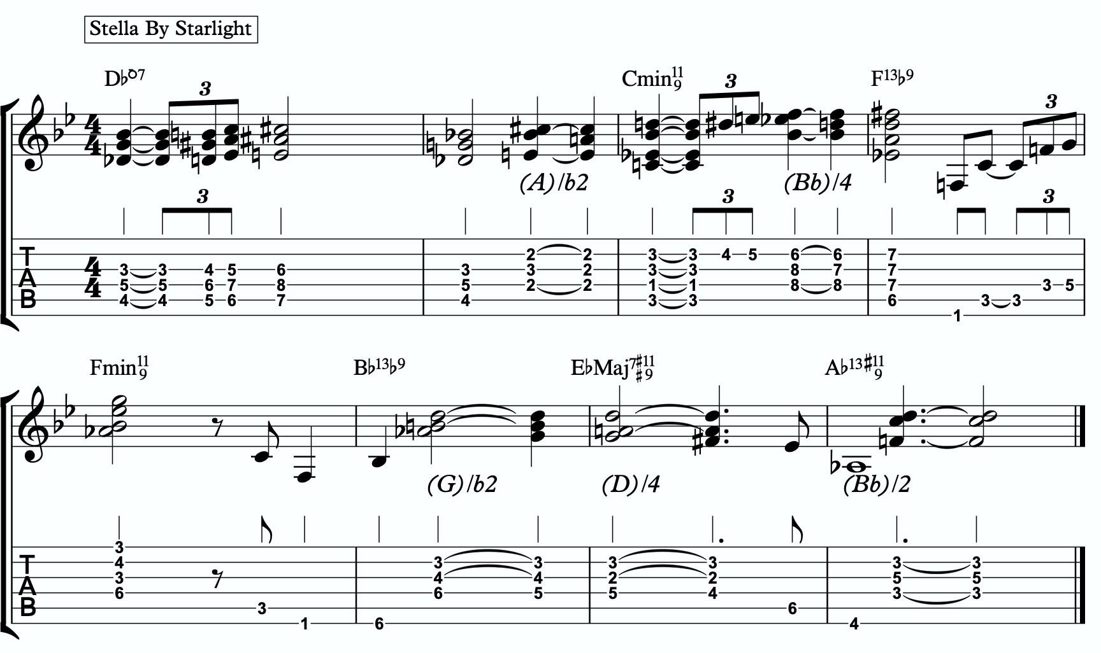
5a

Quadratonic Dyads
This is a similar concept to our quadratonic 3-note voicings, except now we’re creating 2 note grouping by pairing together every other note.

So if our quadratonic is made of B - D# - E - F#, we will group the B and the E together and the D# and F# together. And we will get this:

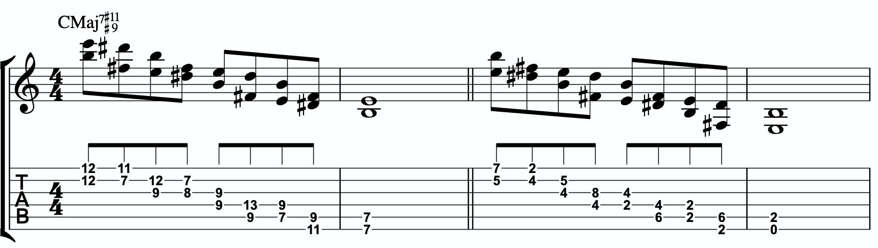
5b

TRIAD PAIRS
Sticking with our melodic triad bebop scale, we actually have our melodic triad version of triad pairs hiding right there in plain site. We know that all the resolution points are the notes of our melodic triad. But if we look at all of the passing tension notes we added, we actually have a second triad. This scale is two triads together. We have our melodic, or our “resolution” triad, and then we have our tension triad.
For this tonality, our triad pair is B and C.
/ C
B

We can of course arpeggiate these triads out to create single note ideas, but this section is specifically about harmony. So let’s look at a harmonic application for our tonality inside a chord progression.

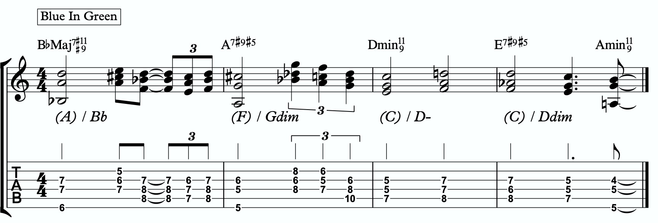
5c

Here is a dyad application, where we leave out one note from each triad.
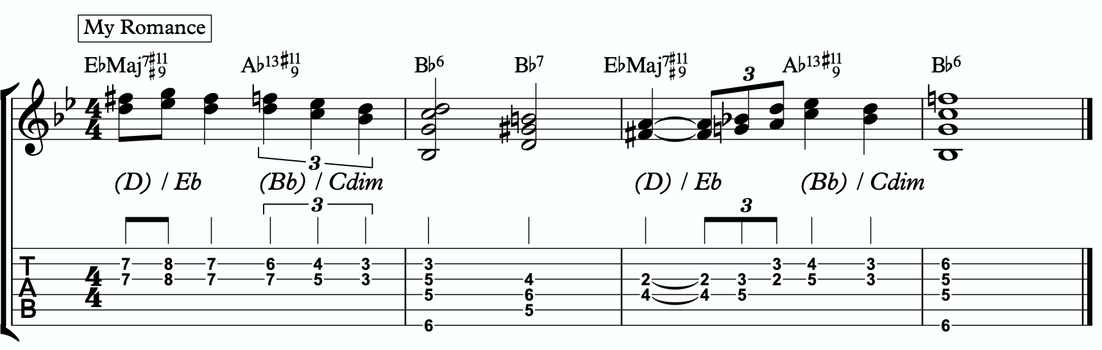
5d

TENSION LAYERS
Everything up until this section has been based on the idea that the melodic triad is the strongest organization for resolution, color, harmony, and melody. We leave the triad temporarily with different techniques to create tension, harmonically and melodically, but always in service to bring us back to rest in the resolved nature of the melodic triad.
In this section, we’re going to talk about the idea of thinking of tension as existing in layers. This way, we have different levels of tension that we can move in and out of - like rungs on a ladder that we can climb up, climb down, or simply pick one and stand still on it to enjoy the view.

LAYER ONE
This one is easy. Layer one is the primary quadratonic. The melodic triad is the most stable set of notes we have for our tonality. The primary tension note offers us a very respectful tension note to create melody. There is tension inside this quadratonic, but it’s accessible and always brings us right back into resolution. We must be comfortable making music with this sound before we can continue.

/ 4
B

LAYER TWO
But what if we want to move up a rung on the ladder? We know from the melodic triads bebop scale that our triad pair for this tonality is B major and C. So far, we have only thought of the C as a tension triad that can be used to bounce back and forth with B. But what if we momentarily “modulated” into the C triad to create a new rung on our ladder? Like modulating in a tune between the relative major and minor of a key, the key doesn’t actually change, but we can momentarily alter the color and the emotion.
By switching over to thinking of our tension triad, we can add a tension note to the triad and create a tension quadratonic.

The tension quadratonic, when mixed with the primary quadratonic will allow us the ability to navigate seven diatonic notes melodically and harmonically in a structured and authoritative way that will imply the harmony, give multiple colors and layers of tension, and allow for six different resolution points within any tonality. That’s half of all of our available pitches.

How do we chose the primary tension note for our new tension quadratonic?

We go back to the hierarchy of harmonic importance. What’s the next chord tone from the hoh? We can account for the root, 3rd, 5th, 7th, #9th, and #11th (or 4th). But we haven’t yet used the 13th. So that’s going to be the tension note for our tension quadratonic.
The 13th of CMaj7 is A. If we add an A note against our tension triad, C major, we get this four note structure - C, E, G, A. That’s a C major triad with a tension 6.

C / 6

This quadratonic will sound less “in” than the primary quadratonic, however the tension note in it will give it a sensation of tension and resolution within itself.

Here is example of this quadratonic pair being used harmonically:
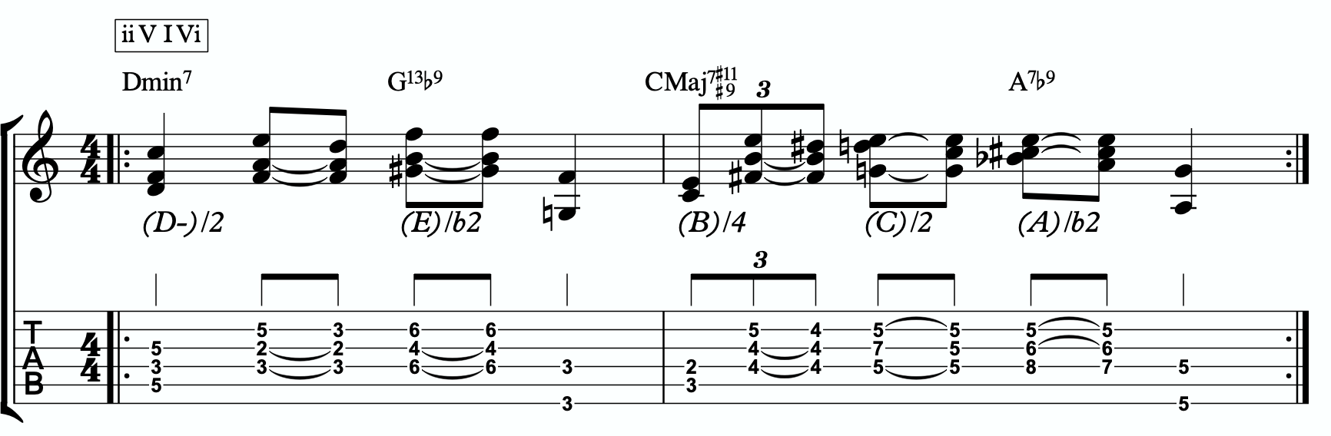
6a

Harmonizing Our Bebop Scale With Tension Layers

Let’s look at our six note melodic triad bebop scale and harmonize it using our quadratonic pairs. We will do this using two different techniques brought up earlier in this study booklet. First, we will move through the bebop scale using our harmonic quadratonics to create liquid harmony within each voicing as we move between the two quadratonics to harmonize each note. Finally, we will apply the three note quadratonic voicing to the bebop scale.

Harmonic Quadratonics & Liquid Harmony

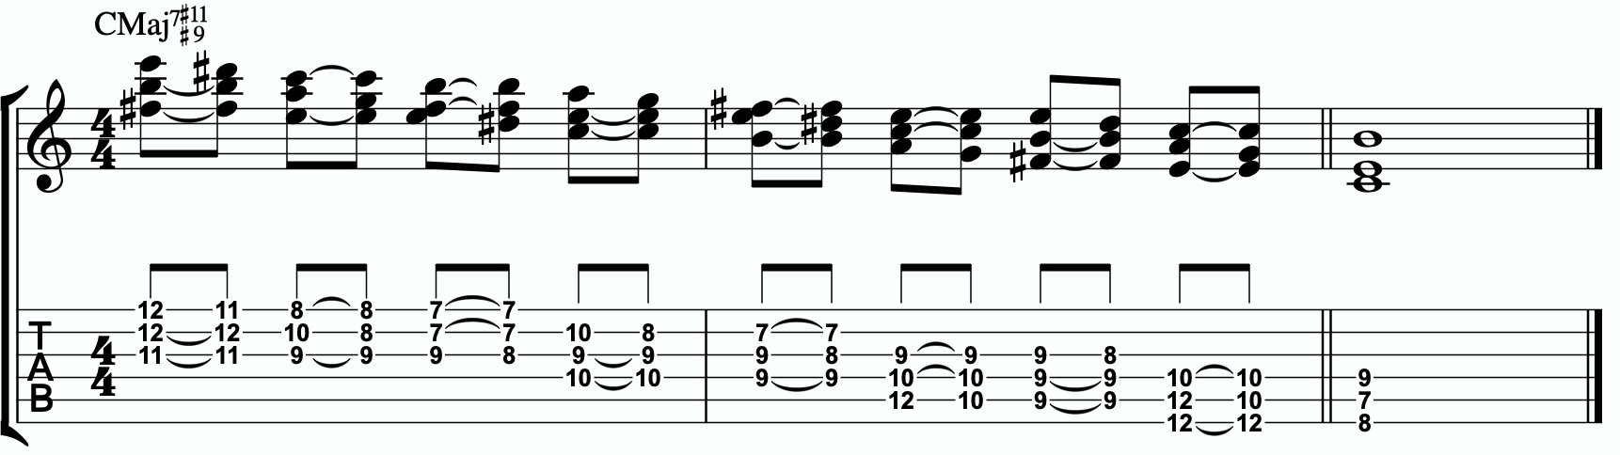
6b

Three Note Quadratonic Voicings

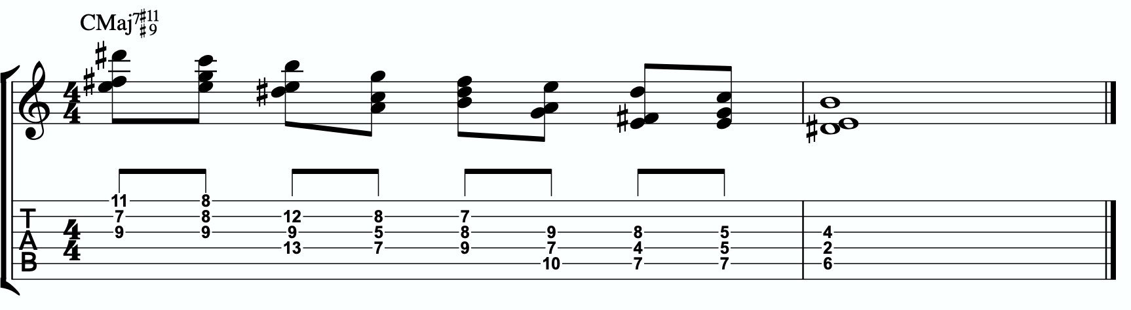
6c

THE OUTRO
I just want to personally thank you for working through these ideas. I am obsessed with exploring, mapping out, and demystifying jazz harmony and melody, and attempting to understand it and execute it using the simplest and most fundamental ingredients in music. I’ve found over many years of playing and study, and learning from some of the greatest minds in the jazz world today, that it’s often times our ego and our own self- inflicted limitations that hold us back the most from growing and evolving towards our potential.
The most dangerous words to development of our musicianship are, “I already know that.”
Most of us generally spend a couple of music theory classes learning our triads. Maybe we read a book about advanced triad application and get some cool intellectual ideas to play with. But for me, it’s all about that Bill Evans quote.
**********************************

The whole process of learning the facility of being able to play jazz is to take these problems from the outer level in, one by one, and to stay with it at a very intense, conscious-concentration level until that process becomes secondary and subconscious. Now, when that becomes subconscious, then you can begin concentrating on that next problem, which will allow you to do a little bit more.

I don’t consider myself as talented as many people but in some ways that was an advantage because I didn’t have a great facility immediately so I had to be more analytical and in a way — that forced me to build something.
Most people just don’t realize the immensity of the problem and, either because they can’t conquer it immediately, think that they haven’t got the ability, or they’re so impatient to conquer it that they never do see it through. If you do understand the problem then you can enjoy your whole trip through.

People tend to approximate the product rather than attacking it in a realistic, true way at any elementary level — regardless of how elementary — but it must be entirely true and entirely real and entirely accurate. They would rather approximate the entire problem than to take a small part of it and be real and true about it. To approximate the whole thing in a vague way gives you a feeling that you’ve more or less touched the thing, but in this way you just lead yourself toward confusion and ultimately you’re going to get so confused that you’ll never find your way out.

It is true of any subject that the person that succeeds in anything has the realistic viewpoint at the beginning and [knows] that the problem is large and that he has to take it a step at a time and that he has to enjoy the step-by-step learning procedure. They’re trying to do a thing in a way that is so general [that] they can’t possibly build on that. If they build on that, they’re building on top of confusion and vagueness and they can’t possibly progress. If you try to approximate something that is very advanced and don’t know what you’re doing, you can’t advance.

**********************************

Was Bill referring to melodic triads? I very highly doubt that. I’ve never heard him talk much about triads. But consider the underlying philosophy he’s pointing at. Know the

basics. Regardless of how elementary! But it must be entirely true, real, and accurate. Be able to play genuine, authentic music using the most fundamental ideas first. Then it leaves room to grow.
This is why I refer to the first section in this ebook as The Must Know. It’s a basic shell voicing, and a basic triad. And while these two concepts are as simple as they come in music, we must understand them in a true, real, and accurate way. If we did this for a handful of tonalities, we could play beautiful music for the rest of our lives, and for me, I would feel fulfilled. It would offer emotion-driven, precise, human, lyrical melody combined with lush, colorful, pianistic harmony. Mix in a strong sense of time and feel, and that’s everything a jazz musician needs.
But like Bill talks about, when we don’t try to approximate but instead start with the elementary ideas and build a foundation with them, then it gives us room for growth. Look at everything we worked through together in this ebook! All built from one triad and how it relates to one chord (piano diagram!). As of the time of putting this together, I’m still working on many of these ideas myself… and I’m still coming up with new ways of building harmony and melody around the melodic triad.
This is why I can’t recommend enough, even to the intermediate and advanced players out there - spend some serious time in The Must Know section. Own it. Be able to play authentic ideas with it. Apply it to tunes. Move it through the circle of 5ths. Do whatever you can to internalize it and develop your ears to it. Then you can begin moving on. I would encourage everyone… peak ahead if you would like to to keep an eye on where this particular path is heading, but be very self-aware and learn to see when you’re getting in over your head. When this happens, not if, just take a deep breath and back up a few sections. It simply means your foundation isn’t quite strong enough yet to carry the weight of those more complex ideas. If you want it, and you put the time and effort it, you’ll get there.
Like one of my students always likes to tell himself at the end of our lessons…..
“Easy does it. But do it.”

Thank you again. Don’t forget to come and hang in our open office hours to ask questions if you’re confused on anything.
Happy Practicing!
-Jordan Klemons

The Melodic Triads Study Group

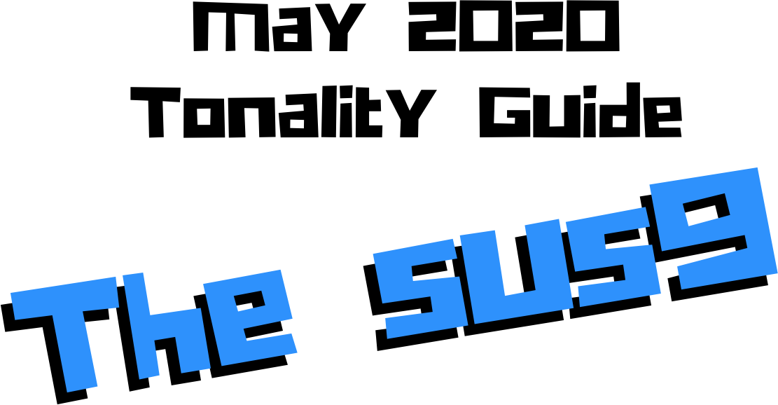

Jordan Klemons
NYC Jazz Guitar Masterclasses

CONTENTS
-INTRODUCTION
-THE MUST KNOW-
-ADVANCING MELODY-
-DIGGING DEEPER-
-THE MELODIC TRIAD BEBOP SCALE-
-ADVANCING HARMONY-
-TENSION LAYERS-
-OUTRO-

This ebook is the copyrighted property of Jordan Klemons. All images, information, layout, and designs belong to Jordan Klemons. This document may not be altered, reproduced, distributed, or transmitted in any form or by any means without the prior written permission of the author.

INTRODUCTION
Thank you for downloading the pdf materials for this month’s melodic triads tonality study guide. Inside you will find all of the supplemental theory, notation, tab, charts, concepts, and examples for the accompanying videos to help you develop your understanding, your ear, your emotional connection with, and your sense of harmonic and melodic freedom within this month’s tonality… as well as its use in some short, common, jazz chord progressions that you will be able to immediately implement in your own playing.
The information in this guide is dangerous. I mean that literally. When the process is respected, and you understand how all of these ideas fit into the puzzle, this guide and the baby steps included can offer tremendous insight into how to begin making real music very quickly, and how to continue evolving and growing as a player for many years to come. However, if approached in the wrong way and the process is not respected, these ideas can confuse and derail a musician’s ability to progress. It’s important not to jump too far ahead of yourself. The advice that a Miles, or a Scofield, or a Coltrane would give to a beginner is different than what they would give an intermediate or to an advanced player. And all of that would be different than how they would talk to a professional who’s already playing on their level. This is important to remember.
This guide is meant to show many different layers of musical growth and how, when using the melodic triad approach, they can all be boiled down and viewed simply as an extension of the most basic elements of music. Namely… a triad. Think of the pages that follow as an architect’s blue prints for a skyscraper. If you haven’t built a strong foundation, your skyscraper will fall. If you attempt to skip the first 50 stories and jump to building the penthouse, the skyscraper will fall. If you try to put up the fancy exterior of the building before you complete the steel frame, the skyscraper will fall. Yes, the information all the way at the end of this guide is constructed using the same ideas and concepts that are presented in the first chapter, but the process must be respected for anything to work. Otherwise it will only leave you confused, frustrated, feeling like a failure, and wanting to give up. Be patient with yourself. The short cut IS the long road. Take it. Spend two or three months working on the long road and watch how much you progress. Focus on your sound, on your ear, and on your musicianship… and trust that the simplicity of the ideas and the process itself will take care of you. They will. But only if you respect them. It’s like a relationship - you have to be present and give of yourself, and then you will receive in abundance.

As you work through these pages, try to keep in mind this Bill Evans’ quote from The Universal Mind.

**********************************

The whole process of learning the facility of being able to play jazz is to take these problems from the outer level in, one by one, and to stay with it at a very intense, conscious-concentration level until that process becomes secondary and subconscious. Now, when that becomes subconscious, then you can begin concentrating on that next problem, which will allow you to do a little bit more.

I don’t consider myself as talented as many people but in some ways that was an advantage because I didn’t have a great facility immediately so I had to be more analytical and in a way — that forced me to build something.
Most people just don’t realize the immensity of the problem and, either because they can’t conquer it immediately, think that they haven’t got the ability, or they’re so impatient to conquer it that they never do see it through. If you do understand the problem then you can enjoy your whole trip through.

People tend to approximate the product rather than attacking it in a realistic, true way at any elementary level — regardless of how elementary — but it must be entirely true and entirely real and entirely accurate. They would rather approximate the entire problem than to take a small part of it and be real and true about it. To approximate the whole thing in a vague way gives you a feeling that you’ve more or less touched the thing, but in this way you just lead yourself toward confusion and ultimately you’re going to get so confused that you’ll never find your way out.

It is true of any subject that the person that succeeds in anything has the realistic viewpoint at the beginning and [knows] that the problem is large and that he has to take it a step at a time and that he has to enjoy the step-by-step learning procedure. They’re trying to do a thing in a way that is so general [that] they can’t possibly build on that. If they build on that, they’re building on top of confusion and vagueness and they can’t possibly progress. If you try to approximate something that is very advanced and don’t know what you’re doing, you can’t advance.

**********************************

I’ve setup the material in these tonality lessons to start with the most basic and fundamental elements of music, and to grow outwards in complexity. Everything builds on what came before it, so everything is connected. You DON’T need to master everything in these lessons to play music. You only really need the first section and a little bit of creativity and concern for your sound - that’s enough to create something beautiful..
I recommend that if you’re new with us, even if you’re already an advanced player, you begin focused entirely on the first section of this guide, The Must Know, and give yourself a minimum of 3 - 6 months to get used to this method and the initial concepts presented. It’s a very different approach to standard theory, and your goal should be (as Bill Evans said) to be able to make genuine, authentic music with the ideas in the first section. Once you feel you can hear and play music using these ideas on a small handful of tonalities and applied to some tunes, then it is time to start advancing forward.

I would continue giving yourself an addition 3 - 6 months for each subsequent section, as each builds on the last and becomes more and more advanced… starting from the most basic and simple ingredients, and eventually working our way up to learning to hear and use all 12 notes of the western chromatic scale harmonically and melodically over any chord in a musical way.
I strongly recommend that you follow this rough timeline. I believe it’s the most effective way to cut through the learning process and get straight to making beautiful music, and then to set yourself on the path to continue growing and building for years to come.
The melodic triad ideas I’m working on today, I didn’t even know they existed during the first few years of my own studies. As we grow and progress and get comfortable, we can naturally start to evolve the ideas into more advanced applications. That’s the beauty of starting with the fundamentals, learning to make genuine, authenticate music from our own self first… and then building layers of complexity on top of, but always connected to, those very fundamentals. Much like a large skyscraper building starts with a huge hole in the earth, then is filled with concrete and steel, and then the steel frame will hold the building as it goes up. We won’t see any of these structures. But without them, the building would collapse. Only once the structure is there can the work of putting up the exterior, the glass, the interior, the design, the furniture, etc. take place.
Thank you again for downloading this study guide and working on your music with us. I look forward to hearing your playing and your contributions to the melodic triad conversation inside our facebook group, and for those of you subscribed to our Private Community, inside our melodic triad mastermind group.
Happy Practicing!
Your friend on the path towards jazz guitar mastery,
-Jordan Klemons

The Melodic Triad Study Group - a part of
NYC Jazz Guitar Masterclasses

THE MUST KNOW
The theory, ideas, voicings, and “scalar” ideas presented in this section may seem too simple and elementary to be of value. But I urge you, even the intermediate and advanced players - do not skip this section. I recommend that if you’re within the first 3 - 12 months of study with us that you focus entirely on learning to apply these ideas to musical situations. You can skim the rest of the pages if you’d like, but this should be where you build from. After close to 25 years of playing music seriously, I still spent my first year of working on melodic triads only on this material. The great thing about these ideas is that not only can you comp, improvise, compose, and arrange beautiful music over standards, bebop, modern jazz, and original works with them, but they also act as the foundation on top of which we can grow into more and more complex ideas without ever leaving behind these basic building blocks of harmony and melody.
Do not simply see these as intellectual theory ideas. These are meant to be internalized. To understand the theory is great. To hear the sounds in your ear with a sense of familiarity is just as important. To connect with them personally and be able to hear and express emotion through them is of the utmost importance when it comes to developing our musicianship. This should be the goal.

THEORY
Sus chords feel like they’re floating just above the surface. Traditionally there is a natural craving to hear the suspended quality released to settle back down. The 4th resolve back down to the 3rd. This dates back hundreds of years and can still be used and heard in modern jazz… a sus9 chord resolving down to a 13b9 or a more standard dominant, and then resolving to I6. We will look at this. Because of this, it can also be subbed in place for a ii-7 chord in a ii V I. In jazz, we can also allow it to replace the dominant7 altogether without resolving the 4th down to the 3rd. Both of these dominant functions usually happen in major keys, as the natural 9 is less organic in a minor key… though possible. And finally, in modern jazz, we can use it as a modal sound. Almost a floating, movable tonic sound.

What makes up a Csus9 tonality?
Two basic ingredients.
- A basic C7sus chord
- A Bb major triad
A good way to think of this is to visualize a piano player with two hands. Their left hand would be playing C-F-Bb (a basic C7sus shell voicing) and their right hand would be playing a Bb major triad.

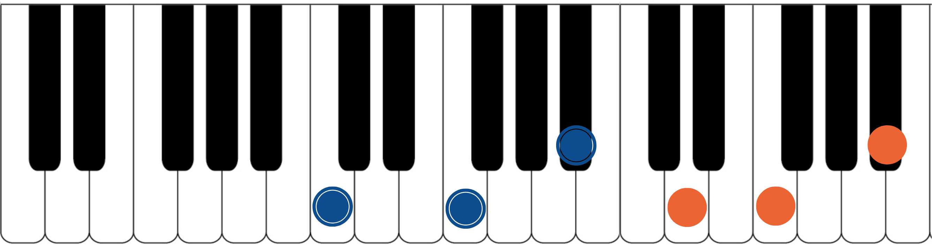

The blue dots would represent the fingers of the piano player’s left hand. Notice they spell out C, F, and Bb. That’s the 1, 4, and b7 of a basic C7sus chord. The orange dots represent the piano player’s right hand. They spell out D, F, and Bbb. That’s an inverted Bb major triad. If you have access to a piano or keyboard, I strongly encourage you sit down and play these seven notes simultaneously. Listen to how big of a sound they create together. Play it a few times. Try and feel the emotion and the color they create together. Then remind yourself of the elementary and simple nature of what’s happening in each of your two hands separately. A basic chord in your left hand. A basic triad in your right hand. The magic happens when we use these sounds together… and when we begin to build chord voicings and melodic ideas around these two simple sounds.

***This Bb major triad, which is now our melodic triad, is built on the b7th of C7sus… ‘Bb’ is minor 7th up from ‘C’. This relationship is critical to understand and memorize as it will allow us to transpose this sus9 tonality into any key quickly. We will notate this as ‘Tb7’. This notation comes from Stefon Harris. The ’T’ is short for ‘triad’ and we make it upper case to notate that it’s a major triad. The b7 tells us that the melodic

triad is built on the b67h of the harmony. So if we want a Gsus9, we think Tb7, we find the b7th of G (which is F), and we know that the melodic triad is F major.***
This pianistic chord construction is the starting point for everything we are going to look at together. Hidden inside of this seven-note chord is a universe of potential harmonic and melodic ideas. The following pages can all be traced back to this construction idea. Basic chord, basic triad. Left hand, right hand. Harmonic structure, melodic structure. Hence the term… melodic triad. Even if you don’t have access to a piano, I encourage you to sit and think about this diagram until it makes sense to you.

GETTING THE PIANISTIC VOICINGS ONTO THE GUITAR
Taking the concept of the piano construction, where the C7sus chord is always underneath the Bb major triad, we can develop three basic inversions of this chord by inverting the Bb triad and keeping the C7sus chord underneath it as much as possible.
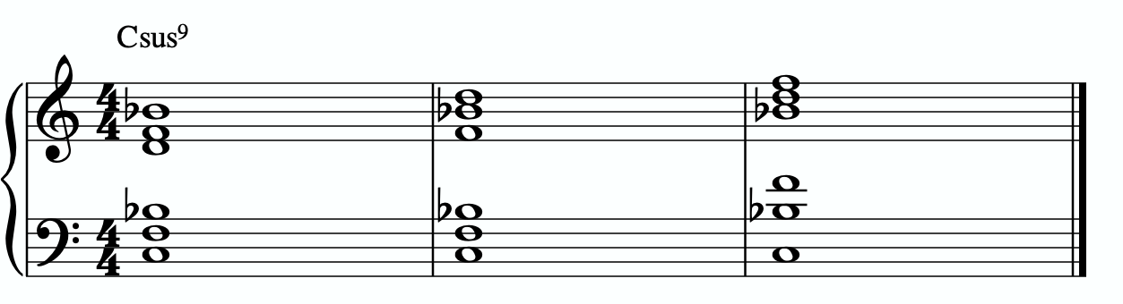
In order to get these three inversions, we will use the piano -> guitar technique described in the video - where we put the shell voicing on the bottom three strings and the triad inversions on the top three strings. This will give us a three “pianistic” inversions of this tonality on the guitar.
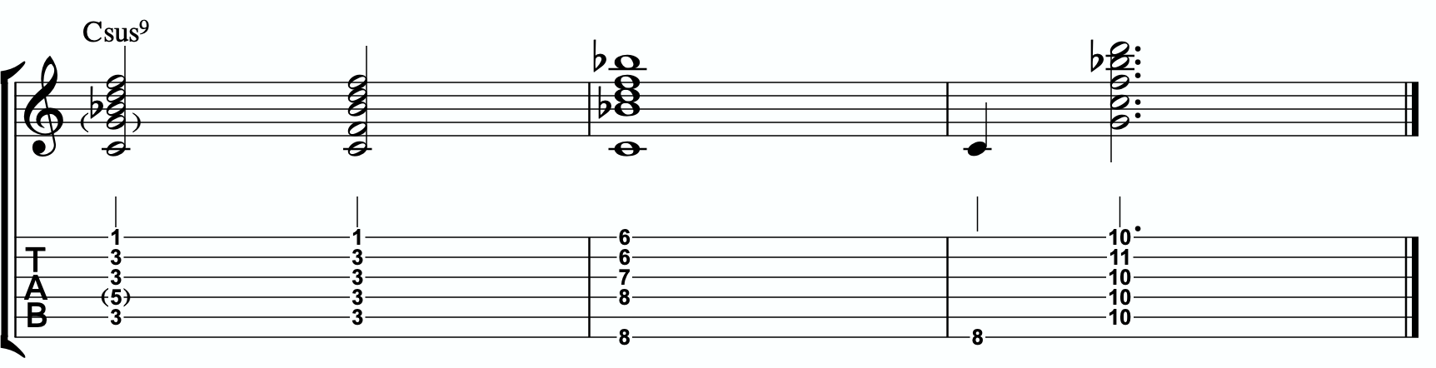
Notice the three basic inversions of the Bb major triad on strings 1 - 3.

A few exceptions are being made here.
In measure 1 I prefer the first option. This voicing uses the 5th instead of the 4th in the shell voicing (our imaginary piano player’s left hand) on the 4th string. Why? Well the 4th of C7sus is F and that’s already present in the melodic triad. So we’re repeating it an octave apart. I like the idea of switching it out for an unused note to beef up the sound a little more. However this voicing is a challenging stretch for me, so I generally only use it farther up the fretboard in the higher register. Instead I notated the 2nd version of it on beat 3 where I followed the basic rule, used the 4th in the lower part of the voicing, and therefore have doubled the F note on the 4th and 1st strings. Both work.
In measure 2 I left out the 4th and the 5th altogether from the shell voicing. This particular voicing is challenging for me to get the 4th. It’s possible using a barre, but it’s awkward. And again, the 4th is already present in the melodic triad. So let’s leave it out. Adding the 5th isn’t quite possible, so we are left with this very straight-ahead, commonly used 5-note voicing.

In measure 3 we can actually get the full sus shell on the lower three strings by barring down the 8th fret, and then placing the Bb triad on the top three strings. It’s playable. But it sounds very dull and empty. Both the 4th and the b7th of C are present in the Bb major triad. So both of those notes are doubled in that voicing. Instead I take out the 4th and replace it with the 5th again, and then it sort of forces me to replace the b7th with the root. This turns my left hand shell into just roots and 5ths of the C chord. With the Bb triad on top this sounds really hip and modern. It’s possible to play the entire voicing simultaneously, but I often break it apart, playing the root first and then the remainder of the chord. Both work.

THE PRIMARY QUADRATONIC
Because this particular type of C7sus contains a Bb major triad in the right hand, that Bb triad is going to be the foundation of our melodic structures. It governs everything. Rather than simply behaving as the chord tones that they correspond to harmonically, when used melodically, they will function as the 1, 3, and 5 of our melody… the strongest and most stable resolution points we can build lines with.
The ideal starting point is our primary quadratonic. A quadratonic is a triad that has one additional note added to it. It’s a four note structure made up of three stable notes (the melodic triad) and one ‘free radical’ or melodic tension note. This extra note serves two functions. First, it’s there to create melodic tension that will help us create movement,

emotion, and lyrical phrases without getting trapped inside running scales or chord tones. Second, it will help imply the sound of the harmony we’re playing over and glue the melodic triad inside the chord so they don’t sound like two separate sounds, but rather one unified, colorful tonality.
We only have 12 notes in western music, and three of those 12 are being used in our melodic triad. That means we only have nine possible melodic tension notes. All nine of these could be used to create melodic tension against our triad. But some will help imply the sound of our original harmony better than others. Our primary quadratonic will be made of our melodic triad and the primary tension note - or the note the most respects the basic harmony.

Straight from Stefon Harris’ brilliant mind comes this rule that will help us figure out what are the most important notes:

The Hierarchy of Harmonic Importance.
3 - 7 - 5 - 9 - 11 - 13 - R

These are the chord tones of our basic harmony (the left hand of our piano player).

Here’s how this works:
- Is the 3rd of C7sus in the Bb major triad?
Yes. The 4th IS the 3rd for a sus chord, and F is in the Bb triad… next
-Is the 7th of C7sus in the Bb major triad?
Yes. The b7 of C7sus is Bb. That’s in the Bb triad… next
-Is the 5th of C7sus in the Bb major triad?
No. The 5th of C7sus is G. That’s not present in the Bb triad.

So our primary tension note is G.
This G - while the b7 of C7sus - is going to be heard by the ear in relationship to the Bb major triad. Since G is the 6 of Bb, we will call this tension 6. So our primary quadratonic is Bb tension 6.
We’ll notate this as:
/ 6
Bb
By making the triad bold and circling it, it draws our eye directly to the melodic triad so we can think first about our strong resolution points, then it quickly lets us know what our primary melodic tension note is.
At this point your primary goals should be to be able to play the three pianistic voicings, to be able to visualize the primary quadratonic over the basic shell voicings on the fretboard, to develop your ears to hear the melodic tension note wanting to move and the root note of the melodic triad as melodic ‘do’ - or the root note of the melody.
Here are some examples of these fundamental voicings, shell voicings, and melodic ideas being used in music situations.
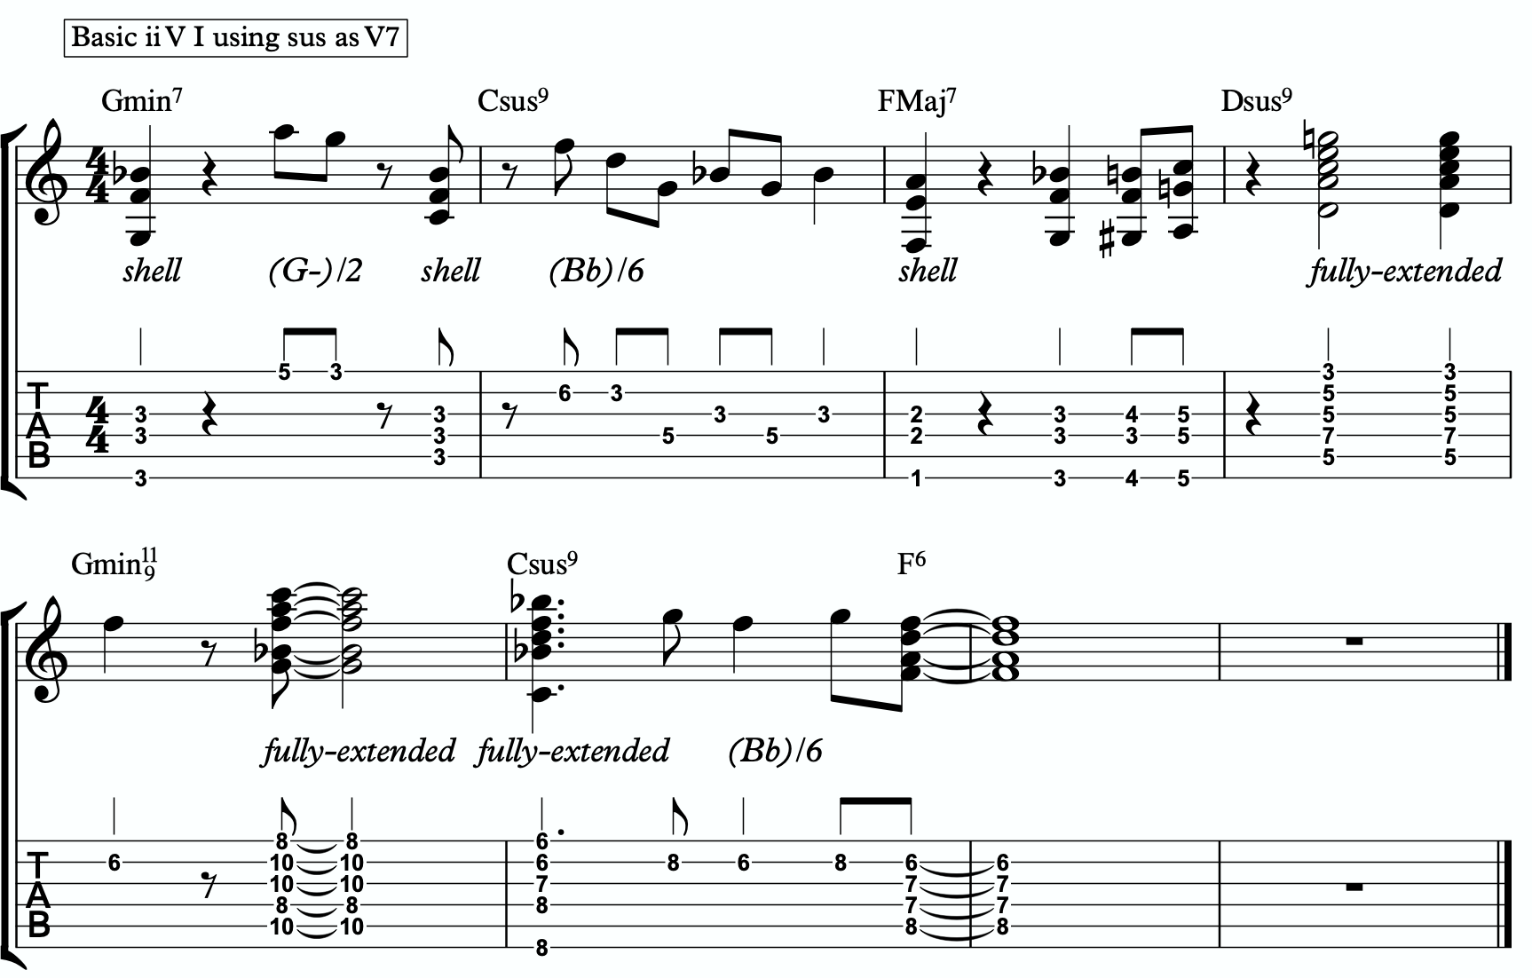
1a

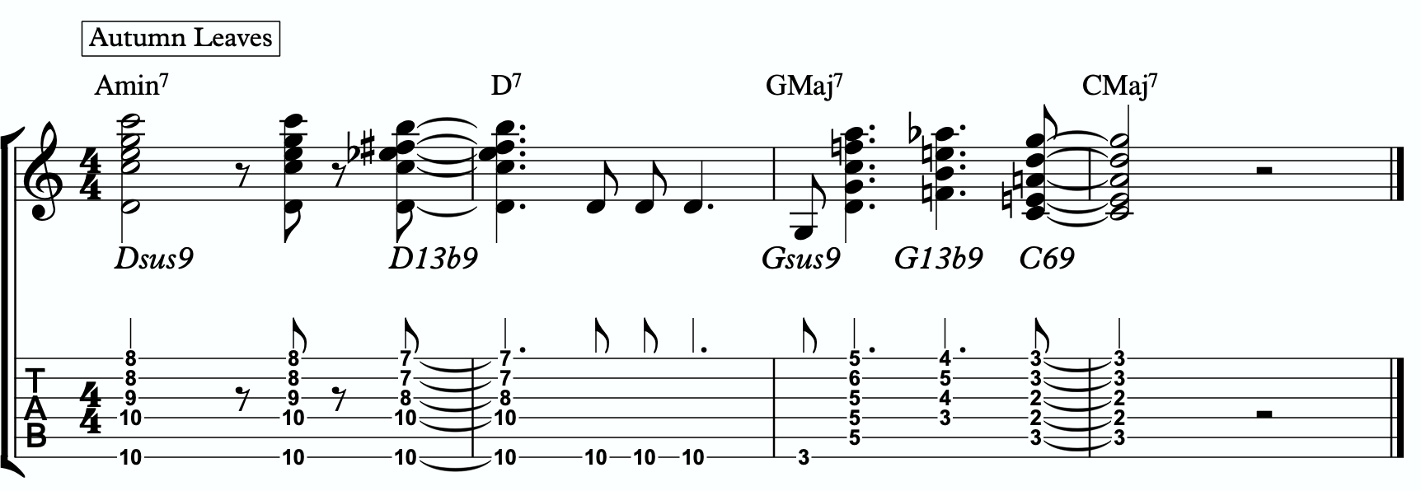
1b

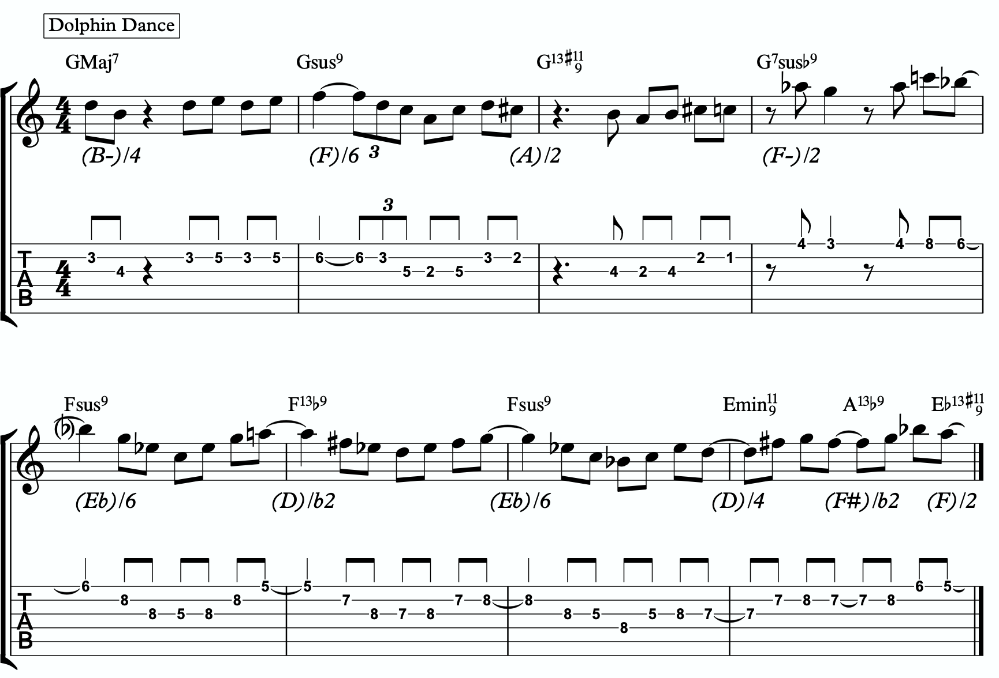
1c

ADVANCING MELODY
This section is going to look at more advanced and complex application of melodic triads to scalar ideas and arpeggios for the creation of bebop and modern jazz vocabulary based on simple structures that we can be playful with rather than memorization of riffs. Don’t be fooled by the idea of these ideas being more advanced or complicated. This doesn’t mean the music you play with these ideas will necessarily be better or more “advanced sounding” then the use of the pure primary quadratonic. In fact, often times I find that the use of the pure quadratonic can carry a level of maturity and intensity into the music that is hard to maintain when using more complicated ideas.
But, I still think it’s worth being aware of how we can build more advanced structures directly from the melodic triad.

Chromaticism Within The Quadratonic
One of the quickest ways to begin developing more complex lines is to incorporate chromaticism and leading tones within the quadratonic. By first learning to master the pure quadratonic, it should make it easier to begin spontaneously connecting individual notes within these structures in a way that will create a sense of improvisational freedom with our bebop and modern jazz playing. Playing this way will allow us to breathe long, flowing, complex lines within very the very basic, simple, steel frames of our buildings.
Here is our primary quadratonic:
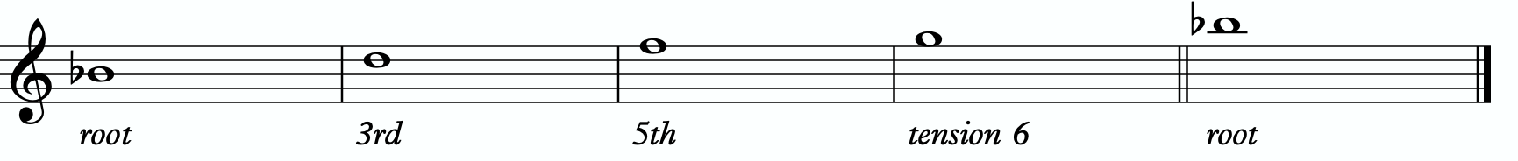

In between any of these notes, we can hang a chromatic line or place a leading tone (a note chromatically below the target) to bring us to the next note. When we use these techniques, we want to make sure that we resolve to a quadratonic note, and ideally we want to play at least two quadratonic notes immediately following the chromatic line to cement our phrase inside the tonality.

Here are an example:
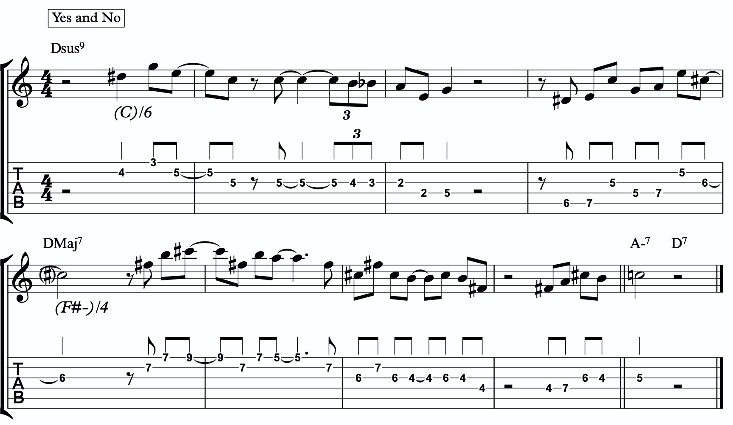
2a

Quadratonic Arpeggios
So far we have only discussed using quadratonics to develop phrases and scalar like ideas. Let’s look at how we can create the sound of arpeggios with them.
We will begin by starting on the primary tension note. After playing this note, we can move to the nearest melodic triad note and sweep quickly through that triad, landing on the tension note an octave away from where we began.
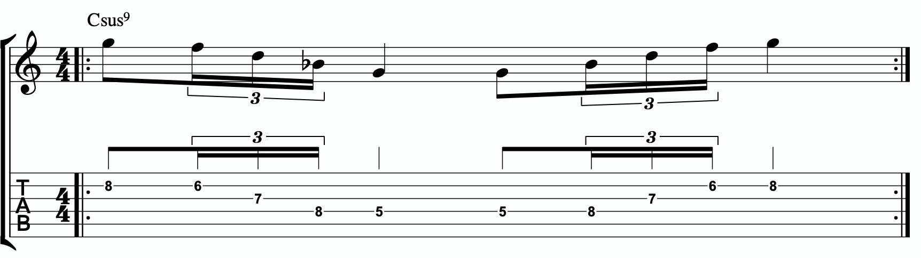
2b

We want to be able to play these ascending and descending starting on any octave of the tension note in any position of the fretboard. If we can incorporate this technique and the chromatic techniques above into our quadratonics then we are giving ourselves resolution notes, tension notes, chromatic runs, leading tones, and quick arpeggio-style runs that we can freely play within during our improvisation while remaining securely inside the color, emotion, and function of any given tonality.

Here is an example of these techniques being used together:
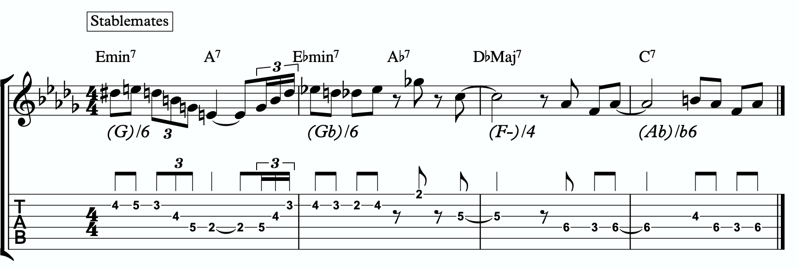
2c

DIGGING DEEPER
The goal of this section is to take small baby steps to evolve the fundamentals of melodic triads in the previous sections into new harmonic and melodic territory. If you are not already comfortable with the shell voicings, the three inversions of the pianistic voicings in all 12 keys, the primary quadratonic, and how to hear and feel the primary tension note against the melodic triad over the sus9, I would hold off and continue working on that.

FOUR NOTE VOICINGS
Let’s begin with harmony. Our first goal should be to minimize down these big, dense, pianistic voicings into something more manageable for the guitar. Four note voicings are ideal for our instrument. But sometimes it can be tough to get those colorful, pianistic type lush chords on the guitar because we just don’t have enough fingers. This is due to what I call bottom-up thinking. We are trained to think R, 3rd, etc etc. From the bottom of the chord moving upwards. By the time we get to the sweet spot notes, we’re out of fingers.
Instead, we’re going to think top-down. Our priority is the melodic triad. With these chords, the very first thing we will think about is the melodic triad. Then we are going to add one note underneath it, much like a slash chord. However, we don’t always use the root note. I usually like to try the 3rd first. But the 3rd for a sus chord is the 4th, and that’s already present. And so is the b7th. Those are the two most harmonically defining notes we have. Next would be the 5th. G. We can use that. We can also use the root if and when necessary/possible.
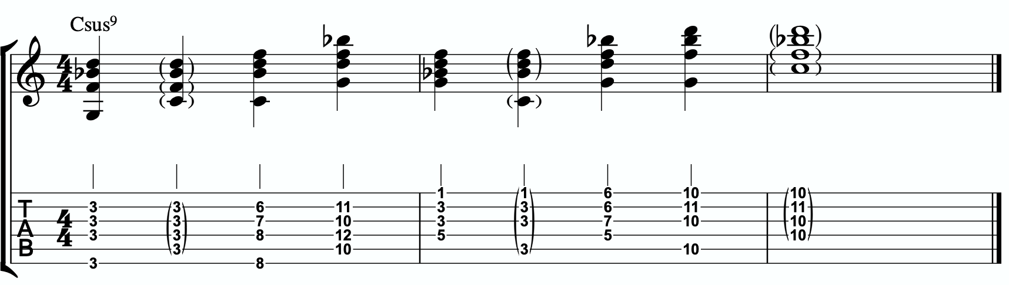
3a
Each of these voicings gives us the b7th, 9th, 4th, and either the 5th or the root of our Csus9.

THREE NOTE QUADRATONIC VOICINGS
Three note qudaratonic voicings are an incredible and special tool for us. Unlike traditional drop chords that can be practiced through all inversions, these three note chord inversions offer us some special benefits. First, they highlight the sweet spot notes and get us into the really colorful parts of the chord. Second, by ignoring one of the four notes in each voicing, we’re not simply jumbling up the same four pitches each time we invert. One pitch is always disappearing or appearing as we move through these inversion. It makes for a much more captivating series of inversions as the ear is unconsciously losing and finding pitches at every turn.
We’re going to follow the “drop 2” idea, however not in the traditional sense. When we speak about “drop 2” chords traditionally, we mean that we take the second to the top note and “drop” it down an octave. We’re not going to do that. We’re simply going to remove it from the picture.

4 |  | 4 | 3 |  | 3
3 | > |  | 2 | >
2 |  | 2 | 1 |  | 1
1 |  | 1 | 4 |  | 4

Notice that when this technique is applied, the first series of numbers is different from the second. They both share 1 and 4, but the first series has a 2 and is missing the 3 whereas the second series has the 3 and is missing the 2. If we did this for every inversion of 1 - 4, each one would be slightly different.

If we apply this to our primary quadratonic, we get this series of three note voicings for our chord.

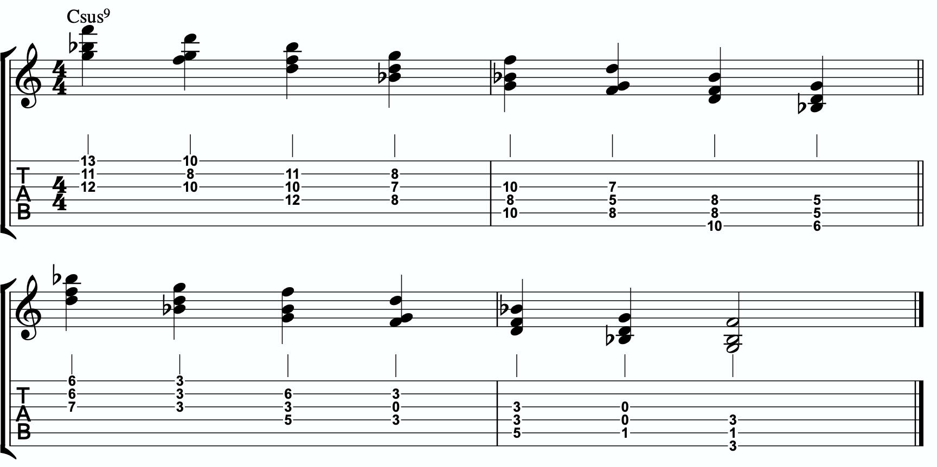
3b

QUADRATONIC SCALAR RUN
Let’s bring it back to single note ideas, melody, and improvisation. The Must Know was all about learning to hear and manipulate melodic tension and resolution using the quadratonic. But we can also use the quadratonic like a scale or an arpeggio. It seems simple because there are only four notes involved… but that’s only one note less than a pentatonic scale. And if you think about it, we only have 12 notes in western music, so if the quadratonic takes up four notes, then that’s actually ONE THIRD of all of the notes in the entire western tonal system. That’s quite a lot.
Let’s start with a scalar type run. Ideally you should already be able to hear and use the tension note and the resolution points of the melodic triad to develop beautiful, clear, authoritative phrasing that works with the harmony, and even implies it, without being stuck outlining it. Not we want to focus on developing the ability to create long, flowing, legato, fluid runs that create the impression of harmony. Traditional scales can sometimes be helpful for this, but they often times have notes that aren’t going to help define the sound of the harmony that’s happening. This quadratonic approach to a run will clear away those less essential notes.

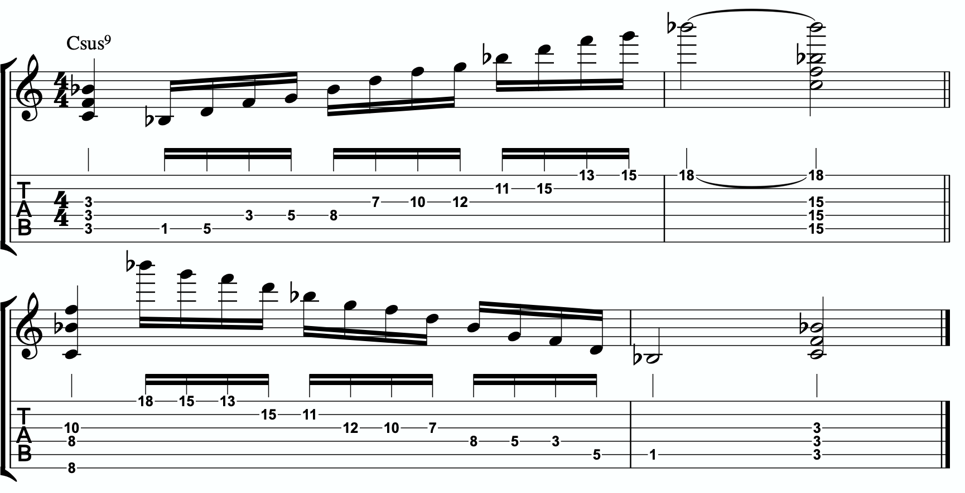
3c

THE SECONDARY TENSION NOTE & PENTATONIC SCALE
Once we can develop authentic phrases with the primary tension note and the quadratonic it gives us, and once we can see it as a scale that we can run through, we can move on and look at the secondary tension note. At this point, I recommend that you put the primary tension note on the back burner and leave it out for a while. Treat this as a whole new tension note. Go back through the ear training process and learn where it is on the fretboard, what it sounds like, how it wants to move, and how to create simple phrases with it.
In order to find the secondary tension note, we go back to Stefon’s formula.

The Hierarchy of Harmonic Importance.
3 - 7 - 5 - 9 - 11 - 13 - R
- Since we started by adding the 5th, is the 9th of C7sus in the Bb major triad?

Yes. The 9th is D, and that’s in our Bb triad. Next.
- Is the 11th of C7sus in the Bb major triad?
The 11th is the 4th. Even though we used it as the 3rd earlier, it’s present. Next.
- Is the 13th of C7sus in the Bb major triad?
The 13th is A. A is not in Bb but it gives us a tension 7. No go. Next.
- Is the root of C7sus in the Bb major triad?
The root is C. It’s not in the triad, and it causes no problems. Boom.

So our secondary tension note is C.
C is the root of C7sus, but it will be heard against the melodic triad which is Bb major. C is the 2 of Bb major, so that means our secondary quadratonic is Bb major tension 2 and it gives us this tonality’s melodic triads pentatonic scale.

/ 6, 2
Bb
Here are an example of this pentatonic scale in use:

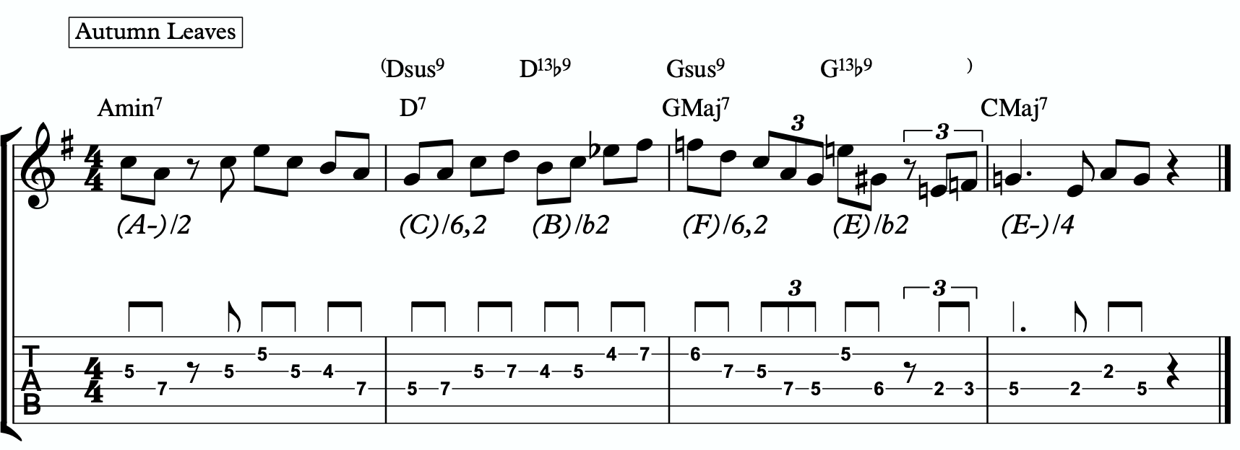
3d

THE MELODIC TRIAD BEBOP SCALE
Hopefully by now you’re starting to see the way melodic triads can offer a very direct path through all the traps of scale running, noodling, and outlining chords progression using 1 - 3 - 5 - 7 chord tones and arpeggios. All of these can be great devices (maybe not noodling), but have dangers to them.
The melodic triads approach helps us start with the sweet spot notes, and build our harmony and melodic from there. Before you start working on the melodic triad bebop scale or anything beyond this point, I strongly encourage you to make sure that you’re not simply reading these ideas like a theory book to be memorized. These are meant to infiltrate your ears, map the fretboard, and apply directly to musical situations in tunes. If you’re been studying and applying the melodic triads approach for enough time that you’re getting comfortable with it, we can take the next step. It’s only one extra note… but it’s a game changer.
In order to understand what the melodic triad bebop scale is, you need to understand what a traditional bebop scale is and the purpose for why it’s built the way it is. The standard diatonic scale is made of seven notes. The problem with playing a seven note scale is that it’s made of an odd number of pitches, so if you’re playing in 8th notes in 4/4 time, it’s going to flip itself around and start to place weak sounding notes on strong beats and strong sounding notes on weak beats.

C major scale

In music, we have strong beats and weak beats. We can see these pretty easily by looking at the beamed groups of 8th notes. There are always two of them. The first one, on the left of each group, is the strong down beat, and the second one, on the right of each grouping, is the weak up beat. We count them:

1 - & - 2 - & - 3 - & - 4 - &

That makes up one full measure of 8th notes in 4/4. The strong beats are on the number, and the weak beats are on the & (the “and”). If we look at the C major scale above, we see that it starts on the C note (very important) on a down beat. Then the next down beat, beat 2, has the E note. That’s the 3rd of CMaj… so we’re doing good. The 3rd down beat has the G note… still good. But the 4th down beat has the 7th of the scale, and then the C root note happens on the & of 4. And that puts the D note, the 2nd of the scale, on the down beat of the following measure. The following few down beats all have weak notes on them, putting the strong CMaj “chord tones” on the weaker up beats. It finally loops back around and lands on the C note on beat 4.
The traditional bebop scales took care of this problem by adding one single note. This evens it out to an eight note scale and lines up the pitches of the scale with the beats in the measure.

Some players would call this a bebop scale, or if you’re familiar with the Barry Harris method, you might call this the 6 diminished scale. Regardless, what’s important is that if you look at the strong beats, the notes spell out C - E - G - A. That’s a C6 chord. It gives

us a perfect combination of melody (the scale - with tension and resolution points), harmony (the C6 chord - the resolution points), and rhythm (the timing of getting all of the important notes to fall on the strong beats). It’s a beautiful, perfect, and very helpful scale to know.
I still rarely if ever think about, practice, or use it. Doesn’t mean you shouldn’t. But hopefully by now you’re starting to see just how powerful triads are. This scale is built around four note chords like C6 or C7, not three note triads.
But there’s a way to combine the two concepts. The pure simplicity and strength of the triad, with the rhythmic perfection of the bebop scale concept.
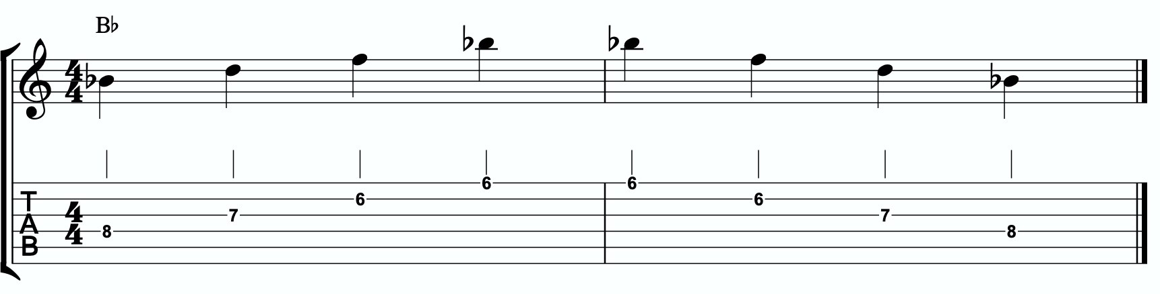
We simply add one single passing note between every triad note. Here’s one octave of a Bb major triad. Our melodic triad for Csus9.

Now I’m going to insert one passing note between each triad note. The key is to pick the passing note that best respects and defines the Csus9.

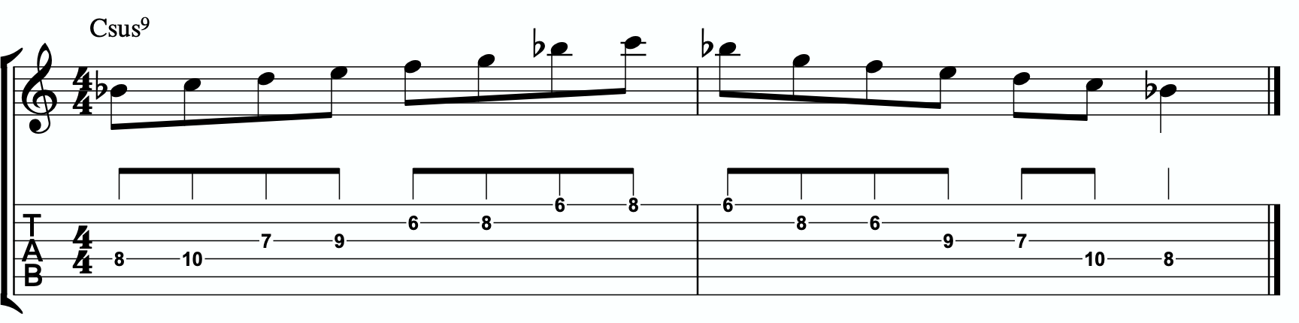

This is our melodic triad bebop scale. It’s a six note scale that helps us outline the tonality we’re working with by stabilizing the notes of our melodic triad.
Notice that it’s just a Bb major triad with passing notes. If we look at those passing notes in relationship to the Bb major triad, we get tension 2, tension #4, and tension 6. Two of the three tension notes are straight from our primary and secondary quadratonics. No, that’s not a coincidence. That’s due to the perfect nature of how triads function when we dig through harmony and melody with them. So we’re simply adding a third tension note. In this case, it’s tension #4. You could use that as a quadratonic - Bb tension #4 over a Csus9 chord. The melodic triad bebop scale gives us a rhythmically aligned “scale” but it also gives us three tension notes, each with their own unique emotional quality to them, that we can take advantage of if we don’t want to get stuck running scales and want to return to a focus on melodic tension and resolution and lyrical phrases.

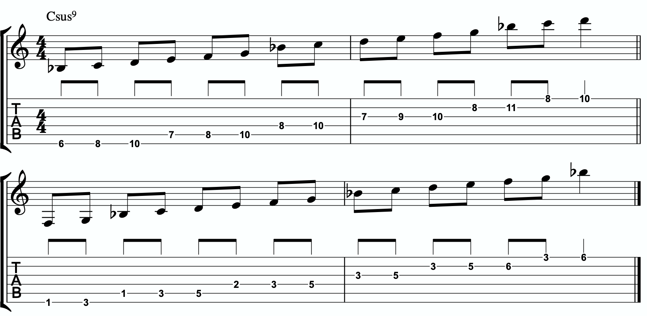
4a

Here is the same scale but harmonizing all of the melodic triad notes with our three note
quadratonic voicings:

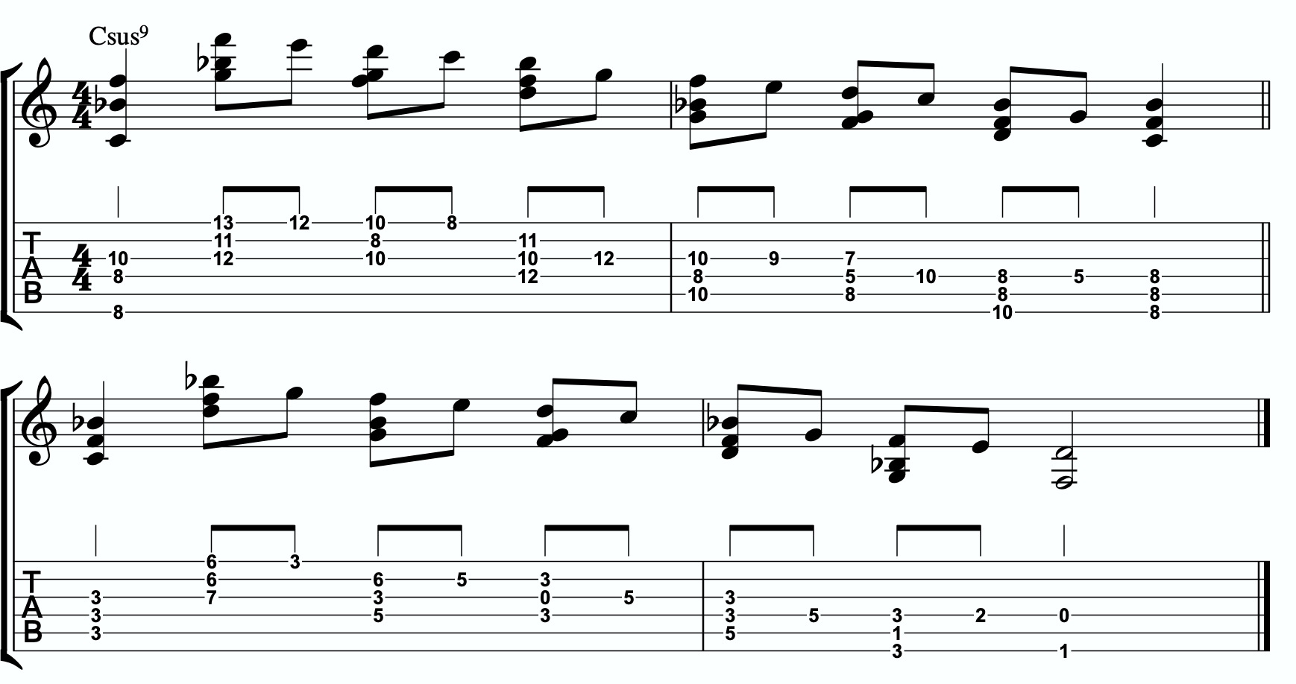
4b

ADVANCING HARMONY
We are getting into more and more advanced material now. Please remember that you do NOT need any of these continued lessons and concepts to play music. It is significantly more important that you develop your ability to be authentic, spontaneous, and playful with the material in The Must Know and then, if you feel comfortable, in Digging Deeper. Each section is building on the last, so if you’re struggling, it’s simply a check engine light to return back to earlier sections.
That said, we’re still far from a complete exploration of the depth of this one little triad.
This section we will explore some more advanced harmonic ideas. You may have heard me talk about liquid harmony. This is a way of visualizing the creation of harmony that involves movement. Think of a chord voicing like a block of ice. It’s frozen in time. We play it, we move to another chord, we move to another chord. Most of us learned to play harmony this way with a focus on shell voicings and drop chords. Liquid harmony is the idea of taking those blocks of ice and melting them down into a little. Not necessarily completely. But we want at least some of the ice to return to water so that it can flow and move. It helps free us up to transcend more static voicings, even cool sounding ones, and creates a more pianistic, movement-oriented sound. Not simply movement from one chord to another, though that’s important as well. But movement inside of a single chord. That’s what this section will explore.

HARMONIC QUADRATONICS
This is possibly the simplest, most effective, and most fun ways to create liquid harmony. The idea is that we play the primary quadratonic, but instead of thinking of it as a scale that we play with single notes, we play it as a chord. We will play three notes of the quadratonic. The tension note will be part of the chord, and it will replace the nearest melodic triad note. So the chord will be made up of two melodic triad notes and the melodic tension note. Then, while holding the two melodic triad notes and allowing them to continue ringing, we will resolve the tension note back into the triad. If we’re playing solo guitar or accompanying another musician, we may want to play the root note of the chord (“left hand”) or even the whole shell voicing. However in a full ensemble with a bass player, or if we’re playing solo and simply want a more impressionist style sound, we can leave that out and play these ideas as rootless “chords”.

Here is an example:
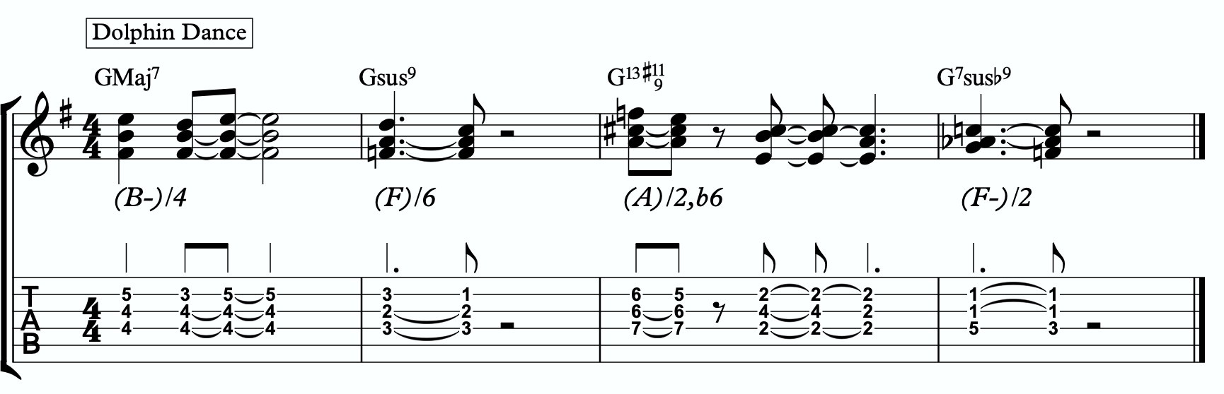
5a

Quadratonic Dyads
This is a similar concept to our quadratonic 3-note voicings, except now we’re creating 2 note grouping by pairing together every other note.

So if our quadratonic is made of Bb - D - F - G, we will group the Bb and the F together and the D and G together. And we will get this:
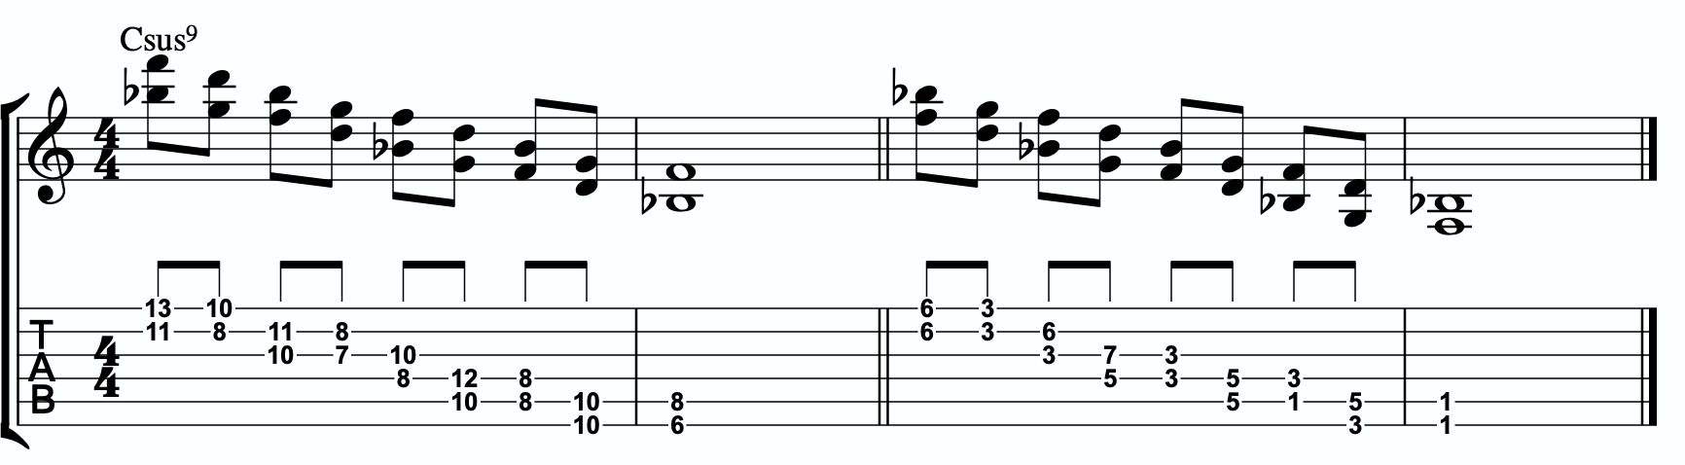
5b

TRIAD PAIRS
Sticking with our melodic triad bebop scale, we actually have our melodic triad version of triad pairs hiding right there in plain site. We know that all the resolution points are the notes of our melodic triad. But if we look at all of the passing tension notes we added, we actually have a second triad. This scale is two triads together. We have our melodic, or our “resolution” triad, and then we have our tension triad.
For this tonality, our triad pair is Bb and C.
/ C
Bb
We can of course arpeggiate these triads out to create single note ideas, but this section is specifically about harmony. So let’s look at a harmonic application for our tonality inside a chord progression.
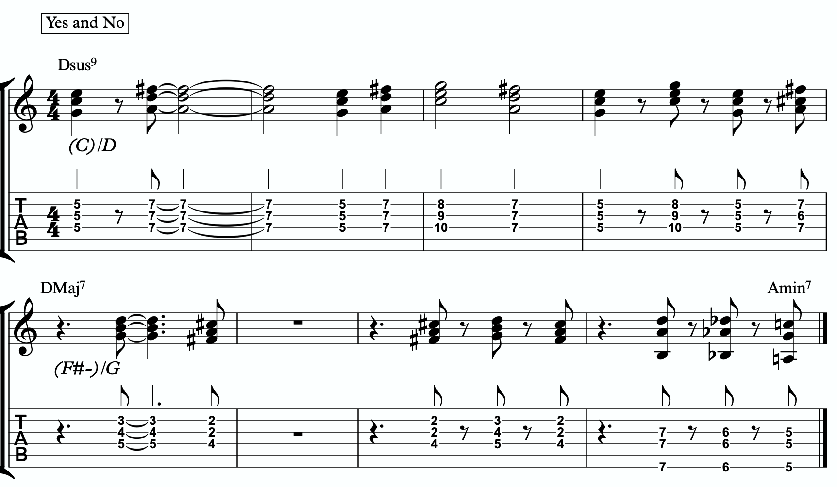
5c

Here is a dyad application, where we leave out one note from each triad.
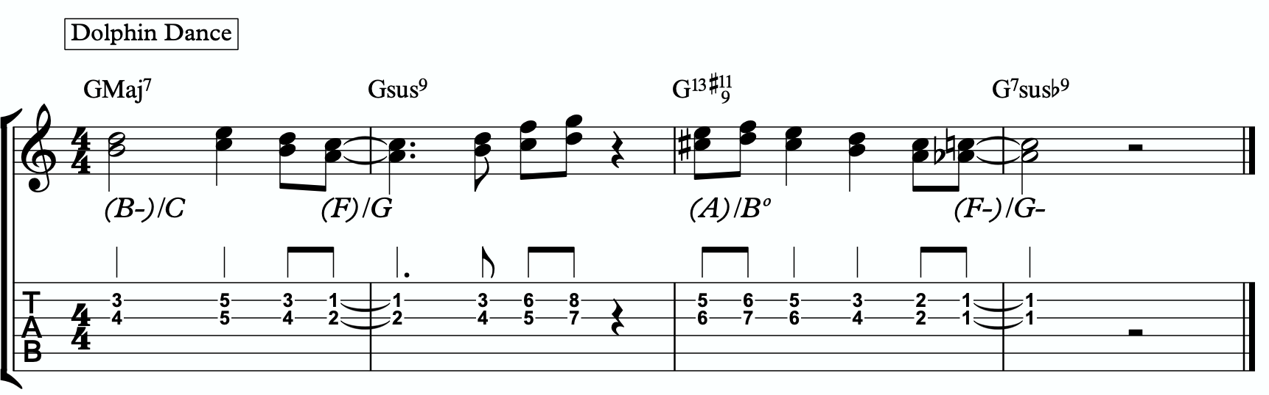
5d

TENSION LAYERS
Everything up until this section has been based on the idea that the melodic triad is the strongest organization for resolution, color, harmony, and melody. We leave the triad temporarily with different techniques to create tension, harmonically and melodically, but always in service to bring us back to rest in the resolved nature of the melodic triad.
In this section, we’re going to talk about the idea of thinking of tension as existing in layers. This way, we have different levels of tension that we can move in and out of - like rungs on a ladder that we can climb up, climb down, or simply pick one and stand still on it to enjoy the view.

LAYER ONE
This one is easy. Layer one is the primary quadratonic. The melodic triad is the most stable set of notes we have for our tonality. The primary tension note offers us a very respectful tension note to create melody. There is tension inside this quadratonic, but it’s accessible and always brings us right back into resolution. We must be comfortable making music with this sound before we can continue.

/ 6
Bb

LAYER TWO
But what if we want to move up a rung on the ladder? We know from the melodic triads bebop scale that our triad pair for this tonality is Bb major and C. So far, we have only thought of the C as a tension triad that can be used to bounce back and forth with Bb. But what if we momentarily “modulated” into the C triad to create a new rung on our ladder? Like modulating in a tune between the relative major and minor of a key, the key doesn’t actually change, but we can momentarily alter the color and the emotion.
By switching over to thinking of our tension triad, we can add a tension note to the triad and create a tension quadratonic.

The tension quadratonic, when mixed with the primary quadratonic will allow us the ability to navigate seven diatonic notes melodically and harmonically in a structured and authoritative way that will imply the harmony, give multiple colors and layers of tension, and allow for six different resolution points within any tonality. That’s half of all of our available pitches.

How do we chose the primary tension note for our new tension quadratonic?

We go back to the hierarchy of harmonic importance. What’s the next chord tone from the hoh? We can account for the root, 3rd, 5th, 7th, 9th, and 11th (or 4th). But we haven’t yet used the 13th. So that’s going to be the tension note for our tension quadratonic.
The 13th of C7sus is A. If we add an A note against our tension triad, C major, we get this four note structure - C, E, G, A. That’s a C major triad with a tension 6.

/ 6
C

This quadratonic will sound less “in” than the primary quadratonic, however the tension note in it will give it a sensation of tension and resolution within itself.

Here are some examples of this quadratonic pair being used harmonically and melodically:
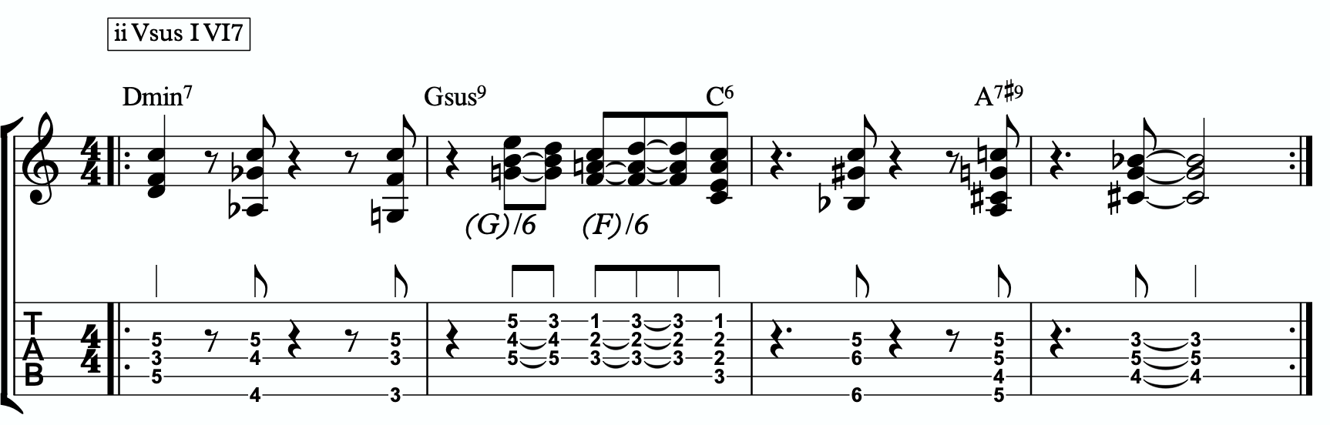
6a

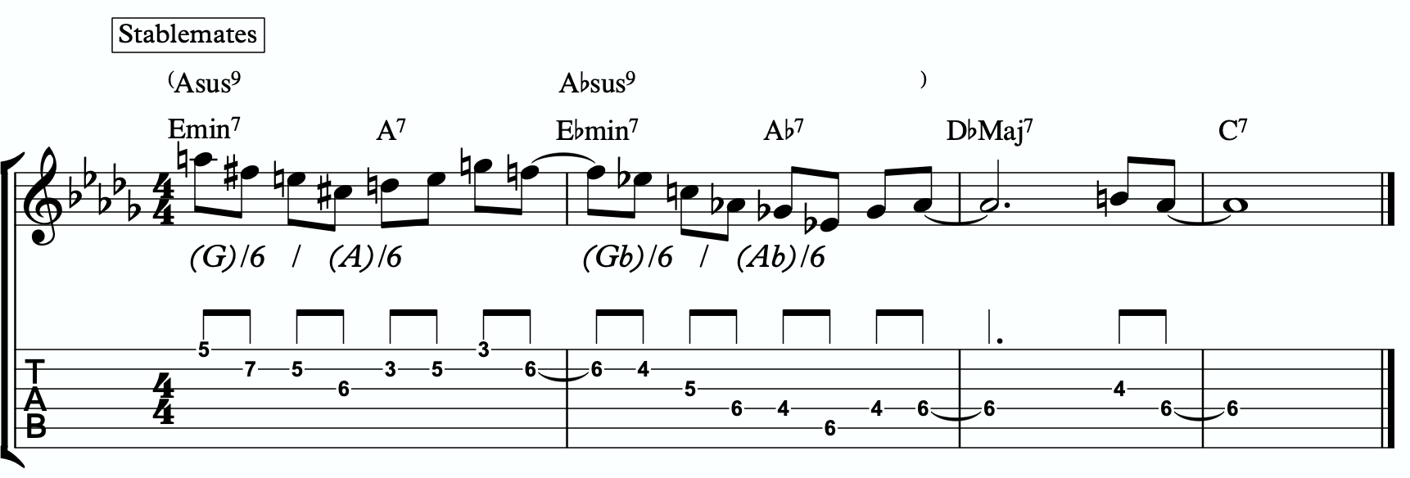
6b

Harmonizing Our Bebop Scale With Tension Layers

Let’s look at our six note melodic triad bebop scale and harmonize it using our quadratonic pairs. We will do this using two different techniques brought up earlier in this study booklet. First, we will move through the bebop scale using our harmonic quadratonics to create liquid harmony within each voicing as we move between the two quadratonics to harmonize each note. Finally, we will apply the three note quadratonic voicing to the bebop scale.

Harmonic Quadratonics & Liquid Harmony
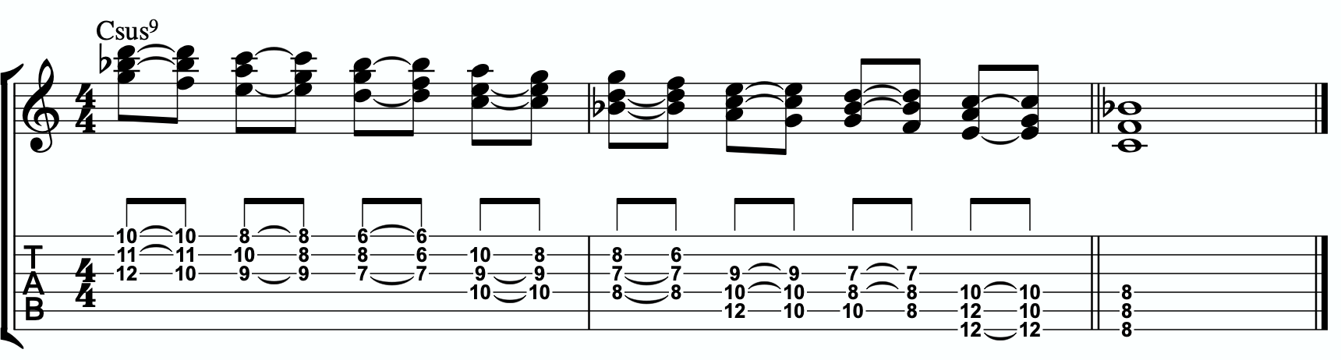
6c

Three Note Quadratonic Voicings
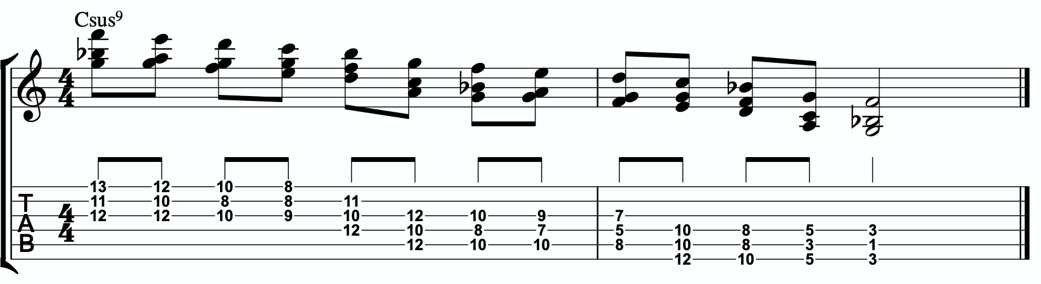
6d

THE OUTRO
I just want to personally thank you for working through these ideas. I am obsessed with exploring, mapping out, and demystifying jazz harmony and melody, and attempting to understand it and execute it using the simplest and most fundamental ingredients in music. I’ve found over many years of playing and study, and learning from some of the greatest minds in the jazz world today, that it’s often times our ego and our own self- inflicted limitations that hold us back the most from growing and evolving towards our potential.
The most dangerous words to development of our musicianship are, “I already know that.”
Most of us generally spend a couple of music theory classes learning our triads. Maybe we read a book about advanced triad application and get some cool intellectual ideas to play with. But for me, it’s all about that Bill Evans quote.
**********************************

The whole process of learning the facility of being able to play jazz is to take these problems from the outer level in, one by one, and to stay with it at a very intense, conscious-concentration level until that process becomes secondary and subconscious. Now, when that becomes subconscious, then you can begin concentrating on that next problem, which will allow you to do a little bit more.

I don’t consider myself as talented as many people but in some ways that was an advantage because I didn’t have a great facility immediately so I had to be more analytical and in a way — that forced me to build something.
Most people just don’t realize the immensity of the problem and, either because they can’t conquer it immediately, think that they haven’t got the ability, or they’re so impatient to conquer it that they never do see it through. If you do understand the problem then you can enjoy your whole trip through.

People tend to approximate the product rather than attacking it in a realistic, true way at any elementary level — regardless of how elementary — but it must be entirely true and entirely real and entirely accurate. They would rather approximate the entire problem than to take a small part of it and be real and true about it. To approximate the whole thing in a vague way gives you a feeling that you’ve more or less touched the thing, but in this way you just lead yourself toward confusion and ultimately you’re going to get so confused that you’ll never find your way out.

It is true of any subject that the person that succeeds in anything has the realistic viewpoint at the beginning and [knows] that the problem is large and that he has to take it a step at a time and that he has to enjoy the step-by-step learning procedure. They’re trying to do a thing in a way that is so general [that] they can’t possibly build on that. If they build on that, they’re building on top of confusion and vagueness and they can’t possibly progress. If you try to approximate something that is very advanced and don’t know what you’re doing, you can’t advance.

**********************************

Was Bill referring to melodic triads? I very highly doubt that. I’ve never heard him talk much about triads. But consider the underlying philosophy he’s pointing at. Know the

basics. Regardless of how elementary! But it must be entirely true, real, and accurate. Be able to play genuine, authentic music using the most fundamental ideas first. Then it leaves room to grow.
This is why I refer to the first section in this ebook as The Must Know. It’s a basic shell voicing, and a basic triad. And while these two concepts are as simple as they come in music, we must understand them in a true, real, and accurate way. If we did this for a handful of tonalities, we could play beautiful music for the rest of our lives, and for me, I would feel fulfilled. It would offer emotion-driven, precise, human, lyrical melody combined with lush, colorful, pianistic harmony. Mix in a strong sense of time and feel, and that’s everything a jazz musician needs.
But like Bill talks about, when we don’t try to approximate but instead start with the elementary ideas and build a foundation with them, then it gives us room for growth. Look at everything we worked through together in this ebook! All built from one triad and how it relates to one chord (piano diagram!). As of the time of putting this together, I’m still working on many of these ideas myself… and I’m still coming up with new ways of building harmony and melody around the melodic triad.
This is why I can’t recommend enough, even to the intermediate and advanced players out there - spend some serious time in The Must Know section. Own it. Be able to play authentic ideas with it. Apply it to tunes. Move it through the circle of 5ths. Do whatever you can to internalize it and develop your ears to it. Then you can begin moving on. I would encourage everyone… peak ahead if you would like to to keep an eye on where this particular path is heading, but be very self-aware and learn to see when you’re getting in over your head. When this happens, not if, just take a deep breath and back up a few sections. It simply means your foundation isn’t quite strong enough yet to carry the weight of those more complex ideas. If you want it, and you put the time and effort it, you’ll get there.
Like one of my students always likes to tell himself at the end of our lessons…..
“Easy does it. But do it.”

Thank you again. Don’t forget to come and hang in our open office hours to ask questions if you’re confused on anything.
Happy Practicing!
-Jordan Klemons

The Melodic Triads Study Group

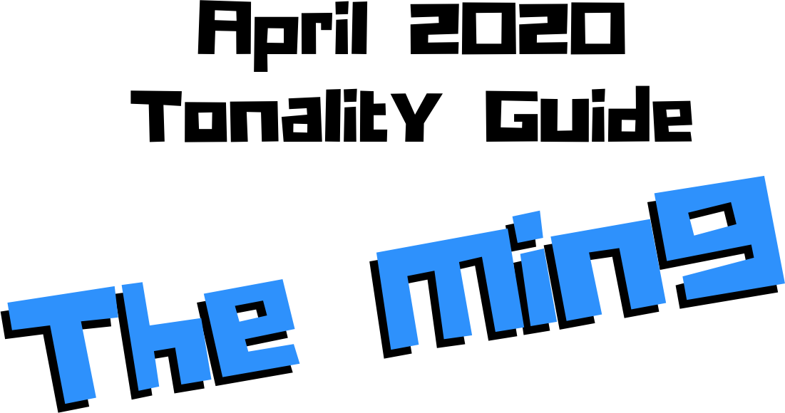

Jordan Klemons
NYC Jazz Guitar Masterclasses

CONTENTS
-INTRODUCTION
-THE MUST KNOW-
-ADVANCING MELODY-
-DIGGING DEEPER-
-THE MELODIC TRIAD BEBOP SCALE-
-ADVANCING HARMONY-
-TENSION LAYERS-
-OUTRO-

This ebook is the copyrighted property of Jordan Klemons. All images, information, layout, and designs belong to Jordan Klemons. This document may not be altered, reproduced, distributed, or transmitted in any form or by any means without the prior written permission of the author.

INTRODUCTION
Thank you for downloading the pdf materials for this month’s melodic triads tonality study guide. Inside you will find all of the supplemental theory, notation, tab, charts, concepts, and examples for the accompanying videos to help you develop your understanding, your ear, your emotional connection with, and your sense of harmonic and melodic freedom within this month’s tonality… as well as its use in some short, common, jazz chord progressions that you will be able to immediately implement in your own playing.
The information in this guide is dangerous. I mean that literally. When the process is respected, and you understand how all of these ideas fit into the puzzle, this guide and the baby steps included can offer tremendous insight into how to begin making real music very quickly, and how to continue evolving and growing as a player for many years to come. However, if approached in the wrong way and the process is not respected, these ideas can confuse and derail a musician’s ability to progress. It’s important not to jump too far ahead of yourself. The advice that a Miles, or a Scofield, or a Coltrane would give to a beginner is different than what they would give an intermediate or to an advanced player. And all of that would be different than how they would talk to a professional who’s already playing on their level. This is important to remember.
This guide is meant to show many different layers of musical growth and how, when using the melodic triad approach, they can all be boiled down and viewed simply as an extension of the most basic elements of music. Namely… a triad. Think of the pages that follow as an architect’s blue prints for a skyscraper. If you haven’t built a strong foundation, your skyscraper will fall. If you attempt to skip the first 50 stories and jump to building the penthouse, the skyscraper will fall. If you try to put up the fancy exterior of the building before you complete the steel frame, the skyscraper will fall. Yes, the information all the way at the end of this guide is constructed using the same ideas and concepts that are presented in the first chapter, but the process must be respected for anything to work. Otherwise it will only leave you confused, frustrated, feeling like a failure, and wanting to give up. Be patient with yourself. The short cut IS the long road. Take it. Spend two or three months working on the long road and watch how much you progress. Focus on your sound, on your ear, and on your musicianship… and trust that the simplicity of the ideas and the process itself will take care of you. They will. But only if you respect them. It’s like a relationship - you have to be present and give of yourself, and then you will receive in abundance.

As you work through these pages, try to keep in mind this Bill Evans’ quote from The Universal Mind.

**********************************

The whole process of learning the facility of being able to play jazz is to take these problems from the outer level in, one by one, and to stay with it at a very intense, conscious-concentration level until that process becomes secondary and subconscious. Now, when that becomes subconscious, then you can begin concentrating on that next problem, which will allow you to do a little bit more.

I don’t consider myself as talented as many people but in some ways that was an advantage because I didn’t have a great facility immediately so I had to be more analytical and in a way — that forced me to build something.
Most people just don’t realize the immensity of the problem and, either because they can’t conquer it immediately, think that they haven’t got the ability, or they’re so impatient to conquer it that they never do see it through. If you do understand the problem then you can enjoy your whole trip through.

People tend to approximate the product rather than attacking it in a realistic, true way at any elementary level — regardless of how elementary — but it must be entirely true and entirely real and entirely accurate. They would rather approximate the entire problem than to take a small part of it and be real and true about it. To approximate the whole thing in a vague way gives you a feeling that you’ve more or less touched the thing, but in this way you just lead yourself toward confusion and ultimately you’re going to get so confused that you’ll never find your way out.

It is true of any subject that the person that succeeds in anything has the realistic viewpoint at the beginning and [knows] that the problem is large and that he has to take it a step at a time and that he has to enjoy the step-by-step learning procedure. They’re trying to do a thing in a way that is so general [that] they can’t possibly build on that. If they build on that, they’re building on top of confusion and vagueness and they can’t possibly progress. If you try to approximate something that is very advanced and don’t know what you’re doing, you can’t advance.

**********************************

I’ve setup the material in these tonality lessons to start with the most basic and fundamental elements of music, and to grow outwards in complexity. Everything builds on what came before it, so everything is connected. You DON’T need to master everything in these lessons to play music. You only really need the first section and a little bit of creativity and concern for your sound - that’s enough to create something beautiful..
I recommend that if you’re new with us, even if you’re already an advanced player, you begin focused entirely on the first section of this guide, The Must Know, and give yourself a minimum of 3 - 6 months to get used to this method and the initial concepts presented. It’s a very different approach to standard theory, and your goal should be (as Bill Evans said) to be able to make genuine, authentic music with the ideas in the first section. Once you feel you can hear and play music using these ideas on a small handful of tonalities and applied to some tunes, then it is time to start advancing forward.

I would continue giving yourself an addition 3 - 6 months for each subsequent section, as each builds on the last and becomes more and more advanced… starting from the most basic and simple ingredients, and eventually working our way up to learning to hear and use all 12 notes of the western chromatic scale harmonically and melodically over any chord in a musical way.
I strongly recommend that you follow this rough timeline. I believe it’s the most effective way to cut through the learning process and get straight to making beautiful music, and then to set yourself on the path to continue growing and building for years to come.
The melodic triad ideas I’m working on today, I didn’t even know they existed during the first few years of my own studies. As we grow and progress and get comfortable, we can naturally start to evolve the ideas into more advanced applications. That’s the beauty of starting with the fundamentals, learning to make genuine, authenticate music from our own self first… and then building layers of complexity on top of, but always connected to, those very fundamentals. Much like a large skyscraper building starts with a huge hole in the earth, then is filled with concrete and steel, and then the steel frame will hold the building as it goes up. We won’t see any of these structures. But without them, the building would collapse. Only once the structure is there can the work of putting up the exterior, the glass, the interior, the design, the furniture, etc. take place.
Thank you again for downloading this study guide and working on your music with us. I look forward to hearing your playing and your contributions to the melodic triad conversation inside our facebook group, and for those of you subscribed to our Private Community, inside our melodic triad mastermind group.
Happy Practicing!
Your friend on the path towards jazz guitar mastery,
-Jordan Klemons

The Melodic Triad Study Group - a part of
NYC Jazz Guitar Masterclasses

THE MUST KNOW
The theory, ideas, voicings, and “scalar” ideas presented in this section may seem too simple and elementary to be of value. But I urge you, even the intermediate and advanced players - do not skip this section. I recommend that if you’re within the first 3 - 12 months of study with us that you focus entirely on learning to apply these ideas to musical situations. You can skim the rest of the pages if you’d like, but this should be where you build from. After close to 25 years of playing music seriously, I still spent my first year of working on melodic triads only on this material. The great thing about these ideas is that not only can you comp, improvise, compose, and arrange beautiful music over standards, bebop, modern jazz, and original works with them, but they also act as the foundation on top of which we can grow into more and more complex ideas without ever leaving behind these basic building blocks of harmony and melody.
Do not simply see these as intellectual theory ideas. These are meant to be internalized. To understand the theory is great. To hear the sounds in your ear with a sense of familiarity is just as important. To connect with them personally and be able to hear and express emotion through them is of the utmost importance when it comes to developing our musicianship. This should be the goal.

THEORY
The min9 reminds me of that famous Dexter Gordon photo used as the cover of his album Ballads. It’s dark, soulful, bluesy, smokey, and just one of the coolest and most laid back energies we have. It’s like hanging in a NYC jazz club, in a dark basement with no windows, filled with smoke, everyone wearing sunglasses and dressed nice, and a killer band is laying in deep to the music. Even though it contains the min7 in the “left hand,” it can be used as a minor tonic chord, but it’s not quite as old school and traditional as the min6. It makes a great ii chord. We do NOT want to use it for a iii chord. And we have to be very careful with using it as a vi chord, as it will require a different set of quadratonics.

What makes up a Cmin9 tonality?
Two basic ingredients.
- A basic Cmin7 chord
- A G minor triad
A good way to think of this is to visualize a piano player with two hands. Their left hand would be playing C-Eb-Bb (a basic Cmin7 shell voicing) and their right hand would be playing a G minor triad.

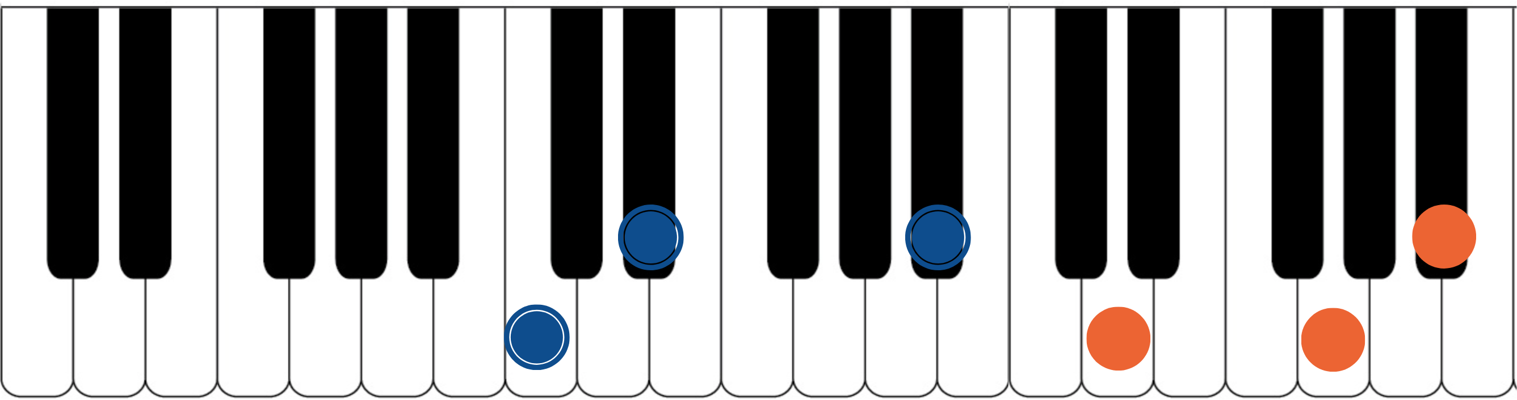

The blue dots would represent the fingers of the piano player’s left hand. Notice they spell out C, Eb, and Bb. That’s the 1, b3, and b7 of a basic Cmin7 chord. We call that a shell voicing. The orange dots represent the piano player’s right hand. They spell out D, G, and Bb. That’s a G minor triad. If you have access to a piano or keyboard, I strongly encourage you sit down and play these six notes simultaneously. Listen to how big of a sound they create together. Play it a few times. Try and feel the emotion and the color they create together. Then remind yourself of the elementary and simple nature of what’s happening in each of your two hands separately. A basic chord in your left hand. A basic triad in your right hand. The magic happens when we use these sounds together… and when we begin to build chord voicings and melodic ideas around these two simple sounds.

***This G minor triad, which is now our melodic triad, is built on the 5th of Cmin7… ‘G’ is a 5th up from ‘C’. This relationship is critical to understand and memorize as it will allow us to transpose this min9 tonality into any key quickly. We will notate this as

‘t5’. This notation comes from Stefon Harris. The ’t’ is short for ‘triad’ and we make it lower case to notate that it’s a minor triad. The 5 tells us that the melodic triad is built on the 5th of the harmony. So if we want a Gmin9, we think t5, we find the 5th of G (which is D), and we know that the melodic triad is D minor.***

This pianistic chord construction is the starting point for everything we are going to look at together. Hidden inside of this six-note chord is a universe of potential harmonic and melodic ideas. The following pages can all be traced back to this construction idea. Basic chord, basic triad. Left hand, right hand. Harmonic structure, melodic structure. Hence the term… melodic triad. Even if you don’t have access to a piano, I encourage you to sit and think about this diagram until it makes sense to you.

GETTING THE PIANISTIC VOICINGS ONTO THE GUITAR
Taking the concept of the piano construction, where the Cmin7 shell is always underneath the G minor triad, we can develop three basic inversions of this chord by inverting the G minor triad and keeping the Cmin7 shell underneath it.
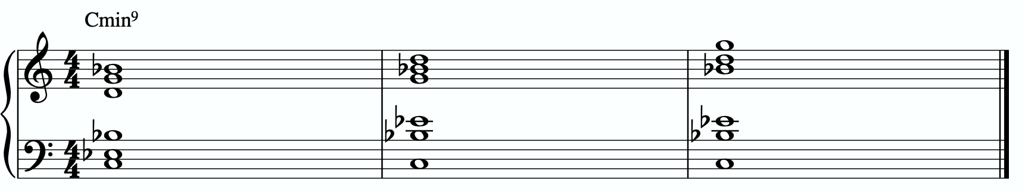
In order to get these three inversions, we will use the piano -> guitar technique described in the video - where we put the shell voicing on the bottom three strings and the triad inversions on the top three strings. This will give us a three “pianistic” inversions of this tonality on the guitar.
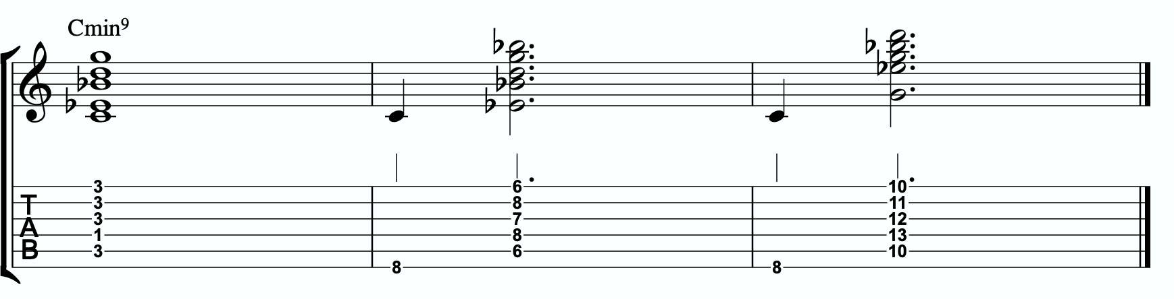

Notice the three basic inversions of the G minor triad on strings 1 - 3.

A few exceptions are being made here.
In measure 1, due to the physical limitations of the guitar, we can’t get the full shell voicing AND the full melodic triad. We have to share the Bb note on the 3rd string. That Bb is the b3 of the G minor triad and the b7 of the Cmin7 shell. That’s why this is a five, and not a six, not voicing.
In measure 2 we also can’t play all six notes here… even though they’re all available in this position. It’s physically not possible to play them at the same time, at least for me. If you can pull it off, go for it! If not, try it the way I do. Play the root note first, then fill in the voicing which contains the m3 and b7 of Cmin7 in the bottom two voices, and the G minor triad on top.

In measure 3 we also need to break the chord apart. So we play the root note first, and then we play the remaining five notes. However this time we’re subbing in the 5th of Cmin7 in place of the b7 in the shell voicing, as it’s not possible to play Eb, Bb, and the G minor triad all at the same time. At least not for me.

THE PRIMARY QUADRATONIC
Because this particular type of Cmin7 contains a G minor triad in the right hand, that G minor triad is going to be the foundation of our melodic structures. It governs everything. Rather than simply behaving as the chord tones that they correspond to harmonically, when used melodically, they will function as the 1, b3, and 5 of our melody… the strongest and most stable resolution points we can build lines with.
The ideal starting point is our primary quadratonic. A quadratonic is a triad that has one additional note added to it. It’s a four note structure made up of three stable notes (the melodic triad) and one ‘free radical’ or melodic tension note. This extra note serves two functions. First, it’s there to create melodic tension that will help us create movement, emotion, and lyrical phrases without getting trapped inside running scales or chord tones. Second, it will help imply the sound of the harmony we’re playing over and glue the melodic triad inside the chord so they don’t sound like two separate sounds, but rather one unified, colorful tonality.
We only have 12 notes in western music, and three of those 12 are being used in our melodic triad. That means we only have nine possible melodic tension notes. All nine of these could be used to create melodic tension against our triad. But some will help imply

the sound of our original harmony better than others. Our primary quadratonic will be made of our melodic triad and the primary tension note - or the note the most respects the basic harmony.

Straight from Stefon Harris’ brilliant mind comes this rule that will help us figure out what are the most important notes:

The Hierarchy of Harmonic Importance.
3 - 7 - 5 - 9 - 11 - 13 - R

These are the chord tones of our basic harmony (the left hand of our piano player).

Here’s how this works:
- Is the 3rd of Cmin7 in the G minor triad?
No. The 3rd is Eb. But adding a Eb to G minor creates an Eb major triad. So skip.
- Is the 7th of Cmin7 in the G minor triad?
Yes. So skip.
- Is the 5th of Cmin7 in the G minor triad?
Yes. So we skip.
- Is the 9th of Cmin7 in the G minor triad?
The 9th is D, and that’s in the G minor triad. So we skip.
- Is the 11th of Cmin7 in the G minor triad?
The 11th is F and isn’t in G minor triad. But it creates a Bb major triad when added to G minor (G - Bb - D - F). Skip.

- Is the 13th of Cmin7 in the G minor triad?
The 13th is A. A is not in the G minor triad. We can use this.

So our primary tension note is A.
This A - while the 13 of Cmin7 - is going to be heard by the ear in relationship to the G minor triad. Since A is the 2nd of G, we will call this tension 2. So our primary quadratonic is G minor tension 2.
We’ll notate this as:
/ 2
G-

By making the triad bold and circling it, it draws our eye directly to the melodic triad so we can think first about our strong resolution points, then it quickly lets us know what our primary melodic tension note is.

At this point your primary goals should be to be able to play the three pianistic voicings, to be able to visualize the primary quadratonic over the basic shell voicings on the fretboard, to develop your ears to hear the melodic tension note wanting to move and the root note of the melodic triad as melodic ‘do’ - or the root note of the melody.

Here are some examples of these fundamental voicings and melodic ideas being used in music situations.

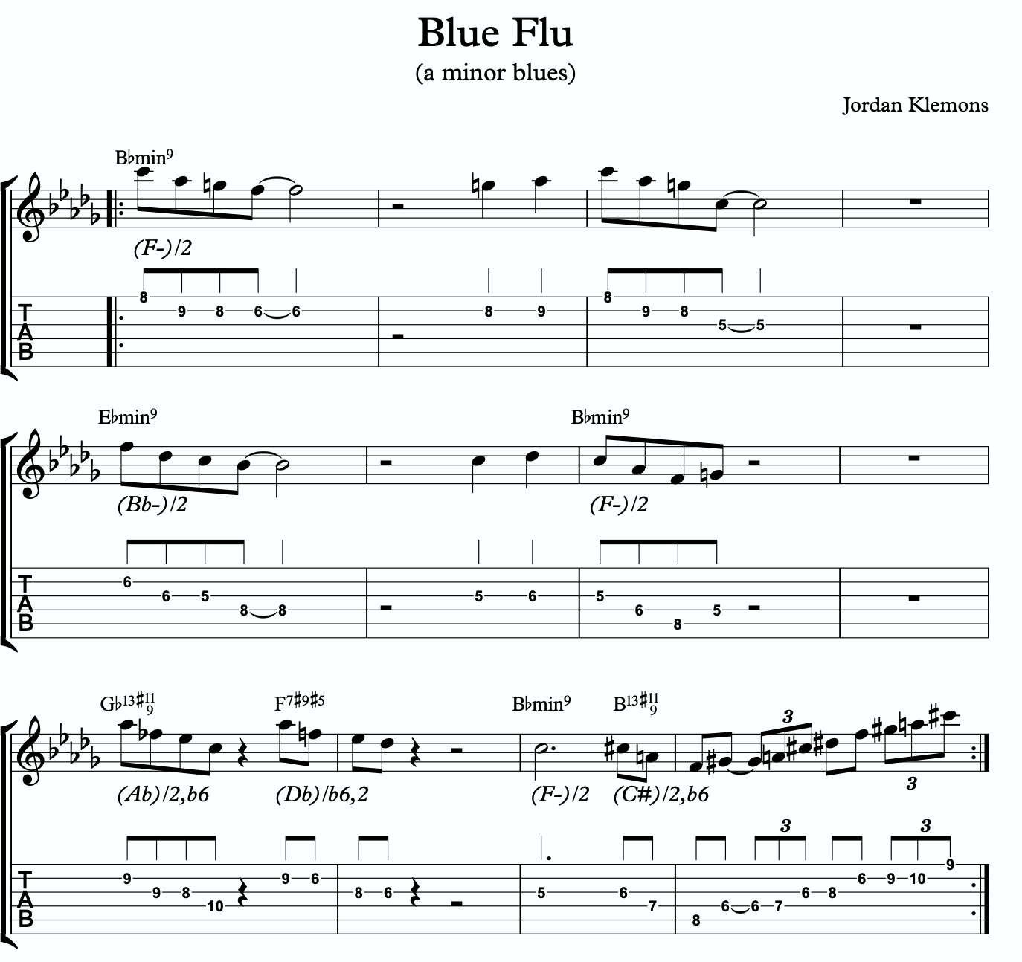
1a
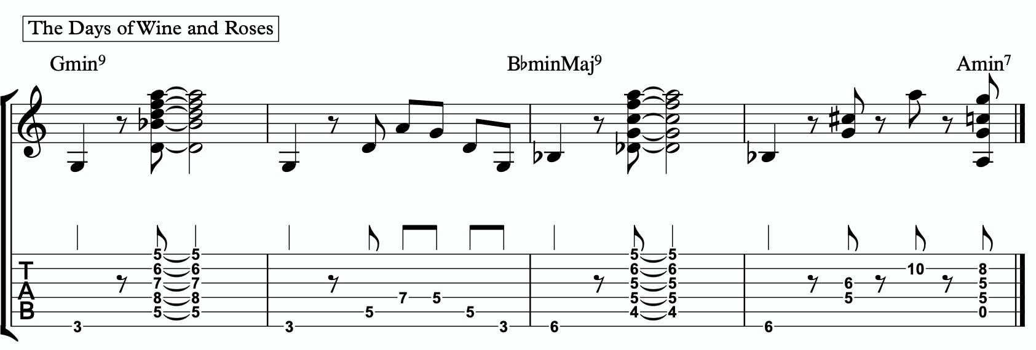
1b

ADVANCING MELODY
This section is going to look at more advanced and complex application of melodic triads to scalar ideas and arpeggios for the creation of bebop and modern jazz vocabulary based on simple structures that we can be playful with rather than memorization of riffs. Don’t be fooled by the idea of these ideas being more advanced or complicated. This doesn’t mean the music you play with these ideas will necessarily be better or more “advanced sounding” then the use of the pure primary quadratonic. In fact, often times I find that the use of the pure quadratonic can carry a level of maturity and intensity into the music that is hard to maintain when using more complicated ideas.
But, I still think it’s worth being aware of how we can build more advanced structures directly from the melodic triad.

Chromaticism Within The Quadratonic
One of the quickest ways to begin developing more complex lines is to incorporate chromaticism and leading tones within the quadratonic. By first learning to master the pure quadratonic, it should make it easier to begin spontaneously connecting individual notes within these structures in a way that will create a sense of improvisational freedom with our bebop and modern jazz playing. Playing this way will allow us to breathe long, flowing, complex lines within very the very basic, simple, steel frames of our buildings.
Here is our primary quadratonic:
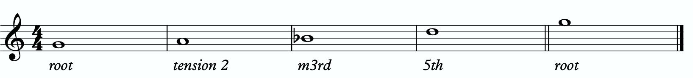

In between any of these notes, we can hang a chromatic line or place a leading tone (a note chromatically below the target) to bring us to the next note. When we use these techniques, we want to make sure that we resolve to a quadratonic note, and ideally we want to play at least two quadratonic notes immediately following the chromatic line to cement our phrase inside the tonality.

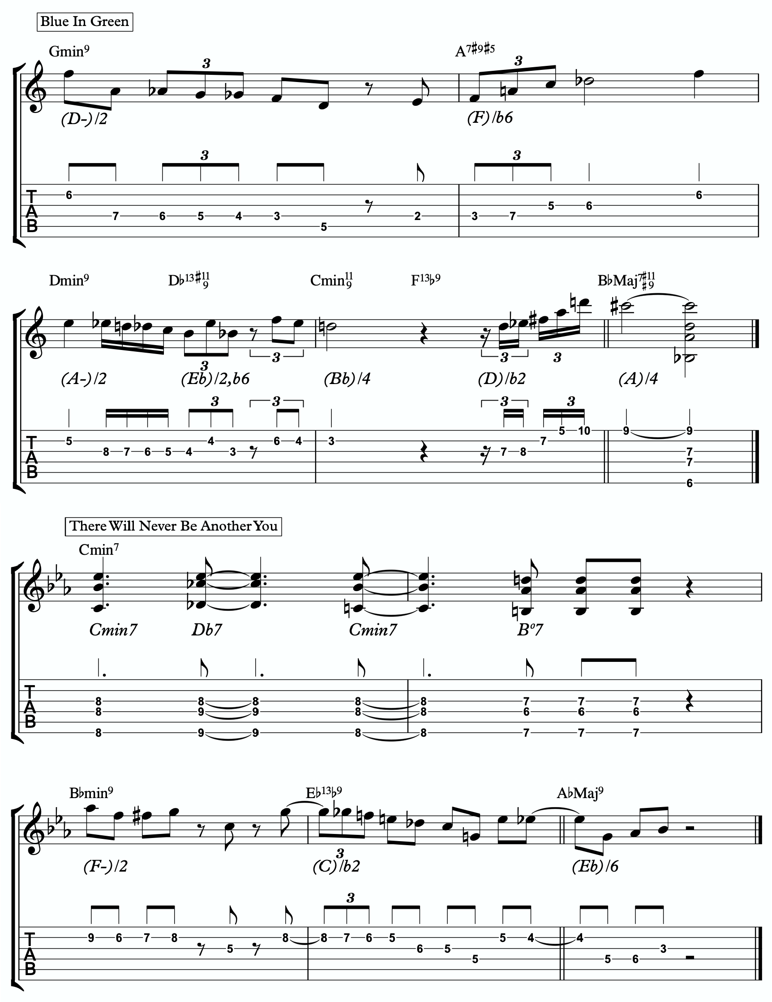
Here are some examples:

2a

2b

Quadratonic Arpeggios
So far we have only discussed using quadratonics to develop phrases and scalar like ideas. Let’s look at how we can create the sound of arpeggios with them.
We will begin by starting on the primary tension note. After playing this note, we can move to the nearest melodic triad note and sweep quickly through that triad, landing on the tension note an octave away from where we began.
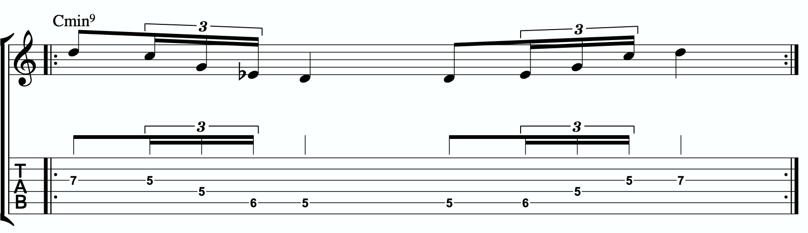
2c
We want to be able to play these ascending and descending starting on any octave of the tension note in any position of the fretboard. If we can incorporate this technique and the chromatic techniques above into our quadratonics then we are giving ourselves resolution notes, tension notes, chromatic runs, leading tones, and quick arpeggio-style runs that we can freely play within during our improvisation while remaining securely inside the color, emotion, and function of any given tonality.

Here is an example of these techniques being used together:
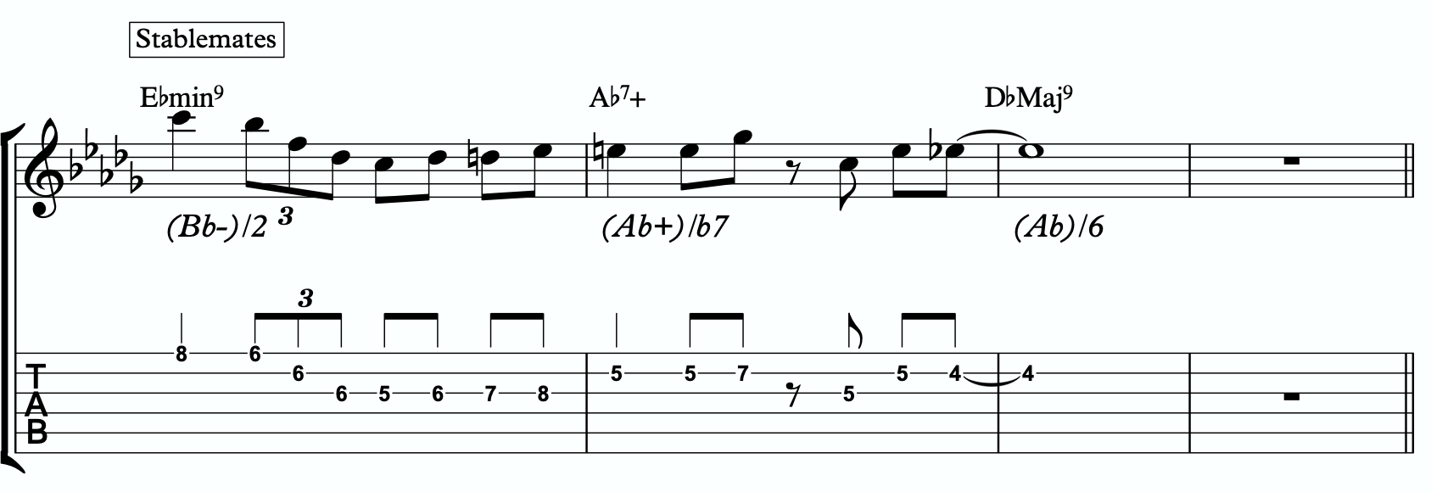
2d

DIGGING DEEPER
The goal of this section is to take small baby steps to evolve the fundamentals of melodic triads in the previous sections into new harmonic and melodic territory. If you are not already comfortable with the three inversions of the pianistic voicings in all 12 keys, the primary quadratonic, and how to hear and feel the primary tension note against the melodic triad over the minMaj9, I would hold off and continue working on that.

FOUR NOTE VOICINGS
Let’s begin with harmony. Our first goal should be to minimize down these big, dense, pianistic voicings into something more manageable for the guitar. Four note voicings are ideal for our instrument. But sometimes it can be tough to get those really colorful, pianistic type lush chords on the guitar because we just don’t have enough fingers. This is due to what I call bottom-up thinking. We are trained to think R, 3rd, etc etc. From the bottom of the chord moving upwards. By the time we get to the sweet spot notes, we’re out of fingers.
Instead, we’re going to think top-down. Our priority is the melodic triad. With these chords, the very first thing we will think about is the melodic triad. Then we are going to add one note underneath it, much like a slash chord. However, we don’t always use the root note. Often times there is a note that will better accentuate the harmony than the root. This will not always be the same extra note that we see in the primary quadratonic, but often times it is. In this case, it is not. Because our triad is made of the 5, b7, and 9 of our chord, our fourth note will be the 3rd. That’s usually the best note to add when available, as it tells our ear the quality of the chord.
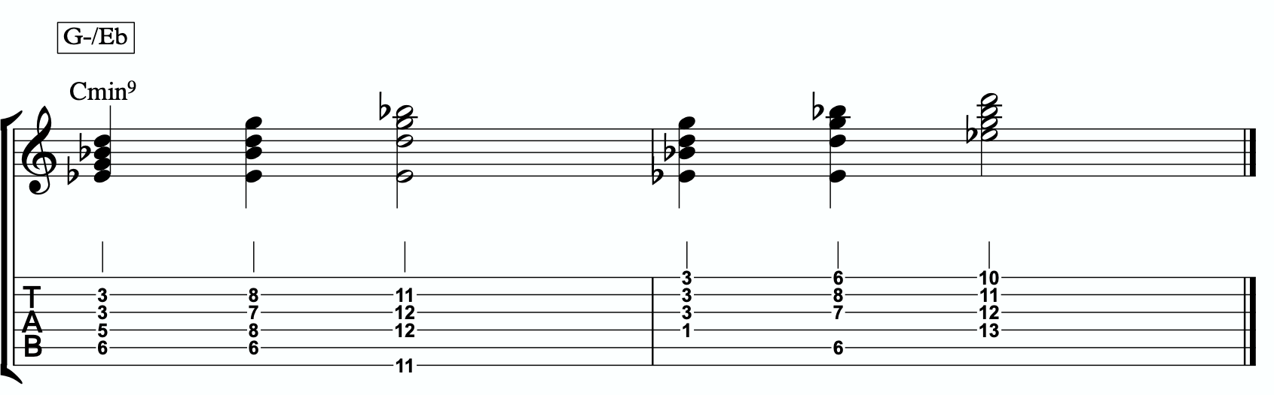
3a

Each of these voicings gives us the b3rd, 5th, b7th, and 9th of the Cmin9.

THREE NOTE QUADRATONIC VOICINGS
Three note qudaratonic voicings are an incredible and special tool for us. Unlike traditional drop chords that can be practiced through all inversions, these three note chord inversions offer us some special benefits. First, they highlight the sweet spot notes and get us into the really colorful parts of the chord. Second, by ignoring one of the four notes in each voicing, we’re not simply jumbling up the same four pitches each time we invert. One pitch is always disappearing or appearing as we move through these inversion. It makes for a much more captivating series of inversions as the ear is unconsciously losing and finding pitches at every turn.
We’re going to follow the “drop 2” idea, however not in the traditional sense. When we speak about “drop 2” chords traditionally, we mean that we take the second to the top note and “drop” it down an octave. We’re not going to do that. We’re simply going to remove it from the picture.

4 |  | 4 | 3 |  | 3
3 | > |  | 2 | >
2 |  | 2 | 1 |  | 1
1 |  | 1 | 4 |  | 4

Notice that when this technique is applied, the first series of numbers is different from the second. They both share 1 and 4, but the first series has a 2 and is missing the 3 whereas the second series has the 3 and is missing the 2. If we did this for every inversion of 1 - 4, each one would be slightly different.
If we apply this to our primary quadratonic, we get this series of three note voicings for our chord.

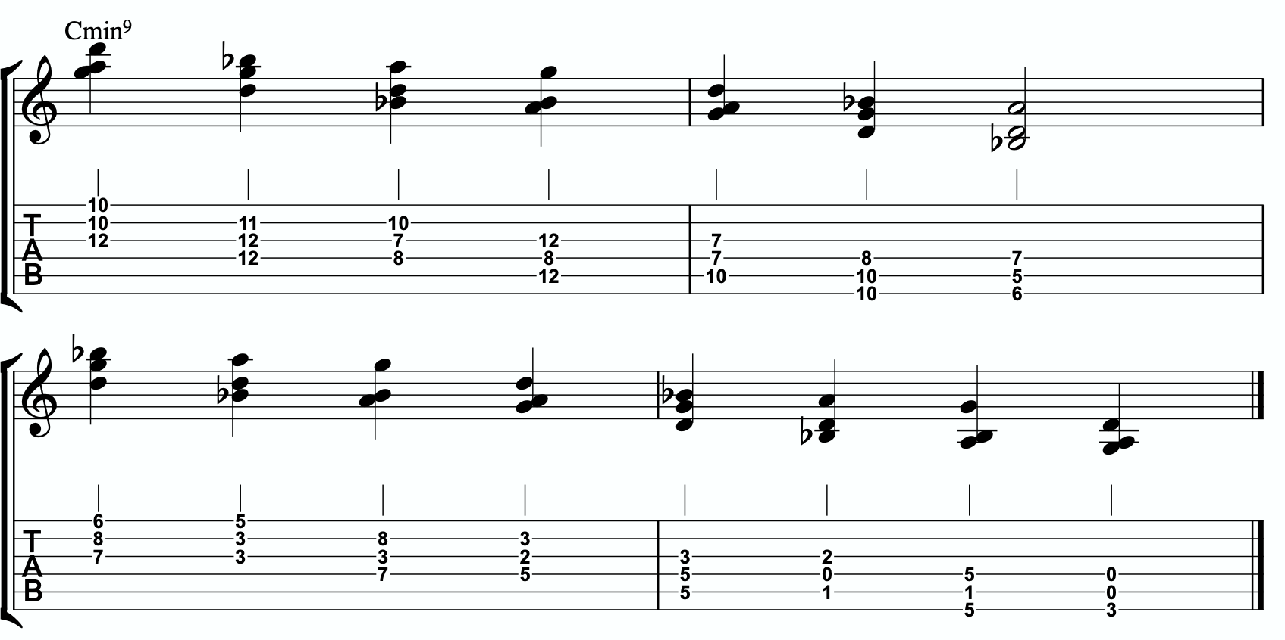
3b

QUADRATONIC SCALAR RUN
Let’s bring it back to single note ideas, melody, and improvisation. The Must Know was all about learning to hear and manipulate melodic tension and resolution using the quadratonic. But we can also use the quadratonic like a scale or an arpeggio. It seems simple because there are only four notes involved… but that’s only one note less than a pentatonic scale. And if you think about it, we only have 12 notes in western music, so if the quadratonic takes up four notes, then that’s actually ONE THIRD of all of the notes in the entire western tonal system. That’s quite a lot.
Let’s start with a scalar type run. Ideally you should already be able to hear and use the tension note and the resolution points of the melodic triad to develop beautiful, clear, authoritative phrasing that works with the harmony, and even implies it, without being stuck outlining it. Not we want to focus on developing the ability to create long, flowing, legato, fluid runs that create the impression of harmony. Traditional scales can sometimes be helpful for this, but they often times have notes that aren’t going to help define the sound of the harmony that’s happening. This quadratonic approach to a run will clear away those less essential notes.

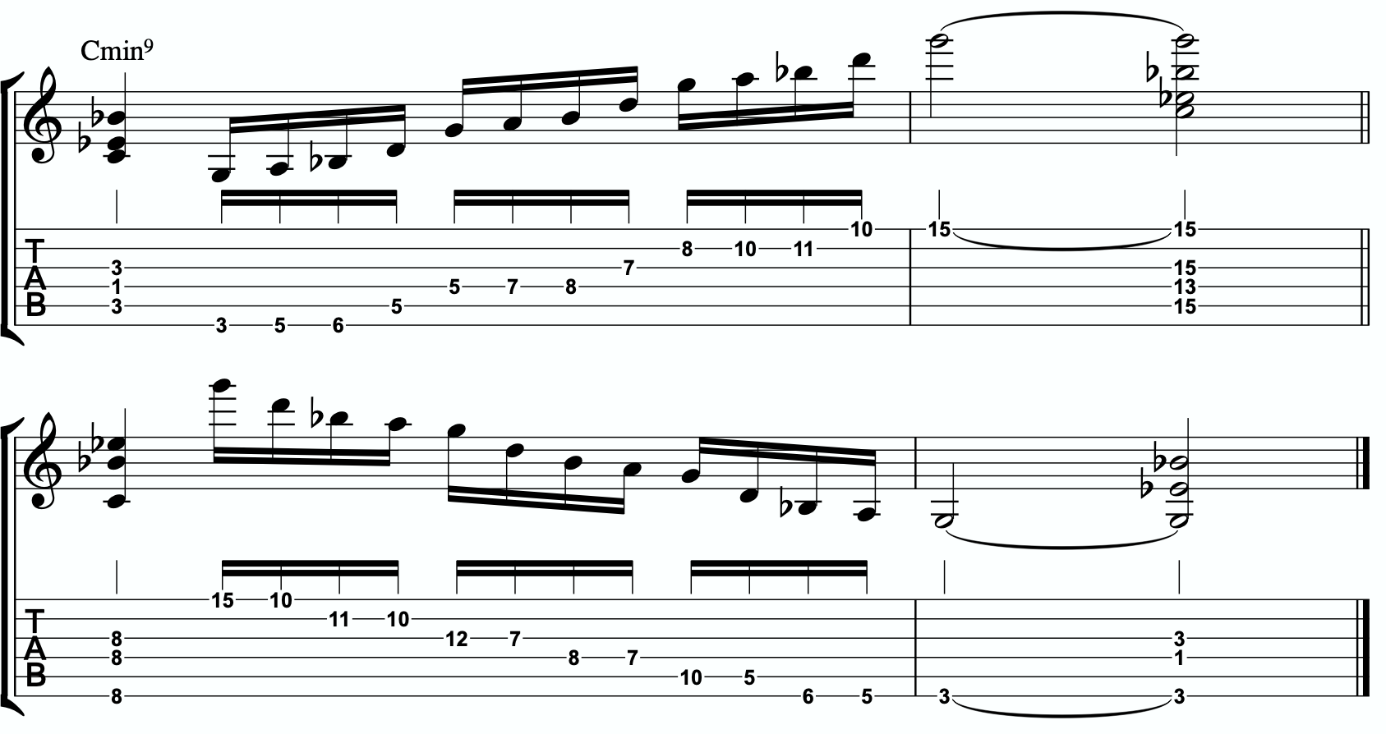
3c

THE SECONDARY TENSION NOTE & PENTATONIC SCALE
Once we can develop authentic phrases with the primary tension note and the quadratonic it gives us, and once we can see it as a scale that we can run through, we can move on and look at the secondary tension note. At this point, I recommend that you put the primary tension note on the back burner and leave it out for a while. Treat this as a whole new tension note. Go back through the ear training process and learn where it is on the fretboard, what it sounds like, how it wants to move, and how to create simple phrases with it.
In order to find the secondary tension note, we go back to Stefon’s formula.

The Hierarchy of Harmonic Importance.
3 - 7 - 5 - 9 - 11 - 13 - R
- Since we started by adding the 13th, is the R of Cmin7 in the G minor triad?
No. The R is C. C is not in the G minor triad.

So our secondary tension note is C.

C is the root of Cmin7, but it will be heard against the melodic triad which is G minor. C is the 4 of G minor, so that means our secondary quadratonic is G minor tension 4 and it gives us our this tonality’s melodic triads pentatonic scale.

/ 2, 4
G-
Here are some examples of this pentatonic scale in use:
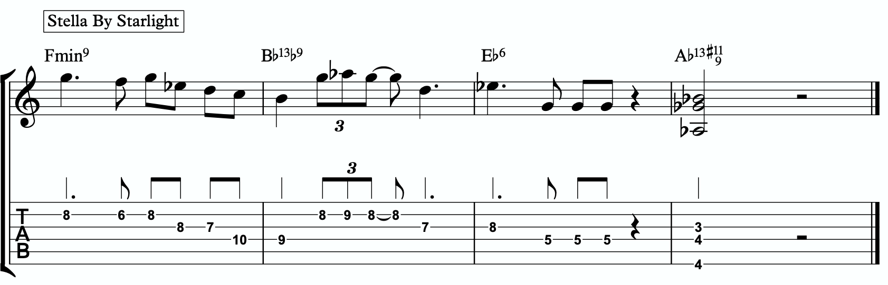
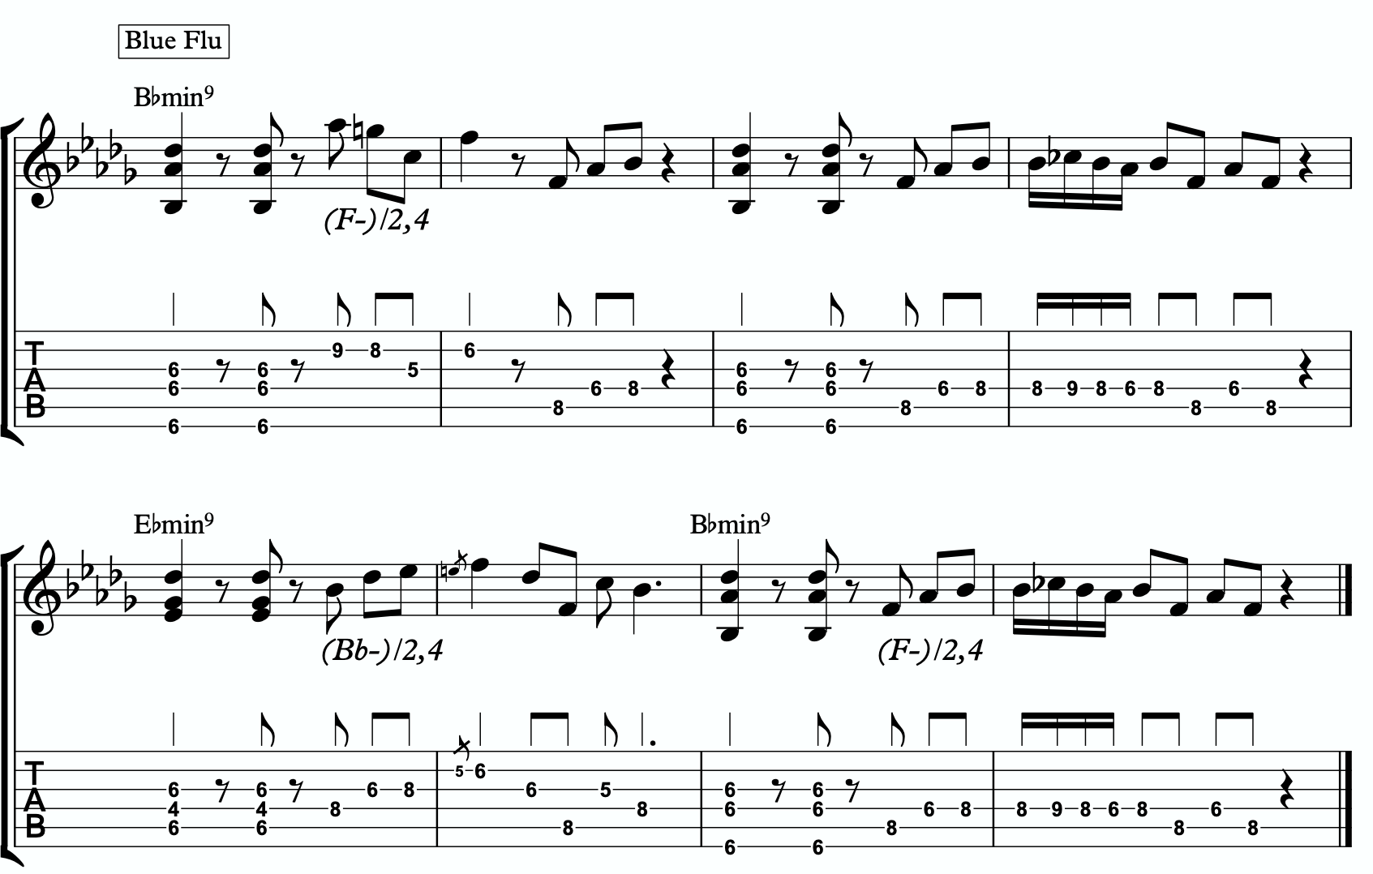
3d
3e

THE MELODIC TRIAD BEBOP SCALE
Hopefully by now you’re starting to see the way melodic triads can offer a very direct path through all the traps of scale running, noodling, and outlining chords progression using 1 - 3 - 5 - 7 chord tones and arpeggios. All of these can be great devices (maybe not noodling), but have dangers to them.
The melodic triads approach helps us start with the sweet spot notes, and build our harmony and melodic from there. Before you start working on the melodic triad bebop scale or anything beyond this point, I strongly encourage you to make sure that you’re not simply reading these ideas like a theory book to be memorized. These are meant to infiltrate your ears, map the fretboard, and apply directly to musical situations in tunes. If you’re been studying and applying the melodic triads approach for enough time that you’re getting comfortable with it, we can take the next step. It’s only one extra note… but it’s a game changer.
In order to understand what the melodic triad bebop scale is, you need to understand what a traditional bebop scale is and the purpose for why it’s built the way it is. The standard diatonic scale is made of seven notes. The problem with playing a seven note scale is that it’s made of an odd number of pitches, so if you’re playing in 8th notes in 4/4 time, it’s going to flip itself around and start to place weak sounding notes on strong beats and strong sounding notes on weak beats.

C major scale

In music, we have strong beats and weak beats. We can see these pretty easily by looking at the beamed groups of 8th notes. There are always two of them. The first one, on the left of each group, is the strong down beat, and the second one, on the right of each grouping, is the weak up beat. We count them:

1 - & - 2 - & - 3 - & - 4 - &

That makes up one full measure of 8th notes in 4/4. The strong beats are on the number, and the weak beats are on the & (the “and”). If we look at the C major scale above, we see that it starts on the C note (very important) on a down beat. Then the next down beat, beat 2, has the E note. That’s the 3rd of CMaj… so we’re doing good. The 3rd down beat has the G note… still good. But the 4th down beat has the 7th of the scale, and then the C root note happens on the & of 4. And that puts the D note, the 2nd of the scale, on the down beat of the following measure. The following few down beats all have weak notes on them, putting the strong CMaj “chord tones” on the weaker up beats. It finally loops back around and lands on the C note on beat 4.
The traditional bebop scales took care of this problem by adding one single note. This evens it out to an eight note scale and lines up the pitches of the scale with the beats in the measure.

Some players would call this a bebop scale, or if you’re familiar with the Barry Harris method, you might call this the 6 diminished scale. Regardless, what’s important is that if you look at the strong beats, the notes spell out C - E - G - A. That’s a C6 chord. It gives

us a perfect combination of melody (the scale - with tension and resolution points), harmony (the C6 chord - the resolution points), and rhythm (the timing of getting all of the important notes to fall on the strong beats). It’s a beautiful, perfect, and very helpful scale to know.
I still rarely if ever think about, practice, or use it. Doesn’t mean you shouldn’t. But hopefully by now you’re starting to see just how powerful triads are. This scale is built around four note chords like C6 or C7, not three note triads.
But there’s a way to combine the two concepts. The pure simplicity and strength of the triad, with the rhythmic perfection of the bebop scale concept.
We simply add one single passing note between every triad note. Here’s one octave of a G minor triad. Our melodic triad for Cmin9.
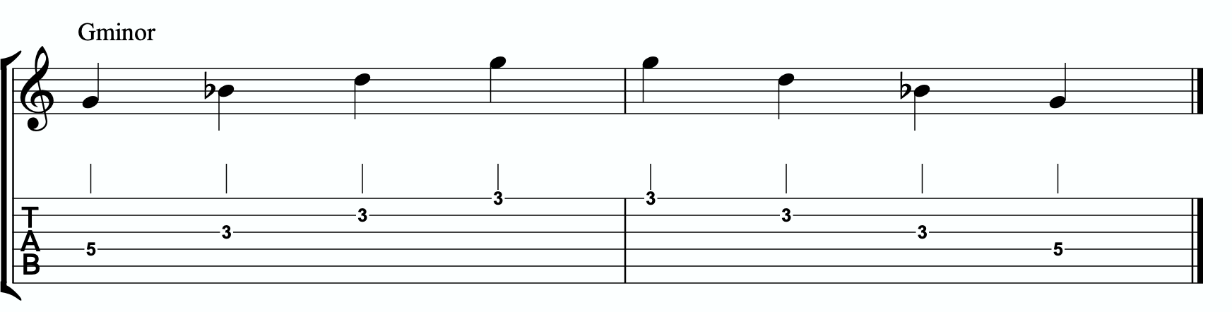

Now I’m going to insert one passing note between each triad note. The key is to pick the passing note that best respects and defines the Cmin7.
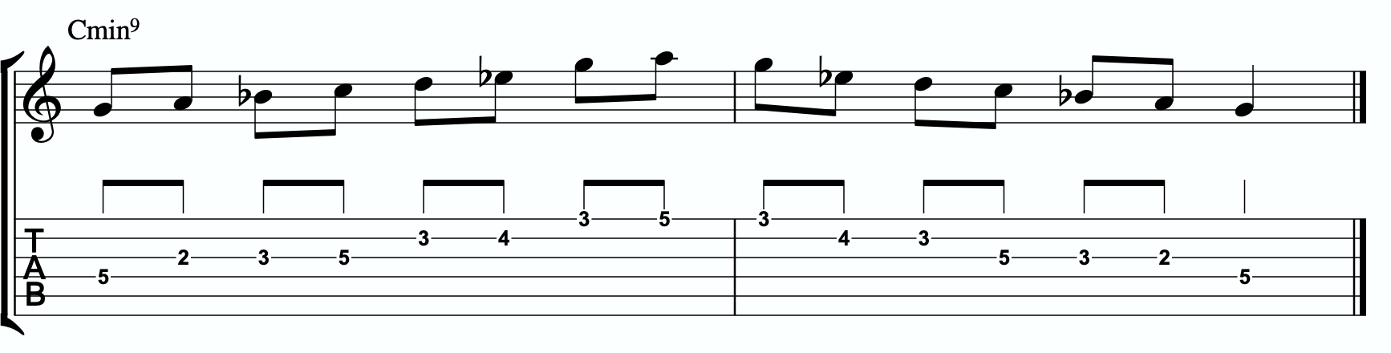

This is our melodic triad bebop scale. It’s a six note scale that helps us outline the tonality we’re working with by stabilizing the notes of our melodic triad.

Notice that it’s just a G minor triad with passing notes. If we look at those passing notes in relationship to the G minor triad, we get tension 2, tension 4, and tension b6. Two of the three tension notes are straight from our primary and secondary quadratonics. No, that’s not a coincidence. That’s due to the perfect nature of how triads function when we dig through harmony and melody with them. So we’re simply adding a third tension note. In this case, it’s tension b6. You could use that as a quadratonic - G minor tension b6 over a Cmin9 chord. The melodic triad bebop scale gives us a rhythmically aligned “scale” but it also gives us three tension notes, each with their own unique emotional quality to them, that we can take advantage of if we don’t want to get stuck running scales and want to return to a focus on melodic tension and resolution and lyrical phrases.
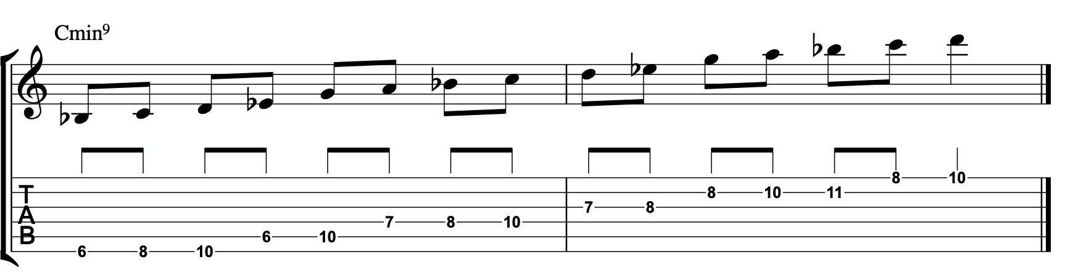
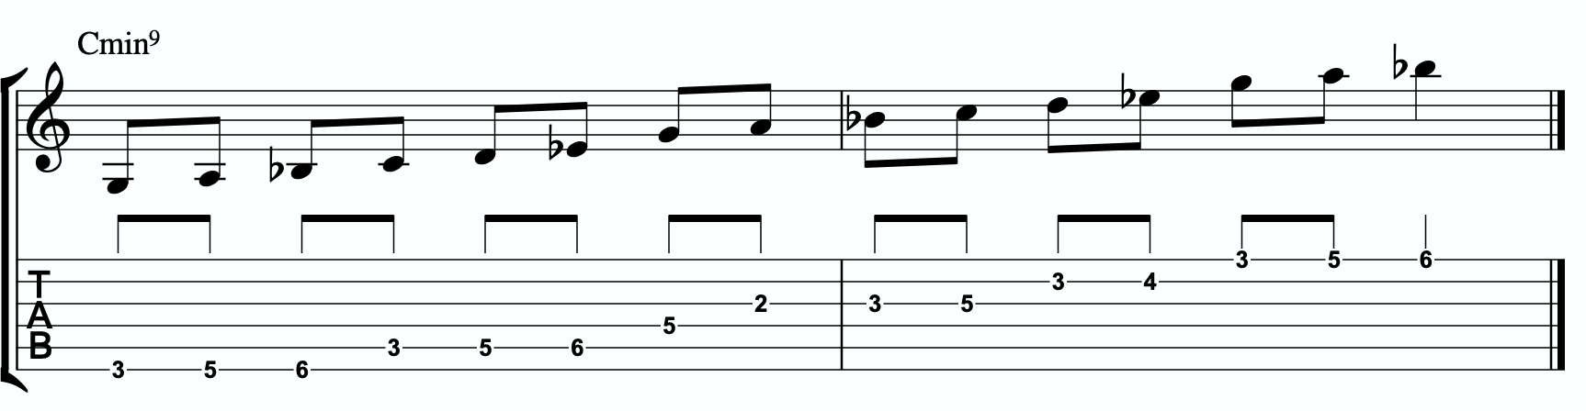
4a

Here is the same scale but harmonizing all of the melodic triad notes with our three note
quadratonic voicings:

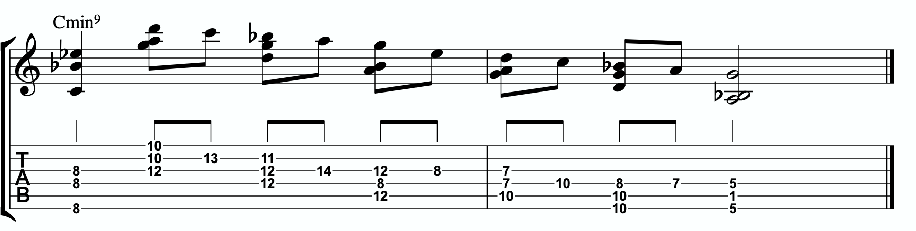
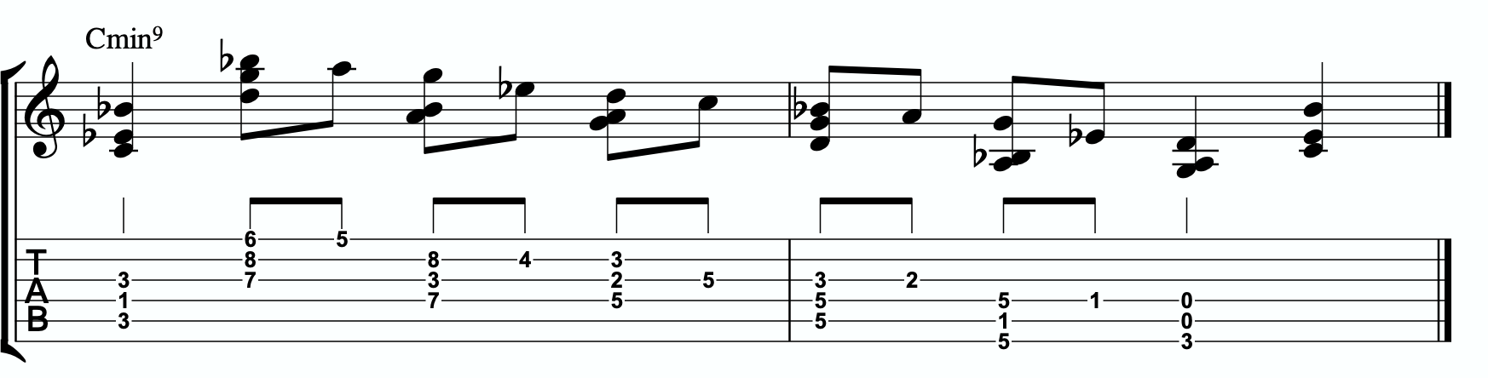
4b

ADVANCING HARMONY
We are getting into more and more advanced material now. Please remember that you do NOT need any of these continued lessons and concepts to play music. It is significantly more important that you develop your ability to be authentic, spontaneous, and playful with the material in The Must Know and then, if you feel comfortable, in Digging Deeper. Each section is building on the last, so if you’re struggling, it’s simply a check engine light to return back to earlier sections.
That said, we’re still far from a complete exploration of the depth of this one little triad.
This section we will explore some more advanced harmonic ideas. You may have heard me talk about liquid harmony. This is a way of visualizing the creation of harmony that involves movement. Think of a chord voicing like a block of ice. It’s frozen in time. We play it, we move to another chord, we move to another chord. Most of us learned to play harmony this way with a focus on shell voicings and drop chords. Liquid harmony is the idea of taking those blocks of ice and melting them down into a little. Not necessarily completely. But we want at least some of the ice to return to water so that it can flow and move. It helps free us up to transcend more static voicings, even cool sounding ones, and creates a more pianistic, movement-oriented sound. Not simply movement from one chord to another, though that’s important as well. But movement inside of a single chord. That’s what this section will explore.

HARMONIC QUADRATONICS
This is possibly the simplest, most effective, and most fun ways to create liquid harmony. The idea is that we play the primary quadratonic, but instead of thinking of it as a scale that we play with single notes, we play it as a chord. We will play three notes of the quadratonic. The tension note will be part of the chord, and it will replace the nearest melodic triad note. So the chord will be made up of two melodic triad notes and the melodic tension note. Then, while holding the two melodic triad notes and allowing them to continue ringing, we will resolve the tension note back into the triad. If we’re playing solo guitar or accompanying another musician, we may want to play the root note of the chord (“left hand”) or even the whole shell voicing. However in a full ensemble with a bass player, or if we’re playing solo and simply want a more impressionist style sound, we can leave that out and play these ideas as rootless “chords”.

Here is an example:
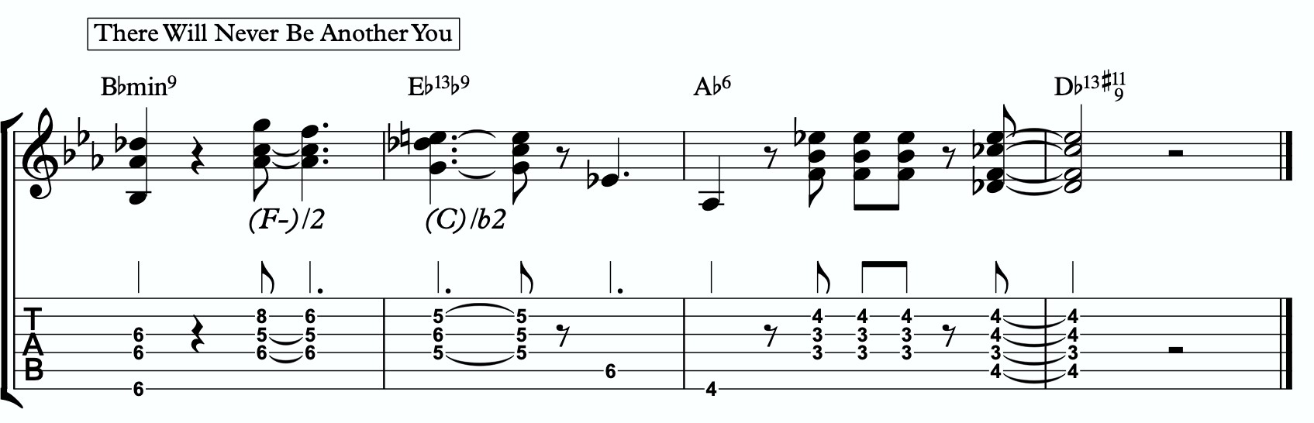
5a

Quadratonic Dyads
This is a similar concept to our quadratonic 3-note voicings, except now we’re creating 2 note grouping by pairing together every other note.

So if our quadratonic is made of G - A - Bb - D, we will group the G and the Bb together and the A and D together. And we will get this:

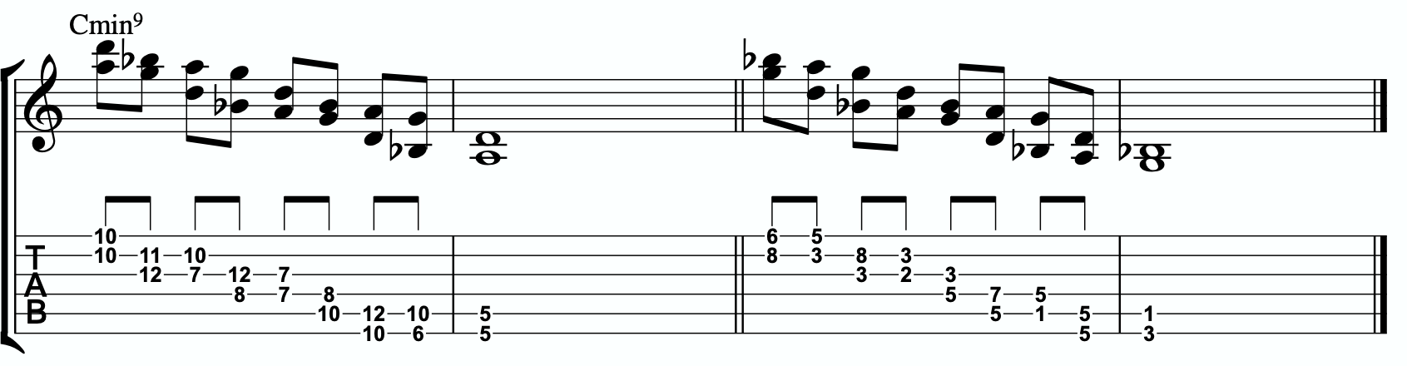
5b

TRIAD PAIRS
Sticking with our melodic triad bebop scale, we actually have our melodic triad version of triad pairs hiding right there in plain site. We know that all the resolution points are the notes of our melodic triad. But if we look at all of the passing tension notes we added, we actually have a second triad. This scale is two triads together. We have our melodic, or our “resolution” triad, and then we have our tension triad.
For this tonality, our triad pair is G minor and A diminished.

/ Aº
G-
We can of course arpeggiate these triads out to create single note ideas, but this section is specifically about harmony. So let’s look at a harmonic application for our tonality inside a chord progression.
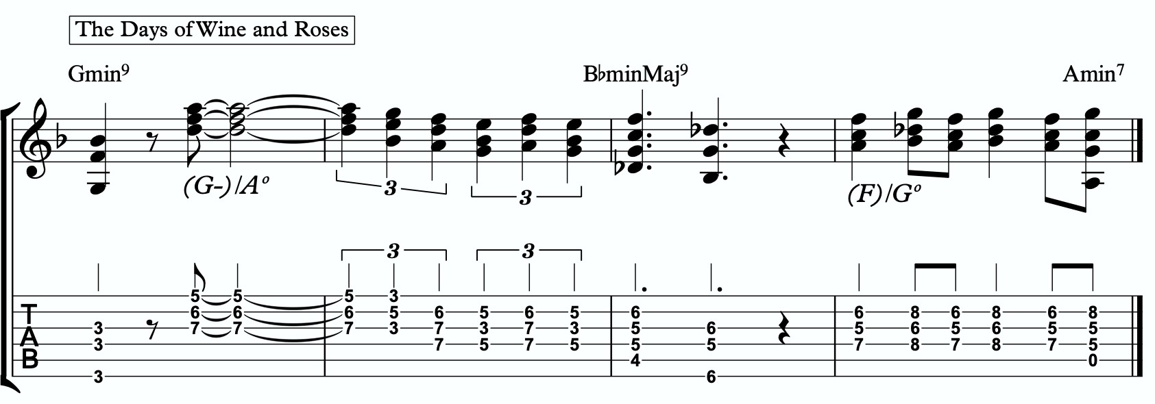
5c

Here is a dyad application, where we leave out one note from each triad.
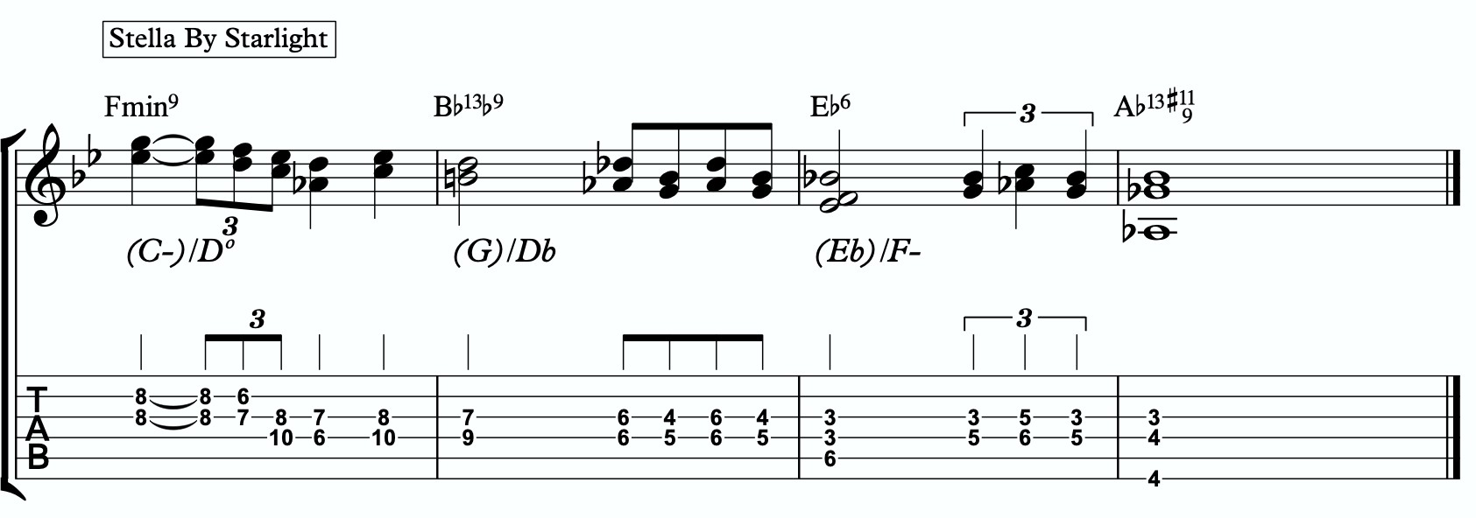
5d

TENSION LAYERS
Everything up until this section has been based on the idea that the melodic triad is the strongest organization for resolution, color, harmony, and melody. We leave the triad temporarily with different techniques to create tension, harmonically and melodically, but always in service to bring us back to rest in the resolved nature of the melodic triad.
In this section, we’re going to talk about the idea of thinking of tension as existing in layers. This way, we have different levels of tension that we can move in and out of - like rungs on a ladder that we can climb up, climb down, or simply pick one and stand still on it to enjoy the view.

LAYER ONE
This one is easy. Layer one is the primary quadratonic. The melodic triad is the most stable set of notes we have for our tonality. The primary tension note offers us a very respectful tension note to create melody. There is tension inside this quadratonic, but it’s accessible and always brings us right back into resolution. We must be comfortable making music with this sound before we can continue.

/ 2
G-

LAYER TWO
But what if we want to move up a rung on the ladder? We know from the melodic triads bebop scale that our triad pair for this tonality is G minor and A diminished. So far, we have only thought of the A diminished as a tension triad that can be used to bounce back and forth with G minor. But what if we momentarily “modulated” into the A diminished triad to create a new rung on our ladder? Like modulating in a tune between the relative major and minor of a key, the key doesn’t actually change, but we can momentarily alter the color and the emotion.
By switching over to thinking of our tension triad, we can add a tension note to the triad and create a tension quadratonic.

The tension quadratonic, when mixed with the primary quadratonic will allow us the ability to navigate seven diatonic notes melodically and harmonically in a structured and authoritative way that will imply the harmony, give multiple colors and layers of tension, and allow for six different resolution points within any tonality. That’s half of all of our available pitches.

How do we chose the primary tension note for our new tension quadratonic?

We go back to the hierarchy of harmonic importance. What’s the only chord tone remaining from the hoh that hasn’t been used yet? The 11. So that’s going to be the tension note for our tension quadratonic.
This causes something funny to happen. The 11 of Cmin7 is F. If we add an F note against our tension triad, A diminished, we get this four note structure - A, C, Eb, F. That’s an inversion of F7. The F major triad we just created is a much stronger sound than the A diminished triad. So our ears are likely going to hear this as an F triad with a tension b7 rather than an A diminished triad with a tension b6. You can try and fight it, but for our purposes I’m going to notate it the way the notes will naturally phrase themselves

F / b7

This quadratonic will sound less “in” than the primary quadratonic, however the tension note in it will give it a sensation of tension and resolution within itself.

Here are an example of this quadratonic pair being used melodically:

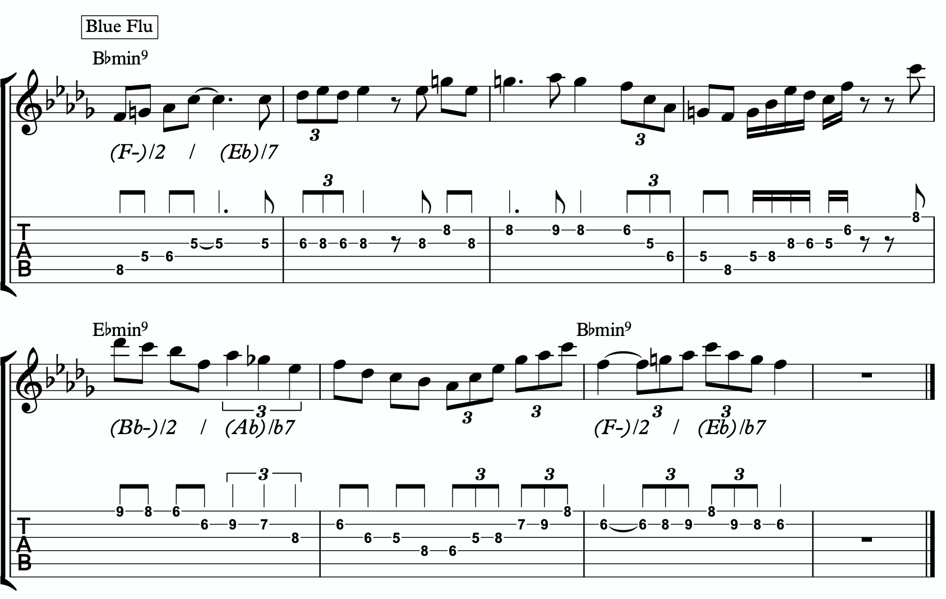
6a

Harmonizing Our Bebop Scale With Tension Layers

Let’s look at our six note melodic triad bebop scale and harmonize it using our quadratonic pairs. We will do this using two different techniques brought up earlier in this study booklet. First, we will move through the bebop scale using our harmonic quadratonics to create liquid harmony within each voicing as we move between the two quadratonics to harmonize each note. Finally, we will apply the three note quadratonic voicing to the bebop scale.

Harmonic Quadratonics & Liquid Harmony
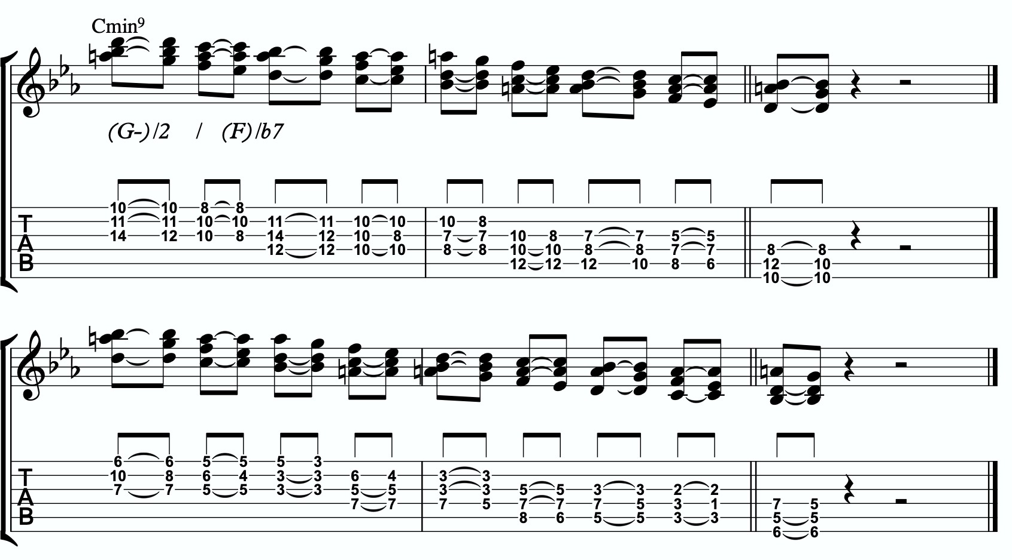
6b

Three Note Quadratonic Voicings
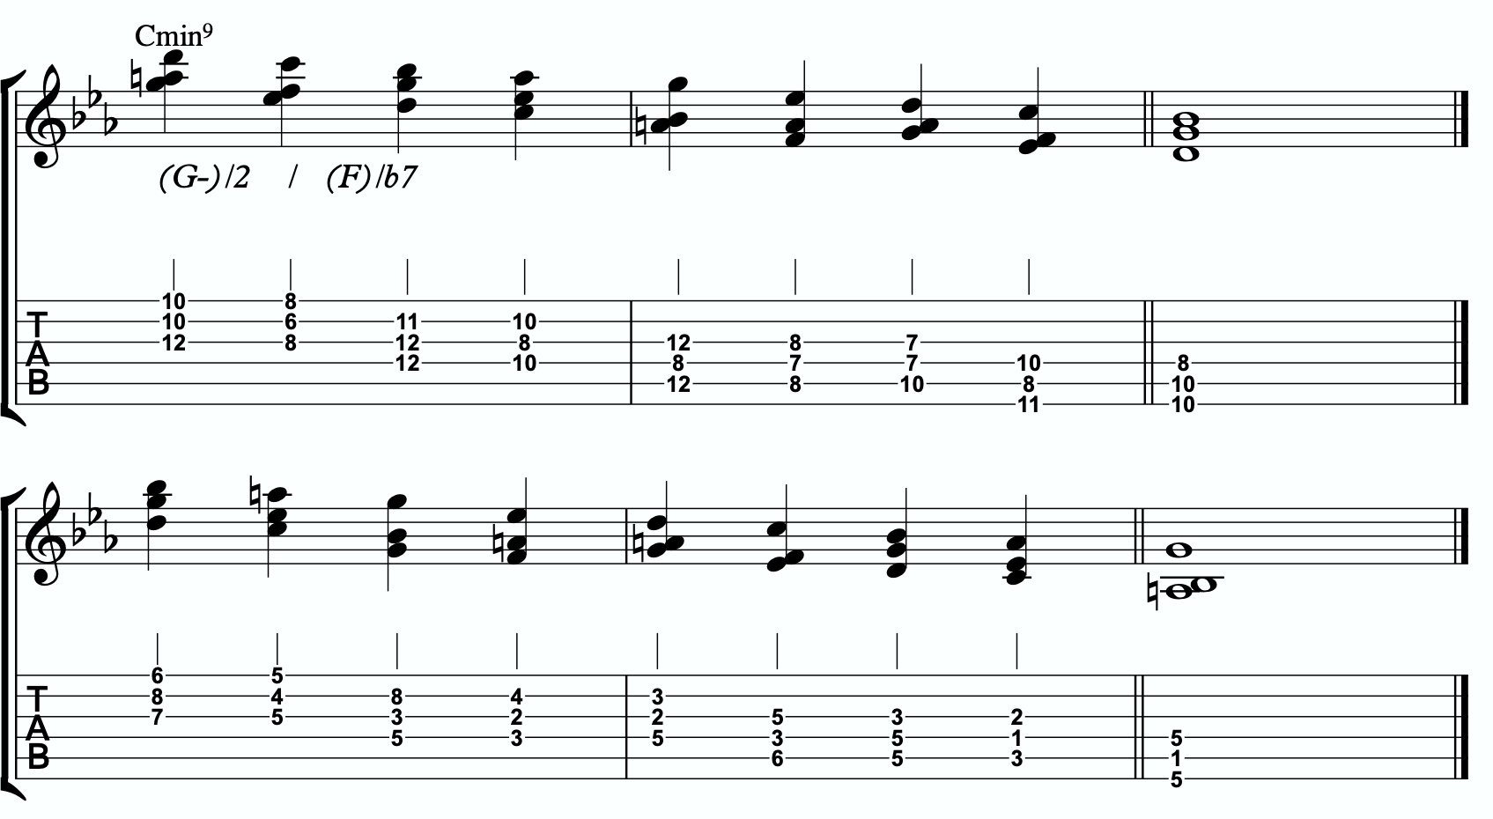
6c

THE OUTRO
I just want to personally thank you for working through these ideas. I am obsessed with exploring, mapping out, and demystifying jazz harmony and melody, and attempting to understand it and execute it using the simplest and most fundamental ingredients in music. I’ve found over many years of playing and study, and learning from some of the greatest minds in the jazz world today, that it’s often times our ego and our own self- inflicted limitations that hold us back the most from growing and evolving towards our potential.
The most dangerous words to development of our musicianship are, “I already know that.”
Most of us generally spend a couple of music theory classes learning our triads. Maybe we read a book about advanced triad application and get some cool intellectual ideas to play with. But for me, it’s all about that Bill Evans quote.
**********************************

The whole process of learning the facility of being able to play jazz is to take these problems from the outer level in, one by one, and to stay with it at a very intense, conscious-concentration level until that process becomes secondary and subconscious. Now, when that becomes subconscious, then you can begin concentrating on that next problem, which will allow you to do a little bit more.

I don’t consider myself as talented as many people but in some ways that was an advantage because I didn’t have a great facility immediately so I had to be more analytical and in a way — that forced me to build something.
Most people just don’t realize the immensity of the problem and, either because they can’t conquer it immediately, think that they haven’t got the ability, or they’re so impatient to conquer it that they never do see it through. If you do understand the problem then you can enjoy your whole trip through.

People tend to approximate the product rather than attacking it in a realistic, true way at any elementary level — regardless of how elementary — but it must be entirely true and entirely real and entirely accurate. They would rather approximate the entire problem than to take a small part of it and be real and true about it. To approximate the whole thing in a vague way gives you a feeling that you’ve more or less touched the thing, but in this way you just lead yourself toward confusion and ultimately you’re going to get so confused that you’ll never find your way out.

It is true of any subject that the person that succeeds in anything has the realistic viewpoint at the beginning and [knows] that the problem is large and that he has to take it a step at a time and that he has to enjoy the step-by-step learning procedure. They’re trying to do a thing in a way that is so general [that] they can’t possibly build on that. If they build on that, they’re building on top of confusion and vagueness and they can’t possibly progress. If you try to approximate something that is very advanced and don’t know what you’re doing, you can’t advance.

**********************************

Was Bill referring to melodic triads? I very highly doubt that. I’ve never heard him talk much about triads. But consider the underlying philosophy he’s pointing at. Know the

basics. Regardless of how elementary! But it must be entirely true, real, and accurate. Be able to play genuine, authentic music using the most fundamental ideas first. Then it leaves room to grow.
This is why I refer to the first section in this ebook as The Must Know. It’s a basic shell voicing, and a basic triad. And while these two concepts are as simple as they come in music, we must understand them in a true, real, and accurate way. If we did this for a handful of tonalities, we could play beautiful music for the rest of our lives, and for me, I would feel fulfilled. It would offer emotion-driven, precise, human, lyrical melody combined with lush, colorful, pianistic harmony. Mix in a strong sense of time and feel, and that’s everything a jazz musician needs.
But like Bill talks about, when we don’t try to approximate but instead start with the elementary ideas and build a foundation with them, then it gives us room for growth. Look at everything we worked through together in this ebook! All built from one triad and how it relates to one chord (piano diagram!). As of the time of putting this together, I’m still working on many of these ideas myself… and I’m still coming up with new ways of building harmony and melody around the melodic triad.
This is why I can’t recommend enough, even to the intermediate and advanced players out there - spend some serious time in The Must Know section. Own it. Be able to play authentic ideas with it. Apply it to tunes. Move it through the circle of 5ths. Do whatever you can to internalize it and develop your ears to it. Then you can begin moving on. I would encourage everyone… peak ahead if you would like to to keep an eye on where this particular path is heading, but be very self-aware and learn to see when you’re getting in over your head. When this happens, not if, just take a deep breath and back up a few sections. It simply means your foundation isn’t quite strong enough yet to carry the weight of those more complex ideas. If you want it, and you put the time and effort it, you’ll get there.
Like one of my students always likes to tell himself at the end of our lessons…..
“Easy does it. But do it.”

Thank you again. Don’t forget to come and hang in our open office hours to ask questions if you’re confused on anything.
Happy Practicing!
-Jordan Klemons

The Melodic Triads Study Group

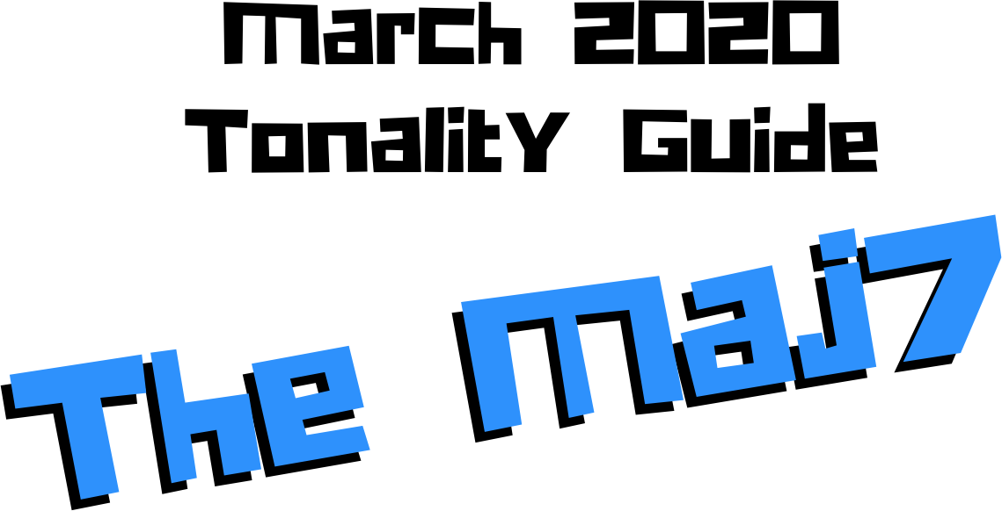

Jordan Klemons
NYC Jazz Guitar Masterclasses

CONTENTS
-INTRODUCTION
-THE MUST KNOW-
-ADVANCING MELODY-
-DIGGING DEEPER-
-THE MELODIC TRIAD BEBOP SCALE-
-ADVANCING HARMONY-
-TENSION LAYERS-
-OUTRO-

This ebook is the copyrighted property of Jordan Klemons. All images, information, layout, and designs belong to Jordan Klemons. This document may not be altered, reproduced, distributed, or transmitted in any form or by any means without the prior written permission of the author.

INTRODUCTION
Thank you for downloading the pdf materials for this month’s melodic triads tonality study guide. Inside you will find all of the supplemental theory, notation, tab, charts, concepts, and examples for the accompanying videos to help you develop your understanding, your ear, your emotional connection with, and your sense of harmonic and melodic freedom within this month’s tonality… as well as its use in some short, common, jazz chord progressions that you will be able to immediately implement in your own playing.
The information in this guide is dangerous. I mean that literally. When the process is respected, and you understand how all of these ideas fit into the puzzle, this guide and the baby steps included can offer tremendous insight into how to begin making real music very quickly, and how to continue evolving and growing as a player for many years to come. However, if approached in the wrong way and the process is not respected, these ideas can confuse and derail a musician’s ability to progress. It’s important not to jump too far ahead of yourself. The advice that a Miles, or a Scofield, or a Coltrane would give to a beginner is different than what they would give an intermediate or to an advanced player. And all of that would be different than how they would talk to a professional who’s already playing on their level. This is important to remember.
This guide is meant to show many different layers of musical growth and how, when using the melodic triad approach, they can all be boiled down and viewed simply as an extension of the most basic elements of music. Namely… a triad. Think of the pages that follow as an architect’s blue prints for a skyscraper. If you haven’t built a strong foundation, your skyscraper will fall. If you attempt to skip the first 50 stories and jump to building the penthouse, the skyscraper will fall. If you try to put up the fancy exterior of the building before you complete the steel frame, the skyscraper will fall. Yes, the information all the way at the end of this guide is constructed using the same ideas and concepts that are presented in the first chapter, but the process must be respected for anything to work. Otherwise it will only leave you confused, frustrated, feeling like a failure, and wanting to give up. Be patient with yourself. The short cut IS the long road. Take it. Spend two or three months working on the long road and watch how much you progress. Focus on your sound, on your ear, and on your musicianship… and trust that the simplicity of the ideas and the process itself will take care of you. They will. But only if you respect them. It’s like a relationship - you have to be present and give of yourself, and then you will receive in abundance.

As you work through these pages, try to keep in mind this Bill Evans’ quote from The Universal Mind.

**********************************

The whole process of learning the facility of being able to play jazz is to take these problems from the outer level in, one by one, and to stay with it at a very intense, conscious-concentration level until that process becomes secondary and subconscious. Now, when that becomes subconscious, then you can begin concentrating on that next problem, which will allow you to do a little bit more.

I don’t consider myself as talented as many people but in some ways that was an advantage because I didn’t have a great facility immediately so I had to be more analytical and in a way — that forced me to build something.
Most people just don’t realize the immensity of the problem and, either because they can’t conquer it immediately, think that they haven’t got the ability, or they’re so impatient to conquer it that they never do see it through. If you do understand the problem then you can enjoy your whole trip through.

People tend to approximate the product rather than attacking it in a realistic, true way at any elementary level — regardless of how elementary — but it must be entirely true and entirely real and entirely accurate. They would rather approximate the entire problem than to take a small part of it and be real and true about it. To approximate the whole thing in a vague way gives you a feeling that you’ve more or less touched the thing, but in this way you just lead yourself toward confusion and ultimately you’re going to get so confused that you’ll never find your way out.

It is true of any subject that the person that succeeds in anything has the realistic viewpoint at the beginning and [knows] that the problem is large and that he has to take it a step at a time and that he has to enjoy the step-by-step learning procedure. They’re trying to do a thing in a way that is so general [that] they can’t possibly build on that. If they build on that, they’re building on top of confusion and vagueness and they can’t possibly progress. If you try to approximate something that is very advanced and don’t know what you’re doing, you can’t advance.

**********************************

I’ve setup the material in these tonality lessons to start with the most basic and fundamental elements of music, and to grow outwards in complexity. Everything builds on what came before it, so everything is connected. You DON’T need to master everything in these lessons to play music. You only really need the first section and a little bit of creativity and concern for your sound - that’s enough to create something beautiful..
I recommend that if you’re new with us, even if you’re already an advanced player, you begin focused entirely on the first section of this guide, The Must Know, and give yourself a minimum of 3 - 6 months to get used to this method and the initial concepts presented. It’s a very different approach to standard theory, and your goal should be (as Bill Evans said) to be able to make genuine, authentic music with the ideas in the first section. Once you feel you can hear and play music using these ideas on a small handful of tonalities and applied to some tunes, then it is time to start advancing forward.

I would continue giving yourself an addition 3 - 6 months for each subsequent section, as e3abch builds on the last and becomes more and more advanced… starting from the most basic and simple ingredients, and eventually working our way up to learning to hear and use all 12 notes of the western chromatic scale harmonically and melodically over any chord in a musical way.
I strongly recommend that you follow this rough timeline. I believe it’s the most effective way to cut through the learning process and get straight to making beautiful music, and then to set yourself on the path to continue growing and building for years to come.
The melodic triad ideas I’m working on today, I didn’t even know they existed during the first few years of my own studies. As we grow and progress and get comfortable, we can naturally start to evolve the ideas into more advanced applications. That’s the beauty of starting with the fundamentals, learning to make genuine, authenticate music from our own self first… and then building layers of complexity on top of, but always connected to, those very fundamentals. Much like a large skyscraper building starts with a huge hole in the earth, then is filled with concrete and steel, and then the steel frame will hold the building as it goes up. We won’t see any of these structures. But without them, the building would collapse. Only once the structure is there can the work of putting up the exterior, the glass, the interior, the design, the furniture, etc. take place.
Thank you again for downloading this study guide and working on your music with us. I look forward to hearing your playing and your contributions to the melodic triad conversation inside our facebook group, and for those of you subscribed to our Private Community, inside our melodic triad mastermind group.
Happy Practicing!
Your friend on the path towards jazz guitar mastery,
-Jordan Klemons

The Melodic Triad Study Group - a part of
NYC Jazz Guitar Masterclasses

THE MUST KNOW
The theory, ideas, voicings, and “scalar” ideas presented in this section may seem too simple and elementary to be of value. But I urge you, even the intermediate and advanced players - do not skip this section. I recommend that if you’re within the first 3 - 12 months of study with us that you focus entirely on learning to apply these ideas to musical situations. You can skim the rest of the pages if you’d like, but this should be where you build from. After close to 25 years of playing music seriously, I still spent my first year of working on melodic triads only on this material. The great thing about these ideas is that not only can you comp, improvise, compose, and arrange beautiful music over standards, bebop, modern jazz, and original works with them, but they also act as the foundation on top of which we can grow into more and more complex ideas without ever leaving behind these basic building blocks of harmony and melody.
Do not simply see these as intellectual theory ideas. These are meant to be internalized. To understand the theory is great. To hear the sounds in your ear with a sense of familiarity is just as important. To connect with them personally and be able to hear and express emotion through them is of the utmost importance when it comes to developing our musicianship. This should be the goal.

THEORY
The Maj7 is often taught as the default major chord in jazz education. However traditionally (and even in school’s of thought like Barry Harris’ approach), it’s the 6 chord that is the default major sound. I separate these two chords into two categories. The pure major (6 chords, Maj, Maj(add2), Sus2, etc) vs Maj7. The pure major has a very happy, joyful sound to it. Maj7 does not. While many of us assume Maj7 is happy sounding because it’s probably our primary major chord for playing, it’s actually quite a sad, remorseful sound… sort of bittersweet. Like having had love and then lost it. It’s like thinking back on the memories of that lost love. It’s sweet and lovely, but really pulls on the heart strings. Because the melodic structure is based on a minor triad.

What makes up a CMaj7 tonality?
Two basic ingredients.
- A basic CMaj7 chord
- An E minor triad
A good way to think of this is to visualize a piano player with two hands. Their left hand would be playing C-E-B (a basic CMaj7 shell voicing) and their right hand would be playing an E minor triad.

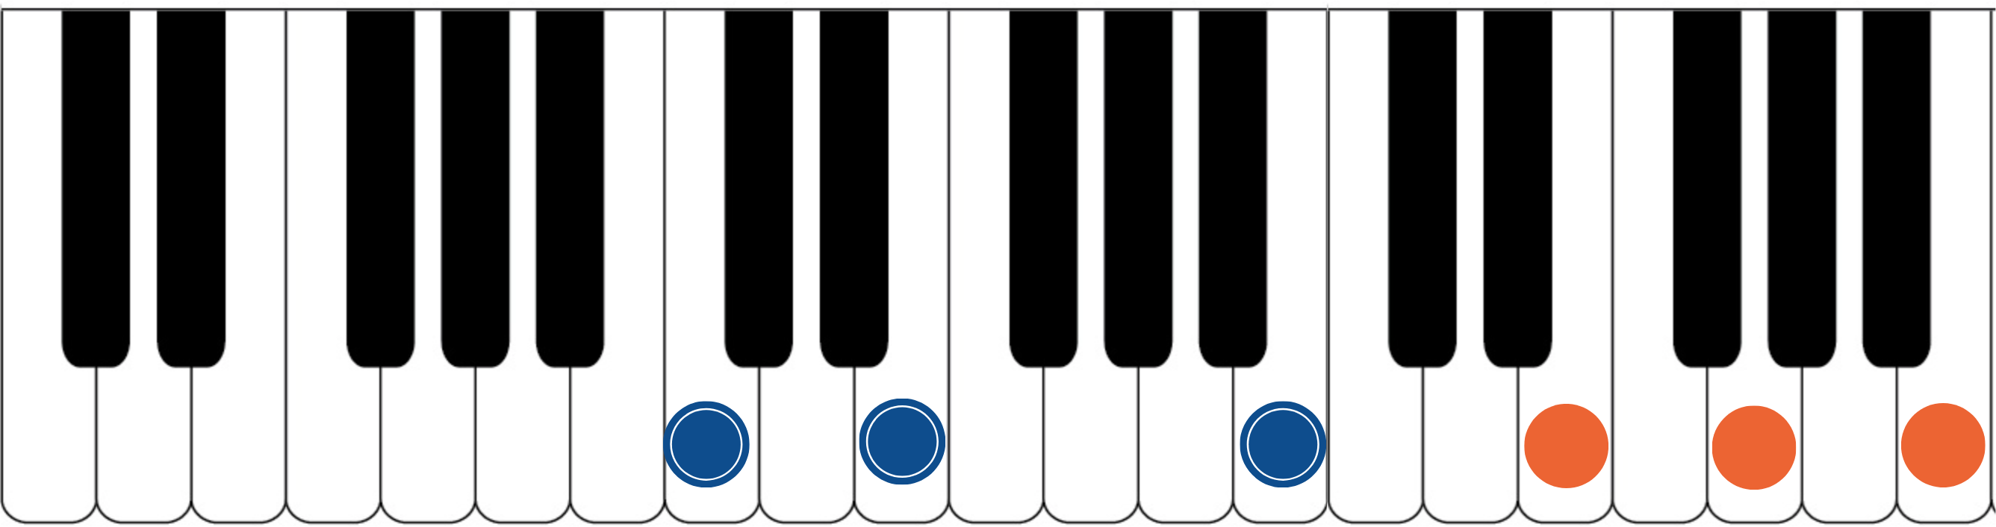

The blue dots would represent the fingers of the piano player’s left hand. Notice they spell out C, E, B. That’s the 1, 3, 7 of a basic CMaj7 chord. The orange dots represent the piano player’s right hand. They spell out E, G, and B. That’s an E minor triad. If you have access to a piano or keyboard, I strongly encourage you sit down and play these seven notes simultaneously. Listen to how big of a sound they create together. This is one of the most simple upper structure triads we can use when building a melodic triad tonality, as we’re still only using basic 1, 3, 5, and 7 chord tones. But by structuring it in this way with the shell voicing on the bottom and the melodic triad on top, it gives a sense of order to the notes that will allow us to develop harmony and melody that work together.
7a

***This E minor triad, which is now our melodic triad, is built on the 3rd of CMaj7… ‘E’ is minor 3rd up from ‘C’. This relationship is critical to understand and memorize as it will allow us to transpose this Maj7 tonality into any key quickly. We will notate this as ‘t3’. This notation comes from Stefon Harris. The ’t’ is short for ‘triad’ and we make it lower case to notate that it’s a minor triad. The 3 tells us that the melodic triad

is built on the 3rd of the harmony. So if we want a GMaj7, we think t3, we find the 3rd of G (which is B), and we know that the melodic triad is B minor.***
This pianistic chord construction is the starting point for everything we are going to look at together. Hidden inside of this seven-note chord is a universe of potential harmonic and melodic ideas. The following pages can all be traced back to this construction idea. Basic chord, basic triad. Left hand, right hand. Harmonic structure, melodic structure. Hence the term… melodic triad. Even if you don’t have access to a piano, I encourage you to sit and think about this diagram until it makes sense to you.

GETTING THE PIANISTIC VOICINGS ONTO THE GUITAR
Taking the concept of the piano construction, where the CMaj7 chord is always underneath the E minor triad, we can develop three basic inversions of this chord by inverting the E minor triad and keeping the CMaj7 chord underneath it.
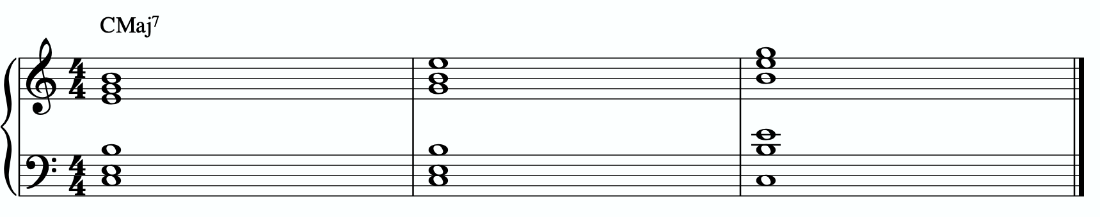
In order to get these three inversions, we will use the piano -> guitar technique described in the video - where we put the shell voicing on the bottom three strings and the triad inversions on the top three strings. This will give us a three “pianistic” inversions of this tonality on the guitar.
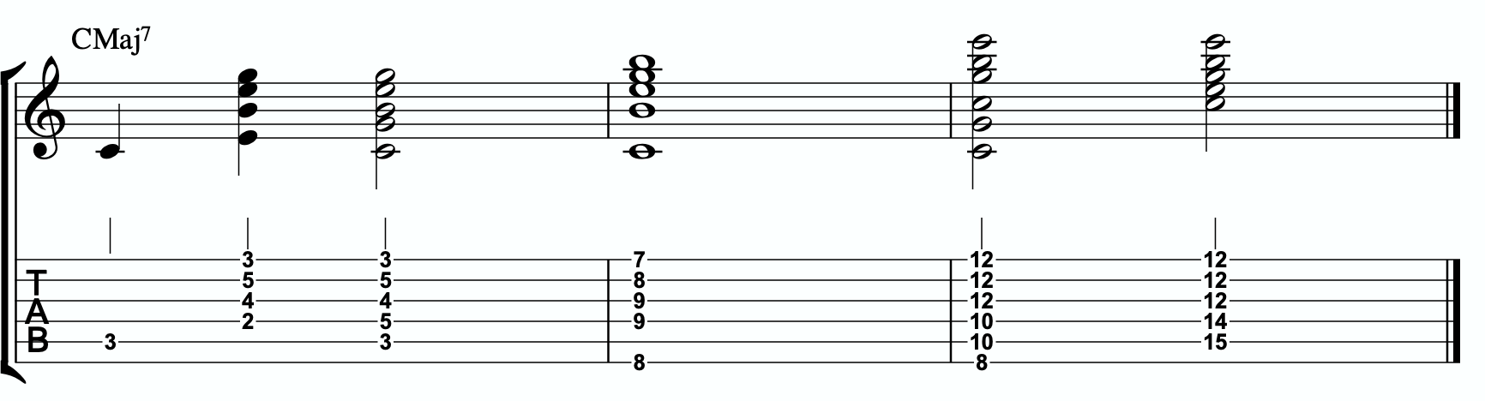
Notice the three basic inversions of the E minor triad on strings 1 - 3.

A few exceptions are being made here.
It’s physically impossible for me to play all six notes of the shell voicing and triad at the same time in measure 1. Instead, a great option is to break the chord apart and play the root note followed by the rest of the voices. This puts the C root note on beat one, followed by a four note voicing, which adds up to a five note voicing. The B note (7th of the CMaj7 shell voicing and 5th of the E minor triad) is shared between the left hand and right hand. So this is a complete voicing. Another option, more common, is the voicing on beat 3. This replaces the 3rd in the shell voicing with the 5th. Allowable and much more common. However as Peter Bernstein once pointed out to me, the perfect 5th in the bottom two voices of this chord can start to sound very thin as it moves up the register of our instrument.
In measure 2 I also can’t play all six notes. This time I decided to let the E note in the E minor triad replace the need for the E note in the CMaj7 shell and to double the B note. So you can see the CMaj7 shell on strings 3-6 and the E minor triad on strings 1-3.

In measure 3 we have two options again. The first way notated is to drop really low and grab the roots and the 5th for our shell (since it’s not quite possible to reach the real shell underneath this triad shape). This gives a very deep, heavy approach. Or we can use the much more common voicing on beat 3. Here we have the E minor triad on top with the root and the 3rd making up the CMaj7 shell voicing. Since the B note is already present in the E minor triad, we can leave it out from the shell without losing the overall quality.

THE PRIMARY QUADRATONIC
Because this CMaj7 contains an E minor triad in the right hand, that E minor triad is going to be the foundation of our melodic structures. It governs everything. Rather than simply behaving as the chord tones that they correspond to harmonically, when used melodically, they will function as the 1, b3, and 5 of our melody… the strongest and most stable resolution points we can build lines with.
The ideal starting point is our primary quadratonic. A quadratonic is a triad that has one additional note added to it. It’s a four note structure made up of three stable notes (the melodic triad) and one ‘free radical’ or melodic tension note. This extra note serves two functions. First, it’s there to create melodic tension that will help us create movement, emotion, and lyrical phrases without getting trapped inside running scales or chord tones. Second, it will help imply the sound of the harmony we’re playing over and glue the

melodic triad inside the chord so they don’t sound like two separate sounds, but rather one unified, colorful tonality.
We only have 12 notes in western music, and three of those 12 are being used in our melodic triad. That means we only have nine possible melodic tension notes. All nine of these could be used to create melodic tension against our triad. But some will help imply the sound of our original harmony better than others. Our primary quadratonic will be made of our melodic triad and the primary tension note - or the note the most respects the basic harmony.

Straight from Stefon Harris’ brilliant mind comes this rule that will help us figure out what are the most important notes:

The Hierarchy of Harmonic Importance.
3 - 7 - 5 - 9 - 11 - 13 - R

These are the chord tones of our basic harmony (the left hand of our piano player).

Here’s how this works:
- Is the 3rd of CMaj7 in the E minor triad?
Yes. The 3rd is E, and E is in the E minor triad… so we can’t add it.
- Is the 7th of CMaj7 in the E minor triad?
Yes. The 7th is B, and it’s in E minor.
- Is the 5th of CMaj7 in the E minor triad?
Yes. The 5th of CMaj7 is G, and it’s in there.
- Is the 9th of CMaj7 in the E minor triad?
No. The 9th is D. That is a tension b7, and we want to avoid that.

- Is the 11th of CMaj7 in the E minor triad?
No. The 11th is F. It’s a tension b2 which we almost always want to avoid against a minor triad, as E-F-G-B will start to sound too much like a G7 arpeggio (G, B, and F… root, 3rd, and b7). It’s too strong a sound so we avoid that.
- Is the 13th of CMaj7 in the E minor triad?
No. The 13th is A. It’s not present and it causes no problems.

So our primary tension note is A.
This A - while the 13th of CMaj7 - is going to be heard by the ear in relationship to the E minor triad. Since A is the 4 of E, we will call this tension 4. So our primary quadratonic is E minor tension 4.
W4ae’ll notate this as:
/ 4
E-

By making the triad bold and circling it, it draws our eye directly to the melodic triad so we can think first about our strong resolution points, then it quickly lets us know what our primary melodic tension note is. Anytime we have a minor melodic triad with a tension 4, we also include tension #4. They are a package deal. Though I strongly recommend you begin by getting used to using only tension 4 and then beginning to work in the #4… it should sound like the blues!

At this point your primary goals should be to be able to play the three pianistic voicings, to be able to visualize the primary quadratonic over the basic shell voicings on the fretboard, to develop your ears to hear the melodic tension note wanting to move and the root note of the melodic triad as melodic ‘do’ - or the root note of the melody.

Here are some examples of these fundamental voicings, shell voicings, and melodic ideas being used in music situations.

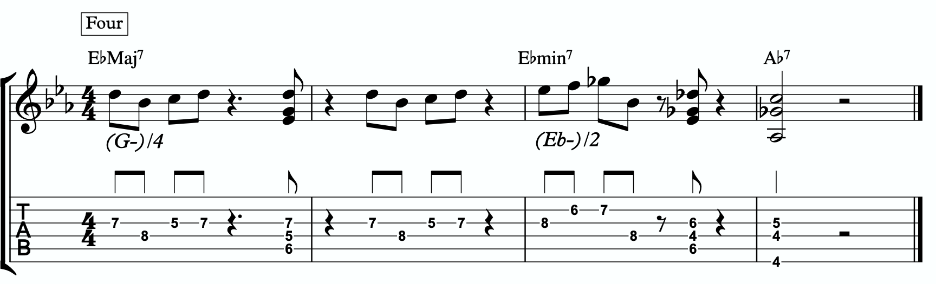
1a
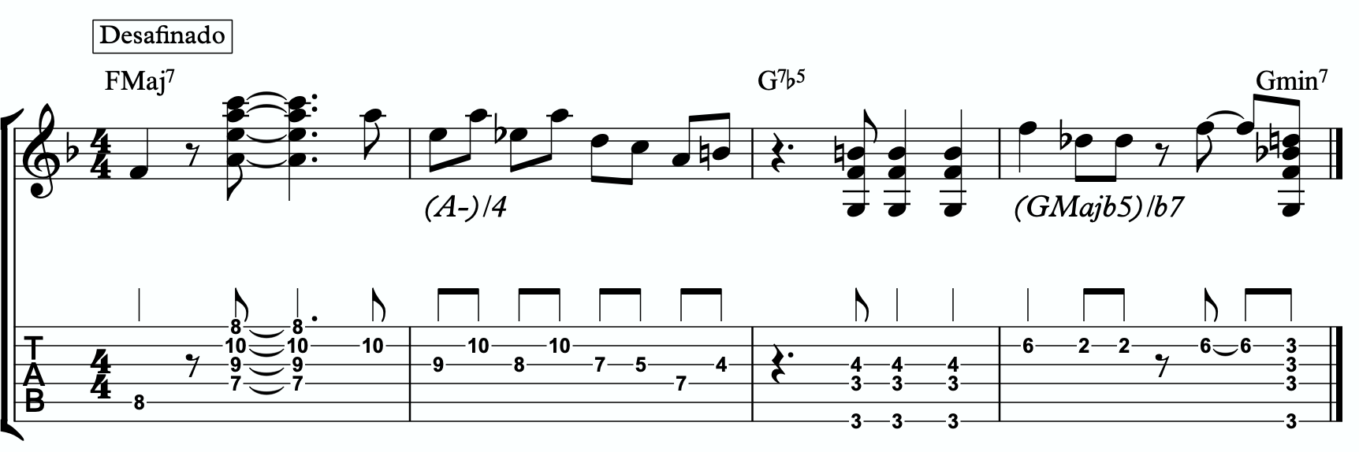
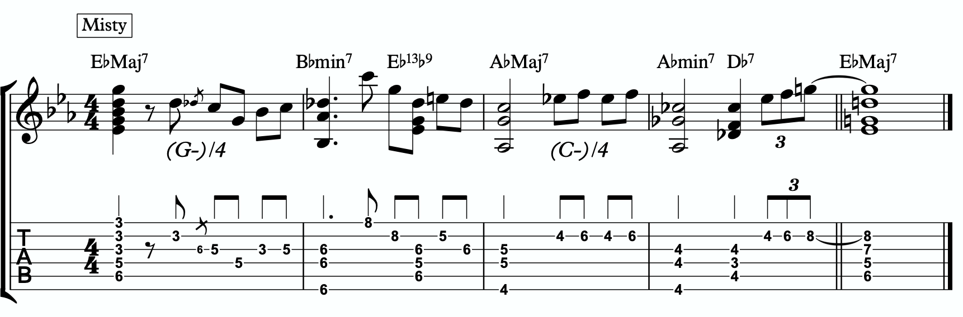
1b
1c

ADVANCING MELODY
This section is going to look at more advanced and complex application of melodic triads to scalar ideas and arpeggios for the creation of bebop and modern jazz vocabulary based on simple structures that we can be playful with rather than memorization of riffs. Don’t be fooled by the idea of these ideas being more advanced or complicated. This doesn’t mean the music you play with these ideas will necessarily be better or more “advanced sounding” then the use of the pure primary quadratonic. In fact, often times I find that the use of the pure quadratonic can carry a level of maturity and intensity into the music that is hard to maintain when using more complicated ideas.
But, I still think it’s worth being aware of how we can build more advanced structures directly from the melodic triad.

Chromaticism Within The Quadratonic
One of the quickest ways to begin developing more complex lines is to incorporate chromaticism and leading tones within the quadratonic. By first learning to master the pure quadratonic, it should make it easier to begin spontaneously connecting individual notes within these structures in a way that will create a sense of improvisational freedom with our bebop and modern jazz playing. Playing this way will allow us to breathe long, flowing, complex lines within very the very basic, simple, steel frames of our buildings.
Here is our primary quadratonic:
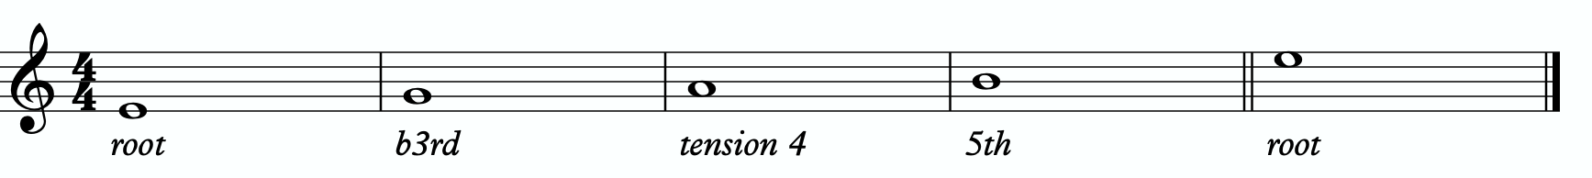
In between any of these notes, we can hang a chromatic line or place a leading tone (a note chromatically below the target) to bring us to the next note. When we use these techniques, we want to make sure that we resolve to a quadratonic note, and ideally we want to play at least two quadratonic notes immediately following the chromatic line to cement our phrase inside the tonality.

Here are some examples:
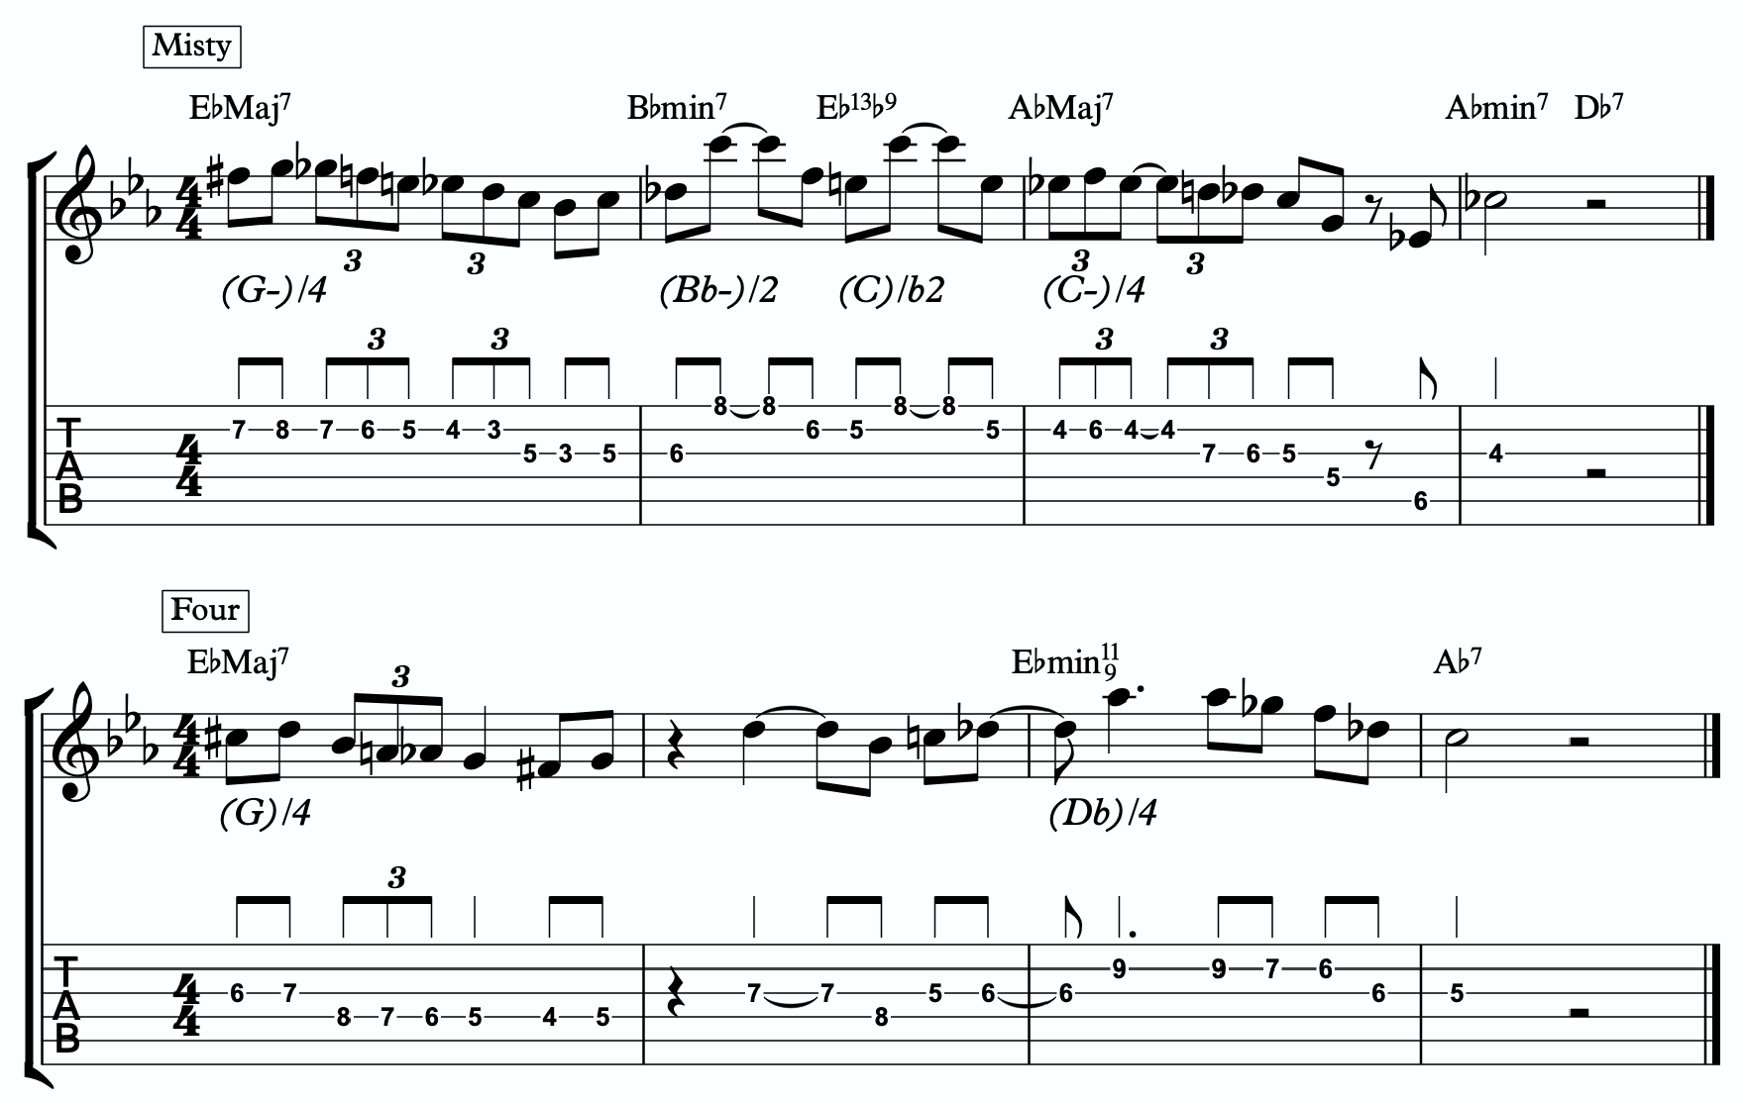
2a
2b
(G-)/4

Quadratonic Arpeggios
So far we have only discussed using quadratonics to develop phrases and scalar like ideas. Let’s look at how we can create the sound of arpeggios with them.
We will begin by starting on the primary tension note. After playing this note, we can move to the nearest melodic triad note and sweep quickly through that triad, landing on the tension note an octave away from where we began.
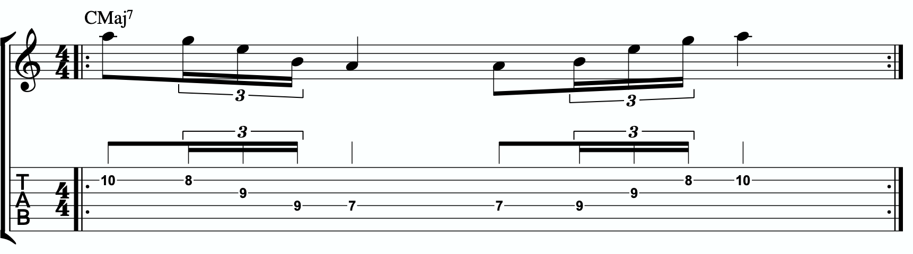
2c

We want to be able to play these ascending and descending starting on any octave of the tension note in any position of the fretboard. If we can incorporate this technique and the chromatic techniques above into our quadratonics then we are giving ourselves resolution notes, tension notes, chromatic runs, leading tones, and quick arpeggio-style runs that we can freely play within during our improvisation while remaining securely inside the color, emotion, and function of any given tonality.

DIGGING DEEPER
The goal of this section is to take small baby steps to evolve the fundamentals of melodic triads in the previous sections into new harmonic and melodic territory. If you are not already comfortable with the shell voicings, the three inversions of the pianistic voicings in all 12 keys, the primary quadratonic, and how to hear and feel the primary tension note against the melodic triad over the CMaj7, I would hold off and continue working on that.

FOUR NOTE VOICINGS
Let’s begin with harmony. Our first goal should be to minimize down these big, dense, pianistic voicings into something more manageable for the guitar. Four note voicings are ideal for our instrument. But sometimes it can be tough to get those colorful, pianistic type lush chords on the guitar because we just don’t have enough fingers. This is due to what I call bottom-up thinking. We are trained to think R, 3rd, etc etc. From the bottom of the chord moving upwards. By the time we get to the sweet spot notes, we’re out of fingers.
Instead, we’re going to think top-down. Our priority is the melodic triad. With these chords, the very first thing we will think about is the melodic triad. Then we are going to add one note underneath it, much like a slash chord. We don’t always use the root note, as often times there is a note that will better accentuate the harmony than the root. That is not the case for this tonality. Because the melodic triad is made of the 3rd, 5th, and 7th, the best note we can add underneath that triad is the harmonic root note. That gives us a Em/C.
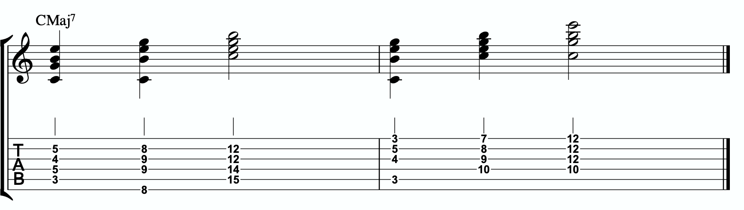
3a

Each of these voicings gives us the root, 3rd, 5th, and 7th of the CMaj7.

THREE NOTE QUADRATONIC VOICINGS
Three note qudaratonic voicings are an incredible and special tool for us. Unlike traditional drop chords that can be practiced through all inversions, these three note chord inversions offer us some special benefits. First, they highlight the sweet spot notes and get us into the really colorful parts of the chord. Second, by ignoring one of the four notes in each voicing, we’re not simply jumbling up the same four pitches each time we invert. One pitch is always disappearing or appearing as we move through these inversion. It makes for a much more captivating series of inversions as the ear is unconsciously losing and finding pitches at every turn.
We’re going to follow the “drop 2” idea, however not in the traditional sense. When we speak about “drop 2” chords traditionally, we mean that we take the second to the top note and “drop” it down an octave. We’re not going to do that. We’re simply going to remove it from the picture.

4 |  | 4 | 3 |  | 3
3 | > |  | 2 | >
2 |  | 2 | 1 |  | 1
1 |  | 1 | 4 |  | 4

Notice that when this technique is applied, the first series of numbers is different from the second. They both share 1 and 4, but the first series has a 2 and is missing the 3 whereas the second series has the 3 and is missing the 2. If we did this for every inversion of 1 - 4, each one would be slightly different.
If we apply this to our primary quadratonic, we get this series of three note voicings for our chord.

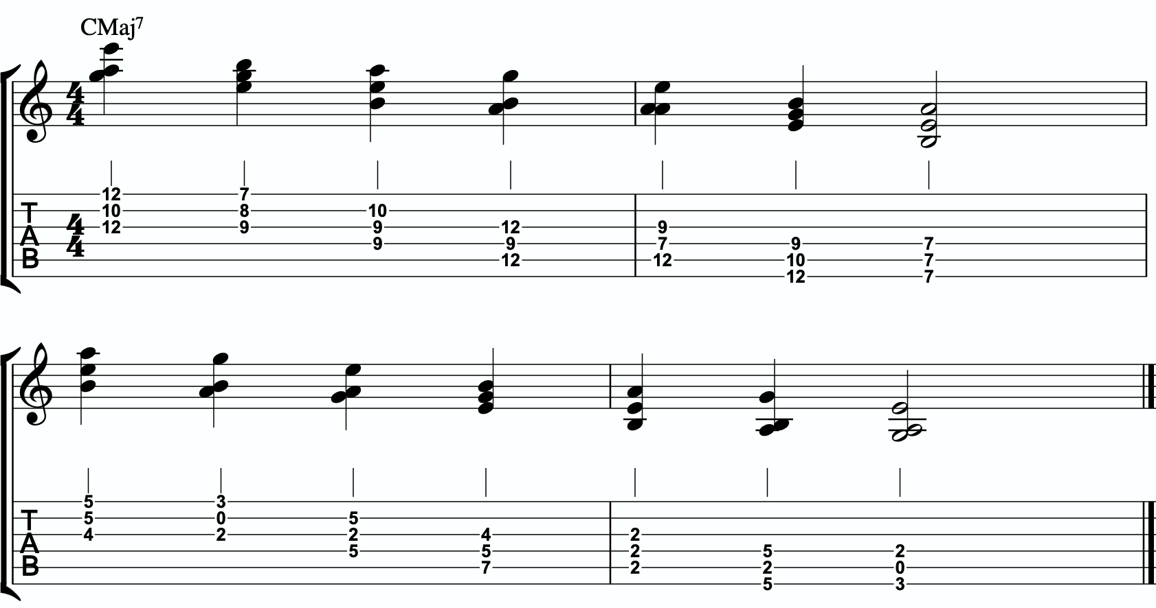
3b

QUADRATONIC SCALAR RUN
Let’s bring it back to single note ideas, melody, and improvisation. The Must Know was all about learning to hear and manipulate melodic tension and resolution using the quadratonic. But we can also use the quadratonic like a scale or an arpeggio. It seems simple because there are only four notes involved… but that’s only one note less than a pentatonic scale. And if you think about it, we only have 12 notes in western music, so if the quadratonic takes up four notes, then that’s actually ONE THIRD of all of the notes in the entire western tonal system. That’s quite a lot.
Let’s start with a scalar type run. Ideally you should already be able to hear and use the tension note and the resolution points of the melodic triad to develop beautiful, clear, authoritative phrasing that works with the harmony, and even implies it, without being stuck outlining it. Not we want to focus on developing the ability to create long, flowing, legato, fluid runs that create the impression of harmony. Traditional scales can sometimes be helpful for this, but they often times have notes that aren’t going to help define the sound of the harmony that’s happening. This quadratonic approach to a run will clear away those less essential notes.

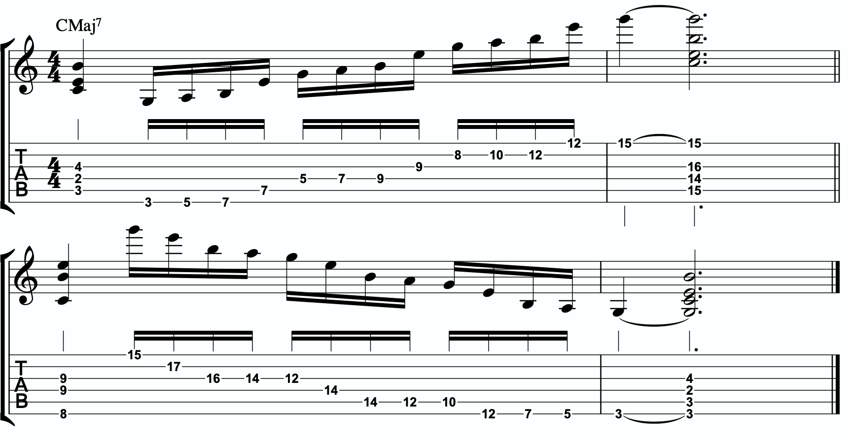
3c

THE SECONDARY TENSION NOTE & PENTATONIC SCALE
Once we can develop authentic phrases with the primary tension note and the quadratonic it gives us, and once we can see it as a scale that we can run through, we can move on and look at the secondary tension note. At this point, I recommend that you put the primary tension note on the back burner and leave it out for a while. Treat this as a whole new tension note. Go back through the ear training process and learn where it is on the fretboard, what it sounds like, how it wants to move, and how to create simple phrases with it.
In order to find the secondary tension note, we go back to Stefon’s formula.

The Hierarchy of Harmonic Importance.
3 - 7 - 5 - 9 - 11 - 13 - R
- Since we started by adding the 13th, is the root of CMaj7 in the E minor triad?
No. The root is C, and that’s not present.
This is a tricky issue, and why I mention in the video that the primary quadratonic is generally all I use for this tonality when improvising. I think it sound complete. But we

want to add more notes to create more melodic and harmonic freedom. Here is the issue with adding the C note. Adding a C note to an E minor triad can be thought of as (E-)/4 OR as (C)/7. We just created a major triad inside the minor triad which - due to the perfection of the major triad - will overpower the minor triad. We generally want to avoid this, so I’d say let’s move on. But we have nowhere else to go. That’s the last note in the hierarchy. We could circle back and try the other notes we skipped. We left out the D note because it was a tension b7. This is true, but it ALSO creates a major triad. E minor with a D note means we also have a G major triad with an E note. So not only are we still creating the major triad, but we’re also using a tension b7 which we don’t want. So that’s even worse than the C note. If we add the 11th (F), we are also implying the sound of a dominant. We almost never want to add a tension b2 against a minor triad… especially over a tonic major chord! Even though using the harmonic root note adds no depth or harmonic color, the other options are even worse.

So our secondary tension note is C.
C is the root of CMaj7, but it will be heard against the melodic triad. C is the b6 of E minor, so that means our secondary quadratonic is E minor tension b6, and it gives us this tonality’s melodic triads pentatonic scale.

/ 4, b6
E-
Here is an examples of this pentatonic scale in use:
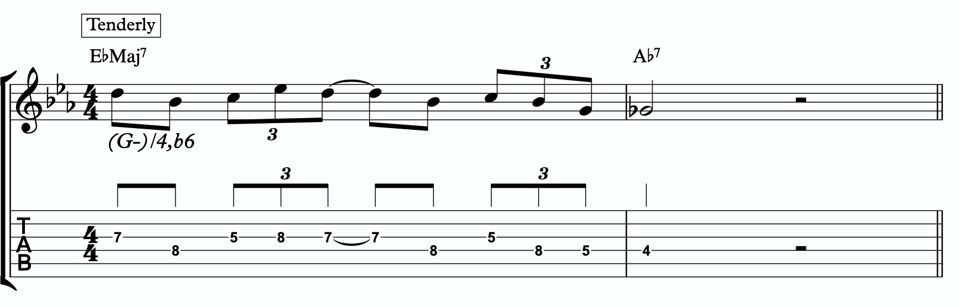
3d

THE MELODIC TRIAD BEBOP SCALE
Hopefully by now you’re starting to see the way melodic triads can offer a very direct path through all the traps of scale running, noodling, and outlining chords progression using 1 - 3 - 5 - 7 chord tones and arpeggios. All of these can be great devices (maybe not noodling), but have dangers to them.
The melodic triads approach helps us start with the sweet spot notes, and build our harmony and melodic from there. Before you start working on the melodic triad bebop scale or anything beyond this point, I strongly encourage you to make sure that you’re not simply reading these ideas like a theory book to be memorized. These are meant to infiltrate your ears, map the fretboard, and apply directly to musical situations in tunes. If you’re been studying and applying the melodic triads approach for enough time that you’re getting comfortable with it, we can take the next step. It’s only one extra note… but it’s a game changer.
In order to understand what the melodic triad bebop scale is, you need to understand what a traditional bebop scale is and the purpose for why it’s built the way it is. The standard diatonic scale is made of seven notes. The problem with playing a seven note scale is that it’s made of an odd number of pitches, so if you’re playing in 8th notes in 4/4 time, it’s going to flip itself around and start to place weak sounding notes on strong beats and strong sounding notes on weak beats.

C major scale
3a

In music, we have strong beats and weak beats. We can see these pretty easily by looking at the beamed groups of 8th notes. There are always two of them. The first one, on the left of each group, is the strong down beat, and the second one, on the right of each grouping, is the weak up beat. We count them:

1 - & - 2 - & - 3 - & - 4 - &

That makes up one full measure of 8th notes in 4/4. The strong beats are on the number, and the weak beats are on the & (the “and”). If we look at the C major scale above, we see that it starts on the C note (very important) on a down beat. Then the next down beat, beat 2, has the E note. That’s the 3rd of CMaj… so we’re doing good. The 3rd down beat has the G note… still good. But the 4th down beat has the 7th of the scale, and then the C root note happens on the & of 4. And that puts the D note, the 2nd of the scale, on the down beat of the following measure. The following few down beats all have weak notes on them, putting the strong CMaj “chord tones” on the weaker up beats. It finally loops back around and lands on the C note on beat 4.
The traditional bebop scales took care of this problem by adding one single note. This evens it out to an eight note scale and lines up the pitches of the scale with the beats in the measure.

Some players would call this a bebop scale, or if you’re familiar with the Barry Harris method, you might call this the 6 diminished scale. Regardless, what’s important is that if you look at the strong beats, the notes spell out C - E - G - A. That’s a C6 chord. It gives

us a perfect combination of melody (the scale - with tension and resolution points), harmony (the C6 chord - the resolution points), and rhythm (the timing of getting all of the important notes to fall on the strong beats). It’s a beautiful, perfect, and very helpful scale to know.
I still rarely if ever think about, practice, or use it. Doesn’t mean you shouldn’t. But hopefully by now you’re starting to see just how powerful triads are. This scale is built around four note chords like C6 or C7, not three note triads.
But there’s a way to combine the two concepts. The pure simplicity and strength of the triad, with the rhythmic perfection of the bebop scale concept.
We simply add one single passing note between every triad note. Here’s one octave of an E minor triad. Our melodic triad for CMaj7.
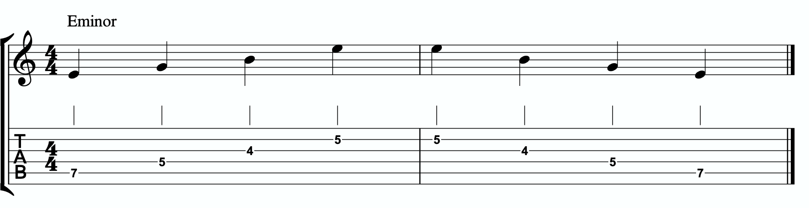

Now I’m going to insert one passing note between each triad note. The key is to pick the passing note that best respects and defines the CMaj7.

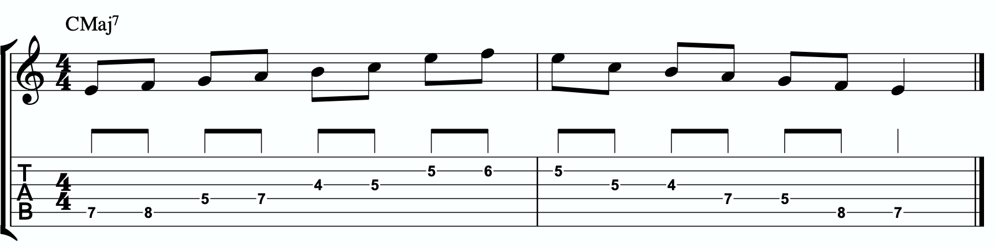

This is our melodic triad bebop scale. It’s a six note scale that helps us outline the tonality we’re working with by stabilizing the notes of our melodic triad.
It’s just an E minor triad with passing notes. If we look at those passing notes in relationship to the E minor triad, we get tension b2, tension 4, and tension b6. Two of the three tension notes are straight from our primary and secondary quadratonics. No, that’s not a coincidence. That’s due to the perfect nature of how triads function when we dig through harmony and melody with them. So we’re simply adding a third tension note. In this case, it’s tension b2. I wouldn’t recommend using it as a standalone quadratonic, but it could be helpful to practice with it to develop your ear to how it sounds. E minor tension b2 over a CMaj7 chord. The melodic triad bebop scale gives us a rhythmically aligned “scale” but it also gives us three tension notes, each with their own unique emotional quality to them, that we can take advantage of if we don’t want to get stuck running scales and want to return to a focus on melodic tension and resolution and lyrical phrases.
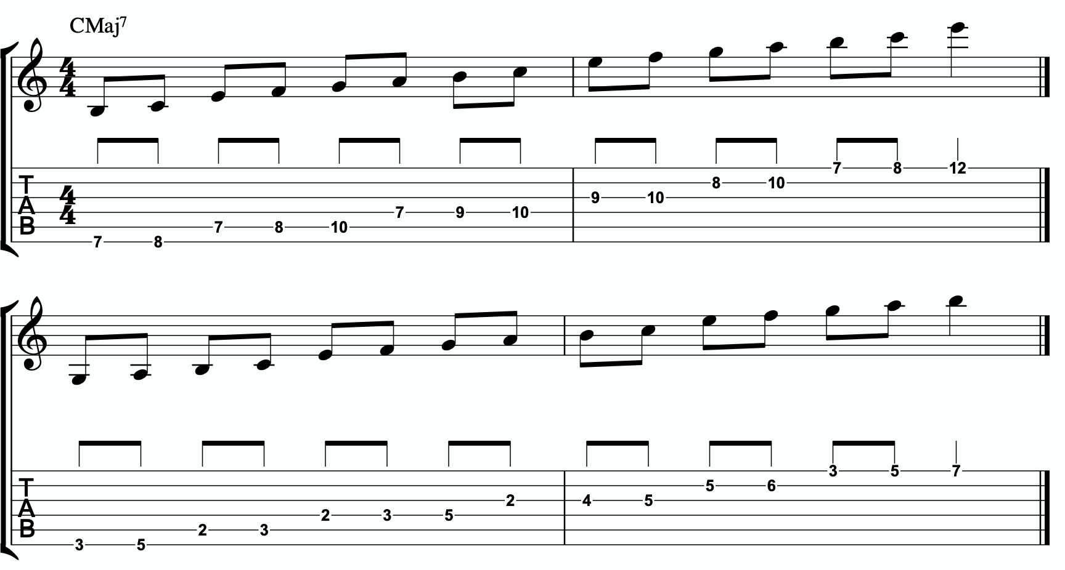
4a

Here is the same scale but harmonizing all of the melodic triad notes with our three note
quadratonic voicings:

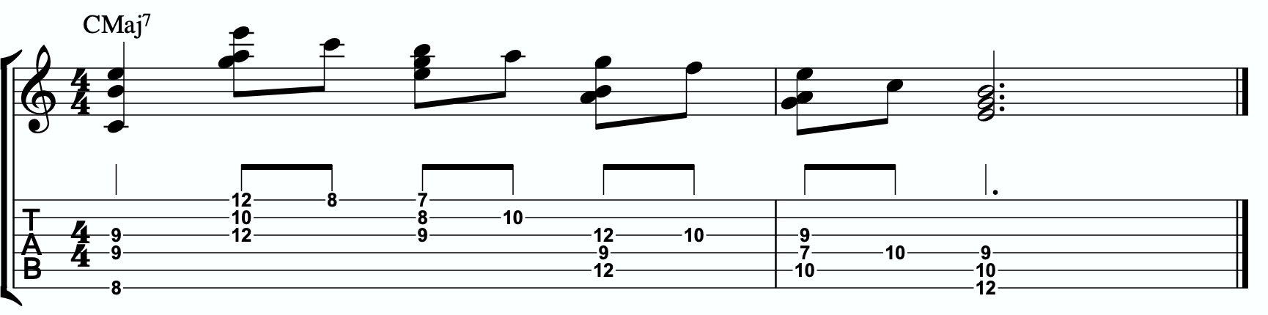
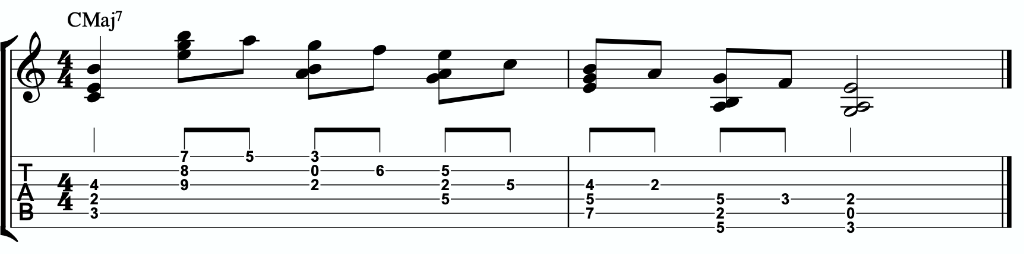
4b

ADVANCING HARMONY
We are getting into more and more advanced material now. Please remember that you do NOT need any of these continued lessons and concepts to play music. It is significantly more important that you develop your ability to be authentic, spontaneous, and playful with the material in The Must Know and then, if you feel comfortable, in Digging Deeper. Each section is building on the last, so if you’re struggling, it’s simply a check engine light to return back to earlier sections.
That said, we’re still far from a complete exploration of the depth of this one little triad.
This section we will explore some more advanced harmonic ideas. You may have heard me talk about liquid harmony. This is a way of visualizing the creation of harmony that involves movement. Think of a chord voicing like a block of ice. It’s frozen in time. We play it, we move to another chord, we move to another chord. Most of us learned to play harmony this way with a focus on shell voicings and drop chords. Liquid harmony is the idea of taking those blocks of ice and melting them down into a little. Not necessarily completely. But we want at least some of the ice to return to water so that it can flow and move. It helps free us up to transcend more static voicings, even cool sounding ones, and creates a more pianistic, movement-oriented sound. Not simply movement from one chord to another, though that’s important as well. But movement inside of a single chord. That’s what this section will explore.

HARMONIC QUADRATONICS
This is possibly the simplest, most effective, and most fun ways to create liquid harmony. The idea is that we play the primary quadratonic, but instead of thinking of it as a scale that we play with single notes, we play it as a chord. We will play three notes of the quadratonic. The tension note will be part of the chord, and it will replace the nearest melodic triad note. So the chord will be made up of two melodic triad notes and the melodic tension note. Then, while holding the two melodic triad notes and allowing them to continue ringing, we will resolve the tension note back into the triad. If we’re playing solo guitar or accompanying another musician, we may want to play the root note of the chord (“left hand”) or even the whole shell voicing. However in a full ensemble with a bass player, or if we’re playing solo and simply want a more impressionist style sound, we can leave that out and play these ideas as rootless “chords”.

Here is an example:
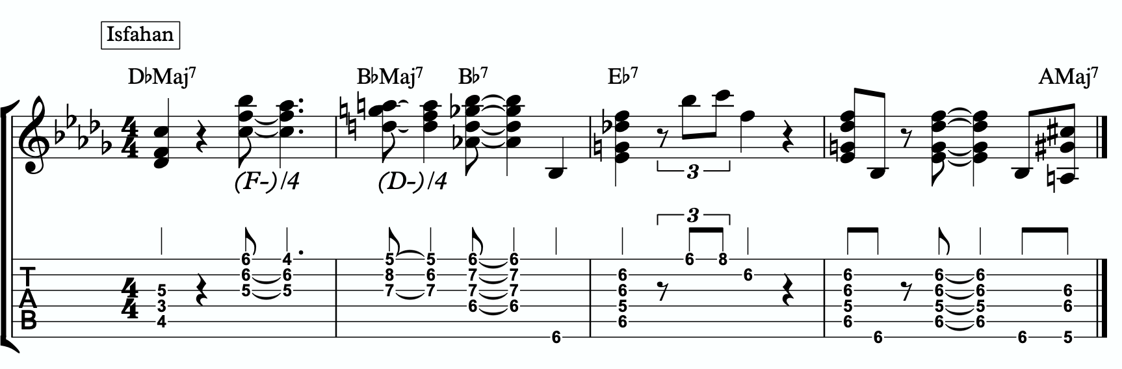
5a

Quadratonic Dyads
This is a similar concept to our quadratonic 3-note voicings, except now we’re creating 2 note grouping by pairing together every other note.

So if our quadratonic is made of E - G - A - B, we will group the E and the A together and the G and B together. And we will get this:
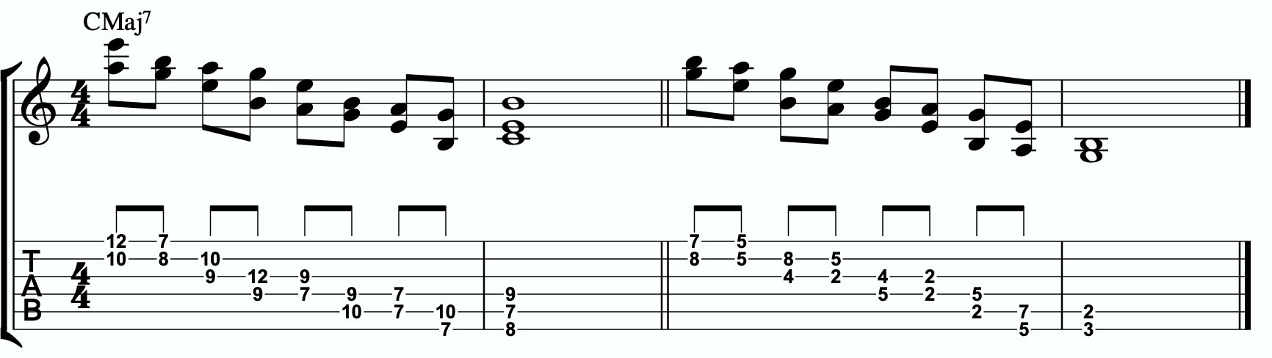
5b

TRIAD PAIRS
Sticking with our melodic triad bebop scale, we actually have our melodic triad version of triad pairs hiding right there in plain site. We know that all the resolution points are the notes of our melodic triad. But if we look at all of the passing tension notes we added, we actually have a second triad. This scale is two triads together. We have our melodic, or our “resolution” triad, and then we have our tension triad.
For this tonality, our triad pair is E minor and F major.
/ F
E-
We can of course arpeggiate these triads out to create single note ideas, but this section is specifically about harmony. So let’s look at a harmonic application for our tonality inside a chord progression.
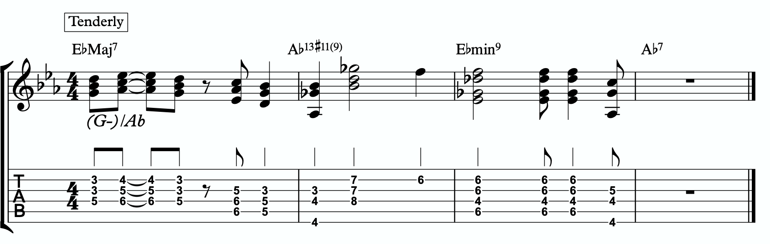
5c

Here is a dyad application, where we leave out one note from each triad.
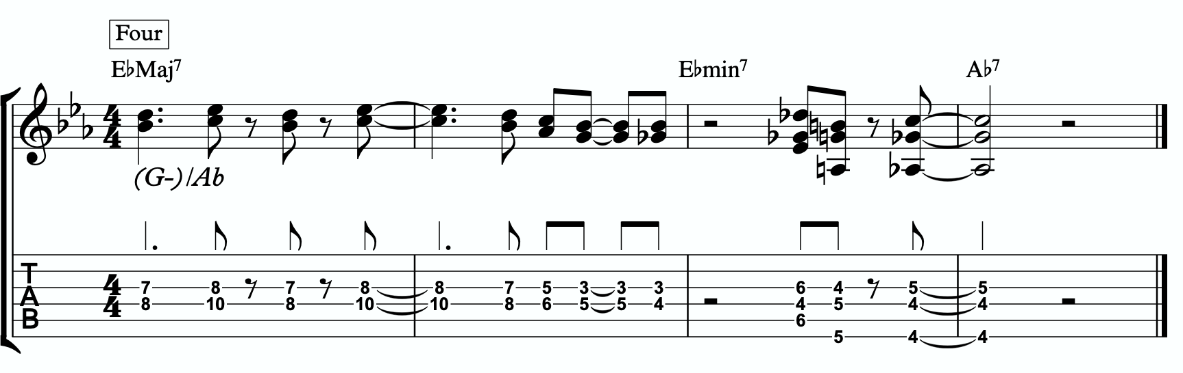
5d

TENSION LAYERS
Everything up until this section has been based on the idea that the melodic triad is the strongest organization for resolution, color, harmony, and melody. We leave the triad temporarily with different techniques to create tension, harmonically and melodically, but always in service to bring us back to rest in the resolved nature of the melodic triad.
In this section, we’re going to talk about the idea of thinking of tension as existing in layers. This way, we have different levels of tension that we can move in and out of - like rungs on a ladder that we can climb up, climb down, or simply pick one and stand still on it to enjoy the view.

LAYER ONE
This one is easy. Layer one is the primary quadratonic. The melodic triad is the most stable set of notes we have for our tonality. The primary tension note offers us a very respectful tension note to create melody. There is tension inside this quadratonic, but it’s accessible and always brings us right back into resolution. We must be comfortable making music with this sound before we can continue.

/ 4
E-

LAYER TWO
But what if we want to move up a rung on the ladder? We know from the melodic triads bebop scale that our triad pair for this tonality is E minor and F. So far, we have only thought of the F as a tension triad that can be used to bounce back and forth with E minor. But what if we momentarily “modulated” into the F major triad to create a new rung on our ladder? Like modulating in a tune between the relative major and minor of a key, the key doesn’t actually change, but we can momentarily alter the color and the emotion.
By switching over to thinking of our tension triad, we can add a tension note to the triad and create a tension quadratonic.

The tension quadratonic, when mixed with the primary quadratonic will allow us the ability to navigate seven diatonic notes melodically and harmonically in a structured and authoritative way that will imply the harmony, give multiple colors and layers of tension, and allow for six different resolution points within any tonality. That’s half of all of our available pitches.

How do we chose the primary tension note for our new tension quadratonic?

We go back to the hierarchy of harmonic importance. What’s the only note we haven’t used yet from the hoh? We can account for the root, 3rd, the 5th, the 7th, 11th, and 13th. But we haven’t yet used the 9th. So that’s going to be the tension note for our tension quadratonic.
The 9th of CMaj7 is D. If we add a D note against our tension triad, F major, we get this four note structure - F, A, C, D. That’s a F major triad with a tension 6.

/ 6
F

This quadratonic will sound less “in” than the primary quadratonic, however the tension note in it will give it a sensation of tension and resolution within itself.

Here are an example of this quadratonic pair being used harmonically:
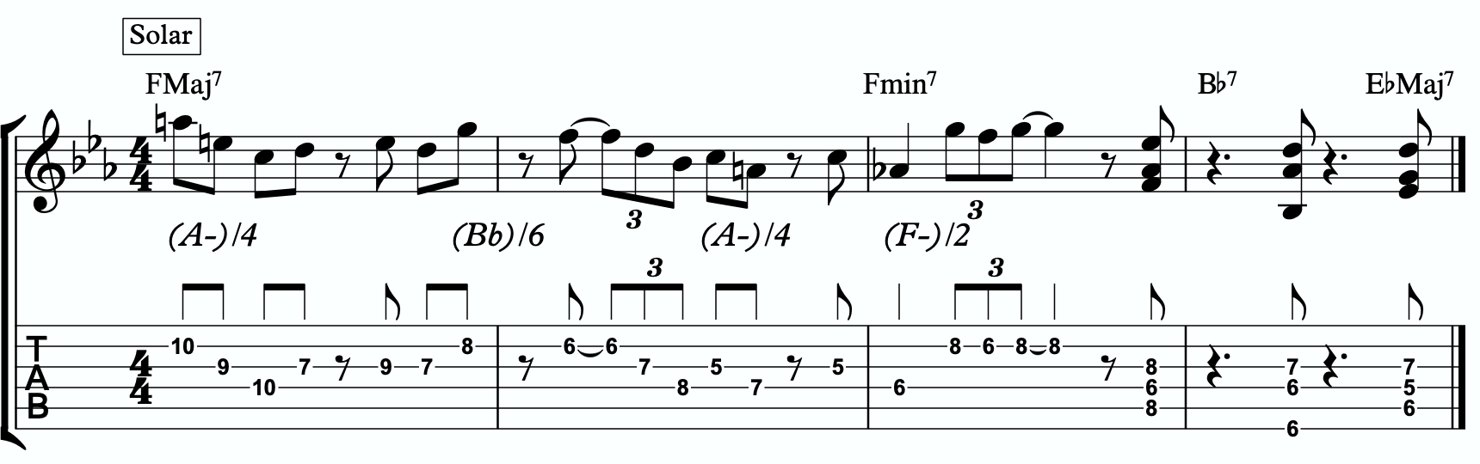
7a

Harmonizing Our Bebop Scale With Tension Layers

Let’s look at our six note melodic triad bebop scale and harmonize it using our quadratonic pairs. We will do this using two different techniques brought up earlier in this study booklet. First, we will move through the bebop scale using our harmonic quadratonics to create liquid harmony within each voicing as we move between the two quadratonics to harmonize each note. Finally, we will apply the three note quadratonic voicing to the bebop scale.

Harmonic Quadratonics & Liquid Harmony
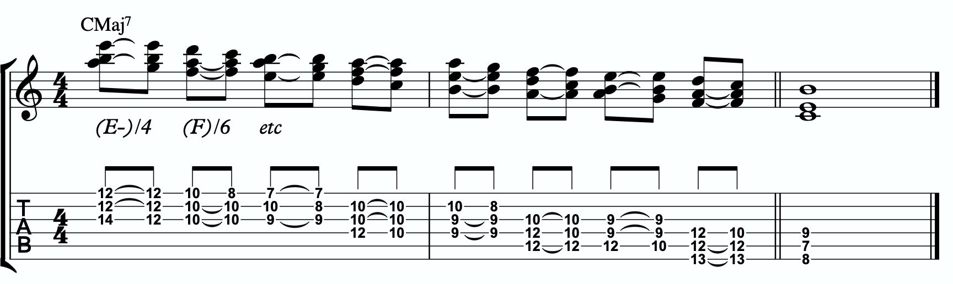
7b

Three Note Quadratonic Voicings
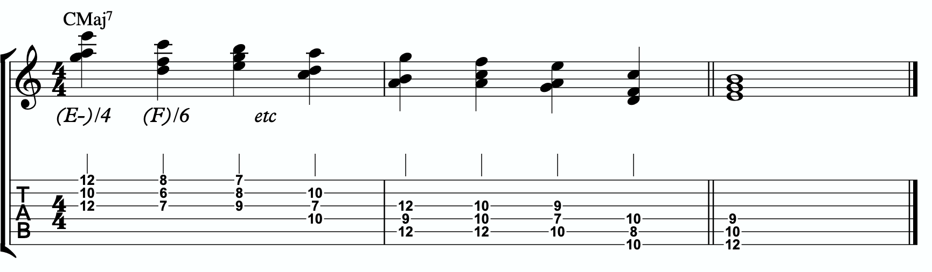
7c

THE OUTRO
I just want to personally thank you for working through these ideas. I am obsessed with exploring, mapping out, and demystifying jazz harmony and melody, and attempting to understand it and execute it using the simplest and most fundamental ingredients in music. I’ve found over many years of playing and study, and learning from some of the greatest minds in the jazz world today, that it’s often times our ego and our own self- inflicted limitations that hold us back the most from growing and evolving towards our potential.
The most dangerous words to development of our musicianship are, “I already know that.”
Most of us generally spend a couple of music theory classes learning our triads. Maybe we read a book about advanced triad application and get some cool intellectual ideas to play with. But for me, it’s all about that Bill Evans quote.
**********************************

The whole process of learning the facility of being able to play jazz is to take these problems from the outer level in, one by one, and to stay with it at a very intense, conscious-concentration level until that process becomes secondary and subconscious. Now, when that becomes subconscious, then you can begin concentrating on that next problem, which will allow you to do a little bit more.

I don’t consider myself as talented as many people but in some ways that was an advantage because I didn’t have a great facility immediately so I had to be more analytical and in a way — that forced me to build something.
Most people just don’t realize the immensity of the problem and, either because they can’t conquer it immediately, think that they haven’t got the ability, or they’re so impatient to conquer it that they never do see it through. If you do understand the problem then you can enjoy your whole trip through.

People tend to approximate the product rather than attacking it in a realistic, true way at any elementary level — regardless of how elementary — but it must be entirely true and entirely real and entirely accurate. They would rather approximate the entire problem than to take a small part of it and be real and true about it. To approximate the whole thing in a vague way gives you a feeling that you’ve more or less touched the thing, but in this way you just lead yourself toward confusion and ultimately you’re going to get so confused that you’ll never find your way out.

It is true of any subject that the person that succeeds in anything has the realistic viewpoint at the beginning and [knows] that the problem is large and that he has to take it a step at a time and that he has to enjoy the step-by-step learning procedure. They’re trying to do a thing in a way that is so general [that] they can’t possibly build on that. If they build on that, they’re building on top of confusion and vagueness and they can’t possibly progress. If you try to approximate something that is very advanced and don’t know what you’re doing, you can’t advance.

**********************************

Was Bill referring to melodic triads? I very highly doubt that. I’ve never heard him talk much about triads. But consider the underlying philosophy he’s pointing at. Know the

basics. Regardless of how elementary! But it must be entirely true, real, and accurate. Be able to play genuine, authentic music using the most fundamental ideas first. Then it leaves room to grow.
This is why I refer to the first section in this ebook as The Must Know. It’s a basic shell voicing, and a basic triad. And while these two concepts are as simple as they come in music, we must understand them in a true, real, and accurate way. If we did this for a handful of tonalities, we could play beautiful music for the rest of our lives, and for me, I would feel fulfilled. It would offer emotion-driven, precise, human, lyrical melody combined with lush, colorful, pianistic harmony. Mix in a strong sense of time and feel, and that’s everything a jazz musician needs.
But like Bill talks about, when we don’t try to approximate but instead start with the elementary ideas and build a foundation with them, then it gives us room for growth. Look at everything we worked through together in this ebook! All built from one triad and how it relates to one chord (piano diagram!). As of the time of putting this together, I’m still working on many of these ideas myself… and I’m still coming up with new ways of building harmony and melody around the melodic triad.
This is why I can’t recommend enough, even to the intermediate and advanced players out there - spend some serious time in The Must Know section. Own it. Be able to play authentic ideas with it. Apply it to tunes. Move it through the circle of 5ths. Do whatever you can to internalize it and develop your ears to it. Then you can begin moving on. I would encourage everyone… peak ahead if you would like to to keep an eye on where this particular path is heading, but be very self-aware and learn to see when you’re getting in over your head. When this happens, not if, just take a deep breath and back up a few sections. It simply means your foundation isn’t quite strong enough yet to carry the weight of those more complex ideas. If you want it, and you put the time and effort it, you’ll get there.
Like one of my students always likes to tell himself at the end of our lessons…..
“Easy does it. But do it.”

Thank you again. Don’t forget to come and hang in our open office hours to ask questions if you’re confused on anything.
Happy Practicing!
-Jordan Klemons

@ 1-Maj7#5.pdf
@ 2-sus b9.pdf
@ 3-minMaj13#11#9,pdf
@ 4-Maj7#11#9.pdf
@ 5-sus9.pdf @ 6-min9.pdf @ 7-Maj7.pdf
@ 8-dim7b13.pdf
@ 9-13#11#9.pdf
@ 10-Maj7#11.pdf @ 11-minMaj9.pdf @ 12-min7b5.pdf @ 13-7#9#5.pdf @ 13b9.pdf
@ 16-Maj9.pdf
@ 15-min11_9_.pdf

The Melodic Triads Study Group

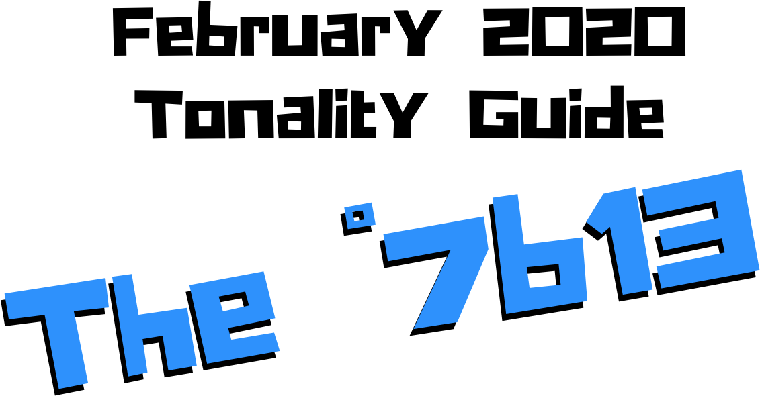

Jordan Klemons
NYC Jazz Guitar Masterclasses

CONTENTS
-INTRODUCTION
-THE MUST KNOW-
-ADVANCING MELODY-
-DIGGING DEEPER-
-THE MELODIC TRIAD BEBOP SCALE-
-ADVANCING HARMONY-
-TENSION LAYERS-
-OUTRO-

This ebook is the copyrighted property of Jordan Klemons. All images, information, layout, and designs belong to Jordan Klemons. This document may not be altered, reproduced, distributed, or transmitted in any form or by any means without the prior written permission of the author.

INTRODUCTION
Thank you for downloading the pdf materials for this month’s melodic triads tonality study guide. Inside you will find all of the supplemental theory, notation, tab, charts, concepts, and examples for the accompanying videos to help you develop your understanding, your ear, your emotional connection with, and your sense of harmonic and melodic freedom within this month’s tonality… as well as its use in some short, common, jazz chord progressions that you will be able to immediately implement in your own playing.
The information in this guide is dangerous. I mean that literally. When the process is respected, and you understand how all of these ideas fit into the puzzle, this guide and the baby steps included can offer tremendous insight into how to begin making real music very quickly, and how to continue evolving and growing as a player for many years to come. However, if approached in the wrong way and the process is not respected, these ideas can confuse and derail a musician’s ability to progress. It’s important not to jump too far ahead of yourself. The advice that a Miles, or a Scofield, or a Coltrane would give to a beginner is different than what they would give an intermediate or to an advanced player. And all of that would be different than how they would talk to a professional who’s already playing on their level. This is important to remember.
This guide is meant to show many different layers of musical growth and how, when using the melodic triad approach, they can all be boiled down and viewed simply as an extension of the most basic elements of music. Namely… a triad. Think of the pages that follow as an architect’s blue prints for a skyscraper. If you haven’t built a strong foundation, your skyscraper will fall. If you attempt to skip the first 50 stories and jump to building the penthouse, the skyscraper will fall. If you try to put up the fancy exterior of the building before you complete the steel frame, the skyscraper will fall. Yes, the information all the way at the end of this guide is constructed using the same ideas and concepts that are presented in the first chapter, but the process must be respected for anything to work. Otherwise it will only leave you confused, frustrated, feeling like a failure, and wanting to give up. Be patient with yourself. The short cut IS the long road. Take it. Spend two or three months working on the long road and watch how much you progress. Focus on your sound, on your ear, and on your musicianship… and trust that the simplicity of the ideas and the process itself will take care of you. They will. But only if you respect them. It’s like a relationship - you have to be present and give of yourself, and then you will receive in abundance.

As you work through these pages, try to keep in mind this Bill Evans’ quote from The Universal Mind.

**********************************

The whole process of learning the facility of being able to play jazz is to take these problems from the outer level in, one by one, and to stay with it at a very intense, conscious-concentration level until that process becomes secondary and subconscious. Now, when that becomes subconscious, then you can begin concentrating on that next problem, which will allow you to do a little bit more.

I don’t consider myself as talented as many people but in some ways that was an advantage because I didn’t have a great facility immediately so I had to be more analytical and in a way — that forced me to build something.
Most people just don’t realize the immensity of the problem and, either because they can’t conquer it immediately, think that they haven’t got the ability, or they’re so impatient to conquer it that they never do see it through. If you do understand the problem then you can enjoy your whole trip through.

People tend to approximate the product rather than attacking it in a realistic, true way at any elementary level — regardless of how elementary — but it must be entirely true and entirely real and entirely accurate. They would rather approximate the entire problem than to take a small part of it and be real and true about it. To approximate the whole thing in a vague way gives you a feeling that you’ve more or less touched the thing, but in this way you just lead yourself toward confusion and ultimately you’re going to get so confused that you’ll never find your way out.

It is true of any subject that the person that succeeds in anything has the realistic viewpoint at the beginning and [knows] that the problem is large and that he has to take it a step at a time and that he has to enjoy the step-by-step learning procedure. They’re trying to do a thing in a way that is so general [that] they can’t possibly build on that. If they build on that, they’re building on top of confusion and vagueness and they can’t possibly progress. If you try to approximate something that is very advanced and don’t know what you’re doing, you can’t advance.

**********************************

I’ve setup the material in these tonality lessons to start with the most basic and fundamental elements of music, and to grow outwards in complexity. Everything builds on what came before it, so everything is connected. You DON’T need to master everything in these lessons to play music. You only really need the first section and a little bit of creativity and concern for your sound - that’s enough to create something beautiful..
I recommend that if you’re new with us, even if you’re already an advanced player, you begin focused entirely on the first section of this guide, The Must Know, and give yourself a minimum of 3 - 6 months to get used to this method and the initial concepts presented. It’s a very different approach to standard theory, and your goal should be (as Bill Evans said) to be able to make genuine, authentic music with the ideas in the first section. Once you feel you can hear and play music using these ideas on a small handful of tonalities and applied to some tunes, then it is time to start advancing forward.

I would continue giving yourself an addition 3 - 6 months for each subsequent section, as each builds on the last and becomes more and more advanced… starting from the most basic and simple ingredients, and eventually working our way up to learning to hear and use all 12 notes of the western chromatic scale harmonically and melodically over any chord in a musical way.
I strongly recommend that you follow this rough timeline. I believe it’s the most effective way to cut through the learning process and get straight to making beautiful music, and then to set yourself on the path to continue growing and building for years to come.
The melodic triad ideas I’m working on today, I didn’t even know they existed during the first few years of my own studies. As we grow and progress and get comfortable, we can naturally start to evolve the ideas into more advanced applications. That’s the beauty of starting with the fundamentals, learning to make genuine, authenticate music from our own self first… and then building layers of complexity on top of, but always connected to, those very fundamentals. Much like a large skyscraper building starts with a huge hole in the earth, then is filled with concrete and steel, and then the steel frame will hold the building as it goes up. We won’t see any of these structures. But without them, the building would collapse. Only once the structure is there can the work of putting up the exterior, the glass, the interior, the design, the furniture, etc. take place.
Thank you again for downloading this study guide and working on your music with us. I look forward to hearing your playing and your contributions to the melodic triad conversation inside our facebook group, and for those of you subscribed to our Private Community, inside our melodic triad mastermind group.
Happy Practicing!
Your friend on the path towards jazz guitar mastery,
-Jordan Klemons

The Melodic Triad Study Group - a part of
NYC Jazz Guitar Masterclasses

THE MUST KNOW
The theory, ideas, voicings, and “scalar” ideas presented in this section may seem too simple and elementary to be of value. But I urge you, even the intermediate and advanced players - do not skip this section. I recommend that if you’re within the first 3 - 12 months of study with us that you focus entirely on learning to apply these ideas to musical situations. You can skim the rest of the pages if you’d like, but this should be where you build from. After close to 25 years of playing music seriously, I still spent my first year of working on melodic triads only on this material. The great thing about these ideas is that not only can you comp, improvise, compose, and arrange beautiful music over standards, bebop, modern jazz, and original works with them, but they also act as the foundation on top of which we can grow into more and more complex ideas without ever leaving behind these basic building blocks of harmony and melody.
Do not simply see these as intellectual theory ideas. These are meant to be internalized. To understand the theory is great. To hear the sounds in your ear with a sense of familiarity is just as important. To connect with them personally and be able to hear and express emotion through them is of the utmost importance when it comes to developing our musicianship. This should be the goal.

THEORY
Due to the symmetrical nature of fully diminished 7 chords, I personally don’t hear a distinguishable difference between different diminished tonalities. They simply all sound, “diminished” to me. The vibe is a general sense of pure tension mixed with stunning beauty. They always remind me of listening to great classical music from the romantic era
- such as Chopin, Beethoven, and Tchaikovsky. I tend to classify diminished chords functionally as the ones that resolve up a half step, the ones that resolve down a step, and the ones that resolve to the same root note (i˚7 -> I) which I think of, ultimately, as just an inversion of the up a half step resolution.
*If Emin7 is a sub/inversion of CMaj7, and Eb˚7 resolves up to Emin7, then C˚7 resolves to CMaj7.

What makes up a C˚7b13 tonality?
Two basic ingredients.
- A basic C˚7 chord
- An Ab major triad
A good way to think of this is to visualize a piano player with two hands. Their left hand would be playing C-Eb-Gb-Bbb (a basic C˚7 voicing - adding in the 5th where we usually leave it out) and their right hand would be playing an Ab major triad.

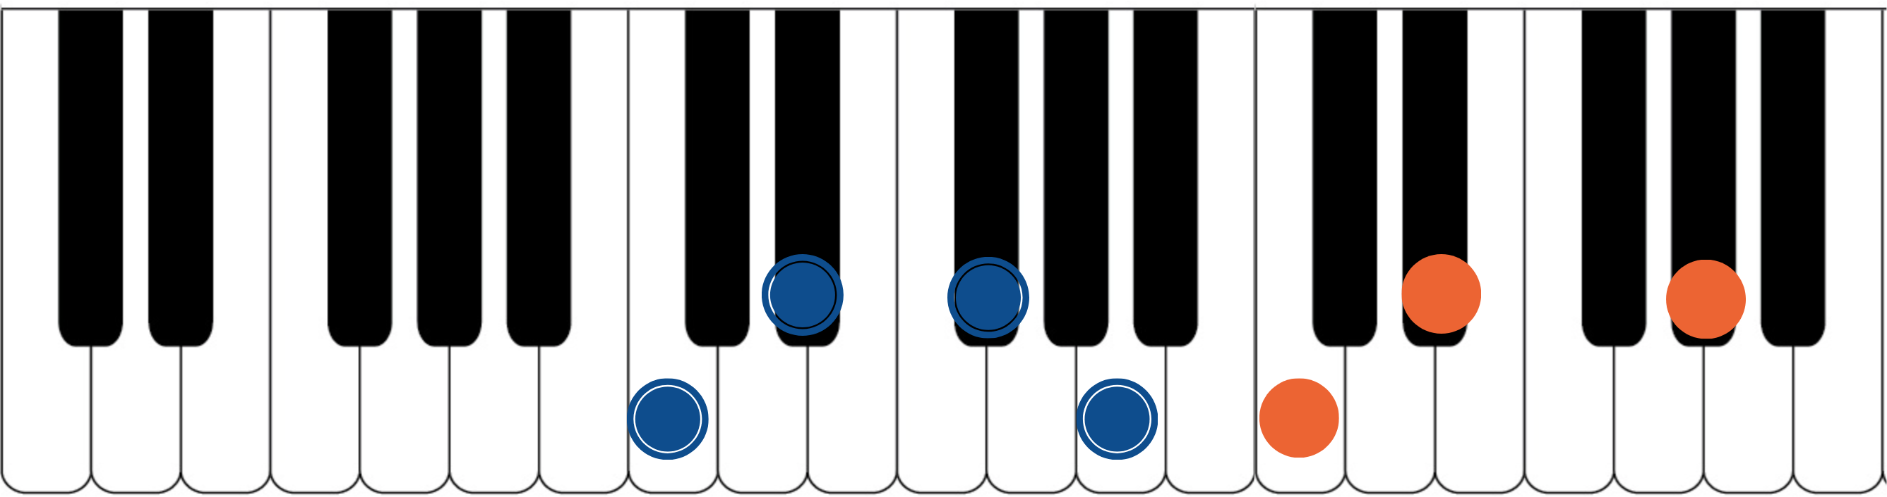

The blue dots would represent the fingers of the piano player’s left hand. Notice they spell out C, Eb, Gb and Bbb (enharmonically, A). That’s the 1, b3, b5 and dim7 of a basic C˚7 chord. Usually we stick with the 1-3-7 shell, but because of how strongly the b5 helps define diminished, it will be included. The orange dots represent the piano player’s right hand. They spell out C, Eb, and Ab. That’s an Ab major triad. If you have access to a piano or keyboard, I strongly encourage you sit down and play these seven notes simultaneously. Listen to how big of a sound they create together. Play it a few times. Try and feel the emotion and the color they create together. Then remind yourself of the elementary and simple nature of what’s happening in each of your two hands separately. A basic chord in your left hand. A basic triad in your right hand. The magic happens when we use these sounds together… and when we begin to build chord voicings and melodic ideas around these two simple sounds.

***This Ab major triad, which is now our melodic triad, is built on the b6th of C˚7… ‘Ab’ is minor 6th up from ‘C’. This relationship is critical to understand and memorize as it will allow us to transpose this ˚7b13 tonality into any key quickly. We will notate

this as ‘Tb6’. This notation comes from Stefon Harris. The ’T’ is short for ‘triad’ and we make it upper case to notate that it’s a major triad. The 2 tells us that the melodic triad is built on the b6th of the harmony. So if we want a G˚7b13, we think Tb6, we find the b6th of G (which is Eb), and we know that the melodic triad is Eb major.***
This pianistic chord construction is the starting point for everything we are going to look at together. Hidden inside of this seven-note chord is a universe of potential harmonic and melodic ideas. The following pages can all be traced back to this construction idea. Basic chord, basic triad. Left hand, right hand. Harmonic structure, melodic structure. Hence the term… melodic triad. Even if you don’t have access to a piano, I encourage you to sit and think about this diagram until it makes sense to you.

GETTING THE PIANISTIC VOICINGS ONTO THE GUITAR
Taking the concept of the piano construction, where the C˚7 chord is always underneath the Ab major triad, we can develop three basic inversions of this chord by inverting the Ab triad and keeping the C˚7 chord underneath it as possible.
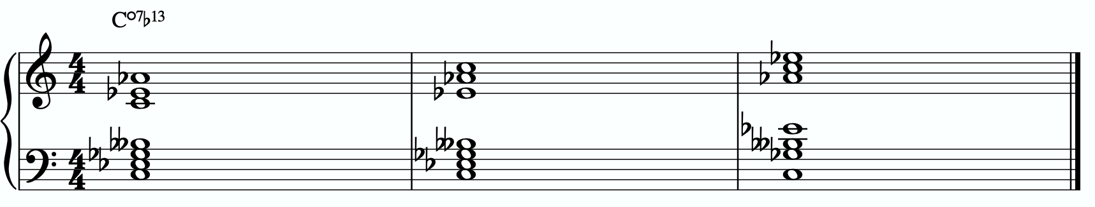

In order to get these three inversions, we will use the piano -> guitar technique described in the video - where we put the shell voicing on the bottom three strings and the triad inversions on the top three strings. This will give us a three “pianistic” inversions of this tonality on the guitar.
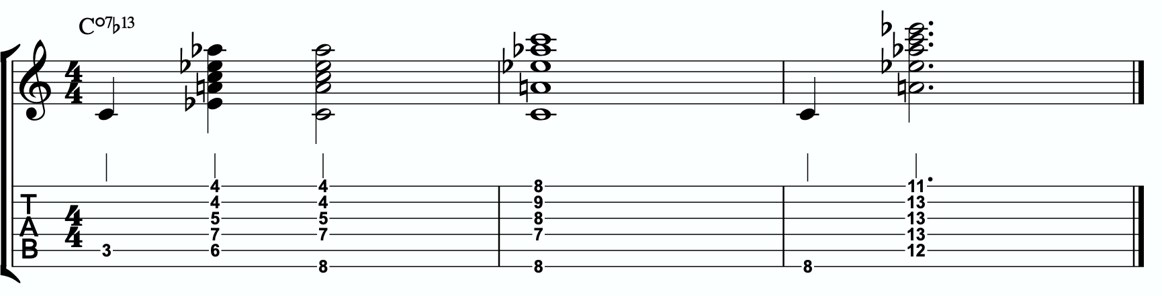

Notice the three basic inversions of the Ab major triad on strings 1 - 3.

A few exceptions are being made here.
In measure 1 I prefer the first option. This involves breaking the basic C˚7 chord into the root followed by the 3rd and the 7th (giving us the full 1-3-7 shell voicing). And when playing the 3rd and the 7th, we are adding the Ab melodic triad on top. The other option is great if your hands can make the stretch and you want to hear the entire chord played in one voicing… however it can be a challenge to reach and is not that realistic at faster tempos.
In measure 2 I personally can not add more than two notes from the basic 1-3-5-7 of the chord. I chose the root and the bb7. This is okay however, since the 3rd of the chord is present in the melodic triad, so we have all the pitches from the basic 1-3-7 shell present… they’re just spread throughout the “left and right hands”.

In measure 3 we again need to break the chord apart to get this voicing into a root position. So I prefer to play the low C note root, followed by a five note voicing with the 3rd and 7th of the C˚7 chord in the bottom voices and the Ab melodic triad in the top three voices.

THE PRIMARY QUADRATONIC
Because this particular type of C˚7 contains an Ab major triad in the right hand, that Ab triad is going to be the foundation of our melodic structures. It governs everything. Rather than simply behaving as the chord tones that they correspond to harmonically, when used melodically, they will function as the 1, 3, and 5 of our melody… the strongest and most stable resolution points we can build lines with.
The ideal starting point is our primary quadratonic. A quadratonic is a triad that has one additional note added to it. It’s a four note structure made up of three stable notes (the melodic triad) and one ‘free radical’ or melodic tension note. This extra note serves two functions. First, it’s there to create melodic tension that will help us create movement, emotion, and lyrical phrases without getting trapped inside running scales or chord tones. Second, it will help imply the sound of the harmony we’re playing over and glue the melodic triad inside the chord so they don’t sound like two separate sounds, but rather one unified, colorful tonality.
We only have 12 notes in western music, and three of those 12 are being used in our
melodic triad. That means we only have nine possible melodic tension notes. All nine of

these could be used to create melodic tension against our triad. But some will help imply the sound of our original harmony better than others. Our primary quadratonic will be made of our melodic triad and the primary tension note - or the note the most respects the basic harmony.

Straight from Stefon Harris’ brilliant mind comes this rule that will help us figure out what are the most important notes:

The Hierarchy of Harmonic Importance.
3 - 7 - 5 - 9 - 11 - 13 - R

These are the chord tones of our basic harmony (the left hand of our piano player).

Here’s how this works:
- Is the 3rd of C˚7 in the Ab major triad?
Yes. The 3rd is Eb, and Eb is in the Ab triad… so we can’t add it.
-Is the 7th of C˚7 in the Ab major triad?
No. The 7th is A, and A is not in the Ab major triad.

So our primary tension note is A (or Bbb).
This A - while the 7 of C˚7 - is going to be heard by the ear in relationship to the Ab major triad. Since A is the b2 of Ab, we will call this tension b2. So our primary quadratonic is Ab tension b2.
We’ll notate this as:
/ b2
Ab

1b
1c
JORDAN KLEMONS
2025-01-14 11:01:26
--------------------------------------------
1a
JORDAN KLEMONS
2025-01-14 11:01:26
--------------------------------------------
1b
JORDAN KLEMONS
2025-01-14 11:01:26
--------------------------------------------
1c
By making the triad bold and circling it, it draws our eye directly to the melodic triad so we can think first about our strong resolution points, then it quickly lets us know what our primary melodic tension note is.
At this point your primary goals should be to be able to play the three pianistic voicings, to be able to visualize the primary quadratonic over the basic shell voicings on the fretboard, to develop your ears to hear the melodic tension note wanting to move and the root note of the melodic triad as melodic ‘do’ - or the root note of the melody.
Here are some examples of these fundamental voicings, shell voicings, and melodic ideas being used in music situations.
1a
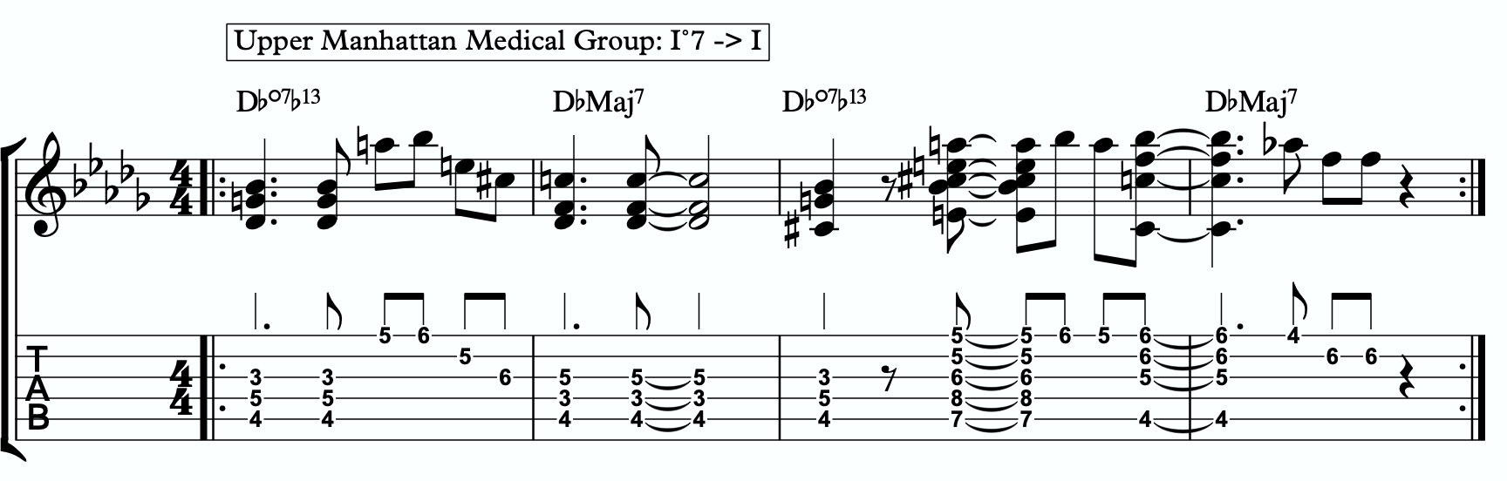
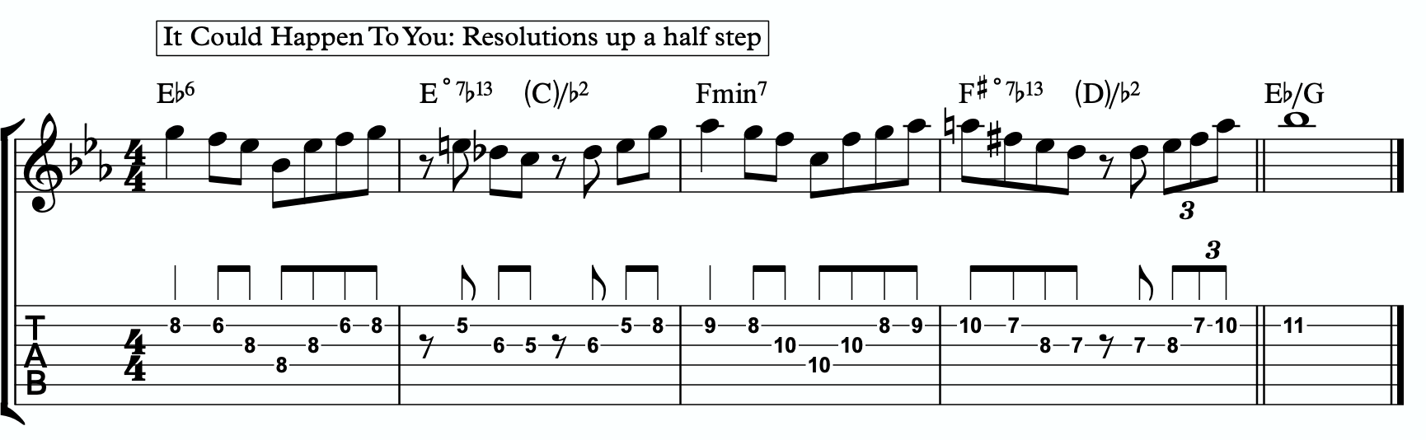
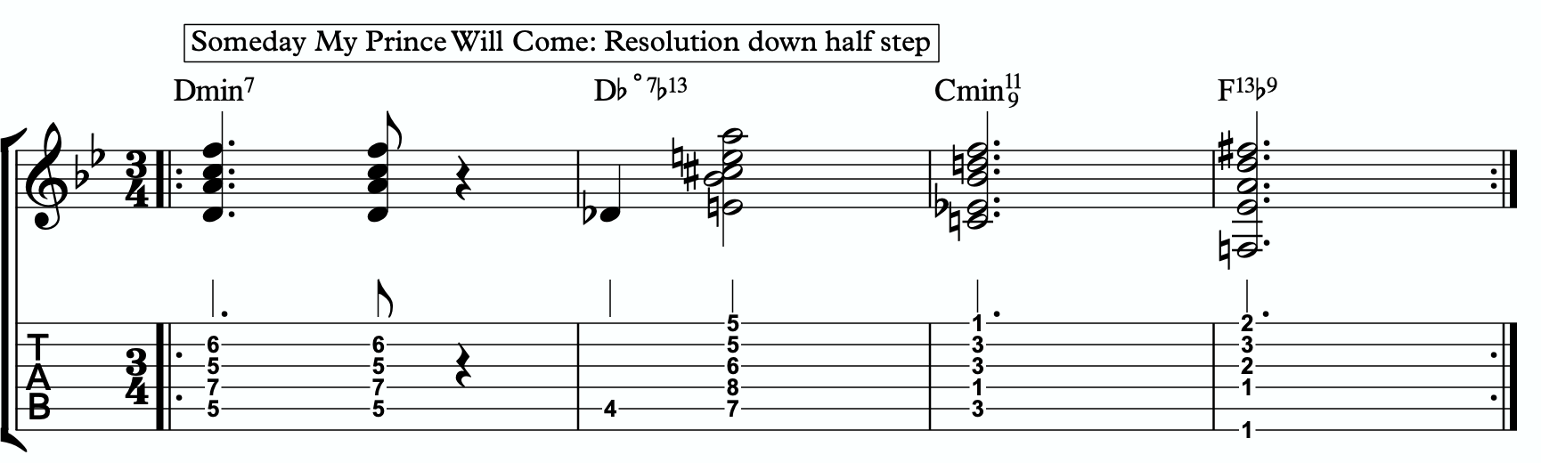

ADVANCING MELODY
This section is going to look at more advanced and complex application of melodic triads to scalar ideas and arpeggios for the creation of bebop and modern jazz vocabulary based on simple structures that we can be playful with rather than memorization of riffs. Don’t be fooled by the idea of these ideas being more advanced or complicated. This doesn’t mean the music you play with these ideas will necessarily be better or more “advanced sounding” then the use of the pure primary quadratonic. In fact, often times I find that the use of the pure quadratonic can carry a level of maturity and intensity into the music that is hard to maintain when using more complicated ideas.
But, I still think it’s worth being aware of how we can build more advanced structures directly from the melodic triad.

Chromaticism Within The Quadratonic
One of the quickest ways to begin developing more complex lines is to incorporate chromaticism and leading tones within the quadratonic. By first learning to master the pure quadratonic, it should make it easier to begin spontaneously connecting individual notes within these structures in a way that will create a sense of improvisational freedom with our bebop and modern jazz playing. Playing this way will allow us to breathe long, flowing, complex lines within very the very basic, simple, steel frames of our buildings.
Here is our primary quadratonic:

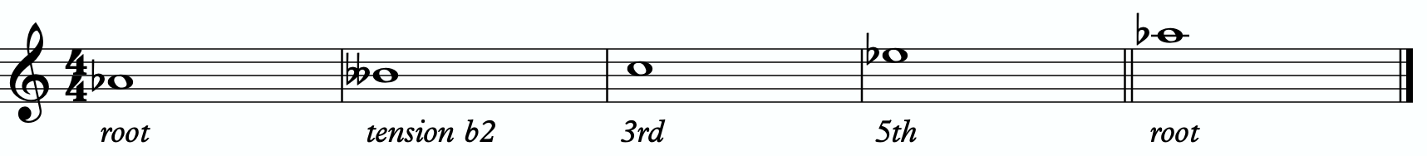

In between any of these notes, we can hang a chromatic line or place a leading tone (a note chromatically below the target) to bring us to the next note. When we use these techniques, we want to make sure that we resolve to a quadratonic note, and ideally we want to play at least two quadratonic notes immediately following the chromatic line to cement our phrase inside the tonality.

JORDAN KLEMONS
2025-01-14 11:01:26
--------------------------------------------
2a
JORDAN KLEMONS
2025-01-14 11:01:26
--------------------------------------------
2b
JORDAN KLEMONS
2025-01-14 11:01:26
--------------------------------------------
2c
Here are some examples:
2a
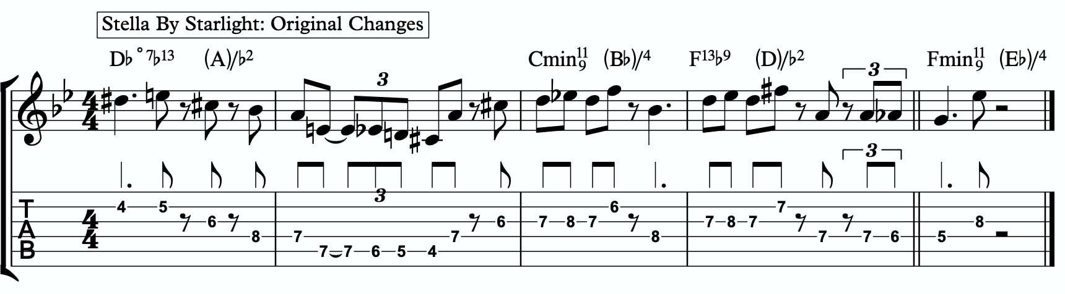
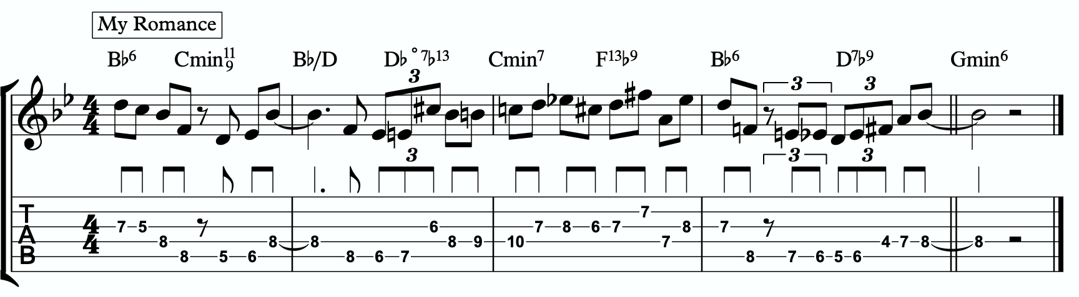

Quadratonic Arpeggios
2b
So far we have only discussed using quadratonics to develop phrases and scalar like ideas. Let’s look at how we can create the sound of arpeggios with them.
We will begin by starting on the primary tension note. After playing this note, we can move to the nearest melodic triad note and sweep quickly through that triad, landing on the tension note an octave away from where we began.
2c
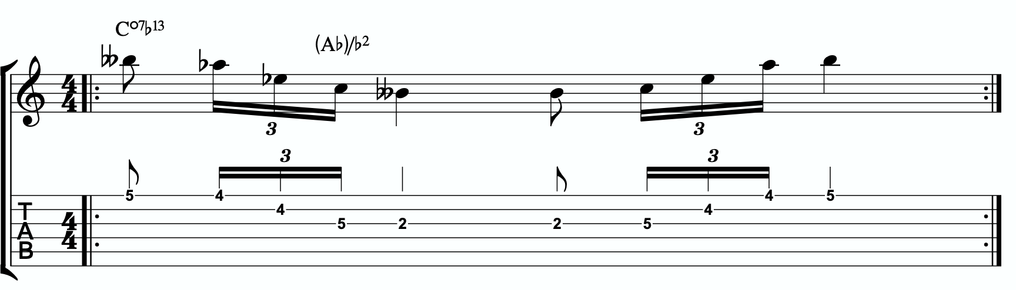

JORDAN KLEMONS
2025-01-14 11:01:26
--------------------------------------------
2d
We want to be able to play these ascending and descending starting on any octave of the tension note in any position of the fretboard. If we can incorporate this technique and the chromatic techniques above into our quadratonics then we are giving ourselves resolution notes, tension notes, chromatic runs, leading tones, and quick arpeggio-style runs that we can freely play within during our improvisation while remaining securely inside the color, emotion, and function of any given tonality.

Here is an example of these techniques being used together:
2d

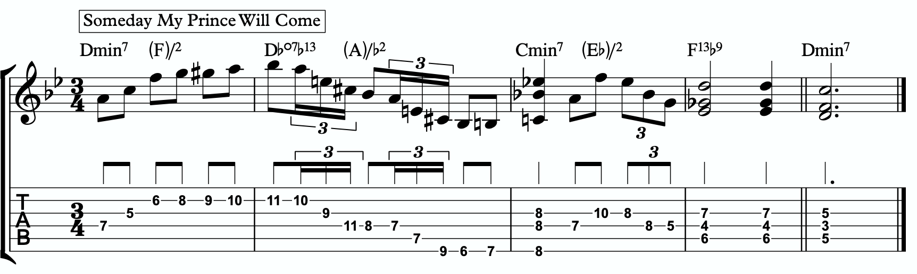

DIGGING DEEPER
JORDAN KLEMONS
2025-01-14 11:01:26
--------------------------------------------
3a
The goal of this section is to take small baby steps to evolve the fundamentals of melodic triads in the previous sections into new harmonic and melodic territory. If you are not already comfortable with the shell voicings, the three inversions of the pianistic voicings in all 12 keys, the primary quadratonic, and how to hear and feel the primary tension note against the melodic triad over the diminshed7b13, I would hold off and continue working on that.

FOUR NOTE VOICINGS
Let’s begin with harmony. Our first goal should be to minimize down these big, dense, pianistic voicings into something more manageable for the guitar. Four note voicings are ideal for our instrument. But sometimes it can be tough to get those colorful, pianistic type lush chords on the guitar because we just don’t have enough fingers. This is due to what I call bottom-up thinking. We are trained to think R, 3rd, etc etc. From the bottom of the chord moving upwards. By the time we get to the sweet spot notes, we’re out of fingers.
Instead, we’re going to think top-down. Our priority is the melodic triad. With these chords, the very first thing we will think about is the melodic triad. Then we are going to add one note underneath it, much like a slash chord. However, we don’t always use the root note. Often times there is a note that will better accentuate the harmony than the root. This will not always be the same extra note that we see in the primary quadratonic, but often times it is. In this case, it is. The 3rd is usually the most harmonically definitive note, but it’s already in the triad. The 7th is next. This is not in the triad and causes not issues. That gives us a Ab/Bbb (aka - Ab/A).
3a
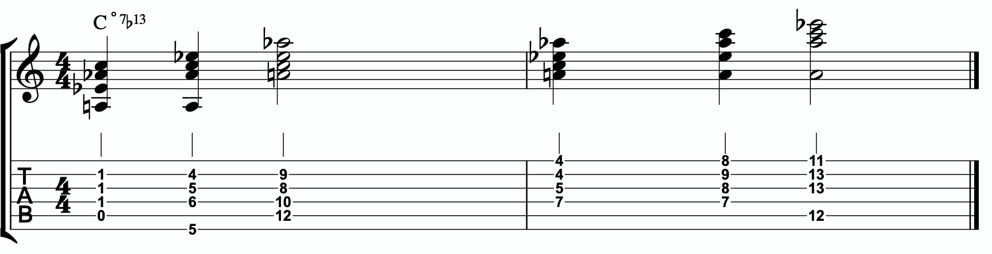

Each of these voicings gives us the bb7th, b3rd, b13th, and root of the C˚7b13.

THREE NOTE QUADRATONIC VOICINGS
Three note qudaratonic voicings are an incredible and special tool for us. Unlike traditional drop chords that can be practiced through all inversions, these three note chord inversions offer us some special benefits. First, they highlight the sweet spot notes and get us into the really colorful parts of the chord. Second, by ignoring one of the four notes in each voicing, we’re not simply jumbling up the same four pitches each time we invert. One pitch is always disappearing or appearing as we move through these inversion. It makes for a much more captivating series of inversions as the ear is unconsciously losing and finding pitches at every turn.
We’re going to follow the “drop 2” idea, however not in the traditional sense. When we speak about “drop 2” chords traditionally, we mean that we take the second to the top note and “drop” it down an octave. We’re not going to do that. We’re simply going to remove it from the picture.

4 |  | 4 | 3 |  | 3
3 | > |  | 2 | >
2 |  | 2 | 1 |  | 1
1 |  | 1 | 4 |  | 4

Notice that when this technique is applied, the first series of numbers is different from the second. They both share 1 and 4, but the first series has a 2 and is missing the 3 whereas the second series has the 3 and is missing the 2. If we did this for every inversion of 1 - 4, each one would be slightly different.
If we apply this to our primary quadratonic, we get this series of three note voicings for our chord.

3b
JORDAN KLEMONS
2025-01-14 11:01:26
--------------------------------------------
3b
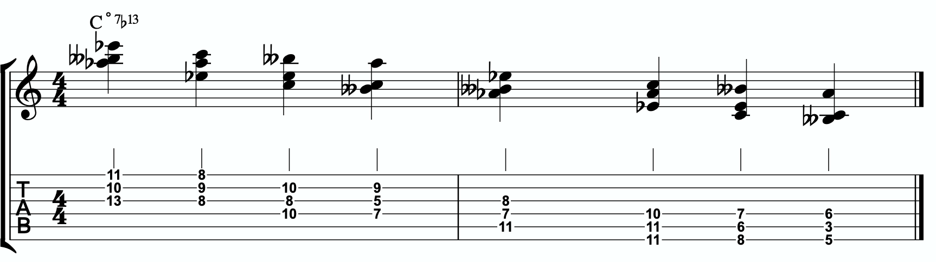
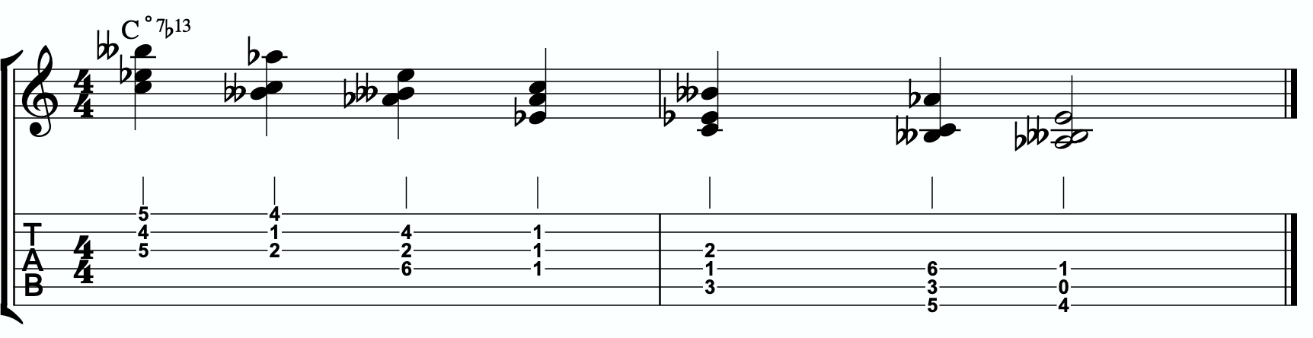

QUADRATONIC SCALAR RUN
Let’s bring it back to single note ideas, melody, and improvisation. The Must Know was all about learning to hear and manipulate melodic tension and resolution using the quadratonic. But we can also use the quadratonic like a scale or an arpeggio. It seems simple because there are only four notes involved… but that’s only one note less than a pentatonic scale. And if you think about it, we only have 12 notes in western music, so if the quadratonic takes up four notes, then that’s actually ONE THIRD of all of the notes in the entire western tonal system. That’s quite a lot.
Let’s start with a scalar type run. Ideally you should already be able to hear and use the tension note and the resolution points of the melodic triad to develop beautiful, clear, authoritative phrasing that works with the harmony, and even implies it, without being stuck outlining it. Not we want to focus on developing the ability to create long, flowing, legato, fluid runs that create the impression of harmony. Traditional scales can sometimes be helpful for this, but they often times have notes that aren’t going to help define the sound of the harmony that’s happening. This quadratonic approach to a run will clear away those less essential notes.

3c
JORDAN KLEMONS
2025-01-14 11:01:26
--------------------------------------------
3c
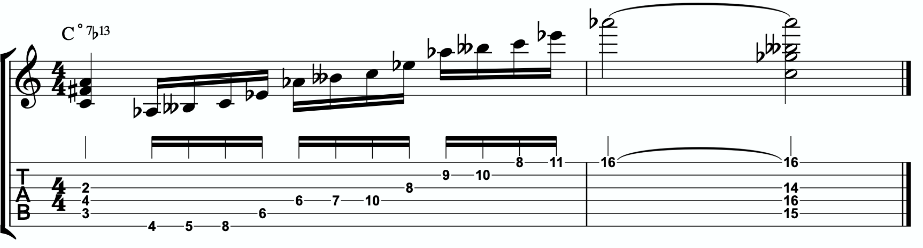
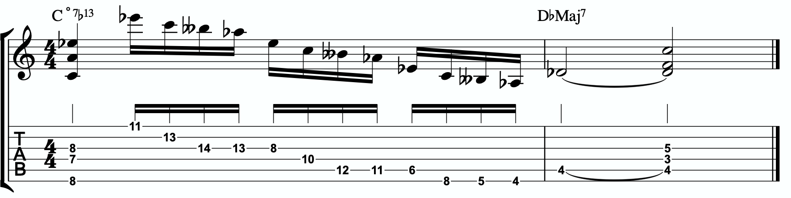

THE SECONDARY TENSION NOTE & PENTATONIC SCALE
Once we can develop authentic phrases with the primary tension note and the quadratonic it gives us, and once we can see it as a scale that we can run through, we can move on and look at the secondary tension note. At this point, I recommend that you put the primary tension note on the back burner and leave it out for a while. Treat this as a whole new tension note. Go back through the ear training process and learn where it is on the fretboard, what it sounds like, how it wants to move, and how to create simple phrases with it.
In order to find the secondary tension note, we go back to Stefon’s formula.

The Hierarchy of Harmonic Importance.
3 - 7 - 5 - 9 - 11 - 13 - R
- Since we started by adding the 7th, is the 5th of C˚7 in the Ab major triad?
No. The 5th of C˚7 is Gb. Gb is not in the Ab major triad.

3e
JORDAN KLEMONS
2025-01-14 11:01:26
--------------------------------------------
3d
JORDAN KLEMONS
2025-01-14 11:01:26
--------------------------------------------
3e

So our secondary tension note is Gb.
Gb is the b7 of C˚7, but it will be heard against the melodic triad which is Ab major. Gb is the b7 of Ab major, so that means our secondary quadratonic is Ab major tension b7 and it gives us this tonality’s melodic triads pentatonic scale.

/ b2, b7
Ab
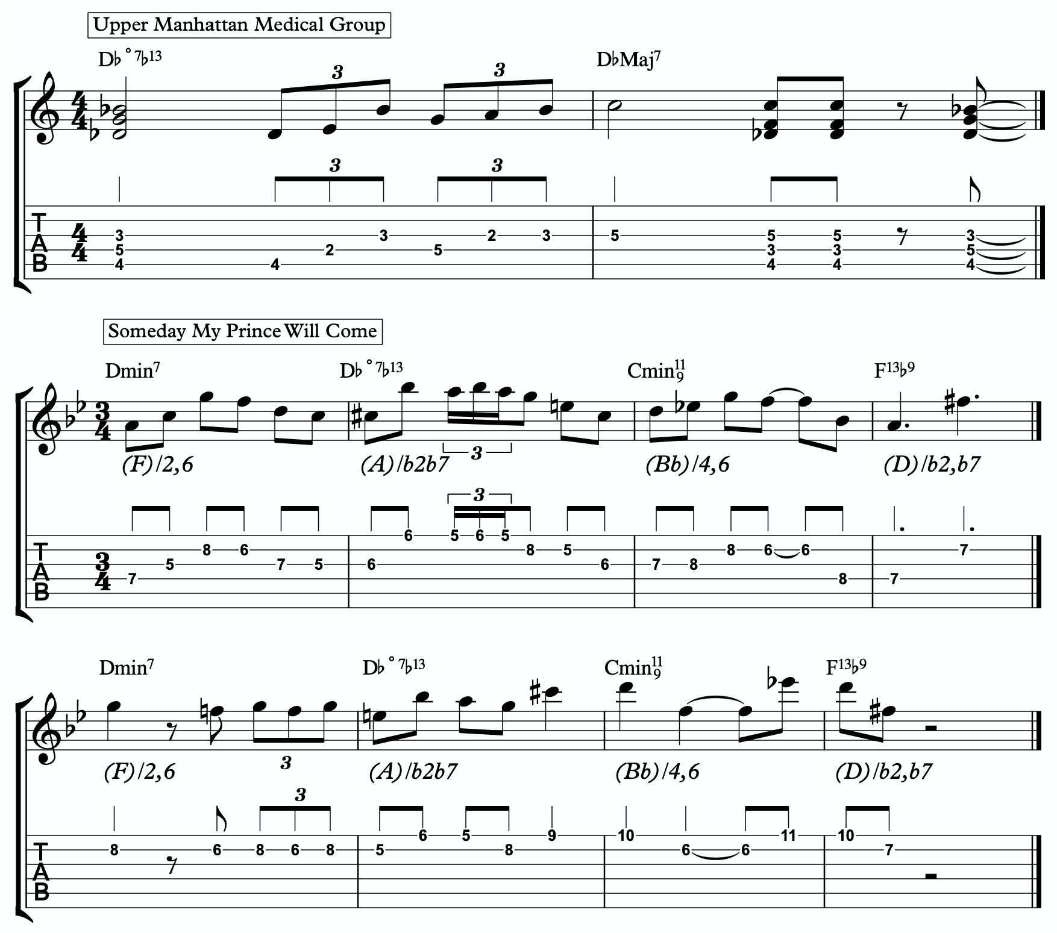
Here are some examples of this pentatonic scale in use:
3d

THE MELODIC TRIAD BEBOP SCALE
Hopefully by now you’re starting to see the way melodic triads can offer a very direct path through all the traps of scale running, noodling, and outlining chords progression using 1 - 3 - 5 - 7 chord tones and arpeggios. All of these can be great devices (maybe not noodling), but have dangers to them.
The melodic triads approach helps us start with the sweet spot notes, and build our harmony and melodic from there. Before you start working on the melodic triad bebop scale or anything beyond this point, I strongly encourage you to make sure that you’re not simply reading these ideas like a theory book to be memorized. These are meant to infiltrate your ears, map the fretboard, and apply directly to musical situations in tunes. If you’re been studying and applying the melodic triads approach for enough time that you’re getting comfortable with it, we can take the next step. It’s only one extra note… but it’s a game changer.
In order to understand what the melodic triad bebop scale is, you need to understand what a traditional bebop scale is and the purpose for why it’s built the way it is. The standard diatonic scale is made of seven notes. The problem with playing a seven note scale is that it’s made of an odd number of pitches, so if you’re playing in 8th notes in 4/4 time, it’s going to flip itself around and start to place weak sounding notes on strong beats and strong sounding notes on weak beats.

C major scale

In music, we have strong beats and weak beats. We can see these pretty easily by looking at the beamed groups of 8th notes. There are always two of them. The first one, on the left of each group, is the strong down beat, and the second one, on the right of each grouping, is the weak up beat. We count them:

1 - & - 2 - & - 3 - & - 4 - &

That makes up one full measure of 8th notes in 4/4. The strong beats are on the number, and the weak beats are on the & (the “and”). If we look at the C major scale above, we see that it starts on the C note (very important) on a down beat. Then the next down beat, beat 2, has the E note. That’s the 3rd of CMaj… so we’re doing good. The 3rd down beat has the G note… still good. But the 4th down beat has the 7th of the scale, and then the C root note happens on the & of 4. And that puts the D note, the 2nd of the scale, on the down beat of the following measure. The following few down beats all have weak notes on them, putting the strong CMaj “chord tones” on the weaker up beats. It finally loops back around and lands on the C note on beat 4.
The traditional bebop scales took care of this problem by adding one single note. This evens it out to an eight note scale and lines up the pitches of the scale with the beats in the measure.

Some players would call this a bebop scale, or if you’re familiar with the Barry Harris method, you might call this the 6 diminished scale. Regardless, what’s important is that if you look at the strong beats, the notes spell out C - E - G - A. That’s a C6 chord. It gives

us a perfect combination of melody (the scale - with tension and resolution points), harmony (the C6 chord - the resolution points), and rhythm (the timing of getting all of the important notes to fall on the strong beats). It’s a beautiful, perfect, and very helpful scale to know.
I still rarely if ever think about, practice, or use it. Doesn’t mean you shouldn’t. But hopefully by now you’re starting to see just how powerful triads are. This scale is built around four note chords like C6 or C7, not three note triads.
But there’s a way to combine the two concepts. The pure simplicity and strength of the triad, with the rhythmic perfection of the bebop scale concept.
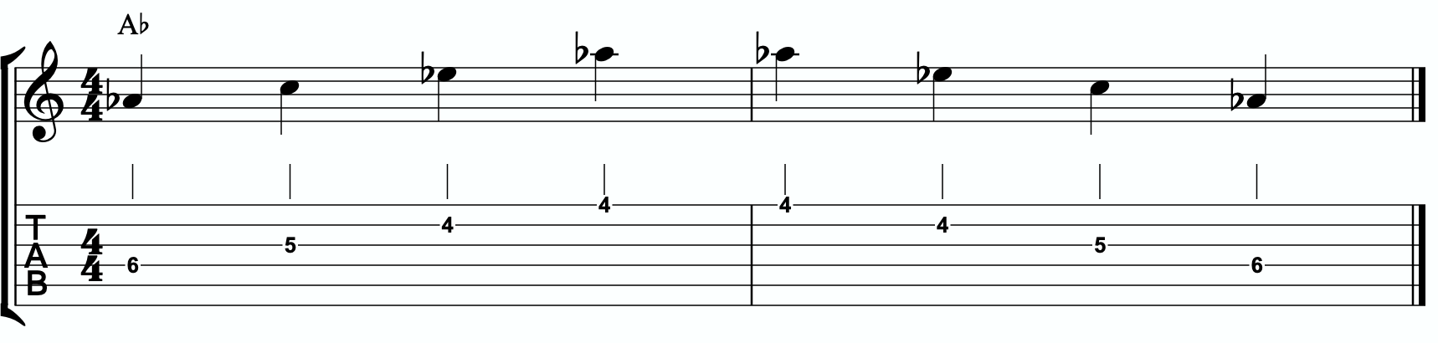
We simply add one single passing note between every triad note. Here’s one octave of an Ab major triad. Our melodic triad for C˚7b13.

Now I’m going to insert one passing note between each triad note. The key is to pick the passing note that best respects and defines the C˚7.

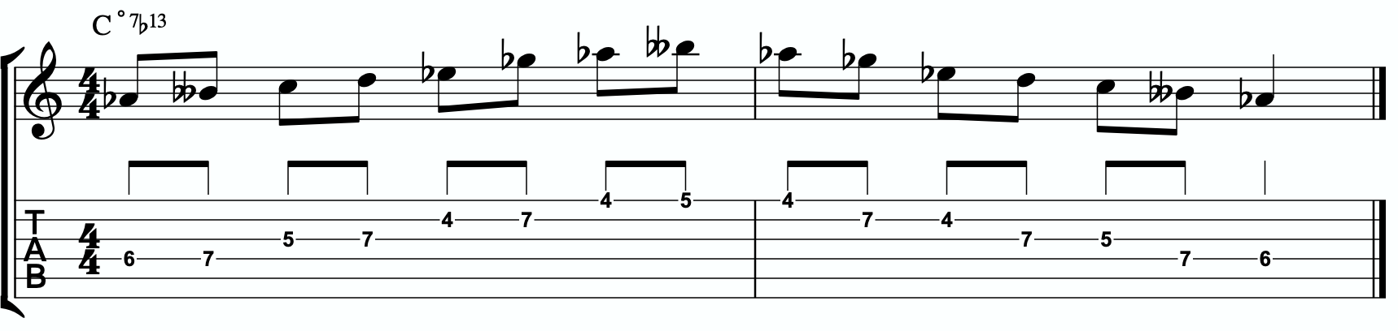

JORDAN KLEMONS
2025-01-14 11:01:26
--------------------------------------------
4a
This is our melodic triad bebop scale. It’s a six note scale that helps us outline the tonality we’re working with by stabilizing the notes of our melodic triad.
Notice that it’s just an Ab major triad with passing notes. If we look at those passing notes in relationship to the Ab major triad, we get tension b2, tension #4, and tension b7. Two of the three tension notes are straight from our primary and secondary quadratonics. No, that’s not a coincidence. That’s due to the perfect nature of how triads function when we dig through harmony and melody with them. So we’re simply adding a third tension note. In this case, it’s tension #4. You could use that as a quadratonic - Ab tension #4 over a C˚7b13 chord. The melodic triad bebop scale gives us a rhythmically aligned “scale” but it also gives us three tension notes, each with their own unique emotional quality to them, that we can take advantage of if we don’t want to get stuck running scales and want to return to a focus on melodic tension and resolution and lyrical phrases.
4a

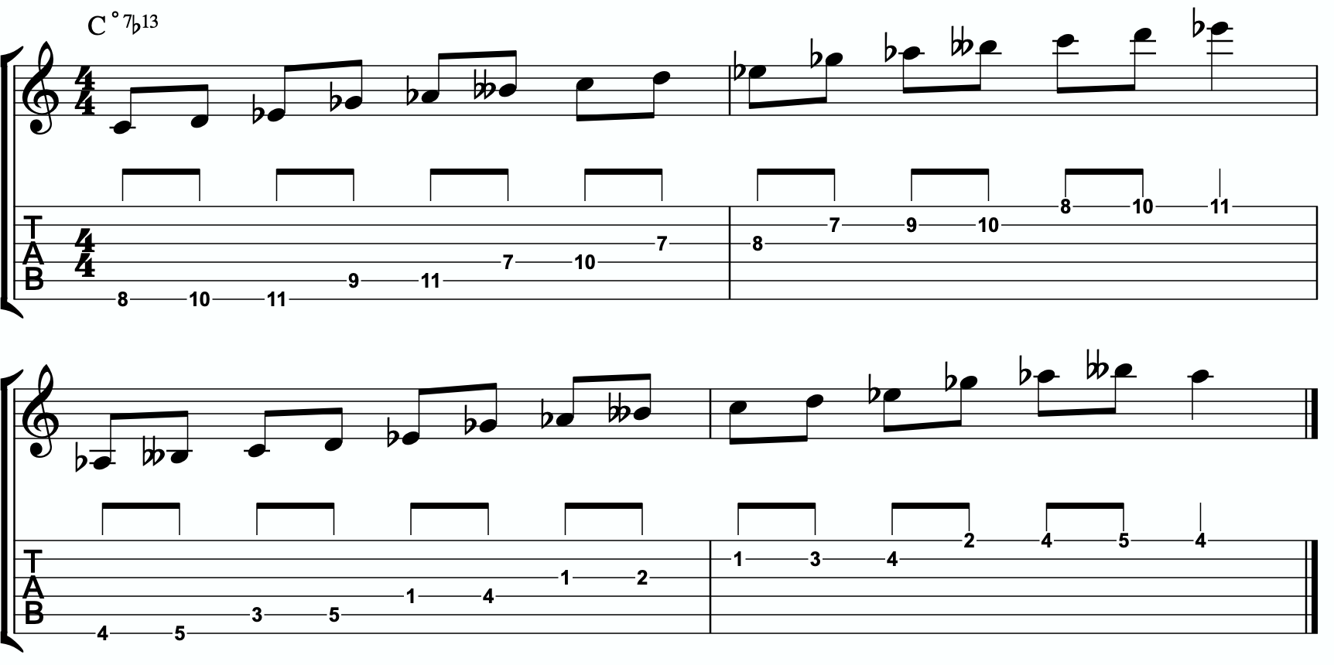

Here is the same scale but harmonizing all of the melodic triad notes with our three note
quadratonic voicings:

4b
JORDAN KLEMONS
2025-01-14 11:01:26
--------------------------------------------
4b

ADVANCING HARMONY
We are getting into more and more advanced material now. Please remember that you do NOT need any of these continued lessons and concepts to play music. It is significantly more important that you develop your ability to be authentic, spontaneous, and playful with the material in The Must Know and then, if you feel comfortable, in Digging Deeper. Each section is building on the last, so if you’re struggling, it’s simply a check engine light to return back to earlier sections.
That said, we’re still far from a complete exploration of the depth of this one little triad.
This section we will explore some more advanced harmonic ideas. You may have heard me talk about liquid harmony. This is a way of visualizing the creation of harmony that involves movement. Think of a chord voicing like a block of ice. It’s frozen in time. We play it, we move to another chord, we move to another chord. Most of us learned to play harmony this way with a focus on shell voicings and drop chords. Liquid harmony is the idea of taking those blocks of ice and melting them down into a little. Not necessarily completely. But we want at least some of the ice to return to water so that it can flow and move. It helps free us up to transcend more static voicings, even cool sounding ones, and creates a more pianistic, movement-oriented sound. Not simply movement from one chord to another, though that’s important as well. But movement inside of a single chord. That’s what this section will explore.

HARMONIC QUADRATONICS
This is possibly the simplest, most effective, and most fun ways to create liquid harmony. The idea is that we play the primary quadratonic, but instead of thinking of it as a scale that we play with single notes, we play it as a chord. We will play three notes of the quadratonic. The tension note will be part of the chord, and it will replace the nearest melodic triad note. So the chord will be made up of two melodic triad notes and the melodic tension note. Then, while holding the two melodic triad notes and allowing them to continue ringing, we will resolve the tension note back into the triad. If we’re playing solo guitar or accompanying another musician, we may want to play the root note of the chord (“left hand”) or even the whole shell voicing. However in a full ensemble with a bass player, or if we’re playing solo and simply want a more impressionist style sound, we can leave that out and play these ideas as rootless “chords”.

JORDAN KLEMONS
2025-01-14 11:01:26
--------------------------------------------
5a
Here is an example:
5a

Quadratonic Dyads
This is a similar concept to our quadratonic 3-note voicings, except now we’re creating 2 note grouping by pairing together every other note.

JORDAN KLEMONS
2025-01-14 11:01:26
--------------------------------------------
5b
JORDAN KLEMONS
2025-01-14 11:01:26
--------------------------------------------
5c
So if our quadratonic is made of Ab - Bbb (A) - C - Eb, we will group the Ab and the C together and the Bbb (A) and Eb together. And we will get this:
5b
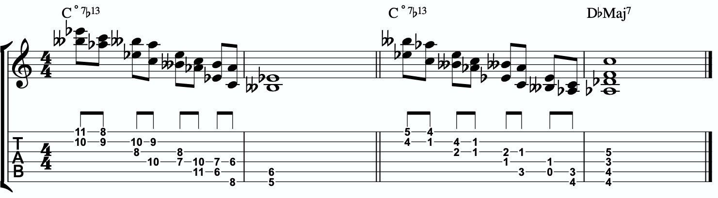

TRIAD PAIRS
Sticking with our melodic triad bebop scale, we actually have our melodic triad version of triad pairs hiding right there in plain site. We know that all the resolution points are the notes of our melodic triad. But if we look at all of the passing tension notes we added, we actually have a second triad. This scale is two triads together. We have our melodic, or our “resolution” triad, and then we have our tension triad.
For this tonality, our triad pair is Ab and D.
/ D
Ab
We can of course arpeggiate these triads out to create single note ideas, but this section is specifically about harmony. So let’s look at a harmonic application for our tonality inside a chord progression.
5c

JORDAN KLEMONS
2025-01-14 11:01:26
--------------------------------------------
5d

Here is a dyad application, where we leave out one note from each triad.
5d

TENSION LAYERS
Everything up until this section has been based on the idea that the melodic triad is the strongest organization for resolution, color, harmony, and melody. We leave the triad temporarily with different techniques to create tension, harmonically and melodically, but always in service to bring us back to rest in the resolved nature of the melodic triad.
In this section, we’re going to talk about the idea of thinking of tension as existing in layers. This way, we have different levels of tension that we can move in and out of - like rungs on a ladder that we can climb up, climb down, or simply pick one and stand still on it to enjoy the view.

LAYER ONE
This one is easy. Layer one is the primary quadratonic. The melodic triad is the most stable set of notes we have for our tonality. The primary tension note offers us a very respectful tension note to create melody. There is tension inside this quadratonic, but it’s accessible and always brings us right back into resolution. We must be comfortable making music with this sound before we can continue.

/ b2
Ab

LAYER TWO
But what if we want to move up a rung on the ladder? We know from the melodic triads bebop scale that our triad pair for this tonality is Ab major and D. So far, we have only thought of the D as a tension triad that can be used to bounce back and forth with Ab. But what if we momentarily “modulated” into the D triad to create a new rung on our ladder? Like modulating in a tune between the relative major and minor of a key, the key doesn’t actually change, but we can momentarily alter the color and the emotion.
By switching over to thinking of our tension triad, we can add a tension note to the triad and create a tension quadratonic.

JORDAN KLEMONS
2025-01-14 11:01:26
--------------------------------------------
6a
The tension quadratonic, when mixed with the primary quadratonic will allow us the ability to navigate seven diatonic notes melodically and harmonically in a structured and authoritative way that will imply the harmony, give multiple colors and layers of tension, and allow for six different resolution points within any tonality. That’s half of all of our available pitches.

How do we chose the primary tension note for our new tension quadratonic?

We go back to the hierarchy of harmonic importance. What’s the next chord tone from the hoh? We can account for the 3rd, the 7th, the 5th, and the 9th. But we haven’t yet used the 11th. So that’s going to be the tension note for our tension quadratonic.
The 11th of C˚7 is F. If we add an F note against our tension triad, D major, we get this four note structure - D, F, F#, A. That’s a D major triad with a tension b3 (or #2).

/ #2
D

This quadratonic will sound less “in” than the primary quadratonic, however the tension note in it will give it a sensation of tension and resolution within itself.

Here are some examples of this quadratonic pair being used harmonically and melodically:
6a

6b
JORDAN KLEMONS
2025-01-14 11:01:26
--------------------------------------------
6b
JORDAN KLEMONS
2025-01-14 11:01:26
--------------------------------------------
6c

Harmonizing Our Bebop Scale With Tension Layers

Let’s look at our six note melodic triad bebop scale and harmonize it using our quadratonic pairs. We will do this using two different techniques brought up earlier in this study booklet. First, we will move through the bebop scale using our harmonic quadratonics to create liquid harmony within each voicing as we move between the two quadratonics to harmonize each note. Finally, we will apply the three note quadratonic voicing to the bebop scale.

Harmonic Quadratonics & Liquid Harmony
6c

JORDAN KLEMONS
2025-01-14 11:01:26
--------------------------------------------
6d

Three Note Quadratonic Voicings
6d

THE OUTRO
I just want to personally thank you for working through these ideas. I am obsessed with exploring, mapping out, and demystifying jazz harmony and melody, and attempting to understand it and execute it using the simplest and most fundamental ingredients in music. I’ve found over many years of playing and study, and learning from some of the greatest minds in the jazz world today, that it’s often times our ego and our own self- inflicted limitations that hold us back the most from growing and evolving towards our potential.
The most dangerous words to development of our musicianship are, “I already know that.”
Most of us generally spend a couple of music theory classes learning our triads. Maybe we read a book about advanced triad application and get some cool intellectual ideas to play with. But for me, it’s all about that Bill Evans quote.
**********************************

The whole process of learning the facility of being able to play jazz is to take these problems from the outer level in, one by one, and to stay with it at a very intense, conscious-concentration level until that process becomes secondary and subconscious. Now, when that becomes subconscious, then you can begin concentrating on that next problem, which will allow you to do a little bit more.

I don’t consider myself as talented as many people but in some ways that was an advantage because I didn’t have a great facility immediately so I had to be more analytical and in a way — that forced me to build something.
Most people just don’t realize the immensity of the problem and, either because they can’t conquer it immediately, think that they haven’t got the ability, or they’re so impatient to conquer it that they never do see it through. If you do understand the problem then you can enjoy your whole trip through.

People tend to approximate the product rather than attacking it in a realistic, true way at any elementary level — regardless of how elementary — but it must be entirely true and entirely real and entirely accurate. They would rather approximate the entire problem than to take a small part of it and be real and true about it. To approximate the whole thing in a vague way gives you a feeling that you’ve more or less touched the thing, but in this way you just lead yourself toward confusion and ultimately you’re going to get so confused that you’ll never find your way out.

It is true of any subject that the person that succeeds in anything has the realistic viewpoint at the beginning and [knows] that the problem is large and that he has to take it a step at a time and that he has to enjoy the step-by-step learning procedure. They’re trying to do a thing in a way that is so general [that] they can’t possibly build on that. If they build on that, they’re building on top of confusion and vagueness and they can’t possibly progress. If you try to approximate something that is very advanced and don’t know what you’re doing, you can’t advance.

**********************************

Was Bill referring to melodic triads? I very highly doubt that. I’ve never heard him talk much about triads. But consider the underlying philosophy he’s pointing at. Know the

basics. Regardless of how elementary! But it must be entirely true, real, and accurate. Be able to play genuine, authentic music using the most fundamental ideas first. Then it leaves room to grow.
This is why I refer to the first section in this ebook as The Must Know. It’s a basic shell voicing, and a basic triad. And while these two concepts are as simple as they come in music, we must understand them in a true, real, and accurate way. If we did this for a handful of tonalities, we could play beautiful music for the rest of our lives, and for me, I would feel fulfilled. It would offer emotion-driven, precise, human, lyrical melody combined with lush, colorful, pianistic harmony. Mix in a strong sense of time and feel, and that’s everything a jazz musician needs.
But like Bill talks about, when we don’t try to approximate but instead start with the elementary ideas and build a foundation with them, then it gives us room for growth. Look at everything we worked through together in this ebook! All built from one triad and how it relates to one chord (piano diagram!). As of the time of putting this together, I’m still working on many of these ideas myself… and I’m still coming up with new ways of building harmony and melody around the melodic triad.
This is why I can’t recommend enough, even to the intermediate and advanced players out there - spend some serious time in The Must Know section. Own it. Be able to play authentic ideas with it. Apply it to tunes. Move it through the circle of 5ths. Do whatever you can to internalize it and develop your ears to it. Then you can begin moving on. I would encourage everyone… peak ahead if you would like to to keep an eye on where this particular path is heading, but be very self-aware and learn to see when you’re getting in over your head. When this happens, not if, just take a deep breath and back up a few sections. It simply means your foundation isn’t quite strong enough yet to carry the weight of those more complex ideas. If you want it, and you put the time and effort it, you’ll get there.
Like one of my students always likes to tell himself at the end of our lessons…..
“Easy does it. But do it.”

Thank you again. Don’t forget to come and hang in our open office hours to ask questions if you’re confused on anything.
Happy Practicing!
-Jordan Klemons

The Melodic Triads Study Group

Jordan Klemons
NYC Jazz Guitar Masterclasses

CONTENTS
-INTRODUCTION
-THE MUST KNOW-
-ADVANCING MELODY-
-DIGGING DEEPER-
-THE MELODIC TRIAD BEBOP SCALE-
-ADVANCING HARMONY-
-TENSION LAYERS-
-OUTRO-

This ebook is the copyrighted property of Jordan Klemons. All images, information, layout, and designs belong to Jordan Klemons. This document may not be altered, reproduced, distributed, or transmitted in any form or by any means without the prior written permission of the author.

INTRODUCTION
Thank you for downloading the pdf materials for this month’s melodic triads tonality study guide. Inside you will find all of the supplemental theory, notation, tab, charts, concepts, and examples for the accompanying videos to help you develop your understanding, your ear, your emotional connection with, and your sense of harmonic and melodic freedom within this month’s tonality… as well as its use in some short, common, jazz chord progressions that you will be able to immediately implement in your own playing.
The information in this guide is dangerous. I mean that literally. When the process is respected, and you understand how all of these ideas fit into the puzzle, this guide and the baby steps included can offer tremendous insight into how to begin making real music very quickly, and how to continue evolving and growing as a player for many years to come. However, if approached in the wrong way and the process is not respected, these ideas can confuse and derail a musician’s ability to progress. It’s important not to jump too far ahead of yourself. The advice that a Miles, or a Scofield, or a Coltrane would give to a beginner is different than what they would give an intermediate or to an advanced player. And all of that would be different than how they would talk to a professional who’s already playing on their level. This is important to remember.
This guide is meant to show many different layers of musical growth and how, when using the melodic triad approach, they can all be boiled down and viewed simply as an extension of the most basic elements of music. Namely… a triad. Think of the pages that follow as an architect’s blue prints for a skyscraper. If you haven’t built a strong foundation, your skyscraper will fall. If you attempt to skip the first 50 stories and jump to building the penthouse, the skyscraper will fall. If you try to put up the fancy exterior of the building before you complete the steel frame, the skyscraper will fall. Yes, the information all the way at the end of this guide is constructed using the same ideas and concepts that are presented in the first chapter, but the process must be respected for anything to work. Otherwise it will only leave you confused, frustrated, feeling like a failure, and wanting to give up. Be patient with yourself. The short cut IS the long road. Take it. Spend two or three months working on the long road and watch how much you progress. Focus on your sound, on your ear, and on your musicianship… and trust that the simplicity of the ideas and the process itself will take care of you. They will. But only if you respect them. It’s like a relationship - you have to be present and give of yourself, and then you will receive in abundance.

As you work through these pages, try to keep in mind this Bill Evans’ quote from The Universal Mind.

**********************************

The whole process of learning the facility of being able to play jazz is to take these problems from the outer level in, one by one, and to stay with it at a very intense, conscious-concentration level until that process becomes secondary and subconscious. Now, when that becomes subconscious, then you can begin concentrating on that next problem, which will allow you to do a little bit more.

I don’t consider myself as talented as many people but in some ways that was an advantage because I didn’t have a great facility immediately so I had to be more analytical and in a way — that forced me to build something.
Most people just don’t realize the immensity of the problem and, either because they can’t conquer it immediately, think that they haven’t got the ability, or they’re so impatient to conquer it that they never do see it through. If you do understand the problem then you can enjoy your whole trip through.

People tend to approximate the product rather than attacking it in a realistic, true way at any elementary level — regardless of how elementary — but it must be entirely true and entirely real and entirely accurate. They would rather approximate the entire problem than to take a small part of it and be real and true about it. To approximate the whole thing in a vague way gives you a feeling that you’ve more or less touched the thing, but in this way you just lead yourself toward confusion and ultimately you’re going to get so confused that you’ll never find your way out.

It is true of any subject that the person that succeeds in anything has the realistic viewpoint at the beginning and [knows] that the problem is large and that he has to take it a step at a time and that he has to enjoy the step-by-step learning procedure. They’re trying to do a thing in a way that is so general [that] they can’t possibly build on that. If they build on that, they’re building on top of confusion and vagueness and they can’t possibly progress. If you try to approximate something that is very advanced and don’t know what you’re doing, you can’t advance.

**********************************

I’ve setup the material in these tonality lessons to start with the most basic and fundamental elements of music, and to grow outwards in complexity. Everything builds on what came before it, so everything is connected. You DON’T need to master everything in these lessons to play music. You only really need the first section and a little bit of creativity and concern for your sound - that’s enough to create something beautiful..
I recommend that if you’re new with us, even if you’re already an advanced player, you begin focused entirely on the first section of this guide, The Must Know, and give yourself a minimum of 3 - 6 months to get used to this method and the initial concepts presented. It’s a very different approach to standard theory, and your goal should be (as Bill Evans said) to be able to make genuine, authentic music with the ideas in the first section. Once you feel you can hear and play music using these ideas on a small handful of tonalities and applied to some tunes, then it is time to start advancing forward.

I would continue giving yourself an addition 3 - 6 months for each subsequent section, as each builds on the last and becomes more and more advanced… starting from the most basic and simple ingredients, and eventually working our way up to learning to hear and use all 12 notes of the western chromatic scale harmonically and melodically over any chord in a musical way.
I strongly recommend that you follow this rough timeline. I believe it’s the most effective way to cut through the learning process and get straight to making beautiful music, and then to set yourself on the path to continue growing and building for years to come.
The melodic triad ideas I’m working on today, I didn’t even know they existed during the first few years of my own studies. As we grow and progress and get comfortable, we can naturally start to evolve the ideas into more advanced applications. That’s the beauty of starting with the fundamentals, learning to make genuine, authenticate music from our own self first… and then building layers of complexity on top of, but always connected to, those very fundamentals. Much like a large skyscraper building starts with a huge hole in the earth, then is filled with concrete and steel, and then the steel frame will hold the building as it goes up. We won’t see any of these structures. But without them, the building would collapse. Only once the structure is there can the work of putting up the exterior, the glass, the interior, the design, the furniture, etc. take place.
Thank you again for downloading this study guide and working on your music with us. I look forward to hearing your playing and your contributions to the melodic triad conversation inside our facebook group, and for those of you subscribed to our Private Community, inside our melodic triad mastermind group.
Happy Practicing!
Your friend on the path towards jazz guitar mastery,
-Jordan Klemons

The Melodic Triad Study Group - a part of
NYC Jazz Guitar Masterclasses

THE MUST KNOW
The theory, ideas, voicings, and “scalar” ideas presented in this section may seem too simple and elementary to be of value. But I urge you, even the intermediate and advanced players - do not skip this section. I recommend that if you’re within the first 3 - 12 months of study with us that you focus entirely on learning to apply these ideas to musical situations. You can skim the rest of the pages if you’d like, but this should be where you build from. After close to 25 years of playing music seriously, I still spent my first year of working on melodic triads only on this material. The great thing about these ideas is that not only can you comp, improvise, compose, and arrange beautiful music over standards, bebop, modern jazz, and original works with them, but they also act as the foundation on top of which we can grow into more and more complex ideas without ever leaving behind these basic building blocks of harmony and melody.
Do not simply see these as intellectual theory ideas. These are meant to be internalized. To understand the theory is great. To hear the sounds in your ear with a sense of familiarity is just as important. To connect with them personally and be able to hear and express emotion through them is of the utmost importance when it comes to developing our musicianship. This should be the goal.

THEORY
The 13#11(9) is the sound of magic. It’s the shock of seeing something that shouldn’t be real. Imagine a small child walking through the woods at night and encountering tiny elves. They bring the child to their secret village. They sprinkle magical dust on the surrounding plants and everything begins to glow brightly, lighting up the dark night.
Imagine the look of awe and wonder in the child’s eyes. That’s the 13#11(9). It’s not a standard dominant. No V -> I movement. It is used primary as a tonic dominant, a dominant that resolves down a half step, or as a II7, a IV7 or a bVII7 in major keys.

What makes up a C13#11(9) tonality?
Two basic ingredients.
- A basic C7 chord
- A D major triad
A good way to think of this is to visualize a piano player with two hands. Their left hand would be playing C-E-Bb (a basic C7 shell voicing) and their right hand would be playing a D major triad.

The blue dots would represent the fingers of the piano player’s left hand. Notice they spell out C, E, and Bb. That’s the 1, 3, and b7 of a basic C7 chord. We call that a shell voicing. The orange dots represent the piano player’s right hand. They spell out D, F#, and A. That’s a D major triad. If you have access to a piano or keyboard, I strongly encourage you sit down and play these six notes simultaneously. Listen to how big of a sound they create together. Play it a few times. Try and feel the emotion and the color they create together. Then remind yourself of the elementary and simple nature of what’s happening in each of your two hands separately. A basic chord in your left hand. A basic triad in your right hand. The magic happens when we use these sounds together… and when we begin to build chord voicings and melodic ideas around these two simple sounds.

***This D major triad, which is now our melodic triad, is built on the 2nd of CMaj7… ‘D’ is a 2nd up from ‘C’. This relationship is critical to understand and memorize as it will allow us to transpose this 13#11(9) tonality into any key quickly. We will notate this as ‘T2’. This notation comes from Stefon Harris. The ’T’ is short for ‘triad’ and we

make it upper case to notate that it’s a major triad. The 2 tells us that the melodic triad is built on the 2nd of the harmony. So if we want a G13#11(9), we think T2, we find the 2ndd of G (which is A), and we know that the melodic triad is A major.***
This pianistic chord construction is the starting point for everything we are going to look at together. Hidden inside of this six-note chord is a universe of potential harmonic and melodic ideas. The following pages can all be traced back to this construction idea. Basic chord, basic triad. Left hand, right hand. Harmonic structure, melodic structure. Hence the term… melodic triad. Even if you don’t have access to a piano, I encourage you to sit and think about this diagram until it makes sense to you.

GETTING THE PIANISTIC VOICINGS ONTO THE GUITAR
Taking the concept of the piano construction, where the C7 shell is always underneath the D major triad, we can develop three basic inversions of this chord by inverting the D triad and keeping the C7 shell underneath it.
In order to get these three inversions, we will use the piano -> guitar technique described in the video - where we put the shell voicing on the bottom three strings and the triad inversions on the top three strings. This will give us a three “pianistic” inversions of this tonality on the guitar.

Notice the three basic inversions of the D major triad on strings 1 - 3.

A few exceptions are being made here.
In measure 1, due to the physical limitations of the guitar, we can’t get a root note AND a b7 in the shell voicing. We have to pick one or the other. I usually prefer the sound of the b7 (the first voicing) however sometimes it’s necessary to put the root note in the lowest voice. So that’s an option as well. But then we lose the b7 from our voicing which is a pungent note.
In measure 2 I also can’t play all six notes. If your hand is big enough, you may be able to. So I usually use the first voicing or I’ll play the root note on the 6th string and then play the first voicing. This breaks the chord apart, but we still hear all six notes. The other option is to play the second voicing and leave out the 7th fret in parenthesis. This leaves out the 3rd of the chord, but still creates a strong impression of the 13#11(9) tonality.

In measure 3 we also can’t physically play all six notes. So we have to basic options. We can add the root and the b7 as is notated in the first voicing. A great option. Can be played all at once with a barre on the 8th fret, or can be broken apart - root first, then the rest of the notes. Or we can move the 3rd and the b7th up to the 13th and 14th frets. It’s not possible to play the root note in this position. So we would either leave it out and play this rootless, or we could break the chord apart, play the root note first, then play the remaining five pitches.

THE PRIMARY QUADRATONIC
Because this particular type of C7 contains a D major triad in the right hand, that D triad is going to be the foundation of our melodic structures. It governs everything. Rather than simply behaving as the chord tones that they correspond to harmonically, when used melodically, they will function as the 1, 3, and 5 of our melody… the strongest and most stable resolution points we can build lines with.
The ideal starting point is our primary quadratonic. A quadratonic is a triad that has one additional note added to it. It’s a four note structure made up of three stable notes (the melodic triad) and one ‘free radical’ or melodic tension note. This extra note serves two functions. First, it’s there to create melodic tension that will help us create movement, emotion, and lyrical phrases without getting trapped inside running scales or chord tones. Second, it will help imply the sound of the harmony we’re playing over and glue the melodic triad inside the chord so they don’t sound like two separate sounds, but rather one unified, colorful tonality.

We only have 12 notes in western music, and three of those 12 are being used in our melodic triad. That means we only have nine possible melodic tension notes. All nine of these could be used to create melodic tension against our triad. But some will help imply the sound of our original harmony better than others. Our primary quadratonic will be made of our melodic triad and the primary tension note - or the note the most respects the basic harmony.

Straight from Stefon Harris’ brilliant mind comes this rule that will help us figure out what are the most important notes:

The Hierarchy of Harmonic Importance.
3 - 7 - 5 - 9 - 11 - 13 - R

These are the chord tones of our basic harmony (the left hand of our piano player).

Here’s how this works:
- Is the 3rd of C7 in the D major triad?
No. The 3rd is E, and E is not in the D major.

So our primary tension note is E.
This E - while the 3 of C7 - is going to be heard by the ear in relationship to the D major triad. Since E is the 2nd of D, we will call this tension 2. So our primary quadratonic is D tension 2.
We’ll notate this as:
/ 2
D

1b
1c
JORDAN KLEMONS
2025-01-14 11:01:26
--------------------------------------------
1a
JORDAN KLEMONS
2025-01-14 11:01:26
--------------------------------------------
1b
JORDAN KLEMONS
2025-01-14 11:01:26
--------------------------------------------
1c
By making the triad bold and circling it, it draws our eye directly to the melodic triad so we can think first about our strong resolution points, then it quickly lets us know what our primary melodic tension note is.
At this point your primary goals should be to be able to play the three pianistic voicings, to be able to visualize the primary quadratonic over the basic shell voicings on the fretboard, to develop your ears to hear the melodic tension note wanting to move and the root note of the melodic triad as melodic ‘do’ - or the root note of the melody.
Here are some examples of these fundamental voicings and melodic ideas being used in music situations.
1a

ADVANCING MELODY
This section is going to look at more advanced and complex application of melodic triads to scalar ideas and arpeggios for the creation of bebop and modern jazz vocabulary based on simple structures that we can be playful with rather than memorization of riffs. Don’t be fooled by the idea of these ideas being more advanced or complicated. This doesn’t mean the music you play with these ideas will necessarily be better or more “advanced sounding” then the use of the pure primary quadratonic. In fact, often times I find that the use of the pure quadratonic can carry a level of maturity and intensity into the music that is hard to maintain when using more complicated ideas.
But, I still think it’s worth being aware of how we can build more advanced structures directly from the melodic triad.

Chromaticism Within The Quadratonic
One of the quickest ways to begin developing more complex lines is to incorporate chromaticism and leading tones within the quadratonic. By first learning to master the pure quadratonic, it should make it easier to begin spontaneously connecting individual notes within these structures in a way that will create a sense of improvisational freedom with our bebop and modern jazz playing. Playing this way will allow us to breathe long, flowing, complex lines within very the very basic, simple, steel frames of our buildings.
Here is our primary quadratonic:
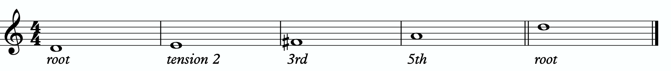

In between any of these notes, we can hang a chromatic line or place a leading tone (a note chromatically below the target) to bring us to the next note. When we use these techniques, we want to make sure that we resolve to a quadratonic note, and ideally we want to play at least two quadratonic notes immediately following the chromatic line to cement our phrase inside the tonality.

2b
2c
JORDAN KLEMONS
2025-01-14 11:01:26
--------------------------------------------
2a
JORDAN KLEMONS
2025-01-14 11:01:26
--------------------------------------------
2b
JORDAN KLEMONS
2025-01-14 11:01:26
--------------------------------------------
2c
Here are some examples:
2a

JORDAN KLEMONS
2025-01-14 11:01:26
--------------------------------------------
2d
JORDAN KLEMONS
2025-01-14 11:01:26
--------------------------------------------
2e

Quadratonic Arpeggios
So far we have only discussed using quadratonics to develop phrases and scalar like ideas. Let’s look at how we can create the sound of arpeggios with them.
We will begin by starting on the primary tension note. After playing this note, we can move to the nearest melodic triad note and sweep quickly through that triad, landing on the tension note an octave away from where we began.
2d
We want to be able to play these ascending and descending starting on any octave of the tension note in any position of the fretboard. If we can incorporate this technique and the chromatic techniques above into our quadratonics then we are giving ourselves resolution notes, tension notes, chromatic runs, leading tones, and quick arpeggio-style runs that we can freely play within during our improvisation while remaining securely inside the color, emotion, and function of any given tonality.

Here is an example of these techniques being used together:
2e

DIGGING DEEPER
JORDAN KLEMONS
2025-01-14 11:01:26
--------------------------------------------
3a
The goal of this section is to take small baby steps to evolve the fundamentals of melodic triads in the previous sections into new harmonic and melodic territory. If you are not already comfortable with the three inversions of the pianistic voicings in all 12 keys, the primary quadratonic, and how to hear and feel the primary tension note against the melodic triad over the minMaj9, I would hold off and continue working on that.

FOUR NOTE VOICINGS
Let’s begin with harmony. Our first goal should be to minimize down these big, dense, pianistic voicings into something more manageable for the guitar. Four note voicings are ideal for our instrument. But sometimes it can be tough to get those really colorful, pianistic type lush chords on the guitar because we just don’t have enough fingers. This is due to what I call bottom-up thinking. We are trained to think R, 3rd, etc etc. From the bottom of the chord moving upwards. By the time we get to the sweet spot notes, we’re out of fingers.
Instead, we’re going to think top-down. Our priority is the melodic triad. With these chords, the very first thing we will think about is the melodic triad. Then we are going to add one note underneath it, much like a slash chord. However, we don’t always use the root note. Often times there is a note that will better accentuate the harmony than the root. This will not always be the same extra note that we see in the primary quadratonic, but often times it is. In this case, it is not. Because our triad is made of the 9, #11, and 13 of our chord, our fourth note SHOULD be the 3rd. That’s usually the best note to add. But not in this case. That would give us a D/E. Classic ‘sus’ sound. And that’s note what we want. It won’t have the wondrous quality we’re looking for. So instead we’ll use the b7.
3a

Each of these voicings gives us the b7th, 9th, #11th, and 13th of the C13#11(9).

THREE NOTE QUADRATONIC VOICINGS
Three note qudaratonic voicings are an incredible and special tool for us. Unlike traditional drop chords that can be practiced through all inversions, these three note chord inversions offer us some special benefits. First, they highlight the sweet spot notes and get us into the really colorful parts of the chord. Second, by ignoring one of the four notes in each voicing, we’re not simply jumbling up the same four pitches each time we invert. One pitch is always disappearing or appearing as we move through these inversion. It makes for a much more captivating series of inversions as the ear is unconsciously losing and finding pitches at every turn.
We’re going to follow the “drop 2” idea, however not in the traditional sense. When we speak about “drop 2” chords traditionally, we mean that we take the second to the top note and “drop” it down an octave. We’re not going to do that. We’re simply going to remove it from the picture.

4 |  | 4 | 3 |  | 3
3 | > |  | 2 | >
2 |  | 2 | 1 |  | 1
1 |  | 1 | 4 |  | 4

Notice that when this technique is applied, the first series of numbers is different from the second. They both share 1 and 4, but the first series has a 2 and is missing the 3 whereas the second series has the 3 and is missing the 2. If we did this for every inversion of 1 - 4, each one would be slightly different.
If we apply this to our primary quadratonic, we get this series of three note voicings for our chord.

3b
JORDAN KLEMONS
2025-01-14 11:01:26
--------------------------------------------
3b

QUADRATONIC SCALAR RUN
Let’s bring it back to single note ideas, melody, and improvisation. The Must Know was all about learning to hear and manipulate melodic tension and resolution using the quadratonic. But we can also use the quadratonic like a scale or an arpeggio. It seems simple because there are only four notes involved… but that’s only one note less than a pentatonic scale. And if you think about it, we only have 12 notes in western music, so if the quadratonic takes up four notes, then that’s actually ONE THIRD of all of the notes in the entire western tonal system. That’s quite a lot.
Let’s start with a scalar type run. Ideally you should already be able to hear and use the tension note and the resolution points of the melodic triad to develop beautiful, clear, authoritative phrasing that works with the harmony, and even implies it, without being stuck outlining it. Not we want to focus on developing the ability to create long, flowing, legato, fluid runs that create the impression of harmony. Traditional scales can sometimes be helpful for this, but they often times have notes that aren’t going to help define the sound of the harmony that’s happening. This quadratonic approach to a run will clear away those less essential notes.

3c
JORDAN KLEMONS
2025-01-14 11:01:26
--------------------------------------------
3c

THE SECONDARY TENSION NOTE & PENTATONIC SCALE
Once we can develop authentic phrases with the primary tension note and the quadratonic it gives us, and once we can see it as a scale that we can run through, we can move on and look at the secondary tension note. At this point, I recommend that you put the primary tension note on the back burner and leave it out for a while. Treat this as a whole new tension note. Go back through the ear training process and learn where it is on the fretboard, what it sounds like, how it wants to move, and how to create simple phrases with it.
In order to find the secondary tension note, we go back to Stefon’s formula.

The Hierarchy of Harmonic Importance.
3 - 7 - 5 - 9 - 11 - 13 - R
- Since we started by adding the 3rd, is the 7th of C7 in the D major triad?
No. The b7 of C7 is Bb. Bb is not in the D major triad.

So our secondary tension note is Bb.

3e
JORDAN KLEMONS
2025-01-14 11:01:26
--------------------------------------------
3d
JORDAN KLEMONS
2025-01-14 11:01:26
--------------------------------------------
3e
Bb is the b7 of C7, but it will be heard against the melodic triad which is D major. Bb is the b6 of D major, so that means our secondary quadratonic is D major tension b6 and it gives us our this tonality’s melodic triads pentatonic scale.

/ 2, b6
D
Here are some examples of this pentatonic scale in use:
3d

THE MELODIC TRIAD BEBOP SCALE
Hopefully by now you’re starting to see the way melodic triads can offer a very direct path through all the traps of scale running, noodling, and outlining chords progression using 1 - 3 - 5 - 7 chord tones and arpeggios. All of these can be great devices (maybe not noodling), but have dangers to them.
The melodic triads approach helps us start with the sweet spot notes, and build our harmony and melodic from there. Before you start working on the melodic triad bebop scale or anything beyond this point, I strongly encourage you to make sure that you’re not simply reading these ideas like a theory book to be memorized. These are meant to infiltrate your ears, map the fretboard, and apply directly to musical situations in tunes. If you’re been studying and applying the melodic triads approach for enough time that you’re getting comfortable with it, we can take the next step. It’s only one extra note… but it’s a game changer.
In order to understand what the melodic triad bebop scale is, you need to understand what a traditional bebop scale is and the purpose for why it’s built the way it is. The standard diatonic scale is made of seven notes. The problem with playing a seven note scale is that it’s made of an odd number of pitches, so if you’re playing in 8th notes in 4/4 time, it’s going to flip itself around and start to place weak sounding notes on strong beats and strong sounding notes on weak beats.

C major scale

In music, we have strong beats and weak beats. We can see these pretty easily by looking at the beamed groups of 8th notes. There are always two of them. The first one, on the left of each group, is the strong down beat, and the second one, on the right of each grouping, is the weak up beat. We count them:

1 - & - 2 - & - 3 - & - 4 - &

That makes up one full measure of 8th notes in 4/4. The strong beats are on the number, and the weak beats are on the & (the “and”). If we look at the C major scale above, we see that it starts on the C note (very important) on a down beat. Then the next down beat, beat 2, has the E note. That’s the 3rd of CMaj… so we’re doing good. The 3rd down beat has the G note… still good. But the 4th down beat has the 7th of the scale, and then the C root note happens on the & of 4. And that puts the D note, the 2nd of the scale, on the down beat of the following measure. The following few down beats all have weak notes on them, putting the strong CMaj “chord tones” on the weaker up beats. It finally loops back around and lands on the C note on beat 4.
The traditional bebop scales took care of this problem by adding one single note. This evens it out to an eight note scale and lines up the pitches of the scale with the beats in the measure.

Some players would call this a bebop scale, or if you’re familiar with the Barry Harris method, you might call this the 6 diminished scale. Regardless, what’s important is that if you look at the strong beats, the notes spell out C - E - G - A. That’s a C6 chord. It gives

us a perfect combination of melody (the scale - with tension and resolution points), harmony (the C6 chord - the resolution points), and rhythm (the timing of getting all of the important notes to fall on the strong beats). It’s a beautiful, perfect, and very helpful scale to know.
I still rarely if ever think about, practice, or use it. Doesn’t mean you shouldn’t. But hopefully by now you’re starting to see just how powerful triads are. This scale is built around four note chords like C6 or C7, not three note triads.
But there’s a way to combine the two concepts. The pure simplicity and strength of the triad, with the rhythmic perfection of the bebop scale concept.
We simply add one single passing note between every triad note. Here’s one octave of a D major triad. Our melodic triad for C13#11(9).

Now I’m going to insert one passing note between each triad note. The key is to pick the passing note that best respects and defines the C7.

JORDAN KLEMONS
2025-01-14 11:01:26
--------------------------------------------
4a
This is our melodic triad bebop scale. It’s a six note scale that helps us outline the tonality we’re working with by stabilizing the notes of our melodic triad.
Notice that it’s just a D major triad with passing notes. If we look at those passing notes in relationship to the D major triad, we get tension 2, tension 4, and tension b6. Two of the three tension notes are straight from our primary and secondary quadratonics. No, that’s not a coincidence. That’s due to the perfect nature of how triads function when we dig through harmony and melody with them. So we’re simply adding a third tension note. In this case, it’s tension 4. You could use that as a quadratonic - D tension 4 over a C13#11(9) chord. The melodic triad bebop scale gives us a rhythmically aligned “scale” but it also gives us three tension notes, each with their own unique emotional quality to them, that we can take advantage of if we don’t want to get stuck running scales and want to return to a focus on melodic tension and resolution and lyrical phrases.
4a

Here is the same scale but harmonizing all of the melodic triad notes with our three note
quadratonic voicings:

4b
JORDAN KLEMONS
2025-01-14 11:01:26
--------------------------------------------
4b

ADVANCING HARMONY
We are getting into more and more advanced material now. Please remember that you do NOT need any of these continued lessons and concepts to play music. It is significantly more important that you develop your ability to be authentic, spontaneous, and playful with the material in The Must Know and then, if you feel comfortable, in Digging Deeper. Each section is building on the last, so if you’re struggling, it’s simply a check engine light to return back to earlier sections.
That said, we’re still far from a complete exploration of the depth of this one little triad.
This section we will explore some more advanced harmonic ideas. You may have heard me talk about liquid harmony. This is a way of visualizing the creation of harmony that involves movement. Think of a chord voicing like a block of ice. It’s frozen in time. We play it, we move to another chord, we move to another chord. Most of us learned to play harmony this way with a focus on shell voicings and drop chords. Liquid harmony is the idea of taking those blocks of ice and melting them down into a little. Not necessarily completely. But we want at least some of the ice to return to water so that it can flow and move. It helps free us up to transcend more static voicings, even cool sounding ones, and creates a more pianistic, movement-oriented sound. Not simply movement from one chord to another, though that’s important as well. But movement inside of a single chord. That’s what this section will explore.

HARMONIC QUADRATONICS
This is possibly the simplest, most effective, and most fun ways to create liquid harmony. The idea is that we play the primary quadratonic, but instead of thinking of it as a scale that we play with single notes, we play it as a chord. We will play three notes of the quadratonic. The tension note will be part of the chord, and it will replace the nearest melodic triad note. So the chord will be made up of two melodic triad notes and the melodic tension note. Then, while holding the two melodic triad notes and allowing them to continue ringing, we will resolve the tension note back into the triad. If we’re playing solo guitar or accompanying another musician, we may want to play the root note of the chord (“left hand”) or even the whole shell voicing. However in a full ensemble with a bass player, or if we’re playing solo and simply want a more impressionist style sound, we can leave that out and play these ideas as rootless “chords”.

JORDAN KLEMONS
2025-01-14 11:01:26
--------------------------------------------
5a
Here is an example:
5a

Quadratonic Dyads
This is a similar concept to our quadratonic 3-note voicings, except now we’re creating 2 note grouping by pairing together every other note.

So if our quadratonic is made of D - E - F# - EA, we will group the D and the F# together and the E and A together. And we will get this:

5b
JORDAN KLEMONS
2025-01-14 11:01:26
--------------------------------------------
5b
JORDAN KLEMONS
2025-01-14 11:01:26
--------------------------------------------
5c

TRIAD PAIRS
Sticking with our melodic triad bebop scale, we actually have our melodic triad version of triad pairs hiding right there in plain site. We know that all the resolution points are the notes of our melodic triad. But if we look at all of the passing tension notes we added, we actually have a second triad. This scale is two triads together. We have our melodic, or our “resolution” triad, and then we have our tension triad.
For this tonality, our triad pair is D major and E diminished.

/ Eº
D

We can of course arpeggiate these triads out to create single note ideas, but this section is specifically about harmony. So let’s look at a harmonic application for our tonality inside a chord progression.
5c

JORDAN KLEMONS
2025-01-14 11:01:26
--------------------------------------------
5d

Here is a dyad application, where we leave out one note from each triad.
5d

TENSION LAYERS
Everything up until this section has been based on the idea that the melodic triad is the strongest organization for resolution, color, harmony, and melody. We leave the triad temporarily with different techniques to create tension, harmonically and melodically, but always in service to bring us back to rest in the resolved nature of the melodic triad.
In this section, we’re going to talk about the idea of thinking of tension as existing in layers. This way, we have different levels of tension that we can move in and out of - like rungs on a ladder that we can climb up, climb down, or simply pick one and stand still on it to enjoy the view.

LAYER ONE
This one is easy. Layer one is the primary quadratonic. The melodic triad is the most stable set of notes we have for our tonality. The primary tension note offers us a very respectful tension note to create melody. There is tension inside this quadratonic, but it’s accessible and always brings us right back into resolution. We must be comfortable making music with this sound before we can continue.

/ 2
D

LAYER TWO
But what if we want to move up a rung on the ladder? We know from the melodic triads bebop scale that our triad pair for this tonality is D major and E diminished. So far, we have only thought of the E diminished as a tension triad that can be used to bounce back and forth with D major. But what if we momentarily “modulated” into the E diminished triad to create a new rung on our ladder? Like modulating in a tune between the relative major and minor of a key, the key doesn’t actually change, but we can momentarily alter the color and the emotion.
By switching over to thinking of our tension triad, we can add a tension note to the triad and create a tension quadratonic.

The tension quadratonic, when mixed with the primary quadratonic will allow us the ability to navigate seven diatonic notes melodically and harmonically in a structured and authoritative way that will imply the harmony, give multiple colors and layers of tension, and allow for six different resolution points within any tonality. That’s half of all of our available pitches.

How do we chose the primary tension note for our new tension quadratonic?

We go back to the hierarchy of harmonic importance. What’s the only chord tone remaining from the hoh that hasn’t been used yet? The root note. So that’s going to be the tension note for our tension quadratonic.
This causes something funny to happen. The root of C7 is F. If we add a C note against our tension triad, E diminished, we get this four note structure - E, G, Bb, C. That’s an inversion of C7. The C major triad we just created is a much stronger sound than the E diminished triad. So our ears are likely going to hear this as a C triad with a tension b7 rather than an E diminished triad with a tension b6. You can try and fight it, but for our purposes I’m going to notate it the way the notes will naturally phrase themselves

C / b7

This quadratonic will sound less “in” than the primary quadratonic, however the tension note in it will give it a sensation of tension and resolution within itself.

Here are some examples of this quadratonic pair being used harmonically and melodically:

6a
6b
JORDAN KLEMONS
2025-01-14 11:01:26
--------------------------------------------
6a
JORDAN KLEMONS
2025-01-14 11:01:26
--------------------------------------------
6b

Harmonizing Our Bebop Scale With Tension Layers

Let’s look at our six note melodic triad bebop scale and harmonize it using our quadratonic pairs. We will do this using two different techniques brought up earlier in this study booklet. First, we will move through the bebop scale using our harmonic quadratonics to create liquid harmony within each voicing as we move between the two quadratonics to harmonize each note. Finally, we will apply the three note quadratonic voicing to the bebop scale.

6f
JORDAN KLEMONS
2025-01-14 11:01:26
--------------------------------------------
6c
JORDAN KLEMONS
2025-01-14 11:01:26
--------------------------------------------
6d
JORDAN KLEMONS
2025-01-14 11:01:26
--------------------------------------------
6e
JORDAN KLEMONS
2025-01-14 11:01:26
--------------------------------------------
6f
Harmonic Quadratonics & Liquid Harmony
6c
6d

Three Note Quadratonic Voicings
6e

THE OUTRO
I just want to personally thank you for working through these ideas. I am obsessed with exploring, mapping out, and demystifying jazz harmony and melody, and attempting to understand it and execute it using the simplest and most fundamental ingredients in music. I’ve found over many years of playing and study, and learning from some of the greatest minds in the jazz world today, that it’s often times our ego and our own self- inflicted limitations that hold us back the most from growing and evolving towards our potential.
The most dangerous words to development of our musicianship are, “I already know that.”
Most of us generally spend a couple of music theory classes learning our triads. Maybe we read a book about advanced triad application and get some cool intellectual ideas to play with. But for me, it’s all about that Bill Evans quote.
**********************************

The whole process of learning the facility of being able to play jazz is to take these problems from the outer level in, one by one, and to stay with it at a very intense, conscious-concentration level until that process becomes secondary and subconscious. Now, when that becomes subconscious, then you can begin concentrating on that next problem, which will allow you to do a little bit more.

I don’t consider myself as talented as many people but in some ways that was an advantage because I didn’t have a great facility immediately so I had to be more analytical and in a way — that forced me to build something.
Most people just don’t realize the immensity of the problem and, either because they can’t conquer it immediately, think that they haven’t got the ability, or they’re so impatient to conquer it that they never do see it through. If you do understand the problem then you can enjoy your whole trip through.

People tend to approximate the product rather than attacking it in a realistic, true way at any elementary level — regardless of how elementary — but it must be entirely true and entirely real and entirely accurate. They would rather approximate the entire problem than to take a small part of it and be real and true about it. To approximate the whole thing in a vague way gives you a feeling that you’ve more or less touched the thing, but in this way you just lead yourself toward confusion and ultimately you’re going to get so confused that you’ll never find your way out.

It is true of any subject that the person that succeeds in anything has the realistic viewpoint at the beginning and [knows] that the problem is large and that he has to take it a step at a time and that he has to enjoy the step-by-step learning procedure. They’re trying to do a thing in a way that is so general [that] they can’t possibly build on that. If they build on that, they’re building on top of confusion and vagueness and they can’t possibly progress. If you try to approximate something that is very advanced and don’t know what you’re doing, you can’t advance.

**********************************

Was Bill referring to melodic triads? I very highly doubt that. I’ve never heard him talk much about triads. But consider the underlying philosophy he’s pointing at. Know the

basics. Regardless of how elementary! But it must be entirely true, real, and accurate. Be able to play genuine, authentic music using the most fundamental ideas first. Then it leaves room to grow.
This is why I refer to the first section in this ebook as The Must Know. It’s a basic shell voicing, and a basic triad. And while these two concepts are as simple as they come in music, we must understand them in a true, real, and accurate way. If we did this for a handful of tonalities, we could play beautiful music for the rest of our lives, and for me, I would feel fulfilled. It would offer emotion-driven, precise, human, lyrical melody combined with lush, colorful, pianistic harmony. Mix in a strong sense of time and feel, and that’s everything a jazz musician needs.
But like Bill talks about, when we don’t try to approximate but instead start with the elementary ideas and build a foundation with them, then it gives us room for growth. Look at everything we worked through together in this ebook! All built from one triad and how it relates to one chord (piano diagram!). As of the time of putting this together, I’m still working on many of these ideas myself… and I’m still coming up with new ways of building harmony and melody around the melodic triad.
This is why I can’t recommend enough, even to the intermediate and advanced players out there - spend some serious time in The Must Know section. Own it. Be able to play authentic ideas with it. Apply it to tunes. Move it through the circle of 5ths. Do whatever you can to internalize it and develop your ears to it. Then you can begin moving on. I would encourage everyone… peak ahead if you would like to to keep an eye on where this particular path is heading, but be very self-aware and learn to see when you’re getting in over your head. When this happens, not if, just take a deep breath and back up a few sections. It simply means your foundation isn’t quite strong enough yet to carry the weight of those more complex ideas. If you want it, and you put the time and effort it, you’ll get there.
Like one of my students always likes to tell himself at the end of our lessons…..
“Easy does it. But do it.”

Thank you again. Don’t forget to come and hang in our open office hours to ask questions if you’re confused on anything.
Happy Practicing!
-Jordan Klemons

The Melodic Triads Study Group

Jordan Klemons
NYC Jazz Guitar Masterclasses

CONTENTS
-INTRODUCTION
-THE MUST KNOW-
-ADVANCING MELODY-
-DIGGING DEEPER-
-THE MELODIC TRIAD BEBOP SCALE-
-ADVANCING HARMONY-
-ADVANCING TENSION LAYERS-
-OUTRO-

This ebook is the copyrighted property of Jordan Klemons. All images, information, layout, and designs belong to Jordan Klemons. This document may not be altered, reproduced, distributed, or transmitted in any form or by any means without the prior written permission of the author.

INTRODUCTION
Thank you for downloading the pdf materials for this month’s melodic triads tonality study guide. Inside you will find all of the supplemental theory, notation, tab, charts, concepts, and examples for the accompanying videos to help you develop your understanding, your ear, your emotional connection with, and your sense of harmonic and melodic freedom within this month’s tonality… as well as its use in some short, common, jazz chord progressions that you will be able to immediately implement in your own playing.
The information in this guide is dangerous. I mean that literally. When the process is respected, and you understand how all of these ideas fit into the puzzle, this guide and the baby steps included can offer tremendous insight into how to begin making real music very quickly, and how to continue evolving and growing as a player for many years to come. However, if approached in the wrong way and the process is not respected, these ideas can confuse and derail a musician’s ability to progress. It’s important not to jump too far ahead of yourself. The advice that a Miles, or a Scofield, or a Coltrane would give to a beginner is different than what they would give an intermediate or to an advanced player. And all of that would be different than how they would talk to a professional who’s already playing on their level. This is important to remember.
This guide is meant to show many different layers of musical growth and how, when using the melodic triad approach, they can all be boiled down and viewed simply as an extension of the most basic elements of music. Namely… a triad. Think of the pages that follow as an architect’s blue prints for a skyscraper. If you haven’t built a strong foundation, your skyscraper will fall. If you attempt to skip the first 50 stories and jump to building the penthouse, the skyscraper will fall. If you try to put up the fancy exterior of the building before you complete the steel frame, the skyscraper will fall. Yes, the information all the way at the end of this guide is constructed using the same ideas and concepts that are presented in the first chapter, but the process must be respected for anything to work. Otherwise it will only leave you confused, frustrated, feeling like a failure, and wanting to give up. Be patient with yourself. The short cut IS the long road. Take it. Spend two or three months working on the long road and watch how much you progress. Focus on your sound, on your ear, and on your musicianship… and trust that the simplicity of the ideas and the process itself will take care of you. They will. But only if you respect them. It’s like a relationship - you have to be present and give of yourself, and then you will receive in abundance.

As you work through these pages, try to keep in mind this Bill Evans’ quote from The Universal Mind.

**********************************

The whole process of learning the facility of being able to play jazz is to take these problems from the outer level in, one by one, and to stay with it at a very intense, conscious-concentration level until that process becomes secondary and subconscious. Now, when that becomes subconscious, then you can begin concentrating on that next problem, which will allow you to do a little bit more.

I don’t consider myself as talented as many people but in some ways that was an advantage because I didn’t have a great facility immediately so I had to be more analytical and in a way — that forced me to build something.
Most people just don’t realize the immensity of the problem and, either because they can’t conquer it immediately, think that they haven’t got the ability, or they’re so impatient to conquer it that they never do see it through. If you do understand the problem then you can enjoy your whole trip through.

People tend to approximate the product rather than attacking it in a realistic, true way at any elementary level — regardless of how elementary — but it must be entirely true and entirely real and entirely accurate. They would rather approximate the entire problem than to take a small part of it and be real and true about it. To approximate the whole thing in a vague way gives you a feeling that you’ve more or less touched the thing, but in this way you just lead yourself toward confusion and ultimately you’re going to get so confused that you’ll never find your way out.

It is true of any subject that the person that succeeds in anything has the realistic viewpoint at the beginning and [knows] that the problem is large and that he has to take it a step at a time and that he has to enjoy the step-by-step learning procedure. They’re trying to do a thing in a way that is so general [that] they can’t possibly build on that. If they build on that, they’re building on top of confusion and vagueness and they can’t possibly progress. If you try to approximate something that is very advanced and don’t know what you’re doing, you can’t advance.

**********************************

I’ve setup the material in these tonality lessons to start with the most basic and fundamental elements of music, and to grow outwards in complexity. Everything builds on what came before it, so everything is connected. You DON’T need to master everything in these lessons to play music. You only really need the first section and a little bit of creativity and concern for your sound - that’s enough to create something beautiful..
I recommend that if you’re new with us, even if you’re already an advanced player, you begin focused entirely on the first section of this guide, The Must Know, and give yourself a minimum of 3 - 6 months to get used to this method and the initial concepts presented. It’s a very different approach to standard theory, and your goal should be (as Bill Evans said) to be able to make genuine, authentic music with the ideas in the first section. Once you feel you can hear and play music using these ideas on a small handful of tonalities and applied to some tunes, then it is time to start advancing forward.

I would continue giving yourself an addition 3 - 6 months for each subsequent section, as each builds on the last and becomes more and more advanced… starting from the most basic and simple ingredients, and eventually working our way up to learning to hear and use all 12 notes of the western chromatic scale harmonically and melodically over any chord in a musical way.
I strongly recommend that you follow this rough timeline. I believe it’s the most effective way to cut through the learning process and get straight to making beautiful music, and then to set yourself on the path to continue growing and building for years to come.
The melodic triad ideas I’m working on today, I didn’t even know they existed during the first few years of my own studies. As we grow and progress and get comfortable, we can naturally start to evolve the ideas into more advanced applications. That’s the beauty of starting with the fundamentals, learning to make genuine, authenticate music from our own self first… and then building layers of complexity on top of, but always connected to, those very fundamentals. Much like a large skyscraper building starts with a huge hole in the earth, then is filled with concrete and steel, and then the steel frame will hold the building as it goes up. We won’t see any of these structures. But without them, the building would collapse. Only once the structure is there can the work of putting up the exterior, the glass, the interior, the design, the furniture, etc. take place.
Thank you again for downloading this study guide and working on your music with us. I look forward to hearing your playing and your contributions to the melodic triad conversation inside our facebook group, and for those of you subscribed to our Private Community, inside our melodic triad mastermind group.
Happy Practicing!
Your friend on the path towards jazz guitar mastery,
-Jordan Klemons

The Melodic Triad Study Group - a part of
NYC Jazz Guitar Masterclasses

THE MUST KNOW
The theory, ideas, voicings, and “scalar” ideas presented in this section may seem too simple and elementary to be of value. But I urge you, even the intermediate and advanced players - do not skip this section. I recommend that if you’re within the first 3 - 12 months of study with us that you focus entirely on learning to apply these ideas to musical situations. You can skim the rest of the pages if you’d like, but this should be where you build from. After close to 25 years of playing music seriously, I still spent my first year of working on melodic triads only on this material. The great thing about these ideas is that not only can you comp, improvise, compose, and arrange beautiful music over standards, bebop, modern jazz, and original works with them, but they also act as the foundation on top of which we can grow into more and more complex ideas without ever leaving behind these basic building blocks of harmony and melody.
Do not simply see these as intellectual theory ideas. These are meant to be internalized. To understand the theory is great. To hear the sounds in your ear with a sense of familiarity is just as important. To connect with them personally and be able to hear and express emotion through them is of the upmost importance when it comes to developing our musicianship. This should be the goal.

THEORY
Unlike most of the tonalities we discuss, we are not calling this a Maj7#11 because it contains the #11 in the melodic triad. Usually that’s where our nomenclature comes from because we are tonicizing those specific notes inside the sound of the tonality. In this case, the #11 isn’t tonicized. It’s going to be a tension note we add to it. However there is such a big difference between a Maj7 and a Maj7#11 that it’s worth naming this with the #11 included to distinguish between the two. Which means for the purposes of harmonic ear training, we will focus primarily on the sound of the Maj7 chord. While many think of this chord as a ‘happy’ major tonic sound, I hear it as rather sad and melancholy. Sort of softly heartbroken… like someone who recently lost a loved one. It pulls on the heart strings.

What makes up a CMaj7#11 tonality?
Two basic ingredients.
- A basic CMaj7 chord
- An E minor triad
A good way to think of this is to visualize a piano player with two hands. Their left hand would be playing C-E-B (a basic CMaj7 shell voicing) and their right hand would be playing an E minor triad.

The blue dots would represent the fingers of the piano player’s left hand. Notice they spell out C, E, and B. That’s the 1, 3, and 7 of a basic CMaj7 chord. We call that a shell voicing. The orange dots represent the piano player’s right hand. They spell out E, G, and
B. That’s an E minor triad. If you have access to a piano or keyboard, I strongly encourage you sit down and play these six notes simultaneously. Listen to how big of a sound they create together. Play it a few times. Try and feel the emotion and the color they create together. Then remind yourself of the elementary and simple nature of what’s happening in each of your two hands separately. A basic chord in your left hand. A basic triad in your right hand. The magic happens when we use these sounds together… and when we begin to build chord voicings and melodic ideas around these two simple sounds.

***This E minor triad, which is now our melodic triad, is built on the 3rd of CMaj7… ‘E’ is a 3rd up from ‘C’. This relationship is critical to understand and memorize as it will allow us to transpose this Maj7#11 tonality into any key quickly. We will notate this as ‘t3’. This notation comes from Stefon Harris. The ’t’ is short for ‘triad’ and we make

it lower case to notate that it’s a minor triad. The 3 tells us that the melodic triad is built on the 3rd of the harmony. So if we want a GMaj7#11, we think t3, we find the 3rd of G (which is B), and we know that the melodic triad is B minor.***
This pianistic chord construction is the starting point for everything we are going to look at together. Hidden inside of this six-note chord is a universe of potential harmonic and melodic ideas. The following pages can all be traced back to this construction idea. Basic chord, basic triad. Left hand, right hand. Harmonic structure, melodic structure. Hence the term… melodic triad. Even if you don’t have access to a piano, I encourage you to sit and think about this diagram until it makes sense to you.

GETTING THE PIANISTIC VOICINGS ONTO THE GUITAR
Taking the concept of the piano construction, where the CMaj7 shell is always underneath the E minor triad, we can develop three basic inversions of this chord by inverting the E minor triad and keeping the CMaj7 shell underneath it.
In order to get these three inversions, we will use the piano -> guitar technique described in the video - where we put the shell voicing on the bottom three strings and the triad inversions on the top three strings. This will give us a three “pianistic” inversions of this tonality on the guitar.

Notice the three basic inversions of the E minor triad on strings 1 - 3.

A few exceptions are being made here.
It’s physically impossible for me to play all six notes of the shell voicing and triad at the same time in measure 1. Instead, a great option is to break the chord apart and play the root note followed by the rest of the voices. This puts the C root note on beat one, followed by a four note voicing, which adds up to a five note voicing. The B note (7th of the CMaj7 shell voicing and 5th of the E minor triad) is shared between the left hand and right hand. So this is a complete voicing. Another option, more common, is the voicing on beat 3. This replaces the 3rd in the shell voicing with the 5th. Allowable and much more common. However as Peter Bernstein once pointed out to me, the perfect 5th in the bottom two voices of this chord can start to sound very thin as it moves up the register of our instrument.
In measure 2 I also can’t play all six notes. This time I decided to let the E note in the E minor triad replace the need for the E note in the CMaj7 shell and to double the B note. So you can see the CMaj7 shell on strings 3-6 and the E minor triad on strings 1-3.

In measure 3 we have two options again. The first way notated is to drop really low and grab the roots and the 5th for our shell (since it’s not quite possible to reach the real shell underneath this triad shape). This gives a very deep, heavy approach. It will also open up some great inner voice movement ideas if we decide to break this shape apart as we will see in the examples at the end of this chapter. Or we can use the much more common voicing on beat 3. Here we have the E minor triad on top with the root and the 3rd making up the CMaj7 shell voicing. Since the B note is already present in the E minor triad, we can leave it out from the shell without losing the overall quality.

THE PRIMARY QUADRATONIC
Because this particular type of CMaj7 contains an E minor triad in the right hand, that E minor triad is going to be the foundation of our melodic structures. It governs everything. Rather than simply behaving as the chord tones that they correspond to harmonically, when used melodically, they will function as the 1, b3, and 5 of our melody… the strongest and most stable resolution points we can build lines with.
The ideal starting point is our primary quadratonic. A quadratonic is a triad that has one additional note added to it. It’s a four note structure made up of three stable notes (the melodic triad) and one ‘free radical’ or melodic tension note. This extra note serves two functions. First, it’s there to create melodic tension that will help us create movement,

emotion, and lyrical phrases without getting trapped inside running scales or chord tones. Second, it will help imply the sound of the harmony we’re playing over and glue the melodic triad inside the chord so they don’t sound like two separate sounds, but rather one unified, colorful tonality.
We only have 12 notes in western music, and three of those 12 are being used in our melodic triad. That means we only have nine possible melodic tension notes. All nine of these could be used to create melodic tension against our triad. But some will help imply the sound of our original harmony better than others. Our primary quadratonic will be made of our melodic triad and the primary tension note - or the note the most respects the basic harmony.

Straight from Stefon Harris’ brilliant mind comes this rule that will help us figure out what are the most important notes:

The Hierarchy of Harmonic Importance.
3 - 7 - 5 - 9 - 11 - 13 - R

These are the chord tones of our basic harmony (the left hand of our piano player).

Here’s how this works:
- Is the 3rd of CMaj7 in the E minor triad?
Yes, the 3rd is E and that’s in E minor. We can’t use it.
- Is the 7th of CMaj7 in the E minor triad?
Yes, the 7th is B and that’s in E minor. We can’t use it.
- Is the 9th of CMaj7 in the E minor triad?
No. But the 9th of CMaj7 is D, which is the b7 of E minor. We want to avoid tension 7 and b7, so we can’t use it.

JORDAN KLEMONS
2025-01-14 11:01:26
--------------------------------------------
1a
- Is the 11th of Cmaj7 in the E minor triad?
The 11th - in this case - is F#, the #11. F# is not in E minor and works.

So our primary tension note is F#.
This F# - while the #11 of CMaj7 - is going to be heard by the ear in relationship to the E minor triad. Since F# is the 2nd of E minor, we will call this tension 2. So our primary quadratonic is E minor tension 2.
We’ll notate this as:
/ 2
E-
By making the triad bold and circling it, it draws our eye directly to the melodic triad so we can think first about our strong resolution points, then it quickly lets us know what our primary melodic tension note is.
At this point your primary goals should be to be able to play the three pianistic voicings, to be able to visualize the primary quadratonic over the basic shell voicings on the fretboard, to develop your ears to hear the melodic tension note wanting to move and the root note of the melodic triad as melodic ‘do’ - or the root note of the melody.
Here are some examples of these fundamental voicings and melodic ideas being used in music situations.
1a

1b
1c
1d
JORDAN KLEMONS
2025-01-14 11:01:26
--------------------------------------------
1b
JORDAN KLEMONS
2025-01-14 11:01:26
--------------------------------------------
1c
JORDAN KLEMONS
2025-01-14 11:01:26
--------------------------------------------
1d

ADVANCING MELODY
This section is going to look at more advanced and complex application of melodic triads to scalar ideas and arpeggios for the creation of bebop and modern jazz vocabulary based on simple structures that we can be playful with rather than memorization of riffs. Don’t be fooled by the idea of these ideas being more advanced or complicated. This doesn’t mean the music you play with these ideas will necessarily be better or more “advanced sounding” then the use of the pure primary quadratonic. In fact, often times I find that the use of the pure quadratonic can carry a level of maturity and intensity into the music that is hard to maintain when using more complicated ideas.
But, I still think it’s worth being aware of how we can build more advanced structures directly from the melodic triad.

Chromaticism Within The Quadratonic
One of the quickest ways to begin developing more complex lines is to incorporate chromaticism and leading tones within the quadratonic. By first learning to master the pure quadratonic, it should make it easier to begin spontaneously connecting individual notes within these structures in a way that will create a sense of improvisational freedom with our bebop and modern jazz playing. Playing this way will allow us to breathe long, flowing, complex lines within very the very basic, simple, steel frames of our buildings.
Here is our primary quadratonic:

In between any of these notes, we can hang a chromatic line or place a leading tone (a note chromatically below the target) to bring us to the next note. When we use these techniques, we want to make sure that we resolve to a quadratonic note, and ideally we want to play at least two quadratonic notes immediately following the chromatic line to cement our phrase inside the tonality.
Here are some examples:

2a
2b
2c
JORDAN KLEMONS
2025-01-14 11:01:26
--------------------------------------------
2a
JORDAN KLEMONS
2025-01-14 11:01:26
--------------------------------------------
2b
JORDAN KLEMONS
2025-01-14 11:01:26
--------------------------------------------
2c

JORDAN KLEMONS
2025-01-14 11:01:26
--------------------------------------------
2d
JORDAN KLEMONS
2025-01-14 11:01:26
--------------------------------------------
2e

Quadratonic Arpeggios
So far we have only discussed using quadratonics to develop phrases and scalar like ideas. Let’s look at how we can create the sound of arpeggios with them.
We will begin by starting on the primary tension note. After playing this note, we can move to the nearest melodic triad note and sweep quickly through that triad, landing on the tension note an octave away from where we began.
2d
We want to be able to play these ascending and descending starting on any octave of the tension note in any position of the fretboard. If we can incorporate this technique and the chromatic techniques above into our quadratonics then we are giving ourselves resolution notes, tension notes, chromatic runs, leading tones, and quick arpeggio-style runs that we can freely play within during our improvisation while remaining securely inside the color, emotion, and function of any given tonality.
Here is an example of these techniques being used together:
2e

DIGGING DEEPER
The goal of this section is to take small baby steps to evolve the fundamentals of melodic triads in the previous sections into new harmonic and melodic territory. If you are not already comfortable with the three inversions of the pianistic voicings in all 12 keys, the primary quadratonic, and how to hear and feel the primary tension note against the melodic triad over the Maj7#11, I would hold off and continue working on that.

FOUR NOTE VOICINGS
Let’s begin with harmony. Our first goal should be to minimize down these big, dense, pianistic voicings into something more manageable for the guitar. Four note voicings are ideal for our instrument. But sometimes it can be tough to get those really colorful, pianistic type lush chords on the guitar because we just don’t have enough fingers. This is due to what I call bottom-up thinking. We are trained to think R, 3rd, etc etc. From the bottom of the chord moving upwards. By the time we get to the sweet spot notes, we’re out of fingers.
Instead, we’re going to think top-down. Our priority is the melodic triad. With these chords, the very first thing we will think about is the melodic triad. Then we are going to add one note underneath it, much like a slash chord. However, we don’t always use the root note. Often times there is a note that will better accentuate the harmony than the root. This will not always be the same extra note that we see in the primary quadratonic, but often times it is. In this case, it is not. Because our triad is made of the 3, 5, and 7 of our tonality, our fourth note for this tonality is the root.
Each of these voicings gives us the root, 3rd, 5th, and 7th of the CMaj7 and CMaj7#11 chords.

THREE NOTE QUADRATONIC VOICINGS
Three note qudaratonic voicings are an incredible and special tool for us. Unlike traditional drop chords that can be practiced through all inversions, these three note chord inversions offer us some special benefits. First, they highlight the sweet spot notes and get us into the really colorful parts of the chord. Second, by ignoring one of the four notes in each voicing, we’re not simply jumbling up the same four pitches each time we invert. One pitch is always disappearing or appearing as we move through these inversion. It makes for a much more captivating series of inversions as the ear is unconsciously losing and finding pitches at every turn.
We’re going to follow the “drop 2” idea, however not in the traditional sense. When we speak about “drop 2” chords traditionally, we mean that we take the second to the top note and “drop” it down an octave. We’re not going to do that. We’re simply going to remove it from the picture.

4 |  | 4 | 3 |  | 3
3 | > |  | 2 | >
2 |  | 2 | 1 |  | 1
1 |  | 1 | 4 |  | 4

Notice that when this technique is applied, the first series of numbers is different from the second. They both share 1 and 4, but the first series has a 2 and is missing the 3 whereas the second series has the 3 and is missing the 2. If we did this for every inversion of 1 - 4, each one would be slightly different.
If we apply this to our primary quadratonic, we get this series of three note voicings for our chord.

3a
3b
JORDAN KLEMONS
2025-01-14 11:01:26
--------------------------------------------
3a
JORDAN KLEMONS
2025-01-14 11:01:26
--------------------------------------------
3b

QUADRATONIC SCALAR RUN
Let’s bring it back to single note ideas, melody, and improvisation. The Must Know was all about learning to hear and manipulate melodic tension and resolution using the quadratonic. But we can also use the quadratonic like a scale or an arpeggio. It seems simple because there are only four notes involved… but that’s only one note less than a pentatonic scale. And if you think about it, we only have 12 notes in western music, so if the quadratonic takes up four notes, than that’s actually A THIRD of all of the notes in the entire western tonal system. That’s quite a lot.
Let’s start with a scalar type run. Ideally you should already be able to hear and use the tension note and the resolution points of the melodic triad to develop beautiful, clear, authoritative phrasing that works with the harmony, and even implies it, without being stuck outlining it. Not we want to focus on developing the ability to create long, flowing, legato, fluid runs that create the impression of harmony. Traditional scales can sometimes be helpful for this, but they often times have notes that aren’t going to help define the sound of the harmony that’s happening. This quadratonic approach to a run will clear away those less essential notes.

3c
JORDAN KLEMONS
2025-01-14 11:01:26
--------------------------------------------
3c

THE SECONDARY TENSION NOTE & PENTATONIC SCALE
Once we can develop authentic phrases with the primary tension note and the quadratonic it gives us, and once we can see it as a scale that we can run through, we can move on and look at the secondary tension note. At this point, I recommend that you put the primary tension note on the back burner and leave it out for a while. Treat this as a whole new tension note. Go back through the ear training process and learn where it is on the fretboard, what it sounds like, how it wants to move, and how to create simple phrases with it.
In order to find the secondary tension note, we go back to Stefon’s formula.

The Hierarchy of Harmonic Importance.
3 - 7 - 5 - 9 - 11 - 13 - R
- Since we started by adding the #11th, is the 13th of CMaj7 in the E minor triad?
No. The 13th is A and is not in E minor.

3e
JORDAN KLEMONS
2025-01-14 11:01:26
--------------------------------------------
3d
JORDAN KLEMONS
2025-01-14 11:01:26
--------------------------------------------
3e

So our secondary tension note is A.
A is the 13 of CMaj7, but it will be heard against the melodic triad which is E minor. A is the 4 of E minor, so that means our secondary quadratonic is E minor tension 4 and it gives us our this tonality’s melodic triads pentatonic scale. Minor triads with tension 4 can always include tension #4 to create the blues. So we have E minor tension 2 plus tension 4/#4.

/ 2, 4
E-
Here are some examples of this pentatonic scale in use:
3d

THE MELODIC TRIAD BEBOP SCALE
Hopefully by now you’re starting to see the way melodic triads can offer a very direct path through all the traps of scale running, noodling, and outlining chords progression using 1 - 3 - 5 - 7 chord tones and arpeggios. All of these can be great devices (maybe not noodling), but have dangers to them.
The melodic triads approach helps us start with the sweet spot notes, and build our harmony and melodic from there. Before you start working on the melodic triad bebop scale or anything beyond this point, I strongly encourage you to make sure that you’re not simply reading these ideas like a theory book to be memorized. These are meant to infiltrate your ears, map the fretboard, and apply directly to musical situations in tunes. If you’re been studying and applying the melodic triads approach for enough time that you’re getting comfortable with it, we can take the next step. It’s only one extra note… but it’s a game changer.
In order to understand what the melodic triad bebop scale is, you need to understand what a traditional bebop scale is and the purpose for why it’s built the way it is. The standard diatonic scale is made of seven notes. The problem with playing a seven note scale is that it’s made of an odd number of pitches, so if you’re playing in 8th notes in 4/4 time, it’s going to flip itself around and start to place weak sounding notes on strong beats and strong sounding notes on weak beats.

C major scale

In music, we have strong beats and weak beats. We can see these pretty easily by looking at the beamed groups of 8th notes. There are always two of them. The first one, on the left of each group, is the strong down beat, and the second one, on the right of each grouping, is the weak up beat. We count them:

1 - & - 2 - & - 3 - & - 4 - &

That makes up one full measure of 8th notes in 4/4. The strong beats are on the number, and the weak beats are on the & (the “and”). If we look at the C major scale above, we see that it starts on the C note (very important) on a down beat. Then the next down beat, beat 2, has the E note. That’s the 3rd of CMaj… so we’re doing good. The 3rd down beat has the G note… still good. But the 4th down beat has the 7th of the scale, and then the C root note happens on the & of 4. And that puts the D note, the 2nd of the scale, on the down beat of the following measure. The following few down beats all have weak notes on them, putting the strong CMaj “chord tones” on the weaker up beats. It finally loops back around and lands on the C note on beat 4.
The traditional bebop scales took care of this problem by adding one single note. This evens it out to an eight note scale and lines up the pitches of the scale with the beats in the measure.

Some players would call this a bebop scale, or if you’re familiar with the Barry Harris method, you might call this the 6 diminished scale. Regardless, what’s important is that if you look at the strong beats, the notes spell out C - E - G - A. That’s a C6 chord. It gives

us a perfect combination of melody (the scale - with tension and resolution points), harmony (the C6 chord - the resolution points), and rhythm (the timing of getting all of the important notes to fall on the strong beats). It’s a beautiful, perfect, and very helpful scale to know.
I still rarely if ever think about, practice, or use it. Doesn’t mean you shouldn’t. But hopefully by now you’re starting to see just how powerful triads are. This scale is built around four note chords like C6 or C7, not three note triads.
But there’s a way to combine the two concepts. The pure simplicity and strength of the triad, with the rhythmic perfection of the bebop scale concept.
We simply add one single passing note between every triad note.
Here’s one octave of an E minor triad. Our melodic triad for CMaj7 and CMaj7#11.

Now I’m going to insert one passing note between each triad note. The key is to pick the passing note that best respects and defines the CMaj7#11.

4b
JORDAN KLEMONS
2025-01-14 11:01:26
--------------------------------------------
4a
JORDAN KLEMONS
2025-01-14 11:01:26
--------------------------------------------
4b

This is the melodic triad bebop scale. It’s a six note scale that helps us outline the tonality we’re working with by stabilizing the notes of our melodic triad.
Notice that it’s just an E minor triad with passing notes. If we look at those passing notes in relationship to the E minor triad, we get tension 2, tension 4, and tension b6. Two of the three tension notes are straight from our primary and secondary quadratonics. No, that’s not a coincidence. That’s due to the perfect nature of how triads function when we dig through harmony and melody with them. So we’re simply adding a third tension note. In this case, it’s tension b6. You could use that as a quadratonic - E minor tension b6 over a CMaj7 chord. The melodic triad bebop scale gives us a rhythmically aligned “scale” but it also gives us three tension notes, each with their own unique emotional quality to them, that we can take advantage of if we don’t want to get stuck running scales and want to return to a focus on melodic tension and resolution and lyrical phrases.
4a

4d
JORDAN KLEMONS
2025-01-14 11:01:26
--------------------------------------------
4c
JORDAN KLEMONS
2025-01-14 11:01:26
--------------------------------------------
4d
Here is the same scale but harmonizing all of the melodic triad notes with our three note
quadratonic voicings:
4c

ADVANCING HARMONY
We are getting into more and more advanced material now. Please remember that you do NOT need any of these continued lessons and concepts to play music. It is significantly more important that you develop your ability to be authentic, spontaneous, and playful with the material in The Must Know and then, if you feel comfortable, in Digging Deeper. Each section is building on the last, so if you’re struggling, it’s simply a check engine light to return back to earlier sections.
That said, we’re still far from a complete exploration of the depth of this one little triad.
This section we will explore some more advanced harmonic ideas. You may have heard me talk about liquid harmony. This is a way of visualizing the creation of harmony that involves movement. Think of a chord voicing like a block of ice. It’s frozen in time. We play it, we move to another chord, we move to another chord. Most of us learned to play harmony this way with a focus on shell voicings and drop chords. Liquid harmony is the idea of taking those blocks of ice and melting them down into a little. Not necessarily completely. But we want at least some of the ice to return to water so that it can flow and move. It helps free us up to transcend more static voicings, even cool sounding ones, and creates a more pianistic, movement-oriented sound. Not simply movement from one chord to another, though that’s important as well. But movement inside of a single chord. That’s what this section will explore.

HARMONIC QUADRATONICS
This is possible the simplest, most effective, and most fun ways to create liquid harmony. The idea is that we play the primary quadratonic, but instead of thinking of it as a scale that we play with single notes, we play it as a chord. We will play three notes of the quadratonic. The tension note will be part of the chord, and it will replace the nearest melodic triad note. So the chord will be made up of two melodic triad notes and the melodic tension note. Then, while holding the two melodic triad notes and allowing them to continue ringing, we will resolve the tension note back into the triad. If we’re playing solo guitar or accompanying another musician, we may want to play the root note of the chord (“left hand”) or even the whole shell voicing. However in a full ensemble with a bass player, or if we’re playing solo and simply want a more impressionist style sound, we can leave that out and play these ideas as rootless “chords”.

JORDAN KLEMONS
2025-01-14 11:01:26
--------------------------------------------
5a
JORDAN KLEMONS
2025-01-14 11:01:26
--------------------------------------------
5b
Here are some examples:
5a
5b

Quadratonic Dyads
This is a similar concept to our quadratonic 3-note voicings, except now we’re creating 2 note grouping by pairing together every other note.

So if our quadratonic is made of E - F# - G - B, we will group the E and the G together and the F# and B together. And we will get this:

5c
5d
JORDAN KLEMONS
2025-01-14 11:01:26
--------------------------------------------
5c
JORDAN KLEMONS
2025-01-14 11:01:26
--------------------------------------------
5d

TRIAD PAIRS
Sticking with our melodic triad bebop scale, we actually have our melodic triad version of triad pairs hiding right there in plain site. We know that all the resolution points are the notes of our melodic triad. But if we look at all of the passing tension notes we added, we actually have a second triad. This scale is two triads together. We have our melodic, or our “resolution” triad, and then we have our tension triad.
For this tonality, our triad pair is E minor and F# diminished.

/ F#º
E-

We can of course arpeggiate these triads out to create single note ideas, but this section is specifically about harmony. So let’s look at a harmonic application for our tonality inside a chord progression.

5e
5f
JORDAN KLEMONS
2025-01-14 11:01:26
--------------------------------------------
5e
JORDAN KLEMONS
2025-01-14 11:01:26
--------------------------------------------
5f
JORDAN KLEMONS
2025-01-14 11:01:26
--------------------------------------------
5g

Here is a dyad application, where we leave out one note from each triad.
5g

ADVANCING TENSION LAYERS
Everything up until this section has been based on the idea that the melodic triad is the strongest organization for resolution, color, harmony, and melody. We leave the triad temporarily with different techniques to create tension, harmonically and melodically, but always in service to bring us back to rest in the resolved nature of the melodic triad.
In this section, we’re going to talk about the idea of thinking of tension as existing in layers. This way, we have different levels of tension that we can move in and out of - like rungs on a ladder that we can climb up, climb down, or simply pick one and stand still on it to enjoy the view.

LAYER ONE
This one is easy. Layer one is the primary quadratonic. The melodic triad is the most stable set of notes we have for our tonality. The primary tension note offers us a very respectful tension note to create melody. There is tension inside this quadratonic, but it’s accessible and always brings us right back into resolution. We must be comfortable making music with this sound before we can continue.

/ 2
E-

LAYER TWO
But what if we want to move up a rung on the ladder? We know from the melodic triads bebop scale that our triad pair for this tonality is E minor and F# diminished. So far, we have only thought of the F# diminished as a tension triad that can be used to bounce back and forth with E minor. But what if we momentarily “modulated” into the F# diminished triad to create a new rung on our ladder? Like modulating in a tune between the relative

major and minor of a key, the key doesn’t actually change, but we can momentarily alter the color and the emotion.
By switching over to thinking of our tension triad, we can add a tension note to the triad and create a tension quadratonic.
The tension quadratonic, when mixed with the primary quadratonic will allow us the ability to navigate seven diatonic notes melodically and harmonically in a structured and authoritative way that will imply the harmony, give multiple colors and layers of tension, and allow for six different resolution points within any tonality. That’s half of all of our available pitches.

How do we chose the primary tension note for our new tension quadratonic?

We go back to the hierarchy of harmonic importance. What’s the only chord tone remaining from the hoh that hasn’t been used yet? The 9. So that’s going to be the tension note for our tension quadratonic.
This causes something funny to happen. The 9 of CMaj7 is D. If we add a D note against our tension triad, F# diminished, we get this four note structure - F#, A, C, D. That’s an inversion of D7. The D major triad we just created is a much stronger sound than the F# diminished triad. So our ears are likely going to hear this as a D triad with a tension b7 rather than an F# diminished triad with a tension b6. You can try and fight it, but for our purposes I’m going to notate it the way the notes will naturally phrase themselves.

D / b7

This quadratonic will sound less “in” than the primary quadratonic, however the tension note in it will give it a sensation of tension and resolution within itself.

Here are some examples of this quadratonic pair being used harmonically and melodically:

6a
6b
JORDAN KLEMONS
2025-01-14 11:01:26
--------------------------------------------
6a
JORDAN KLEMONS
2025-01-14 11:01:26
--------------------------------------------
6b

THE OUTRO
I just want to personally thank you for working through these ideas. I am obsessed with exploring, mapping out, and demystifying jazz harmony and melody, and attempting to understand it and execute it using the simplest and most fundamental ingredients in music. I’ve found over many years of playing and study, and learning from some of the greatest minds in the jazz world today, that it’s often times our ego and our own self- inflicted limitations that hold us back the most from growing and evolving towards our potential.
The most dangerous words to development of our musicianship are, “I already know that.”
Most of us generally spend a couple of music theory classes learning our triads. Maybe we read a book about advanced triad application and get some cool intellectual ideas to play with. But for me, it’s all about that Bill Evans quote.
**********************************

The whole process of learning the facility of being able to play jazz is to take these problems from the outer level in, one by one, and to stay with it at a very intense, conscious-concentration level until that process becomes secondary and subconscious. Now, when that becomes subconscious, then you can begin concentrating on that next problem, which will allow you to do a little bit more.

I don’t consider myself as talented as many people but in some ways that was an advantage because I didn’t have a great facility immediately so I had to be more analytical and in a way — that forced me to build something.
Most people just don’t realize the immensity of the problem and, either because they can’t conquer it immediately, think that they haven’t got the ability, or they’re so impatient to conquer it that they never do see it through. If you do understand the problem then you can enjoy your whole trip through.

People tend to approximate the product rather than attacking it in a realistic, true way at any elementary level — regardless of how elementary — but it must be entirely true and entirely real and entirely accurate. They would rather approximate the entire problem than to take a small part of it and be real and true about it. To approximate the whole thing in a vague way gives you a feeling that you’ve more or less touched the thing, but in this way you just lead yourself toward confusion and ultimately you’re going to get so confused that you’ll never find your way out.

It is true of any subject that the person that succeeds in anything has the realistic viewpoint at the beginning and [knows] that the problem is large and that he has to take it a step at a time and that he has to enjoy the step-by-step learning procedure. They’re trying to do a thing in a way that is so general [that] they can’t possibly build on that. If they build on that, they’re building on top of confusion and vagueness and they can’t possibly progress. If you try to approximate something that is very advanced and don’t know what you’re doing, you can’t advance.

**********************************

Was Bill referring to melodic triads? I very highly doubt that. I’ve never heard him talk much about triads. But consider the underlying philosophy he’s pointing at. Know the

basics. Regardless of how elementary! But it must be entirely true, real, and accurate. Be able to play genuine, authentic music using the most fundamental ideas first. Then it leaves room to grow.
This is why I refer to the first section in this ebook as The Must Know. It’s a basic shell voicing, and a basic triad. And while these two concepts are as simple as they come in music, we must understand them in a true, real, and accurate way. If we did this for a handful of tonalities, we could play beautiful music for the rest of our lives, and for me, I would feel fulfilled. It would offer emotion-driven, precise, human, lyrical melody combined with lush, colorful, pianistic harmony. Mix in a strong sense of time and feel, and that’s everything a jazz musician needs.
But like Bill talks about, when we don’t try to approximate but instead start with the elementary ideas and build a foundation with them, then it gives us room for growth. Look at everything we worked through together in this ebook! All built from one triad and how it relates to one chord (piano diagram!). As of the time of putting this together, I’m still working on many of these ideas myself… and I’m still coming up with new ways of building harmony and melody around the melodic triad.
This is why I can’t recommend enough, even to the intermediate and advanced players out there - spend some serious time in The Must Know section. Own it. Be able to play authentic ideas with it. Apply it to tunes. Move it through the circle of 5ths. Do whatever you can to internalize it and develop your ears to it. Then you can begin moving on. I would encourage everyone… peak ahead if you would like to to keep an eye on where this particular path is heading, but be very self-aware and learn to see when you’re getting in over your head. When this happens, not if, just take a deep breath and back up a few sections. It simply means your foundation isn’t quite strong enough yet to carry the weight of those more complex ideas. If you want it, and you put the time and effort it, you’ll get there.
Like one of my students always likes to tell himself at the end of our lessons…..
“Easy does it. But do it.”

Thank you again. Don’t forget to come and hang in our open office hours to ask questions if you’re confused on anything.
Happy Practicing!
-Jordan Klemons

The Melodic Triads Study Group

Jordan Klemons
NYC Jazz Guitar Masterclasses

CONTENTS
-INTRODUCTION
-THE MUST KNOW-
-ADVANCING MELODY-
-DIGGING DEEPER-
-THE MELODIC TRIAD BEBOP SCALE-
-ADVANCING HARMONY-
-ADVANCING TENSION LAYERS-
-OUTRO-

This ebook is the copyrighted property of Jordan Klemons. All images, information, layout, and designs belong to Jordan Klemons. This document may not be altered, reproduced, distributed, or transmitted in any form or by any means without the prior written permission of the author.

INTRODUCTION
Thank you for downloading the pdf materials for this month’s melodic triads tonality study guide. Inside you will find all of the supplemental theory, notation, tab, charts, concepts, and examples for the accompanying videos to help you develop your understanding, your ear, your emotional connection with, and your sense of harmonic and melodic freedom within this month’s tonality… as well as its use in some short, common, jazz chord progressions that you will be able to immediately implement in your own playing.
The information in this guide is dangerous. I mean that literally. When the process is respected, and you understand how all of these ideas fit into the puzzle, this guide and the baby steps included can offer tremendous insight into how to begin making real music very quickly, and how to continue evolving and growing as a player for many years to come. However, if approached in the wrong way and the process is not respected, these ideas can confuse and derail a musician’s ability to progress. It’s important not to jump too far ahead of yourself. The advice that a Miles, or a Scofield, or a Coltrane would give to a beginner is different than what they would give an intermediate or to an advanced player. And all of that would be different than how they would talk to a professional who’s already playing on their level. This is important to remember.
This guide is meant to show many different layers of musical growth and how, when using the melodic triad approach, they can all be boiled down and viewed simply as an extension of the most basic elements of music. Namely… a triad. Think of the pages that follow as an architect’s blue prints for a skyscraper. If you haven’t built a strong foundation, your skyscraper will fall. If you attempt to skip the first 50 stories and jump to building the penthouse, the skyscraper will fall. If you try to put up the fancy exterior of the building before you complete the steel frame, the skyscraper will fall. Yes, the information all the way at the end of this guide is constructed using the same ideas and concepts that are presented in the first chapter, but the process must be respected for anything to work. Otherwise it will only leave you confused, frustrated, feeling like a failure, and wanting to give up. Be patient with yourself. The short cut IS the long road. Take it. Spend two or three months working on the long road and watch how much you progress. Focus on your sound, on your ear, and on your musicianship… and trust that the simplicity of the ideas and the process itself will take care of you. They will. But only if you respect them. It’s like a relationship - you have to be present and give of yourself, and then you will receive in abundance.

As you work through these pages, try to keep in mind this Bill Evans’ quote from The Universal Mind.

**********************************

The whole process of learning the facility of being able to play jazz is to take these problems from the outer level in, one by one, and to stay with it at a very intense, conscious-concentration level until that process becomes secondary and subconscious. Now, when that becomes subconscious, then you can begin concentrating on that next problem, which will allow you to do a little bit more.

I don’t consider myself as talented as many people but in some ways that was an advantage because I didn’t have a great facility immediately so I had to be more analytical and in a way — that forced me to build something.
Most people just don’t realize the immensity of the problem and, either because they can’t conquer it immediately, think that they haven’t got the ability, or they’re so impatient to conquer it that they never do see it through. If you do understand the problem then you can enjoy your whole trip through.

People tend to approximate the product rather than attacking it in a realistic, true way at any elementary level — regardless of how elementary — but it must be entirely true and entirely real and entirely accurate. They would rather approximate the entire problem than to take a small part of it and be real and true about it. To approximate the whole thing in a vague way gives you a feeling that you’ve more or less touched the thing, but in this way you just lead yourself toward confusion and ultimately you’re going to get so confused that you’ll never find your way out.

It is true of any subject that the person that succeeds in anything has the realistic viewpoint at the beginning and [knows] that the problem is large and that he has to take it a step at a time and that he has to enjoy the step-by-step learning procedure. They’re trying to do a thing in a way that is so general [that] they can’t possibly build on that. If they build on that, they’re building on top of confusion and vagueness and they can’t possibly progress. If you try to approximate something that is very advanced and don’t know what you’re doing, you can’t advance.

**********************************

I’ve setup the material in these tonality lessons to start with the most basic and fundamental elements of music, and to grow outwards in complexity. Everything builds on what came before it, so everything is connected. You DON’T need to master everything in these lessons to play music. You only really need the first section and a little bit of creativity and concern for your sound - that’s enough to create something beautiful..
I recommend that if you’re new with us, even if you’re already an advanced player, you begin focused entirely on the first section of this guide, The Must Know, and give yourself a minimum of 3 - 6 months to get used to this method and the initial concepts presented. It’s a very different approach to standard theory, and your goal should be (as Bill Evans said) to be able to make genuine, authentic music with the ideas in the first section. Once you feel you can hear and play music using these ideas on a small handful of tonalities and applied to some tunes, then it is time to start advancing forward.

I would continue giving yourself an addition 3 - 6 months for each subsequent section, as each builds on the last and becomes more and more advanced… starting from the most basic and simple ingredients, and eventually working our way up to learning to hear and use all 12 notes of the western chromatic scale harmonically and melodically over any chord in a musical way.
I strongly recommend that you follow this rough timeline. I believe it’s the most effective way to cut through the learning process and get straight to making beautiful music, and then to set yourself on the path to continue growing and building for years to come.
The melodic triad ideas I’m working on today, I didn’t even know they existed during the first few years of my own studies. As we grow and progress and get comfortable, we can naturally start to evolve the ideas into more advanced applications. That’s the beauty of starting with the fundamentals, learning to make genuine, authenticate music from our own self first… and then building layers of complexity on top of, but always connected to, those very fundamentals. Much like a large skyscraper building starts with a huge hole in the earth, then is filled with concrete and steel, and then the steel frame will hold the building as it goes up. We won’t see any of these structures. But without them, the building would collapse. Only once the structure is there can the work of putting up the exterior, the glass, the interior, the design, the furniture, etc. take place.
Thank you again for downloading this study guide and working on your music with us. I look forward to hearing your playing and your contributions to the melodic triad conversation inside our facebook group, and for those of you subscribed to our Private Community, inside our melodic triad mastermind group.
Happy Practicing!
Your friend on the path towards jazz guitar mastery,
-Jordan Klemons

The Melodic Triad Study Group - a part of
NYC Jazz Guitar Masterclasses

THE MUST KNOW
The theory, ideas, voicings, and “scalar” ideas presented in this section may seem too simple and elementary to be of value. But I urge you, even the intermediate and advanced players - do not skip this section. I recommend that if you’re within the first 3 - 12 months of study with us that you focus entirely on learning to apply these ideas to musical situations. You can skim the rest of the pages if you’d like, but this should be where you build from. After close to 25 years of playing music seriously, I still spent my first year of working on melodic triads only on this material. The great thing about these ideas is that not only can you comp, improvise, compose, and arrange beautiful music over standards, bebop, modern jazz, and original works with them, but they also act as the foundation on top of which we can grow into more and more complex ideas without ever leaving behind these basic building blocks of harmony and melody.
Do not simply see these as intellectual theory ideas. These are meant to be internalized. To understand the theory is great. To hear the sounds in your ear with a sense of familiarity is just as important. To connect with them personally and be able to hear and express emotion through them is of the upmost importance when it comes to developing our musicianship. This should be the goal.

THEORY
This tonality is dark and mysterious. Many people, even outside our Melodic Triads community refer to this chord as The James Bond chord. This tonality seems to be used during scene transitions during these spy, thriller movies, and emotionally we could associate the sound with that… perhaps shaping our hand like a gun, holding it against our chest, and backing up against a wall to hide. Stefon once told me that he pictures himself submerged under murky water, watching the seaweed slowly moving with the water’s current.

What makes up a CminMaj9 tonality?
Two basic ingredients.
- A basic CminMaj7 chord

- A G major triad
A good way to think of this is to visualize a piano player with two hands. Their left hand would be playing C-Eb-B (a basic CminMaj7 shell voicing) and their right hand would be playing a G major triad.

The blue dots would represent the fingers of the piano player’s left hand. Notice they spell out C, Eb, and B. That’s the 1, b3, and 7 of a basic CminMaj7 chord. We call that a shell voicing. The orange dots represent the piano player’s right hand. They spell out D, G, and B. That’s an inverted G major triad. If you have access to a piano or keyboard, I strongly encourage you sit down and play these six notes simultaneously. Listen to how big of a sound they create together. Play it a few times. Try and feel the emotion and the color they create together. Then remind yourself of the elementary and simple nature of what’s happening in each of your two hands separately. A basic chord in your left hand. A basic triad in your right hand. The magic happens when we use these sounds together… and when we begin to build chord voicings and melodic ideas around these two simple sounds.

***This G triad, which is now our melodic triad, is built on the 5th of CminMaj7… ‘G’ is a 5th up from ‘C’. This relationship is critical to understand and memorize as it will allow us to transpose this minMaj9 tonality into any key quickly. We will notate this as ‘T5’. This notation comes from Stefon Harris. The ’T’ is short for ‘triad’ and we make it upper case to notate that it’s a major triad. The 5 tells us that the melodic triad is built on the 5th of the harmony. So if we want a GminMaj9, we think T5, we find the 5th of G (which is D), and we know that the melodic triad is D major.***
This pianistic chord construction is the starting point for everything we are going to look at together. Hidden inside of this six-note chord is a universe of potential harmonic and

melodic ideas. The following pages can all be traced back to this construction idea. Basic chord, basic triad. Left hand, right hand. Harmonic structure, melodic structure. Hence the term… melodic triad. Even if you don’t have access to a piano, I encourage you to sit and think about this diagram until it makes sense to you.

GETTING THE PIANISTIC VOICINGS ONTO THE GUITAR
Taking the concept of the piano construction, where the CminMaj7 shell is always underneath the G major triad, we can develop three basic inversions of this chord by inverting the G triad and keeping the CminMaj7 shell underneath it.

In order to get these three inversions, we will use the piano -> guitar technique described in the video - where we put the shell voicing on the bottom three strings and the triad inversions on the top three strings. This will give us a three “pianistic” inversions of this tonality on the guitar.

Notice the three basic inversions of the G major triad on strings 1 - 3.

A few exceptions are being made here.
It’s physically impossible for me to play all six notes of the shell voicing and triad at the same time in measure 1. You’ll notice the first voicing written is only five notes. Because both the shell and the melodic triad each contain the B natural note, I let them share that note on the 3rd string. Still, this five note voicing isn’t possible for me to play. It may be for you, but I can’t play it. So I either will break it apart and play the C root note alone followed by the upper four voices, or to fill it out even more I play what’s written on beats 3 and 4… the C root note followed by a five note voicing made of the melodic triad on top over the b3rd and 5th of the basic chord. Together this gives us root, b3rd, 5th, 7th, and 9th.
Measure 2 I again cannot physically play all six notes. So again I break it apart. C root note followed by a five note voicing that’s made of the G melodic triad on top over the b3rd and 6th! No, that’s not a typo. The 6th. The major 7th of this shell voicing is tough to reach for me, and it’s already in the melodic triad. So I wanted to find a more realistic option. The 6th is often view in the same category as the 7th… that’s why we can often sub them in and out for each other. So by using it, we’re still reinforcing the same minMaj quality. Root, b3rd, 6th, 9th, 5th, and 7th.

Same problem in measure 3. Can’t physically play them all together. So I break them apart. Root first followed by a five note voicing. G melodic triad on the top three strings with the Eb underneath it and then a G note underneath that. Again, I decided not to play the 7th in the shell voicing. It’s already in the melodic triad and absurdly difficult to get into this voicing. I could have put the 6th in the shell again, it works. But for this voicing, the 5th is just so much easier, and it’s still a perfectly acceptable note to help fill out the left hand.

THE PRIMARY QUADRATONIC
Because this particular type of CminMaj7 contains a G major triad in the right hand, that G major triad is going to be the foundation of our melodic structures. It governs everything. Rather than simply behaving as the chord tones that they correspond to harmonically, when used melodically, they will function as the 1, 3, and 5 of our melody… the strongest and most stable resolution points we can build lines with.
The ideal starting point is our primary quadratonic. A quadratonic is a triad that has one additional note added to it. It’s a four note structure made up of three stable notes (the melodic triad) and one ‘free radical’ or melodic tension note. This extra note serves two

functions. First, it’s there to create melodic tension that will help us create movement, emotion, and lyrical phrases without getting trapped inside running scales or chord tones. Second, it will help imply the sound of the harmony we’re playing over and glue the melodic triad inside the chord so they don’t sound like two separate sounds, but rather one unified, colorful tonality.
We only have 12 notes in western music, and three of those 12 are being used in our melodic triad. That means we only have nine possible melodic tension notes. All nine of these could be used to create melodic tension against our triad. But some will help imply the sound of our original harmony better than others. Our primary quadratonic will be made of our melodic triad and the primary tension note - or the note the most respects the basic harmony.

Straight from Stefon Harris’ brilliant mind comes this rule that will help us figure out what are the most important notes:

The Hierarchy of Harmonic Importance.
3 - 7 - 5 - 9 - 11 - 13 - R

These are the chord tones of our basic harmony (the left hand of our piano player).

Here’s how this works:
- Is the 3rd of CminMaj7 in the G major triad?
The 3rd of CminMaj7 is Eb. That’s not in the G major triad.

So our primary tension note is Eb.
This Eb - while the b3 of CminMaj7 - is going to be heard by the ear in relationship to the G triad. Since Eb is the b6th of G, we will call this tension b6. So our primary quadratonic is G major tension b6.

We’ll notate this as:

G / b6

By making the triad bold and circling it, it draws our eye directly to the melodic triad so we can think first about our strong resolution points, then it quickly lets us know what our primary melodic tension note is.
1b
JORDAN KLEMONS
2025-01-14 11:01:26
--------------------------------------------
1a
JORDAN KLEMONS
2025-01-14 11:01:26
--------------------------------------------
1b
At this point your primary goals should be to be able to play the three pianistic voicings, to be able to visualize the primary quadratonic over the basic shell voicings on the fretboard, to develop your ears to hear the melodic tension note wanting to move and the root note of the melodic triad as melodic ‘do’ - or the root note of the melody.
Here are some examples of these fundamental voicings and melodic ideas being used in music situations.
1a

1c
1d
JORDAN KLEMONS
2025-01-14 11:01:26
--------------------------------------------
1c
JORDAN KLEMONS
2025-01-14 11:01:26
--------------------------------------------
1d

ADVANCING MELODY
This section is going to look at more advanced and complex application of melodic triads to scalar ideas and arpeggios for the creation of bebop and modern jazz vocabulary based on simple structures that we can be playful with rather than memorization of riffs. Don’t be fooled by the idea of these ideas being more advanced or complicated. This doesn’t mean the music you play with these ideas will necessarily be better or more “advanced sounding” then the use of the pure primary quadratonic. In fact, often times I find that the use of the pure quadratonic can carry a level of maturity and intensity into the music that is hard to maintain when using more complicated ideas.
But, I still think it’s worth being aware of how we can build more advanced structures directly from the melodic triad.

Chromaticism Within The Quadratonic
One of the quickest ways to begin developing more complex lines is to incorporate chromaticism and leading tones within the quadratonic. By first learning to master the pure quadratonic, it should make it easier to begin spontaneously connecting individual notes within these structures in a way that will create a sense of improvisational freedom with our bebop and modern jazz playing. Playing this way will allow us to breathe long, flowing, complex lines within very the very basic, simple, steel frames of our buildings.
Here is our primary quadratonic:

In between any of these notes, we can hang a chromatic line or place a leading tone (a note chromatically below the target) to bring us to the next note. When we use these techniques, we want to make sure that we resolve to a quadratonic note, and ideally we want to play at least two quadratonic notes immediately following the chromatic line to cement our phrase inside the tonality.
Here are some examples:

2a
2b
JORDAN KLEMONS
2025-01-14 11:01:26
--------------------------------------------
2a
JORDAN KLEMONS
2025-01-14 11:01:26
--------------------------------------------
2b

JORDAN KLEMONS
2025-01-14 11:01:26
--------------------------------------------
2c
JORDAN KLEMONS
2025-01-14 11:01:26
--------------------------------------------
2d

Quadratonic Arpeggios
So far we have only discussed using quadratonics to develop phrases and scalar like ideas. Let’s look at how we can create the sound of arpeggios with them.
We will begin by starting on the primary tension note. After playing this note, we can move to the nearest melodic triad note and sweep quickly through that triad, landing on the tension note an octave away from where we began.
2c
We want to be able to play these ascending and descending starting on any octave of the tension note in any position of the fretboard. If we can incorporate this technique and the chromatic techniques above into our quadratonics then we are giving ourselves resolution notes, tension notes, chromatic runs, leading tones, and quick arpeggio-style runs that we can freely play within during our improvisation while remaining securely inside the color, emotion, and function of any given tonality.

Here is an example of these techniques being used together:
2d

DIGGING DEEPER
The goal of this section is to take small baby steps to evolve the fundamentals of melodic triads in the previous sections into new harmonic and melodic territory. If you are not already comfortable with the three inversions of the pianistic voicings in all 12 keys, the primary quadratonic, and how to hear and feel the primary tension note against the melodic triad over the minMaj9, I would hold off and continue working on that.

FOUR NOTE VOICINGS
Let’s begin with harmony. Our first goal should be to minimize down these big, dense, pianistic voicings into something more manageable for the guitar. Four note voicings are ideal for our instrument. But sometimes it can be tough to get those really colorful, pianistic type lush chords on the guitar because we just don’t have enough fingers. This is due to what I call bottom-up thinking. We are trained to think R, 3rd, etc etc. From the bottom of the chord moving upwards. By the time we get to the sweet spot notes, we’re out of fingers.
Instead, we’re going to think top-down. Our priority is the melodic triad. With these chords, the very first thing we will think about is the melodic triad. Then we are going to add one note underneath it, much like a slash chord. However, we don’t always use the root note. Often times there is a note that will better accentuate the harmony than the root. This will not always be the same extra note that we see in the primary quadratonic, but often times it is. In this case, it is. Because our triad is made of the 5, 7, and 9 of our chord, our fourth note for this tonality is the b3rd.
The 5th, 7th, and 9th of a CminMaj9 chord are all present inside the G major triad. Therefore the best note that we can use to help define the sound is the 3rd. So we create our four note voicings by placing an Eb note underneath any inversion of a G major triad.

Each of these voicings gives us the b3rd, 5th, 7th, and 9th of the CminMaj9 chord.

THREE NOTE QUADRATONIC VOICINGS
Three note qudaratonic voicings are an incredible and special tool for us. Unlike traditional drop chords that can be practiced through all inversions, these three note chord inversions offer us some special benefits. First, they highlight the sweet spot notes and get us into the really colorful parts of the chord. Second, by ignoring one of the four notes in each voicing, we’re not simply jumbling up the same four pitches each time we invert. One pitch is always disappearing or appearing as we move through these inversion. It makes for a much more captivating series of inversions as the ear is unconsciously losing and finding pitches at every turn.
We’re going to follow the “drop 2” idea, however not in the traditional sense. When we speak about “drop 2” chords traditionally, we mean that we take the second to the top note and “drop” it down an octave. We’re not going to do that. We’re simply going to remove it from the picture.

4 |  | 4 | 3 |  | 3
3 | > |  | 2 | >
2 |  | 2 | 1 |  | 1
1 |  | 1 | 4 |  | 4

Notice that when this technique is applied, the first series of numbers is different from the second. They both share 1 and 4, but the first series has a 2 and is missing the 3 whereas the second series has the 3 and is missing the 2. If we did this for every inversion of 1 - 4, each one would be slightly different.
If we apply this to our primary quadratonic, we get this series of three note voicings for our chord.

3a
JORDAN KLEMONS
2025-01-14 11:01:26
--------------------------------------------
3a

QUADRATONIC SCALAR RUN
Let’s bring it back to single note ideas, melody, and improvisation. The Must Know was all about learning to hear and manipulate melodic tension and resolution using the quadratonic. But we can also use the quadratonic like a scale or an arpeggio. It seems simple because there are only four notes involved… but that’s only one note less than a pentatonic scale. And if you think about it, we only have 12 notes in western music, so if the quadratonic takes up four notes, than that’s actually A THIRD of all of the notes in the entire western tonal system. That’s quite a lot.
Let’s start with a scalar type run. Ideally you should already be able to hear and use the tension note and the resolution points of the melodic triad to develop beautiful, clear, authoritative phrasing that works with the harmony, and even implies it, without being stuck outlining it. Not we want to focus on developing the ability to create long, flowing, legato, fluid runs that create the impression of harmony. Traditional scales can sometimes be helpful for this, but they often times have notes that aren’t going to help define the sound of the harmony that’s happening. This quadratonic approach to a run will clear away those less essential notes.

3b
3c
JORDAN KLEMONS
2025-01-14 11:01:26
--------------------------------------------
3b
JORDAN KLEMONS
2025-01-14 11:01:26
--------------------------------------------
3c

THE SECONDARY TENSION NOTE & PENTATONIC SCALE
Once we can develop authentic phrases with the primary tension note and the quadratonic it gives us, and once we can see it as a scale that we can run through, we can move on and look at the secondary tension note. At this point, I recommend that you put the primary tension note on the back burner and leave it out for a while. Treat this as a whole new tension note. Go back through the ear training process and learn where it is on the fretboard, what it sounds like, how it wants to move, and how to create simple phrases with it.
In order to find the secondary tension note, we go back to Stefon’s formula.

The Hierarchy of Harmonic Importance.
3 - 7 - 5 - 9 - 11 - 13 - R
- Since we started by adding the 3rd, is the 7th of CminMaj7 in the G major triad?
Yes, so we can’t add it.
- Is the 5th of CminMaj7 in the G major triad?
Yes, so we can’t add it.

3e
JORDAN KLEMONS
2025-01-14 11:01:26
--------------------------------------------
3d
JORDAN KLEMONS
2025-01-14 11:01:26
--------------------------------------------
3e
- Is the 9th of CminMaj7 in the G major triad?
Yes, so we can’t add it.
- Is the 11th of CminMaj7 in the G major triad?
No. But the 11th is an F note. Adding F to a G major triad would give us a G7 arpeggios, and since we’re not applying this over a dominant or diminished chord, we want to avoid that. So we skip this.
- Is the 13th of CminMaj7 in the G major triad?
The 13th is A. A is not in G major.

So our secondary tension note is A.
A is the 13 of CminMaj7, but it will be heard against the melodic triad which is G major. A is the 2 of G major, so that means our secondary quadratonic is G major tension 2 and it gives us our this tonality’s melodic triads pentatonic scale.

/ b6, 2
G
Here are some examples of this pentatonic scale in use:
3d

THE MELODIC TRIAD BEBOP SCALE
Hopefully by now you’re starting to see the way melodic triads can offer a very direct path through all the traps of scale running, noodling, and outlining chords progression using 1 - 3 - 5 - 7 chord tones and arpeggios. All of these can be great devices (maybe not noodling), but have dangers to them.
The melodic triads approach helps us start with the sweet spot notes, and build our harmony and melodic from there. Before you start working on the melodic triad bebop scale or anything beyond this point, I strongly encourage you to make sure that you’re not simply reading these ideas like a theory book to be memorized. These are meant to infiltrate your ears, map the fretboard, and apply directly to musical situations in tunes. If you’re been studying and applying the melodic triads approach for enough time that you’re getting comfortable with it, we can take the next step. It’s only one extra note… but it’s a game changer.
In order to understand what the melodic triad bebop scale is, you need to understand what a traditional bebop scale is and the purpose for why it’s built the way it is. The standard diatonic scale is made of seven notes. The problem with playing a seven note scale is that it’s made of an odd number of pitches, so if you’re playing in 8th notes in 4/4 time, it’s going to flip itself around and start to place weak sounding notes on strong beats and strong sounding notes on weak beats.

C major scale

In music, we have strong beats and weak beats. We can see these pretty easily by looking at the beamed groups of 8th notes. There are always two of them. The first one, on the left of each group, is the strong down beat, and the second one, on the right of each grouping, is the weak up beat. We count them:

1 - & - 2 - & - 3 - & - 4 - &

That makes up one full measure of 8th notes in 4/4. The strong beats are on the number, and the weak beats are on the & (the “and”). If we look at the C major scale above, we see that it starts on the C note (very important) on a down beat. Then the next down beat, beat 2, has the E note. That’s the 3rd of CMaj… so we’re doing good. The 3rd down beat has the G note… still good. But the 4th down beat has the 7th of the scale, and then the C root note happens on the & of 4. And that puts the D note, the 2nd of the scale, on the down beat of the following measure. The following few down beats all have weak notes on them, putting the strong CMaj “chord tones” on the weaker up beats. It finally loops back around and lands on the C note on beat 4.
The traditional bebop scales took care of this problem by adding one single note. This evens it out to an eight note scale and lines up the pitches of the scale with the beats in the measure.

Some players would call this a bebop scale, or if you’re familiar with the Barry Harris method, you might call this the 6 diminished scale. Regardless, what’s important is that if you look at the strong beats, the notes spell out C - E - G - A. That’s a C6 chord. It gives

us a perfect combination of melody (the scale - with tension and resolution points), harmony (the C6 chord - the resolution points), and rhythm (the timing of getting all of the important notes to fall on the strong beats). It’s a beautiful, perfect, and very helpful scale to know.
I still rarely if ever think about, practice, or use it. Doesn’t mean you shouldn’t. But hopefully by now you’re starting to see just how powerful triads are. This scale is built around four note chords like C6 or C7, not three note triads.
But there’s a way to combine the two concepts. The pure simplicity and strength of the triad, with the rhythmic perfection of the bebop scale concept.
We simply add one single passing note between every triad note. Here’s one octave of a G major triad. Our melodic triad for CminMaj9.

Now I’m going to insert one passing note between each triad note. The key is to pick the passing note that best respects and defines the CminMaj7.

JORDAN KLEMONS
2025-01-14 11:01:26
--------------------------------------------
4a
JORDAN KLEMONS
2025-01-14 11:01:26
--------------------------------------------
4b
This is the melodic triad bebop scale. It’s a six note scale that helps us outline the tonality we’re working with by stabilizing the notes of our melodic triad.
Notice that it’s just a G major triad with passing notes. If we look at those passing notes in relationship to the G major triad, we get tension 2, tension 4, and tension b6. Two of the three tension notes are straight from our primary and secondary quadratonics. No, that’s not a coincidence. That’s due to the perfect nature of how triads function when we dig through harmony and melody with them. So we’re simply adding a third tension note. In this case, it’s tension 4. You could use that as a quadratonic - G tension 4 over a CminMaj9 chord. The melodic triad bebop scale gives us a rhythmically aligned “scale” but it also gives us three tension notes, each with their own unique emotional quality to them, that we can take advantage of if we don’t want to get stuck running scales and want to return to a focus on melodic tension and resolution and lyrical phrases.
4a
4b

Here is the same scale but harmonizing all of the melodic triad notes with our three note
quadratonic voicings:

4c
4d
JORDAN KLEMONS
2025-01-14 11:01:26
--------------------------------------------
4c
JORDAN KLEMONS
2025-01-14 11:01:26
--------------------------------------------
4d

ADVANCING HARMONY
We are getting into more and more advanced material now. Please remember that you do NOT need any of these continued lessons and concepts to play music. It is significantly more important that you develop your ability to be authentic, spontaneous, and playful with the material in The Must Know and then, if you feel comfortable, in Digging Deeper. Each section is building on the last, so if you’re struggling, it’s simply a check engine light to return back to earlier sections.
That said, we’re still far from a complete exploration of the depth of this one little triad.
This section we will explore some more advanced harmonic ideas. You may have heard me talk about liquid harmony. This is a way of visualizing the creation of harmony that involves movement. Think of a chord voicing like a block of ice. It’s frozen in time. We play it, we move to another chord, we move to another chord. Most of us learned to play harmony this way with a focus on shell voicings and drop chords. Liquid harmony is the idea of taking those blocks of ice and melting them down into a little. Not necessarily completely. But we want at least some of the ice to return to water so that it can flow and move. It helps free us up to transcend more static voicings, even cool sounding ones, and creates a more pianistic, movement-oriented sound. Not simply movement from one chord to another, though that’s important as well. But movement inside of a single chord. That’s what this section will explore.

HARMONIC QUADRATONICS
This is possible the simplest, most effective, and most fun ways to create liquid harmony. The idea is that we play the primary quadratonic, but instead of thinking of it as a scale that we play with single notes, we play it as a chord. We will play three notes of the quadratonic. The tension note will be part of the chord, and it will replace the nearest melodic triad note. So the chord will be made up of two melodic triad notes and the melodic tension note. Then, while holding the two melodic triad notes and allowing them to continue ringing, we will resolve the tension note back into the triad. If we’re playing solo guitar or accompanying another musician, we may want to play the root note of the chord (“left hand”) or even the whole shell voicing. However in a full ensemble with a bass player, or if we’re playing solo and simply want a more impressionist style sound, we can leave that out and play these ideas as rootless “chords”.

JORDAN KLEMONS
2025-01-14 11:01:26
--------------------------------------------
5a
Here is an example:
5a

Quadratonic Dyads
This is a similar concept to our quadratonic 3-note voicings, except now we’re creating 2 note grouping by pairing together every other note.

So if our quadratonic is made of G - B - D - Eb, we will group the G and the D together and the B and Eb together. And we will get this:

5b
5c
JORDAN KLEMONS
2025-01-14 11:01:26
--------------------------------------------
5b
JORDAN KLEMONS
2025-01-14 11:01:26
--------------------------------------------
5c

TRIAD PAIRS
Sticking with our melodic triad bebop scale, we actually have our melodic triad version of triad pairs hiding right there in plain site. We know that all the resolution points are the notes of our melodic triad. But if we look at all of the passing tension notes we added, we actually have a second triad. This scale is two triads together. We have our melodic, or our “resolution” triad, and then we have our tension triad.
For this tonality, our triad pair is G major and A diminished.

/ Aº
G

We can of course arpeggiate these triads out to create single note ideas, but this section is specifically about harmony. So let’s look at an harmonic application for our tonality inside a chord progression.

5d
JORDAN KLEMONS
2025-01-14 11:01:26
--------------------------------------------
5d
JORDAN KLEMONS
2025-01-14 11:01:26
--------------------------------------------
5e

Here is a dyad application, where we leave out one note from each triad.
5e

ADVANCING TENSION LAYERS
Everything up until this section has been based on the idea that the melodic triad is the strongest organization for resolution, color, harmony, and melody. We leave the triad temporarily with different techniques to create tension, harmonically and melodically, but always in service to bring us back to rest in the resolved nature of the melodic triad.
In this section, we’re going to talk about the idea of thinking of tension as existing in layers. This way, we have different levels of tension that we can move in and out of - like rungs on a ladder that we can climb up, climb down, or simply pick one and stand still on it to enjoy the view.

LAYER ONE
This one is easy. Layer one is the primary quadratonic. The melodic triad is the most stable set of notes we have for our tonality. The primary tension note offers us a very respectful tension note to create melody. There is tension inside this quadratonic, but it’s accessible and always brings us right back into resolution. We must be comfortable making music with this sound before we can continue.

/ b6
G

LAYER TWO
But what if we want to move up a rung on the ladder? We know from the melodic triads bebop scale that our triad pair for this tonality is G major and A diminished. So far, we have only thought of the A diminished as a tension triad that can be used to bounce back and forth with G major. But what if we momentarily “modulated” into the A diminished triad to create a new rung on our ladder? Like modulating in a tune between the relative

major and minor of a key, the key doesn’t actually change, but we can momentarily alter the color and the emotion.
By switching over to thinking of our tension triad, we can add a tension note to the triad and create a tension quadratonic.
The tension quadratonic, when mixed with the primary quadratonic will allow us the ability to navigate seven diatonic notes melodically and harmonically in a structured and authoritative way that will imply the harmony, give multiple colors and layers of tension, and allow for six different resolution points within any tonality. That’s half of all of our available pitches.

How do we chose the primary tension note for our new tension quadratonic?

We go back to the hierarchy of harmonic importance. What’s the only chord tone remaining from the hoh that hasn’t been used yet? The 11. So that’s going to be the tension note for our tension quadratonic.
This causes something funny to happen. The 11 of CminMaj7 is F. If we add an F note against our tension triad, A diminished, we get this four note structure - A, C, Eb, F. That’s an inversion of F7. The F major triad we just created is a much stronger sound than the A diminished triad. So our ears are likely going to hear this as an F triad with a tension b7 rather than an A diminished triad with a tension b6. You can try and fight it, but for our purposes I’m going to notate it the way the notes will naturally phrase themselves

/ b7
F

This quadratonic will sound less “in” than the primary quadratonic, however the tension note in it will give it a sensation of tension and resolution within itself.

6b
JORDAN KLEMONS
2025-01-14 11:01:26
--------------------------------------------
6a
JORDAN KLEMONS
2025-01-14 11:01:26
--------------------------------------------
6b
Here are some examples of this quadratonic pair being used harmonically and melodically:
6a

THE OUTRO
I just want to personally thank you for working through these ideas. I am obsessed with exploring, mapping out, and demystifying jazz harmony and melody, and attempting to understand it and execute it using the simplest and most fundamental ingredients in music. I’ve found over many years of playing and study, and learning from some of the greatest minds in the jazz world today, that it’s often times our ego and our own self- inflicted limitations that hold us back the most from growing and evolving towards our potential.
The most dangerous words to development of our musicianship are, “I already know that.”
Most of us generally spend a couple of music theory classes learning our triads. Maybe we read a book about advanced triad application and get some cool intellectual ideas to play with. But for me, it’s all about that Bill Evans quote.
**********************************

The whole process of learning the facility of being able to play jazz is to take these problems from the outer level in, one by one, and to stay with it at a very intense, conscious-concentration level until that process becomes secondary and subconscious. Now, when that becomes subconscious, then you can begin concentrating on that next problem, which will allow you to do a little bit more.

I don’t consider myself as talented as many people but in some ways that was an advantage because I didn’t have a great facility immediately so I had to be more analytical and in a way — that forced me to build something.
Most people just don’t realize the immensity of the problem and, either because they can’t conquer it immediately, think that they haven’t got the ability, or they’re so impatient to conquer it that they never do see it through. If you do understand the problem then you can enjoy your whole trip through.

People tend to approximate the product rather than attacking it in a realistic, true way at any elementary level — regardless of how elementary — but it must be entirely true and entirely real and entirely accurate. They would rather approximate the entire problem than to take a small part of it and be real and true about it. To approximate the whole thing in a vague way gives you a feeling that you’ve more or less touched the thing, but in this way you just lead yourself toward confusion and ultimately you’re going to get so confused that you’ll never find your way out.

It is true of any subject that the person that succeeds in anything has the realistic viewpoint at the beginning and [knows] that the problem is large and that he has to take it a step at a time and that he has to enjoy the step-by-step learning procedure. They’re trying to do a thing in a way that is so general [that] they can’t possibly build on that. If they build on that, they’re building on top of confusion and vagueness and they can’t possibly progress. If you try to approximate something that is very advanced and don’t know what you’re doing, you can’t advance.

**********************************

Was Bill referring to melodic triads? I very highly doubt that. I’ve never heard him talk much about triads. But consider the underlying philosophy he’s pointing at. Know the

basics. Regardless of how elementary! But it must be entirely true, real, and accurate. Be able to play genuine, authentic music using the most fundamental ideas first. Then it leaves room to grow.
This is why I refer to the first section in this ebook as The Must Know. It’s a basic shell voicing, and a basic triad. And while these two concepts are as simple as they come in music, we must understand them in a true, real, and accurate way. If we did this for a handful of tonalities, we could play beautiful music for the rest of our lives, and for me, I would feel fulfilled. It would offer emotion-driven, precise, human, lyrical melody combined with lush, colorful, pianistic harmony. Mix in a strong sense of time and feel, and that’s everything a jazz musician needs.
But like Bill talks about, when we don’t try to approximate but instead start with the elementary ideas and build a foundation with them, then it gives us room for growth. Look at everything we worked through together in this ebook! All built from one triad and how it relates to one chord (piano diagram!). As of the time of putting this together, I’m still working on many of these ideas myself… and I’m still coming up with new ways of building harmony and melody around the melodic triad.
This is why I can’t recommend enough, even to the intermediate and advanced players out there - spend some serious time in The Must Know section. Own it. Be able to play authentic ideas with it. Apply it to tunes. Move it through the circle of 5ths. Do whatever you can to internalize it and develop your ears to it. Then you can begin moving on. I would encourage everyone… peak ahead if you would like to to keep an eye on where this particular path is heading, but be very self-aware and learn to see when you’re getting in over your head. When this happens, not if, just take a deep breath and back up a few sections. It simply means your foundation isn’t quite strong enough yet to carry the weight of those more complex ideas. If you want it, and you put the time and effort it, you’ll get there.
Like one of my students always likes to tell himself at the end of our lessons…..
“Easy does it. But do it.”

Thank you again. Don’t forget to come and hang in our open office hours to ask questions if you’re confused on anything.
Happy Practicing!
-Jordan Klemons

The Melodic Triads Study Group

Jordan Klemons
NYC Jazz Guitar Masterclasses

CONTENTS
-INTRODUCTION
-THE MUST KNOW-
-ADVANCING MELODY-
-DIGGING DEEPER-
-THE MELODIC TRIAD BEBOP SCALE-
-ADVANCING HARMONY-
-ADVANCING TENSION LAYERS-
-OUTRO-

This ebook is the copyrighted property of Jordan Klemons. All images, information, layout, and designs belong to Jordan Klemons. This document may not be altered, reproduced, distributed, or transmitted in any form or by any means without the prior written permission of the author.

INTRODUCTION
Thank you for downloading the pdf materials for this month’s melodic triads tonality study guide. Inside you will find all of the supplemental theory, notation, tab, charts, concepts, and examples for the accompanying videos to help you develop your understanding, your ear, your emotional connection with, and your sense of harmonic and melodic freedom within this month’s tonality… as well as its use in some short, common, jazz chord progressions that you will be able to immediately implement in your own playing.
The information in this guide is dangerous. I mean that literally. When the process is respected, and you understand how all of these ideas fit into the puzzle, this guide and the baby steps included can offer tremendous insight into how to begin making real music very quickly, and how to continue evolving and growing as a player for many years to come. However, if approached in the wrong way and the process is not respected, these ideas can confuse and derail a musician’s ability to progress. It’s important not to jump too far ahead of yourself. The advice that a Miles, or a Scofield, or a Coltrane would give to a beginner is different than what they would give an intermediate or to an advanced player. And all of that would be different than how they would talk to a professional who’s already playing on their level. This is important to remember.
This guide is meant to show many different layers of musical growth and how, when using the melodic triad approach, they can all be boiled down and viewed simply as an extension of the most basic elements of music. Namely… a triad. Think of the pages that follow as an architect’s blue prints for a skyscraper. If you haven’t built a strong foundation, your skyscraper will fall. If you attempt to skip the first 50 stories and jump to building the penthouse, the skyscraper will fall. If you try to put up the fancy exterior of the building before you complete the steel frame, the skyscraper will fall. Yes, the information all the way at the end of this guide is constructed using the same ideas and concepts that are presented in the first chapter, but the process must be respected for anything to work. Otherwise it will only leave you confused, frustrated, feeling like a failure, and wanting to give up. Be patient with yourself. The short cut IS the long road. Take it. Spend two or three months working on the long road and watch how much you progress. Focus on your sound, on your ear, and on your musicianship… and trust that the simplicity of the ideas and the process itself will take care of you. They will. But only if you respect them. It’s like a relationship - you have to be present and give of yourself, and then you will receive in abundance.

As you work through these pages, try to keep in mind this Bill Evans’ quote from The Universal Mind.

**********************************

The whole process of learning the facility of being able to play jazz is to take these problems from the outer level in, one by one, and to stay with it at a very intense, conscious-concentration level until that process becomes secondary and subconscious. Now, when that becomes subconscious, then you can begin concentrating on that next problem, which will allow you to do a little bit more.

I don’t consider myself as talented as many people but in some ways that was an advantage because I didn’t have a great facility immediately so I had to be more analytical and in a way — that forced me to build something.
Most people just don’t realize the immensity of the problem and, either because they can’t conquer it immediately, think that they haven’t got the ability, or they’re so impatient to conquer it that they never do see it through. If you do understand the problem then you can enjoy your whole trip through.

People tend to approximate the product rather than attacking it in a realistic, true way at any elementary level — regardless of how elementary — but it must be entirely true and entirely real and entirely accurate. They would rather approximate the entire problem than to take a small part of it and be real and true about it. To approximate the whole thing in a vague way gives you a feeling that you’ve more or less touched the thing, but in this way you just lead yourself toward confusion and ultimately you’re going to get so confused that you’ll never find your way out.

It is true of any subject that the person that succeeds in anything has the realistic viewpoint at the beginning and [knows] that the problem is large and that he has to take it a step at a time and that he has to enjoy the step-by-step learning procedure. They’re trying to do a thing in a way that is so general [that] they can’t possibly build on that. If they build on that, they’re building on top of confusion and vagueness and they can’t possibly progress. If you try to approximate something that is very advanced and don’t know what you’re doing, you can’t advance.

**********************************

I’ve setup the material in these tonality lessons to start with the most basic and fundamental elements of music, and to grow outwards in complexity. Everything builds on what came before it, so everything is connected. You DON’T need to master everything in these lessons to play music. You only really need the first section and a little bit of creativity and concern for your sound - that’s enough to create something beautiful..
I recommend that if you’re new with us, even if you’re already an advanced player, you begin focused entirely on the first section of this guide, The Must Know, and give yourself a minimum of 3 - 6 months to get used to this method and the initial concepts presented. It’s a very different approach to standard theory, and your goal should be (as Bill Evans said) to be able to make genuine, authentic music with the ideas in the first section. Once you feel you can hear and play music using these ideas on a small handful of tonalities and applied to some tunes, then it is time to start advancing forward.

I would continue giving yourself an addition 3 - 6 months for each subsequent section, as each builds on the last and becomes more and more advanced… starting from the most basic and simple ingredients, and eventually working our way up to learning to hear and use all 12 notes of the western chromatic scale harmonically and melodically over any chord in a musical way.
I strongly recommend that you follow this rough timeline. I believe it’s the most effective way to cut through the learning process and get straight to making beautiful music, and then to set yourself on the path to continue growing and building for years to come.
The melodic triad ideas I’m working on today, I didn’t even know they existed during the first few years of my own studies. As we grow and progress and get comfortable, we can naturally start to evolve the ideas into more advanced applications. That’s the beauty of starting with the fundamentals, learning to make genuine, authenticate music from our own self first… and then building layers of complexity on top of, but always connected to, those very fundamentals. Much like a large skyscraper building starts with a huge hole in the earth, then is filled with concrete and steel, and then the steel frame will hold the building as it goes up. We won’t see any of these structures. But without them, the building would collapse. Only once the structure is there can the work of putting up the exterior, the glass, the interior, the design, the furniture, etc. take place.
Thank you again for downloading this study guide and working on your music with us. I look forward to hearing your playing and your contributions to the melodic triad conversation inside our facebook group, and for those of you subscribed to our Private Community, inside our melodic triad mastermind group.
Happy Practicing!
Your friend on the path towards jazz guitar mastery,
-Jordan Klemons

The Melodic Triad Study Group - a part of
NYC Jazz Guitar Masterclasses

THE MUST KNOW
The theory, ideas, voicings, and “scalar” ideas presented in this section may seem too simple and elementary to be of value. But I urge you, even the intermediate and advanced players - do not skip this section. I recommend that if you’re within the first 3 - 12 months of study with us that you focus entirely on learning to apply these ideas to musical situations. You can skim the rest of the pages if you’d like, but this should be where you build from. After close to 25 years of playing music seriously, I still spent my first year of working on melodic triads only on this material. The great thing about these ideas is that not only can you comp, improvise, compose, and arrange beautiful music over standards, bebop, modern jazz, and original works with them, but they also act as the foundation on top of which we can grow into more and more complex ideas without ever leaving behind these basic building blocks of harmony and melody.
Do not simply see these as intellectual theory ideas. These are meant to be internalized. To understand the theory is great. To hear the sounds in your ear with a sense of familiarity is just as important. To connect with them personally and be able to hear and express emotion through them is of the upmost importance when it comes to developing our musicianship. This should be the goal.

THEORY
This tonality is dark, sad, and tortured. It is utterly heartbroken and longing to find peace… like a person who has lost everything and hitting rock bottom, overtaken by grief, despondent.

What makes up a Cmin7b5 tonality?
Two basic ingredients.
- A basic Cmin7b5 chord
- An Eb minor triad

0A good way to think of this is to visualize a piano player with two hands. Their left hand would be playing C-Eb-Bb (a basic Cmin7b5 shell voicing) and their right hand would be playing an Eb minor triad.

The blue dots would represent the fingers of the piano player’s left hand. Notice they spell out C, Eb, and Bb. That’s the 1, b3, and b7 of a basic Cmin7b5 chord. We call that a shell voicing. The orange dots represent the piano player’s right hand. They spell out Eb, Gb, and Bb. That’s an inverted Eb minor triad. If you have access to a piano or keyboard, I strongly encourage you sit down and play these six notes simultaneously. Listen to how big of a sound they create together. Play it a few times. Try and feel the emotion and the color they create together. Then remind yourself of the elementary and simple nature of what’s happening in each of your two hands separately. A basic chord in your left hand. A basic triad in your right hand. The magic happens when we use these sounds together… and when we begin to build chord voicings and melodic ideas around these two simple sounds.

***This Eb minor triad, which is now our melodic triad, is built on the b3rd of Cmin7b5. This relationship is critical to understand and memorize as it will allow us to transpose this min7b5 tonality into any key quickly. We will notate this as ‘tb3’. This notation comes from Stefon Harris. The ’t’ is short for ‘triad’ and we make it lower case to notate that it’s a minor triad. The b3 tells us that the melodic triad is built on the b3 of the harmony. So if we want a Gmin7b5, we think tb3, we find the b3rd of G (which is Bb), and we know that the melodic triad is Bb minor.***
This pianistic chord construction is the starting point for everything we are going to look at together. Hidden inside of this six-note chord is a universe of potential harmonic and melodic ideas. The following pages can all be traced back to this construction idea. Basic chord, basic triad. Left hand, right hand. Harmonic structure, melodic structure. Hence

the term… melodic triad. Even if you don’t have access to a piano, I encourage you to sit and think about this diagram until it makes sense to you.

GETTING THE PIANISTIC VOICINGS ONTO THE GUITAR
Taking the concept of the piano construction, where the Cmin7b5 shell is always underneath the Eb minor triad, we can develop three basic inversions of this chord by inverting the Eb minor triad and keeping the Cmin7b5 shell underneath it.

In order to get these three inversions, we will use the piano -> guitar technique described in the video - where we put the shell voicing on the bottom three strings and the triad inversions on the top three strings. This will give us a three “pianistic” inversions of this tonality on the guitar.

Notice the three basic inversions of the Eb minor triad on strings 1 - 3.

A few exceptions are being made here.
The general rule of thumb we follow is to put the shell voicing on the bottom three strings. The basic shell voicing is usually made up of the root, 3rd, and 7th. In each of our inversions, we see the 5th of the Cmin7b5 replacing the 3rd. So it’s root, b5th, b7th.
This is primarily happening for physical reasons. It’s simply not possible to play the standard shell voicing and the triad inversions on the guitar. So I switched that note in to find an option that was physically possible.
Because the melodic triad contains the 3rd, 5th, and 7th of our harmony, the only note that’s TRULY necessary to fill out the sound of our harmony is the root note. So anything else we add will simply double the pitches already present.
The parenthesis around certain notes shows notes shows notes that could be left out (since they’re already present in the melodic triad), but that if we use barring techniques creatively, we can make them happen. In faster tempos, or until you’re comfortable with these, you may want to leave them out.

THE PRIMARY QUADRATONIC
Because this particular type of Cmin7 contains an Eb minor triad in the right hand, that Eb minor triad is going to be the foundation of our melodic structures. It governs everything. Rather than simply behaving as the chord tones that they correspond to harmonically, when used melodically, they will function as the 1, b3, and 5 of our melody… the strongest and most stable resolution points we can build lines with.
The ideal starting point is our primary quadratonic. A quadratonic is a triad that has one additional note added to it. It’s a four note structure made up on three stable notes (the melodic triad) and one ‘free radical’ or melodic tension note. This extra note serves two functions. First, it’s there to create melodic tension that will help us create movement, emotion, and lyrical phrases without getting trapped inside running scales or chord tones. Second, it will help imply the sound of the harmony we’re playing over and glue the melodic triad inside the chord so they don’t sound like two separate sounds, but rather one unified, colorful tonality.
We only have 12 notes in western music, and three of those 12 are being used in our melodic triad. That means we only have nine possible melodic tension notes. All nine of these could be used to create melodic tension against our triad. But some will help imply

the sound of our original harmony better than others. Our primary quadratonic will be made of our melodic triad and the primary tension note - or the note the most respects the basic harmony.

Straight from Stefon Harris’ brilliant mind comes this rule that will help us figure out what are the most important notes:

The Hierarchy of Harmonic Importance.
3 - 7 - 5 - 9 - 11 - 13 - R

These are the chord tones of our basic harmony (the left hand of our piano player). Here’s how this works:
- Is the 3rd of Cmin7b5 in the Eb minor triad?
Yes, so we can’t add it.
- Is the 7th of Cmin7b5 in the Eb minor triad?
Yes, so we can’t add it.
- Is the 5th of Cmin7b5 in the Eb minor triad?
Yes, so we can’t add it.
- Is the 9th of Cmin7b5 in the Eb minor triad?
No. But that would give us a tension 7, so we can’t add it.
- Is the 11th of Cmin7b5 in the Eb minor triad?
No, and it causes no issues.

So our primary tension note is F.

This F - while the 11th of Cmin7b5 - is going to be heard by the ear in relationship to the Eb minor triad. Since F is the 2nd of Eb minor, we will call this tension 2. So our primary quadratonic is Eb minor tension 2.
We’ll notate this as:
/ 2
Eb-
By making the triad bold and circling it, it draws our eye directly to the melodic triad so we can think first about our strong resolution points, then it quickly lets us know what our primary melodic tension note is.
At this point your primary goals should be to be able to play the three pianistic voicings, to be able to visualize the primary quadratonic over the basic shell voicings on the fretboard, to develop your ears to hear the melodic tension note wanting to move and the root note of the melodic triad as melodic ‘do’ - or the root note of the melody.
Here are some examples of these fundamental voicings and melodic ideas being used in music situations.

ADVANCING MELODY
This section is going to look at more advanced and complex application of melodic triads to scalar ideas and arpeggios for the creation of bebop and modern jazz vocabulary based on simple structures that we can be playful with rather than memorization of riffs. Don’t be fooled by the idea of these ideas being more advanced or complicated. This doesn’t mean the music you play with these ideas will necessarily be better or more “advanced sounding” then the use of the pure primary quadratonic. In fact, often times I find that the use of the pure quadratonic can carry a level of maturity and intensity into the music that is hard to maintain when using more complicated ideas.
But, I still think it’s worth being aware of how we can build more advanced structures directly from the melodic triad.

Chromaticism Within The Quadratonic
One of the quickest ways to begin developing more complex lines is to incorporate chromaticism and leading tones within the quadratonic. By first learning to master the pure quadratonic, it should make it easier to begin spontaneously connecting individual notes within these structures in a way that will create a sense of improvisational freedom with our bebop and modern jazz playing. Playing this way will allow us to breathe long, flowing, complex lines within very the very basic, simple, steel frames of our buildings.
Here is our primary quadratonic:

In between any of these notes, we can hang a chromatic line or place a leading tone (a note chromatically below the target) to bring us to the next note. When we use these techniques, we want to make sure that we resolve to a quadratonic note, and ideally we want to play at least two quadratonic notes immediately following the chromatic line to cement our phrase inside the tonality.

Here are some examples:

Quadratonic Arpeggios
So far we have only discussed using quadratonics to develop phrases and scalar like ideas. Let’s look at how we can create the sound of arpeggios with them.
We will begin by starting on the primary tension note. After playing this note, we can move to the nearest melodic triad note and sweep quickly through that triad, landing on the tension note an octave away from where we began.

We want to be able to play these ascending and descending starting on any octave of the tension note in any position of the fretboard. If we can incorporate this technique and the chromatic techniques above into our quadratonics then we are giving ourselves resolution notes, tension notes, chromatic runs, leading tones, and quick arpeggio-style runs that we can freely play within during our improvisation while remaining securely inside the color, emotion, and function of any given tonality.
Here is an example of these techniques being used together:

DIGGING DEEPER
The goal of this section is to take small baby steps to evolve the fundamentals of melodic triads in the previous sections into new harmonic and melodic territory. If you are not already comfortable with the three inversions of the pianistic voicings in all 12 keys, the primary quadratonic, and how to hear and feel the primary tension note against the melodic triad over the min7b5, I would hold off and continue working on that.

FOUR NOTE VOICINGS
Let’s begin with harmony. Our first goal should be to minimize down these big, dense, pianistic voicings into something more manageable for the guitar. Four note voicings are ideal for our instrument. But sometimes it can be tough to get those really colorful, pianistic type lush chords on the guitar because we just don’t have enough fingers. This is due to what I call bottom-up thinking. We are trained to think R, 3rd, etc etc. From the bottom of the chord moving upwards. By the time we get to the sweet spot notes, we’re out of fingers.
Instead, we’re going to think top-down. Our priority is the melodic triad. With these chords, the very first thing we will think about is the melodic triad. Then we are going to add one note underneath it, much like a slash chord. However, we don’t always use the root note. Often times there is a note that will better accentuate the harmony than the root. This will not always be the same extra note that we see in the primary quadratonic, but often times it is. In this case, it is not. Because our triad is made of the 3, 5, and 7 of our chord, our fourth note for this tonality IS the harmonic root note.
The 3rd, 5th, and 7th of a Cmin7b5 chord are all present inside the Eb minor triad. Therefore the only additional note that we can use to help define the sound is the harmonic root note. So our four note voicings will be create by placing a C note underneath any inversion of an Eb minor triad.

Each of these voicings gives us the R, b3rd, b5th, and b7th of the Cmin7b5 chord.

THREE NOTE QUADRATONIC VOICINGS
Three note qudaratonic voicings are an incredible and special tool for us. Unlike traditional drop chords that can be practiced through all inversions, these three note chord inversions offer us some special benefits. First, they highlight the sweet spot notes and get us into the really colorful parts of the chord. Second, by ignoring one of the four notes in each voicing, we’re not simply jumbling up the same four pitches each time we invert. One pitch is always disappearing or appearing as we move through these inversion. It makes for a much more captivating series of inversions as the ear is unconsciously losing and finding pitches at every turn.
We’re going to follow the “drop 2” idea, however not in the traditional sense. When we speak about “drop 2” chords traditionally, we mean that we take the second to the top note and “drop” it down an octave. We’re not going to do that. We’re simply going to remove it from the picture.

4 |  | 4 | 3 |  | 3
3 | > |  | 2 | >
2 |  | 2 | 1 |  | 1
1 |  | 1 | 4 |  | 4

Notice that when this technique is applied, the first series of numbers is different from the second. They both share 1 and 4, but the first series has a 2 and is missing the 3 whereas the second series has the 3 and is missing the 2. If we did this for every inversion of 1 - 4, each one would be slightly different.
If we apply this to our primary quadratonic, we get this series of three note voicings for our chord.

QUADRATONIC SCALAR RUN
Let’s bring it back to single note ideas, melody, and improvisation. The Must Know was all about learning to hear and manipulate melodic tension and resolution using the quadratonic. But we can also use the quadratonic like a scale or an arpeggio. It seems simple because there are only four notes involved… but that’s only one note less than a pentatonic scale. And if you think about it, we only have 12 notes in western music, so if the quadratonic takes up four notes, than that’s actually A THIRD of all of the notes in the entire western tonal system. That’s quite a lot.
Let’s start with a scalar type run. Ideally you should already be able to hear and use the tension note and the resolution points of the melodic triad to develop beautiful, clear, authoritative phrasing that works with the harmony, and even implies it, without being stuck outlining it. Not we want to focus on developing the ability to create long, flowing, legato, fluid runs that create the impression of harmony. Traditional scales can sometimes be helpful for this, but they often times have notes that aren’t going to help define the sound of the harmony that’s happening. This quadratonic approach to a run will clear away those less essential notes.

THE SECONDARY TENSION NOTE & PENTATONIC SCALE
Once we can develop authentic phrases with the primary tension note and the quadratonic it gives us, and once we can see it as a scale that we can run through, we can move on and look at the secondary tension note. At this point, I recommend that you put the primary tension note on the back burner and leave it out for a while. Treat this as a whole new tension note. Go back through the ear training process and learn where it is on the fretboard, what it sounds like, how it wants to move, and how to create simple phrases with it.
In order to find the secondary tension note, we go back to Stefon’s formula.

The Hierarchy of Harmonic Importance.
3 - 7 - 5 - 9 - 11 - 13 - R
- Since we started with the 11, is the 13th of Cmin7b5 in the Eb minor triad?
No, Ab is not in the Eb minor triad.

So our secondary tension note is Ab.
Ab is the b13 of Cmin7b5, but it will be heard against the melodic triad which is Eb minor. Ab is the 4 of Eb minor, so that means our secondary quadratonic is Eb minor tension 4 (meaning we can add the bluesy tension of the #4 as well) and it gives us our this tonality’s melodic triads pentatonic scale.

/ 2,4
Eb-

Here are some examples of this pentatonic scale being used over a iimin7b5 V i

THE MELODIC TRIAD BEBOP SCALE
Hopefully by now you’re starting to see the way melodic triads can offer a very direct path through all the traps of scale running, noodling, and outlining chords progression using 1 - 3 - 5 - 7 chord tones and arpeggios. All of these can be great devices (maybe not noodling), but have dangers to them.
The melodic triads approach helps us start with the sweet spot notes, and build our harmony and melodic from there. Before you start working on the melodic triad bebop scale or anything beyond this point, I strongly encourage you to make sure that you’re not simply reading these ideas like a theory book to be memorized. These are meant to infiltrate your ears, map the fretboard, and apply directly to musical situations in tunes. If you’re been studying and applying the melodic triads approach for enough time that you’re getting comfortable with it, we can take the next step. It’s only one extra note… but it’s a game changer.
In order to understand what the melodic triad bebop scale is, you need to understand what a traditional bebop scale is and the purpose for why it’s built the way it is. The standard diatonic scale is made of seven notes. The problem with playing a seven note scale is that it’s made of an odd number of pitches, so if you’re playing in 8th notes in 4/4 time, it’s going to flip itself around and start to place weak sounding notes on strong beats and strong sounding notes on weak beats.

C major scale

In music, we have strong beats and weak beats. We can see these pretty easily by looking at the beamed groups of 8th notes. There are always two of them. The first one, on the left of each group, is the strong down beat, and the second one, on the right of each grouping, is the weak up beat. We count them:

1 - & - 2 - & - 3 - & - 4 - &

That makes up one full measure of 8th notes in 4/4. The strong beats are on the number, and the weak beats are on the & (the “and”). If we look at the C major scale above, we see that it starts on the C note (very important) on a down beat. Then the next down beat, beat 2, has the E note. That’s the 3rd of CMaj… so we’re doing good. The 3rd down beat has the G note… still good. But the 4th down beat has the 7th of the scale, and then the C root note happens on the & of 4. And that puts the D note, the 2nd of the scale, on the down beat of the following measure. The following few down beats all have weak notes on them, putting the strong CMaj “chord tones” on the weaker up beats. It finally loops back around and lands on the C note on beat 4.
The traditional bebop scales took care of this problem by adding one single note. This evens it out to an eight note scale and lines up the pitches of the scale with the beats in the measure.

Some players would call this a bebop scale, or if you’re familiar with the Barry Harris method, you might call this the 6 diminished scale. Regardless, what’s important is that if you look at the strong beats, the notes spell out C - E - G - A. That’s a C6 chord. It gives

us a perfect combination of melody (the scale - with tension and resolution points), harmony (the C6 chord - the resolution points), and rhythm (the timing of getting all of the important notes to fall on the strong beats). It’s a beautiful, perfect, and very helpful scale to know.
I still rarely if ever think about, practice, or use it. Doesn’t mean you shouldn’t. But hopefully by now you’re starting to see just how powerful triads are. This scale is built around four note chords like C6 or C7, not three note triads.
But there’s a way to combine the two concepts. The pure simplicity and strength of the triad, with the rhythmic perfection of the bebop scale concept.
We simply add one single passing note between every triad note.
Here’s one octave of an Eb minor triad. Our melodic triad for Cmin7b5.

Now I’m going to insert one passing note between each triad note. The key is to pick the passing note that best respects and defines the Cmin7b5.

This is the melodic triad bebop scale. It’s a six note scale that helps us outline the tonality we’re working with by stabilizing the notes of our melodic triad.
Notice that it’s just an Eb minor triad with passing notes. If we look at those passing notes in relationship to the Eb minor triad, we get tension 2, tension 4, and tension 6. Two of the three tension notes are straight from our primary and secondary quadratonics. No, that’s not a coincidence. That’s due to the perfect nature of how triads function when we dig through harmony and melody with them. So we’re simply adding a third tension note. In this case, it’s tension 6. You could use that as a quadratonic - Eb minor tension 6 over a Cmin7b5 chord. The melodic triad bebop scale gives us a rhythmically aligned “scale” but it also gives us three tension notes, each with their own unique emotional quality to them, that we can take advantage of if we don’t want to get stuck running scales and want to return to a focus on melodic tension and resolution and lyrical phrases.

Here is the same scale but harmonizing all of the melodic triad notes with our three note
quadratonic voicings:

ADVANCING HARMONY
We are getting into more and more advanced material now. Please remember that you do NOT need any of these continued lessons and concepts to play music. It is significantly more important that you develop your ability to be authentic, spontaneous, and playful with the material in The Must Know and then, if you feel comfortable, in Digging Deeper. Each section is building on the last, so if you’re struggling, it’s simply a check engine light to return back to earlier sections.
That said, we’re still far from a complete exploration of the depth of this one little triad.
This section we will explore some more advanced harmonic ideas. You may have heard me talk about liquid harmony. This is a way of visualizing the creation of harmony that involves movement. Think of a chord voicing like a block of ice. It’s frozen in time. We play it, we move to another chord, we move to another chord. Most of us learned to play harmony this way with a focus on shell voicings and drop chords. Liquid harmony is the idea of taking those blocks of ice and melting them down into a little. Not necessarily completely. But we want at least some of the ice to return to water so that it can flow and move. It helps free us up to transcend more static voicings, even cool sounding ones, and creates a more pianistic, movement-oriented sound. Not simply movement from one chord to another, though that’s important as well. But movement inside of a single chord. That’s what this section will explore.

HARMONIC QUADRATONICS
This is possible the simplest, most effective, and most fun ways to create liquid harmony. The idea is that we play the primary quadratonic, but instead of thinking of it as a scale that we play with single notes, we play it as a chord. We will play three notes of the quadratonic. The tension note will be part of the chord, and it will replace the nearest melodic triad note. So the chord will be made up of two melodic triad notes and the melodic tension note. Then, while holding the two melodic triad notes and allowing them to continue ringing, we will resolve the tension note back into the triad. If we’re playing solo guitar or accompanying another musician, we may want to play the root note of the chord (“left hand”) or even the whole shell voicing. However in a full ensemble with a bass player, or if we’re playing solo and simply want a more impressionist style sound, we can leave that out and play these ideas as rootless “chords”.

Here are some examples.

Quadratonic Dyads
This is a similar concept to our quadratonic 3-note voicings, except now we’re creating 2 note grouping by pairing together every other note.

So if our quadratonic is made of Eb - F - Gb - Bb, we will group the Eb and the Gb together and the F and the Bb together. And we will get this:

TRIAD PAIRS
Sticking with our melodic triad bebop scale, we actually have our melodic triad version of triad pairs hiding right there in plain site. We know that all the resolution points are the notes of our melodic triad. But if we look at all of the passing tension notes we added, we actually have a second triad. This scale is two triads together. We have our melodic, or our “resolution” triad, and then we have our tension triad.
For this tonality, our triad pair is Eb minor and F minor.

/ F-
Eb-

We can of course arpeggiate these triads out to create single note ideas, but this section is specifically about harmony. So let’s look a couple of harmonic applications for our tonality inside a chord progression.

Here is a dyad application, where we leave out one note from each triad.

Same concept, but now the top voice is moving to the next triad before the bottom voice follows. Part of the “chord” is moving while another part is not. This is liquid harmony.

ADVANCING TENSION LAYERS
Everything up until this section has been based on the idea that the melodic triad is the strongest organization for resolution, color, harmony, and melody. We leave the triad temporarily with different techniques to create tension, harmonically and melodically, but always in service to bring us back to rest in the resolved nature of the melodic triad.
In this section, we’re going to talk about the idea of thinking of tension as existing in layers. This way, we have different levels of tension that we can move in and out of - like rungs on a ladder that we can climb up, climb down, or simply pick one and stand still on it to enjoy the view.

LAYER ONE
This one is easy. Layer one is the primary quadratonic. The melodic triad is the most stable set of notes we have for our tonality. The primary tension note offers us a very respectful tension note to create melody. There is tension inside this quadratonic, but it’s accessible and always brings us right back into resolution. We must be comfortable making music with this sound before we can continue.

/ 2
Eb-

LAYER TWO
But what if we want to move up a rung on the ladder? We know from the melodic triads bebop scale that our triad pair for this tonality is Ab major and Bb diminished. So far, we have only thought of the Bb diminished as a tension triad that can be used to bounce back and forth with Ab major. But what if we momentarily “modulated” into the Bb diminished triad to create a new rung on our ladder? Like modulating in a tune between

the relative major and minor of a key, the key doesn’t actually change, but we can momentarily alter the color and the emotion.
By switching over to thinking of our tension triad, we can add a tension note to the triad and create a tension quadratonic.
The tension quadratonic, when mixed with the primary quadratonic will allow us the ability to navigate seven diatonic notes melodically and harmonically in a structured and authoritative way that will imply the harmony, give multiple colors and layers of tension, and allow for six different resolution points within any tonality. That’s half of all of our available pitches.

How do we chose the primary tension note for our new tension quadratonic?

We go back to the hierarchy of harmonic importance. What’s the only chord tone remaining from the hoh that hasn’t been used yet? The 9. So that’s going to be the tension note for our tension quadratonic.
This causes a bit of dilemma. Is it a b9 like we would expect to see in a standard modal chord-scale approach like lydian? Or is it a natural 9 like we would see in the super locrian mode of melodic minor? Both are options. For our purposes, we will keep it diatonic to the basic major scale modes, and we will use the b9. Meaning Db. When we add this Db to the F minor triad, it creates a new major triad, Db Major. This major triad will want to overpower the F minor triad, so we will have to be very careful with our phrasing to make sure we convey the sound of F minor with a sense of authority.

F- / b6

This quadratonic will sound less “in” than the primary quadratonic, however the tension note in it will give it a sensation of tension and resolution within itself.

Here are some examples of this quadratonic pair being used harmonically and melodically.

THE OUTRO
I just want to personally thank you for working through these ideas. I am obsessed with exploring, mapping out, and demystifying jazz harmony and melody, and attempting to understand it and execute it using the simplest and most fundamental ingredients in music. I’ve found over many years of playing and study, and learning from some of the greatest minds in the jazz world today, that it’s often times our ego and our own self- inflicted limitations that hold us back the most from growing and evolving towards our potential.
The most dangerous words to development of our musicianship are, “I already know that.”
Most of us generally spend a couple of music theory classes learning our triads. Maybe we read a book about advanced triad application and get some cool intellectual ideas to play with. But for me, it’s all about that Bill Evans quote.
**********************************

The whole process of learning the facility of being able to play jazz is to take these problems from the outer level in, one by one, and to stay with it at a very intense, conscious-concentration level until that process becomes secondary and subconscious. Now, when that becomes subconscious, then you can begin concentrating on that next problem, which will allow you to do a little bit more.

I don’t consider myself as talented as many people but in some ways that was an advantage because I didn’t have a great facility immediately so I had to be more analytical and in a way — that forced me to build something.
Most people just don’t realize the immensity of the problem and, either because they can’t conquer it immediately, think that they haven’t got the ability, or they’re so impatient to conquer it that they never do see it through. If you do understand the problem then you can enjoy your whole trip through.

People tend to approximate the product rather than attacking it in a realistic, true way at any elementary level — regardless of how elementary — but it must be entirely true and entirely real and entirely accurate. They would rather approximate the entire problem than to take a small part of it and be real and true about it. To approximate the whole thing in a vague way gives you a feeling that you’ve more or less touched the thing, but in this way you just lead yourself toward confusion and ultimately you’re going to get so confused that you’ll never find your way out.

It is true of any subject that the person that succeeds in anything has the realistic viewpoint at the beginning and [knows] that the problem is large and that he has to take it a step at a time and that he has to enjoy the step-by-step learning procedure. They’re trying to do a thing in a way that is so general [that] they can’t possibly build on that. If they build on that, they’re building on top of confusion and vagueness and they can’t possibly progress. If you try to approximate something that is very advanced and don’t know what you’re doing, you can’t advance.

**********************************

Was Bill referring to melodic triads? I very highly doubt that. I’ve never heard him talk much about triads. But consider the underlying philosophy he’s pointing at. Know the

basics. Regardless of how elementary! But it must be entirely true, real, and accurate. Be able to play genuine, authentic music using the most fundamental ideas first. Then it leaves room to grow.
This is why I refer to the first section in this ebook as The Must Know. It’s a basic shell voicing, and a basic triad. And while these two concepts are as simple as they come in music, we must understand them in a true, real, and accurate way. If we did this for a handful of tonalities, we could play beautiful music for the rest of our lives, and for me, I would feel fulfilled. It would offer emotion-driven, precise, human, lyrical melody combined with lush, colorful, pianistic harmony. Mix in a strong sense of time and feel, and that’s everything a jazz musician needs.
But like Bill talks about, when we don’t try to approximate but instead start with the elementary ideas and build a foundation with them, then it gives us room for growth. Look at everything we worked through together in this ebook! All built from one triad and how it relates to one chord (piano diagram!). As of the time of putting this together, I’m still working on many of these ideas myself… and I’m still coming up with new ways of building harmony and melody around the melodic triad.
This is why I can’t recommend enough, even to the intermediate and advanced players out there - spend some serious time in The Must Know section. Own it. Be able to play authentic ideas with it. Apply it to tunes. Move it through the circle of 5ths. Do whatever you can to internalize it and develop your ears to it. Then you can begin moving on. I would encourage everyone… peak ahead if you would like to to keep an eye on where this particular path is heading, but be very self-aware and learn to see when you’re getting in over your head. When this happens, not if, just take a deep breath and back up a few sections. It simply means your foundation isn’t quite strong enough yet to carry the weight of those more complex ideas. If you want it, and you put the time and effort it, you’ll get there.
Like one of my students always likes to tell himself at the end of our lessons…..
“Easy does it. But do it.”

Thank you again. Don’t forget to come and hang in our open office hours to ask questions if you’re confused on anything.
Happy Practicing!
-Jordan Klemons

The Melodic Triads Study Group

Jordan Klemons
NYC Jazz Guitar Masterclasses

CONTENTS
-INTRODUCTION
-THE MUST KNOW-
-ADVANCING MELODY-
-DIGGING DEEPER-
-THE MELODIC TRIAD BEBOP SCALE-
-ADVANCING HARMONY-
-ADVANCING TENSION LAYERS-
-OUTRO-

This ebook is the copyrighted property of Jordan Klemons. All images, information, layout, and designs belong to Jordan Klemons. This document may not be altered, reproduced, distributed, or transmitted in any form or by any means without the prior written permission of the author.

INTRODUCTION
Thank you for downloading the pdf materials for this month’s melodic triads tonality study guide. Inside you will find all of the supplemental theory, notation, tab, charts, concepts, and examples for the accompanying videos to help you develop your understanding, your ear, your emotional connection with, and your sense of harmonic and melodic freedom within this month’s tonality… as well as its use in some short, common, jazz chord progressions that you will be able to immediately implement in your own playing.
The information in this guide is dangerous. I mean that literally. When the process is respected, and you understand how all of these ideas fit into the puzzle, this guide and the baby steps included can offer tremendous insight into how to begin making real music very quickly, and how to continue evolving and growing as a player for many years to come. However, if approached in the wrong way and the process is not respected, these ideas can confuse and derail a musician’s ability to progress. It’s important not to jump too far ahead of yourself. The advice that a Miles, or a Scofield, or a Coltrane would give to a beginner is different than what they would give an intermediate or to an advanced player. And all of that would be different than how they would talk to a professional who’s already playing on their level. This is important to remember.
This guide is meant to show many different layers of musical growth and how, when using the melodic triad approach, they can all be boiled down and viewed simply as an extension of the most basic elements of music. Namely… a triad. Think of the pages that follow as an architect’s blue prints for a skyscraper. If you haven’t built a strong foundation, your skyscraper will fall. If you attempt to skip the first 50 stories and jump to building the penthouse, the skyscraper will fall. If you try to put up the fancy exterior of the building before you complete the steel frame, the skyscraper will fall. Yes, the information all the way at the end of this guide is constructed using the same ideas and concepts that are presented in the first chapter, but the process must be respected for anything to work. Otherwise it will only leave you confused, frustrated, feeling like a failure, and wanting to give up. Be patient with yourself. The short cut IS the long road. Take it. Spend two or three months working on the long road and watch how much you progress. Focus on your sound, on your ear, and on your musicianship… and trust that the simplicity of the ideas and the process itself will take care of you. They will. But only if you respect them. It’s like a relationship - you have to be present and give of yourself, and then you will receive in abundance.

As you work through these pages, try to keep in mind this Bill Evans’ quote from The Universal Mind.

**********************************

The whole process of learning the facility of being able to play jazz is to take these problems from the outer level in, one by one, and to stay with it at a very intense, conscious-concentration level until that process becomes secondary and subconscious. Now, when that becomes subconscious, then you can begin concentrating on that next problem, which will allow you to do a little bit more.

I don’t consider myself as talented as many people but in some ways that was an advantage because I didn’t have a great facility immediately so I had to be more analytical and in a way — that forced me to build something.
Most people just don’t realize the immensity of the problem and, either because they can’t conquer it immediately, think that they haven’t got the ability, or they’re so impatient to conquer it that they never do see it through. If you do understand the problem then you can enjoy your whole trip through.

People tend to approximate the product rather than attacking it in a realistic, true way at any elementary level — regardless of how elementary — but it must be entirely true and entirely real and entirely accurate. They would rather approximate the entire problem than to take a small part of it and be real and true about it. To approximate the whole thing in a vague way gives you a feeling that you’ve more or less touched the thing, but in this way you just lead yourself toward confusion and ultimately you’re going to get so confused that you’ll never find your way out.

It is true of any subject that the person that succeeds in anything has the realistic viewpoint at the beginning and [knows] that the problem is large and that he has to take it a step at a time and that he has to enjoy the step-by-step learning procedure. They’re trying to do a thing in a way that is so general [that] they can’t possibly build on that. If they build on that, they’re building on top of confusion and vagueness and they can’t possibly progress. If you try to approximate something that is very advanced and don’t know what you’re doing, you can’t advance.

**********************************

I’ve setup the material in these tonality lessons to start with the most basic and fundamental elements of music, and to grow outwards in complexity. Everything builds on what came before it, so everything is connected. You DON’T need to master everything in these lessons to play music. You only really need the first section and a little bit of creativity and concern for your sound - that’s enough to create something beautiful..
I recommend that if you’re new with us, even if you’re already an advanced player, you begin focused entirely on the first section of this guide, The Must Know, and give yourself a minimum of 3 - 6 months to get used to this method and the initial concepts presented. It’s a very different approach to standard theory, and your goal should be (as Bill Evans said) to be able to make genuine, authentic music with the ideas in the first section. Once you feel you can hear and play music using these ideas on a small handful of tonalities and applied to some tunes, then it is time to start advancing forward.

I would continue giving yourself an addition 3 - 6 months for each subsequent section, as each builds on the last and becomes more and more advanced… starting from the most basic and simple ingredients, and eventually working our way up to learning to hear and use all 12 notes of the western chromatic scale harmonically and melodically over any chord in a musical way.
I strongly recommend that you follow this rough timeline. I believe it’s the most effective way to cut through the learning process and get straight to making beautiful music, and then to set yourself on the path to continue growing and building for years to come.
The melodic triad ideas I’m working on today, I didn’t even know they existed during the first few years of my own studies. As we grow and progress and get comfortable, we can naturally start to evolve the ideas into more advanced applications. That’s the beauty of starting with the fundamentals, learning to make genuine, authenticate music from our own self first… and then building layers of complexity on top of, but always connected to, those very fundamentals. Much like a large skyscraper building starts with a huge hole in the earth, then is filled with concrete and steel, and then the steel frame will hold the building as it goes up. We won’t see any of these structures. But without them, the building would collapse. Only once the structure is there can the work of putting up the exterior, the glass, the interior, the design, the furniture, etc. take place.
Thank you again for downloading this study guide and working on your music with us. I look forward to hearing your playing and your contributions to the melodic triad conversation inside our facebook group, and for those of you subscribed to our Private Community, inside our melodic triad mastermind group.
Happy Practicing!
Your friend on the path towards jazz guitar mastery,
-Jordan Klemons

The Melodic Triad Study Group - a part of
NYC Jazz Guitar Masterclasses

THE MUST KNOW
The theory, ideas, voicings, and “scalar” ideas presented in this section may seem too simple and elementary to be of value. But I urge you, even the intermediate and advanced players - do not skip this section. I recommend that if you’re within the first 3 - 12 months of study with us that you focus entirely on learning to apply these ideas to musical situations. You can skim the rest of the pages if you’d like, but this should be where you build from. After close to 25 years of playing music seriously, I still spent my first year of working on melodic triads only on this material. The great thing about these ideas is that not only can you comp, improvise, compose, and arrange beautiful music over standards, bebop, modern jazz, and original works with them, but they also act as the foundation on top of which we can grow into more and more complex ideas without ever leaving behind these basic building blocks of harmony and melody.
Do not simply see these as intellectual theory ideas. These are meant to be internalized. To understand the theory is great. To hear the sounds in your ear with a sense of familiarity is just as important. To connect with them personally and be able to hear and express emotion through them is of the upmost importance when it comes to developing our musicianship. This should be the goal.

THEORY
This tonality is a dark, intense, heavy, dominant chord. Imagine hiking with a friend. They slip and fall over the edge of a cliff. You grab them by the hand, holding them up from a deadly fall. You hold as tightly as you can, but as your muscles shake and begin to give out you cramp up, and your friend drops. In that moment, you would hear the 7#9#5. It is generally referred to, and used as an altered dominant - the 7th mode of melodic minor - and is ideal for resolving to a minor tonic chord.

What makes up a C7#9#5 tonality?
Two basic ingredients.
- A basic C7 chord
- An Ab major triad

A good way to think of this is to visualize a piano player with two hands. Their left hand would be playing C-E-Bb (a basic C7 shell voicing) and their right hand would be playing an Ab major triad.

The blue dots would represent the fingers of the piano player’s left hand. Notice they spell out C, E, and Bb. That’s the 1, 3, and b7 of a basic C7 chord. We call that a shell voicing. The orange dots represent the piano player’s right hand. They spell out C, Eb, and Ab. That’s an inverted Ab major triad. If you have access to a piano or keyboard, I strongly encourage you sit down and play these six notes simultaneously. Listen to how big of a sound they create together. Play it a few times. Try and feel the emotion and the color they create together. Then remind yourself of the elementary and simple nature of what’s happening in each of your two hands separately. A basic chord in your left hand. A basic triad in your right hand. The magic happens when we use these sounds together… and when we begin to build chord voicings and melodic ideas around these two simple sounds.

***This Ab triad, which is now our melodic triad, is built on the b6th of CMaj7… ‘Ab’ is a b6th up from ‘C’. This relationship is critical to understand and memorize as it will allow us to transpose this 7#9#5 tonality into any key quickly. We will notate this as ‘Tb6’. This notation comes from Stefon Harris. The ’T’ is short for ‘triad’ and we make it upper case to notate that it’s a major triad. The b6 tells us that the melodic triad is built on the b6 of the harmony. So if we want a G7#9#5, we think Tb6, we find the b6th of G (which is Eb), and we know that the melodic triad is Eb major.***
This pianistic chord construction is the starting point for everything we are going to look at together. Hidden inside of this six-note chord is a universe of potential harmonic and melodic ideas. The following pages can all be traced back to this construction idea. Basic chord, basic triad. Left hand, right hand. Harmonic structure, melodic structure. Hence

the term… melodic triad. Even if you don’t have access to a piano, I encourage you to sit and think about this diagram until it makes sense to you.

GETTING THE PIANISTIC VOICINGS ONTO THE GUITAR
Taking the concept of the piano construction, where the C7 shell is always underneath the Ab major triad, we can develop three basic inversions of this chord by inverting the Ab triad and keeping the C7 shell underneath it.

In order to get these three inversions, we will use the piano -> guitar technique described in the video - where we put the shell voicing on the bottom three strings and the triad inversions on the top three strings. This will give us a three “pianistic” inversions of this tonality on the guitar.

Notice the three basic inversions of the Ab major triad on strings 1 - 3.

A few exceptions are being made here.
It’s physically impossible to play all six notes (R-3-b7 / triad) for two of these voicings, and very difficult to play it for the remaining. You may have better luck (or longer and more flexible fingers), but I am incapable of getting all of our six notes for inversion in measures 1 and 3. In measure 1, I put the root note in parenthesis. It’s good to be able to see it. It’s an important note, and it’s right there in the shell voicing. I like to play this note first, and then follow it with the remaining five notes in order to imply the entire tonality.

In measure 2, I am able to wrap my thumb around the back of the fretboard to reach the root note and play the remaining five notes using a barre on the 8th fret for strings 3 and
4. But it can be a tough stretch. So again I placed the root note in parenthesis as we may want to play the root note separately again.
The final voicing is tough. I didn’t bother putting the root note in it at all. If we were to include it in the actual shell voicing, it would ideal go on the 5th string. But this would get rid of the b7. While this is a possibility, I prefer to keep the dominant7 sound strong by leaving the b7 and making this rootless. We can play the low 8th fret 6 string C note and jump up for the remaining notes again if we want to.

THE PRIMARY QUADRATONIC
Because this particular type of C7 contains an Ab major triad in the right hand, that Ab major triad is going to be the foundation of our melodic structures. It governs everything. Rather than simply behaving as the chord tones that they correspond to harmonically, when used melodically, they will function as the 1, 3, and 5 of our melody… the strongest and most stable resolution points we can build lines with.
The ideal starting point is our primary quadratonic. A quadratonic is a triad that has one additional note added to it. It’s a four note structure made up on three stable notes (the melodic triad) and one ‘free radical’ or melodic tension note. This extra note serves two functions. First, it’s there to create melodic tension that will help us create movement, emotion, and lyrical phrases without getting trapped inside running scales or chord tones. Second, it will help imply the sound of the harmony we’re playing over and glue the melodic triad inside the chord so they don’t sound like two separate sounds, but rather one unified, colorful tonality.
We only have 12 notes in western music, and three of those 12 are being used in our
melodic triad. That means we only have nine possible melodic tension notes. All nine of

these could be used to create melodic tension against our triad. But some will help imply the sound of our original harmony better than others. Our primary quadratonic will be made of our melodic triad and the primary tension note - or the note the most respects the basic harmony.

Straight from Stefon Harris’ brilliant mind comes this rule that will help us figure out what are the most important notes:

The Hierarchy of Harmonic Importance.
3 - 7 - 5 - 9 - 11 - 13 - R

These are the chord tones of our basic harmony (the left hand of our piano player).

Here’s how this works:
- Is the 3rd of C7 in the Ab major triad?
The 3rd of C7 is E. That’s not in the Ab major triad.

So our primary tension note is E.
This E - while the 3 of C7 - is going to be heard by the ear in relationship to the Ab triad. Since E is the b6th of Ab, we will call this tension b6. So our primary quadratonic is Ab major tension b6.
We’ll notate this as:
/ b6
Ab
By making the triad bold and circling it, it draws our eye directly to the melodic triad so we can think first about our strong resolution points, then it quickly lets us know what our primary melodic tension note is.

1b
1c
JORDAN KLEMONS
2025-01-14 11:01:26
--------------------------------------------
1a
JORDAN KLEMONS
2025-01-14 11:01:26
--------------------------------------------
1b
JORDAN KLEMONS
2025-01-14 11:01:26
--------------------------------------------
1c
At this point your primary goals should be to be able to play the three pianistic voicings, to be able to visualize the primary quadratonic over the basic shell voicings on the fretboard, to develop your ears to hear the melodic tension note wanting to move and the root note of the melodic triad as melodic ‘do’ - or the root note of the melody.
Here are some examples of these fundamental voicings and melodic ideas being used in music situations.
1a

ADVANCING MELODY
This section is going to look at more advanced and complex application of melodic triads to scalar ideas and arpeggios for the creation of bebop and modern jazz vocabulary based on simple structures that we can be playful with rather than memorization of riffs. Don’t be fooled by the idea of these ideas being more advanced or complicated. This doesn’t mean the music you play with these ideas will necessarily be better or more “advanced sounding” then the use of the pure primary quadratonic. In fact, often times I find that the use of the pure quadratonic can carry a level of maturity and intensity into the music that is hard to maintain when using more complicated ideas.
But, I still think it’s worth being aware of how we can build more advanced structures directly from the melodic triad.

Chromaticism Within The Quadratonic
One of the quickest ways to begin developing more complex lines is to incorporate chromaticism and leading tones within the quadratonic. By first learning to master the pure quadratonic, it should make it easier to begin spontaneously connecting individual notes within these structures in a way that will create a sense of improvisational freedom with our bebop and modern jazz playing. Playing this way will allow us to breathe long, flowing, complex lines within very the very basic, simple, steel frames of our buildings.
Here is our primary quadratonic:

In between any of these notes, we can hang a chromatic line or place a leading tone (a note chromatically below the target) to bring us to the next note. When we use these techniques, we want to make sure that we resolve to a quadratonic note, and ideally we want to play at least two quadratonic notes immediately following the chromatic line to cement our phrase inside the tonality.

2b
2c
2d
JORDAN KLEMONS
2025-01-14 11:01:26
--------------------------------------------
2a
JORDAN KLEMONS
2025-01-14 11:01:26
--------------------------------------------
2b
JORDAN KLEMONS
2025-01-14 11:01:26
--------------------------------------------
2c
JORDAN KLEMONS
2025-01-14 11:01:26
--------------------------------------------
2d
Here are some examples:
2a

JORDAN KLEMONS
2025-01-14 11:01:26
--------------------------------------------
2e
JORDAN KLEMONS
2025-01-14 11:01:26
--------------------------------------------
2f

Quadratonic Arpeggios
So far we have only discussed using quadratonics to develop phrases and scalar like ideas. Let’s look at how we can create the sound of arpeggios with them.
We will begin by starting on the primary tension note. After playing this note, we can move to the nearest melodic triad note and sweep quickly through that triad, landing on the tension note an octave away from where we began.
2e

We want to be able to play these ascending and descending starting on any octave of the tension note in any position of the fretboard. If we can incorporate this technique and the chromatic techniques above into our quadratonics then we are giving ourselves resolution notes, tension notes, chromatic runs, leading tones, and quick arpeggio-style runs that we can freely play within during our improvisation while remaining securely inside the color, emotion, and function of any given tonality.

Here are some examples of these techniques being used together:
2f

2g
2h
2i
JORDAN KLEMONS
2025-01-14 11:01:26
--------------------------------------------
2g
JORDAN KLEMONS
2025-01-14 11:01:26
--------------------------------------------
2h
JORDAN KLEMONS
2025-01-14 11:01:26
--------------------------------------------
2i

DIGGING DEEPER
The goal of this section is to take small baby steps to evolve the fundamentals of melodic triads in the previous sections into new harmonic and melodic territory. If you are not already comfortable with the three inversions of the pianistic voicings in all 12 keys, the primary quadratonic, and how to hear and feel the primary tension note against the melodic triad over the 7#9#5, I would hold off and continue working on that.

FOUR NOTE VOICINGS
Let’s begin with harmony. Our first goal should be to minimize down these big, dense, pianistic voicings into something more manageable for the guitar. Four note voicings are ideal for our instrument. But sometimes it can be tough to get those really colorful, pianistic type lush chords on the guitar because we just don’t have enough fingers. This is due to what I call bottom-up thinking. We are trained to think R, 3rd, etc etc. From the bottom of the chord moving upwards. By the time we get to the sweet spot notes, we’re out of fingers.
Instead, we’re going to think top-down. Our priority is the melodic triad. With these chords, the very first thing we will think about is the melodic triad. Then we are going to add one note underneath it, much like a slash chord. However, we don’t always use the root note. Often times there is a note that will better accentuate the harmony than the root. This will not always be the same extra note that we see in the primary quadratonic, but often times it is. In this case, it is.
The 3rd of the chord is the most harmonically defining note we have. Since E (the 3rd of C7) is not present in our melodic triad, that will be the 4th note we place below the triad for our voicings. So our four note voicings will be created by starting with any inversion of Ab major, and putting an E note underneath it… and generally as close as possible.
Here are some examples.

Each of these voicings gives us the 3rd, #5th, R, and #9th of the C7#9#5 chord. You can add a C note under any of these, or play a C note and then one of these voicings, or let the bass player cover the C note, or simply play them as rootless voicings.

THREE NOTE QUADRATONIC VOICINGS
Three note qudaratonic voicings are an incredible and special tool for us. Unlike traditional drop chords that can be practiced through all inversions, these three note chord inversions offer us some special benefits. First, they highlight the sweet spot notes and get us into the really colorful parts of the chord. Second, by ignoring one of the four notes in each voicing, we’re not simply jumbling up the same four pitches each time we invert. One pitch is always disappearing or appearing as we move through these inversion. It makes for a much more captivating series of inversions as the ear is unconsciously losing and finding pitches at every turn.
We’re going to follow the “drop 2” idea, however not in the traditional sense. When we speak about “drop 2” chords traditionally, we mean that we take the second to the top note and “drop” it down an octave. We’re not going to do that. We’re simply going to remove it from the picture.

4 |  | 4 | 3 |  | 3
3 | > |  | 2 | >
2 |  | 2 | 1 |  | 1
1 |  | 1 | 4 |  | 4

Notice that when this technique is applied, the first series of numbers is different from the second. They both share 1 and 4, but the first series has a 2 and is missing the 3 whereas the second series has the 3 and is missing the 2. If we did this for every inversion of 1 - 4, each one would be slightly different.
If we apply this to our primary quadratonic, we get this series of three note voicings for our chord.

QUADRATONIC SCALAR RUN
Let’s bring it back to single note ideas, melody, and improvisation. The Must Know was all about learning to hear and manipulate melodic tension and resolution using the quadratonic. But we can also use the quadratonic like a scale or an arpeggio. It seems simple because there are only four notes involved… but that’s only one note less than a pentatonic scale. And if you think about it, we only have 12 notes in western music, so if the quadratonic takes up four notes, than that’s actually A THIRD of all of the notes in the entire western tonal system. That’s quite a lot.
Let’s start with a scalar type run. Ideally you should already be able to hear and use the tension note and the resolution points of the melodic triad to develop beautiful, clear, authoritative phrasing that works with the harmony, and even implies it, without being stuck outlining it. Not we want to focus on developing the ability to create long, flowing, legato, fluid runs that create the impression of harmony. Traditional scales can sometimes be helpful for this, but they often times have notes that aren’t going to help define the sound of the harmony that’s happening. This quadratonic approach to a run will clear away those less essential notes.

THE SECONDARY TENSION NOTE
Once we can develop authentic phrases with the primary tension note and the quadratonic it gives us, and once we can see it as a scale that we can run through, we can move on and look at the secondary tension note. At this point, I recommend that you put the primary tension note on the back burner and leave it out for a while. Treat this as a whole new tension note. Go back through the ear training process and learn where it is on the fretboard, what it sounds like, how it wants to move, and how to create simple phrases with it.
In order to find the secondary tension note, we go back to Stefon’s formula.

The Hierarchy of Harmonic Importance.
3 - 7 - 5 - 9 - 11 - 13 - R
- Is the 3rd of C7 in the Ab major triad?
No, but we’ve already used that and can’t use it again. Skip.

JORDAN KLEMONS
2025-01-14 11:01:26
--------------------------------------------
3a
- Is the 7th of C7 in the Ab major triad?
The 7th of C7 is Bb. That is not in the Ab major triad and it causes no issues.

So our secondary tension note is Bb.
Bb is the b7 of C7, but it will be heard against the melodic triad which is Ab. Bb is the 2 of Ab, so that means our secondary quadratonic is Ab major tension 2.

/ 2
Ab

Here is an example of this quadartonic being used over a V7#9#5 - i6 with a three note quadratonic voicings thrown in to harmonize and accentuate one of our melody notes.
3a

THE PENTATONIC
Now that we have explored two different tension notes, we can put them together and it will give us a pentatonic scale. Your first goal should be to be able to hear the melodic triad as the resolution points within this “scale” and to be able to use the two tension notes as with emotion to create a wider spectrum of phrases. Once you can do that, this

3c
JORDAN KLEMONS
2025-01-14 11:01:26
--------------------------------------------
3b
JORDAN KLEMONS
2025-01-14 11:01:26
--------------------------------------------
3c
pentatonic scale can now be used however you’re comfortable. Here’s how we notate this scale and a few examples of runs and riffs with it.

/ 2, b6
Ab
Ab major triad with a tension 2 and a tension b6

Some examples in use:
3b

THE MELODIC TRIAD BEBOP SCALE
Hopefully by now you’re starting to see the way melodic triads can offer a very direct path through all the traps of scale running, noodling, and outlining chords progression using 1 - 3 - 5 - 7 chord tones and arpeggios. All of these can be great devices (maybe not noodling), but have dangers to them.
The melodic triads approach helps us start with the sweet spot notes, and build our harmony and melodic from there. Before you start working on the melodic triad bebop scale or anything beyond this point, I strongly encourage you to make sure that you’re not simply reading these ideas like a theory book to be memorized. These are meant to infiltrate your ears, map the fretboard, and apply directly to musical situations in tunes. If you’re been studying and applying the melodic triads approach for enough time that you’re getting comfortable with it, we can take the next step. It’s only one extra note… but it’s a game changer.
In order to understand what the melodic triad bebop scale is, you need to understand what a traditional bebop scale is and the purpose for why it’s built the way it is. The standard diatonic scale is made of seven notes. The problem with playing a seven note scale is that it’s made of an odd number of pitches, so if you’re playing in 8th notes in 4/4 time, it’s going to flip itself around and start place weak sounding notes on strong beats and strong sounding notes on weak beats.

C major scale

In music, we have strong beats and weak beats. We can see these pretty easily by looking at the beamed groups of 8th notes. There are always two of them. The first one, on the left of each group, is the strong down beat, and the second one, on the right of each grouping, is the weak up beat. We count them:

1 - & - 2 - & - 3 - & - 4 - &

That makes up one full measure of 8th notes in 4/4. The strong beats are on the number, and the weak beats are on the & (the “and”). If we look at the C major scale above, we see that it starts on the C note (very important) on a down beat. Then the next down beat, beat 2, has the E note. That’s the 3rd of CMaj… so we’re doing good. The 3rd down beat has the G note… still good. But the 4th down beat has the 7th of the scale, and then the C root note happens on the & of 4. And that puts the D note, the 2nd of the scale, on the down beat of the following measure. The following few down beats all have weak notes on them, putting the strong CMaj “chord tones” on the weaker up beats. It finally loops back around and lands on the C note on beat 4.
The traditional bebop scales took care of this problem by adding one single note. This evens it out to an eight note scale and lines up the pitches of the scale with the beats in the measure.

Some players would call this a bebop scale, or if you’re familiar with the Barry Harris method, you might call this the 6 diminished scale. Regardless, what’s important is that if you look at the strong beats, the notes spell out C - E - G - A. That’s a C6 chord. It gives

us a perfect combination of melody (the scale - with tension and resolution points), harmony (the C6 chord - the resolution points), and rhythm (the timing of getting all of the important notes to fall on the strong beats). It’s a beautiful, perfect, and very helpful scale to know.
I still rarely if ever think about, practice, or use it. Doesn’t mean you shouldn’t. But hopefully by now you’re starting to see just how powerful triads are. This scale is built around four note chords like C6 or C7, not three note triads.
But there’s a way to combine the two concepts. The pure simplicity and strength of the triad, with the rhythmic perfection of the bebop scale concept.
We simply add one single passing note between every triad note. Here’s one octave of an Ab major triad. Our melodic triad for C7#9#5.

Now I’m going to insert one passing note between each triad note. The key is to pick the passing note that best respects and defines the C7#9#5.

This is the melodic triad bebop scale. It’s a six note scale that helps us outline the tonality we’re working with by stabilizing the notes of our melodic triad.
Notice that it’s just an Ab major triad with passing notes. If we look at those passing notes in relationship to the Ab triad, we get tension 2, tension 4, and tension b6. Two of the three tension notes are straight from our primary and secondary quadratonics. No, that’s not a coincidence. That’s due to the perfect nature of how triads function when we dig through harmony and melody with them. So we’re simply adding a third tension note. In this case, it’s tension 4. You could use that as a quadratonic - Ab major tension 4 over a C7 chord. The melodic triad bebop scale gives us a rhythmically aligned “scale” but it also gives us three tension notes, each with their own unique emotional quality to them, that we can take advantage of if we don’t want to get stuck running scales and want to return to a focus on melodic tension and resolution and lyrical phrases.

Here is the same scale but harmonizing all of the melodic triad notes with our three note
quadratonic voicings:

ADVANCING HARMONY
We are getting into more and more advanced material now. Please remember that you do NOT need any of these continued lessons and concepts to play music. It is significantly more important that you develop your ability to be authentic, spontaneous, and playful with the material in The Must Know and then, if you feel comfortable, in Digging Deeper. Each section is building on the last, so if you’re struggling, it’s simply a check engine light to return back to earlier sections.
That said, we’re still far from a complete exploration of the depth of this one little triad.
This section we will explore some more advanced harmonic ideas. You may have heard me talk about liquid harmony. This is a way of visualizing the creation of harmony that involves movement. Think of a chord voicing like a block of ice. It’s frozen in time. We play it, we move to another chord, we move to another chord. Most of us learned to play harmony this way with a focus on shell voicings and drop chords. Liquid harmony is the idea of taking those blocks of ice and melting them down into a little. Not necessarily completely. But we want at least some of the ice to return to water so that it can flow and move. It helps free us up to transcend more static voicings, even cool sounding ones, and creates a more pianistic, movement-oriented sound. Not simply movement from one chord to another, though that’s important as well. But movement inside of a single chord. That’s what this section will explore.

HARMONIC QUADRATONICS
This is possible the simplest, most effective, and most fun ways to create liquid harmony. The idea is that we play the primary quadratonic, but instead of thinking of it as a scale that we play with single notes, we play it as a chord. We will play three notes of the quadratonic. The tension note will be part of the chord, and it will replace the nearest melodic triad note. So the chord will be made up of two melodic triad notes and the melodic tension note. Then, while holding the two melodic triad notes and allowing them to continue ringing, we will resolve the tension note back into the triad. If we’re playing solo guitar or accompanying another musician, we may want to play the root note of the chord (“left hand”) or even the whole shell voicing. However in a full ensemble with a bass player, or if we’re playing solo and simply want a more impressionist style sound, we can leave that out and play these ideas as rootless “chords”.

JORDAN KLEMONS
2025-01-14 11:01:26
--------------------------------------------
5a
JORDAN KLEMONS
2025-01-14 11:01:26
--------------------------------------------
5b
JORDAN KLEMONS
2025-01-14 11:01:26
--------------------------------------------
5c
Here are some examples.
5a
5b

Quadratonic Dyads
5c
This is a similar concept to our quadratonic 3-note voicings, except now we’re creating 2 note grouping by pairing together every other note.

JORDAN KLEMONS
2025-01-14 11:01:26
--------------------------------------------
5d
JORDAN KLEMONS
2025-01-14 11:01:26
--------------------------------------------
5e
So if our quadratonic is made of Ab - C - Eb - Fb, we will group the Ab and the Eb together and the C and the Fb together. And we will get this:
5d
5e

TRIAD PAIRS
Sticking with our melodic triad bebop scale, we actually have our melodic triad version of triad pairs hiding right there in plain site. We know that all the resolution points are the notes of our melodic triad. But if we look at all of the passing tension notes we added, we actually have a second triad. This scale is two triads together. We have our melodic, or our “resolution” triad, and then we have our tension triad.
For this tonality, our triad pair is Ab major and Bb diminished.
/ Bbº
Ab
We can of course arpeggiate these triads out to create single note ideas, but this section is specifically about harmony. So let’s look a couple of harmonic applications for our tonality inside a chord progression.

5f
JORDAN KLEMONS
2025-01-14 11:01:26
--------------------------------------------
5f
JORDAN KLEMONS
2025-01-14 11:01:26
--------------------------------------------
5g
JORDAN KLEMONS
2025-01-14 11:01:26
--------------------------------------------
5h

Here is a dyad application, where we leave out one note from each triad.
5g

Same concept, but now the top voice is moving to the next triad before the bottom voice follows. Part of the “chord” is moving while another part is not. This is liquid harmony.
5h

ADVANCING TENSION LAYERS
Everything up until this section has been based on the idea that the melodic triad is the strongest organization for resolution, color, harmony, and melody. We leave the triad temporarily with different techniques to create tension, harmonically and melodically, but always in service to bring us back to rest in the resolved nature of the melodic triad.
In this section, we’re going to talk about the idea of thinking of tension as existing in layers. This way, we have different levels of tension that we can move in and out of - like rungs on a ladder that we can climb up, climb down, or simply pick one and stand still on it to enjoy the view.

LAYER ONE
This one is easy. Layer one is the primary quadratonic. The melodic triad is the most stable set of notes we have for our tonality. The primary tension note offers us a very respectful tension note to create melody. There is tension inside this quadratonic, but it’s accessible and always brings us right back into resolution. We must be comfortable making music with this sound before we can continue.

/ b6
Ab

LAYER TWO
But what if we want to move up a rung on the ladder? We know from the melodic triads bebop scale that our triad pair for this tonality is Ab major and Bb diminished. So far, we have only thought of the Bb diminished as a tension triad that can be used to bounce back and forth with Ab major. But what if we momentarily “modulated” into the Bb diminished triad to create a new rung on our ladder? Like modulating in a tune between

the relative major and minor of a key, the key doesn’t actually change, but we can momentarily alter the color and the emotion.
By switching over to thinking of our tension triad, we can add a tension note to the triad and create a tension quadratonic.
The tension quadratonic, when mixed with the primary quadratonic will allow us the ability to navigate seven diatonic notes melodically and harmonically in a structured and authoritative way that will imply the harmony, give multiple colors and layers of tension, and allow for six different resolution points within any tonality. That’s half of all of our available pitches.

How do we chose the primary tension note for our new tension quadratonic?

The Hierarchy of Harmonic Importance.
3 - 7 - 5 - 9 - 11 - 13 - R
Thinking of C7 - our harmony - and based on the fact that our triad pair is Ab and Bbº:
- Have we used the 3rd yet? Yes.
- Have we used the 7th yet? Yes.
- Have we used the 5th yet? Yes, the #5
- Have we used the 9th yet? Yes, the b9 and the #9.
- Have we used the 11th yet? No.
So the 11th is the next note up. If we want to treat this 7#9#5 tonality as an altered dominant sound, with a #11, we will use F#. This is going to create a (Bbº)/b6. But this creates an exception. This tension note creates a Gb/F# major triad. There is no way we can convince our ears to hear this major triad as tension wanting to resolve to a diminished triad. By nature of the quality and emotion of these triads, we must treat the major triad here as stable, and the additional note as the tension for this tension quadratonic.
/ b7
Gb

6b
6c
JORDAN KLEMONS
2025-01-14 11:01:26
--------------------------------------------
6a
JORDAN KLEMONS
2025-01-14 11:01:26
--------------------------------------------
6b
JORDAN KLEMONS
2025-01-14 11:01:26
--------------------------------------------
6c
This quadratonic will sound less “in” than the primary quadratonic, however the tension note in it will give it a sensation of tension and resolution within itself.
Here are some examples of this quadratonic pair being used harmonically and melodically.
6a

THE OUTRO
I just want to personally thank you for working through these ideas. I, personally, am obsessed with exploring, mapping out, and demystifying jazz harmony and melody, and attempting to understand it and execute it using the simplest and most fundamental ingredients in music. I’ve found over many years of playing and study, and learning from some of the greatest minds in the jazz world today, that it’s often times our ego and our own self-inflicted limitations that hold us back the most from growing and evolving towards our potential.
The most dangerous words to development of our musicianship are, “I already know that.”
Most of us generally spend a couple of music theory classes learning our triads. Maybe we read a book about advanced triad application and get some cool intellectual ideas to play with. But for me, it’s all about that Bill Evans quote.
**********************************

The whole process of learning the facility of being able to play jazz is to take these problems from the outer level in, one by one, and to stay with it at a very intense, conscious-concentration level until that process becomes secondary and subconscious. Now, when that becomes subconscious, then you can begin concentrating on that next problem, which will allow you to do a little bit more.

I don’t consider myself as talented as many people but in some ways that was an advantage because I didn’t have a great facility immediately so I had to be more analytical and in a way — that forced me to build something.
Most people just don’t realize the immensity of the problem and, either because they can’t conquer it immediately, think that they haven’t got the ability, or they’re so impatient to conquer it that they never do see it through. If you do understand the problem then you can enjoy your whole trip through.

People tend to approximate the product rather than attacking it in a realistic, true way at any elementary level — regardless of how elementary — but it must be entirely true and entirely real and entirely accurate. They would rather approximate the entire problem than to take a small part of it and be real and true about it. To approximate the whole thing in a vague way gives you a feeling that you’ve more or less touched the thing, but in this way you just lead yourself toward confusion and ultimately you’re going to get so confused that you’ll never find your way out.

It is true of any subject that the person that succeeds in anything has the realistic viewpoint at the beginning and [knows] that the problem is large and that he has to take it a step at a time and that he has to enjoy the step-by-step learning procedure. They’re trying to do a thing in a way that is so general [that] they can’t possibly build on that. If they build on that, they’re building on top of confusion and vagueness and they can’t possibly progress. If you try to approximate something that is very advanced and don’t know what you’re doing, you can’t advance.

**********************************

Was Bill referring to melodic triads? I very highly doubt that. I’ve never heard him talk much about triads. But consider the underlying philosophy he’s pointing at. Know the

basics. Regardless of how elementary! But it must be entirely true, real, and accurate. Be able to play genuine, authentic music using the most fundamental ideas first. Then it leaves room to grow.
This is why I refer to the first section in this ebook as The Must Know. It’s a basic shell voicing, and a basic triad. And while these two concepts are as simple as they come in music, we must understand them in a true, real, and accurate way. If we did this for a handful of tonalities, we could play beautiful music for the rest of our lives, and for me, I would feel fulfilled. It would offer emotion-driven, precise, human, lyrical melody combined with lush, colorful, pianistic harmony. Mix in a strong sense of time and feel, and that’s everything a jazz musician needs.
But like Bill talks about, when we don’t try to approximate but instead start with the elementary ideas and build a foundation with them, then it gives us room for growth. Look at everything we worked through together in this ebook! All built from one triad and how it relates to one chord (piano diagram!). As of the time of putting this together, I’m still working on many of these ideas myself… and I’m still coming up with new ways of building harmony and melody around the melodic triad.
This is why I can’t recommend enough, even to the intermediate and advanced players out there - spend some serious time in The Must Know section. Own it. Be able to play authentic ideas with it. Apply it to tunes. Move it through the circle of 5ths. Do whatever you can to internalize it and develop your ears to it. Then you can begin moving on. I would encourage everyone… peak ahead if you would like to to keep an eye on where this particular path is heading, but be very self-aware and learn to see when you’re getting in over your head. When this happens, not if, just take a deep breath and back up a few sections. It simply means your foundation isn’t quite strong enough yet to carry the weight of those more complex ideas. If you want it, and you put the time and effort it, you’ll get there.
Like one of my students always likes to tell himself at the end of our lessons…..
“Easy does it. But do it.”

Thank you again. Don’t forget to come and hang in our open office hours to ask questions if you’re confused on anything.
Happy Practicing!
-Jordan Klemons

The Melodic Triads Study Group

June 2019 Tonality Guide

Jordan Klemons
NYC Jazz Guitar Masterclasses

CONTENTS
-INTRODUCTION
-THE MUST KNOW-
-DIGGING DEEPER-
-THE MELODIC TRIAD BEBOP SCALE-
-ADVANCING HARMONY-
-ADVANCING MELODY-
-ADVANCING TENSION LAYERS-
-OUTRO-

This ebook is the copyrighted property of Jordan Klemons. All images, information, layout, and designs belong to Jordan Klemons. This document may not be altered, reproduced, distributed, or transmitted in any form or by any means without the prior written permission of the author.

INTRODUCTION
Thank you for downloading the pdf materials for this month’s melodic triads tonality study guide. Inside you will find all of the supplemental theory, notation, tab, charts, concepts, and examples for the accompanying videos to help you develop your understanding, your ear, your emotional connection with, and your sense of harmonic and melodic freedom within this month’s tonality… as well as its use in some short, common, jazz chord progressions that you will be able to immediately implement in your own playing.
The information in this guide is dangerous. I mean that literally. When the process is respected, and you understand how all of these ideas fit into the puzzle, this guide and the baby steps included can offer tremendous insight into how to begin making real music very quickly, and how to continue evolving and growing as a player for many years to come. However, if approached in the wrong way and the process is not respected, these ideas can confuse and derail a musician’s ability to progress. It’s important not to jump too far ahead of yourself. The advice that a Miles, or a Scofield, or a Coltrane would give to a beginner is different than what they would give an intermediate or to an advanced player. And all of that would be different than how they would talk to a professional who’s already playing on their level. This is important to remember.
This guide is meant to show many different layers of musical growth and how, when using the melodic triad approach, they can all be boiled down and viewed simply as an extension of the most basic elements of music. Namely… a triad. Think of the pages that follow as an architect’s blue prints for a skyscraper. If you haven’t built a strong foundation, your skyscraper will fall. If you attempt to skip the first 50 stories and jump to building the penthouse, the skyscraper will fall. If you try to put up the fancy exterior of the building before you complete the steel frame, the skyscraper will fall. Yes, the information all the way at the end of this guide is constructed using the same ideas and concepts that are presented in the first chapter, but the process must be respected for anything to work. Otherwise it will only leave you confused, frustrated, feeling like a failure, and wanting to give up. Be patient with yourself. The short cut IS the long road. Take it. Spend two or three months working on the long road and watch how much you progress. Focus on your sound, on your ear, and on your musicianship… and trust that the simplicity of the ideas and the process itself will take care of you. They will. But only if you respect them. It’s like a relationship - you have to be present and give of yourself, and then you will receive in abundance.

As you work through these pages, try to keep in mind this Bill Evans’ quote from The Universal Mind.

**********************************

The whole process of learning the facility of being able to play jazz is to take these problems from the outer level in, one by one, and to stay with it at a very intense, conscious-concentration level until that process becomes secondary and subconscious. Now, when that becomes subconscious, then you can begin concentrating on that next problem, which will allow you to do a little bit more.

I don’t consider myself as talented as many people but in some ways that was an advantage because I didn’t have a great facility immediately so I had to be more analytical and in a way — that forced me to build something.
Most people just don’t realize the immensity of the problem and, either because they can’t conquer it immediately, think that they haven’t got the ability, or they’re so impatient to conquer it that they never do see it through. If you do understand the problem then you can enjoy your whole trip through.

People tend to approximate the product rather than attacking it in a realistic, true way at any elementary level — regardless of how elementary — but it must be entirely true and entirely real and entirely accurate. They would rather approximate the entire problem than to take a small part of it and be real and true about it. To approximate the whole thing in a vague way gives you a feeling that you’ve more or less touched the thing, but in this way you just lead yourself toward confusion and ultimately you’re going to get so confused that you’ll never find your way out.

It is true of any subject that the person that succeeds in anything has the realistic viewpoint at the beginning and [knows] that the problem is large and that he has to take it a step at a time and that he has to enjoy the step-by-step learning procedure. They’re trying to do a thing in a way that is so general [that] they can’t possibly build on that. If they build on that, they’re building on top of confusion and vagueness and they can’t possibly progress. If you try to approximate something that is very advanced and don’t know what you’re doing, you can’t advance.

**********************************

I’ve setup the material in these tonality lessons to start with the most basic and fundamental elements of music, and to grow outwards in complexity. Everything builds on what came before it, so everything is connected. You DON’T need to master everything in these lessons to play music. You only really need the first section and a little bit of creativity and concern for your sound - that’s enough to create something beautiful..
I recommend that if you’re new with us, even if you’re already an advanced player, you begin focused entirely on the first section of this guide, The Must Know, and give yourself a minimum of 3 - 6 months to get used to this method and the initial concepts presented. It’s a very different approach to standard theory, and your goal should be (as Bill Evans said) to be able to make genuine, authentic music with the ideas in the first section. Once you feel you can hear and play music using these ideas on a small handful of tonalities and applied to some tunes, then it is time to start advancing forward.

I would continue giving yourself an addition 3 - 6 months for each subsequent section, as each builds on the last and becomes more and more advanced… starting from the most basic and simple ingredients, and eventually working our way up to learning to hear and use all 12 notes of the western chromatic scale harmonically and melodically over any chord in a musical way.
I strongly recommend that you follow this rough timeline. I believe it’s the most effective way to cut through the learning process and get straight to making beautiful music, and then to set yourself on the path to continue growing and building for years to come.
The melodic triad ideas I’m working on today, I didn’t even know they existed during the first few years of my own studies. As we grow and progress and get comfortable, we can naturally start to evolve the ideas into more advanced applications. That’s the beauty of starting with the fundamentals, learning to make genuine, authenticate music from our own self first… and then building layers of complexity on top of, but always connected to, those very fundamentals. Much like a large skyscraper building starts with a huge hole in the earth, then is filled with concrete and steel, and then the steel frame will hold the building as it goes up. We won’t see any of these structures. But without them, the building would collapse. Only once the structure is there can the work of putting up the exterior, the glass, the interior, the design, the furniture, etc. take place.
Thank you again for downloading this study guide and working on your music with us. I look forward to hearing your playing and your contributions to the melodic triad conversation inside our facebook group, and for those of you subscribed to our Private Community, inside our melodic triad mastermind group.
Happy Practicing!
Your friend on the path towards jazz guitar mastery,
-Jordan Klemons

The Melodic Triad Study Group - a part of
NYC Jazz Guitar Masterclasses

THE MUST KNOW
The theory, ideas, voicings, and “scalar” ideas presented in this section may seem too simple and elementary to be of value. But I urge you, even the intermediate and advanced players - do not skip this section. I recommend that if you’re within the first 3 - 12 months of study with us that you focus entirely on learning to apply these ideas to musical situations. You can skim the rest of the pages if you’d like, but this should be where you build from. After close to 25 years of playing music seriously, I still spent my first year of working on melodic triads only on this material. The great thing about these ideas is that not only can you comp, improvise, compose, and arrange beautiful music over standards, bebop, modern jazz, and original works with them, but they also act as the foundation on top of which we can grow into more and more complex ideas without ever leaving behind these basic building blocks of harmony and melody.
Do not simply see these as intellectual theory ideas. These are meant to be internalized. To understand the theory is great. To hear the sounds in your ear with a sense of familiarity is just as important. To connect with them personally and be able to hear and express emotion through them is of the upmost importance when it comes to developing our musicianship. This should be the goal.

THEORY
The 13b9 tonality is lush and romantic and carries a visceral feeling that is enticing and captivating even to non-jazz listeners. It carries a level of drama and intrigue, yet is easily digested by a listener. It can be applied in a variety of ways, but I believe its ultimate use is as a V7 dominant chord resolving to a major tonic. You can experiment with it resolving to a minor tonic if you’d like, but for the sake of our study, we will be looking at examples of its use resolving to major.

What makes up a C13b9 tonality?
Two basic ingredients.
- A basic C7 chord
- An A major triad

A good way to think of this is to visualize a piano player with two hands. Their left hand would be playing C-E-Bb (a basic C7 shell voicing) and their right hand would be playing an A major triad.

The blue dots would represent the fingers of the piano player’s left hand. Notice they spell out C, E, and Bb. That’s the 1, 3, and b7 of a basic C7 chord. We call that a shell voicing. The orange dots represent the piano player’s right hand. They spell out C#, E, and A. That’s an inverted A major triad. If you have access to a piano or keyboard, I strongly encourage you sit down and play these six notes simultaneously. Listen to how big of a sound they create together. Play it a few times. Try and feel the emotion and the color they create together. Then remind yourself of the elementary and simple nature of what’s happening in each of your two hands separately. A basic chord in your left hand. A basic triad in your right hand. The magic happens when we use these sounds together… and when we begin to build chord voicings and melodic ideas around these two simple sounds.

***This A triad, which is now our melodic triad, is built on the 6th of C7… ‘A’ is a 6th up from ‘C’. This relationship is critical to understand and memorize as it will allow us to transpose this 13b9 tonality into any key quickly. We will notate this as ‘T6’. This notation comes from my teacher, Stefon Harris. The ’T’ is short for ‘triad’ and we make it upper case to notate that it’s a major triad. The 6 tells us that the melodic triad is built on the 6 of the harmony. So if we want a G13b9, we think T6, we find the 6th of G (which is E), and we know that the melodic triad is E major.***
This pianistic chord construction is the starting point for everything we are going to look at together. Hidden inside of this six-note chord is a universe of potential harmonic and melodic ideas. The following pages can all be traced back to this construction idea. Basic chord, basic triad. Left hand, right hand. Harmonic structure, melodic structure. Hence

the term… melodic triad. Even if you don’t have access to a piano, I encourage you to sit and think about this diagram until it makes sense to you.

GETTING THE PIANISTIC VOICINGS ONTO THE GUITAR
Taking the concept of the piano construction, where the C7 shell is always underneath an A major triad, we can develop three basic inversions of this chord by inverting the A triad and keeping the C7 shell underneath it.

In order to get these three inversions, we will use the piano -> guitar technique described in the video - where we put the shell voicing on the bottom three strings and the triad inversions on the top three strings. This will give us a three “pianistic” inversions of this tonality on the guitar.
Notice the three basic inversions of the A major triad on strings 1 - 3.

A few exceptions are being made here.
The shell voicing on the bottom three strings should ideally contain the root, 3rd, and b7th. Notice in measure one, the root is missing. This is because the only way to get the root note would be to play it on the 3rd fret 5th string which would remove the b7 that’s there. You theoretically can choose to play it this way, however without that b7, my ear has a hard time accepting this chord. It doesn’t come across as a dominant. By having the 3rd and b7th in the bottom two notes, it’s enough to make it work. In the following measures, the 3rd is missing from the shell voicings. Again, in an ideal world it would be there. But guitar is a challenging instrument. I personally am not capable of adding the 7th fret 5th string E note to complete the voicings. Since the E note is already present in the melodic triad, I omit it from the shell voicing. This way, we’ve omitted it from the lower structure of the chord, but our ear is still hearing that pitch.

THE PRIMARY QUADRATONIC
Because this particular type of C7 contains an A major triad in the right hand, that A major triad is going to be the foundation of our melodic structures. It governs everything. Rather than simply behaving as the chord tones that they correspond to harmonically, when used melodically, they will function as the 1, 3, and 5 of our melody… the strongest and most stable resolution points we can build lines with.
The ideal starting point is our primary quadratonic. A quadratonic is a triad that has one additional note added to it. It’s a four note structure made up on three stable notes (the melodic triad) and one ‘free radical’ or melodic tension note. This extra note serves two functions. First, it’s there to create melodic tension that will help us create movement, emotion, and lyrical phrases without getting trapped inside running scales or chord tones. Second, it will help imply the sound of the harmony we’re playing over and glue the melodic triad inside the chord so they don’t sound like two separate sounds, but rather one unified, colorful tonality.
We only have 12 notes in western music, and three of those 12 are being used in our melodic triad. That means we only have nine possible melodic tension notes. All nine of these could be used to create melodic tension against our triad. But some will help imply the sound of our original harmony better than others. Our primary quadratonic will be made of our melodic triad and the primary tension note - or the note the most respects the basic harmony.

Straight from Stefon Harris’ brilliant mind comes this rule that will help us figure out what are the most important notes:

The Hierarchy of Harmonic Importance.
3 - 7 - 5 - 9 - 11 - 13 - R

These are the chord tones of our basic harmony (the left hand of our piano player).

Here’s how this works:
- Is the 3rd of C7 in the A major triad?
The 3rd of C7 is E and that already exists in the A triad, so we can’t add it.
- Is the 7th of C7 in the A major triad?
The 7th of C7 is Bb. That’s not in A triad.

So our primary tension note is Bb.
This Bb - while the b7 of C7 - is going to be heard by the ear in relationship to the A triad. Since Bb is the b2 of A, we will call this tension b2. So our primary quadratonic is A major tension b2.
We’ll notate this as:
/ b2
A
By making the triad bold and circling it, it draws our eye directly to the melodic triad so we can think first about our strong resolution points, then it quickly lets us know what our primary melodic tension note is.
At this point your primary goals should be to be able to play the three pianistic voicings, to be able to visualize the primary quadratonic over the basic shell voicings on the fretboard, to develop your ears to hear the melodic tension note wanting to move and the root note of the melodic triad as melodic ‘do’ - or the root note of the melody.

Here are some examples of these fundamental voicings and melodic ideas in use in a V13b9 - IMaj7 setting to help you get started.

DIGGING DEEPER
The goal of this section is to take small baby steps to evolve the fundamentals of melodic triads in the previous section into new harmonic and melodic territory. If you are not already comfortable with the three inversions of the pianistic voicings in all 12 keys, the primary quadratonic, how to hear and feel the primary tension note against the melodic triad, and how to execute simple phrases using it and basic shell voicings to move through V13b9 - IMaj7 chord progressions, I would hold off on continue working on that. You should spend roughly 3 - 12 months on the previous section. A good indication that you’re ready to move forward is that you can apply the previous ideas to all major V - I's and ii - V - I’s through standards that you’re already comfortable with.
If so… let’s spice things up!

FOUR NOTE VOICINGS
Let’s begin with harmony. Our first goal should be to minimize down these big, dense, pianistic voicings into something more manageable for the guitar. Four note voicings are ideal for our instrument. But sometimes it can be tough to get those really colorful, pianistic type lush chords on the guitar because we just don’t have enough fingers. This is due to what I call bottom-up thinking. We are trained to think R, 3rd, etc etc. From the bottom of the chord moving upwards. By the time we get to the sweet spot notes, we’re out of fingers.
Instead, we’re going to think top-down. Our priority is the melodic triad. With these chords, the very first thing we will think about is the melodic triad. Then we are going to add one note underneath it, much like a slash chord. However, we don’t always use the root note. Often times there is a note that will better accentuate the harmony than the root. This will not always be the same extra note that we see in the primary quadratonic, but often times it is. In this case, it is.
The 3rd of the chord is the most harmonically defining note we have. But E is already present in the A major triad. The b7 is the next best option. The b7 of C7 is a Bb note, so our four note voicings will be created by starting with any inversion of A major, and putting a Bb note underneath it… and generally as close as possible. Here are some examples.

Each of these voicings gives us the 3rd, b7th, 13th, and b9th of the C13b9 chord. You can add a C note under any of these, or play a C note and then one of these voicings, or let the bass player cover the C note, or simply play them as rootless voicings. They all work and will move beautiful to FMaj7.

THREE NOTE QUADRATONIC VOICINGS
Three note qudaratonic voicings are an incredible and special tool for us. Unlike traditional drop chords that can be practiced through all inversions, these three note chord inversions offer us some special benefits. First, they highlight the sweet spot notes and get us into the really colorful parts of the chord. Second, by ignoring one of the four notes in each voicing, we’re not simply jumbling up the same four pitches each time we invert. One pitch is always disappearing or appearing as we move through these inversion. It makes for a much more captivating series of inversions as the ear is unconsciously losing and finding pitches at every turn.
We’re going to follow the “drop 2” idea, however not in the traditional sense. When we speak about “drop 2” chords traditionally, we mean that we take the second to the top note and “drop” it down an octave. We’re not going to do that. We’re simply going to remove it from the picture.

4 |  | 4 | 3 |  | 3
3 | > |  | 2 | >
2 |  | 2 | 1 |  | 1
1 |  | 1 | 4 |  | 4

Notice that when this technique is applied, the first series of numbers is different from the second. They both share 1 and 4, but the first series has a 2 and is missing the 3 whereas the second series has the 3 and is missing the 2. If we did this for every inversion of 1 - 4, each one would be slightly different.
If we apply this to our primary quadratonic, we get this series of three note voicings for our chord.

QUADRATONIC SCALAR RUN
Let’s bring it back to single note ideas, melody, and improvisation. The Must Know was all about learning to hear and manipulate melodic tension and resolution using the quadratonic. But we can also use the quadratonic like a scale or an arpeggio. It seems simple because there are only four notes involved… but that’s only one note less than a pentatonic scale. And if you think about it, we only have 12 notes in western music, so if

the quadratonic takes up four notes, than that’s actually A THIRD of all of the notes in the entire western tonal system. That’s quite a lot.
Let’s start with a scalar type run. Ideally you should already be able to hear and use the tension note and the resolution points of the melodic triad to develop beautiful, clear, authoritative phrasing that works with the harmony, and even implies it, without being stuck outlining it. Not we want to focus on developing the ability to create long, flowing, legato, fluid runs that create the impression of harmony. Traditional scales can sometimes be helpful for this, but they often times have notes that aren’t going to help define the sound of the harmony that’s happening. This quadratonic approach to a run will clear away those less essential notes.

THE SECONDARY TENSION NOTE
Once we can develop authentic phrases with the primary tension note and the quadratonic it gives us, and once we can see it as a scale that we can run through, we can move on and look at the secondary tension note. At this point, I recommend that you put the primary tension note on the back burner and leave it out for a while. Treat this as a whole new tension note. Go back through the ear training process and learn where it is on the fretboard, what it sounds like, how it wants to move, and how to create simple phrases with it.
In order to find the secondary tension note, we go back to Stefon’s formula.

The Hierarchy of Harmonic Importance.
3 - 7 - 5 - 9 - 11 - 13 - R

- Is the 3rd of C7 in the A major triad?
Yes the 3rd is E, and that’s in A major. Skip.
- Is the 7th of C7 in the A major triad?
No, but we’ve already used that and can’t use it again. Skip.
- Is the 5th of C7 in the A major triad?
The 5th of C7 is G, and that is not in the A major triad.

So our secondary tension note is G.
G is the 5th of C7, but it will be heard against the melodic triad which is A. G is the b7 of A, so that means our secondary quadratonic is A major tension b7.

/ b7
A

Here is an example of this quadartonic being used over a V13b9 - IMaj7 with a three note quadratonic voicings thrown in to harmonize and accentuate one of our melody notes.

THE PENTATONIC
Now that we have explored two different tension notes, we can put them together and it will give us a pentatonic scale. Your first goal should be to be able to hear the melodic triad as the resolution points within this “scale” and to be able to use the two tension notes as with emotion to create a wider spectrum of phrases. Once you can do that, this pentatonic scale can now be used however you’re comfortable. Here’s how we notate this scale and a few examples of runs and riffs with it.

/ b2, b7
A
A major triad with a tension b2 and a tension b7

Some examples in use:

THE MELODIC TRIAD BEBOP SCALE
Hopefully by now you’re starting to see the way melodic triads can offer a very direct path through all the traps of scale running, noodling, and outlining chords progression using 1 - 3 - 5 - 7 chord tones and arpeggios. All of these can be great devices (maybe not noodling), but have dangers to them.
The melodic triads approach helps us start with the sweet spot notes, and build our harmony and melodic from there. Before you start working on the melodic triad bebop scale or anything beyond this point, I strongly encourage you to make sure that you’re not simply reading these ideas like a theory book to be memorized. These are meant to infiltrate your ears, map the fretboard, and apply directly to musical situations in tunes. If you’re been studying and applying the melodic triads approach for enough time that you’re getting comfortable with it, we can take the next step. It’s only one extra note… but it’s a game changer.
In order to understand what the melodic triad bebop scale is, you need to understand what a traditional bebop scale is and the purpose for why it’s built the way it is. The standard diatonic scale is made of seven notes. The problem with playing a seven note scale is that it’s made of an odd number of pitches, so if you’re playing in 8th notes in 4/4 time, it’s going to flip itself around and start place weak sounding notes on strong beats and strong sounding notes on weak beats.

C major scale

In music, we have strong beats and weak beats. We can see these pretty easily by looking at the beamed groups of 8th notes. There are always two of them. The first one, on the left of each group, is the strong down beat, and the second one, on the right of each grouping, is the weak up beat. We count them:

1 - & - 2 - & - 3 - & - 4 - &

That makes up one full measure of 8th notes in 4/4. The strong beats are on the number, and the weak beats are on the & (the “and”). If we look at the C major scale above, we see that it starts on the C note (very important) on a down beat. Then the next down beat, beat 2, has the E note. That’s the 3rd of CMaj… so we’re doing good. The 3rd down beat has the G note… still good. But the 4th down beat has the 7th of the scale, and then the C root note happens on the & of 4. And that puts the D note, the 2nd of the scale, on the down beat of the following measure. The following few down beats all have weak notes on them, putting the strong CMaj “chord tones” on the weaker up beats. It finally loops back around and lands on the C note on beat 4.
The traditional bebop scales took care of this problem by adding one single note. This evens it out to an eight note scale and lines up the pitches of the scale with the beats in the measure.

Some players would call this a bebop scale, or if you’re familiar with the Barry Harris method, you might call this the 6 diminished scale. Regardless, what’s important is that if you look at the strong beats, the notes spell out C - E - G - A. That’s a C6 chord. It gives

us a perfect combination of melody (the scale - with tension and resolution points), harmony (the C6 chord - the resolution points), and rhythm (the timing of getting all of the important notes to fall on the strong beats). It’s a beautiful, perfect, and very helpful scale to know.
I still rarely if ever think about, practice, or use it. Doesn’t mean you shouldn’t. But hopefully by now you’re starting to see just how powerful triads are. This scale is built around four note chords like C6 or C7, not three note triads.
But there’s a way to combine the two concepts. The pure simplicity and strength of the triad, with the rhythmic perfection of the bebop scale concept.
We simply add one single passing note between every triad note. Here’s one octave of an A major triad. Our melodic triad for C13b9.

Now I’m going to insert one passing note between each triad note. The key is to pick the passing note that best respects and defines the C13b9.

I call this the melodic triad bebop scale. It’s a six note scale that helps us outline the tonality we’re working with by stabilizing the notes of our melodic triad.
Notice that it’s just an A major triad with passing notes. If we look at those passing notes in relationship to the A triad, we get tension b2, tension #4, and tension b7. Two of the three tension notes are straight from our primary and secondary quadratonics. No, that’s not a coincidence. That’s due to the perfect nature of how triads function when we dig through harmony and melody with them. So we’re simply adding a third tension note. In this case, it’s tension #4. You could use that as a quadratonic - A major tension #4 over a C7 chord. The melodic triad bebop scale gives us a rhythmically aligned “scale” but it also gives us three tension notes, each with their own unique emotional quality to them, that we can take advantage of if we don’t want to get stuck running scales and want to return to a focus on melodic tension and resolution and lyrical phrases.

Here is the same scale but harmonizing all of the melodic triad notes with our three note
quadratonic voicings:

Notice that the sound is starting to get denser as we continue adding notes to the mix. We’re now playing with six of our 12 possible notes… that’s half of what’s available to us. But we haven’t left the color of the tonality. Because of the strong beat/weak beat nature of the bebop scale, we can still clearly hear the harmony we’re playing with. And by adding our three note quadratonic voicings, all of which are on the downbeat, it’s even more obvious.
This also might be a good time to take a moment and reflect back to the piano diagram. Left hand right hand. Notice the tiny shell voicings chord stabs we’ve been using, and consider that everything else we’re playing, as complex as it’s starting to become, it all derived directly from the melodic triad in the “right hand” of our imaginary piano player.

ADVANCING HARMONY
We are getting into more and more advanced material now. Please remember that you do NOT need any of these continued lessons and concepts to play music. It is significantly more important that you develop your ability to be authentic, spontaneous, and playful with the material in The Must Know and then, if you feel comfortable, in Digging Deeper. Each section is building on the last, so if you’re struggling, it’s simply a check engine light to return back to earlier sections.
That said, we’re still far from complete exploring the depth of this one little triad.
This section we will explore some more advanced harmonic ideas. You may have heard me talk about liquid harmony. This is a way of visualizing the creation of harmony that involves movement. Think of a chord voicing like a block of ice. It’s frozen in time. We play it, we move to another chord, we move to another chord. Most of us learned to play harmony this way with a focus on shell voicings and drop chords. Liquid harmony is the idea of taking those blocks of ice and melting them down into a little. Not necessarily completely. But we want at least some of the ice to return to water so that it can flow and move. It helps free us up to transcend more static voicings, even cool sounding ones, and creates a more pianistic, movement-oriented sound. Not simply movement from one chord to another, though that’s important as well. But movement inside of a single chord. That’s what this section will explore.

HARMONIC QUADRATONICS
This is possible the simplest, most effective, and most fun ways to create liquid harmony. The idea is that we play the primary quadratonic, but instead of thinking of it as a scale that we play with single notes, we play it as a chord. We will play three notes of the quadratonic. The tension note will be part of the chord, and it will replace the nearest melodic triad note. So the chord will be made up of two melodic triad notes and the melodic tension note. Then, while holding the two melodic triad notes and allowing them to continue ringing, we will resolve the tension note back into the triad. If we’re playing solo guitar or accompanying another musician, we may want to play the root note of the chord (“left hand”) or even the whole shell voicing. However in a full ensemble with a bass player, or if we’re playing solo and simply want a more impressionist style sound, we can leave that out and play these ideas as rootless “chords”.

Here are some examples.

FOUR NOTE SHELL VOICINGS
Let’s go back to our melodic triads bebop scale now. We’re going to combine this scale with the basic shell voicings. By harmonizing each note of our basic bebop scale with the

shell voicing, we’re going to create a series of chord voicings built around scale-type movement while maintaining the obvious harmonic element of shell voicings.

TRIAD PAIRS
Sticking with our melodic triad bebop scale, we actually have our melodic triad version of triad pairs hiding right there in plain site. We know that all the resolution points are the notes of our melodic triad. But if we look at all of the passing tension notes we added, we actually have a second triad. This scale is two triads together. We have our melodic, or our “resolution” triad, and then we have our tension triad.
For this tonality, our triad pair is A major and Eb major.
/ Eb
A

We can of course arpeggiate these triads out to create single note ideas, but this section is specifically about harmony. So let’s look a couple of harmonic applications for our tonality inside a chord progression.

Here is a dyad application, where we leave out one note from each triad.

Same concept, but now the top voice is moving to the next triad before the bottom voice follows. Part of the “chord” is moving while another part is not. This is liquid harmony.

ADVANCING MELODY
This section is going to look at more advanced and complex application of melodic triads to scales and arpeggios. Don’t be fooled by the idea of these ideas being more advanced or complicated. This doesn’t mean the music you play with these ideas will necessarily be better or more “advanced sounding” then the use of the pure primary quadratonic. In fact, often times I find that the use of the pure quadratonic can carry a level of maturity and intensity into the music that is hard to maintain when using more complicated ideas.
But, I still think it’s worth being aware of how we can build more advanced structures directly from the melodic triad.

THE EXPANDING BEBOP SCALE
By now you should have worked through the basic melodic triad bebop scale. This was developed by adding one single passing tone in between each note of the melodic triad.

The six note melodic triad bebop scale for C13b9:

melodic triad
A | - Bb | - C# | - D# | - E | - G | - A
R | b2 | 3 | #4 | 5 | b7 | R

harmonic tones 13 b7 b9 #9 3 5 13

The concept of the “expanding” bebop scale is that we can add more notes in between each triad note to yield melodic triad bebop scales with greater levels of density and chromaticism. Scales that will still align perfectly with our tonality, but allow for more scalar types of flow.
If we add two notes in between each melodic triad note and phrase those notes in triplets
- or some rhythmic type of three note groupings - then we still get the sound of the tonality, but now we’re dealing with a nine note melodic triad bebop scale.
The goal with picking the second tension note to insert between triad notes is to first shoot for harmonically respectful notes and chord tones (to the harmony), and if there aren’t any, we simply use a chromatic passing note.

Again, pay close attention to the first note of each triplet. They are still the notes of our melodic triad. So we are still “outlining” the triad itself. Also, at least one of the two passing notes is a strong chord tone to our harmony. And finally, we have some additional chromatic notes that have no direct relationship to the harmony but work because of the phrasing and the rhythm of the scale. These don’t have to be played in triplets. But the

notes do flow best when played in groups of three. For example, you could play
something like this as well, and it will still work.
The nine note melodic triad bebop scale for C13b9:

 | A | - Bb | - C - | C# | - D | - D# - | E | - F# | - G - | A
mt | R | b2 | #2 | 3 | 4 | #4 | 5 | 6 | b7 | R
ht | 13 | b7 | R | b9 | * | #9 | 3 | #11 | 5 | 13

This has every “diatonic scale” note that we tend to be taught about for this chord, plus chromaticism. The asterisk (*) indicates any non-diatonic, unrelated, chromatic notes. But all of these notes are organized to still imply the sound of our tonality.
Let’s take this one more step. If we add a third passing note, then we have four notes built from each melodic triad note. This gives us a 12 note melodic triad bebop scale, and it gives us an even number of scale note, which means we can phrase with 8th notes in a more traditional jazz vocabulary. This is a very common rhythmic value in jazz and bebop, making this an important scale to practice and internalize.
Don’t move too quickly though. Just because this is a 12 note scale does not mean it’s the chromatic scale. We still have to prioritize the notes of the melodic triads and make sure they land on the strong beats. This means that we have to be thoughtful and creative when organizing this 12 note melodic triad bebop scale. Once it’s created, it’s all about practice and muscle memory to internalize it and learn to feel the melodic triad notes falling on

the strong beats. But before we can do that work, we have to figure out how to squeeze three passing notes in between each triad note. This is going to require some creativity given that some of our triad notes are a minor 3rd apart and therefore only have two pitches that separate them. When this happens, we will deal with this by jumping over our target note, inserting a note outside the flow of our scale, and then return to the target note. This means our 12 note melodic triad bebop scale will be a direction-changing scale. If played ascending, there will be moments where we momentarily descend before continuing to ascend. And likewise when descending, there will be moments where we momentarily ascend.
Here is the rule we will follow. We ascending, if we run out of room and can’t squeeze another passing note in before the melodic triad note occurs, we will jump over the melodic triad note to the diatonic note above it and then resolve down. When descending, we will jump over the melodic triad note and land on the leading tone below it and resolve chromatically up to our target. That means that the scale will be slightly different ascending versus descending.

TONALITY ARPEGGIOS
Tonality arpeggios are when we arpeggiate the full tonality. Remember, the tonality includes the harmonic structure and the melodic structure, or the melodic triad. All arpeggios are great and can be used effectively, but this is a unique type of arpeggio to our melodic triad approach. The cool thing about our arpeggios is that we arpeggiate the harmonic structure first and then arpeggiate the melodic structure above it. This gives us two interesting benefits. One is that we end up playing a different set of notes for the first half then we do for the second half, and the other is that it outlines the COMPLETE tonality. Remember our piano diagram from The Must Know? Think of playing that chord but only one note at a time starting on the left and moving across the keyboard to the right. We start in the left hand (harmonic structure) and we end in the right hand (melodic structure). This is a good starting point for visualizing the idea. But we execute slightly differently. Instead of simply playing the shell voicing (1 - 3 - 7), we will arpeggiate the full 1 - 3 - 5 - 7 chord spelling for the harmonic structure. And instead of playing the melodic triad, we will play the primary quadratonic. We could leave out the tension note. But I find the quadratonic yields a more complete, music, and beautiful sound.
When switching from the lower part of the chord/arpeggio/tonality (the harmonic structure) to the upper part we want to voice lead to the closest note. We can either ascend all the way up - jumping to the nearest quadratonic note above the last harmonic chord tone, or we can briefly change directions by voice leading to the nearest quadratonic note below the below the last harmonic chord tone.
This gives us eight different versions of the arpeggio. We have four inversion of the basic chord tones, and for each inversion we can move through it in two different ways.

Here we see the C7 get arpeggiated starting on the G. We play G, Bb, C, and E and then notice we voice lead up to the closest note from (A) / b2. That is the A note. In the next

example you will see the same inversion but with descending voice leading from the harmonic to the melodic structure. Then you will find all of the other inversions.

ADVANCING TENSION LAYERS
Everything up until this section has been based on the idea that the melodic triad is the strongest organization for resolution, color, harmony, and melody. We leave the triad temporarily with different techniques to create tension, harmonically and melodically, but always in service to bring us back to rest in the resolved nature of the melodic triad.
In this section, we’re going to talk about the idea of thinking of tension as existing in layers. This way, we have different levels of tension that we can move in and out of - like rungs on a ladder that we can climb up, climb down, or simply pick one and stand still on it to enjoy the view.

LAYER ONE
This one is easy. Layer one is the primary quadratonic. The melodic triad is the most stable set of notes we have for our tonality. The primary tension note offers us a very respectful tension note to create melody. There is tension inside this quadratonic, but it’s accessible and always brings us right back into resolution. We must be comfortable making music with this sound before we can continue.

/ b2
A

LAYER TWO
But what if we want to move up a rung on the ladder? We know from the melodic triads bebop scale that our triad pair for this tonality is A major and Eb major. So far, we have only thought of the Eb as a tension triad that can be used to bounce back and forth with
A. But what if we momentarily “modulated” into the Eb triad to create a new rung on our ladder? Like modulating in a tune between the relative major and minor of a key, the key doesn’t actually change, but we can momentarily alter the color and the emotion.

By switching over to thinking of our tension triad, temporarily, as a standalone triad, we can then build a quadratonic from it. Something interesting happens here. The entire purpose of our tension triad has been to bring us back to the melodic triad. BUT, if we add a tension note against it that is respectful to the original harmony, that tension note will be heard in relation to the tension triad and will want to resolve back to it. Now we can tonicize the tension triad. It will still want to move back to A - that will feel more fully resolved. But by taking advantage of the concept of the quadratonic within the tension triad itself, we will be able to create tension and resolution INSIDE a new, stabilized layer of tension.
Think of the melodic triad as being the sun in our tonal solar system. It holds the whole thing together. The tension triad is like the earth revolving around the sun. It’s being completely controlled by the massive gravitational force of the sun. But it is stable enough that it can create its own atmosphere. And then circling the earth is the moon. The moon held in by the earth’s gravitational force, much like this new tension note will be held in place by the tension triad… which is all held in place by the melodic triad.
We will call this new structure, the tension quadratonic.
The tension quadratonic, when mixed with the primary quadratonic will allow us the ability to navigate seven diatonic notes melodically and harmonically in a structured and authoritative way that will imply the harmony, give multiple colors and layers of tension, and allow for six different resolution points within any tonality. That’s half of all of our available pitches.

So how do we chose the primary tension note for our new tension quadratonic?

The Hierarchy of Harmonic Importance.
3 - 7 - 5 - 9 - 11 - 13 - R

Thinking of C7 - our harmony - and based on the fact that our triad pair is A and Eb:
- Have we used the 3rd yet? Yes.
- Have we used the 7th yet? Yes.

- Have we used the 5th yet? Yes.
- Have we used the 9th yet? Yes. Both the b9 and the #9.
- Have we used the 11th yet? No.
So the 11th is the next note up. Because it’s more fitting to the harmony and its diatonic scale, we will make it a #11. The #11 of C7 is F#. We add this F# as the tension note against the Eb major triad. So our tension quadratonic is:
/ #2
Eb
This quadratonic will sound less “in” than the primary quadratonic, however the tension note in it will give it a sensation of tension and resolution within itself.
Here are some examples of this quadratonic pair being used harmonically and melodically.

LAYER THREE - THE CHAOS
The previous two layers brought us our quadratonic pairs, which is a great way to improvise advanced sounding melody and harmony and to dance in and out of different colors and levels of tension. But there’s still one more layer of tension to consider. This layer of tension is complete chaos tension. It’s comprised of all the notes that don’t belong. All the remaining notes that have not been used yet. We can lump all of these “wrong” notes together and introduce them as a new layer… a new rung on our ladder of tension. It’s like the negative space. There is everything that SHOULD be present, and then everything that’s missing.



A - A#/Bb -
B
C
-
- C#/Db -
- D#/Eb - E -
- F#/Gb - G -


Above are all of the 12 notes of our chromatic scale. The five notes that are circled are the only notes that do not already exist inside of our quadratonic pair. Remember, the primary tension note that’s inside our primary quadratonic is inside the tension triad also. So while each quadratonic has four notes, the quadratonic pair only uses seven pitches. Ignoring the seven notes that already working within our tonality, we’re left with five pitches. These five pitches are related to our tonality in the sense that they have no relation. That is what they offer the tonality. Chaos.
G#/Ab
F
D
If the melodic triad is the sun, the tension triad is the earth orbiting it, and the tension note that we used to create the tension quadratonic is the moon revolving around the earth… then these five notes are the black hole that’s looming near our solar system. Their only purpose is to eat up and destroy the stability of the sound. If you’re a straight ahead traditionalist who wants a clean, no nonsense sound, this is a layer of tension you might want to tread lightly around. But if you want the ability to tastefully and purposefully play “out” (to put it lightly) harmonically and melodically in an intentional way where you’re not simply noodling around with nonsense but are offering a structured sound to your out playing, these five notes will offer that.
You can play around with using this as a scale, in a more traditional way, if you’d like to. However I recommend that step one is to look for any triads that exists here, as our goal will be to develop a chaos quadratonics that will allow us to utilize tension and resolution to create harmonic and melodic movement within this chaos. Our notes are as follows.

B - C - D - F - G#/Ab
Ideally, we will want to focus on finding basic major and minor triads, as these will be the easiest to manipulate and take advantage of, however for your own exploration, any triad here is usable.
The triad basic triad that is present here is F minor. And when we compare the other notes against that F minor triad, our chaos quadratonics are:
/ #4, 6
F-

Here are some examples of these quadratonics being used harmonically and melodically moving in and out of the primary quadratonic, the tension quadratonic, and the chaos quadratonics over C13b9.

THE OUTRO
I just want to personally thank you for working through these ideas. I, personally, am obsessed with exploring, mapping out, and demystifying jazz harmony and melody, and attempting to understand it and execute it using the simplest and most fundamental ingredients in music. I’ve found over many years of playing and study, and learning from some of the greatest minds in the jazz world today, that it’s often times our ego and our own self-inflicted limitations that hold us back the most from growing and evolving towards our potential.
The most dangerous words to development of our musicianship are, “I already know that.”
Most of us generally spend a couple of music theory classes learning our triads. Maybe we read a book about advanced triad application and get some cool intellectual ideas to play with. But for me, it’s all about that Bill Evans quote.
**********************************

The whole process of learning the facility of being able to play jazz is to take these problems from the outer level in, one by one, and to stay with it at a very intense, conscious-concentration level until that process becomes secondary and subconscious. Now, when that becomes subconscious, then you can begin concentrating on that next problem, which will allow you to do a little bit more.

I don’t consider myself as talented as many people but in some ways that was an advantage because I didn’t have a great facility immediately so I had to be more analytical and in a way — that forced me to build something.
Most people just don’t realize the immensity of the problem and, either because they can’t conquer it immediately, think that they haven’t got the ability, or they’re so impatient to conquer it that they never do see it through. If you do understand the problem then you can enjoy your whole trip through.

People tend to approximate the product rather than attacking it in a realistic, true way at any elementary level — regardless of how elementary — but it must be entirely true and entirely real and entirely accurate. They would rather approximate the entire problem than to take a small part of it and be real and true about it. To approximate the whole thing in a vague way gives you a feeling that you’ve more or less touched the thing, but in this way you just lead yourself toward confusion and ultimately you’re going to get so confused that you’ll never find your way out.

It is true of any subject that the person that succeeds in anything has the realistic viewpoint at the beginning and [knows] that the problem is large and that he has to take it a step at a time and that he has to enjoy the step-by-step learning procedure. They’re trying to do a thing in a way that is so general [that] they can’t possibly build on that. If they build on that, they’re building on top of confusion and vagueness and they can’t possibly progress. If you try to approximate something that is very advanced and don’t know what you’re doing, you can’t advance.

**********************************

Was Bill referring to melodic triads? I very highly doubt that. I’ve never heard him talk much about triads. But consider the underlying philosophy he’s pointing at. Know the

basics. Regardless of how elementary! But it must be entirely true, real, and accurate. Be able to play genuine, authentic music using the most fundamental ideas first. Then it leaves room to grow.
This is why I refer to the first section in this ebook as The Must Know. It’s a basic shell voicing, and a basic triad. And while these two concepts are as simple as they come in music, we must understand them in a true, real, and accurate way. If we did this for a handful of tonalities, we could play beautiful music for the rest of our lives, and for me, I would feel fulfilled. It would offer emotion-driven, precise, human, lyrical melody combined with lush, colorful, pianistic harmony. Mix in a strong sense of time and feel, and that’s everything a jazz musician needs.
But like Bill talks about, when we don’t try to approximate but instead start with the elementary ideas and build a foundation with them, then it gives us room for growth. Look at everything we worked through together in this ebook! All built from one triad and how it relates to one chord (piano diagram!). As of the time of putting this together, I’m still working on many of these ideas myself… and I’m still coming up with new ways of building harmony and melody around the melodic triad.
This is why I can’t recommend enough, even to the intermediate and advanced players out there - spend some serious time in The Must Know section. Own it. Be able to play authentic ideas with it. Apply it to tunes. Move it through the circle of 5ths. Do whatever you can to internalize it and develop your ears to it. Then you can begin moving on. I would encourage everyone… peak ahead if you would like to to keep an eye on where this particular path is heading, but be very self-aware and learn to see when you’re getting in over your head. When this happens, not if, just take a deep breath and back up a few sections. It simply means your foundation isn’t quite strong enough yet to carry the weight of those more complex ideas. If you want it, and you put the time and effort it, you’ll get there.
Like one of my students always likes to tell himself at the end of our lessons…..
“Easy does it. But do it.”

Thank you again. Don’t forget to come and hang in our open office hours to ask questions if you’re confused on anything.
Happy Practicing!
-Jordan Klemons

The Melodic Triads Study Group

Jordan Klemons
NYC Jazz Guitar Masterclasses

CONTENTS
-INTRODUCTION
-THE MUST KNOW-
-DIGGING DEEPER-
-THE MELODIC TRIAD BEBOP SCALE-
-ADVANCING HARMONY-
-ADVANCING MELODY-
-ADVANCING TENSION LAYERS-
-OUTRO-

This ebook is the copyrighted property of Jordan Klemons. All images, information, layout, and designs belong to Jordan Klemons. This document may not be altered, reproduced, distributed, or transmitted in any form or by any means without the prior written permission of the author.

INTRODUCTION
Thank you for downloading the pdf materials for this month’s melodic triads tonality study guide. Inside you will find all of the supplemental theory, notation, tab, charts, concepts, and examples for the accompanying videos to help you develop your understanding, your ear, your emotional connection with, and your sense of harmonic and melodic freedom within this month’s tonality… as well as its use in some short, common, jazz chord progressions that you will be able to immediately implement in your own playing.
The information in this guide is dangerous. I mean that literally. When the process is respected, and you understand how all of these ideas fit into the puzzle, this guide and the baby steps included can offer tremendous insight into how to begin making real music very quickly, and how to continue evolving and growing as a player for many years to come. However, if approached in the wrong way and the process is not respected, these ideas can confuse and derail a musician’s ability to progress. It’s important not to jump too far ahead of yourself. The advice that a Miles, or a Scofield, or a Coltrane would give to a beginner is different than what they would give an intermediate or to an advanced player. And all of that would be different than how they would talk to a professional who’s already playing on their level. This is important to remember.
This guide is meant to show many different layers of musical growth and how, when using the melodic triad approach, they can all be boiled down and viewed simply as an extension of the most basic elements of music. Namely… a triad. Think of the pages that follow as an architect’s blue prints for a skyscraper. If you haven’t built a strong foundation, your skyscraper will fall. If you attempt to skip the first 50 stories and jump to building the penthouse, the skyscraper will fall. If you try to put up the fancy exterior of the building before you complete the steel frame, the skyscraper will fall. Yes, the information all the way at the end of this guide is constructed using the same ideas and concepts that are presented in the first chapter, but the process must be respected for anything to work. Otherwise it will only leave you confused, frustrated, feeling like a failure, and wanting to give up. Be patient with yourself. The short cut IS the long road. Take it. Spend two or three months working on the long road and watch how much you progress. Focus on your sound, on your ear, and on your musicianship… and trust that the simplicity of the ideas and the process itself will take care of you. They will. But only if you respect them. It’s like a relationship - you have to be present and give of yourself, and then you will receive in abundance.

As you work through these pages, try to keep in mind this Bill Evans’ quote from The Universal Mind.

**********************************

The whole process of learning the facility of being able to play jazz is to take these problems from the outer level in, one by one, and to stay with it at a very intense, conscious-concentration level until that process becomes secondary and subconscious. Now, when that becomes subconscious, then you can begin concentrating on that next problem, which will allow you to do a little bit more.

I don’t consider myself as talented as many people but in some ways that was an advantage because I didn’t have a great facility immediately so I had to be more analytical and in a way — that forced me to build something.
Most people just don’t realize the immensity of the problem and, either because they can’t conquer it immediately, think that they haven’t got the ability, or they’re so impatient to conquer it that they never do see it through. If you do understand the problem then you can enjoy your whole trip through.

People tend to approximate the product rather than attacking it in a realistic, true way at any elementary level — regardless of how elementary — but it must be entirely true and entirely real and entirely accurate. They would rather approximate the entire problem than to take a small part of it and be real and true about it. To approximate the whole thing in a vague way gives you a feeling that you’ve more or less touched the thing, but in this way you just lead yourself toward confusion and ultimately you’re going to get so confused that you’ll never find your way out.

It is true of any subject that the person that succeeds in anything has the realistic viewpoint at the beginning and [knows] that the problem is large and that he has to take it a step at a time and that he has to enjoy the step-by-step learning procedure. They’re trying to do a thing in a way that is so general [that] they can’t possibly build on that. If they build on that, they’re building on top of confusion and vagueness and they can’t possibly progress. If you try to approximate something that is very advanced and don’t know what you’re doing, you can’t advance.

**********************************

I’ve setup the material in these tonality lessons to start with the most basic and fundamental elements of music, and to grow outwards in complexity. Everything builds on what came before it, so everything is connected. You DON’T need to master everything in these lessons to play music. You only really need the first section and a little bit of creativity and concern for your sound - that’s enough to create something beautiful..
I recommend that if you’re new with us, even if you’re already an advanced player, you begin focused entirely on the first section of this guide, The Must Know, and give yourself a minimum of 3 - 6 months to get used to this method and the initial concepts presented. It’s a very different approach to standard theory, and your goal should be (as Bill Evans said) to be able to make genuine, authentic music with the ideas in the first section. Once you feel you can hear and play music using these ideas on a small handful of tonalities and applied to some tunes, then it is time to start advancing forward.

I would continue giving yourself an addition 3 - 6 months for each subsequent section, as each builds on the last and becomes more and more advanced… starting from the most basic and simple ingredients, and eventually working our way up to learning to hear and use all 12 notes of the western chromatic scale harmonically and melodically over any chord in a musical way.
I strongly recommend that you follow this rough timeline. I believe it’s the most effective way to cut through the learning process and get straight to making beautiful music, and then to set yourself on the path to continue growing and building for years to come.
The melodic triad ideas I’m working on today, I didn’t even know they existed during the first few years of my own studies. As we grow and progress and get comfortable, we can naturally start to evolve the ideas into more advanced applications. That’s the beauty of starting with the fundamentals, learning to make genuine, authenticate music from our own self first… and then building layers of complexity on top of, but always connected to, those very fundamentals. Much like a large skyscraper building starts with a huge hole in the earth, then is filled with concrete and steel, and then the steel frame will hold the building as it goes up. We won’t see any of these structures. But without them, the building would collapse. Only once the structure is there can the work of putting up the exterior, the glass, the interior, the design, the furniture, etc. take place.
Thank you again for downloading this study guide and working on your music with us. I look forward to hearing your playing and your contributions to the melodic triad conversation inside our facebook group, and for those of you subscribed to our Private Community, inside our melodic triad mastermind group.
Happy Practicing!
Your friend on the path towards jazz guitar mastery,
-Jordan Klemons

The Melodic Triad Study Group - a part of
NYC Jazz Guitar Masterclasses

THE MUST KNOW
The theory, ideas, voicings, and “scalar” ideas presented in this section may seem too simple and elementary to be of value. But I urge you, even the intermediate and advanced players - do not skip this section. I recommend that if you’re within the first 3 - 12 months of study with us that you focus entirely on learning to apply these ideas to musical situations. You can skim the rest of the pages if you’d like, but this should be where you build from. After close to 25 years of playing music seriously, I still spent my first year of working on melodic triads only on this material. The great thing about these ideas is that not only can you comp, improvise, compose, and arrange beautiful music over standards, bebop, modern jazz, and original works with them, but they also act as the foundation on top of which we can grow into more and more complex ideas without ever leaving behind these basic building blocks of harmony and melody.
Do not simply see these as intellectual theory ideas. These are meant to be internalized. To understand the theory is great. To hear the sounds in your ear with a sense of familiarity is just as important. To connect with them personally and be able to hear and express emotion through them is of the upmost importance when it comes to developing our musicianship. This should be the goal.

THEORY
The minor11(9) tonality is fascinating sound. It’s a minor chord and carries with it that dark, soulful quality we would expect. But its melodic structure is actually made of a major triad, which gives it a bright and joyful sound. Combining this minor harmonic structure with the major melodic structure yields a very complex and deep sounding tonality. And having the 11 tonicized in the melodic structure mixed with the bright major sound gives it the sensation of gliding through the air. I imagine an eagle way up in the sky. It’s caught a wind stream and doesn’t even need to flap its wings. They’re simply spread out wide as the bird hangs motionless on the wind. I am often asked why I specify the “9” in the notation and don’t simply call this a min11 chord, as many people believe the 11 implies the 9 as well. This can be true but isn’t always. In general, if we’re playing a min7 chord on the iii of a key, this chord does not have a natural 9. Therefore we could play a min11 for that iii-11, but we would not want to use this tonality in that context, generally speaking. This tonality works best for ii, vi, modal vamps, and really modern i chords, if we want to get away from the i-6 sound from traditional jazz.

What makes up a Cmin11(9) tonality?
Two basic ingredients.
- A basic C-7 chord
- A Bb major triad
A good way to think of this is to visualize a piano player with two hands. Their left hand would be playing C-Eb-Bb (a basic Cmin7 shell voicing) and their right hand would be playing a Bb major triad.

The blue dots would represent the fingers of the piano player’s left hand. Notice they spell out C, Eb, and Bb. That’s the 1, b3, and b7 of a basic Cmin7 chord. We call that a shell voicing. The orange dots represent the piano player’s right hand. They spell out D, F, and Bb. That’s an inverted Bb major triad. If you have access to a piano or keyboard, I strongly encourage you sit down and play these six notes simultaneously. Listen to how big of a sound they create together. Play it a few times. Try and feel the emotion and the color they create together. Then remind yourself of the elementary and simple nature of what’s happening in each of your two hands separately. A basic chord in your left hand. A basic triad in your right hand. The magic happens when we use these sounds together… and when we begin to build chord voicings and melodic ideas around these two simple sounds.

***This Bb triad, which is now our melodic triad, is built on the b7th of Cmin7… ‘Bb’ is a minor 7th up from ‘C’. This relationship is critical to understand and memorize as it will allow us to transpose this min11(9) tonality into any key quickly. We will notate this as ‘Tb7’. This notation comes from Stefon Harris. The ’T’ is short for ‘triad’ and

we make it upper case to notate that it’s a major triad. The b7 tells us that the melodic triad is built on the b7 of the harmony. So if we want a Gmin11(9), we think Tb7. We find the b7th of G (which is F), and we know that the melodic triad is F major.***
This pianistic chord construction is the starting point for everything we are going to look at together. Hidden inside of this six-note chord is a universe of potential harmonic and melodic ideas. The following pages can all be traced back to this construction idea. Basic chord, basic triad. Left hand, right hand. Harmonic structure, melodic structure. Hence the term… melodic triad. Even if you don’t have access to a piano, I encourage you to sit and think about this diagram until it makes sense to you.

GETTING THE PIANISTIC VOICINGS ONTO THE GUITAR
Taking the concept of the piano construction, where the Cmin7 shell is always underneath a Bb major triad, we can develop three basic inversions of this chord by inverting the Bb triad and keeping the Cmin7 shell underneath it.
In order to get these three inversions, we will use the piano -> guitar technique described in the video - where we put the shell voicing on the bottom three strings and the triad inversions on the top three strings. This will give us a three “pianistic” inversions of this tonality on the guitar.
Notice the three basic inversions of the Bb major triad on strings 1 - 3.

A few exceptions are being made here.
The shell voicing on the bottom three strings should ideally contain the root, 3rd, and b7th. Notice in measure one, the b7 is missing. This is because in this position, we have to pick either the b7 or the root. Because this chord can sound a little odd with the b7 in the lowest voice, and because the b7 is already present in the melodic triad anyway, I opted to keep the root note in the bottom and leave our the b7 from the shell voicing - so it’s only the root and the m3. In measure 3 you will notice that the “shell voicing” is actually just the 5th and 3rd of the chord. This is less than ideal, but the guitar is imperfect in its layout, and it’s not always going to be possible to play things perfectly the way we want to. I simply can not reach the root note on the 6th string. Since I can’t physically reach the root note, and since the b7 is already in the melodic triad, I chose to fill in the harmonic structure with the 5th and the 3rd. It not ideal, but it physically works, and it sounds really hip. We can always play the root note on the 6th string first and then jump up to fill in the rest of the chord. Or we can play it rootless. If you have longer fingers than I do and can find it way to incorporate the root note, go for it… I’m sure it’ll sound fantastic!

THE PRIMARY QUADRATONIC
Because this particular type of Cmin7 contains a Bb major triad in the right hand, that Bb major triad is going to be the foundation of our melodic structures. It governs everything. Rather than simply behaving as the chord tones that they correspond to harmonically, when used melodically, they will function as the 1, 3, and 5 of our melody… the strongest and most stable resolution points we can build lines with.
The ideal starting point is our primary quadratonic. A quadratonic is a triad that has one additional note added to it. It’s a four note structure made up on three stable notes (the melodic triad) and one ‘free radical’ or melodic tension note. This extra note serves two functions. First, it’s there to create melodic tension that will help us create movement, emotion, and lyrical phrases without getting trapped inside running scales or chord tones. Second, it will help imply the sound of the harmony we’re playing over and glue the melodic triad inside the chord so they don’t sound like two separate sounds, but rather one unified, colorful tonality.
We only have 12 notes in western music, and three of those 12 are being used in our melodic triad. That means we only have nine possible melodic tension notes. All nine of these could be used to create melodic tension against our triad. But some will help imply the sound of our original harmony better than others. Our primary quadratonic will be

made of our melodic triad and the primary tension note - or the note the most respects the basic harmony.

Straight from Stefon Harris’ brilliant mind comes this rule that will help us figure out what are the most important notes:

The Hierarchy of Harmonic Importance.
3 - 7 - 5 - 9 - 11 - 13 - R

These are the chord tones of our basic harmony (the left hand of our piano player).

Here’s how this works:
- Is the 3rd of Cmin7 in the Bb major triad?
The 3rd of Cmin7 is Eb and that does not exist in a Bb triad.

So our primary tension note is Eb.
This Eb - while the minor 3rd of Cmin7 - is going to be heard by the ear in relationship to the Bb triad. Since Eb is the 4 of Bb, we will call this tension 4. So our primary quadratonic is Bb major tension 4.
We’ll notate this as:
/ 4
Bb
By making the triad bold and circling it, it draws our eye directly to the melodic triad so we can think first about our strong resolution points, then it quickly lets us know what our primary melodic tension note is.
At this point your primary goals should be to be able to play the three pianistic voicings, to be able to visualize the primary quadratonic over the basic shell voicings on the

fretboard, to develop your ears to hear the melodic tension note wanting to move and the root note of the melodic triad as melodic ‘do’ - or the root note of the melody.
Here are some examples of these fundamental voicings and melodic ideas in use as a ii-11(9) in a ii V and as a sort of tonic in some modal settings.
1a
1b
1c

DIGGING DEEPER
The goal of this section is to take small baby steps to evolve the fundamentals of melodic triads in the previous section into new harmonic and melodic territory. If you are not already comfortable with the three inversions of the pianistic voicings in all 12 keys, the primary quadratonic, how to hear and feel the primary tension note against the melodic triad, and how to execute simple phrases using it and basic shell voicings to move through the basic chord progressions mentioned in the Must Know, I would hold off on continue working on this section. You should spend roughly 3 - 12 months on the previous section. A good indication that you’re ready to move forward is that you can apply the previous ideas to all ii - V - I, vi - ii - V - I, V - i, and modal sections to standards that you’re already comfortable with.
If so… let’s spice things up!

FOUR NOTE VOICINGS
Let’s begin with harmony. Our first goal should be to minimize down these big, dense, pianistic voicings into something more manageable for the guitar. Four note voicings are ideal for our instrument. But sometimes it can be tough to get those really colorful, pianistic type lush chords on the guitar because we just don’t have enough fingers. This is due to what I call bottom-up thinking. We are trained to think R, 3rd, etc etc. From the bottom of the chord moving upwards. By the time we get to the sweet spot notes, we’re out of fingers.
Instead, we’re going to think top-down. Our priority is the melodic triad. With these chords, the very first thing we will think about is the melodic triad. Then we are going to add one note underneath it, much like a slash chord. However, we don’t always use the root note. Often times there is a note that will better accentuate the harmony than the root. This will not always be the same extra note that we see in the primary quadratonic, but often times it is. In this case, it is.
The 3rd of the chord is the most harmonically defining note we have. For the Cmin11(9), the 3rd of Cmin (Eb) is not already inside our melodic triad, and it doesn’t clash with it or cause any issues. So our 4-note voicings will be made by playing any inversion of our Bb major triad and putting an Eb note underneath it, as close in range as is possible. Here are some examples.

2a

Each of these voicings gives us the b3rd, b7th, 11th, and 9th of the Cmin11(9) chord. You can add a C note under any of these, or play a C note and then one of these voicings, or let the bass player cover the C note, or simply play them as rootless voicings. They all work and will move beautiful when used as a ii, a vi, or a modern sounding i chord.

THREE NOTE QUADRATONIC VOICINGS
Three note qudaratonic voicings are an incredible and special tool for us. Unlike traditional drop chords that can be practiced through all inversions, these three note chord inversions offer us some special benefits. First, they highlight the sweet spot notes and get us into the really colorful parts of the chord. Second, by ignoring one of the four notes in each voicing, we’re not simply jumbling up the same four pitches each time we invert. One pitch is always disappearing or appearing as we move through these inversion. It makes for a much more captivating series of inversions as the ear is unconsciously losing and finding pitches at every turn.
We’re going to follow the “drop 2” idea, however not in the traditional sense. When we speak about “drop 2” chords traditionally, we mean that we take the second to the top note and “drop” it down an octave. We’re not going to do that. We’re simply going to remove it from the picture.

4 |  | 4 | 3 |  | 3
3 | > |  | 2 | >
2 |  | 2 | 1 |  | 1
1 |  | 1 | 4 |  | 4

Notice that when this technique is applied, the first series of numbers is different from the second. They both share 1 and 4, but the first series has a 2 and is missing the 3 whereas the second series has the 3 and is missing the 2. If we did this for every inversion of 1 - 4, each one would be slightly different.
If we apply this to our primary quadratonic, we get this series of three note voicings for our chord.
2b

QUADRATONIC SCALAR RUN
Let’s bring it back to single note ideas, melody, and improvisation. The Must Know was all about learning to hear and manipulate melodic tension and resolution using the quadratonic. But we can also use the quadratonic like a scale or an arpeggio. It seems simple because there are only four notes involved… but that’s only one note less than a pentatonic scale. And if you think about it, we only have 12 notes in western music, so if the quadratonic takes up four notes, than that’s actually A THIRD of all of the notes in the entire western tonal system. That’s quite a lot.

Let’s start with a scalar type run. Ideally you should already be able to hear and use the tension note and the resolution points of the melodic triad to develop beautiful, clear, authoritative phrasing that works with the harmony, and even implies it, without being stuck outlining it. Not we want to focus on developing the ability to create long, flowing, legato, fluid runs that create the impression of harmony. Traditional scales can sometimes be helpful for this, but they often times have notes that aren’t going to help define the sound of the harmony that’s happening. This quadratonic approach to a run will clear away those less essential notes.
2c

THE SECONDARY TENSION NOTE
Once we can develop authentic phrases with the primary tension note and the quadratonic it gives us, and once we can see it as a scale that we can run through, we can move on and look at the secondary tension note. At this point, I recommend that you put the primary tension note on the back burner and leave it out for a while. Treat this as a whole new tension note. Go back through the ear training process and learn where it is on the fretboard, what it sounds like, how it wants to move, and how to create simple phrases with it.
In order to find the secondary tension note, we go back to Stefon’s formula.

The Hierarchy of Harmonic Importance.
3 - 7 - 5 - 9 - 11 - 13 - R

- Is the 3rd of Cmin7 in the Bb major triad?
No, but we’ve already used that and can’t use it again. Skip.
- Is the 7th of Cmin7 in the Bb major triad?
Yes. Bb is the b7 of Cmin7 and is in the Bb triad so we can’t add it. Skip.
- Is the 5th of Cmin7 in the Bb major triad?
The 5th of Cmin7 is G, and that is not in the Bb major triad.

So our secondary tension note is G.
G is the 5th of Cmin7, but it will be heard against the melodic triad which is Bb. G is the 6 of Bb, so that means our secondary quadratonic is Bb major tension 6.

/ 6
Bb

Here is an example of this quadartonic being used in a ii V I with a three note
quadratonic voicings thrown in to harmonize and accentuate one of our melody notes.
2d

THE PENTATONIC
Now that we have explored two different tension notes, we can put them together and it will give us a pentatonic scale. Your first goal should be to be able to hear the melodic triad as the resolution points within this “scale” and to be able to use the two tension notes as with emotion to create a wider spectrum of phrases. Once you can do that, this pentatonic scale can now be used however you’re comfortable. Here’s how we notate this scale and a few examples of runs and riffs with it.

/ 4, 6
Bb
Bb major triad with a tension 4 and a tension 6

Some examples in use:

2e

2f

2g

THE MELODIC TRIAD BEBOP SCALE
Hopefully by now you’re starting to see the way melodic triads can offer a very direct path through all the traps of scale running, noodling, and outlining chords progression using 1 - 3 - 5 - 7 chord tones and arpeggios. All of these can be great devices (maybe not noodling), but have dangers to them.
The melodic triads approach helps us start with the sweet spot notes, and build our harmony and melodic from there. Before you start working on the melodic triad bebop scale or anything beyond this point, I strongly encourage you to make sure that you’re not simply reading these ideas like a theory book to be memorized. These are meant to infiltrate your ears, map the fretboard, and apply directly to musical situations in tunes. If you’re been studying and applying the melodic triads approach for enough time that you’re getting comfortable with it, we can take the next step. It’s only one extra note… but it’s a game changer.
In order to understand what the melodic triad bebop scale is, you need to understand what a traditional bebop scale is and the purpose for why it’s built the way it is. The standard diatonic scale is made of seven notes. The problem with playing a seven note scale is that it’s made of an odd number of pitches, so if you’re playing in 8th notes in 4/4 time, it’s going to flip itself around and start place weak sounding notes on strong beats and strong sounding notes on weak beats.

C major scale

In music, we have strong beats and weak beats. We can see these pretty easily by looking at the beamed groups of 8th notes. There are always two of them. The first one, on the left of each group, is the strong down beat, and the second one, on the right of each grouping, is the weak up beat. We count them:

1 - & - 2 - & - 3 - & - 4 - &

That makes up one full measure of 8th notes in 4/4. The strong beats are on the number, and the weak beats are on the & (the “and”). If we look at the C major scale above, we see that it starts on the C note (very important) on a down beat. Then the next down beat, beat 2, has the E note. That’s the 3rd of CMaj… so we’re doing good. The 3rd down beat has the G note… still good. But the 4th down beat has the 7th of the scale, and then the C root note happens on the & of 4. And that puts the D note, the 2nd of the scale, on the down beat of the following measure. The following few down beats all have weak notes on them, putting the strong CMaj “chord tones” on the weaker up beats. It finally loops back around and lands on the C note on beat 4.
The traditional bebop scales took care of this problem by adding one single note. This evens it out to an eight note scale and lines up the pitches of the scale with the beats in the measure.

Some players would call this a bebop scale, or if you’re familiar with the Barry Harris method, you might call this the 6 diminished scale. Regardless, what’s important is that if you look at the strong beats, the notes spell out C - E - G - A. That’s a C6 chord. It gives

us a perfect combination of melody (the scale - with tension and resolution points), harmony (the C6 chord - the resolution points), and rhythm (the timing of getting all of the important notes to fall on the strong beats). It’s a beautiful, perfect, and very helpful scale to know.
I still rarely if ever think about, practice, or use it. Doesn’t mean you shouldn’t. But hopefully by now you’re starting to see just how powerful triads are. This scale is built around four note chords like C6 or C7, not three note triads.
But there’s a way to combine the two concepts. The pure simplicity and strength of the triad, with the rhythmic perfection of the bebop scale concept.
We simply add one single passing note between every triad note.
Here’s one octave of a Bb major triad. Our melodic triad for Cmin11(9).
Now I’m going to insert one passing note between each triad note. The key is to pick the passing note that best respects and defines the Cmin11(9).
I call this the melodic triad bebop scale. It’s a six note scale that helps us outline the tonality we’re working with by stabilizing the notes of our melodic triad.

Notice that it’s just a Bb major triad with passing notes. If we look at those passing notes in relationship to the Bb triad, we get tension 2, tension 4, and tension 6. Two of the three tension notes are straight from our primary and secondary quadratonics. No, that’s not a coincidence. That’s due to the perfect nature of how triads function when we dig through harmony and melody with them. So we’re simply adding a third tension note. In this case, it’s tension 2. You could use that as a quadratonic - Bb major tension 2 over a Cmin7 chord. The melodic triad bebop scale gives us a rhythmically aligned “scale” but it also gives us three tension notes, each with their own unique emotional quality to them, that we can take advantage of if we don’t want to get stuck running scales and want to return to a focus on melodic tension and resolution and lyrical phrases.

3a
3b

Here is the same scale but harmonizing all of the melodic triad notes with our three note
quadratonic voicings:

3c
3d

Notice that the sound is starting to get denser as we continue adding notes to the mix. We’re now playing with six of our 12 possible notes… that’s half of what’s available to us. But we haven’t left the color of the tonality. Because of the strong beat/weak beat nature of the bebop scale, we can still clearly hear the harmony we’re playing with. And by adding our three note quadratonic voicings, all of which are on the downbeat, it’s even more obvious.
This also might be a good time to take a moment and reflect back to the piano diagram. Left hand right hand. Notice the tiny shell voicings chord stabs we’ve been using, and consider that everything else we’re playing, as complex as it’s starting to become, it all derived directly from the melodic triad in the “right hand” of our imaginary piano player.

ADVANCING HARMONY
We are getting into more and more advanced material now. Please remember that you do NOT need any of these continued lessons and concepts to play music. It is significantly more important that you develop your ability to be authentic, spontaneous, and playful with the material in The Must Know and then, if you feel comfortable, in Digging Deeper. Each section is building on the last, so if you’re struggling, it’s simply a check engine light to return back to earlier sections.
That said, we’re still far from complete exploring the depth of this one little triad.
This section we will explore some more advanced harmonic ideas. You may have heard me talk about liquid harmony. This is a way of visualizing the creation of harmony that involves movement. Think of a chord voicing like a block of ice. It’s frozen in time. We play it, we move to another chord, we move to another chord. Most of us learned to play harmony this way with a focus on shell voicings and drop chords. Liquid harmony is the idea of taking those blocks of ice and melting them down into a little. Not necessarily completely. But we want at least some of the ice to return to water so that it can flow and move. It helps free us up to transcend more static voicings, even cool sounding ones, and creates a more pianistic, movement-oriented sound. Not simply movement from one chord to another, though that’s important as well. But movement inside of a single chord. That’s what this section will explore.

HARMONIC QUADRATONICS
This is possible the simplest, most effective, and most fun ways to create liquid harmony. The idea is that we play the primary quadratonic, but instead of thinking of it as a scale that we play with single notes, we play it as a chord. We will play three notes of the quadratonic. The tension note will be part of the chord, and it will replace the nearest melodic triad note. So the chord will be made up of two melodic triad notes and the melodic tension note. Then, while holding the two melodic triad notes and allowing them to continue ringing, we will resolve the tension note back into the triad. If we’re playing solo guitar or accompanying another musician, we may want to play the root note of the chord (“left hand”) or even the whole shell voicing. However in a full ensemble with a bass player, or if we’re playing solo and simply want a more impressionist style sound, we can leave that out and play these ideas as rootless “chords”.

Here are some examples.
4a

4b

4c

FOUR NOTE SHELL VOICINGS
Let’s go back to our melodic triads bebop scale now. We’re going to combine this scale with the basic shell voicings. By harmonizing each note of our basic bebop scale with the shell voicing, we’re going to create a series of chord voicings built around scale-type movement while maintaining the obvious harmonic element of shell voicings.
4d

TRIAD PAIRS
Sticking with our melodic triad bebop scale, we actually have our melodic triad version of triad pairs hiding right there in plain site. We know that all the resolution points are the notes of our melodic triad. But if we look at all of the passing tension notes we added, we actually have a second triad. This scale is two triads together. We have our melodic, or our “resolution” triad, and then we have our tension triad.

4g
For this tonality, our triad pair is Bb major and C minor.
/ Cmin
Bb
We can of course arpeggiate these triads out to create single note ideas, but this section is specifically about harmony. So let’s look a couple of harmonic applications for our tonality inside a chord progression.
4e
Here is a dyad application, where we leave out one note from each triad.
4f
Same concept, but now the top voice is moving to the next triad before the bottom voice follows. Part of the “chord” is moving while another part is not. This is liquid harmony.

ADVANCING MELODY
This section is going to look at more advanced and complex application of melodic triads to scales and arpeggios. Don’t be fooled by the idea of these ideas being more advanced or complicated. This doesn’t mean the music you play with these ideas will necessarily be better or more “advanced sounding” than the use of the pure primary quadratonic. In fact, often times I find that the use of the pure quadratonic can carry a level of maturity and intensity into the music that is hard to maintain when using more complicated ideas.
But, I still think it’s worth being aware of how we can build more advanced structures directly from the melodic triad.

THE EXPANDING BEBOP SCALE
By now you should have worked through the basic melodic triad bebop scale. This was developed by adding one single passing tone in between each note of the melodic triad.

The six note melodic triad bebop scale for Cmin11(9):

 | Bb | - C - | D | - Eb - | F | - G - | Bb
melodic triad | R | 2 | 3 | 4 | 5 | 6 | R
harmonic tones | b7 | R | 9 | b3 | 11 | 5 | b7

The concept of the “expanding” bebop scale is that we can add more notes in between each triad note to yield melodic triad bebop scales with greater levels of density and chromaticism. Scales that will still align perfectly with our tonality, but allow for more scalar types of flow.
If we add two notes in between each melodic triad note and phrase those notes in triplets
- or some rhythmic type of three note groupings - then we still get the sound of the tonality, but now we’re dealing with a nine note melodic triad bebop scale.
When picking the second tension note to insert between triad notes we first shoot for harmonically respectful notes and chord tones (to the harmony) - being careful of the tension 7 and b7 - and if there aren’t any, we use a chromatic passing note.
5a

Again, pay close attention to the first note of each triplet. They are still the notes of our melodic triad. So we are still “outlining” the triad itself. Also, at least one of the two passing notes is a strong chord tone to our harmony. And finally, we have some additional chromatic notes that have no direct relationship to the harmony but work because of the phrasing and the rhythm of the scale. These don’t have to be played in triplets. But the

notes do flow best when played in groups of three. For example, you could play something like this as well, and it will still work.
5b

The nine note melodic triad bebop scale for C1min11(9):

 | Bb | - B - | C - | D | - Eb | - E - | F | - F# | - G - | Bb
mt | R | b2 | 2 | 3 | 4 | #4 | 5 | #5 | 6 | R
ht | b7 | * | R | 9 | b3 | * | 11 | * | 5 | b7

The asterisk (*) indicates any non-diatonic, unrelated, chromatic notes. But all of these notes are organized to still imply the sound of our tonality.

Let’s take this one more step. If we add a third passing note, then we have four notes built from each melodic triad note. This gives us a 12 note melodic triad bebop scale, and it gives us an even number of scale note, which means we can phrase with 8th notes in a more traditional jazz vocabulary. This is a very common rhythmic value in jazz and bebop, making this an important scale to practice and internalize.
Don’t move too quickly though. Just because this is a 12 note scale does not mean it’s the chromatic scale. We still have to prioritize the notes of the melodic triads and make sure they land on the strong beats. This means that we have to be thoughtful and creative when organizing this 12 note melodic triad bebop scale. Once it’s created, it’s all about practice

and muscle memory to internalize it and learn to feel the melodic triad notes falling on the strong beats. But before we can do that work, we have to figure out how to squeeze three passing notes in between each triad note. This is going to require some creativity given that some of our triad notes are a minor 3rd apart and therefore only have two pitches that separate them. When this happens, we will deal with this by jumping over our target note, inserting a note outside the flow of our scale, and then return to the target note. This means our 12 note melodic triad bebop scale will be a direction-changing scale. If played ascending, there will be moments where we momentarily descend before continuing to ascend. And likewise when descending, there will be moments where we momentarily ascend.
Here is the rule we will follow. When ascending, if we run out of room and can’t squeeze another passing note in before the melodic triad note occurs, we will jump over the melodic triad note to the diatonic note above it and then resolve down. When descending, we will jump over the melodic triad note and land on the leading tone below it and resolve chromatically up to our target. That means that the scale will be slightly different ascending versus descending.
5c

TONALITY ARPEGGIOS
Tonality arpeggios are when we arpeggiate the full tonality. Remember, the tonality includes the harmonic structure and the melodic structure, or the melodic triad. All arpeggios are great and can be used effectively, but this is a unique type of arpeggio to our melodic triad approach. The cool thing about our arpeggios is that we arpeggiate the harmonic structure first and then arpeggiate the melodic structure above it. This gives us two interesting benefits. One is that we end up playing a different set of notes for the first half then we do for the second half, and the other is that it outlines the COMPLETE tonality. Remember our piano diagram from The Must Know? Think of playing that chord but only one note at a time starting on the left and moving across the keyboard to the right. We start in the left hand (harmonic structure) and we end in the right hand (melodic structure). This is a good starting point for visualizing the idea. But we execute slightly differently. Instead of simply playing the shell voicing (1 - 3 - 7), we will arpeggiate the full 1 - 3 - 5 - 7 chord spelling for the harmonic structure. And instead of playing the melodic triad, we will play the primary quadratonic. We could leave out the tension note. But I find the quadratonic yields a more complete, music, and beautiful sound.
When switching from the lower part of the chord/arpeggio/tonality (the harmonic structure) to the upper part we want to voice lead to the closest note. We can either ascend all the way up - jumping to the nearest quadratonic note above the last harmonic chord tone, or we can briefly change directions by voice leading to the nearest quadratonic note below the below the last harmonic chord tone.
This gives us eight different versions of the arpeggio. We have four inversion of the basic chord tones, and for each inversion we can move through it in two different ways.
5d
Here we see the Cmin7 get arpeggiated starting on the G. We play G, Bb, C, and Eb and then notice we voice lead up to the closest note from (Bb) / 4 - F note - then continue up the quadratonic, then descend. In the next example you will see the same inversion but with descending voice leading from the harmonic to the melodic structure. Then you will find all of the other inversions.

5e
5f
5g

5h

5i
5j

5k

ADVANCING TENSION LAYERS
Everything up until this section has been based on the idea that the melodic triad is the strongest organization for resolution, color, harmony, and melody. We leave the triad temporarily with different techniques to create tension, harmonically and melodically, but always in service to bring us back to rest in the resolved nature of the melodic triad.
In this section, we’re going to talk about the idea of thinking of tension as existing in layers. This way, we have different levels of tension that we can move in and out of - like rungs on a ladder that we can climb up, climb down, or simply pick one and stand still on it to enjoy the view.

LAYER ONE
This one is easy. Layer one is the primary quadratonic. The melodic triad is the most stable set of notes we have for our tonality. The primary tension note offers us a very respectful tension note to create melody. There is tension inside this quadratonic, but it’s accessible and always brings us right back into resolution. We must be comfortable making music with this sound before we can continue.

/ 4
Bb

LAYER TWO
But what if we want to move up a rung on the ladder? We know from the melodic triads bebop scale that our triad pair for this tonality is Bb major and C minor. So far, we have only thought of the C minor as a tension triad that can be used to bounce back and forth with Bb. But what if we momentarily “modulated” into the C minor triad to create a new rung on our ladder? Like modulating in a tune between the relative major and minor of a

key, the key doesn’t actually change, but we can momentarily alter the color and the emotion.
By switching over to thinking of our tension triad, temporarily, as a standalone triad, we can then build a quadratonic from it. Something interesting happens here. The entire purpose of our tension triad has been to bring us back to the melodic triad. BUT, if we add a tension note against it that is respectful to the original harmony, that tension note will be heard in relation to the tension triad and will want to resolve back to it. Now we can tonicize the tension triad. It will still want to move back to Bb - that will feel more fully resolved. But by taking advantage of the concept of the quadratonic within the tension triad itself, we will be able to create tension and resolution INSIDE a new, stabilized layer of tension.
Think of the melodic triad as being the sun in our tonal solar system. It holds the whole thing together. The tension triad is like the earth revolving around the sun. It’s being completely controlled by the massive gravitational force of the sun. But it is stable enough that it can create its own atmosphere. And then circling the earth is the moon. The moon held in by the earth’s gravitational force, much like this new tension note will be held in place by the tension triad… which is all held in place by the melodic triad.
We will call this new structure, the tension quadratonic.
The tension quadratonic, when mixed with the primary quadratonic will allow us the ability to navigate seven diatonic notes melodically and harmonically in a structured and authoritative way that will imply the harmony, give multiple colors and layers of tension, and allow for six different resolution points within any tonality. That’s half of all of our available pitches.

So how do we chose the primary tension note for our new tension quadratonic?

The Hierarchy of Harmonic Importance.
3 - 7 - 5 - 9 - 11 - 13 - R

Using Cmin7 - our harmony - and based on the fact that our triad pair is Bb and C minor:
- Have we used the 3rd yet? Yes.
- Have we used the 7th yet? Yes.
- Have we used the 5th yet? Yes.
- Have we used the 9th yet? Yes.
- Have we used the 11th yet? Yes.
- Have we used the 13th yet? No.
So the 13th is the next note up. The 13th of Cmin7 is A. We add this A as the tension note
against the C minor triad. So our tension quadratonic is:
/ 6
C-
6a

6b

6c
This quadratonic will sound less “in” than the primary quadratonic, however the tension note in it will give it a sensation of tension and resolution within itself.
Here are some examples of this quadratonic pair being used harmonically and melodically.

LAYER THREE - THE CHAOS
The previous two layers brought us our quadratonic pairs, which is a great way to improvise advanced sounding melody and harmony and to dance in and out of different colors and levels of tension. But there’s still one more layer of tension to consider. This layer of tension is complete chaos tension. It’s comprised of all the notes that don’t belong. All the remaining notes that have not been used yet. We can lump all of these “wrong” notes together and introduce them as a new layer… a new rung on our ladder of tension. It’s like the negative space. There is everything that SHOULD be present, and then everything that’s missing.
C#/Db
F#/Gb
E
G#/Ab

Bb -
B
- C -

D - D#/Eb -
- F -

G - - A

Above are all of the 12 notes of our chromatic scale. The five notes that are circled are the only notes that do not already exist inside of our quadratonic pair. Remember, the primary tension note that’s inside our primary quadratonic is inside the tension triad also. So while each quadratonic has four notes, the quadratonic pair only uses seven pitches. Ignoring the seven notes that already working within our tonality, we’re left with

five pitches. These five pitches are related to our tonality in the sense that they have no relation. That is what they offer the tonality. Chaos.
If the melodic triad is the sun, the tension triad is the earth orbiting it, and the tension note that we used to create the tension quadratonic is the moon revolving around the earth… then these five notes are the black hole that’s looming near our solar system. Their only purpose is to eat up and destroy the stability of the sound. If you’re a straight ahead traditionalist who wants a clean, no nonsense sound, this is a layer of tension you might want to tread lightly around. But if you want the ability to tastefully and purposefully play “out” (to put it lightly) harmonically and melodically in an intentional way where you’re not simply noodling around with nonsense but are offering a structured sound to your out playing, these five notes will offer that.
You can play around with using this as a scale, in a more traditional way, if you’d like to. However I recommend that step one is to look for any triads that exists here, as our goal will be to develop a chaos quadratonics that will allow us to utilize tension and resolution to create harmonic and melodic movement within this chaos. Our notes are as follows.

B - C# - E - F# - G#
This gives us an E major / C# minor pentatonic scale and can be used as such with a chromatic sidestep up from the root of out original chord. But for the melodic triad approach we will want to focus on finding basic major and minor triads, as these will be the easiest to manipulate and take advantage of harmonically and melodically.
The basic triads available are E major and C# minor. When we compare the other notes against these triads, our chaos quadratonics are:
/ 2, 6 and / 4
E
C#-

Here are some examples of these quadratonics being used harmonically and melodically moving in and out of the primary quadratonic, the tension quadratonic, and the chaos quadratonics over Cmin11(9).

First 8 bars of a minor blues:
6d

Opening chord progression from Stella By Starlight:
6e

THE OUTRO
I just want to personally thank you for working through these ideas. I, personally, am obsessed with exploring, mapping out, and demystifying jazz harmony and melody, and attempting to understand it and execute it using the simplest and most fundamental ingredients in music. I’ve found over many years of playing and study, and learning from some of the greatest minds in the jazz world today, that it’s often times our ego and our own self-inflicted limitations that hold us back the most from growing and evolving towards our potential.
The most dangerous words to development of our musicianship are, “I already know that.”
Most of us generally spend a couple of music theory classes learning our triads. Maybe we read a book about advanced triad application and get some cool intellectual ideas to play with. But for me, it’s all about that Bill Evans quote.
**********************************

The whole process of learning the facility of being able to play jazz is to take these problems from the outer level in, one by one, and to stay with it at a very intense, conscious-concentration level until that process becomes secondary and subconscious. Now, when that becomes subconscious, then you can begin concentrating on that next problem, which will allow you to do a little bit more.

I don’t consider myself as talented as many people but in some ways that was an advantage because I didn’t have a great facility immediately so I had to be more analytical and in a way — that forced me to build something.
Most people just don’t realize the immensity of the problem and, either because they can’t conquer it immediately, think that they haven’t got the ability, or they’re so impatient to conquer it that they never do see it through. If you do understand the problem then you can enjoy your whole trip through.

People tend to approximate the product rather than attacking it in a realistic, true way at any elementary level — regardless of how elementary — but it must be entirely true and entirely real and entirely accurate. They would rather approximate the entire problem than to take a small part of it and be real and true about it. To approximate the whole thing in a vague way gives you a feeling that you’ve more or less touched the thing, but in this way you just lead yourself toward confusion and ultimately you’re going to get so confused that you’ll never find your way out.

It is true of any subject that the person that succeeds in anything has the realistic viewpoint at the beginning and [knows] that the problem is large and that he has to take it a step at a time and that he has to enjoy the step-by-step learning procedure. They’re trying to do a thing in a way that is so general [that] they can’t possibly build on that. If they build on that, they’re building on top of confusion and vagueness and they can’t possibly progress. If you try to approximate something that is very advanced and don’t know what you’re doing, you can’t advance.

**********************************

Was Bill referring to melodic triads? I very highly doubt that. I’ve never heard him talk much about triads. But consider the underlying philosophy he’s pointing at. Know the

basics. Regardless of how elementary! But it must be entirely true, real, and accurate. Be able to play genuine, authentic music using the most fundamental ideas first. Then it leaves room to grow.
This is why I refer to the first section in this ebook as The Must Know. It’s a basic shell voicing, and a basic triad. And while these two concepts are as simple as they come in music, we must understand them in a true, real, and accurate way. If we did this for a handful of tonalities, we could play beautiful music for the rest of our lives, and for me, I would feel fulfilled. It would offer emotion-driven, precise, human, lyrical melody combined with lush, colorful, pianistic harmony. Mix in a strong sense of time and feel, and that’s everything a jazz musician needs.
But like Bill talks about, when we don’t try to approximate but instead start with the elementary ideas and build a foundation with them, then it gives us room for growth. Look at everything we worked through together in this ebook! All built from one triad and how it relates to one chord (piano diagram!). As of the time of putting this together, I’m still working on many of these ideas myself… and I’m still coming up with new ways of building harmony and melody around the melodic triad.
This is why I can’t recommend enough, even to the intermediate and advanced players out there - spend some serious time in The Must Know section. Own it. Be able to play authentic ideas with it. Apply it to tunes. Move it through the circle of 5ths. Do whatever you can to internalize it and develop your ears to it. Then you can begin moving on. I would encourage everyone… peak ahead if you would like to to keep an eye on where this particular path is heading, but be very self-aware and learn to see when you’re getting in over your head. When this happens, not if, just take a deep breath and back up a few sections. It simply means your foundation isn’t quite strong enough yet to carry the weight of those more complex ideas. If you want it, and you put the time and effort it, you’ll get there.
Like one of my students always likes to tell himself at the end of our lessons…..
“Easy does it. But do it.”

Thank you again. Don’t forget to come and hang in our open office hours to ask questions if you’re confused on anything.
Happy Practicing!
-Jordan Klemons

The Melodic Triads Study Group

Jordan Klemons
NYC Jazz Guitar Masterclasses

CONTENTS
-INTRODUCTION
-THE MUST KNOW-
-DIGGING DEEPER-
-ADVANCING MELODY-
-THE MELODIC TRIAD BEBOP SCALE-
-ADVANCING HARMONY-
-ADVANCING TENSION LAYERS-
-OUTRO-

This ebook is the copyrighted property of Jordan Klemons. All images, information, layout, and designs belong to Jordan Klemons. This document may not be altered, reproduced, distributed, or transmitted in any form or by any means without the prior written permission of the author.

INTRODUCTION
Thank you for downloading the pdf materials for this month’s melodic triads tonality study guide. Inside you will find all of the supplemental theory, notation, tab, charts, concepts, and examples for the accompanying videos to help you develop your understanding, your ear, your emotional connection with, and your sense of harmonic and melodic freedom within this month’s tonality… as well as its use in some short, common, jazz chord progressions that you will be able to immediately implement in your own playing.
The information in this guide is dangerous. I mean that literally. When the process is respected, and you understand how all of these ideas fit into the puzzle, this guide and the baby steps included can offer tremendous insight into how to begin making real music very quickly, and how to continue evolving and growing as a player for many years to come. However, if approached in the wrong way and the process is not respected, these ideas can confuse and derail a musician’s ability to progress. It’s important not to jump too far ahead of yourself. The advice that a Miles, or a Scofield, or a Coltrane would give to a beginner is different than what they would give an intermediate or to an advanced player. And all of that would be different than how they would talk to a professional who’s already playing on their level. This is important to remember.
This guide is meant to show many different layers of musical growth and how, when using the melodic triad approach, they can all be boiled down and viewed simply as an extension of the most basic elements of music. Namely… a triad. Think of the pages that follow as an architect’s blue prints for a skyscraper. If you haven’t built a strong foundation, your skyscraper will fall. If you attempt to skip the first 50 stories and jump to building the penthouse, the skyscraper will fall. If you try to put up the fancy exterior of the building before you complete the steel frame, the skyscraper will fall. Yes, the information all the way at the end of this guide is constructed using the same ideas and concepts that are presented in the first chapter, but the process must be respected for anything to work. Otherwise it will only leave you confused, frustrated, feeling like a failure, and wanting to give up. Be patient with yourself. The short cut IS the long road. Take it. Spend two or three months working on the long road and watch how much you progress. Focus on your sound, on your ear, and on your musicianship… and trust that the simplicity of the ideas and the process itself will take care of you. They will. But only if you respect them. It’s like a relationship - you have to be present and give of yourself, and then you will receive in abundance.

As you work through these pages, try to keep in mind this Bill Evans’ quote from The Universal Mind.

**********************************

The whole process of learning the facility of being able to play jazz is to take these problems from the outer level in, one by one, and to stay with it at a very intense, conscious-concentration level until that process becomes secondary and subconscious. Now, when that becomes subconscious, then you can begin concentrating on that next problem, which will allow you to do a little bit more.

I don’t consider myself as talented as many people but in some ways that was an advantage because I didn’t have a great facility immediately so I had to be more analytical and in a way — that forced me to build something.
Most people just don’t realize the immensity of the problem and, either because they can’t conquer it immediately, think that they haven’t got the ability, or they’re so impatient to conquer it that they never do see it through. If you do understand the problem then you can enjoy your whole trip through.

People tend to approximate the product rather than attacking it in a realistic, true way at any elementary level — regardless of how elementary — but it must be entirely true and entirely real and entirely accurate. They would rather approximate the entire problem than to take a small part of it and be real and true about it. To approximate the whole thing in a vague way gives you a feeling that you’ve more or less touched the thing, but in this way you just lead yourself toward confusion and ultimately you’re going to get so confused that you’ll never find your way out.

It is true of any subject that the person that succeeds in anything has the realistic viewpoint at the beginning and [knows] that the problem is large and that he has to take it a step at a time and that he has to enjoy the step-by-step learning procedure. They’re trying to do a thing in a way that is so general [that] they can’t possibly build on that. If they build on that, they’re building on top of confusion and vagueness and they can’t possibly progress. If you try to approximate something that is very advanced and don’t know what you’re doing, you can’t advance.

**********************************

I’ve setup the material in these tonality lessons to start with the most basic and fundamental elements of music, and to grow outwards in complexity. Everything builds on what came before it, so everything is connected. You DON’T need to master everything in these lessons to play music. You only really need the first section and a little bit of creativity and concern for your sound - that’s enough to create something beautiful..
I recommend that if you’re new with us, even if you’re already an advanced player, you begin focused entirely on the first section of this guide, The Must Know, and give yourself a minimum of 3 - 6 months to get used to this method and the initial concepts presented. It’s a very different approach to standard theory, and your goal should be (as Bill Evans said) to be able to make genuine, authentic music with the ideas in the first section. Once you feel you can hear and play music using these ideas on a small handful of tonalities and applied to some tunes, then it is time to start advancing forward.

I would continue giving yourself an addition 3 - 6 months for each subsequent section, as each builds on the last and becomes more and more advanced… starting from the most basic and simple ingredients, and eventually working our way up to learning to hear and use all 12 notes of the western chromatic scale harmonically and melodically over any chord in a musical way.
I strongly recommend that you follow this rough timeline. I believe it’s the most effective way to cut through the learning process and get straight to making beautiful music, and then to set yourself on the path to continue growing and building for years to come.
The melodic triad ideas I’m working on today, I didn’t even know they existed during the first few years of my own studies. As we grow and progress and get comfortable, we can naturally start to evolve the ideas into more advanced applications. That’s the beauty of starting with the fundamentals, learning to make genuine, authenticate music from our own self first… and then building layers of complexity on top of, but always connected to, those very fundamentals. Much like a large skyscraper building starts with a huge hole in the earth, then is filled with concrete and steel, and then the steel frame will hold the building as it goes up. We won’t see any of these structures. But without them, the building would collapse. Only once the structure is there can the work of putting up the exterior, the glass, the interior, the design, the furniture, etc. take place.
Thank you again for downloading this study guide and working on your music with us. I look forward to hearing your playing and your contributions to the melodic triad conversation inside our facebook group, and for those of you subscribed to our Private Community, inside our melodic triad mastermind group.
Happy Practicing!
Your friend on the path towards jazz guitar mastery,
-Jordan Klemons

The Melodic Triad Study Group - a part of
NYC Jazz Guitar Masterclasses

THE MUST KNOW
The theory, ideas, voicings, and “scalar” ideas presented in this section may seem too simple and elementary to be of value. But I urge you, even the intermediate and advanced players - do not skip this section. I recommend that if you’re within the first 3 - 12 months of study with us that you focus entirely on learning to apply these ideas to musical situations. You can skim the rest of the pages if you’d like, but this should be where you build from. After close to 25 years of playing music seriously, I still spent my first year of working on melodic triads only on this material. The great thing about these ideas is that not only can you comp, improvise, compose, and arrange beautiful music over standards, bebop, modern jazz, and original works with them, but they also act as the foundation on top of which we can grow into more and more complex ideas without ever leaving behind these basic building blocks of harmony and melody.
Do not simply see these as intellectual theory ideas. These are meant to be internalized. To understand the theory is great. To hear the sounds in your ear with a sense of familiarity is just as important. To connect with them personally and be able to hear and express emotion through them is of the upmost importance when it comes to developing our musicianship. This should be the goal.

THEORY
The Maj9 tonality is a bright, relaxing, and airy tonality that is perfect for lifting up a basic Maj7. My teacher Stefon Harris referred to this as “The Nirvana Chord” (no, not the band). A good way to learn to feel the emotion of this chord is to play one of the fully-extended voicings below and, while it’s ringing, close your eyes, take a deep breath in, and sigh it out… dropping your shoulders as your lungs empty. It should sound like relaxation.

What makes up a CMaj9 tonality?
Two basic ingredients.
- A basic CMaj7 chord
- A G major triad

A good way to think of this is to visualize a piano player with two hands. Their left hand would be playing C-E-B (a basic CMaj7 shell voicing) and their right hand would be playing a G major triad.

The blue dots would represent the fingers of the piano player’s left hand. Notice they spell out C, E, and B. That’s the 1, 3, and 7 of a basic CMaj7 chord. We call that a shell voicing. The orange dots represent the piano player’s right hand. They spell out D, G, and
B. That’s an inverted G major triad. If you have access to a piano or keyboard, I strongly encourage you sit down and play these six notes simultaneously. Listen to how big of a sound they create together. Play it a few times. Try and feel the emotion and the color they create together. Then remind yourself of the elementary and simple nature of what’s happening in each of your two hands separately. A basic chord in your left hand. A basic triad in your right hand. The magic happens when we use these sounds together… and when we begin to build chord voicings and melodic ideas around these two simple sounds.

***This G triad, which is now our melodic triad, is built on the 5th of CMaj7… ‘G’ is a 5th up from ‘C’. This relationship is critical to understand and memorize as it will allow us to transpose this Maj9 tonality into any key quickly. We will notate this as ‘T5’. This notation comes from Stefon Harris. The ’T’ is short for ‘triad’ and we make it upper case to notate that it’s a major triad. The 5 tells us that the melodic triad is built on the 5 of the harmony. So if we want a GMaj9, we think T5, we find the 5th of G (which is D), and we know that the melodic triad is D major.***
This pianistic chord construction is the starting point for everything we are going to look at together. Hidden inside of this six-note chord is a universe of potential harmonic and melodic ideas. The following pages can all be traced back to this construction idea. Basic chord, basic triad. Left hand, right hand. Harmonic structure, melodic structure. Hence

the term… melodic triad. Even if you don’t have access to a piano, I encourage you to sit and think about this diagram until it makes sense to you.

GETTING THE PIANISTIC VOICINGS ONTO THE GUITAR
Taking the concept of the piano construction, where the CMaj7 shell is always underneath the G major triad, we can develop three basic inversions of this chord by inverting the G triad and keeping the CMaj7 shell underneath it.
In order to get these three inversions, we will use the piano -> guitar technique described in the video - where we put the shell voicing on the bottom three strings and the triad inversions on the top three strings. This will give us a three “pianistic” inversions of this tonality on the guitar.
Notice the three basic inversions of the G major triad on strings 1 - 3.

A few exceptions are being made here.
The shell voicing on the bottom three strings should ideally contain the root, 3rd, and b7th. Notice in measure one there are multiple voicings. The first one has the shell voicing and the melodic triad sharing the B note. The only way I have found it possible to play this voicing is to barre down the 1st and 2nd strings with me ring finger. This is possible sometimes, but I find it very uncomfortable and inconsistent for my own playing. If you can pull this off, the first voicing is the ideal option. If you’re struggling to make it work, the next voicing is a more realistic replacement. This voicing takes the 3rd (the E note) out of the shell voicing and replaces it with the 5th (G). It’s not ideal, but it works. The final option in this measure requires bringing the thumb up over the top of the neck and barring down the 5th and 6th strings. This allows me to get the root and the 3rd in the shell voicing without needing to barre the top two strings with my ring finger, however it does put the 5th of the chord down in the lowest voice making this an inversion. It’s still a great sound and worth knowing, just be aware that it has the G note in the lowest voice of a C chord. The voicing in measure 2 is a perfect reflection of our ideal situation. We have the 1 - 3 - 7 shell voicing of the chord on the bottom strings, and the melodic triad on the top strings. It doesn’t always work out on guitar this perfectly.
The inversion in measure 3 is a tough one. The first example shows the triad on top over the 3rd and 7th of the chord… it’s not realistic to play the root note with this. We could play the root note and THEN play the rest of the notes, but honestly, even the remaining 5 notes are near impossible for me to play realistically which makes this voicing sort of a dud for me and means we need to get creative to make it work. I choose to take the close position G triad and turn it into an open position G triad by dropping the B note down an octave. Then I add the 3rd of the CMaj7 chord (the E note from the shell) on the 4th string. It’s not the ideal way to follow our piano -> guitar rules for chord translation, but it works and gives a great voicing. Another way to view this voicing is to see the 1 - 3 - 7 shell on the E - G strings with one note of the melodic triad included in the shell and the remaining two notes place on the top two strings.

THE PRIMARY QUADRATONIC
Because this particular type of CMaj7 contains a G major triad in the right hand, that G major triad is going to be the foundation of our melodic structures. It governs everything. Rather than simply behaving as the chord tones that they correspond to harmonically, when used melodically, they will function as the 1, 3, and 5 of our melody… the strongest and most stable resolution points we can build lines with.

The ideal starting point is our primary quadratonic. A quadratonic is a triad that has one additional note added to it. It’s a four note structure made up on three stable notes (the melodic triad) and one ‘free radical’ or melodic tension note. This extra note serves two functions. First, it’s there to create melodic tension that will help us create movement, emotion, and lyrical phrases without getting trapped inside running scales or chord tones. Second, it will help imply the sound of the harmony we’re playing over and glue the melodic triad inside the chord so they don’t sound like two separate sounds, but rather one unified, colorful tonality.
We only have 12 notes in western music, and three of those 12 are being used in our melodic triad. That means we only have nine possible melodic tension notes. All nine of these could be used to create melodic tension against our triad. But some will help imply the sound of our original harmony better than others. Our primary quadratonic will be made of our melodic triad and the primary tension note - or the note the most respects the basic harmony.

Straight from Stefon Harris’ brilliant mind comes this rule that will help us figure out what are the most important notes:

The Hierarchy of Harmonic Importance.
3 - 7 - 5 - 9 - 11 - 13 - R

These are the chord tones of our basic harmony (the left hand of our piano player).

Here’s how this works:
- Is the 3rd of CMaj7 in the G major triad?
The 3rd of CMaj7 is E. That’s not in the G major triad.

1B
JORDAN KLEMONS
2025-01-14 11:01:26
--------------------------------------------
1A
JORDAN KLEMONS
2025-01-14 11:01:26
--------------------------------------------
1B

So our primary tension note is E.
This E - while the 3 of CMaj7 - is going to be heard by the ear in relationship to the G triad. Since E is the 6th of G, we will call this tension 6. So our primary quadratonic is G major tension 6.
We’ll notate this as:
/ 6
G
By making the triad bold and circling it, it draws our eye directly to the melodic triad so we can think first about our strong resolution points, then it quickly lets us know what our primary melodic tension note is.
At this point your primary goals should be to be able to play the three pianistic voicings, to be able to visualize the primary quadratonic over the basic shell voicings on the fretboard, to develop your ears to hear the melodic tension note wanting to move and the root note of the melodic triad as melodic ‘do’ - or the root note of the melody.
Here are some examples of these fundamental voicings and melodic ideas being used in music situations.
1A

1C
1D
1E
JORDAN KLEMONS
2025-01-14 11:01:26
--------------------------------------------
1C
JORDAN KLEMONS
2025-01-14 11:01:26
--------------------------------------------
1D
JORDAN KLEMONS
2025-01-14 11:01:26
--------------------------------------------
1E

DIGGING DEEPER
The goal of this section is to take small baby steps to evolve the fundamentals of melodic triads in the previous section into new harmonic and melodic territory. If you are not already comfortable with the three inversions of the pianistic voicings in all 12 keys, the primary quadratonic, and how to hear and feel the primary tension note against the melodic triad over the IMaj9, I would hold off and continue working on that. You should spend roughly 3 - 12 months focusing on The Must Know of several monthly tonalities. A good indication that you’re ready to move forward is that you can apply the previous ideas to all major V - I's and ii - V - I’s through standards that you’re already comfortable with.
If so… let’s spice things up!

FOUR NOTE VOICINGS
Let’s begin with harmony. Our first goal should be to minimize down these big, dense, pianistic voicings into something more manageable for the guitar. Four note voicings are ideal for our instrument. But sometimes it can be tough to get those really colorful, pianistic type lush chords on the guitar because we just don’t have enough fingers. This is due to what I call bottom-up thinking. We are trained to think R, 3rd, etc etc. From the bottom of the chord moving upwards. By the time we get to the sweet spot notes, we’re out of fingers.
Instead, we’re going to think top-down. Our priority is the melodic triad. With these chords, the very first thing we will think about is the melodic triad. Then we are going to add one note underneath it, much like a slash chord. However, we don’t always use the root note. Often times there is a note that will better accentuate the harmony than the root. This will not always be the same extra note that we see in the primary quadratonic, but often times it is. In this case, it is.
The 3rd of the chord is the most harmonically defining note we have. Since E (the 3rd of CMaj7) is not present in our melodic triad, that will be the 4th note we place below the triad for our voicings. So our four note voicings will be created by starting with any inversion of G major, and putting an E note underneath it… and generally as close as possible. Here are some examples.

Each of these voicings gives us the 3rd, 5th, 7th, and 9th of the CMaj9 chord. You can add a C note under any of these, or play a C note and then one of these voicings, or let the bass player cover the C note, or simply play them as rootless voicings. If necessary, we can sub out the extra E note and use the C root note instead, much like we did with the
5-6 note pianistic voicings. These will give us 3rd-less chords, but will still imply the sound of the Maj9 and are sometimes more realistic to reach. Plus, when playing solo guitar unaccompanied, it can be advantageous to put the root in the lowest voice of a Maj chord to avoid creating harmonic confusion.

THREE NOTE QUADRATONIC VOICINGS
Three note qudaratonic voicings are an incredible and special tool for us. Unlike traditional drop chords that can be practiced through all inversions, these three note chord inversions offer us some special benefits. First, they highlight the sweet spot notes and get us into the really colorful parts of the chord. Second, by ignoring one of the four notes in each voicing, we’re not simply jumbling up the same four pitches each time we invert. One pitch is always disappearing or appearing as we move through these inversion. It makes for a much more captivating series of inversions as the ear is unconsciously losing and finding pitches at every turn.
We’re going to follow the “drop 2” idea, however not in the traditional sense. When we speak about “drop 2” chords traditionally, we mean that we take the second to the top note and “drop” it down an octave. We’re not going to do that. We’re simply going to remove it from the picture.

4 |  | 4 | 3 |  | 3
3 | > |  | 2 | >
2 |  | 2 | 1 |  | 1
1 |  | 1 | 4 |  | 4

Notice that when this technique is applied, the first series of numbers is different from the second. They both share 1 and 4, but the first series has a 2 and is missing the 3 whereas the second series has the 3 and is missing the 2. If we did this for every inversion of 1 - 4, each one would be slightly different.
If we apply this to our primary quadratonic, we get this series of three note voicings for our chord.

QUADRATONIC SCALAR RUN
Let’s bring it back to single note ideas, melody, and improvisation. The Must Know was all about learning to hear and manipulate melodic tension and resolution using the quadratonic. But we can also use the quadratonic like a scale or an arpeggio. It seems simple because there are only four notes involved… but that’s only one note less than a pentatonic scale. And if you think about it, we only have 12 notes in western music, so if the quadratonic takes up four notes, than that’s actually A THIRD of all of the notes in the entire western tonal system. That’s quite a lot.

JORDAN KLEMONS
2025-01-14 11:01:26
--------------------------------------------
2A
Let’s start with a scalar type run. Ideally you should already be able to hear and use the tension note and the resolution points of the melodic triad to develop beautiful, clear, authoritative phrasing that works with the harmony, and even implies it, without being stuck outlining it. Not we want to focus on developing the ability to create long, flowing, legato, fluid runs that create the impression of harmony. Traditional scales can sometimes be helpful for this, but they often times have notes that aren’t going to help define the sound of the harmony that’s happening. This quadratonic approach to a run will clear away those less essential notes.
2A

THE SECONDARY TENSION NOTE
Once we can develop authentic phrases with the primary tension note and the quadratonic it gives us, and once we can see it as a scale that we can run through, we can move on and look at the secondary tension note. At this point, I recommend that you put the primary tension note on the back burner and leave it out for a while. Treat this as a whole new tension note. Go back through the ear training process and learn where it is on the fretboard, what it sounds like, how it wants to move, and how to create simple phrases with it.

In order to find the secondary tension note, we go back to Stefon’s formula.

The Hierarchy of Harmonic Importance.
3 - 7 - 5 - 9 - 11 - 13 - R

- Is the 3rd of CMaj7 in the G major triad?
No, but we’ve already used that and can’t use it again. Skip.
- Is the 7th of CMaj7 in the G major triad?
Yes the 7th is B, and that’s in G major. Skip.
- Is the 5th of CMaj7 in the G major triad?
Yes the 5th is G, and that’s in G major. Skip. The 5th of C7 is G, and that is not in the A major triad.
- Is the 9th of CMaj7 in the G major triad?
Yes the 9th is D, and that’s in G major. Skip.
- Is the 11th of CMaj7 in the G major triad?
No, but we’re going to skip it. Whether we choose to use it as a natural 11 or a #11, it will create a tension 7 (or tension b7) against the melodic triad. This is something we want to avoid over a Maj7 chord.
- Is the 13th of CMaj7 in the G major triad?
The 13th of CMaj7 is A. That is not in the G major triad and it causes no issues.

So our secondary tension note is A.
A is the 13th of CMaj7, but it will be heard against the melodic triad which is G. A is the 2 of G, so that means our secondary quadratonic is G major tension 2.

JORDAN KLEMONS
2025-01-14 11:01:26
--------------------------------------------
2B

/ 2
G

Here is an example of this quadartonic being used over a V13b9 - IMaj7 with a three note quadratonic voicings thrown in to harmonize and accentuate one of our melody notes.
2B

THE PENTATONIC
Now that we have explored two different tension notes, we can put them together and it will give us a pentatonic scale. Your first goal should be to be able to hear the melodic triad as the resolution points within this “scale” and to be able to use the two tension notes as with emotion to create a wider spectrum of phrases. Once you can do that, this pentatonic scale can now be used however you’re comfortable. Here’s how we notate this scale and a few examples of runs and riffs with it.

/ 2, 6
G
G major triad with a tension 2 and a tension 6

2D
2E
JORDAN KLEMONS
2025-01-14 11:01:26
--------------------------------------------
2C
JORDAN KLEMONS
2025-01-14 11:01:26
--------------------------------------------
2D
JORDAN KLEMONS
2025-01-14 11:01:26
--------------------------------------------
2E

Some examples in use:
2C

ADVANCING MELODY
This section is going to look at more advanced and complex application of melodic triads to scalar ideas and arpeggios for the creation of bebop and modern jazz vocabulary based on simple structures that we can be playful with rather than memorization of riffs. Don’t be fooled by the idea of these ideas being more advanced or complicated. This doesn’t mean the music you play with these ideas will necessarily be better or more “advanced sounding” then the use of the pure primary quadratonic. In fact, often times I find that the use of the pure quadratonic can carry a level of maturity and intensity into the music that is hard to maintain when using more complicated ideas.
But, I still think it’s worth being aware of how we can build more advanced structures directly from the melodic triad.

Chromaticism Within The Quadratonic
One of the quickest ways to begin developing more complex lines is to incorporate chromaticism and leading tones within the quadratonic. By first learning to master the pure quadratonic, it should make it easier to begin spontaneously connecting individual notes within these structures in a way that will create a sense of improvisational freedom with our bebop and modern jazz playing. Playing this way will allow us to breathe long, flowing, complex lines within very the very basic, simple, steel frames of our buildings.
Here is our primary quadratonic:

In between any of these notes, we can hang a chromatic line or place a leading tone (a note chromatically below the target) to bring us to the next note. When we use these techniques, we want to make sure that we resolve to a quadratonic note, and ideally we want to play at least two quadratonic notes immediately following the chromatic line to cement out phrase inside the tonality.

3B
3C
3D
JORDAN KLEMONS
2025-01-14 11:01:26
--------------------------------------------
3A
JORDAN KLEMONS
2025-01-14 11:01:26
--------------------------------------------
3B
JORDAN KLEMONS
2025-01-14 11:01:26
--------------------------------------------
3C
JORDAN KLEMONS
2025-01-14 11:01:26
--------------------------------------------
3D
Here are some examples:
3A

JORDAN KLEMONS
2025-01-14 11:01:26
--------------------------------------------
3E
These same two techniques of inserting chromatic passing lines between quadratonic notes and insert leading tones into a quadratonic note can also be applied to the quadratonic using our secondary tension note. However, there is so much possibility for improvisational freedom and vocabulary growth using only the primary quadratonic that I would advise against wasting your time and slowing yourself down worrying about two different quadratonics. Focus your energy on accomplishing these ideas with the primary quadratonic until you’re able to improvise complex sounding lines while actually playing tunes. That should be the goal. Once you have accomplished that (which will take you some time), then you can opt to bring the other tension notes into the picture. But don’t let yourself fooled into thinking that “more stuff” will help you play music more naturally. There’s no short cut. Focus on one thing and get as close to mastering it as you can. A LOT of music can be played with these “simple” ideas.

Quadratonic Arpeggios
So far we have only discussed using quadratonics to develop phrases and scalar like ideas. Let’s look at how we can create the sound of arpeggios with them.
We will begin by starting on the primary tension note. After playing this note, we can move to the nearest melodic triad note and sweep quickly through that triad, landing on the tension note an octave away from where we began.
3E

3G
3H
JORDAN KLEMONS
2025-01-14 11:01:26
--------------------------------------------
3F
JORDAN KLEMONS
2025-01-14 11:01:26
--------------------------------------------
3G
JORDAN KLEMONS
2025-01-14 11:01:26
--------------------------------------------
3H
We want to be able to play these ascending and descending starting on any octave of the tension note in any position of the fretboard. If we can incorporate this technique and the chromatic techniques above into our quadratonics then we are giving ourselves resolution notes, tension notes, chromatic runs, leading tones, and quick arpeggio-style runs that we can freely play within during our improvisation while remaining securely inside the color, emotion, and function of any given tonality.

Here are some examples of these techniques being used together:
3F

THE MELODIC TRIAD BEBOP SCALE
Hopefully by now you’re starting to see the way melodic triads can offer a very direct path through all the traps of scale running, noodling, and outlining chords progression using 1 - 3 - 5 - 7 chord tones and arpeggios. All of these can be great devices (maybe not noodling), but have dangers to them.
The melodic triads approach helps us start with the sweet spot notes, and build our harmony and melodic from there. Before you start working on the melodic triad bebop scale or anything beyond this point, I strongly encourage you to make sure that you’re not simply reading these ideas like a theory book to be memorized. These are meant to infiltrate your ears, map the fretboard, and apply directly to musical situations in tunes. If you’re been studying and applying the melodic triads approach for enough time that you’re getting comfortable with it, we can take the next step. It’s only one extra note… but it’s a game changer.
In order to understand what the melodic triad bebop scale is, you need to understand what a traditional bebop scale is and the purpose for why it’s built the way it is. The standard diatonic scale is made of seven notes. The problem with playing a seven note scale is that it’s made of an odd number of pitches, so if you’re playing in 8th notes in 4/4 time, it’s going to flip itself around and start place weak sounding notes on strong beats and strong sounding notes on weak beats.

C major scale

In music, we have strong beats and weak beats. We can see these pretty easily by looking at the beamed groups of 8th notes. There are always two of them. The first one, on the left of each group, is the strong down beat, and the second one, on the right of each grouping, is the weak up beat. We count them:

1 - & - 2 - & - 3 - & - 4 - &

That makes up one full measure of 8th notes in 4/4. The strong beats are on the number, and the weak beats are on the & (the “and”). If we look at the C major scale above, we see that it starts on the C note (very important) on a down beat. Then the next down beat, beat 2, has the E note. That’s the 3rd of CMaj… so we’re doing good. The 3rd down beat has the G note… still good. But the 4th down beat has the 7th of the scale, and then the C root note happens on the & of 4. And that puts the D note, the 2nd of the scale, on the down beat of the following measure. The following few down beats all have weak notes on them, putting the strong CMaj “chord tones” on the weaker up beats. It finally loops back around and lands on the C note on beat 4.
The traditional bebop scales took care of this problem by adding one single note. This evens it out to an eight note scale and lines up the pitches of the scale with the beats in the measure.

Some players would call this a bebop scale, or if you’re familiar with the Barry Harris method, you might call this the 6 diminished scale. Regardless, what’s important is that if you look at the strong beats, the notes spell out C - E - G - A. That’s a C6 chord. It gives

us a perfect combination of melody (the scale - with tension and resolution points), harmony (the C6 chord - the resolution points), and rhythm (the timing of getting all of the important notes to fall on the strong beats). It’s a beautiful, perfect, and very helpful scale to know.
I still rarely if ever think about, practice, or use it. Doesn’t mean you shouldn’t. But hopefully by now you’re starting to see just how powerful triads are. This scale is built around four note chords like C6 or C7, not three note triads.
But there’s a way to combine the two concepts. The pure simplicity and strength of the triad, with the rhythmic perfection of the bebop scale concept.
We simply add one single passing note between every triad note. Here’s one octave of a G major triad. Our melodic triad for CMaj9.
Now I’m going to insert one passing note between each triad note. The key is to pick the passing note that best respects and defines the CMaj9.

JORDAN KLEMONS
2025-01-14 11:01:26
--------------------------------------------
4A
I call this the melodic triad bebop scale. It’s a six note scale that helps us outline the tonality we’re working with by stabilizing the notes of our melodic triad.
Notice that it’s just a G major triad with passing notes. If we look at those passing notes in relationship to the G triad, we get tension 2, tension 4, and tension 6. Two of the three tension notes are straight from our primary and secondary quadratonics. No, that’s not a coincidence. That’s due to the perfect nature of how triads function when we dig through harmony and melody with them. So we’re simply adding a third tension note. In this case, it’s tension 4. You could use that as a quadratonic - G major tension 4 over a CMaj7 chord. The melodic triad bebop scale gives us a rhythmically aligned “scale” but it also gives us three tension notes, each with their own unique emotional quality to them, that we can take advantage of if we don’t want to get stuck running scales and want to return to a focus on melodic tension and resolution and lyrical phrases.
4A

4B
JORDAN KLEMONS
2025-01-14 11:01:26
--------------------------------------------
4B
JORDAN KLEMONS
2025-01-14 11:01:26
--------------------------------------------
4C

Here is the same scale but harmonizing all of the melodic triad notes with our three note
quadratonic voicings:
4C

4D
JORDAN KLEMONS
2025-01-14 11:01:26
--------------------------------------------
4D

Notice that the sound is starting to get denser as we continue adding notes to the mix. We’re now playing with six of our 12 possible notes… that’s half of what’s available to us. But we haven’t left the color of the tonality. Because of the strong beat/weak beat nature of the bebop scale, we can still clearly hear the harmony we’re playing with. And by adding our three note quadratonic voicings, all of which are on the downbeat, it’s even more obvious.
This also might be a good time to take a moment and reflect back to the piano diagram. Left hand right hand. Notice the tiny shell voicings chord stabs we’ve been using, and consider that everything else we’re playing, as complex as it’s starting to become, it all derived directly from the melodic triad in the “right hand” of our imaginary piano player.

ADVANCING HARMONY
We are getting into more and more advanced material now. Please remember that you do NOT need any of these continued lessons and concepts to play music. It is significantly more important that you develop your ability to be authentic, spontaneous, and playful with the material in The Must Know and then, if you feel comfortable, in Digging Deeper. Each section is building on the last, so if you’re struggling, it’s simply a check engine light to return back to earlier sections.
That said, we’re still far from a complete exploration of the depth of this one little triad.
This section we will explore some more advanced harmonic ideas. You may have heard me talk about liquid harmony. This is a way of visualizing the creation of harmony that involves movement. Think of a chord voicing like a block of ice. It’s frozen in time. We play it, we move to another chord, we move to another chord. Most of us learned to play harmony this way with a focus on shell voicings and drop chords. Liquid harmony is the idea of taking those blocks of ice and melting them down into a little. Not necessarily completely. But we want at least some of the ice to return to water so that it can flow and move. It helps free us up to transcend more static voicings, even cool sounding ones, and creates a more pianistic, movement-oriented sound. Not simply movement from one chord to another, though that’s important as well. But movement inside of a single chord. That’s what this section will explore.

HARMONIC QUADRATONICS
This is possible the simplest, most effective, and most fun ways to create liquid harmony. The idea is that we play the primary quadratonic, but instead of thinking of it as a scale that we play with single notes, we play it as a chord. We will play three notes of the quadratonic. The tension note will be part of the chord, and it will replace the nearest melodic triad note. So the chord will be made up of two melodic triad notes and the melodic tension note. Then, while holding the two melodic triad notes and allowing them to continue ringing, we will resolve the tension note back into the triad. If we’re playing solo guitar or accompanying another musician, we may want to play the root note of the chord (“left hand”) or even the whole shell voicing. However in a full ensemble with a bass player, or if we’re playing solo and simply want a more impressionist style sound, we can leave that out and play these ideas as rootless “chords”.

JORDAN KLEMONS
2025-01-14 11:01:26
--------------------------------------------
5A
JORDAN KLEMONS
2025-01-14 11:01:26
--------------------------------------------
5B
JORDAN KLEMONS
2025-01-14 11:01:26
--------------------------------------------
5C
Here are some examples.
5A
5B

Quadratonic Dyads
5C
This is a similar concept to our quadratonic 3-note voicings, except now we’re creating 2 note grouping by pairing together every other note.

JORDAN KLEMONS
2025-01-14 11:01:26
--------------------------------------------
5D
So if our quadratonic is made of G - B - D - E, we will group the G and the D together and the B and the E together. And we will get this:
5D

TRIAD PAIRS
Sticking with our melodic triad bebop scale, we actually have our melodic triad version of triad pairs hiding right there in plain site. We know that all the resolution points are the notes of our melodic triad. But if we look at all of the passing tension notes we added, we actually have a second triad. This scale is two triads together. We have our melodic, or our “resolution” triad, and then we have our tension triad.
For this tonality, our triad pair is G major and A minor.
/ A-
G
We can of course arpeggiate these triads out to create single note ideas, but this section is specifically about harmony. So let’s look a couple of harmonic applications for our tonality inside a chord progression.

5E
JORDAN KLEMONS
2025-01-14 11:01:26
--------------------------------------------
5E
JORDAN KLEMONS
2025-01-14 11:01:26
--------------------------------------------
5F
JORDAN KLEMONS
2025-01-14 11:01:26
--------------------------------------------
5G

Here is a dyad application, where we leave out one note from each triad.
5F

Same concept, but now the top voice is moving to the next triad before the bottom voice follows. Part of the “chord” is moving while another part is not. This is liquid harmony.
5G

ADVANCING TENSION LAYERS
Everything up until this section has been based on the idea that the melodic triad is the strongest organization for resolution, color, harmony, and melody. We leave the triad temporarily with different techniques to create tension, harmonically and melodically, but always in service to bring us back to rest in the resolved nature of the melodic triad.
In this section, we’re going to talk about the idea of thinking of tension as existing in layers. This way, we have different levels of tension that we can move in and out of - like rungs on a ladder that we can climb up, climb down, or simply pick one and stand still on it to enjoy the view.

LAYER ONE
This one is easy. Layer one is the primary quadratonic. The melodic triad is the most stable set of notes we have for our tonality. The primary tension note offers us a very respectful tension note to create melody. There is tension inside this quadratonic, but it’s accessible and always brings us right back into resolution. We must be comfortable making music with this sound before we can continue.

/ 6
G

LAYER TWO
But what if we want to move up a rung on the ladder? We know from the melodic triads bebop scale that our triad pair for this tonality is G major and A minor. So far, we have only thought of the A minor as a tension triad that can be used to bounce back and forth with G major. But what if we momentarily “modulated” into the A minot triad to create a new rung on our ladder? Like modulating in a tune between the relative major and minor

of a key, the key doesn’t actually change, but we can momentarily alter the color and the emotion.
By switching over to thinking of our tension triad, temporarily, as a standalone triad, we can then build a quadratonic from it. Something interesting happens here. The entire purpose of our tension triad has been to bring us back to the melodic triad. BUT, if we add a tension note against it that is respectful to the original harmony, that tension note will be heard in relation to the tension triad and will want to resolve back to it. Now we can tonicize the tension triad. It will still want to move back to A - that will feel more fully resolved. But by taking advantage of the concept of the quadratonic within the tension triad itself, we will be able to create tension and resolution INSIDE a new, stabilized layer of tension.
Think of the melodic triad as being the sun in our tonal solar system. It holds the whole thing together. The tension triad is like the earth revolving around the sun. It’s being completely controlled by the massive gravitational force of the sun. But it is stable enough that it can create its own atmosphere. And then circling the earth is the moon. The moon held in by the earth’s gravitational force, much like this new tension note will be held in place by the tension triad… which is all held in place by the melodic triad.
We will call this new structure, the tension quadratonic.
The tension quadratonic, when mixed with the primary quadratonic will allow us the ability to navigate seven diatonic notes melodically and harmonically in a structured and authoritative way that will imply the harmony, give multiple colors and layers of tension, and allow for six different resolution points within any tonality. That’s half of all of our available pitches.

So how do we chose the primary tension note for our new tension quadratonic?

The Hierarchy of Harmonic Importance.
3 - 7 - 5 - 9 - 11 - 13 - R

JORDAN KLEMONS
2025-01-14 11:01:26
--------------------------------------------
6A
Thinking of CMaj7 - our harmony - and based on the fact that our triad pair is G and A minor:
- Have we used the 3rd yet? Yes.
- Have we used the 7th yet? Yes.
- Have we used the 5th yet? Yes.
- Have we used the 9th yet? Yes.
- Have we used the 11th yet? No.
So the 11th is the next note up. If we wanted to treat this Maj9 tonality as a lydian sound, with a #11, we would use F# for this 11. But because we are basing this on a pure major, “ionian”, tonic sound… we will be using the natural 11. The natural 11 of CMaj9 is F. This is generally an avoid note, but because we are using it as a tension note which will want to move, we can get away with its presence… especially since it is a tension note within the tension quadratonic. Lots of tension and desire for movement. F natural is the b6 of A minor, so our tension quadratonic is:
/ b6
A-
This quadratonic will sound less “in” than the primary quadratonic, however the tension note in it will give it a sensation of tension and resolution within itself.

Here are some examples of this quadratonic pair being used harmonically and melodically.
6A

6B
6C
6D
JORDAN KLEMONS
2025-01-14 11:01:26
--------------------------------------------
6B
JORDAN KLEMONS
2025-01-14 11:01:26
--------------------------------------------
6C
JORDAN KLEMONS
2025-01-14 11:01:26
--------------------------------------------
6D

THE OUTRO
I just want to personally thank you for working through these ideas. I, personally, am obsessed with exploring, mapping out, and demystifying jazz harmony and melody, and attempting to understand it and execute it using the simplest and most fundamental ingredients in music. I’ve found over many years of playing and study, and learning from some of the greatest minds in the jazz world today, that it’s often times our ego and our own self-inflicted limitations that hold us back the most from growing and evolving towards our potential.
The most dangerous words to development of our musicianship are, “I already know that.”
Most of us generally spend a couple of music theory classes learning our triads. Maybe we read a book about advanced triad application and get some cool intellectual ideas to play with. But for me, it’s all about that Bill Evans quote.
**********************************

The whole process of learning the facility of being able to play jazz is to take these problems from the outer level in, one by one, and to stay with it at a very intense, conscious-concentration level until that process becomes secondary and subconscious. Now, when that becomes subconscious, then you can begin concentrating on that next problem, which will allow you to do a little bit more.

I don’t consider myself as talented as many people but in some ways that was an advantage because I didn’t have a great facility immediately so I had to be more analytical and in a way — that forced me to build something.
Most people just don’t realize the immensity of the problem and, either because they can’t conquer it immediately, think that they haven’t got the ability, or they’re so impatient to conquer it that they never do see it through. If you do understand the problem then you can enjoy your whole trip through.

People tend to approximate the product rather than attacking it in a realistic, true way at any elementary level — regardless of how elementary — but it must be entirely true and entirely real and entirely accurate. They would rather approximate the entire problem than to take a small part of it and be real and true about it. To approximate the whole thing in a vague way gives you a feeling that you’ve more or less touched the thing, but in this way you just lead yourself toward confusion and ultimately you’re going to get so confused that you’ll never find your way out.

It is true of any subject that the person that succeeds in anything has the realistic viewpoint at the beginning and [knows] that the problem is large and that he has to take it a step at a time and that he has to enjoy the step-by-step learning procedure. They’re trying to do a thing in a way that is so general [that] they can’t possibly build on that. If they build on that, they’re building on top of confusion and vagueness and they can’t possibly progress. If you try to approximate something that is very advanced and don’t know what you’re doing, you can’t advance.

**********************************

Was Bill referring to melodic triads? I very highly doubt that. I’ve never heard him talk much about triads. But consider the underlying philosophy he’s pointing at. Know the

basics. Regardless of how elementary! But it must be entirely true, real, and accurate. Be able to play genuine, authentic music using the most fundamental ideas first. Then it leaves room to grow.
This is why I refer to the first section in this ebook as The Must Know. It’s a basic shell voicing, and a basic triad. And while these two concepts are as simple as they come in music, we must understand them in a true, real, and accurate way. If we did this for a handful of tonalities, we could play beautiful music for the rest of our lives, and for me, I would feel fulfilled. It would offer emotion-driven, precise, human, lyrical melody combined with lush, colorful, pianistic harmony. Mix in a strong sense of time and feel, and that’s everything a jazz musician needs.
But like Bill talks about, when we don’t try to approximate but instead start with the elementary ideas and build a foundation with them, then it gives us room for growth. Look at everything we worked through together in this ebook! All built from one triad and how it relates to one chord (piano diagram!). As of the time of putting this together, I’m still working on many of these ideas myself… and I’m still coming up with new ways of building harmony and melody around the melodic triad.
This is why I can’t recommend enough, even to the intermediate and advanced players out there - spend some serious time in The Must Know section. Own it. Be able to play authentic ideas with it. Apply it to tunes. Move it through the circle of 5ths. Do whatever you can to internalize it and develop your ears to it. Then you can begin moving on. I would encourage everyone… peak ahead if you would like to to keep an eye on where this particular path is heading, but be very self-aware and learn to see when you’re getting in over your head. When this happens, not if, just take a deep breath and back up a few sections. It simply means your foundation isn’t quite strong enough yet to carry the weight of those more complex ideas. If you want it, and you put the time and effort it, you’ll get there.
Like one of my students always likes to tell himself at the end of our lessons…..
“Easy does it. But do it.”

Thank you again. Don’t forget to come and hang in our open office hours to ask questions if you’re confused on anything.
Happy Practicing!
-Jordan Klemons

@ 1-Maj7#5.pdf
@ 2-sus b9.pdf
@ 3-minMaj13#11#9,pdf
@ 4-Maj7#11#9.pdf
@ 5-sus9.pdf @ 6-min9.pdf @ 7-Maj7.pdf
@ 8-dim7b13.pdf
@ 9-13#11#9.pdf
@ 10-Maj7#11.pdf @ 11-minMaj9.pdf @ 12-min7b5.pdf @ 13-7#9#5.pdf @ 13b9.pdf
@ 16-Maj9.pdf
@ 15-min11_9_.pdf

